

BULGARIA SPENDING REVIEW

Improving Efficiency and Effectiveness

of Waste Management Spending

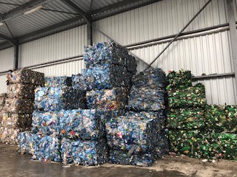

**DISCLAIMER**

This paper is developed by the World Bank team. The findings, interpretations and conclusions expressed do not necessarily reflect the views of the Executive Directors of the World Bank or the governments they represent. The study was produced to provide advisory support to the Ministry of Finance (MoF) and does not necessarily represent the views of Government of Bulgaria or of the MoF.

**ACKNOWLEDGEMENTS**

This paper was led by a core team led by Stella Ilieva (Senior Economist and Task Team Leader) and Kremena Ionkova (Senior Urban Development Specialist) and is prepared by Gerard Simonis (Waste Management Expert) focusing on efficiency analysis, Rene Boesten (Waste Management Expert), focusing on effectiveness analysis, Tzvetanka Kostadinova (Waste Management Expert), Vincent Belinga (Economist). The team is grateful to Lalita Moorty, Practice Manager, David Sislen, Practice Manager, and Antony Thompson, Country Manager, for their valuable support and guidance. Eva Yoneva and Ana Petkova provided research assistance while Adela Delcheva Nachkova provided administrative support. The team is extending appreciation to the officials of the Ministry of Finance, the Ministry of Environment and Water, the Executive Environment Agency, the National Association of Municipalities in the Republic of Bulgaria, and NSI for their excellent collaboration and feedback during our work. In addition, the team expresses its appreciation to officials from the municipalities of Sofia, Septemvri, and Dolna Mitropolia for participating actively in the Waste Management Working Group and officials and staff of municipalities of Gabrovo, Levski, Pavlikeni, Plovdiv and Veliko Tarnovo for the hospitality and excellent collaboration in providing detailed information and sharing their views.

|  |  |
| --- | --- |
| Country Manager:  Practice Manager: | Antony Thompson  Lalita Moorty |
| Task Team Leader: | Stella Ilieva |

**Table of Contents**

ABBREVIATIONS AND ACRONYMS 5

Executive Summary 6

Introduction 12

1. Key Challenges in Waste Management Spending 13

High waste management spending 13

Efficiency of spending appears low 16

Effectiveness of waste management spending could be improved 19

2. Efficiency of waste management spending 20

General 20

Waste collection & transportation 22

Waste separation 25

Waste landfilling 27

Waste composting 28

Public area cleaning 28

Total operational costs 30

3. Effectiveness of waste management 31

General 31

Waste collection and pre-treatment by municipalities 33

Collection of packaging materials (dry recyclables) by PROs 35

Total amounts of dry recyclables 36

Recommendations 39

Annex 1. References 43

Annex A-1 Analysis of Actual Waste Collection Costs 44

Annex A-2. Analysis of Estimated Waste Collection Costs 45

Annex B-1 Waste Treatment Actual Costs 47

Annex B-2 Waste treatment Estimated Costs 49

Annex B-3 Cost calculation landfills 50

Annex C-1 Public area cleaning actual costs 52

Annex C-2 Estimated public area cleaning costs 53

Annex D Template for cost calculation 54

Annex E National cost assessment 55

Figure 1: Bulgaria spends more on waste management and generates more waste. 13

Figure 2: Waste management spending is an important spending item for general government and municipalities budgets. 14

Figure 3: Waste management spending has been on the rise 15

Figure 4: …in line with improved revenue collection 15

Figure 5: Collection of waste and public area cleaning drive growth of waste management spending 15

Figure 6: Recent growth in total spending was driven by municipalities that outsource collection and transportation of waste in large municipalities 16

Figure 7: Current spending per ton of municipalities that provide services in-house appears higher than in municipalities outsourcing waste management services 17

Figure 8: There are large variations in current spending per ton of generated waste by group of municipalities 18

Figure 9: Despite significant investments in building regional waste management systems 20

Figure 10: …the share of landfilled waste remains significant, albeit falling 20

Figure 11: In contrast to international experience, largest municipalities pay the most per ton of collected waste 23

Figure 12: Variation of cost/ton per municipality is high 23

Figure 13: Actual costs of in-house services are almost double the estimated costs 25

Figure 14: Actual costs of outsourced activities are by 67 percent higher than estimated costs 25

Figure 15: Gate fees for separation vary 26

Figure 16: Actual gate fees for landfilling costs are broadly comparable across municipalities 27

Figure 17: Actual public area cleaning costs are highest for largest urban municipalities 29

Figure 18: Recycling rates in the EU 36

Table 1: Actual Collection & Transportation Costs per Ton of Collected Waste, 2016 (BGN/ton) 23

Table 2: Estimated Collection Costs per Ton of Collected Waste, 2016 (BGN/ton) 24

Table 3: Estimated Separation Costs per Ton of Separated Waste, BGN/ton 26

Table 4: Comparison of Actual and Estimated Waste Separation Costs, BGN/ton 26

Table 5: Comparison of Actual and Estimated Waste Separation Costs, BGN/ton 27

Table 6: Actual Cleaning costs (BGN/inhabitant) 29

Table 7: Comparison of Actual and Estimated Public Area Cleaning Costs, BGN/inhabitant 30

Table 8: Average public area cleaning cost in European countries 30

Table 9: Difference between actual and estimated spending for the sample of 20 municipalities 31

Table 10: Difference between actual and estimated spending for all municipalities 31

Table 11: New recycling targets for packaging waste 32

Table 12: Waste Generation and Treatment, 2016 34

Table 13: Amounts of municipal waste collected and recovered only by municipalities in newly established RWMCs, 2016 34

Table 14: Waste recycling via municipalities, ton 35

Table 15: Waste Recycling via PROs 35

Table 16: Total Waste Recycling 37

Table 17: Typical Morphology of Municipal Solid Waste, 2012-15 37

Table 18: Waste and recyclables, ton 38

Table 19: Estimated amount of packaging waste in MSW 39

# ABBREVIATIONS AND ACRONYMS

|  |  |
| --- | --- |
| BGN | Bulgarian Lev |
| COFOG | Classification of the Functions of Government |
| EEA | Executive Environment Agency |
| EMEPA | Enterprise for Management of Environment Activities |
| EU | European Union |
| GDP | Gross Domestic Product |
| GOB | Government of Bulgaria |
| MOEW | Ministry of Environment and Water |
| MOF | Ministry of Finance |
| MSW | Municipal Solid Waste |
| NAMRB | National Association of Municipalities in the Republic of Bulgaria |
| NSI | National Statistical Institute |
| OP | Operational Program |
| PRO | Producer Responsibility Organization |
| RIEW | Regional Inspectorates for Environment and Water |
| RWM | Regional Waste Management |
| RWMA | Regional Waste Management Association |
| RWMC | Regional Waste Management Center |
| SR | Spending Review |
| VAT | Value added tax |
| WB | World Bank |
| WEEE | Waste Electric and Electronic Equipment |
| WMA | Waste Management Act |

# Executive Summary

1. This study is an input to the second pilot Spending Review (SR) on Bulgaria. In 2016, the Government of Bulgaria (GoB) decided to initiate spending reviews to improve the efficiency and effectiveness of its spending in the context of a moderate fiscal consolidation process. Although Bulgaria has one of the lowest overall spending in the European Union (EU), spending outcomes lag those of other EU member states. In the case of waste management, Bulgaria spends the most among comparable EU countries, but outcomes could be significantly improved. Still a large part (48 percent in 2016[1]) of municipal solid waste generated is landfilled even though waste management infrastructure is under development.
2. To help address these challenges the Ministry of Finance (MoF) requested analytical and advisory support from the World Bank. Such support was intended to identify spending pressures and potential efficiency and effectiveness gains in waste management. In contrast to most spending reviews, where saving targets are identified upfront and the primary objective is to find ways of reducing the budget, the primary objective of this review is to increase performance and use any savings derived from efficiency gains for additional priority spending on waste management. A secondary objective is for this SR to help increase the transparency of spending on waste management, as information on spending categories by activity and municipality has not been analyzed until now. The last objective is to inform forthcoming SRs produced by the GoB by creating awareness of different methodologies available for analysis of spending. Collaboration of the Working Group members, representing key stakeholders—Ministry of Environment and Water (MOEW), MOF, Enterprise for Management of Environment Activities (EMEPA), National Association of Municipalities in the Republic of Bulgaria (NAMRB), National Statistical Institute (NSI), Executive Environment Agency (EEA), and municipalities—has been crucial in providing information for the analysis and serving as a sounding board for preliminary findings and conclusions.
3. The findings are derived from methodologies that are based on assumptions and partial data, and thus need to be interpreted with caution. The timeline limited the depth of the analysis, and therefore, the report focuses on broad trends, noting interesting findings as well as unexpected findings. Understanding the underlying causes of these unexpected findings, as well as obtaining more specific recommendations would require additional analysis. It is hoped that this first attempt at understanding efficiency and effectiveness of waste management spending will motivate further analysis in the area.
4. Over the last decade, Bulgaria has invested significant resources in improving the municipal waste collection and treatment (recovery and disposal) facilities. Public spending has increased and services provided by municipalities improved, waste disposal improved by replacing small, barely controlled landfills with fully controlled regional waste landfills. The private sector has taken up its own responsibility via Producer Responsibility Organisations (PROs) and is active in the collection of packaging waste, Waste Electric and Electronic Equipment (WEEE), batteries etc., originating from households and institutions that generate similar waste. This spending review offers a quick snapshot analysis of spending based on country level data as well as data from 20 selected municipalities. The analysis reveals many differences in costs among municipalities, shows some inconsistencies and poses multiple questions as well as the need for further detailed investigations to arrive at conclusive results.
5. Despite these significant achievements, challenges remain to enhance the efficiency of the municipal waste management system to ensure that public money is indeed spent in the most efficient way and the effectiveness of the system to achieve the targets set in the legislation.

*Key Findings*

1. **Bulgaria allocates significant resources of its GDP on waste management.** It spends the most compared to its regional peers both as percent of GDP and as a share of overall budget.[2] Like its peers, Bulgaria has increased waste management spending over the last couple of years but while in regional comparators, the increase was due to higher investments, in Bulgaria current spending (personnel and operations and maintenance costs) contributed significantly to overall spending growth. The main cost drivers were waste collection & transportation and public area cleaning, mostly in municipalities that outsource waste management activities to the private sector.
2. **There are large variations of spending across municipalities that need to be further analyzed.** Such variations could be a sign of inefficiency. The largest variations are in smaller municipalities and municipalities that provide in-house services. Providing services in-house seems to be more expensive than outsourced services even though the private provider includes profit/risk margin and amortization when calculating costs. Larger municipalities tend to outsource activities and could share experience in managing better contracts with private providers. Comparing current spending per ton of generated waste has its limitations in terms of quality and coverage of data. To address some of these limitations a more detailed analysis is done based on detailed questionnaire for 20 municipalities.
3. **The general finding of the spending review is that, based on the analysis of available information and data, cost reductions may be possible**. While further, in-depth investigations are required, costs for collection & transportation and costs for public area cleaning seem to have significant room for optimization. In addition, separation at source could be improved, increasing the share of waste that is reused and recycled and allowing Bulgaria to reach set targets.[3] Improving separation at source will also reduce the overall volumes of mixed waste which is currently serviced by municipalities. Key observations are presented below.
4. **When benchmarked against calculated costs (i.e. would-be costs based on a professionally run system in line with international practice but with local unit prices), actual costs for collection/transportation and street cleaning are substantially higher; they are comparable for waste separation and somewhat lower for landfilling**. Actual costs for in-house collection & transportation are by 92 percent higher than calculated costs (BGN/ton 71 vs. BGN/ton 37) and 27 percent higher for outsourced service (BGN/ton 98 vs. BGN/ton 77). In the case of public area cleaning, benchmarking with EU member states show that public area cleaning cost per inhabitant in Bulgaria is close to the average cost in some old EU member states. Despite large differences in wage costs, which make up close to 60 percent of overall street cleaning costs in EU countries, average cost per inhabitant in Bulgaria is higher than the average cost in Belgium, the Netherlands, and England.
5. **From the analysis of 20 municipalities it seems like that the largest gains in efficiency could be achieved in collection & transportation of waste and public area cleaning**. Spending on these activities is close to ¾ of overall waste management spending. If spending was more efficient, municipalities in Bulgaria could achieve the same level of service with BGN 138 million less, or savings of close to 31 percent of current waste management spending. Municipalities providing in-house services could achieve savings of close to 41 percent of their current spending, or close to BGN 30 million. These estimates need to be further verified to ensure results from analysis of 20 municipalities are applicable for all municipalities in Bulgaria.
6. **Despite popular belief, in-house collection & transportation activities do not appear to be more cost efficient than outsourced services, especially for smaller municipalities**. Average costs per ton for the sample of municipalities for outsourced activities is by 29 percent higher compared to in-house services but there are considerable differences by group of municipalities and not all costs have been taken into account in the cost of in-house services.For smaller municipalities providing in-house services[4], costs per ton are much higher than for outsourced services—by close to 30 percent for municiplaities with population of less than 50,000. Moreover, cost for in-house services does not include amortization and VAT is not levied on personnel spending while outsourced activities are subject to amortization and VAT on the total amount of the contract, including the wage and social contributions. This would mean that comparable costs for in-house services would be substantially higher as compared to outsourced services.
7. **Revenues from municipal waste fees are intended to cover mostly operational costs except for outsourced services where amortisation is typically factored in the costs**. To achieve financially sustainable in-house services, revenues must cover both operational and amortization costs which would however result in a substantial increase of cost per ton prices for in-house services.
8. **Cost per ton for collection & transportation services increases with increase in size of municipality.** This is in contradiction to international practices showing decrease of cost per ton with increase of waste quantities.
9. **Based on data from the PROs received from MoEW it seems that the amounts of packaging materials put on the market as reported to MoEW by the PROs may be lower than the actual amount put on the market**. Based on analysis utilizing the morphology of the mixed municipal solid waste, it appears that reported amounts could be as much as 30 percent lower than actual. This anomaly needs to be investigated further. If indeed large amounts of packaging waste remain in the mixed waste, this burdens the municipalities as they finance the management of such waste through the mixed waste stream.
10. **The majority of recycling materials are collected by the PROs who have the responsibility to finance the recovery of a set percentage of packaging materials placed on the market**. The recycling rate of recyclables compared to the total amount of waste is approximately 10–15 percent while the recycling rate compared to the total amount of recyclables (i.e. recycling potential) is between 32–42 percent. According to existing legislation,[5] at least 50 percent by weight of the waste from households needs to be recycled by 2020. It is therefore essential that separation at source improves significantly from current levels.
11. **The effectiveness of separating recyclables from mixed municipal solid waste after collection is limited to 3–5 percent which is low, also compared with international practice**. It should be noted that separation lines for mixed waste are not commonly used in the EU to increase recycling rates.
12. **The lack of sufficiently detailed guidelines on reporting requirements for waste management spending and waste quantities constitutes a serious drawback and a limitation for the assessment of the efficiency and effectiveness of the waste management system in Bulgaria**. At the national level, this is observed by differences in the statistical information available with different ministries and organizations (MoF, MoEW/EEA, NSI) and at municipal level it is displayed through inconsistent reporting of costs by municipalities. There is also lack of sufficient information and details related to the activities of PROs and RWMAs. Consequently, on certain instances as this paper reports, the available data show anomalies which are difficult to interpret and require further investigation.

*Key recommendations*

1. **Establish a uniform and transparent cost reporting system on municipal solid waste management services with clear guidelines for municipalities on cost items to be included in each waste management activity.**[6] These guidelines, planned to be finalized by March 2019, should be accompanied by capacity building for municipal staff for cost monitoring and reporting.
2. **Initiate an in-depth analysis of actual costs of many municipalities with high costs for collection & transportation of waste and public area cleaning and benchmark them with municipalities having acceptable cost levels**. The analysis could be useful in identifying the cost breakdown for each activity both for in-house and outsourced services; would allow better understanding of any errors of inclusion as well as errors of exclusion; and would facilitate the development of the guidelines.
3. **Include in the guidelines a basic methodology for calculation of operational and amortization costs separately for individual services within the value chain**: (i) waste collection and transport to facilities and treatment installations; (ii) treatment of waste in facilities and installations: separation services with associated recovery services of the recycled materials, RDF production and stabilization of biodegradables, etc.; composting including the associated separate collection costs; landfilling at a sanitary landfill; (iii) public area cleaning with description of the activities included. On basis of the cost calculations the tariff setting procedure must be decided including taxes (VAT, deductions, landfill fee), public area cleaning cost to be included, etc. Tariff invoicing to be based on the actual quantity of waste that represents the leading ground for determinig the extent of municipal waste fee, or on other grounds determined by the Municipal Council – for example, the number of persons in households pursuant to the provisions of art. 67, para 8 of the Local Taxes and Fees Act - for each type of service.
4. **Review and to the extent possible eliminate differences in the statistical information available with different ministries and organizations, at municipal level as well as PROs and RWMAs need to be reviewed**. This would greatly facilitate the process of comparing and analysing data from different sources that should be complementary, including data from each of the different treatment installations per RWMA.
5. **Ensure waste management key performance indicators (KPI) are adequate and transparent.** The planned information system of the EEA needs to be completed as soon as possible. Collecting and processing information in paper form reduces transparency and accuracy of information. Potential KPI could include—collected waste by municipality—overall quantity and per capita; share of landfilled waste by municipality; input and output of all fractions per treatment installation, share of recycled waste by municipality, progress in reaching the targets, etc.
6. **Consider developing a dashboard with selected indicators by municipality to increase transparency and help municipalities learn from each other.** Such indicators could include spending on waste collection & transportation per ton of collected waste, spending on public area cleaning per inhabitant, as well as some key performance indicators mentioned above (share of landfilled waste, progress in reaching the targets, etc.).
7. **Consider introduction of legal obligation for municipal enterprises to prepare audited annual financial reports**. This is expected to increase transparency of in-house waste management services of municipalities and could lead to efficiency gains.
8. **Invest in tracking systems to improve surveillance of collection & transportation of municipal solid waste**. There are cheap modern technologies that can be used to track planned routes of waste trucks, location accuracy of containers, fullness of containers, servicing of waste containers etc. Such technologies could improve efficiency and effectiveness of waste management services.
9. **Draft a separate methodology to determine the morphological composition of the waste collected via the separate collection systems of the PROs**. Both the methodology for the PROs and the Methodology for identification of morphological content of municipal waste will need to include specific method how to split the recyclables (packaging/ non-packaging) in the municipal waste stream. Proposed measures will lead to more precise calculation of the amount of packaging waste in municipal waste stream and could improve efficiency of spending of municipalities for management of municipal solid waste (MSW).
10. **Promote significant improvement of separation at source and separate collection by investing in public awareness**. It is unlikely that the recycling rate can be increased with the present system of post collection separation of MSW and the separation at source via the PROs.

# Introduction

1. **This study is an input to the second pilot Spending Review (SR) on Bulgaria**. In 2016, the Government of Bulgaria (GoB) decided to initiate spending reviews to improve the efficiency and effectiveness of its spending in the context of a moderate fiscal consolidation process. Though Bulgaria has one of the lowest overall spending in the European Union (EU), spending outcomes lag those of other EU member states. In the case of waste management, Bulgaria spends the most among comparable EU countries[7] but outcomes could be significantly improved. Still, most of the waste collected by municipalities is landfilled despite significant investments in waste processing facilities.
2. **The findings of the study are derived from methodologies that are based on assumptions and partial data, and thus need to be interpreted with caution.** The timeline limited the depth of the analysis, and therefore, the report focuses on broad trends, noting interesting findings as well as unexpected findings. Understanding the underlying causes of these unexpected findings, as well as obtaining more specific recommendations would require additional analysis. It is hoped that this first attempt at understanding efficiency and effectiveness of waste management spending will motivate further analysis in the area.
3. **This is the first study of municipal waste management spending and most of the analysis is based on data from 20 municipalities**. To address issues related to availability and reliability of detailed information by municipality, the analysis is based on specially designed questionnaires that were filled in by 20 municipalities and the Operators of the Regional Waste Management Systems, accepting waste from these municipalities. The municipalities were selected by MOEW and MOF based on criteria such as size (4 groups according to population); participation in established integrated RWM systems, which are in operation; and participation in different regional waste management associations (15 associations are presented in this study). The questionnaires covered information on the organization of the waste management activities, amounts of municipal waste collected, separated and recyclables delivered for material recycling, produced RDF (if it is part of the system), produced compost and waste, destined for landfill disposal, and spending data by activity and economic classification. However, the reliability of all data provided could not be checked[8] and therefore the results should be treated with some caution.
4. **The objectives set by the GoB for this waste management spending report are threefold**. First, to identify areas of efficiency gains within the existing budget envelope. Municipalities collect municipal waste fees to cover the cost of waste management activities but find it difficult to raise fees or improve markedly revenue collection and compliance given the still low incomes of the population. The second objective is to improve the transparency of waste management spending. Public information on costs of waste management activities and comparisons across municipalities is difficult to find and comprehend by non-experts. The third objective is to inform GoB’s pilot SRs and, together with the SR Manual, create awareness of the methodologies available for the implementation of SRs in Bulgaria. This report is a first attempt at better understanding spending efficiency and effectiveness of municipal waste management in Bulgaria. In a limited amount of time and with the existing data limitations, it provides a first round of preliminary findings and identifies some areas where more detailed data and further analysis will be needed.

# Key Challenges in Waste Management Spending

1. **This section presents an overview of waste management spending in Bulgaria based on macro data from Eurostat, NSI, and MOF as well as data obtained from 20 municipalities**. The analysis benchmarks Bulgaria with its regional comparators, looks at the spending patterns and composition of spending and benchmarks municipalities by groups of municipalities to identify potential spending pressures. It should be noted that the analysis and interpretation of collected data sets has been constrained by certain inconsistencies and data gaps. The key findings are presented below.

# High waste management spending

1. **Bulgaria spends more on waste management compared to its regional peers reflecting high amount of waste generated.**[9] Between 2012 and 2016, Bulgaria spent on average 0.62 percent of GDP per year on waste management, the highest level of spending in the EU (Figure 1), and almost double the levels in Romania and the Baltic countries. While there might be differences in the coverage of waste management services across countries, it is worth exploring why Bulgaria’s public spending is so high. Bulgaria stands out also with its high quantities of generated waste per capita despite its low per capita income. Usually richer countries generate more waste per capita. Over the same period, Bulgaria generated on average 431 kg of waste per person per year while Romania only generated 252 kg per person and Poland 296 kg.

|  |  |  |
| --- | --- | --- |
| Figure 1: Bulgaria spends more on waste management and generates more waste. | | |
|  |  | |
| **Note:** Waste management includes collection, treatment and disposal of waste.  **Source:** Eurostat, COFOG data | | |

1. **Waste management in Bulgaria is an important expenditure item for general government and municipal budgets**. Waste management spending makes up a significant share of general and local government spending in Bulgaria. In 2016, spending on waste management in Bulgaria accounted for 1.6 percent of general government spending, and for 7.9 percent of local government spending—the highest shares compared to regional comparators (Figure 2). Municipalities in Bulgaria are responsible for waste collection & transportation, treatment and public area cleaning. To provide these services, municipalities collect municipal waste fees.

|  |
| --- |
| Figure 2: Waste management spending is an important spending item for general government and municipalities budgets. |

**Source:** Eurostat, COFOG data

1. **Waste management spending has been on the rise in line with increasing revenues and financing from the EU**. According to MOF data, municipal spending[10] on waste management increased by close to BGN90 million between 2013 and 2016 (Figure 3). Municipalities charge citizens and firms for waste management activities and have recently improved collection of municipal waste fees (Figure 4). Revenues from fees, however, are not sufficient to cover all the investment needs of municipalities. Additional funds have been provided from the Operational Program (OP) Environment, financed by the EU, for building regional waste management systems and for recultivation of old landfill sites. The Government also supports municipalities for such investments, through the EMEPA.

|  |  |
| --- | --- |
| Figure 3: Waste management spending has been on the rise | Figure 4: …in line with improved revenue collection |
|  |  |
| **Source:** Ministry of Finance | **Note:** Excludes Sofia City municipality  **Source:** World Bank staff estimates based on data from questionnaires. |

1. **Collection and transportation of waste and public area cleaning contributed most to recent growth in waste management spending** (Figure 5). Collection & transportation of waste accounted to close to 45 percent of waste management spending in 2016 and grew by 10 percent compared to 2015, driving overall growth in waste management spending of municipalities. Public area cleaning (sweeping of streets, parks, cleaning of snow, and washing of streets) represents 1/3 of total waste management spending, and experienced a growth of about 7 percent per year in 2016. Only spending on waste treatment (separation, recovery and landfilling) declined in 2016 because of declining investments in waste management infrastructure financed with EU funds. In the absence of significant investments in infrastructure in 2016, the share of spending on waste treatment is declining at the expense of spending on waste collection & transportation and public area cleaning.

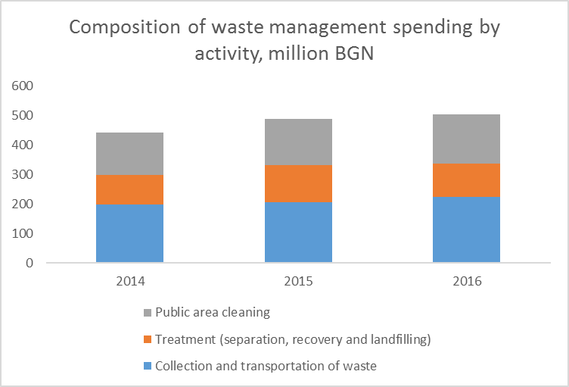Figure 5: Collection of waste and public area cleaning drive growth of waste management spending

|  |
| --- |
| **Source:** World Bank staff estimates based on NSI data and data from questionnaires. |

1. **Significant share of waste management activities are outsourced with up to BGN 420 million paid to private companies**. 145 municipalities outsourced collection and transportation of waste in 2016 and account for the bulk of overall spending on waste management. Usually municipalities that outsource collection and transportation, outsource also other waste management activities such as separation and treatment of waste, and public area cleaning. Some of the largest municipalities that outsource services also have in-house activities but since detailed breakdown is not available, all their activities are considered outsourced for the purposes of this analysis. If there were no changes in the organization of services provided,[11] municipalities that outsource activities increased their total spending by 14.9 percent (Figure 6) in 2016 compared to 2015. Municipalities providing in-house services are usually smaller municipalities with population of less than 150,000. Despite their large number (120), their spending represents only 18 percent of overall waste management spending.

|  |  |
| --- | --- |
| Figure 6: Recent growth in total spending was driven by municipalities that outsource collection and transportation of waste in large municipalities | |
|  | |
| **Source:** World Bank staff calculations based on MoF data | |

# Efficiency of spending appears low

1. **Municipalities providing in-house collection and transportation services seem to spend more per ton of generated waste than municipalities outsourcing activities**. The cost of providing in-house services appears higher on average and for all groups of municipalities (Figure 7) even though the private providers include profit and amortization in their costs. For instance, the weighted average of the current spending per ton for in-house services is by 28 percent higher than for outsourced services. This difference is much larger for municipalities with population between 15,000 and 50,000 where municipalities providing in-house services pay on average 50 percent more than their peers that outsource services. However, some municipalities consider outsourcing to be costlier compared to in-house services and try to expand in-house activities (for municipalities providing both outsourced and in-house activities) or shift entirely to in-house provision. At aggregate level and based on the existing data, there is no evidence that shifting to in-house services leads to savings. Section 2 provides comparison of unit costs based on more detailed data for 20 municipalities.

Figure 7: Current spending per ton of municipalities that provide services in-house appears higher than in municipalities outsourcing waste management services

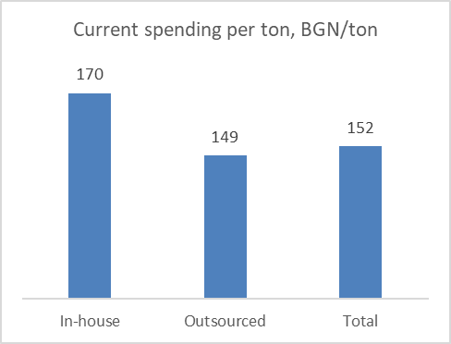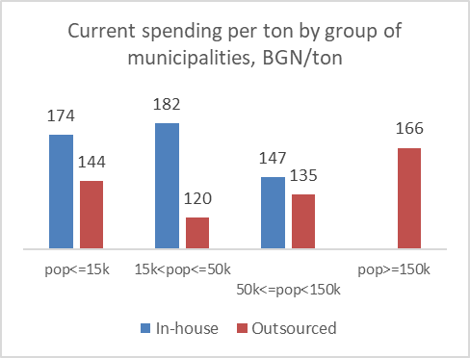

**Source**: World Bank staff estimates based on MOF and NSI data.

**Note:** Data refer to 2016. The estimates of outsourced activities exclude VAT.

1. **There are large variations in current spending per ton of generated waste, especially in the smallest municipalities**. Large variations in spending per ton across municipalities can be an indication of inefficient use of resources or may reflect unreliable spending or waste data. As shown in Figure 8, the variation of current spending[12] per ton of generated waste is very high across all groups of municipalities. The highest variation, however, is observed in the smallest municipalities with less than 15,000 inhabitants. For example, spending per ton in these municipalities varies between BGN20 and BGN690 per ton. Such high variations will need to be explored in more details to understand if spending is sufficient to provide adequate service (for municipalities with the low-cost levels), if there is room for efficiency gains (for municipalities with high cost levels), and if there is an issue with data reliability (underreporting of spending or of generated waste). Understanding the factors affecting the cost differences would require a more in-depth analysis, decomposing spending by type of activities and estimating unit costs based on amounts of waste collected by municipalities. Such analysis is presented in Section 3 based on detailed data received from 20 municipalities.
2. **Variations in larger municipalities, albeit smaller, are also worth exploring as these municipalities contributed most to waste management spending growth**. Current spending per ton in municipalities with population between 15,000 to 50,000 was between BGN53 in Omurtag to BGN557 in Radomir. In the other two groups of municipalities variations were smaller—from BGN100 to less than BGN300. Nevertheless, comparisons between municipalities can provide useful lessons. For example, Burgas with an estimated unit cost of BGN 263/ton could learn from Varna (BGN 121/ton) how to reduce by half its current spending per ton as these two cities have similar characteristics in terms of size of population and inflows of tourists.

|  |  |
| --- | --- |
| Figure 8: There are large variations in current spending per ton of generated waste by group of municipalities | |
|  | |
|  | |
|  |  |
| **Source:** World Bank staff calculations using data from MOF and NSI | |

1. **It should be noted that estimated spending per ton of generated waste is indicative and has two major limitations**. First, the spending includes also spending on public area cleaning which is not associated with amounts of waste generated. Second, generated waste reported by NSI includes waste collected not only by municipalities but also waste collected by PROs and companies collecting recyclables. The EEA is responsible for gathering detailed information on flows of waste by municipality but the data is not readily available. Despite these limitations, unit costs shown in this section provide an indication of potential outliers.
2. **Comparison of waste management unit costs for all 265 municipalities in the future should be based on information by municipality on spending per type of activity and amounts of waste collected by municipalities and delivered for waste treatment to Regional Waste Management Centers (RWMCs)**. Provided such breakdown is available, a data envelopment analysis[13] could be considered to compare spending and performance of all municipalities.The NSI collects information from all municipalities on the spending per type of activity but wage spending is shown separately instead of being allocated to the three types of activities—collection, treatment, and public cleaning. This information is not publicly available, neither in aggregate amounts or by municipalities, even though municipalities use similar breakdown of activities when justifying the rate of the waste fee. The EEA collects detailed information from municipalities but the data is provided in paper form and summary tables in easy to understand format—by the users of waste management services (citizens and firms) and decision makers alike—are not publicly available. Municipalities are also obliged by law to publish the justification for the proposed setting of the waste fee, detailing planned spending per type of activity and reporting of actual spending. However, the information is provided in different formats and breakdowns and in most cases is difficult to find on the municipalities websites.

# Effectiveness of waste management spending could be improved

1. **Significant investments were made in Bulgaria in building regional waste management systems but the share of landfilled waste remains high**. Nearly BGN720 million[14] were invested between 2007 and 2015 in building modern pre-treatment facilities , including separation, recovery, composting and landgfilling, which serve the municipalities participating in the corresponding regional waste management associations (RWMAs) (Figure 9). These investments were used to support 26 RWMAs, covering 120 municipalities. The rest of municipalities would receive financing from the new OP Environment 2014-2020. Bulgaria still landfills 48 percent of the generated waste in 2016[15] and the analysis in section 4 shows that the effectiveness of separation and recycling is low.

|  |  |
| --- | --- |
| Figure 9: Despite significant investments in building regional waste management systems | Figure 10: …the share of landfilled waste remains significant, albeit falling |
|  |  |
| **Source:** Information System for Management and Monitoring of EU funds (ISUN) | *Source*: NSI |

# Efficiency of waste management spending

## General

1. **Brief description of the organization of the waste management system in Bulgaria**. The common waste collection system consists of a bring system using various capacity containers for mixed municipal waste combined with bring systems for recyclables. The mixed waste system is the responsibility of municipalities while PROs are fully responsible for separate collection of packaging waste and the financing of all its costs to meet the take back and recycling requirements under the Extended Producer Responsibility (EPR) legislation. Bulgaria has around 55 regional landfills under the management of RWMAs. In 2016, 49 percent of the mixed municipal waste is transported to separation lines at RWMA’s, close to 3 percent are recyclables from municipal solid waste delivered for recycling, and 48 percent is transported directly to a regional sanitary landfill owned by the municipalities which are members of the corresponding RWMA. The RWMCs separate plastics, paper and cardboard, glass and metals, and produce compost from green waste. There are several RWMCs producing Refuse Derived Fuel (RDF) which is then delivered for incineration with energy recovery to cement plants. In some of the RWMCs biodegradable waste is stabilized and as a result a compost-like output (CLO) is produced, part of which is used for covering of landfills.
2. **Availability and reliability of statistical information limits the depth of the analysis and could affect the findings.** There is lack of uniform and transparent information on spending both at national and municipal level by type of waste management services. In the process of preparing this report, some inconsistencies were detected in statistical information by different ministries/organizations (MOF, MoEW, EEA, NSI). For example, NSI reports a quantity of waste delivered to separation lines of 1,42 million tons in 2016 where EEA reports a quantity of 1,15 million tons. Data reported by Regional Inspectorates for Environment and Water (RIEW) on landfilled waste by municipality show substantial differences with data reported by NSI and by 20 municipalities.
3. **To address the issues related to availability of information, the analysis is based on specially designed questionnaires that were filled in by 20 municipalities and the Operators of the Regional Waste Management Systems, accepting waste from these municipalities**. The municipalities were selected by MOEW and MOF based on criteria such as size (4 groups according to population); participation in established integrated regional waste management systems, which are in operation; and participation in RWMAs (15 associations are presented in this study). The questionnaires covered information on the organization of the waste management activities, amounts of municipal waste collected, separated and recyclables delivered for material recycling, produced RDF (if it is part of the system), produced compost and waste, destined for landfill disposal, and spending data by activity and economic classification. However, the reliability of all data provided could not be checked[16] and therefore the results should be treated with some caution. The efficiency assessment carried out in this report is based on an analysis of the actual cost/ton or cost/inhabitant in case of public area cleaning for the various waste management activities and the identification of possible lower cost for the same services. The assessment is based on information provided by 20 municipalities (by means of completed questionnaires for year 2016). The 20 municipalities represent 40 percent of the total population and 33 percent of total waste collected.
4. **Actual cost/ton used in this analysis follow established municipal practice.** Municipalities report on cash basis for four main activities i.e. (i) containers/bins; (ii) collection and transport, (iii) treatment including separation, recovery, composting, and landfilling; and (iv) public area cleaning. It is not understood why municipalities must report separately on investments on containers, while the investments in vehicles are included in the “collection and transportation” activity. The total costs per activity include personnel costs, operations and maintenance costs as well as:

* Investments and thus cost/ton can vary per year
* VAT paid by municipality (“reverse charge” system). VAT for in-house services is only on purchases and not on wages but full VAT payment is applied on outsourced services. As a result, the overall VAT costs to be added for in-house services is lower than for outsourced services
* Additions such as costs for closure of landfills and fee for every ton of waste disposed into landfill (art. 60 and 64 of WMA)
* Amortization and margin to cover profit/risks on outsourced services and no amortization on in-house services.

1. **Estimated costs, i.e. would-be costs based on a professionally run system in line with international practice but governed by local legislation requirements and with local unit prices**, are presented below for the individual segments of the value chain, i.e. collection & transportation, separation, landfilling and street sweeping. Annex E presents a full summary of the actual and the estimated costs based on the prevailing situation:

* 20 municipalities: In-house or outsourced services for collection and public area cleaning while separation and landfilling services are subcontracted to a private company operating the facilities owned by the municipalities. In-house services are without amortization and at lower VAT cost (no VAT on wages) while outsourced services are subject to full VAT charge, amortization and a margin for profit/risk. No VAT is applicable on street cleaning services.

**Box 1: Basic principles of efficiency assessment**

Waste is defined as Municipal Solid Waste generated by households and similar type of waste from commercial, institutional and industrial entities and street cleaning waste. Efficiency is defined as assessment of the actual operational cost/ton for WM services and the possibility to provide same services for a lower cost.

The assessment is based on following approach:

1. Information is used given in questionnaires filled in by 20 municipalities representing 40 percent of population and 33 percent of total generated municipal solid waste.
2. In addition, information from national organisations such as the NSI and the EEA under MOEW is used.
3. Information on amounts of packaging waste collected and recycled are received from MOEW.
4. Information on amounts of recyclables (plastics, paper, glass and metals) collected and recycled by the municipalities (or via their RWMCs) is taken from the questionnaires filled in by 20 municipalities.
5. Total costs for each waste management activity (collection & transportation of waste, waste treatment (separation, recovery, and landfilling) and public area cleaning) are used as reported by Municipalities being a mix of investment costs and operational costs excluding amortization.
6. Total costs are corrected by deducting (i) investment expenditures and (ii) costs under art. 60 and 64 of WMA (landfill closure and fee for every ton of waste disposed into landfill) as far as reported. It is assumed that total costs include VAT paid by municipalities for in-house and outsourced services whereby municipalities do not pay VAT on wages (estimated at 40 percent of operational costs).
7. Actual cost/ton is analysed using the corrected total costs and the quantities collected and delivered to the RWMC as reported by the municipalities.
8. The actual costs/ton are compared with own estimated cost/ton or cost/inhabitant for each activity i.e. collection & transportation, waste treatment (separation, recovery, and landfilling) of mixed waste and public area cleaning.

## Waste collection & transportation

***Actual operational costs***

1. **Analysis of actual costs of 20 municipalities (Annex A-1) suggest that the larger the municipality the higher the cost of collection and transportation** (Figure 11). By contrast, international practices show economies of scale where costs per ton decrease with the increase of waste quantities. All large municipalities in the sample outsource collection and transportation of waste but some municipalities provide also in-house services. Plovdiv municipality, where the collection & transportation cost is one of the lowest among the group of large municipalities, hires in collection trucks while collection of waste is performed by staff employed by the municipality.
2. **There is a great variation of costs per ton among individual municipalities.** The largest variation of unit costs is observed among the smallest municipalities (Figure 12) in the first two groups—municipalities with population below 15,000 and municipalities with population between 15,000 and 50,000. These variations could be due to differences in distance to disposal area, frequency of collection, urbanization degree, organization of the work (if the service is provided in-house or outsourced). In most of the smallest municipalities, collection & transportation of waste is provided by the municipality—either directly or by a municipal enterprise. Larger municipalities tend to outsource such services.

|  |  |
| --- | --- |
| Figure 11: In contrast to international experience, largest municipalities pay the most per ton of collected waste | Figure 12: Variation of cost/ton per municipality is high |
|  |  |
| **Source:** World Bank staff estimates based on data from questionnaires | **Source:** World Bank staff estimates based on data from questionnaires |

1. **Despite popular belief, in-house activities do not appear to be more cost efficient, especially for smaller municipalities**. Average cost/ton for outsourced services is almost twice the cost of in-house services (Table 1), but there are significant differences by group of municipalities and reporting of costs. For smaller municipalities (with population of less than 50,000) in-house services are much more expensive while for larger municipalities it is the opposite. Only three out of ten larger municipalities, however, provide in-house services (Vidin, Gabrovo, and Plovdiv). In addition, the cost of in-house services for all municipalities excludes amortization and is subject to lower VAT costs as there is not VAT on personnel cost for in-house services. Including VAT and amortization in in-house service costs would mean that comparable costs for in-house services would be substantially higher as compared to outsourced services, especially for municiplaities with population of less than 150,000 inhabitants. In-house and outsourced services are about 50-50 percent quantity-wise and 12-88 percent cost-wise in the sample of 20 municipalities. The total costs for collection & transportation is corrected for any investment as far as reported.

Table 1: Actual Collection & Transportation Costs per Ton of Collected Waste, 2016 (BGN/ton)

|  |  |  |  |
| --- | --- | --- | --- |
| **Municipal size** | **Average** | **In-house¹** | **Outsourced** |
| <15,000 | 61.6 | 78.9 | 42.0 |
| 15,000-50,000 | 96.7 | 127.2 | 88.3 |
| 50,000-150,000 | 79.3 | 62.4 | 87.2 |
| >150,000 | 122.7 | 71,0 | 134.6 |
| **Total** | **117.0** | **65.5** | **128.8** |

**Notes: ¹** Excluding amortization and margin for profit/risk; subject to lower VAT costs. See Annex A-1

**Source***:* World Bank staff estimates based on data from questionnaires.

***Estimated costs***

1. **Analysis of estimated costs (Table 2) is based on international practices and considering the cost level and legislation in Bulgaria**. Benchmarking with costs in other EU countries or countries in the region might be misleading as it will very much depend on the design of the collection system (bring system versus kerbside collection, frequency of collection, urbanization degree, distance to disposal area, salary level, etc.). Therefore, cost estimates are made based on international practises and considering the cost level (of inputs such as energy and wages) and legislation (applicable VAT regime). (Annex A-2)

Table 2: Estimated Collection Costs per Ton of Collected Waste, 2016 (BGN/ton)

|  |  |  |  |  |  |  |
| --- | --- | --- | --- | --- | --- | --- |
| Inhabitants | Outsourced (BGN/ton)¹ | | | In-house (BGN/ton) | | |
|  | OPEX² | CAPEX³ | Total | OPEX² | CAPEX³ | Total |
| Up to 30,000 | 57.22 | 40.41 | 97.64 | 48.55 | 36.74 | 85.29 |
| Up to 60,000 | 45.26 | 36.29 | 81.55 | 38.41 | 32.99 | 71.40 |
| Up to 150,000 | 41.81 | 32.17 | 73.99 | 35.48 | 29.25 | 64.73 |
| Average | 43.27 | 33.4 | **76.68** | 36.72 | 30.37 | **67.09** |

**Notes:** ¹ Including margin for profit/risk. All amounts including VAT. Source: Annex A-2;

² OPEX means operational costs;

³ CAPEX is amortization costs considering depreciation and interest.

**Source***:* World Bank staff estimates based on data from questionnaires.

1. **Comparison of actual and estimated costs shows that in-house services (**Figure 13**) spend per ton almost double the estimated cost per ton**. The second group of municipalities (with population between 15,000 and 50,000) appears to be an outlier. However, the significant difference could reflect longer distance to RWMC as Levski and Pavlikeni municipalities fall within this group and transport their waste to Nikopol (the distance is more than 60 km). The estimated cost of in-house services includes only operational costs (OPEX) as no amortization is accrued.

|  |  |
| --- | --- |
| Figure 13: Actual costs of in-house services are almost double the estimated costs | Figure 14: Actual costs of outsourced activities are by 67 percent higher than estimated costs |
|  |  |
| **Source***:* World Bank staff estimates based on data from questionnaires | **Source:** World Bank staff estimates based on data from questionnaires |

1. **Differences between actual and estimated costs, albeit significant, are less pronounced for outsourced services (**Figure 14**).** Actual costs for all municipalities in the sample that outsource services are by 67 percent higher than estimated costs, mostly on the account of significant differences in large municipalities. Estimated costs for municipalities in the first two groups (with population below 50,000) appear lower than the actuals. These results, however, could be affected by deficiencies in reported amounts of waste as some of these municipalities are outliers in terms of waste per capita per year. For larger municipalities (above 50,000 population) actual costs of Varna and Pernik are meeting the estimated cost levels.

## Waste separation

***Actual operational costs***

1. **The separation operations at the RWMA are generally outsourced** realizing about 82,500 tons of plastics and paper/cardboard. This would be 7 percent of the input (according to EEA). Data from the municipal questionnaires however show that no more than 3 – 5 percent of the waste are separated recyclables (**Error! Reference source not found.**). The discrepancy between the EEA data and the data from the questionnaires remains unexplained.
2. **A gate fee is charged by the private operator for separation services** including all operational costs such as costs for wages, maintenance and repair, energy and transport to landfill but excluding amortization and VAT. No amortization costs are considered as the municipalities-members of the RWMA are the owners of the facilities.
3. **The weighted average gate fee is BGN 23/ton excluding VAT** (Annex B-1). The separation costs in Sofia are BGN 32.20/ton excluding VAT but it includes biodegradable waste stabilisation and RDF production. This gate fee is based on a minimum reduction by weight of 20-25 percent of landfilled waste subject to landfill fee. In case this target is not realized, the gate fee will be lower in the following year. Landfill reduction is realized through separation of recyclables, loss of humidity during waste stabilisation treatment and production of compost-like output for waste covering.

Figure 15: Gate fees for separation vary

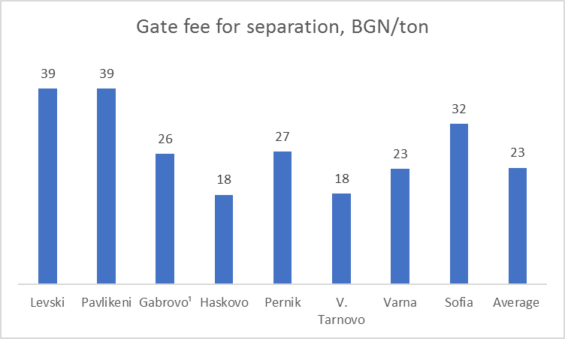

**Note:** Excluding VAT

**Source:** World Bank staff estimates based on data from questionnaires.

***Estimated cost***

1. Most operations of separation lines are outsourced to private companies while the municipalities being member of the RWMA are generally the owner of the facilities. The private company is responsible for all direct operational costs such as maintenance and repair, energy consumption, etc. For benchmarking purposes own estimates have been prepared for a 15t/h line operating 10hrs/day during 312 days/year (Annex B-2). The results are summarized in the table below:

Table 3: Estimated Separation Costs per Ton of Separated Waste, BGN/ton

|  |  |  |  |
| --- | --- | --- | --- |
|  | OPEX¹ | CAPEX² | Total |
| Estimated | 18.5 | 10.8 | 29.3 |

¹ Excluding VAT and margin for profit/risk; ² CAPEX is amortization

**Source:** World Bank staff estimates based on data from questionnaires.

Table 4: Comparison of Actual and Estimated Waste Separation Costs, BGN/ton

|  |  |  |
| --- | --- | --- |
|  | Actual cost1 | Estimated cost² |
| Average cost of waste separation (based on data for 7 municipalities) | 23.3 | 21.3 |

¹ Covers only operational expenses, including profit/risk margin; ² Includes risk margin of 15 percent.

**Source:** World Bank staff estimates based on data from questionnaires.

1. Actual separation costs are in line with the estimated costs. Estimated operational costs (OPEX) including margin for profit/risk would average BGN 21.3/ton (risk margin of 15 percent as gate fee will depend on separation percentage).

## Waste landfilling

***Actual Operational Cost***

1. **Landfills at RWMCs are normally operated by the private company also operating the separation line**. The landfill is owned by the municipality on the territory of which the landfill is located. The gate fee for landfilling is related to the expected quantities and thus the size of the cell in exploitation. The weighted average of actual gate fees has been estimated at BGN 19.8/ton excluding VAT and amortization (Annex B-1). In addition to the gate fee, a deduction under art. 60 of WMA (depending on the size of the landfill) is applied for closing and monitoring of landfills, and deductions under art.64 of WMA—for every ton of waste disposed into a landfill (BGN 36/ton in 2016)[17]. No gate fee nor deduction is paid for waste covering materials such as stabilised material from the separation line.

Figure 16: Actual gate fees for landfilling costs are broadly comparable across municipalities

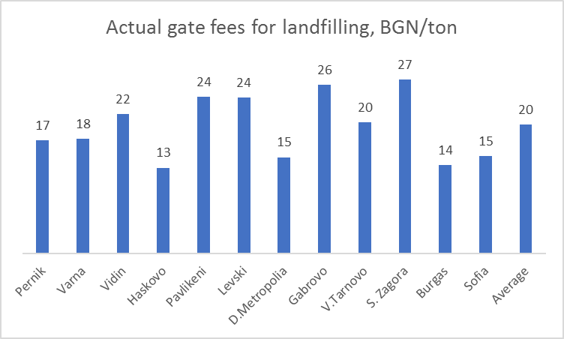

**Source*:*** World Bank staff estimates based on data from questionnaires.

***Estimated cost***

1. **The actual gate fees are lower than the estimated costs.** This might result in deterioration of the landfill into a sub-standard facility (low compaction by trying to save on fuel, no adequate waste covering, insufficient leachate treatment, no adequate maintenance, etc.). Most landfill operations are outsourced to the same company operating the separation line and, in some cases, a municipal enterprise might operate the landfill. For benchmarking purposes own cost estimates are prepared (Annex B-3) resulting in BGN 24/ton including 10 percent margin for profit/risk and excluding VAT as compared with the actual gate fee of BGN 19.8/ton excluding VAT.

Table 5: Comparison of Actual and Estimated Waste Separation Costs, BGN/ton

|  |  |  |
| --- | --- | --- |
|  | Actual cost1 | Estimated cost |
| Average cost of landfilling waste | 19.8 | 24.0 |

**Note:** ¹ Covers only operational expenses, including VAT and profit/risk margin;

**Source:** World Bank staff estimates based on data from questionnaires.

## Waste composting

***Actual operational cost***

1. **Composting infrastructure in Bulgaria is under development.** Composting facilities are constructed at RWMCs based on aerobic or anaerobic technologies. The composting facilities are mainly used for pre-separated “green waste” coming from park maintenance as separate collection of organic waste from households is in its infancy although Sofia municipality is also reporting on food waste to be delivered for anaerobic digestion. The total national annual quantity of biowaste in 2016 is reported by EEA at 109,926 tons although only 5 out of 20 municipalities are reporting on costs for composting. No costs are reported for green waste collection and transport while the annual costs reported for composting are between BGN 20,000-30,000 per municipality. No information is available on type, number and investment costs for composting installations in the 20 municipalities. Therefore, further analysis on the efficiency and effectiveness of composting could not be carried out.

## Public area cleaning

***Actual Operational Cost***

1. **Public area cleaning spending is an important spending activity for municipalities.** Municipalities include costs for provision of litterbins and its emptying, sweeping and washing of streets, cleaning of municipal roads, graffiti cleaning, weed cleaning, cleaning illegal dumps, summer (sweeping and washing) and winter cleaning of streets and parks in urban areas, cleaning of municipal roads and other activities. Public area cleaning spending could include also some expenses related to park or road maintenance that need to be classified under other government functions but municipalities find it difficult to distinguish always costs pertaining to waste management only. Detailed guidelines for correct classification of expenses under public area cleaning is key as these expenses are used for the calculation of the waste fee.
2. **As expected, actual public area cleaning cost per inhabitant (Annex C-1) tends to be higher for larger urban municipalities although there is high variation of unit costs in these municipalities.** Large urban municipalities tend to provide more services to its citizens, labor costs are higher in cities, demand for higher quality services is greater requiring higher frequency of services. High variation of unit costs in larger municipalities needs to be further analyzed as it might signal inefficiencies. Some municipalities include costs for activities that are not related to waste management such as development, repairs, snow cleaning, disinfection, landscaping, etc., that unlawfully increses services costs.

Figure 17: Actual public area cleaning costs are highest for largest urban municipalities

**Source:** World Bank staff estimates based on data from questionnaires.

1. **Actual cost per inhabitant for public area cleaning for in-house services appears lower than for outsourced services, although the results vary according to the size of municipality (Table 6).** Cost/inhabitant for in-house services is by 13 percent lower than for outsourced services but the private provider includes profit and VAT in the cost of contracted services. Most of the smallest municipalities provide the cleaning services in-house while most of large municipalities (with population of more than 50,000) outsource all or part of these services. Municipalities believe that provision of in-house services is more efficient as the service cost does not include VAT and profit margin. Some large municipalities, such as Veliko Tarnovo, have started to increase the share of in-house services with the aim of reducing costs and increasing effectiveness. Available data does not provide evidence however for such gains so far. The low outsourced cost/inhabitant must be taken with some caution as it is based on a limited number of municipalities. Cost breakdown of the reported total costs is lacking and therefore no detailed assessment could be made of the efficiency.

Table 6: Actual Cleaning costs (BGN/inhabitant)

|  |  |  |  |
| --- | --- | --- | --- |
| Municipal size | Average | In-house | Outsourced |
| < 15,000 | 6.73 | 7.16 | 5.38 |
| 15-50,000 | 7.70 | 6.37 | 8.70 |
| 50-150,000 | 24.29 | 16.35 | 27.53 |
| >150,000 | 37.87 | 41.08 | 37.34 |
| Total | 34.53 | 30.95 | 35.46 |

**Note:** For more details Annex C-1

**Source:** World Bank staff estimates based on data from questionnaires.

***Estimated costs***

1. **Analysis of estimated costs (Annex C-2) show that on average they are by 22 percent lower than actual costs**. The differential between actual and estimated costs is higher for in-house services **(**Table 7). The estimated cost per person does not take into account differences in the scope and quality of services covered.

Table 7: Comparison of Actual and Estimated Public Area Cleaning Costs, BGN/inhabitant

|  |  |  |
| --- | --- | --- |
|  | Actual cost | Estimated cost |
| In-house services | 30.95 | 20.38 |
| Outsourced | 35.46 | 29.64 |
| Average cost | 34.53 | 26.79 |

**Source:** World Bank staff estimates based on data from questionnaires and own estimates.

1. **Public area cleaning cost per inhabitant in Bulgaria is close to the average cost in some old EU member states**. Despite large differences in wage costs, which make up close to 60 percent of overall cleaning costs in EU countries, average cost per inhabitant in Bulgaria of EUR 18 is higher than the average cost in Belgium, the Netherlands, and England (Table 8). Differences in cost levels depend on the service level such as frequency of cleaning, mechanisation, in-house or outsourced services and on tourist flows. Experience in some EU member states shows that about 75 percent of total public area cleaning costs is for cleaning operations (with 60 percent personnel costs), 20 percent for materials such as litterbins, 5 percent for transport, treatment and communications/ PA raising. It will be important to analyze in detail the cost structure of public cleaning in Bulgaria to understand where the largest inefficiencies are. More automation of processes, including of monitoring of contract implementation of services could offer efficiency gains and make room for improvements in effectiveness.

Table 8: Average public area cleaning cost in European countries

|  |  |
| --- | --- |
| Country | Euro/inhabitant |
| Spain | 54 |
| Wales | 41 |
| Denmark/Sweden/France | 40 |
| Germany | 33 |
| N-Ireland | 29 |
| Switzerland | 22 |
| Bulgaria | 18 |
| England | 14 |
| Netherlands | 12 |
| Belgium | 10 |

**Source:** Clean Europe Network and World Bank staff estimates based on survey of 20 municipalities for Bulgaria.

## Total operational costs

1. **Comparison between actual and estimated costs suggests that nearly 31.2 percent of the actual spending of the 20 municipalities could potentially be saved.** The largest savings **could** be achieved in collection & transportation of waste and in public area cleaning. Municipalities providing in-house services could achieve savings of close to 49 percent in collection & transportation of waste and about 34 percent in public area cleaning. Actual costs for separation with recovery operations and landfilling are in line with estimated costs.

Table 9: Difference between actual and estimated spending for the sample of 20 municipalities

|  |  |  |  |
| --- | --- | --- | --- |
|  | In-house | Outsourced | Total |
|  | million BGN | | |
| Collection & transportation | 6.8 | 40.7 | 47.5 |
| Public area cleaning | 5.7 | 13.9 | 19.6 |
| **Total** | 12.5 | 54.6 | 67.1 |
|  | percent of total | | |
| Collection & transportation | 48.5 | 41.5 | 42.4 |
| Public area cleaning | 34.1 | 16.1 | 19.0 |
| **Total** | **40.7** | **29.6** | **31.2** |

**Note:** Estimated spending is based on estimated unit costs and waste collected for collection & transportation and number of population for public area cleaning.

**Source:** World Bank staff estimates based on data from questionnaires and own estimates.

1. **Provided that similar savings could be achieved for all municipalities, total savings could reach BGN 138 million.** If savings as percent of actual spending would be applicable for all other municipalities, BGN 30 million could potentially be saved from in-house services and BGN 108 million from outsourced services. These estimates should be treated with caution because unit costs are based on a limited number of municipalities (20) that may not be representative for all municipalities. The selection of the sample of municipalities is tilted to municipalities participating in RWMAs which affects overall waste management spending. There are also difference in coverage of waste management activities and cost items between data provided by 20 municipalities and MOF data. MOF spending data includes also spending on separation and landfilling and exclude VAT paid on outsourced activities and deductions under articles 60 and 64 of WMA.

Table 10: Difference between actual and estimated spending for all municipalities

|  |  |  |  |
| --- | --- | --- | --- |
|  | In-house | Outsourced | Total |
| Actual current spending, BGN million | 73.1 | 365.8 | 438.9 |
| Estimated saving, million BGN | 29.7 | 108.2 | 137.9 |
| Estimated saving, percent of actual current spending | 40.7 | 29.6 | 31.4 |

**Source:** World Bank staff estimates based on MOF data and own estimates.

# Effectiveness of waste management

## General

1. Effectiveness is defined as the extent to which the applied technologies and methodologies contribute to achieving the targets set in the legislation on re-use of recyclables. The targets set in the Waste Framework Directive (2008/98/EC), the Packaging Directive 94/62/EC and the Landfill Directive (1999/31/EC) with derogations for implementation dates as agreed in the Accession treaty need to be calculated according to one of the four methods prescribed in EU commission decision 2011/753/EU.
2. The most recently adopted (May 2018) EU rules envisage further economic incentives towards prevention of waste, packaging optimization, reuse and recycling (Table 11). In addition, hazardous household waste will have to be collected separately by 2022, bio-waste by 2023 and textiles by 2025. By 2035 the amount of municipal waste landfilled must be reduced to 10 percent or less of the total amount of municipal waste generated.

Table 11: New recycling targets for packaging waste

|  |  |  |
| --- | --- | --- |
|  | **By 2025** | **By 2030** |
| All packaging | 65% | 70% |
| Plastic | 50% | 55% |
| Wood | 25% | 30% |
| Ferrous metals | 70% | 80% |
| Aluminium | 50% | 60% |
| Glass | 70% | 75% |
| Paper and cardboard | 75% | 85% |

**Source:** European Commission

1. The analysis of effectiveness of waste management carried out focusses on waste collection, separation and (pre)treatment. Due to data limitations, analysis of public area cleaning was not performed. The analysis is based on data received from 20 municipalities and information during follow-up visits to selected municipalities as well as national data from NSI, MOEW, and EEA.
2. In Bulgaria, municipalities are generally responsible for mixed waste collection, transportation, treatment and disposal whereas PROs have the responsibilities related to separated at source dry packaging materials (recyclables) under the Extended Producer Responsibility obligations set in national legislation (see Box 2).

**Box 2: Extended Producer Responsibility**

Extended Producer Responsibility (EPR) is an efficient resource management tool whereby producers take over the responsibility for the end of life management of their used products. This can include collection, sorting and treating these for their recycling and recovery.

Its basic feature is that actors across the packaging value chain (manufacturers, importers and retailers) assume a significant degree of responsibility for the environmental impact of their products throughout their life-cycle. This includes products’ ‘upstream’ impact linked to the selection of materials, product design and production processes as such, as well as ‘downstream’ impact relating to the products’ use and disposal.

In so doing, producers accept their responsibility when designing their products so as to minimise their life-cycle environmental impact. They thereby assume legal and economic liability for their products’ environmental impact, starting from the design phase.

Through EPR, Member States also share public service responsibilities with private companies, which have to assume these themselves.

The policy first appeared in the early 1990s in a few European Member States, especially for packaging waste, and has later on expanded across the EU and beyond. Since then, EPR has contributed to significant increases in recycling rates and public spending savings on waste management, and helped decouple waste management from economic growth.

The general requirements for the waste management in EU are established through the Waste Framework Directive that allows EU Member States to set up EPR schemes in which the producers and importers jointly manage the responsibilities assigned to them in the directives. The majority of EU countries decided to set up EPR schemes for packaging waste (25 out of 28) and only three Member States (Croatia, Denmark, Hungary) implemented ministerial or public fund managed schemes where the obliged industry is paying a tax to the state budget or environmental fund and then the revenues generated are used to support the separate collection and sorting organized by the local authorities. The EU legislation allows for a great level of flexibility on the approaches to implement EPR to be defined in the specific national legislation.

The implementation of EPR is linked to the different policy instruments used by the national authorities. These include setting up recycling and recovery targets and take back requirements for the used products or packaging, taxes on the products placed on the market, obligations for labelling of product and providing information to consumers about the material content, separate collection patterns and recycling. The selected models can vary between the countries and the concerned product groups depending on the political objectives and the specific legal, economic, social and technical conditions and constraints.

## Waste collection and pre-treatment by municipalities

1. **The effectiveness of post collection waste separation is low as evident from the low share of waste delivered for recycling by municipalities.** Municipalities submit for preliminary treatment 49 percent of municipal waste to the sites of the RWMAs (Table 12) where the waste is further processed in treatment installations such as separation, shredding and sieving. Part of this waste is send for recycling, part is bio-stabilised and landfilled, part is processed into RDF. Municipalities deliver for recycling only approximately 3 percent of generated municipal waste. This low recovery rate is confirmed by the data from 20 municipalities (**Error! Reference source not found.**).
2. **International experience suggests that sending waste for recycling cannot be improved via post collection separa**tion. Even with more sophisticated equipment and automation, higher recovery rates are unlikely as long as biodegradable waste is in the mixed waste. It may even be expected that the recovery rate of such installations will drop further if the effectiveness of the collection system of the PROs and possibly complemented with other, municipal separate collection systems improves.

Table 12: Waste Generation and Treatment, 2016

|  |  |  |
| --- | --- | --- |
|  | Ton | Percent |
| Total generated municipal waste | 2,881,330 | 100 |
| Landfilled municipal waste | 1,383,005 | 48 |
| Submitted for preliminary treatment* | 1,417,702 | 49 |
| Delivered for recycling municipal waste** | 80,623 | 3 |

**\*** *Submitted for preliminary treatment* includes waste brought to the sites of the RWMCs where the waste is further processed in treatment installations such as separation, shredding and sieving. Part of this waste is sent for recycling, part is bio-stabilised and landfilled, part is processed into RDF. ** *Delivered for recycling municipal waste* is understood as separately collected municipal waste. To validate the amount of waste *delivered for recycling*, the data from the questionnaires that were send to the municipalities is used.

**Source*:*** NSI

Table 13: Amounts of municipal waste collected and recovered only[18] by municipalities in newly established RWMCs, 2016

|  |  |  |  |  |  |  |  |  |
| --- | --- | --- | --- | --- | --- | --- | --- | --- |
| Municipality | Collected solid waste | separated paper | separated plastic | separated glass | separated metals | separated wood | submitted for recycling | Recovery rate |
|  | Ton | | | | | | | percent |
| Aksakovo | 8,933 | 8 | 2 | 6 | 0 | 0 | 15 | 0.2% |
| Bratia Daskalovi | 2,391 |  |  |  |  |  |  | 0.0% |
| Burgas | 63,796 | 703 | 353 | 398 | 39 |  | 1493 | 2.3% |
| Dolna Banya | 895 |  |  |  |  |  |  | 0.0% |
| Dolna Mitropoliya | 4,044 |  |  |  |  |  |  | 0.0% |
| Elena | 3,816 |  |  |  |  |  |  | 0.0% |
| Gabrovo | 16,208 | 403 | 396 | 254 | 86 |  | 1139 | 7.0% |
| Haskovo | 24,593 | 565 | 331 |  | 119 |  | 1,015 | 4.1% |
| Krushari | 216 | 6 | | | | | 6 | 2.9% |
| Levski | 3,189 | 127 | | | | | 184 | 5.8% |
| Pavlikeni | 2,074 | 25 | 60 | 21 | 15 | 0 | 121 | 5.8% |
| Pernik | 28,245 | 6,491 | | | | | 6,491 | 23.0% |
| Plovdiv | 153,771 | 4,243 | 7,633 | 0 | 182 | 0 | 12,058 | 7.8% |
| Septemvri | 2,174 |  |  |  |  |  |  | 0.0% |
| Shabla | 806 |  |  |  |  |  |  | 0.0% |
| Sofia* | 365,055 | 1,328 | 1,099 | 7,331 | 5,096 |  | 5,844 | 1.6% |
| Stara Zagora | 49,991 | 20,093 | | | | | 20,093 | 40.2% |
| Veliko Tarnovo | 18,752 | 2,024 | | | | | 2,024 | 10.8 |
| Varna | 132,057 | 2,435 | 2,764 | 99 | 1,143 |  | 6,441 | 4.9% |
| Vidin | 16,774 | 40 | 47 | 36 |  |  | 123 | 0.7% |
| Total | **819,543** |  |  |  |  |  | **30,502** | **3.7%** |

**Note:** Outliers (data in red) are not taken into account in the estimation of total recovery rate. In fact the analysis is based on information from 15 municipalities because the other 5 municipalities were not part of RWM systems in 2016.

*According to Sofia Municipality, the amount of waste submitted for recycling from Sofia municipality covers only recycables separated through MBT installation during the defect notification period when the installation was put in opeartion and excludes waste quantities delivered for recovery through other methods. In addition, waste submitted for recycling does not include compost of 5,324 t from installations for biological treatment which are part of RWMC.

**Source:** Data from questionnaires.

1. The total amount of waste captured by municipalities that is recycled is presented in Table 14.

Table 14: Waste recycling via municipalities, ton

|  |  |
| --- | --- |
| Delivered for recycling municipal waste | 80,623 |
| Recycling after pre-treatment1 | 52,454 |
| Total | 133,077 |

**Note:** 1 Represents 3.7 percent of waste submitted for preliminary treatment (1,417,702).

**Source:** NSI and World Bank staff estimations.

## Collection of packaging materials (dry recyclables) by PROs

1. The PROs responsible for packaging waste also collect and recycle waste. According to NSI data, they recover approximately 68 percent of the amounts placed on the market (Table 15).

Table 15: Waste Recycling via PROs

|  |  |
| --- | --- |
|  | 2016 |
| Packaging materials put on the market, ton | 421,145 |
| Recycled, ton | 287,777 |
| Recycled, percent of packaging materials | 68 |

**Source***:* NSI.

1. The requirements of Directive 94/62/EC as amended have been transposed into Bulgarian legislation via Bulgarian WMA and Regulation on packaging and packaging waste. The Government of Bulgaria negotiated a transitional period for achievement of recycling and recovery targets until 2014. The current targets for packaging are:

* Overall recovery target (by weight): 60 percent.
* Overall recycling target (by weight): 55 percent with specific recycling target for paper/cardboard (60 percent), plastic (22,5 percent), metal (50 percent), wood (15 percent) and glass (60 percent).

1. In addition, the Waste Framework directive introduces targets for separate collection and recycling of paper, plastics, glass and metals (this includes packaging waste). These targets are transposed in the Bulgarian legislation:

* Recycling: 50 percent of the waste form households (Article 31, par.1, item 1 of the WMA). The 50 percent target for re-use preparation and recycling of waste materials, including at least paper and cardboard, metal, plastics and glass from households and similar waste from other sources, can be reached by each municipality within the following deadlines and quantities under para 15 of the Transitional and Conclusive Provisions of WMA:
  + by 1 January 2016 – at least 25 percent of their total weight;
  + by 1 January 2018 – at least 40 percent of their total weight;
  + by 1 January 2020 – at least 50 percent of their total weight.

1. **Bulgaria, like almost all EU member states, has met the target for recycled packaging waste** (Figure 18). The recycling covers: material recycling and other forms of recycling (e.g. organic recycling). The target of 55 percent recycled packaging waste was met by all member states except Hungary, Malta, Latvia and Romania.

Figure 18: Recycling rates in the EU

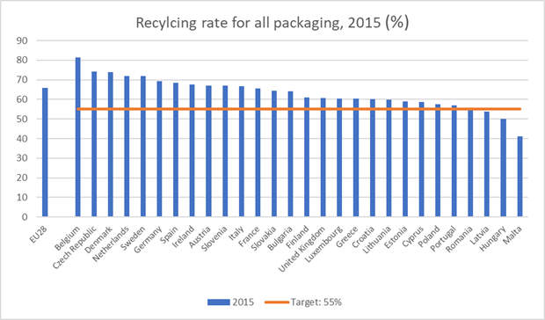

**Note:** Data for Malta and Cyprus is for 2014.

**Source:** Eurostat.

## Total amounts of dry recyclables

1. Combining the results in Table 14 and Table 15 shows the total amount of waste delivered for recycling:

Table 16: Total Waste Recycling

|  |  |  |
| --- | --- | --- |
|  | Ton | Share of total waste generated, % |
| Delivered for recycling municipal waste | 80,623 | 2.8 |
| Recycling via pre-treatment | 52,455 | 1.8 |
| Recycling via PROs | 287,777 | 10.0 |
| Total delivered for recycling, ton | **420,855** | **14.6** |
| Total generated waste | **2,881,330** | **100.0** |

**Source:** World Bank staff estimates based on MoEW and NSI data.

1. 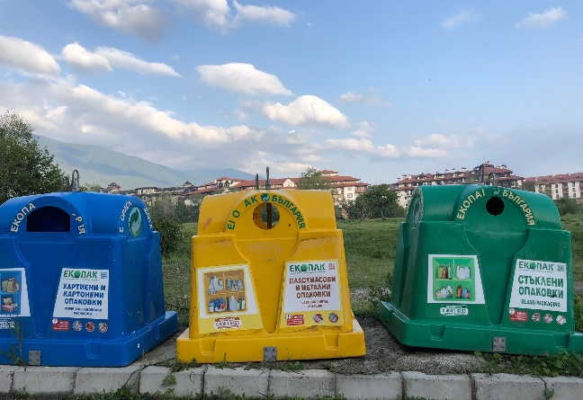**It could be concluded that about 15 percent of the total municipal solid waste is recycled and these 15 percent apply for paper, plastics, metal and glass only** (calculated according to the respective method as in Commission Decision 2011/753). Recycling of green waste from parks etc. as compost is not considered because most of the composting installations have become operational only recently and only in few municipalities, giving insufficient time to assess effectiveness. Please note that the production of compost like output or RDF via processing of mixed MSW cannot be considered “recycling,” at best this is “recovery.”
2. To estimate the recycling as a percentage of the recyclables (i.e. recycling potential) in the waste, the morphological composition needs to be used as given by MoEW.

Table 17: Typical Morphology of Municipal Solid Waste, 2012-15

|  |  |  |  |  |  |
| --- | --- | --- | --- | --- | --- |
|  | **above 150 000** | **50 000 – 150 000** | **25 000 – 50 000** | **3 000 -25 000** | **Below  3 000** |
|  | **inhabitants** | **inhabitants** | **inhabitants** | **inhabitants** | **inhabitants** |
| Food waste | 28.9% | 30.6% | 28.0% | 23.2% | 15.6% |
| Paper | 11.4% | 9.4% | 8.1% | 8.5% | 6.1% |
| Cardboard | 9.4% | 8.2% | 6.9% | 5.5% | 4.0% |
| Plastics | 11.3% | 15.4% | 12.8% | 10.1% | 10.3% |
| Textile | 2.8% | 2.9% | 2.9% | 3.7% | 2.0% |
| Rubber | 0.9% | 1.0% | 1.0% | 0.9% | 1.0% |
| Leather | 0.9% | 1.0% | 1.0% | 0.9% | 1.0% |
| Green waste | 11.0% | 11.0% | 13.1% | 21.7% | 30.9% |
| Wood | 2.0% | 2.1% | 2.9% | 2.0% | 2.9% |
| Glass | 9.2% | 7.8% | 7.0% | 6.1% | 2.4% |
| Metals | 1.9% | 2.0% | 2.0% | 2.0% | 1.9% |
| Inert waste | 9.7% | 8.0% | 13.7% | 14.8% | 21.3% |
| Hazardous waste from households | 0.6% | 0.6% | 0.6% | 0.6% | 0.6% |
| ***Total*** | ***100.00%*** | ***100.0%о*** | ***100.00%*** | ***100.00%*** | ***100.00%*** |

**Source:** MoEW[19]

1. For calculating the recyclables, a summary as presented in Table 18 is used, where the ranges are based on medium and bigger cities where the majority of the population lives:

Table 18: Waste and recyclables, ton

|  |  |  |  |  |
| --- | --- | --- | --- | --- |
| Total waste |  |  |  | 2,881,330 |
| waste composition | Min (%) | Max (%) | Min (t) | Max (t) |
| Paper and cardboard | 17 | 20 | 489,826 | 576,266 |
| Glass | 7 | 9 | 201,693 | 259,320 |
| Metal | 2 | 2 | 43,220 | 66,271 |
| Plastics | 10 | 15 | 288,133 | 432,199 |
| Total | 36 | 46 | 1,022,872 | 1,334,056 |

**Note:** This table summarizes table 17.

**Source:** World Bank staff estimates based on MOEW

1. **It could be concluded that between 32 - 42 percent of the total amount of recyclables in the waste is recycled based on the amount of waste delivered for recycling of 420,855 ton as presented inTable 18.**
2. **A critical issue is the amount of packaging materials put on the market as listed by the PROs[20] (421,145 ton,Table 15)**. Compared to the total amount of recyclables (table 18), this is rather low. There is however no data available for packaging waste in the total waste flow as the method to analyse this is not included in the before mentioned “Methodology for identification of morphological content of municipal waste”. Since there is no Bulgarian data available and since the split in packaging dry recyclables and non-packaging dry recyclables is not included in the Bulgarian methodology for determining the morphology of MSW, for some estimations data from the Netherlands and Germany has been used. The estimated amounts of packaging materials in the total MSW are presented in Table 19.

Table 19: Estimated amount of packaging waste in MSW

|  |  |  |  |  |  |  |  |  |
| --- | --- | --- | --- | --- | --- | --- | --- | --- |
| Total waste |  |  |  | 2,881,330 |  | Percent packaging | amount packaging waste | |
| waste composition | Min (%) | Max (%) | Min (t) | Max (t) |  |  | Min (t) | Max (t) |
| Paper and cardboard | 17 | 20 | 489,826 | 576,266 |  | 40 | 195,930 | 230,506 |
| Glass | 7 | 9 | 201,693 | 259,320 |  | 90 | 181,524 | 233,388 |
| Metal | 2 | 2 | 43,220 | 66,271 |  | 25 | 10,805 | 16,568 |
| Plastics | 10 | 15 | 288,133 | 432,199 |  | 65 | 187,286 | 280,930 |
| Total | 36 | 46 | 1,022,872 | 1,334,056 |  |  | 575,546 | 761,391 |

**Source:** World Bank staff estimates.

1. **It could therefore be concluded there is a significant difference between the NSI data on packaging materials put on the market and the estimated data.** The difference can partly be explained by differences in waste composition between Germany and the Netherlands and Bulgaria but the difference indicates that further research needs to be done by MoEW into the validity of the PRO data[21]. To this end, the methodology for assessing the morphology needs to include an analysis of the packaging waste compared to non-packaging waste.
2. **Suggested recommendations to improve effectiveness.** If indeed large amounts of packaging waste remain in the mixed waste, this burdens the municipal public sector which finances the management of such waste through the mixed waste stream. Conversely, the more packaging waste is channelled to the separated at source dry collection system, the financial burden on municipalities will be eased as they will need to handle less waste. It is therefore recommended that the initial findings of this review are studied further to confirm if there is indeed room for reducing public spending and optimizing municipal waste stream.

# Recommendations

**Waste management spending**

1. Currently spending in municipal waste management improvement is mostly concentrated on the construction of RWMCs including mixed waste separation lines with recovery operations, (RDF production and bio-waste stabilisation), composting facilities for separately collected green waste (three anaerobic installations and facilities for aerobic composting) and sanitary landfills for non-hazardous waste. The spending is initiated by the prevailing situation in Bulgaria and the requirement to meet EU targets. It seems however, that the high spending up to now is resulting in low outcomes such as quantity of separated recyclables at low quality, quantities of compost from green waste and bio-waste treatment by anaerobic installations. To improve the spending situation, it might be worthwhile to investigate in more detail the need for:

* enhancing separation at source especially of plastics, paper, glass and metals as shown by prevailing practices within target compliant EU member states. Separation at source will result in lower overall costs and substantially higher effectiveness as compared to separation after collection as shown by waste separation practices in many EU member states. However substantial communications and public awareness campaigns will be needed. Therefore, budget allocations will be needed by municipalities and could partially be covered by PROs. In EU member states the allocation varies between Euro 1-6/inhabitant depending on the size of municipality. With an average of BGN 6/inhabitant it would mean a total annual budget of BGN 42 million.
* the projects proposed under OPE 2014-2020 include aerobic and anaerobic composting installations and waste separation lines with recovery operations. Home composting could be promoted especially of garden waste. Moreover, throughput improvement of existing composting installations could be investigated. Thereto a market survey study would be needed to assess demand, prices, required quality, etc. Implementation of certain technical solutions and including avoided landfilling costs (and deductions) in the cost calculations should meet the prevailing economic conditions so that cost/ton will be affordable.
* processing biowaste from sorting installations (and not from separate collected biowaste) should be referred to as “biostabilisation” and not as “composting”; it should be noted that the use of the output of the biostabilisation process as backfilling material is not considered recycling but can be considered “material recovery” as mentioned in art 11.2(b) of the Waste Framework Directive.
* a detailed assessment of the operational costs of selected municipalities having high costs/ton for waste collection and public area cleaning is recommended to be carried out and subsequently benchmarking with municipalities currently having acceptable cost/ton levels. Information given in the questionnaires have to be taken with some caution as municipalities have different opinion on cost items to be included.
* the gradual introduction of amortization in tariffs to be paid also in case of asset acquisition, grant/subsidy financing in order to create sustainable operations and to make the waste generator more aware of the need to separate at source. Currently, invoices for households and CII sector do not clearly show the breakdown of costs of services. Tariff to be paid has to be clear and transparent.
* reduction or exemption of VAT payment for households and levelling the VAT payment for municipalities with private sector payment. Several EU member states have exemption of VAT payment on household waste or reduction of VAT on certain activities such as recycling. A critical review might be needed especially when amortization will be introduced in tariff setting meeting the generally acceptable affordability level (1-1.5 percent of spendable income for households).

**Data collection and reporting**

1. Improvement of efficiency and effectiveness is primarily the responsibility of the municipality. Therefore, reliable data are needed. These data must be used by the municipalities to review and enhance their own systems and need to be reported to one centralized organization for analysis and policy development. Data needs to be gathered from individual treatment operations, even if they are operated (or owned) by one entity. All stakeholders (collectors, transporters, recyclers, landfill operators, etc) in the waste management chain should report on quantities (weight) received, processed, transported, etc. Monitoring and enforcement is a task of the centralised organization. Although these requirements exist in current Bulgarian legislation it seems that the system is not properly functioning, considering the differences in statistical information between the various ministries/organizations.

**Financial reports**

1. The establishment of uniform and transparent reporting system on MSWM services with clear guidelines for municipalities on cost items is a priority. Cost reporting system by municipalities to MOF needs to be amended showing clearly each activity and cost items for each activity and the amortization costs. In this respect, the Local Taxes and Fees Act already envisages the development of an Ordinance on unified chart of accounts for delivery of waste management services in municipalities (by March 2019). It is recommended that the Ordinance is combined with Guidelines on generating revenue from municipal waste fee and calculating the eligible expenditures for the provision of waste management services on the territory of the municipality included in the chart of accounts. A tentative template for waste management services and eligible expenditures is given in Annex D. To ensure uniform implementation, training of the staff on implementation of the Ordinance and Guidelines will be needed to be delivered to all 265 municipalities.
2. Like private companies also municipal enterprises involved in waste management should be obliged to prepare audited annual financial reports.

**Waste collection and waste separation**

1. Investing in tracking systems (GPS) could improve efficiency and effectiveness of waste collection & transportation. There are relative cheap modern technologies that can be used to track planned routes of waste trucks, location accuracy of containers, fullness of containers, servicing of waste containers etc.
2. To achieve the targets set for recyclable materials, improving the separation at source would be critical. Today, the PROs have set up systems for collecting of packaging waste but evidently (as in many other countries) the public does not distinguish between packaging and non-packaging materials but separates on type of material: paper, plastic, glass and metal. Setting up a parallel system for collecting “dry recyclables” next to the PRO system (as is ongoing in Gabrovo) is not considered a recommended practice as it would be very difficult to explain to the public the difference between packaging and other dry recyclable; and it is therefore doubtful whether such parallel system will contribute to higher recovery rates.
3. Instead, it is recommended to enhance the collection system of the PROs via public awareness actions aimed to increase the recovery of recyclables. To this end a system to determine the packaging / non-packaging quantities in the collected waste needs to be developed and an agreement between the municipalities and the PROs on costs and benefit sharing needs to be developed.
4. Further investment in sorting lines dedicated to separation of recyclables from mixed municipal waste should be critically reviewed and consider the efforts proposed and needed to increase the effectiveness of separate collection of recyclables. The effectiveness of waste separation cannot be improved via post collection separation. This is evident from international experiences. Even with more sophisticated equipment and automation, sufficiently higher recovery rates are unlikely if biodegradable waste is in the mixed waste. It may even be expected that the recovery rate at such installations will drop further if the effectiveness of the collection system of the PROs improves.
5. Investment in treatment of mixed municipal solid waste is needed to reduce the amount of biodegradable waste that needs to be landfilled. Any bio-stabilisation process benefits from sorting out those materials that hamper stabilisation. Sorting as pre-treatment option needs to focus on removing these materials, secondary might be to sort out materials in such a way that they can be send for re-use.

Annex 1. References

Clean Europe Network

Hall, D. (2010) *Waste Management in Europe: Framework, Trends, and Issues,* Public Services International Research Unit, Business School, University of Greenwich, London

European Commission Press Release, Circular Economy: New rules will make EU the global front-runner in waste management and recycling, May 22, 2018.

http://europa.eu/rapid/press-release_IP-18-3846_en.htm

Ministry of Environment and Water (2014). *National Waste Management Plan 2014-2020,* Sofia Bulgaria

Ministry of Environment and Water (2012) Methodology for identification of morphological content of municipal waste (approved by the Minister of Environment and Water with Ministerial Order №744/29 September 2012)

World Bank (2012) *What a Waste: A Global Review of Solid Waste Management*, Washington, D.C.

World Bank (2018) *Spending Review on Policing and Firefighting,* Washington, D.C.

Annex A-1 Analysis of Actual Waste Collection Costs

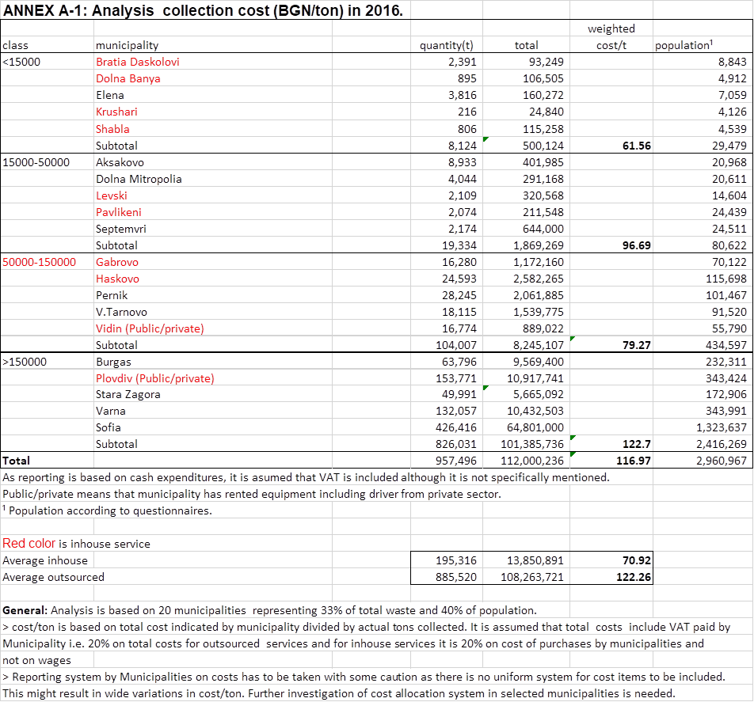

Annex A-2. Analysis of Estimated Waste Collection Costs





Annex B-1 Waste Treatment Actual Costs



continued



Annex B-2 Waste treatment Estimated Costs



Annex B-3 Cost calculation landfills





Annex C-1 Public area cleaning actual costs

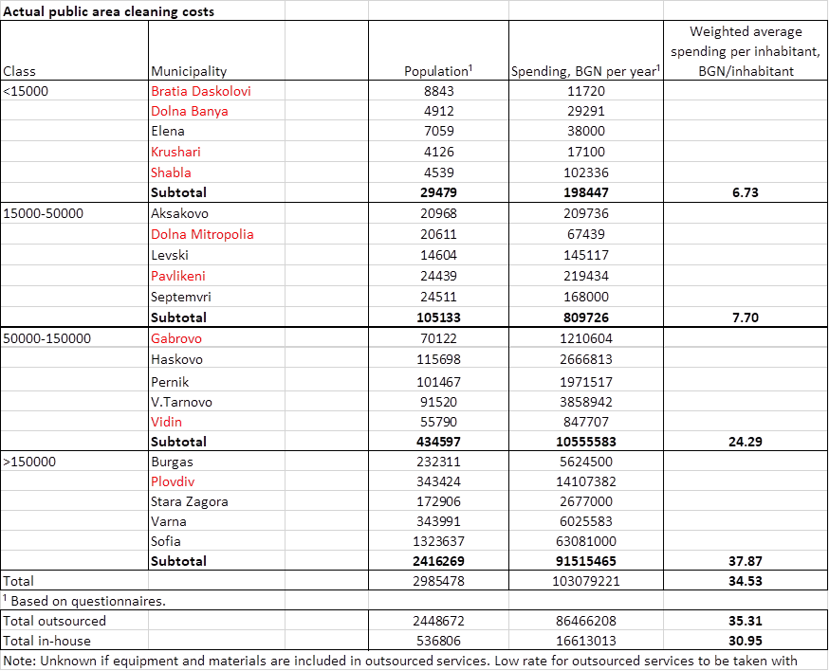

Annex C-2 Estimated public area cleaning costs



Annex D Template for cost calculation

|  |  |
| --- | --- |
| **Template for cost calculation** | |
| Waste management activity | Cost items |
| 1.Collection and transport to delivery point of household waste and CII waste (mixed and separated fractions) | Direct costs  -wages incl. uniforms, training, social charges  -fuel, lubricants, tires, repair and maintenance  -insurances  -amortization of long-term loans  - 3rd party costs (in case of outsourcing)  Indirect costs  -management, administration  -office (cleaning, telephone, energy, repairs, rent, etc.)  -communication/advertising  -third party services (accountant, ICT, consultancy, etc.)  -bank costs (short term loans, etc.)  -monitoring, enforcement  -other costs (taxesand fees)  -unforeseen |
| 2. Management “bring stations” | See activity 1 |
| 3.Transfer and long-haul transport to final disposal | See activity 1 or gate fee(outsourcing) |
| 4. Separation mixed waste or sorting dry recyclables | See activity 1 plus transport and landfilling costs of rejects or gate fee(outsourcing) |
| 5. Any treatment such as composting, incineration, MBT | See activity 1 or gate fee(outsourcing) |
| 6. Landfill operations | See activity 1 plus closing/ aftercare, leachate management, LFG collection, monitoring, landfill tax or gate fee(outsourcing) |
| 7. Street cleaning | See activity 1 plus final disposal |
| 8.Market cleaning | See activity 1 plus final disposal |
| 9 Other activities |  |

(see also Annex A and B with calculation examples)

✶ VAT or landfill tax

Template is based on following procedure:

**Task 1**: Collect reliable data on type and quantity of waste fractions for design of WM system

**Task 2**: Describe clearly the activities (collection, separation, composting, landfilling, etc.) and the tasks for each waste fraction together with a cost budget number. Task examples are:

-collection and transport: might include cleaning around containers

-separation mixed waste: cost to be excluding revenues from sales of recyclables, costs to be including or excluding transport to landfill and landfilling costs of rejects

-landfill operations: costs including or excluding closure/after care

- street cleaning including or excluding weed maintenance, graffiti removal, litterbins handling, snow cleaning, illegal dumps cleaning, etc.

**Task 3**: Identify the cost items for each activity with budget number depending on the design (in-house or outsourced) of the WM system. Introduce internally a reporting system.

**Task 4**: Monitor monthly the actual expenditures with the budget.

Annex E National cost assessment

Comparison of estimated and actual spending for collection &transportation of waste



*Source:* World Bank staff estimates based on data from questionnaires and own estimates.

Comparison of estimated and actual spending for public area cleaning



1. NSI data. Eurostat data show a larger share of landfilled waste—64 percent of waste generated.
2. Based on Eurostat data. It should be noted that countries do not follow unified data reporting when reporting their data to Eurostat therefore inter-country comparisons should be taken with some caution.
3. Targets for Bulgaria are primarily based on the targets set in the Waste Framework Directive (2008/98/EC), the Landfill Directive (1999/31/EC and the Packaging Directive 94/62/EC. Modifications of implementation dates are agreed between the EU and Bulgaria in the Act of Accession, April 2005.
4. 115 of municipalities out of 265 have a population of less than 50,000 inhabitants.
5. The rules and calculation methods for verifying compliance with the targets set in Article 11(2) of the Waste Framework Directive are laid down in Commission Decision 2011/753/EU.
6. See Annex D
7. Based on Eurostat data. It should be noted that countries may have difference in coverage of waste management activities and cross-country comparisons should be taken with some caution.
8. The team visited municipalities of Gabrovo, Levski, Plovdiv, and Veliko Tarnovo. Some of the information previously provided by municipalities was revised based on these visits.
9. Ibid.
10. Municipal expenditure reported by MOF (activity 625 and 627) do not include VAT paid on outsourced services and deductions under articles 60 and 64 of the Waste Management Act.
11. Some municipalities might have shifted to providing in-house services but the information on organization of serve provision is only for 2016.
12. To eliminate the impact of significant fluctuations in capital spending, only current spending is taken into account.
13. The data envelopment analysis examines efficiency by comparing outputs with inputs. Such analysis was performed for the Spending Review on Policing and Firefighting (World Bank, 2018).
14. EU financing, national financing and financing from beneficiary.
15. Eurostat data show a larger share of landfilled waste—64 percent of waste generated in 2016.
16. The team visited municipalities of Gabrovo, Levski, Plovdiv, and Veliko Tarnovo. Some of the information previously provided by municipalities was revised based on these visits.
17. The deductions are growing gradually each year and the level set for 2020 is BGN 95/ton.
18. These amounts include only amounts processed by municipalities through separation lines/MBT in the newly constructed RWMCs while the amounts used to calculate the target under art, 31 of the WMA include also amounts collected by PROs, by collection points, separated waste delivered directly by firms, and compost from separately collected green waste.
19. Methodology for identification of morphological content of municipal waste (approved by the Minister of Environment and Water with Ministerial Order №744/29 September 2012).
20. Тhe total amount of packaging materials put on the market exceeds the reported amounts by PROs and is therefore subject to adjustments based on an additional survey.
21. According to MOEW, based on sample of morphology of selected municipalities, the share of recycables hovers around 25 percent, max 30-32 percent for municipalities with mostly urban population.