# 

**State-Owned Enterprises**

**in the Russian Federation:**

Employment Practices, Labor Markets, and Firm Performance

June 2019



**CONTENTS**

ACKNOWLEDGEMENTS v

EXECUTIVE SUMMARY vi

1. OBJECTIVE AND ANALYTICAL FRAMEWORK 1

Objective 1

Analytical framework and main findings 3

Structure of the report 5

2. RUSSIA’S SOE SECTOR: DEFINITIONS AND SIZE 6

Legal definition and regulatory framework 6

Data sources 8

Sizing the Russian SOE sector 9

3. SOE COMPENSATION AND LABOR MARKET 15

SOE compensation 17

Effects on labor supply and allocation 22

4. SOE EMPLOYMENT PRACTICES AND INTERNAL CAPABILITIES 27

SOE personnel management 27

SOE use of information technology 30

5. GOVERNMENT SUPPORT AND ITS EFFECTS 34

State support for SOEs 34

State support and SOE employment practices 36

6. POLICY RECOMMENDATIONS 39

Better data and monitoring 40

Support for improved management practices 41

Incentives for improved compensation and management practices 42

Regulation 44

ANNEX A - Data sources 45

ANNEX B - Regression Results 47

REFERENCES 53

**List of Figures**

Figure 1. 1 Analytical framework linking SOE employment practices to productivity 3

Figure 2. 1 Public establishments: classification according to Civil Code. 6

Figure 2. 2 Formal sector employment trends, by ownership sector, 1994-2017 11

Figure 2. 3 Share of SOEs (majority and minority government stakes) in total non-agricultural employment, Russia compared 2015-2016. 12

Figure 2. 4 SOE share in total employment, by type of SOE and by region. 13

Figure 3. 1 Adjusted wage gaps (private sector=0), by categories of public sector workers 16

Figure 3. 2 Distribution of public sector wage premia by country income. 16

Figure 3. 3 The wage premium for SOEs varies by firm size 17

Figure 3. 4 SOEs pay a higher wage premium in more competitive industries 18

Figure 3. 5 The wage premium for SOEs varies across industries 19

Figure 3. 6 The wage premium for mixed SOEs varies across regions 20

Figure 3. 7 SOES offer more generous benefits 21

Figure 3. 8 Difference in percent of public-private workers satisfied with their job 22

Figure 3. 9 Public sector workers’ have higher self-reported social status 22

Figure 3. 10 Percentage of workers quitting jobs between consecutive rounds of RLMS. 23

Figure 3. 11 Growth in the share of university graduates, relative to base year (1994). 24

Figure 3.12 Unemployment rates, Russia and comparators 2010-2018 25

Figure 3.13 Share of firms reporting labor shortages to be a major or severe constraint. 25

Figure 3. 14 SOE performance relative to private sector equivalent, by firm size, 2017-2018. 26

Figure 4. 1 Share of firms providing training for employees. 29

Figure 4. 2 Share of employees trained by firms that provide training. 29

Figure 4. 3 Share of firms using KPIs. 30

Figure 4. 4 Share of firms giving manager performance bonuses. 30

Figure 4. 5 Average weekly working hours. 31

Figure 4. 6 Tenure in current job, in years. 31

Figure 4. 7 On the job computer and internet usage among workers. 31

Figure 4. 8 Share of companies using ERP/IFMIS. 32

Figure 4. 9 Share of companies with English-language website. 32

Figure 4. 10 Share of firms benchmarking wages to closest competitors. 33

Figure 5. 1 Share of firms receiving state subsidies, contracts, and non-financial assistance. 36

Figure 5. 2 Share of firms whose prices of main products/services do not depend on competition. 37

Figure 5. 3 SOE-private wage gap, with and without government subsidy 38

Figure 6. 1 Select Policy recommendations 40

**List of Tables**

Table 2. 1 SOE share in formal employment and value added (sales), by industry. 13

Table 2. 2 Average firm size (number of employees), by firm type 14

Table 2. 3 Share of SOE firms, by size (number of employees) 14

Table 3. 1 SOE-private Adjusted gaps in mean hourly wages, in percent (private=0) 17

**List of Boxes**

Box 1. 1 GoR policy commitments to improve productivity and reduce SOE footprint 2

Box 1. 2 Study’s main questions and messages 4

Box 2. 1 Main microlevel data sources used in the study 8

Box 2. 2 Indirect state ownership 10

Box 4. 1 Select cases of “positive deviance” - Russian SOEs with frontier employment practices 34

Box 5. 1 Measures of state support in RuFiGE 2014 and IIELM 2017 surveys 35

# ACKNOWLEDGEMENTS

This report was prepared by Zahid Hasnain (Senior Public Sector Specialist, GGOEW) and Anya Vodopyanov (Extended Term Consultant, GGOEW), with a core team comprising Galina Kuznetsova (Senior Financial Management Specialist, GGOEW), and Rong Shi (Consultant, GGOEW). The research was carried out in collaboration with Anna Lukyanova (Professor of Labor Economics and Senior Research Fellow at the Higher School of Economics, Russia), and parts of the report draw on a background paper prepared by Dr Lukyanova. The report benefitted greatly from incisive comments from peer reviewers Stefka Slavova (Lead Economist, GFCEE), Henri Fortin (Lead Financial Management Specialist, GGOAC), and Gregory Kisunko (Senior Public Sector Specialist, GGOAE), as well as technical discussions with Lorena Vinuela (Senior Public Sector Specialist, GGOEW), Christopher Miller (Program Lead, ECCRU), Apurva Sanghi (Lead Economist, GMTE2), Denis Medvedev (Practice Manager, GFCFE), Ana Cusolito (Senior Economist, GFCMT), Arti Grover (Senior Economist, GFCFE), Maurizio Bussolo (Lead Economist, ECACE), Samuel Freije-Rodriguez (Lead Economist, GPV03), Leonardo Iacovone (Lead Economist, GFCFE), Mikhail Bunchuk (ECCRU), Dorota Novak (Program Coordinator, ECCRU), Mikhail Matytsin (Research Analyst, GPV03), Elwyn Davies (Economist, GFCFE), and Cesar Cancho (Economist, GPV03). Helpful feedback was received from Russian researchers during initial stakeholder consultations in April 2019, including Gleb Pokatovich (First Deputy Head, Analytical Center for the Government), Marina Moskvina (Senior Economist and Managing Director, Union of Russian Industrialists and Entrepreneurs), Alexander Abramov (Senior Economist and Deputy Director, Russian Academy of National Economy and Public Administration), and Mikhail Gershman (Assistant Professor of Economics, Higher School of Economics). The team would like to thank the Higher School of Economics, Denis Medvedev, Arti Grover, and Ana Cusolito, for making available key data used for the report. Overall guidance was provided by Andras Horvai (Country Director, ECCRU) and Roby Senderowitsch (Practice Manager, GGOEW).

# EXECUTIVE SUMMARY

**Low productivity and the competitiveness of Russian firms have been among Russia’s primary economic challenges over the past decade**. The Government of Russia (GoR) has made boosting productivity a policy priority and since 2012 has rolled out several visible policy initiatives to strengthen employment practices in firms to raise their productivity and positive spillovers, including the 2012 Plan for Raising the Productivity of Companies, the 2018-2024 National Project on Labor Productivity, and 2018-2019 National Plan for Competition Development.

The **objective of this report is to contribute to this productivity agenda by analyzing the employment practices of state-owned enterprises (SOEs), their implications for labor supply and internal firm capabilities, and the influence of state policy.** SOEs contribute a significant share of output and employment in Russia’s economy and academic recent research shows that they have lower productivity than private sector firms. The implications of SOE employment practices—compensation and management—on overall productivity however, has not been investigated, a gap that this report aims to fill by analyzing the following questions:

* What are SOE employment practices and how do they compare to international and private sector benchmarks?
* How do SOE employment practices, particularly compensation, affect allocation of labor across firms?
* How do SOE compensation and management practices shape their internal capabilities?
* How does government financial and non-financial support to SOEs influence these employment practices?

Taking the level and form of government participation in the economy as a given, the report focuses primarily on the sector’s current practices, and how government policies towards the sector can be improved to boost SOE performance and positive spillovers. We explore these questions using five Russian microlevel datasets, including worker and firm surveys and a large firm register. The report utilizes a taxonomy of SOEs that includes state SOEs which have 100 percent government ownership, and mixed SOEs which have some share of state ownership that is less than 100 percent.

**The report finds that Russian SOEs pay an overall compensation premium and that this premium contributes to labor shortages in the private sector.** While overall the SOE sector has a small wage penalty, wage differentials with the private sector vary by type and size of the SOEs. Mixed SOEs pay a small wage premium over the private sector while state SOEs have a small wage penalty. Both types of SOEs pay a wage premium in competitive settings. SOEs have an overall compensation premium as they provide more generous benefits like paid vacations, maternity leave, and training than private sector firms. Workers in SOEs are more satisfied with their jobs than workers in the private sector, have a higher assessment of their social and economic status in society, and are less likely to quit their jobs. SOEs have been more successful at attracting highly skilled workers than private sector firms over the past two decades which, in the context of Russia’s tight labor markets, contributes to skill shortages in the private sector. This finding complements the World Bank’s ongoing research on competition conditions in the Russian Federation.

**SOEs also have relatively weaker management practices compared to international comparators and in many cases to Russian private sector firms**. Global experience shows that firms that adopt good management practices—such as incentivizing and managing performance, and investing in human capital and technology—maximize their productive potential. By international standards, Russian SOEs are low users of performance incentives and performance management, and under-utilize information technology like management information systems. Small and medium sized companies have the weakest management practices, while large companies perform mostly on par with the private sector. These findings complement the World Bank’s ongoing engagement on firm-level management and performance in Russia.

**State support to SOEs influences and sustains these employment practices.** SOEs are more likely than private firms to receive financial assistance and state contracts, non-financial assistance, and protection from competition, and SOEs that receive state support are more likely to offer higher wages to their employees. State support is also not correlated with quality of SOE management practices.

**International experience shows that SOEs can contribute to overall productivity growth if managed well, and the report suggests several high-impact policy areas in which the Russian Government can invest to support that outcome, complementing its existing interventions.** The Government can improve SOE employment practices through a combination of support, incentives, and regulation, underlaid by a foundation of good data on SOE employment practices which would enable better monitoring and evaluation. Support would include business development services, or business training, for SOEs, with a focus on management training. This capacity building would need to be accompanied by improved incentives for SOE performance, through hardening the soft budget constraint for SOEs through more competitive public procurement and allocation of subsidies and awards and recognition for good SOE managers. These measures would complement the on-going reforms of the Government to foster competition. The government can also explore more regulatory oversight over SOE compensation, though this will need to be modest as there is a tradeoff between regulation and autonomy, particularly for commercial SOEs. Finally, and most importantly, none of these interventions will be successful without better data, monitoring and evaluation.

# 1. OBJECTIVE AND ANALYTICAL FRAMEWORK

## Objective

1. **Low productivity and competitiveness of Russian firms have hurt Russia’s economic growth over the past decade**. Each year fewer new private sector firms are created, and only 10 percent report technological innovation activity compared to 30-40 percent in OECD countries. As a result, the economy’s overall productivity growth has been falling and turned negative in recent years. The low firm productivity has affected not only the country’s macroeconomic prospects but also individual incomes, particularly for the bottom 40 percent of the distribution, as Russians increasingly enter low-productivity informal jobs (World Bank 2016, Global Entrepreneurship Monitor).
2. **The proximate causes of Russia’s weak productivity are structural, including inefficient allocation of resources and weaknesses in internal firm capabilities**.Basic factors of production, such as land, labor, and capital, are not allocated to the most productive sectors and firms. SOEs, which comprise a large share of Russian establishments and formal employment, are believed to distort markets and crowd out more efficient private firms due to their privileged access to markets, financing, and factor inputs (World Bank 2016, IMF 2018). Additionally, SOEs have been shown to lag behind international comparators and in many cases private domestic firms on key internal capability measures such as capacity for innovation, adoption of technology,managerial skills, and workforce skills (World Bank 2016, Cusolito & Winkler 2017; Abramov et al 2017, 2019).
3. **The objective of this report is to contribute to the Russian Government’s productivity agenda by empirically understanding SOE employment practices, the influence of state support on these practices, and their implications for labor supply and internal firm capabilities.** Given substantial prior research on the connections between allocative efficiency, firm capabilities and productivity growth, this study takes them as given. Instead, we focus on the less studied micro-foundation of productivity—the links between SOE employment practices, labor supply, and SOE capabilities. We define SOE employment practices as salient attributes of compensation and management of human resources. Compensation includes all major pecuniary and non-pecuniary rewards from the job, including wages, allowances, current and deferred benefits, formal contract, and job security. Key dimensions of management practices include performance incentives, performance management, and use of technology. Taking the level and form of government participation in the economy as a given, the report focuses primarily on how government participation can be improved to boost firm performance and positive spillovers.
4. **The report contributes to the Government of Russia’s (GoR) reform priority of boosting productivity.** Since the financial crisis of 2008, Russia has faced a painful and slow recovery, compounded by depressed commodity prices, and international sanctions since 2014. These immediate challenges and the longer-term goal of strengthening Russia’s economy have encouraged policy makers to direct more attention to sources of productivity and growth. Several recent policy initiatives, featured in Box 1. 1, seek to raise overall productivity through improved competition and firm management practices in SOEs and other firms. The GoR's commitment is also indirectly visible from its support for research in top state-affiliated economics institutes and think tanks on SOE productivity, state's economic footprint, and firm management and innovation practices.[1] This report’s premise is that while policy corrections are necessary, they need not entail (only) changes in company ownership. International experience shows that SOEs can contribute to overall productivity growth if managed well. This report provides initial evidence on steps policy makers can take to improve the internal management of SOEs, to unlock that productive potential.

|  |
| --- |
| Box 1. 1 GoR policy commitments to improve productivity and reduce SOE footprint |
| * **National Project on Labor Productivity 2018-2024.** Launched in January 2019 to boost labor productivity of 10,000 medium-large enterprises; also private sector development, export competitiveness, and employment.[2] Offers support to enterprises * **National Plan for Competition Development 2018-2019,** draft Law No 554026-7 introduced by the Federal Antimonopoly Service. Envisions liquidation of unitary enterprises and forbids GoR from acquiring enterprises operating in competitive product markets * **Presidential Decree No 618 of 21 December 2017** laying out Competition Policy Guidelines, calls for stimulating efficiency and competitiveness of economic entities in all sectors, envisions reduction of commercial establishments established or controlled by the state[3] * **Government Decree No 2-548** **of 14 November 2017** laid out a number of key performance indicators for regional authorities (currently 20 governors), including those related to private sector development and employment, and incentive to boost productivity * **Government Decree No 227-R of 8 February 2017.** Envisions during 2017-2019 reduction or sale of government shares in Joint Stock Companies, including large JSCs (e.g. Alrosa, VTB bank) * **2012-2015 Government decree 12-50R “Plan for raising Productivity of Companies”.** Part of May Decrees (**Presidential Decree of 7 May 2012 No 596 by 2016).** Focus on 200 hand-picked state companies * **Presidential Decree No Pr-307 of 2011, Innovative Russia 2020 Strategy.** Aimed to boost innovation, management, and productivity in large SOEs by strengthening role and responsibilities of managers, use of KPIs, mechanisms for motivating employees, investment in technologies. Benchmarked 60 largest SOEs against international industry leaders, revealed weaknesses in management practices and low level of R&D. Led by Ministry of Economic Development, Ministry of Education, Ministry of Finance. |

## Analytical framework and main findings

1. **The analytical framework for the report is depicted in Figure 1. 1**. It does not cover the full range of mechanisms affecting overall productivity growth, which is beyond the scope of this study. Instead, we focus on the previously less studied mechanisms relating to SOE employment practices.
2. **Firm compensation practices affect allocative efficiency, particularly allocation of labor, because they shape labor supply.** This link is based on standard labor economics theory, that workers gravitate to the highest paying jobs and firms paying the highest wages can recruit the best workers. In competitive markets, labor compensation is correlated with productivity, so the most productive firms offer the highest wages and attract the best workers, which further reinforces their productive capacity. Allocative inefficiencies arise if wages do not reflect firm productivity, the highest wages are paid by less productive firms, and the best workers stream to unproductive jobs while productive firms are starved of skilled labor. The inefficient scenario can arise even in competitive markets if less productive firms benefit from external support. Since SOEs often benefit from direct or indirect government assistance, and therefore face softer budget constraints, they could distort efficient allocation of labor. Whether or not the distortions materialize depends on two conditions: if government support is untied to performance and if SOEs invest the windfall rents into added worker compensation rather than improved productive capacity, which itself depends on the conditions of the assistance.

Figure 1. 1 Analytical framework linking SOE employment practices to productivity

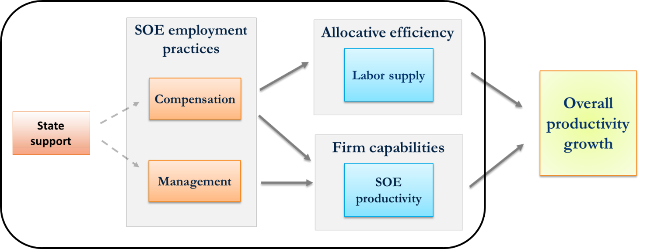

*Source*: Authors depiction, based on Cirera & Maloney (2017) and Grover, Medvedev, & Olafsen (2018)

1. **Compensation and management practices also affect SOEs’ internal capabilities and performance.** This prediction builds on a growing literature in industrial and management economics (Cirera and Maloney 2017, Grover et al 2018, Bloom et al 2016), but extends it from private commercial firms to SOEs. In competitive markets, firms are expected adopt compensation and management practices that maximize their productive potential and profits, such as paying competitive wages, incentivizing and managing performance, and investing in human capital and technology. If SOEs invest in these practices at the same rate as private firms, their internal capabilities will develop at the same rate, but if not their efficiency and productivity will fall behind over time. State support to SOEs can either help or hurt in this regard, depending on how it is conditioned. If state support is conditioned on performance it can push SOEs to invest in improved compensation and management practices that grow their internal capabilities, but if not it may lower SOEs’ incentives to invest in productive capacity since managers will know their firms will survive even if they remain unproductive.
2. **The study’s main questions and findings are summarized in Box 1. 2.** We go beyond previous studies in providing detailed new evidence on SOE compensation practices, showing that SOEs pay above-market total compensation compared to private firms for similar workers in similar jobs, and that SOE compensation distorts labor markets and hurts labor supply to the private sector.[4] SOEs also have weaker management practices compared to domestic private sector and foreign comparators.[5] These SOE employment practices are sustained by state financial and non-financial support.

|  |  |
| --- | --- |
| Box 1. 2 Study’s main questions and messages | |
| **Questions**   * What are SOE employment practices and how do they compare to international and private sector benchmarks? * How does SOE compensation affect the allocation of labor across firms? * How do SOE management practices shape their own internal firm capabilities? * Do current government policies ameliorate or exacerbate possible inefficiencies and distortions? Is the government getting good value for money in providing financial or non-financial support to SOEs? What policy changes could improve outcomes? | **Findings**   * SOEs have an overall compensation premium over private firms. * Mixed SOEs pay a small wage premium over the private sector while state SOEs have a small wage penalty; both types of SOEs pay a wage premium in competitive settings. * SOEs provide significantly more generous benefits like paid vacations, maternity leave, and training than private sector firms. * Workers in SOEs are more satisfied with their jobs than workers in the private sector, have a higher assessment of their social and economic status in society, and are less likely to quit their jobs. * SOEs have been more successful at attracting highly skilled workers than private sector firms which contributes to skill shortages in the private sector. * SOEs have relatively weaker management compared to Russian private sector firms and international comparators as evidenced by low use of performance incentives, performance management, and use of technologies. Smaller-sized SOEs are the weakest. * Financial and non-financial state support may be a factor in sustaining these employment practices |

## Structure of the report

1. The report is structured as follows. Chapter 2 provides the legal definition and classification of SOEs in the Russian context and provides indicative estimates of the sector’s footprint on the country’s labor market and economy. It also discusses the data sources used in the report. Chapters 3 and 4 trace the effects of SOE employment practices on proximate drivers of firm productivity, showing significant inefficiencies and distortions in both cases. Chapter 5 presents how inefficiencies in SOE employment practices are enabled by government support which, as currently formulated, does little to incentivize firm performance. Finally, Chapter 6 concludes with initial policy recommendations.

# 2. RUSSIA’S SOE SECTOR: DEFINITIONS AND SIZE

## Legal definition and regulatory framework

1. **According to the national statistics agency (Rosstat), SOEs are defined as any public non-budgetary establishment with a positive direct government share.** The definition of SOEs differs across countries, and Russia’s is broader than the OECD’s, which requires majority ownership or equivalent other means of control, and a minimum 10 percent state stake (OECD 2015, Abramov et al 2017). Russian SOEs can take four legal forms (Figure 2. 1):

**Figure 2. 1** Public establishments: classification according to Civil Code.

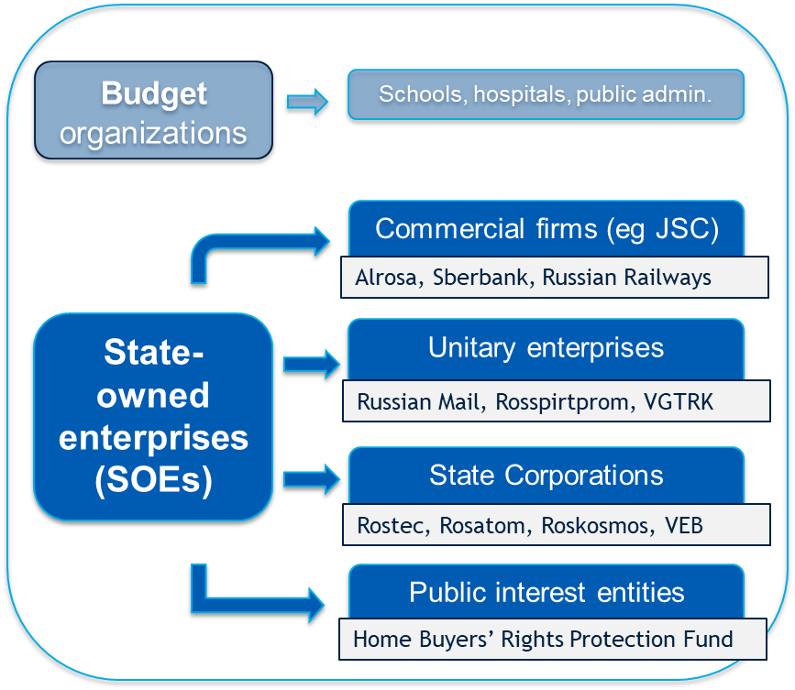

*Source***:** Russian Civil Code.

* *Commercial companies with state participation* include joint stock and limited liability companies. While a fraction are fully state owned, most have mixed public and private ownership, and are often referred to as “*mixed*”. This heterogeneous category includes both small-medium sized SOEs as well as some of Russia’s largest companies, in various industries, including Alrosa (diamonds), Sberbank, Russian Railways, and Aeroflot (national airline). Some of the larger mixed companies are listed on the stock exchange.
* *Unitary enterprises*, like mixed companies, are commercial establishments of different sizes. They differ from mixed in their use of state property for operations. Unitary enterprises can be federal or municipal. Examples of federal unitary enterprises include Russian Mail, Rosspirtprom (alcohol), Goznak (minting), VGTRK (media corporation). As of March 2019, there were over 18,000[6] federal and municipal unitary enterprises in Russia, although a recent draft law passed in the State Duma envisions potentially reorganizing them into mixed companies by January 2021.[7]
* *State corporations* are large non-commercial SOEs with 100 percent state ownership, created to carry out strategic research and social functions, using government properties and funding. At present there are six state corporations in Russia, including Rostec (technology research), Rosatom (atomic research), Roskosmos (space agency), Russian Development Bank (VEB), Deposit Insurance Agency, and Housing Reform Fund. Although themselves non-commercial, state corporations can own commercial subsidiaries (also fully or partially state-owned). For example Rostec owns over 70 commercial companies, including Avtovaz and Kamaz (automobile).
* *Public interest entities* are non-commercial establishments, often created through the organizations of state corporations, that work in defense of specific public causes. An example is Home Buyers’ Rights Protection Fund.

1. **Russia does not have a single law regulating all companies with state participation, but rather a series of regulations that apply to different categories of SOEs**. The Law on Federal and Municipal Unitary Enterprises regulates many important aspects of governance and management in unitary companies, including approval of company charter, director, chief accountant, financial statements, and KPIs. Mixed companies follow the provisions of the Joint stock company law, Civil Code, Accounting law, Audit law, Central Bank bylaws, Government decrees, Corporate Governance Code (on a voluntary basis), and, if applicable, the Securities Market Law.
2. **Legally, Russian SOEs, particularly the commercial mixed and unitary enterprises, have considerable discretion over their employment practices.** All must comply with the basic provisions of the Labor Code, including on the minimum wage and basic worker rights and safety, but beyond that compensation and management practices are regulated at the company level. Companies’ internal codes regulate pay scales and day to day management principles. One partial exception are salaries of senior management of federal and municipal unitary enterprises, state corporations, and mixed companies with state participation exceeding 50 percent, which are capped by law.[8] The high level of firm-level discretion in employment practices is relatively unusual by international standard, but from an economic standpoint it is not necessarily inefficient, especially if companies have strong incentives to be productive.
3. **Russia, like many countries, does not have a single central institution regulating and overseeing all SOEs, but rather a constellation of institutions.** At the federal level, the Ministry for Economic Development (MED) and its subordinate Federal Agency for State Property Management (FASPM) play a leading role in SOE-related regulation, monitoring, and legislative proposals, as well as sales of shares and state properties. FASPM represents the federal government as shareholder in SOEs.[9] Line ministries, and regional and municipal governments may buy shares in mixed companies or establish their own unitary enterprises, in which case they take on oversight functions, including appointing directors, and approving and monitoring of financial statements and KPIs. Any public sector organizations can sign contracts with SOEs for particular services or goods orders; SOEs can also contract other SOEs. In practice, SOEs--particularly unitary companies--often have special contracting relationships with certain agencies, usually their founding agency or ministry. Line ministries and agencies also apportion subsidies for SOEs, with approval from the Government (cabinet). The Ministry of Finance checks the legal basis for the subsidy requests and the justification for the amounts requested. Finally, the Federal Antimonopoly Service plays an indirect role in monitoring for potential anticompetitive practices and has in the past championed legislation to reduce state participation in commercial entities.

## Data sources

1. **The report draws on five main microlevel datasets for its core empirical analyses (Box 2. 1).** The datasets were collected by Rosstat (national statistics agency) and the Higher School of Economics, Russia’s top economics research institute. The RLMS and SOW are worker surveys which permit granular analyses of worker characteristics, employment dynamics, and job attributes, including compensation, at the individual level. They also complement each other in several ways: RLMS is a panel dataset with self-reported wage data, while SOW is a cross-section dataset representative at the regional level, with wage data from administrative payroll records. The IIELM and RuFiGE are firm-level surveys that are used for capturing firm-level characteristics of interest such as management practices, overall employment, wage bill, state support, and skill shortages, which cannot be elicited from worker surveys. Finally, the Ruslana is a firm registry containing administrative financial and tax data for almost 10 million Russian firms. The advantage of this dataset is its precise measures of firm performance and detail on firm ownership, including indirect state ownership. We exploit this dataset for descriptive comparisons of SOE and non-SOE firm performance. We also connect it (using unique firm tax ID) to one of the firm surveys to refine that survey’s measures of firm ownership and performance. A more detailed description of the data is provided in Annex A.

|  |
| --- |
| Box 2. 1 Main microlevel data sources used in the study |
| **Russia Longitudinal Monitoring Survey / RLMS (Higher School of Economics)**, annual panel 1994-2017, sample of 10000 adults, nationally representative, may partially capture indirect state ownership, only formal sector workers included in analyses;  **Survey of Occupational Wages / SOW (Rosstat)**, bi-annual cross-section 2005-2015, two-stage sample of firms and 700000 (formal sector) workers, all sectors excluding finance & agriculture sectors, includes all size firms but representative for medium-large, only direct ownership captured, wage information from firms’ payroll; SOE workers are 20 percent of 2015 sample (30 percent of 2005 sample) and of these 36 percent in mixed SOEs and 64 percent in state SOEs;  **Survey of Interaction of Internal and External Labor Markets / IIELM (HSE)**, cross-section 2017, 1540 firms, direct & indirect state ownership (from Ruslana, dataset connected using tax ID), 229 SOEs in sample;  **Russian Firms in the Global Economy / RuFiGE (HSE)**, cross-section 2014,[10] 1950 firms, direct ownership only, 78 SOEs in sample;  **Ruslana**, administrative register (**Bureau Van Dyck, originally** **Rosstat** / financial-tax records), 2013-present, updated quarterly , ~ 10 million firms.  *See Annex A for further details on the sources.* |

1. **We also draw on the World Management Survey and Enterprise Surveys** to show how Russian companies compare to peers in other countries on various dimensions, as well as other aggregated cross-country datasets, including an OECD dataset on the size and sectoral composition of national state-owned enterprise sectors.

## Sizing the Russian SOE sector

1. **How large is the Russian SOE sector?** The sector’s footprint was always substantial but has seen many fluctuations over the last thirty years. From the Soviet period, when it encompassed the country’s *entire* economic activity and labor force, the sector shrunk rapidly under rapid privatization policies in the 1990s, and expanded quickly again in the 2000s when the government decided to recover control (Chernykh, 2011). By the mid-2000s, the state had re-assembled substantial stakes in formerly privatized companies and strategic sectors (Grosman et al 2016). Today the state is not only holding on to old companies but also establishing new SOEs, including, by some estimates, around 600 unitary enterprises per year (Kovaleva et al 2019).
2. **Accurate measures of the SOE sector footprint are challenging, not least due to data gaps**. Russia lacks a comprehensive publicly available register of SOEs, as the lists maintained by MED and line ministries are fragmented and incomplete, and Rosstat’s roster of establishments also has gaps.[11] There is additional difficulty in estimating the SOE footprint on the labor market because the national labor force survey does not include data on sector of firm ownership. Finally, most existing data does not account for SOE subsidiaries—companies that are fully or partially owned by other SOEs, and therefore indirectly under state control or influence (see Box 2. 2).
3. **The data sources used for this study get around some of these constraints, albeit imperfectly.** Ownership data is accurately captured in the SOW dataset, which draws on administrative firm records, and is closely traced by the RLMS.LIRT and RuFiGE alsoprovide reliable measures as the data comes from firm managers, who should be familiar with the firm’s shareholders. Indirect ownership is measured partially Ruslana and was also used to inform ownership measures in IIELM but not in the other datasets which lacked information on firm unique identifiers.

|  |
| --- |
| Box 2. 2 Indirect state ownership |
| Existing official and academic data sources do not fully account for SOE subsidiaries. A good example is Rosneft, one of the world’s largest energy companies. Although the government owns a “golden share” of Rosneft’s stock, Rosstat does not classify the company as an SOE because FASPM does not hold a direct stake in the company, only indirectly through Rosneftegaz, an SOE owned by FASPM. By IMF’s conservative estimates in 2016, at least 21 % of all SOE employment, and more than 3 percent of Russia’s total employment and 5 percent of formal employment, was in subsidiary SOEs.[12] Misclassifying this segment as private both underestimates the sector’s true footprint and biases analyses of inter-sectoral gaps and differences. |

1. **We classify SOEs by a mix of industry[13] and reported level of state ownership.** Since most sources lack accurate data on legal form, we classify SOEs by the degree and nature of government ownership. This yields three categories: firms with 100 percent state ownership, which we call “state SOEs”; firms with less than 100 percent direct state ownership, “direct mixed SOEs;” and firms with indirect state ownership, “indirect mixed SOEs.” In practice, state SOEs capture mostly unitary enterprises and state corporations, and some joint-stock companies; the majority of mixed companies are direct mixed SOEs; and indirect mixed include mixed companies usually misclassified as private. Due to the limited number of mixed SOEs in our data sources, we are not able to distinguish companies with majority and minority state ownership in analyses, although this distinction is important. A larger and more granular dataset of companies with state participation would permit more nuanced analyses in the future.
2. **Initial estimates suggest that, despite gradual consolidation, the SOE sector remains large by international standards**. According to the IMF, today Russia has approximately 32,500 SOEs with direct state ownership, which account for 33 percent of total output (revenues) (IMF 2018). The number of subsidiary or indirect SOEs is not known but believed to be in the tens if not hundreds of thousands of companies. The SOE Russian Railroads alone is believed to have over 20,000 subsidiaries.
3. **In terms of employment, which is the focus of the present study, RLMS and SOW suggest the sector has diminished over time but remains large**. RLMS suggests that during 1994-2017 the public sector and SOE share in formal employment diminished from 76 to 42 percent and 50 to 17 percent respectively (Figure 2. 2). In the view of many economists, the drop did not necessarily imply a reduction of state economic participation but a possible shift in the locus of state control towards indirect channels (Lukyanova 2019), which are not (fully) captured by RLMS. IMF calculations, which try to account for some indirect state ownership, yield higher estimates of public sector and SOE share in 2016-2017 formal employment than RLMS, namely 50 percent and 25 percent respectively (IMF 2018).[14]

Figure 2. 2 Formal sector employment trends, by ownership sector, 1994-2017

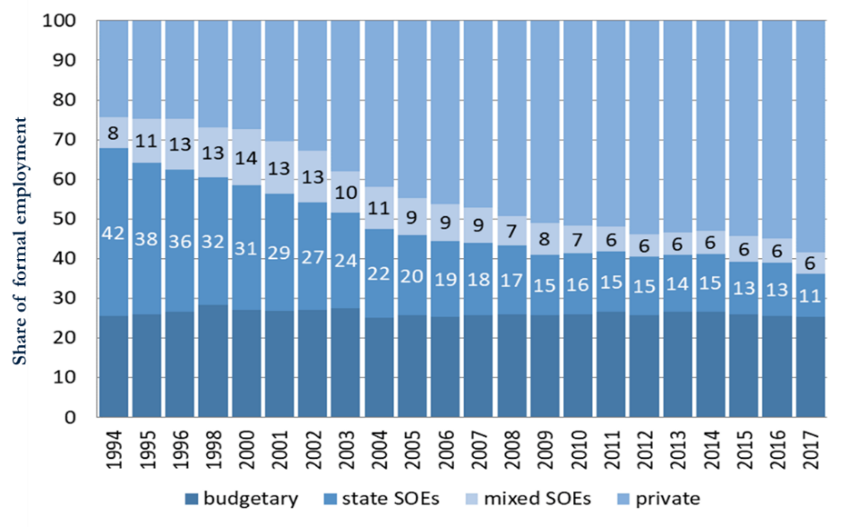

*Source*: RLMS

1. **Cross-nationally, Russia’s share exceeds even the most “SOE-heavy” Nordic states and France (Figure 2. 3).** We compare the Russian SOE share in non-agricultural employment with that of 15 top SOE-employing OECD countries. Differences in OECD and Russian definitions of SOEs[15] do not explain the stark difference in the shares. Even if we only include fully state-owned SOEs in the Russian sample, which is more restrictive than the measure used by OECD for the comparator countries, the share of Russian SOEs in total non-agricultural employment becomes 12.7 percent, which is on par with Norway, a country with the highest share of SOE employment in the OECD.
2. **This high average masks significant regional variation.** Figure 2. 4 shows SOE share in total employment,[16] broken down by SOE type and by region. It shows that the total SOE share ranges from 5 to almost 50 percent across regions.[17] There does not appear to be a clear geographic pattern, as SOEs are concentrated in the most populous and wealthy regions of Western Russia as well as in sparely populated lagging regions of the Far East.

Figure 2. 3 Share of SOEs (majority and minority government stakes) in total non-agricultural employment, Russia compared 2015-2016.

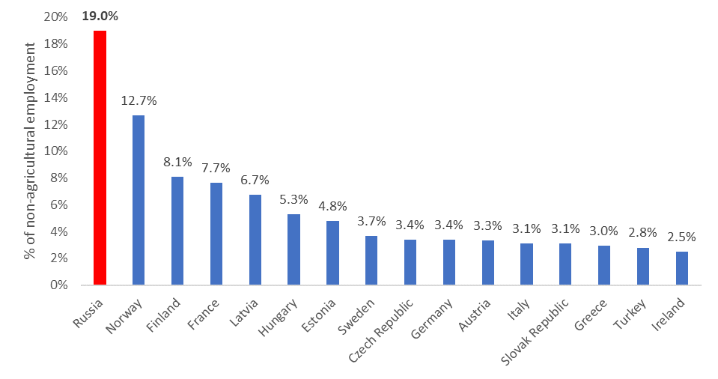

*Source*: RLMS 2015-6, OECD Labor Force Statistics (2015) in OECD 2017.

1. **Variation also emerges at the industry level**. SOEs play a key role in several sectors deemed strategic by the government (Table 2. 1). According to the SOW, four sectors—transport and communications, manufacturing, business services, and electricity, gas and water supply—account for over 85 percent of all SOEs by employment. In 2015, over 60 percent of all formal sector employees in these sectors were hired by SOEs (Lukyanova 2019). The concentrated presence of SOEs in these important sectors makes their performance and spillovers very relevant for the rest of the economy. The concentration patterns are similar across measures of SOE footprint, as sectors with high shares of SOE employment generally mirror those with high share of SOE in value added.
2. **Interesting patterns emerge when we look inside the SOE sector**. First, the sector is still dominated by fully-owned State SOEs. Not counting indirect ownership, State SOEs employ two thirds of all SOE employees, while one third is employed by Mixed companies (RLMS 2017).[18] Second, Table 2. 2 and Table 2. 3 show that SOEs are very large. The average SOE employs 3-4 times the number of workers than the average private sector firm, and that the largest firms are indirectly owned SOEs while the difference in average size between directly owned State and Mixed SOEs is negligible. The spread in average firm sizes is partly driven by outliers. The median size of private firms is 93 employees, state SOE 170 employees, direct mixed SOE 255, and indirect mixed SOE 309 employees.

Figure 2. 4 SOE share in total employment, by type of SOE and by region.

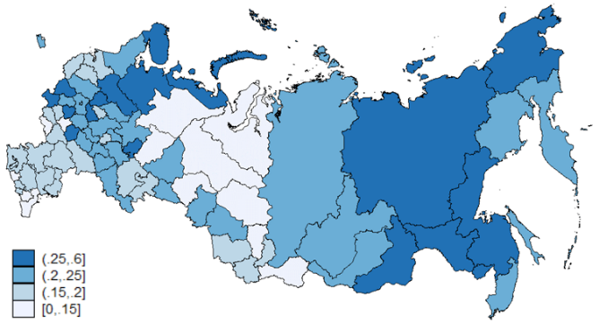

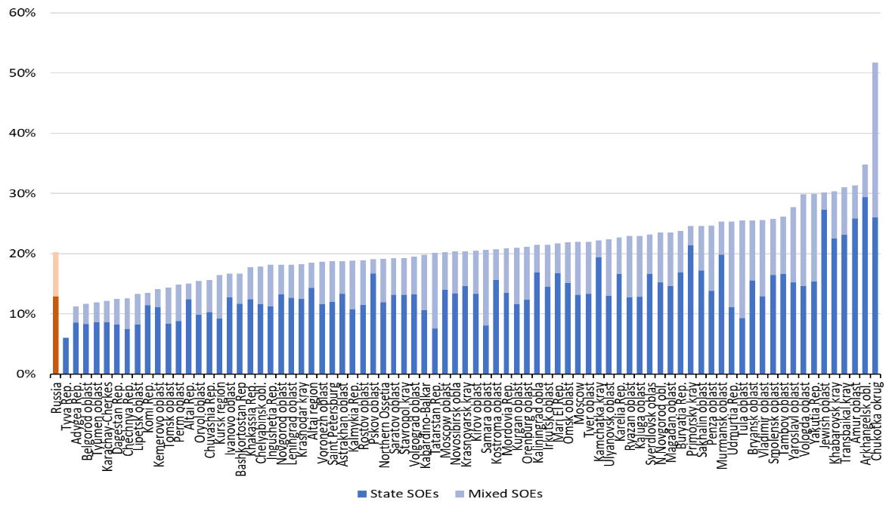

*Source*: SOW 2015.

Table 2. 1 SOE share in formal employment and value added (sales), by industry.

|  |  |  |  |
| --- | --- | --- | --- |
| **Share in Employment** |  | | **Share in Value added** |
|  | | |  |  | |

*Sources*: RLMS 2017, SOW 2015, OECD 2015, IMF 2018.

Table 2. 2 Average firm size (number of employees), by firm type

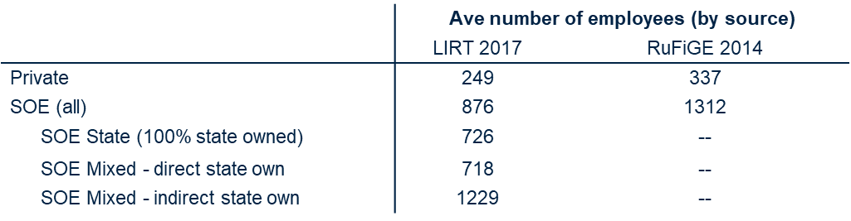

*Sources*: IIELM 2017, RuFiGE 2014.

Table 2. 3 Share of SOE firms, by size (number of employees)

|  |  |  |
| --- | --- | --- |
|  | **Number of firms, by source** | |
|  | SOW 2015 | IIELM 2017 |
| Large (500+) | 41.4% | 24.5% |
| Medium-large (250-499) | 17.4% | 25.8% |
| Medium (100-249) | 19.1% | 23.1% |
| Small-micro (1-99) | 22.2% | 26.6% |

*Sources*: SOW 2015, IIELM 2017

# 3. SOE COMPENSATION AND LABOR MARKET

|  |
| --- |
| Main findings:   * **On average, SOEs provide higher total compensation than private firms.** * **Mixed SOEs pay a small wage premium over private sector and state SOEs have a small wage penalty.**  The magnitude of the premium (penalty) varies, particularly by firm size, region, and industry * **All types of SOEs pay a wage premium in competitive settings** * **All types of SOEs provide more generous benefits** than private sector firms * **SOEs’ generous compensation affects labor supply.** SOEs have a higher ability to attract new skilled labor,which in the context of a tight labor market contributes to skill shortages in the private sector |

1. **Very little research exists on compensation practices in Russian SOEs,[19] but several lessons are relevant from studies of compensation in the country’s broader public sector**. One lesson is that Russia’s overall public sector wage gap may hide significant heterogeneity at the sub-sector level, and that it is important to disaggregate. In past studies, adjusted wage regressions showed little to no statistical difference between the wages of civil servants and private sector comparators, but up to 40 percent wage penalties for public health workers relative to private equivalent (we reproduce these results with standard controls[20], in Figure 3. 1). The second lesson is that wages do not tell the full story and that a comprehensive analysis should look at total compensation, including non-wage benefits. Globally, the public sector pays a wage premium of approximately 16 percent compared to private wage jobs, and it pays an even higher total compensation premium due to a variety of benefits .[21] Russia stands out cross-nationally in having a large public sector wage penalty (Figure 3. 2), but past research has shown that this penalty is more than compensated by generous benefits. Even for the budgetary sector, which has seen the widest wage penalties since the 1990s, researchers found that wages together with (monetized) benefits essentially match the private sector (Zhuravleva 2016, Gimpelson et al 2009, 2015). For these reasons, present analyses will explicitly explore heterogeneity in SOE wage-setting behavior and attempt to capture total compensation and not only wages.
2. **Our analyses in this section draw primarily on data from SOW and RLMS, and on a background paper by Lukyanova (2019).** SOW is the most reliable source on worker wages in Russia as the information comes from payrolls of surveyed establishments, and because the dataset is large, with over 700,000 workers in each survey wave. RLMS data is less reliable on wages because it is self-reported by workers, however we use the dataset for its unique data on (self-reported) benefits which are missing from SOW. Lukyanova estimates average hourly wage premia over the last decade using several models shown in Annex 3, which are variations of the Mincer wage regression. The preferred basic wage model (specification 3) includes gender, education, age, age squared, occupation, firm size, and year and region fixed effects as controls; industry controls are excluded because they are judged to have no significant effect on wages or wage gaps in SOEs.[22] The same basic controls are used for wage regressions throughout the chapter, with minor variations.

Figure 3. 1 Adjusted wage gaps (private sector=0), by categories of public sector workers

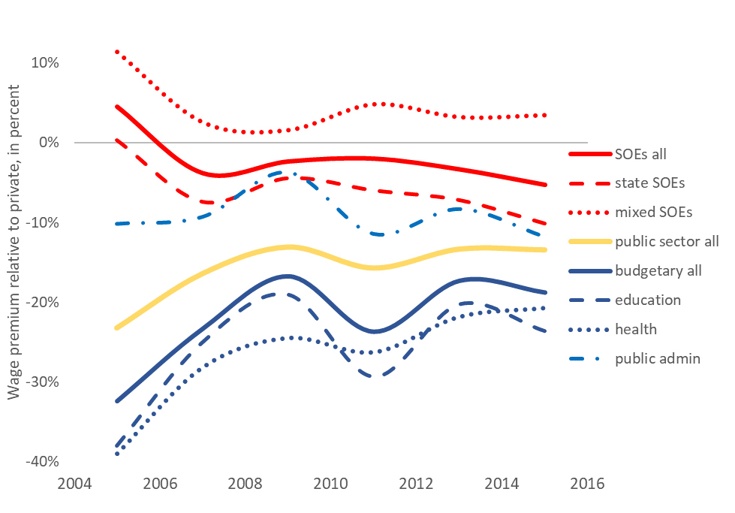

Source: SOW 2005-2015, RLMS 2005-2015

**Figure 3. 2 Distribution of public sector wage premia by country income.**

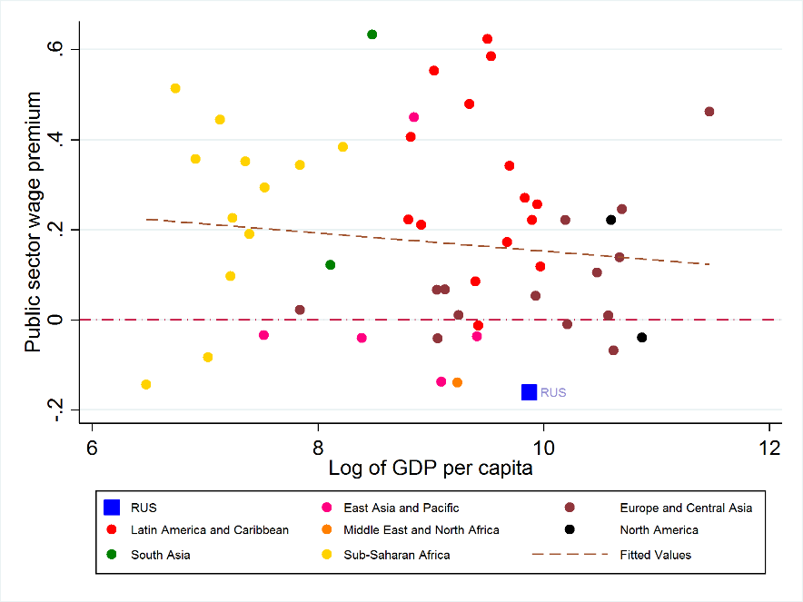

*Source*: Worldwide Bureaucracy Indicators (2017 Russia, 2010-2017 comparators)

## SOE compensation

1. **Our analyses show heterogeneity in wage premia relative to the private sector across different types of SOEs.** While overall the SOE sector demonstrates a small and stable wage penalty since 2006 (Figure 3. 1), a more nuanced picture emerges when we disaggregate by company type. Our adjusted wage regressions show that mixed state-owned enterprises in the Russian Federation pay 6 percent higher hourly wages compared to the formal private sector for similar workers in similar jobs, while fully state-owned enterprises pay 4.7 percent lower wages (Table 3. 1**,** see Annex B for regression results). These differences are statistically significantandhave been generally stable over the past decade (Figure 3. 1).Mixed SOEs pay higher wages compared to the private sector across all major occupations, although the gaps are highest in mid-skill occupations. This pattern is different from that found cross-nationally where public sector wage premiums are declining in skill levels. For mixed SOEs the wage gaps are largest for services and sales occupations, and for technicians and associate professionals. Both blue-collar workers and managers have lower, though still positive, premiums. Women receive a significant wage penalty in both SOEs and the private sector, and there is no significant difference in female wages across the two sectors.

Table 3. 1 SOE-private Adjusted gaps in mean hourly wages, in percent (private=0)

|  |  |
| --- | --- |
|  | *Wage gap, in percent (private =0)* |
| **Mixed SOEs** | 6.3% |
| **Fully state-owned SOEs** | -4.7% |

*Source:* SOW 2005-2015

1. **The wage premium for mixed SOEs varies by firm size and is larger in small and medium-sized companies (Figure 3. 3).** Using the Rosstat definition of firm size—small firms have 15-100 employees, medium have 100-250 employees, and large have more than 250 employees—we replicate the wage regression from Table 3.1., for each size category. We find that the observed premium in mixed SOEs is driven by small and medium sized companies. Controlling for worker and job characteristics, these firms pay a wage premium of 4 to 9 percent compared to the private sector. The wage penalty for fully state-owned SOEs is also smaller for these firms. (See Annex B for regression results.)

|  |
| --- |
| Figure 3. 3 The wage premium for SOEs varies by firm size |
|  |
| *Source*: SOW |

1. **SOE wage premiums are higher in more competitive industries.** We regressed log hourly wage on job ownership sector interacted with a continuous measure of market concentration (sales share of the top four firms in an industry),[23] controlling for worker demographics, occupation, firm size and region fixed effects. The market concentration measure was derived from the Ruslana dataset, based on all firms (almost 2 million) for which industry and sales data was available for 2018 or latest year. (See Annex B for table with estimated top-four market shares by industry.) Figure 3. 4shows how the wage premium varies by market concentration. While fully state-owned SOEs have an overall wage penalty, they pay a wage premium in competitive industries, with up to 9 percent market concentration; and mixed SOEs pay a premium in markets with up to 33 percent market concentration. This finding is in line with standard predictions of economics theory, that in competitive settings firms raise wages to attract good workers. It also shows that SOE compensation practices are most distortionary in settings where other firms are competing on the lowest profit margins and therefore least able to counter SOEs’ above-market wage rates. See Annex 2 for detailed regression results.

Figure 3. 4 SOEs pay a higher wage premium in more competitive industries[24]

|  |
| --- |
|  |
| ***Source*:** SOW 2015 (wage gaps), Ruslana 2018 (market concentration) |

1. **We find a similar pattern when analyzing the premiums across industries**. Mixed SOEs pay a positive wage premium in almost all industry sectors, and especially in competitive industries like trade, hospitality, real estate, and construction. They pay a more modest premiums in manufacturing and public utilities, and a small wage penalty in mining and transport and communications (Figure 3. 5). For fully state-owned SOEs, the wage gaps are also positive in competitive industries like trade and construction, but negative in the rest, and significantly negative in electricity and real estate.

|  |
| --- |
| Figure 3. 5 The wage premium for SOEs varies across industries |
|  |
| *Source*: SOW |

1. **A more nuanced picture emerges when we disaggregate the industry-level analyses by firm size**. Medium sized SOEs—both mixed and state—have larger wage premia, including in some industries where the mixed and state SOEs overall have wage penalties. For example, for fully state-owned companies, the overall negative wage gaps in mining and manufacturing sectors reported in Figure 3. 5 turn positive and the small premium in the construction sector grows six-fold when we limit our analysis to medium sized firms. Similarly, for mixed SOEs, the overall negative wage gap in the mining and transport sectors reported earlier turns positive when we focus on medium-sized firms. Overall, these analyses support our previous finding about a strong correlation between size and wage premia independent of industry or SOE type, and it would be important for future research to unpack and explain this result. For detailed regression results see Annex B.
2. **Finally, there is significant regional heterogeneity in the wage premium, with the premia higher in regions with more concentrated labor markets.** Russia has high regional variation in the structure of its labor markets, and it’s not surprising that the size of the wage premium also differs across the regions. Approximately two-thirds of the regions have a positive wage premium for mixed SOEs, ranging from a high of 30 percent to a low of -20 percent (Figure 3. 6). There is no association between a region’s level of economic development (per capita gross regional product (GRP) or GRP growth rate) and the wage premium, or any clear regional patterns except that the premium is higher in the Far East and more negative in the southern regions. There is a correlation between the size of the SOE sector and the wage premium, with the premia higher in regions with a higher share of SOE employment.

Figure 3. 6 The wage premium for mixed SOEs varies across regions

|  |
| --- |
|  |
| *Source*: SOW (2005-2015) |

1. **Turning to benefits, we find that all types of SOEs provide more generous packages than private firms.** Figure 3.7 presents the raw percent of workers in SOE and formal private sectors with access to benefits measured by RLMS. It shows that SOEs are significantly more likely to provide a formal contract and a variety of mandatory benefits like paid vacations, sick leave, and maternity leave; and non-mandatory benefits like free or subsidized health care and childcare, early pension, paid training, subsidized transportation and meals, and vacation subsidies in addition to the paid annual leave. For example, nearly 100 percent of workers in SOEs reported that their employer provided paid annual leave compared to 81 percent of workers in private formal sector firms. SOE workers take longer vacations (on average 4 days longer per year). Differences in the availability of maternity leave are even more striking, with 85 percent of females in SOEs reporting that their employers adhere to providing maternity leave as compared to 65 percent in the private sector. SOEs are also more generous than the private sector in the provision of non-mandatory benefits. Last but not least, SOE employment comes with the implicit benefit of higher job security: both mixed and state SOEs are 12-14 percent more likely to offer a formal contract than private firms and tenure in a given position is 3 years longer on average. Overall, of the observed benefits in our dataset, mixed SOEs provide the best package, followed closely by state SOEs, and, with a big gap, formal private firms.

Figure 3. 7 SOES offer more generous benefits

|  |
| --- |
|  |
| *Source*: WB staff calculations based on RLMS data, latest available |

1. **These findings suggest that SOEs may provide higher total compensation than the private sector**. Comparing total compensation, a sum of all monetary and non-monetary benefits from a job, requires monetizing benefits. We build on the work of Zhuravleva (2016), who carefully monetized some of the benefits mentioned in this paper, including paid vacations, paid sick leave, paid maternity leave, free health care, free childcare, subsidized meals, free or transport subsidies, and paid training. Since she does not monetize access to a formal contract, job security, and right to early pension, as well as a host of other benefits such as housing and vacation subsidies, her results could be seen as a lower bound for our purposes. Zhuravleva runs a series of modified Mincer wage regressions[25] with total compensation (wages and monetized benefits) as her dependent variable. She finds that by including even a limited sample of benefits in her wage model, the wage gap for the budgetary sector falls by two thirds and for SOEs by one third and almost below statistical significance. Further measurement is needed, but Zhuravleva’s results suggest a strong possibility that the inclusion of additional benefits—particularly job security and access to a formal contract and pension—would drive the SOE-private wage gap to zero or render it positive for all types of SOEs.

## Effects on labor supply and allocation

1. **We expect these compensation differentials to impact workers’ job preferences and relative ability of public and private sector firms to recruit skilled workers, and hence the efficiency of labor allocation in the economy.** Establishing a causal relationship is difficult given an absence of direct questions in the data sources on workers’ sectoral employment preferences or on reservation wages, and the relative dearth of new job openings in SOEs. We instead provide evidence on worker satisfaction and self-assessed social standing in the two sectors, which we take to be indicative proxies for job preferences, and descriptive statistics on the relative growth in skilled worker shares and relative skill shortages in the two sectors.
2. **Workers in SOEs are more satisfied with their jobs than workers in the private sector**. Employee job satisfaction has been used in numerous studies as a summary measure of all job attributes that is correlated with worker turnover, and that indirectly could be indicative of job preferences. Workers that are more satisfied with their jobs are less likely to quit. The RLMS measures job satisfaction on a 5-point scale, and Figure 3. 8 presents the differences in worker satisfaction for the public sector compared to the private sector controlling for worker and job characteristics. Controlling only for gender, age, education, occupation, tenure, firm size, region, and year effects (specification 1), workers in mixed SOEs have the highest level of job satisfaction, followed by budgetary sector workers. Workers in the private and sector and state SOEs are the least happy with their jobs. When also controlling for wages and working hours (specification 2), workers across the public sector are more satisfied than their private sector counterparts, and these results hold when additional controls such as occupational safety and presence of a formal labor contract (specification 3) are added. These findings suggest that the disadvantages of lower wages in state SOEs and the budgetary sector are offset by generous benefits, sector selection, and other unobservable personal and job characteristics.

|  |  |
| --- | --- |
| Figure 3. 8 Difference in percent of public-private workers satisfied with their job | Figure 3. 9 Public sector workers’ have higher self-reported social status |
|  |  |
| *Source:* RLMS | *Source*: RLMS |

1. **Workers in the public sector also have a higher assessment of their social and economic status in society.** Figure 3. 9 presents the results of analyses using RLMS 2005-2017, controlling for worker and job characteristics (regression results are in Annex B). The RLMS asks respondents to rank themselves from 1 to 9 on wealth and power. Since these are general questions and may not be related to main job directly, the results should be interpreted with caution. Conditional on personal and job characteristics, wages, hours worked, occupation, firm size, year and region fixed effects, workers in state and mixed SOEs assess themselves as having significantly more economic status and power compared to their private sector counterparts. The power rankings are higher than economic rankings, which is suggestive of the greater benefits and non-pecuniary aspects of public sector jobs that compensate for the wage penalty for state SOEs.
2. **Consistent with our expectations, the SOE workers’ higher job satisfaction and perceived prestige is correlated with the sector’s better retention of existing workers.** Workers in SOEs are both 25 percent less likely to desire to change jobs (Lukyanova 2019) and less likely to actually quit their jobs compared to private sector workers. The panel structure of the RLMS enables the tracking of workers over time to analyze job separations, defined as a worker either having a different job compared to the previous period or having no job. These separations could be either voluntary or involuntary (the data does not allow one to distinguish). Figure 3. 10 shows that while separations have been declining over time, approximately 15 percent of public sector workers are likely to quit their jobs in a year compared to 22 percent of private sector workers. Although we cannot draw causal conclusions, the higher quit rates of private sector workers are in line with their lower job satisfaction and lower self-reported economic and power prestige.

Figure 3. 10 Percentage of workers quitting jobs between consecutive rounds of RLMS.

|  |
| --- |
|  |
| *Note:* Workers could either get a new job or no job in the next round.  *Source*: RLMS-HSE |

1. **SOE worker’s higher job satisfaction and prestige are also correlated with the sector’s higher ability to attract new skilled labor.** Intersectoral transition matrices based on RLMS 2012-2016 datashow that the net flow of workers from the private sector to SOEs is consistently higher--on average, by 20 percent--than the reverse. This result is consistent with our expectations and could reflect the SOE sector’s attractive compensation and terms of employment. Although we cannot rule out the possibility that the net positive flow of workers to SOEs is driven by job openings--a hypothesis we cannot test with available data--we believe this explanation is less persuasive because most jobs in Russia are created in the private sector.
2. **The results from transition matrices, while consistent with our expectations, only show the net flow of workers, not of skills*.*** A clearer picture emerges if we compare growth in the share of skilled workers in the two sectors.Figure 3. 11 shows that SOEs have been more successful at attracting highly skilled workers than private sector firms over the past two decades. While the share of university graduates in formal sector employment has been growing steadily across all sectors, the growth has been much higher in SOEs than in the private sector—the share increased two-and-a-half fold in SOEs compared to one-and-a-half times in the private sector. These differences are observed despite the two sectors’ similar demand for skills as observed from their similar occupational structures (Lukyanova 2019).

Figure 3. 11 Growth in the share of university graduates, relative to base year (1994).

|  |
| --- |
|  |
| *Source*: RSLM-HSE |

1. **In the context of Russia’s tight labor market, the relatively stronger pull of skilled labor towards the SOE sector is expected to cause disproportionate skill shortages in the private sector.** Russia’s record-low unemployment rate since 2012 (Figure 3.12) has tightened labor markets and contributed to overall skill shortages in the economy.Cross-national data from the World Bank’s Enterprise Surveys reveal that 25 percent of Russian private sector firms state that skills shortages are a “major or severe constraint”, higher than all but three countries in the dataset (Figure 3.13). As predicted, we find that these skill shortages disproportionately affect the private sector. Controlling for standard firm characteristics, private sector firms in Russia are 17 percent more likely to report shortages of skilled workers than SOEs, and the difference is statistically significant. These shortages are highest for smaller-sized private firms which face the widest wage gap with SOEs.[26] Although skill shortages could be due to a variety of factors, sectoral differences in total compensation likely play a major role. RuFiGE data suggests that, controlling for firm size, sector, share of educated workers, share of managerial-level staff, and other characteristics, a 1 percent lower average skilled-worker wage predicts a 9 percent higher probability that the firm will experience skilled worker shortages.

|  |  |
| --- | --- |
| Figure 3.12 Unemployment rates, Russia and comparators 2010-2018 | Figure 3.13 Share of firms reporting labor shortages to be a major or severe constraint. |
|  |  |
| *Source:* World Development Indicators, modeled ILO | *Source:* Enterprise Surveys, Russia 2012-2013, other 2012-2017 |

1. **Indicative evidence suggests that SOEs’ attraction of the best workers creates allocative inefficiencies.** Allocative inefficiencies arise if the best workers stream to less productive firms, while the most productive firms are starved of skilled labor, and existing evidence suggests this dynamic is reflected in Russia. Existing studies find a statistically significant negative difference between the average productivity of Russian SOEs and equivalent private firms. Bogetic and Olusi (2013) find in a large sample of Russian manufacturing firms that a strong and statistically significant negative relationship between state and municipal ownership and firm total factor productivity (TFP). In their meta-analysis of 29 studies, Iwasaki, Mizobata, Muravyev (2018) broadly confirm this result, finding a significant negative correlation between government ownership (all levels of government) and measures of output, for a broad array of industries.[27] Using labor productivity and efficiency measures from 2017-2018 Ruslana and IIELM survey data, we get a similar result, but unlike previous studies we go further by disaggregating the results by firm size. Figure 3. 14 presents the results of regressions for each firm size group, with industry controls (see Annex B for detailed regression results). The data suggest that the SOE sector’s overall lagging performance could be mostly driven by small and medium sized companies. Small and medium sized SOEs have significantly lower labor productivity (revenue per worker) and efficiency (return on capital) than private firms of similar size, while the difference is not significant for larger SOEs.

Figure 3. 14 SOE performance relative to private sector equivalent, by firm size, 2017-2018.

|  |  |  |
| --- | --- | --- |
| **Firm size** | **Labor productivity Revenue per employee** | **Efficiency**  **Return on Capital** |
| Small/micro (1-100) | -54%*** | -136% *** |
| Medium (101-250) | -13%*** | -98%** |
| Medium-large (251-500) | -3% | -64% |
| Large (>500) | 7% | -37 |

*Sources:* IIELM 2017 (return on capital), Lukyanova 2019 / Ruslana 2018 (revenue per worker)

1. **The ability of large SOEs to perform on par with the private sector suggests that state ownership can be fairly productive in Russia.** The question why small and medium sized firms are less productive will require further research. We address some of the factors that might improve firm productivity and efficiency, in the next section.

# 4. SOE EMPLOYMENT PRACTICES AND INTERNAL CAPABILITIES

|  |
| --- |
| Main findings:   * **SOEs underinvest in human capital and performance management** compared to Russian private firms or international comparators * **SOEs are low users of technology** * **State SOEs and smaller SOEs exhibit lowest performance** |

1. **Management practices shape SOEs’ internal capabilities and performance.** Global experience shows that firms that adopt good management practices—such as incentivizing and managing performance, and investing in human capital and technology—maximize their productive potential. Prior research has shown that by international standards, Russian firms underinvest in these good practices, but since most previous analyses have focused on the private sector,[28] very little is known about employment practices in SOEs. How do they compare to private firms operating in Russia, both domestic and multinational? How to they measure up against firms in other BRICs and advanced economies? How much variation is there within the SOE sector? Are there cases of “positive deviance” that could serve as models for other SOEs? A deeper understanding of these questions and others related to employment practices in SOEs is critical for diagnosing the sources of the sector’s performance gap, and for developing a practical empirically-driven policy response.

## SOE personnel management

1. **Firms, particularly those that expect to hold on to workers for some time, get high returns from training and properly managing their workers’ performance.** Workers are more productive when they understand their managers’ expectations, have the skills and competencies needed for their jobs, and feel motivated and supported in their professional development. If workers are productive, the firm benefits. Data on performance management in Russian firms is scarce in worker and firm surveys, but the few existing questions suggest it is an area of weakness for SOEs.
2. **SOEs substantially underinvest in their human capital**. On average, 41 percent of all SOEs provide training for their employees compared to 60 percent of foreign firms in Russia, or 85 percent of firms in China (Figure 4. 1). This result is relatively consistent across all sizes of SOEs.[29] SOEs that do provide training, train very few workers—on average, only 16 percent, less than half of other firms in Russia, and considerably lower than the OECD countries or China (Figure 4. 2).This is a missed opportunity, as research suggests that there are high returns to investment in general and firm-specific worker human capital for internal firm capabilities.

|  |  |
| --- | --- |
| Figure 4. 1 Share of firms providing training for employees. | Figure 4. 2 Share of employees trained by firms that provide training. |
|  |  |
| *Sources:* RuFiGE 2014 (Russian firms), Enterprise surveys 2012-2017 (comparators) | |

1. **Russian SOEs are also relatively low adopters of compensation-based performance incentives**. A growing body of research shows the importance of basing a portion of workers’, including managers’, pay on achievement of clear realistic performance targets, which aligns worker incentives with the overall goal of firm performance. The most recent IIELM and World Management surveys show Russian SOEs trailing global comparators, including China, other BRICs, and OECD countries in setting performance targets (Figure 4. 3) and rewarding managers on the basis of performance (Figure 4. 4). On average, only 49 percent of Russian SOEs set key performance indicators (KPIs) compared to 90 percent of Chinese firms, and only 17 percent give managers performance bonuses compared to 75 and 94 percent of Brazilian and Chinese firms, respectively. Although we lack data on the *quality* of performance targets—a separate, important dimension that merits further study—the quantitative comparison alone suggests that SOEs may be underinvesting in this key predictor of firm capabilities.
2. **The data also show significant heterogeneity within the SOE sector—a 50 percent spread in adoption of KPIs and 34 percent spread in use of manager performance rewards**. This heterogeneity is helpful both for identifying the laggards—small and fully state-owned SOEs in particular—and demonstrates that major improvements are within reach. The fact that large mixed SOEs are close to the BRIC frontier and in some cases outrank private domestic and multinational firms suggests that there are no inherent reason why state ownership should constrain the adoption of these good management practices, and also creates opportunities for peer learning.business climate.

Figure 4. 3 Share of firms using KPIs.

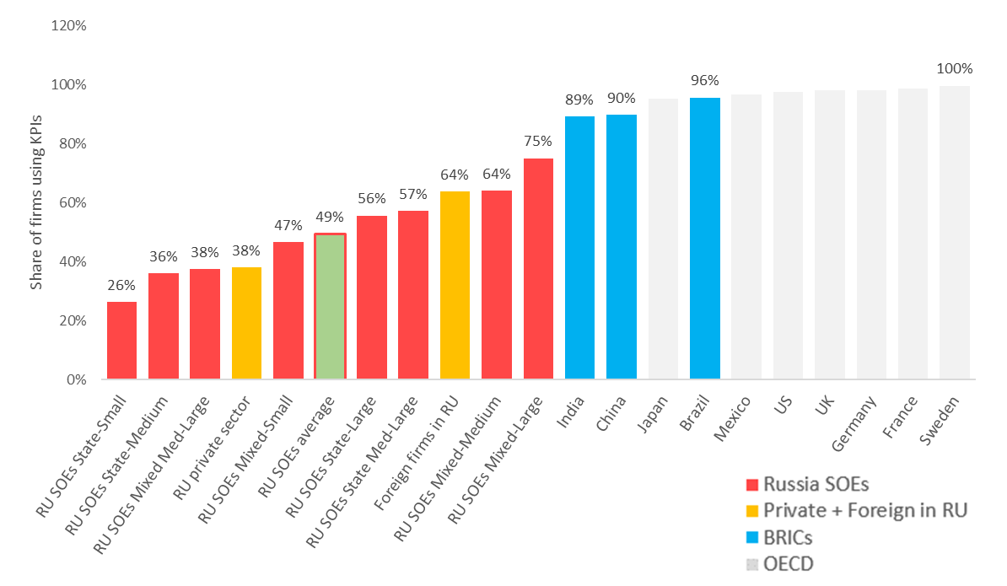

*Sources:* IIELM 2017 (Russian firms), World Management Survey 2014 (global comparators)

Figure 4. 4 Share of firms giving manager performance bonuses.

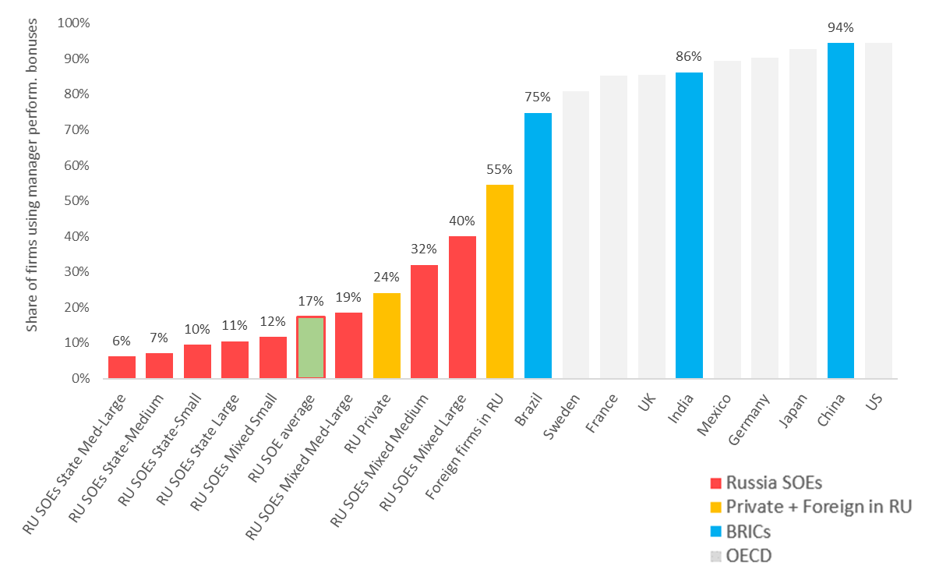

*Sources:* IIELM 2017 (Russian firms), World Management Survey (global comparators)

1. **SOEs elicit lower effort from their employees, measured in weekly hours worked**. SOE workers on average have 3 hours shorter working weeks (Figure 4. 5), and the difference is statistically significant. Although time is not a perfect measure of effort, it could suggest gaps in performance management, including managers’ attention to worker motivation, discipline, and accountability.
2. **Lastly, SOE workers appear to be less mobile, which could contribute to their reduced productivity, and could reflect gaps in management practices**. Our measure of mobility is average tenure on the job. Studies show that although tenure can bring positive externalities, such as from workers’ accumulated firm-specific capital, overall the gains tend to be outweighed by reduced worker motivation for a net loss in productivity (Ng & Feldman 2013). RLMS data suggest that SOE workers’ tenures tend to be almost twice as long as those of their private sector counterparts (Figure 4. 6).

|  |  |
| --- | --- |
| Figure 4. 5 Average weekly working hours. | Figure 4. 6 Tenure in current job, in years. |
|  |  |
| *Source:* RLMS | |

|  |
| --- |
| Figure 4. 7 On the job computer and internet usage among workers. |
|  |
| *Source:* RLMS 2017. |

## SOE use of information technology

1. **Evidence suggests that the use of technology for routine and complex business processes raises firm productivity.** Computers and internet usage speed up internal processes and communications in all firms, regardless of sector. Automated integrated electronic resource planning (ERP) systems optimize internal business processes and can significantly aid efficiency. Development of an online presence for the firm, particularly in English-language website, can be a low-cost way to boost marketing and sales, including exports. Managers who invest in these tools help their employees be more productive and invest in long-term firm capabilities.
2. **SOEs are low users of information technology compared to foreign private sector firms in Russia**. According to worker surveys, on-the-job computer and internet usage among SOE workers remains low compared to workers in private domestic and Russia-based foreign firms, and differences are statistically significant (Figure 4. 7). Although usage levels have steadily risen over time, the gap with the private sector has not closed. A low share of Russian SOEs use integrated electronic resource planning (ERP) systems or possess English-language websites (Figure 4. 8, Figure 4. 9). The use of these management tools, however, is strongly correlated with size: small and mid-sized SOEs have very low usage rates, while the larger firms match multinational firms. The wide variance in adoption within the SOE sector suggests significant potential for learning and improvement for laggard SOEs.

|  |  |
| --- | --- |
| Figure 4. 8 Share of companies using ERP/IFMIS. | Figure 4. 9 Share of companies with English-language website. |
|  |  |
| *Sources:* RuFiGE 2014 (Russian firms), Eurostat 2017-2018 (EU comparators) | |

1. **SOEs relatively high wage bill may be crowding out investment in information technology.** IIELM data suggests that the higher wage bills significantly reduce their investment in research and development, which depresses the firms’ long-term productive potential. Firm surveys also reveal that only 2 percent of SOEs benchmark their pay compared to 9 percent of private firms, and that the large contingent of state SOEs do not benchmark at all (Figure 4. 10).[30] This lack of benchmarking implies that some SOEs may underpay relative to market rates, while many pay above-market compensation for the same work.[31] Analyses also show no correlation between the firm’s average wage and worker productivity measured by sales per worker, so their higher compensation does not buy better performance.[32]

Figure 4. 10 Share of firms benchmarking wages to closest competitors.

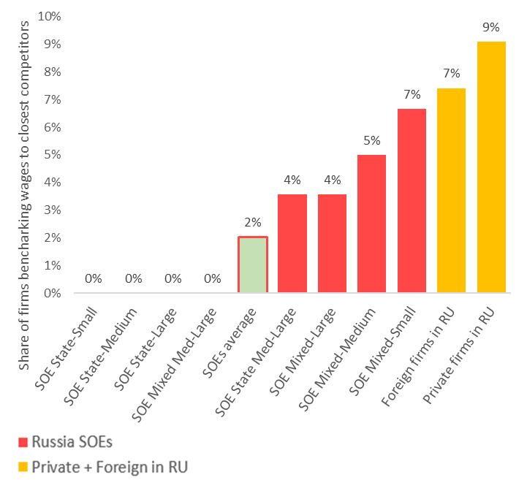

*Source:* IIELM 2017

1. **Examples of “positive deviance” of SOE management practices can be a motivation for reform (Box 4. 1)**. It is important to acknowledge and study these cases for several reasons. They show that there is nothing about the local business or institutional context that inherently prevents companies from adopting the good practices. They also show that government ownership does not have to be associated with poor practices, and that, if given appropriate attention, other parts of the SOE sector too can closer to the frontier. Finally, the cases of positive deviance show other firms a model for how they can improve their practices, what worked or did not work, what lessons were learned.

|  |
| --- |
| Box 4. 1 Select cases of “positive deviance” - Russian SOEs with frontier employment practices |
| **Aeroflot** (Russian national airlines company). Since 2007introduced several new management practices. It appointed “innovation managers.” The innovation managers worked with functional managers to develop measurable and feasible KPIs, improve communication between employees and management, encourage employees to voice opinions about challenges with existing practices, reengineer processes to reduce bureaucratic bottlenecks. The outcome of these and other changes was measurable improvement in passenger rating of the quality of services received on board, one of Aeroflot’s KPIs (Gershman & Thurner 2016)  **Russian Railways** (largest transport company in the world with 1 million employees). Starting in 2010, it introduced several changes to management practices, including a new corporate management system; new measurable KPIs including on service reliability, security, and quality of service; a financial information management system; and an innovation management system. Results have been improved financial indicators and customer perceptions of service (Thurner & Gershman 2014) |

# 5. GOVERNMENT SUPPORT AND ITS EFFECTS

|  |
| --- |
| Main findings:   * **SOEs benefit more than private firms from various forms of state support** * **State subsidies enable the observed wage gap between SOEs and non-SOEs,** and contribute to potential labor market distortions * **State support is not correlated with firms’ adoption of good management practices** |

## State support for SOEs

1. **The discussion in chapters 4 and 5 raises the question how SOEs sustain their employment practices in competitive markets**. In competitive markets, less productive firms would not normally be expected to afford above-market wages and firms with weaker employment practices and internal capabilities would not be expected to remain in business. Yet SOEs appear to be doing both.
2. **We find that at least part of the answer may lie with current government policy, which manifests through various forms of support.** Firm-level data on state support is scarce, and to our knowledge administrative data on the ruble amounts or transactions received by individual firms is not available to the public or researchers. Fortunately, the RuFiGE and IIELM surveys field several questions that allow us to measure the presence and type of state support at the firm level. We focus on four questions related to financial support, non-financial support, state contracts, and protection from competition (see Box 5. 1 for detailed description of the questions and our measures). The data shows that SOEs benefit more than private firms from state generosity, on all measures of state support. Our findings come with important caveats. First, we are not able to observe the level of government support or to monetize its non-monetary forms, we only see if (not) support was received. Second, we are not able to account for potential public service functions of SOEs, which could affect levels of support. Finally, we are only able to report what the data show, which may not reflect the outcomes intended by relevant policy-makers or implementing bodies. Further research will be needed to better understand these important aspects.

|  |
| --- |
| Box 5. 1 Measures of state support in RuFiGE 2014 and IIELM 2017 surveys |
| **Financial support (subsidies).** “During 2012-2013, has your enterprise received any financial support from …. 1. federal, 2. regional, 3. local authorities?” [RuFiGE, Question B104]   * *Binary measure: 1 if firm receives financial support from any source, 0 otherwise.*   **Non-financial support.** “During 2012-2013, has your enterprise received any organizational support from … 1. federal, 2. regional, 3. local authorities? By organizational support we mean any non-financial support, such as facilitation of connections to Russian or international partners, facilitation of connections to other government organs, help attracting investors, etc.” [RuFiGE, Question B105]   * *Binary measure: 1 if firm receives non-financial support from any source, 0 otherwise.*   **State contracts.** “In 2013, did your enterprise work on any state contracts? (Yes/No/DK/NR)”  [RuFiGE, Question B106]   * *Binary measure: 1 if firm worked on state contract, 0 otherwise.*   **Protection from competition.** “As concerns the prices of the main products or services of your enterprise, how strongly do they depend on competition from other firms producing and/or selling similar products? (1-4 Likert, 1=does not depend at all, 2=most often does not depend)” [IIELM, Question 6a]   * *Binary measure: 1 if Likert responses 1 or 2, 0 otherwise.* |

1. **SOEs are more likely than private firms to receive financial assistance and state contracts, non-financial assistance, and protection from competition.** A large academic literature has argued, and empirically demonstrated, that SOEs are subject to a “soft-budget constraint” which shields them from competitive pressures and may enable them to offer higher wages without being subjected to market discipline. SOEs in Russia receive a variety of state support that gives them a financial advantage over private firms (Figure 5. 1). Approximately 60 percent of SOEs receive subsidies from the government, compared to 10 percent of private firms; and 60 percent of SOEs receive a procurement contract from the government compared to 27 percent of private firms. [33] Available administrative data supports the view that SOEs may be more likely to receive single-source government contracts than other firms.According to the Federal Antimonopoly Service 20 percent of all government contracts are single source, buta recent publication from the Analytical Center for the Government finds that50 percent of government contracts with unitary companies are single source (data shared by FAS, Kovaleva et al 2019). The data also reveal important differences across different sizes and types of SOEs. Smaller SOEs are more frequent recipients of state financial assistance. Meanwhile larger SOEs receive more state contracts and non-financial assistance, most of it designed to bring in contracts from other sources.

|  |
| --- |
| Figure 5. 1 Share of firms receiving state subsidies, contracts, and non-financial assistance. |
|  |
| *Source:* RuFiGE 2014 |

1. **SOEs are almost twice as likely to be shielded from competition than private domestic or expatriate firms (Figure 5. 2).** State SOEs are significantly more shielded than mixed, but the fact that mixed are significantly more protected than private firms is noteworthy because these mixed SOEs compete more directly in the market and, besides partial state ownership, are supposed to be in every way like private firms.

Figure 5. 2 Share of firms whose prices of main products/services do not depend on competition.



*Source:* IIELM 2017

## State support and SOE employment practices

1. **State support appears to influence SOE compensation practices, as SOEs that receive it are more likely to offer higher wages to their employees**. We run a series of regressions using wage data from RuFiGE. Since RuFiGE is a firm survey we cannot run standard worker-level wage regressions, and instead use firm average wage as our dependent variable and firm-level controls that approximate potential determinants of the average wage, such as average labor productivity, share of workers with tertiary education and in top management positions, firm size, and firm membership in a business union. Our first regression measures the SOE-private wage gap when the firms do not receive a state subsidy, the second when they receive a state subsidy, and two more when firms receive a subsidy disaggregated by firm size. We find that SOEs that do not receive subsides pay statistically identical wages to private sector firms, but those that receive a subsidy pay a 35 percent wage premium over equivalent private sector firms (Figure 5. 3).[34] Probing further, we find that the wage premium is in small and medium-sized SOEs, as the wage gap remains statistically insignificant for large firms (Figure 5. 3, regression tables are presented in Annex B). Further research is needed, but the data suggest that state subsidies may serve to soften the budget constraints of small and medium sized SOEs, but not that of larger SOEs or private firms.[35]
2. **State support is also not correlated with the quality of management practices.** In competitive markets, profit maximizing firms receiving government assistance would be expected to invest in improved management practices, such as more training for workers or improved technologies. Lack of panel or even time-series data precludes accurate measures of these dynamics for Russia, but what we do see from the RuFiGE and IIELM cross-sections is that government support for SOEs is uncorrelated with good management practices in these firms.[36] There is no difference in these practices between SOEs (irrespective of size) that receive state subsidies, non-financial assistance, access to contracts, or protection from competition, and those that do not.

|  |
| --- |
| Figure 5. SOE-private wage gap, with and without government subsidy |
|  |
| *Source*: RuFiGE |

1. **These data suggest that the current manner of government support for SOEs may be compromising its goal to raise overall productivity in the economy.** The total cost of subsidies, contracts, indirect assistance, and other measures is substantial,[37] yet our tentative analyses suggest that this support is uncorrelated with firm productivity. We estimate the marginal effects of firm labor productivity on the probability of receiving a subsidy (since our measure of subsidy is binary), with controls for observable factors that might affect this probability, including the firm’s access to finance and its human and managerial capital. We find a small but significant correlation between labor productivity (measured by revenue per worker) and probability of a subsidy for non-SOEs, but no such correlation for SOEs (see Annex B for detailed regression table). Results presented earlier in this paper also seem to point to the same conclusion: Small and medium-sized SOEs have the same access to state support as medium-large (between 250 and 500 employees) and large (over 500) SOEs despite having significantly lower productivity. Labor productivity and efficiency of medium-large and large SOEs is not statistically different from equivalent private firms, while small and medium SOEs perform measurably worse (see Figure 3. 13). Their revenue per worker is, respectively, 54 and 13 percent lower than that of equivalent private firms, and their return on capital is 93-107 percent lower. This might be evidence of the government’s lack of selectivity in choosing SOEs for contracts and assistance, or lack of information on the firms’ employment practices and productivity. More research is needed to better understand this nexus.

# 6. POLICY RECOMMENDATIONS

1. **This report has shown some strengths and weaknesses in the employment practices of the Russian SOE, and their effects on the efficient allocation of labor and within-SOE performance.** The natural question for policy makers and those who care about boosting Russia’s economic potential is what should be done to address some of the weaknesses that pose a potential obstacle to productivity growth. Additional, more granular analytical work would be needed to identify concrete policy options. Here we present preliminary recommendations in four policy areas, depicted in Figure 6. 1, that the Government can focus on to improve SOE employment practices. These pillars are informed partly by the study’s empirical findings and partly by initial consultations with stakeholders in Russia. The main message is that relatively modest changes could lead to substantial positive spillovers and improvements in SOE performance.
2. **The Government can improve SOE employment practices through a combination of support, incentives, and regulation, underlaid by a foundation of good data on SOE employment practices which would enable better monitoring and evaluation**. Support would be business development services, or business training, for SOEs, with a focus on management training. This capacity building would need to be accompanied by improved incentives for SOE performance, through hardening the soft budget constraint for SOEs through more competitive public procurement and allocation of subsidies and awards and recognition for good SOE managers. The government can also explore more regulatory oversight over SOE compensation, though this will need to be modest as there is a tradeoff between regulation and autonomy, particularly for commercial SOEs. Finally, and most importantly, none of these interventions will be successful without better data, monitoring and evaluation.

Figure 6. 1 Select Policy recommendations

|  |
| --- |
|  |
| *Source*: Authors drawing on Grover, Medvedev, & Olafsen (2018) |

## Better data and monitoring

1. **To fulfill the ambitious goals it set itself under the May Decrees, the National Labor Productivity Project, and Plan for Competition Development, the Russian Government needs more and better data on performance and performance drivers of the country’s firms, especially SOEs**. Better and more detailed data is critical for helping the Government make informed, evidence-based decisions as it embarks on its ambitious new projects. It will give decision-makers an accurate “baseline” snapshot of challenges before the projects start; it will help guide or refine interventions under the projects; and at the end of implementation, it will give an accurate measure of the projects’ impact to inform future interventions. In addition to improving internal decision-making, more accurate data can help the Government to more credibly showcase its good achievements under the projects to the public, and rally momentum for future reforms.
2. **There is currently limited administrative data collected on SOEs.** Ideally, there should be a centralized database of key indicators for SOEs, though this will be difficult in practice given the federal structure of Russia and the very large number of SOEs, many of them small and medium size municipal level entities. The Ministry of Economic Development (MED) through Federal Agency for State Property Management (FASPM) keeps a database of federally owned companies, while information on those founded or owned by regional or municipal authorities is kept by those founding institutions and not consolidated with MED’s/FASPM’s database. It is difficult to assess whether FASPM’s registry of federally-owned SOEs is collected and stored in a way that allows meaningful analysis. The information available publicly from FASPM does not show the total number of companies with state ownership, whether subsidiaries are included, or breakdown by company size or share of state ownership. A more thorough assessment would be required, but analyses by researchers working with FASPM, including former FASPM employees, point to certain data gaps within the Agency’s internal data systems, and confirm that subsidiaries of SOEs are not tracked.
3. **For SOEs that are tracked, only basic information is collected and little systematic monitoring and evaluation (M&E) is done on performance and employment practices.** By law, owners of SOEs (FAPSM, or other) have the responsibility to approve and monitor economic KPIs for the companies,[38] but de facto less than 50 percent of SOEs report using KPIs, suggesting poor monitoring. Similarly, poor monitoring was one frequent criticism of the Government’s 2012-2015 Plan for Raising Firm Productivity,[39] which invested in firm-level management interventions, but did not track any outcomes or impacts.
4. **The Government can take several measures to improve administrative data on SOEs, particularly for large SOEs and for firms benefitting from government support**. First the MED should review existing legislation to identify legal barriers to collecting and consolidating data in one place. As part of this review, it should consider amending existing regulations to have a unified definition of SOE that includes companies with both direct and indirect state ownership. Second, the Government should consider imposing a legal obligation on SOEs—perhaps starting with large federal SOEs and later broadening to other categories and levels—to report the data deemed necessary for monitoring the effectiveness of state investment in them. Government Decree 738 of 2004 requires MED to collect and report key financial performance indicators of joint stock companies with over 50 percent state participation. This requirement could be broadened to other commercial SOEs with the state ownership over 50 percent. These data may include the size of subsidy received by SOEs; the list of KPIs adopted at the company level; the status of KPIs achievement; the dividends planned and amounts received; and other payments received from the company. Finally, the administrative data systems of MED can serve as a model for the regional and municipal authorities. For example, the Government Decree 447 of 12 July 2007, which required MED/FASPM to digitize its records of SOEs and other state properties, could be used as an example to be replicated by regional and municipal authorities.
5. **The Government should also expand and utilize its existing surveys for better monitoring of SOE employment practices.** Rosstat’s Survey of Occupational Wages (SOW) provides detailed information on compensation in establishments, including SOEs, with large coverage (700,000 workers in each wave) and representativeness at the subnational level, which if expanded and used could become a powerful instrument for M&E. The SOW currently is limited to compensation and does not have any questions on other firm employment practices. The SOW should be broadened to include additional questions such as on target setting (KPIs), performance incentives and monitoring, talent management, and technology to better enable regular measurement and monitoring of the micro-foundations of firm productivity. The additional modules could come from the World Management Survey (applied in many OECD countries) or the Management and Organizational Practices Survey (used by the United States Census Bureau). The management data, if matched with objective data on firm performance such as from tax records or SPARK datasets, could also enable both government evaluators and researchers to measure the linkages between management practices, innovation, and productivity in Russian firms.

## Support for improved management practices

1. **A growing body of evidence suggests that direct support to firms to improve management practices can result in significant improvements in productivity (Bandiera et al 2011, Bloom et al 2013, Anderson et al 2016, Bruhn et al 2018)**. Many countries have seen a broad range of successful government-supported business training and advisory programs over many years. These programs include training in setting performance targets, talent management including workforce training, supply chain development, customer acquisition, and use of information technology. They can be delivered in a cost-effective way through classroom training or targeted consulting services, the first usually for small and medium enterprises while the second for larger firms (Mckenzie and Woodruff, 2012). The justification for these services is that firms, due to market failures and cognitive biases, can underappreciate their own lack of capabilities or the returns to improving their management practices, or are simply unable to invest in improvements. Government support helps to overcome these market failures and helps firms adopt improved practices. The menu of government interventions is large. One cost-effective intervention is management extension, a business development service which involves more individualized training of firm managers and workers by a management specialist. The service can be offered, for example, through business support organizations contracted by the government through performance based contracts. Evidence from impact evaluations so far has shown very positive results, including measurable improvements in firm management practices and higher firm productivity, which more than pay for the cost of the training.[40]
2. **The focus of the proposed training could be on small and medium sized SOEs which this report has shown to be the lowest performing and most distortionary.** Previous government efforts to improve firm productivity have focused on large companies. Working with smaller companies would both complement those previous engagements with the larger firms and give the Government more room for experimentation on what works, given the lower stakes.
3. **Management extension services for SOEs could complement the Government’s planned business support programs under the National Project for Labor Productivity**. While specific interventions under the Project, which started in January 2019, are still being defined, a heavy focus on training is expected. Some plans include training of hundreds of thousands of formal sector workers, and training for managers in business skills and management.

## Incentives for improved compensation and management practices

1. **Our data support the view voiced by Russian economic observers that an important reason for the low adoption of good employment practices by Russian firms, and SOEs in particular, is the lack of incentives**. The 2012-2015 Plan for Raising Productivity of Companies aimed to help 60 SOEs upgrade their management practices, but in light of neither a positive incentive from the program nor a punishment regime, by the end of the program few firms adopted the envisioned practices. A similar challenge may face the new current National Project on Labor Productivity, which has few built-in carrots or sticks for nudging firms to adopt desired practices. The most effective nudges are not administrative requirements but incentives, and these should be used to encourage firms to *willingly* adopt the desired practices.
2. **The Government of Russia provides significant financial assistance to SOEs and this gives it leverage to incentivize SOEs to take desired reform steps to improve their employment practices and performance.** One of the main findings of this report is that SOEs are more likely to receive budget subsidies and government contracts than private sector firms, but that the benefits do not appear to be tied to good employment practices or overall firm performance. If SOE managers know they will continue receiving subsidies and government contracts no matter how poorly they manage their businesses and how low their productivity and efficiency, they may see no reason to change the status quo.
3. **Many governments across the world have linked financial incentives to improvements in management and other firm-level practices, through different instruments**. These include vouchers, grants and matching grants, equity financing, public procurement, fiscal and tax incentives, and loan guarantees, and their effectiveness varies by context.
4. **In the context of the Russian SOE sector, we believe three complementary instruments could have significant impact, the first of which is competitive public procurement**. In 2017 public procurement in Russia made up approximately 10 percent of the country’s non-resource GDP (Best et al 2017), with a lion’s share of contracts going to SOEs. Although systematic data is unavailable, available evidence suggest that over 50 percent of all state contracts fall short of the competitive mark (are either single source or canceled competitive)[41] and this fraction is almost certainly higher for SOEs, since many have exclusive supplier relationships with their parent agencies (Kovaleva et al 2019). Competitive public procurement is potentially a powerful policy instrument to induce improvements in firm capabilities for both SOEs and the private sector. In addition to improving the quality of public goods and encourage greater firm participation, a transparent and competitive procurement system can create incentives for SOEs to upgrade their internal capacities to win more contracts. Many OECD and EU member countries use public procurement to incentivize improvements in firm capabilities by requiring demonstrated innovation as a criterion for winning a bid.[42] Recent cross-national studies have found strong positive correlations between the quality of public procurement systems and the number of firms bidding for contracts[43]; and with different measures of firm innovation, such as product innovation, process innovation, R&D spending, technology licensed from foreign firms, and internationally recognized quality certification.[44]
5. **Second, the Government should ensure that subsidies are clearly linked to SOE performance.** Like procurement contracts, subsidies can have distortionary effects if they are untied to performance incentives; indeed, they can be even more distortionary than state contracts because they can be a form of pure budget support and thus more fungible. If there is an economic justification for subsides then these should be conditioned on the SOEs’ continued good performance, perhaps even fulfillment of a performance-based contract. By tightening the firms’ budget constraint but making it possible to win additional funds through competition, the Government can encourage firms to invest in good employment practices voluntarily—to set competitive market-level compensation, avoid excessive spending on wages, and invest available capital in the company’s improved productive potential.
6. **Finally, the Government can use awards and recognition for well-performing companies to spur improvements in firm performance.** The Government has an ongoing program that recognizes firms that are ‘productivity leaders’ though this program has been largely limited to private sector firms. International experience suggests that prizes and awards, which are commonly used in many countries, can be successful in improving firm capabilities provided that the governance of the awards is transparent and fair, and if firms are not otherwise financially and institutionally constrained.[45] The award can be non-monetary, as research shows that simple recognition and prestige attached to the award can be sufficient to motivate performance. Drawing on this evidence, the Government can devise an award that is tailor-made for SOEs, and that emphasizes improvements in employment practices, such as management, use of digital technologies, and investments in employee training.
7. **These three measures would complement Government of Russia’s reforms on competition policy**. Russia has streamlined business regulations over the past five years and improved its Doing Business ranking, but declining investment trends point to continuing challenges to improving the investment climate that go beyond regulatory simplification and reflect systemic problems of competition.[46] Competitive markets encourage investment, innovation, higher productivity, and job creation, and improved state policy towards SOEs can help level the playing field with the private sector and foster competition.

## Regulation

**81. The Government can consider some controls over SOE compensation for those SOEs that receive government support**. As discussed earlier, SOEs in Russia have considerable discretion in setting their compensation. As commercial companies, mixed and unitary enterprises are not subject to government wage regulations beyond general minimum wage requirements and mandatory benefits, such as annual leave, of Labor Code. This autonomy is appropriate provided SOEs that are financially independent from the government and do not receive significant state support. For those companies that receive government subsidies from the general budget it is justifiable for the government to set a framework for compensation, such as limits on executive pay and requirements for disclosure of salaries. The government already sets limits on salaries of senior management of federal and municipal unitary enterprises, state corporations, and companies with state participation exceeding 50 percent. The same logic can be more generally applied to SOEs that receive state support above a certain threshold. Furthermore, it could be beneficial to link total remuneration (including bonuses) received by top management of top 200 companies to the companies’ achievement of KPIs, and to make this information public. Doing so would reinforce incentives for SOE performance and increase public trust in the good management of state resources.

# ANNEX A - Data sources

**Russia Longitudinal Monitoring Survey (RLMS)**

Nationally representative household survey 1994-2017, with panel structure, collected by the Higher School of Economics. Contains detailed information about individuals' demographic and human capital characteristics, occupational classification, hours of work, earnings, and wide range of job characteristics. Publicly available at <http://www.cpc.unc.edu/projects/rlms-hse/> and [www.hse.ru/rlms](http://www.hse.ru/rlms).

For the present study, the sample is limited to adults (16 and above) working in the formal sector. The formal sector includes those employed at enterprises or organizations full time or part time and excludes the self-employed and casual labor. SOE employees are defined as workers in establishments owned or co-owned by the government who do not work for the general government (“budget” sector), which in turn is defined as government-(co)owned establishments in education, health, government and public administration, science, culture, arts, army, police, or security sectors. “State SOEs” are establishments with no private owners. “Mixed SOEs” are establishments with both private and state owners. All monetary variables are adjusted for inflation using the data on annual CPIs from the World Bank online database (2010 = 100): <https://data.worldbank.org/indicator/FP.CPI.TOTL>. Survey weights constructed by the RLMS team are used in all estimations.

**The Survey of Occupational Wages**

A repeated cross-section conducted every two years by the Russian Statistical Office (Rosstat) and designed as an establishment survey. The survey first samples establishments and then workers within establishments. Data on wages, worker characteristics, and selected firm characteristics are provided by establishments. This design minimizes the number of missing observations and reporting errors which are common in household surveys. Each wave covers approximately 700,000 workers and is representative at the regional level for all Russian regions.

The sample is representative of formal medium and large sized firms; small and micro-size firms are included (22 percent of sample) but not considered representative because Rosstat does not have a reliable sampling frame of such firms. For 2015, the results are representative for 27.7 million workers (38 percent of total employment and 83 percent of payroll employment in large and medium-size establishments). Public administration and financial sectors are not in the dataset, and we exclude agriculture because it is missing for most years. We drop observations for Chechnya, Crimea, and Sevastopol as observations are missing for most years (Crimea and Sevastopol appear only in 2015, and Chechnya after 2009). Autonomous districts are distinguished within Arkhangelsk oblast’ and Tyumen’ oblast’ due to inconsistences in aggregation of data within these regions across the surveyed years.

The survey covers employees who worked all working days, regardless full-time or part-time, in the reference month (October). CEOs, independent contractors and other workers not on payroll are excluded. We use the rounds of the survey administered between 2005 and 2015. Survey weights used in all estimations are constructed by the Rosstat.

The survey allows us to define 3 types of state ownership: private, state (100 percent direct state ownership), and mixed (direct state stakes larger than 0% but less than 100% - exact share is unknown). State SOEs include establishments owned by the federal government and those owned by regional and municipal governments.

**IIELM survey**

A series of annual cross-section surveys of a representative sample of Russian firms, conducted annually since 2009 by the Laboratory for Labour Market Studies of Higher School of Economics. Each sample consists of 1000-2000 firms from different industries and different Russian regions. Topics covered include compensation policies, human resource management practices, skill shortages, compliance with labor protection legislation. Additional information at <https://www.hse.ru/en/org/projects/118524681> and <https://lirt.hse.ru/ielm>.

We use the data from the 2017 wave. We classify firms into 3 categories: private, state SOEs (100 percent government owned), and mixed SOEs. State and mixed SOEs are defined by shares owned by the state (100 percent or less than 100 percent), legal status (unitary enterprises are defined as state SOEs), and industry (not public administration, health, education, culture, and science and technology, which are associated with general government).

**The RuFiGE survey**

Conducted by the Institute for Industrial and Market Studies of Higher School of Economics, collected in 2014 and 2018 (2018 data not yet available), covers only the manufacturing sector. The survey sample is constructed with the use of RUSLANA. The sample is stratified by industry (11 NACE industry codes) and size (10-19; 20-49; 50-250; more than 250 employees). The sample relatively oversamples small firms. Additional information about the RuFiGE survey can found at <https://iims.hse.ru/en/rfge/about>.

We use the data from the 2014 wave of the survey. Companies are classified as private, state SOE, and mixed SOEs. State and mixed SOEs are defined by shares owned by the state and by legal status (unitary enterprises are defined as state SOEs).

**Ruslana database**

The Ruslana database is compiled by a commercial company (Bureau van Dijk Electronic Publishing, BvD) based on administrative and financial records, originally from government sources. The database covers almost 10 million Russian companies. It collects data on company activity codes, employment and financials with up to ten years of history, stock data for listed companies, directors and contacts, ownership structures, shareholders and subsidiaries.

# ANNEX B - Regression Results

1. **Table 3.1 Adjusted gaps in mean hourly wages, in percent (private=0)**

|  |  |  |  |  |  |  |  |  |
| --- | --- | --- | --- | --- | --- | --- | --- | --- |
|  | **Dependent variable: log hourly wage in Rubles** | | | | | | | |
|  | Specification 1 | | Specification 2 | | Specification 3 | | Specification 4 | |
|  | Coef. | se | Coef. | se | Coef. | se | Coef. | se |
| Sector (private) |  |  |  |  |  |  |  |  |
| budgetary | -0.467*** | 0.002 | -0.393*** | 0.001 | -0.323*** | 0.001 | -0.134*** | 0.003 |
| state SOEs | -0.072*** | 0.001 | -0.044*** | 0.001 | -0.048*** | 0.001 | -0.069*** | 0.001 |
| mixed SOEs | 0.053*** | 0.002 | 0.110*** | 0.002 | 0.061*** | 0.001 | 0.052*** | 0.002 |
| Male | 0.257*** | 0.001 | 0.250*** | 0.001 | 0.187*** | 0.001 | 0.176*** | 0.001 |
| Education (high school) |  |  |  |  |  |  |  |  |
| University | 0.623*** | 0.002 | 0.598*** | 0.001 | 0.257*** | 0.002 | 0.270*** | 0.002 |
| Some university | 0.225*** | 0.005 | 0.214*** | 0.004 | 0.033*** | 0.003 | 0.052*** | 0.003 |
| Technical college | 0.179*** | 0.002 | 0.191*** | 0.001 | 0.055*** | 0.001 | 0.058*** | 0.001 |
| Vocational | 0.039*** | 0.002 | 0.063*** | 0.002 | 0.020*** | 0.001 | 0.024*** | 0.001 |
| HS drop-outs | -0.118*** | 0.003 | -0.101*** | 0.002 | -0.047*** | 0.002 | -0.046*** | 0.002 |
| Age | 0.029*** | 0.000 | 0.036*** | 0.000 | 0.028*** | 0.000 | 0.026*** | 0.000 |
| Age sq. | -0.000*** | 0.000 | -0.000*** | 0.000 | -0.315*** | 0.003 | -0.000*** | 0.000 |
| Part-time work | 0.460*** | 0.004 | 0.503*** | 0.003 | 0.503*** | 0.003 | 0.545*** | 0.003 |
| Year (2005) |  |  |  |  |  |  |  |  |
| 2007 | 0.200*** | 0.002 | 0.201*** | 0.002 | 0.060*** | 0.002 | 0.110*** | 0.002 |
| 2009 | 0.306*** | 0.002 | 0.304*** | 0.002 | 0.164*** | 0.002 | 0.213*** | 0.002 |
| 2011 | 0.427*** | 0.002 | 0.425*** | 0.002 | 0.288*** | 0.002 | 0.337*** | 0.002 |
| 2013 | 0.500*** | 0.002 | 0.492*** | 0.002 | 0.351*** | 0.002 | 0.400*** | 0.002 |
| 2015 | 0.418*** | 0.002 | 0.406*** | 0.002 | 0.277*** | 0.002 | 0.324*** | 0.002 |
| Firm size (less than 50 employees) |  |  |  |  |  |  |  |  |
| 50-99 |  |  |  |  | 0.046*** | 0.001 | 0.027*** | 0.001 |
| 100-249 |  |  |  |  | 0.100*** | 0.001 | 0.048*** | 0.001 |
| 250-499 |  |  |  |  | 0.171*** | 0.002 | 0.101*** | 0.002 |
| 500-999 |  |  |  |  | 0.206*** | 0.001 | 0.134*** | 0.002 |
| 1000+ employees |  |  |  |  | 0.281*** | 0.002 | 0.214*** | 0.002 |
| Occupation (Managers) |  |  |  |  |  |  |  |  |
| Professionals |  |  |  |  | -0.259*** | 0.002 | -0.249*** | 0.002 |
| Technicians & clerks |  |  |  |  | -0.419*** | 0.002 | -0.428*** | 0.002 |
| Services and sales workers |  |  |  |  | -0.735*** | 0.002 | -0.694*** | 0.002 |
| Blue collars |  |  |  |  | -0.437*** | 0.002 | -0.457*** | 0.002 |
| Elementary occupations |  |  |  |  | -0.925*** | 0.002 | -0.907*** | 0.002 |
| Industry dummies | No | | No | | No | | Yes | |
| Region FE | No | | Yes | | Yes | | Yes | |
| Constant | 2.868*** | 0.008 | 2.529*** | 0.007 | 3.303*** | 0.007 | 3.024*** | 0.007 |
| Adjusted R2 | 0.306 | | 0.465 | | 0.557 | | 0.569 | |

Note: *** p<0.01, ** p<0.05, * p<0.1. Robust standard errors.

1. **Figure 3.3 SOE-private wage premium, by firm size**

|  |  |  |  |  |  |  |  |  |  |  |  |  |
| --- | --- | --- | --- | --- | --- | --- | --- | --- | --- | --- | --- | --- |
|  | **Dependent variable: log hourly wage in Rubles** | | | | | | | | | | | |
|  | Firm size  <50 | | Firm size  50-99 | | Firm size  100-249 | | Firm size  250-499 | | Firm size  500-999 | | Firm size  1000+ | |
|  | Coef. | se | Coef. | se | Coef. | se | Coef. | se | Coef. | se | Coef. | se |
| Sector (private) |  |  |  |  |  |  |  |  |  |  |  |  |
| state SOEs | -0.126*** | 0.003 | -0.046*** | 0.003 | -0.027*** | 0.002 | -0.043*** | 0.003 | -0.088*** | 0.002 | -0.087*** | 0.003 |
| mixed SOEs | 0.038*** | 0.004 | 0.090*** | 0.006 | 0.083*** | 0.003 | 0.048*** | 0.003 | -0.003 | 0.003 | -0.001*** | 0.003 |
| Controls | | | | | | | | | | | | |
| Gender | Yes | | Yes | | Yes | | Yes | | Yes | | Yes | |
| Education | Yes | | Yes | | Yes | | Yes | | Yes | | Yes | |
| Age | Yes | | Yes | | Yes | | Yes | | Yes | | Yes | |
| Age sq. | Yes | | Yes | | Yes | | Yes | | Yes | | Yes | |
| Occupation | Yes | | Yes | | Yes | | Yes | | Yes | | Yes | |
| Year FE (base 2005) | Yes | | Yes | | Yes | | Yes | | Yes | | Yes | |
| Region FE | Yes | | Yes | | Yes | | Yes | | Yes | | Yes | |
| Constant | 3.356*** | 0.015 | 3.382*** | 0.016 | 3.525*** | 0.012 | 3.624*** | 0.020 | 3.554*** | 0.015 | 3.608*** | 0.019 |
| N | 693959 | | 622279 | | 974894 | | 604501 | | 452102 | | 391281 | |
| Adjusted R2 | 0.5653 | | 0.5346 | | 0.4874 | | 0.5040 | | 0.5238 | | 0.5031 | |

1. **Figure 3.4 SOE-private wage premium, interacted with market concentration**

|  |  |  |
| --- | --- | --- |
|  | **Dependent variable: log hourly wage** | |
|  | Coef. | se |
| Sector (private) |  |  |
| state SOEs | 0.174*** | 0.006 |
| mixed SOEs | 0.054*** | 0.008 |
| Market_concentr | 0.006*** | 0.000 |
| Sector#c.market_concentr |  |  |
| budgetary | 0 | (omitted) |
| state SOEs | -0.021*** | 0.000 |
| mixed SOEs | 0.002*** | 0.001 |
| Controls | | |
| Gender | Yes | |
| Education | Yes | |
| Age | Yes | |
| Age sq. | Yes | |
| Occupation | Yes | |
| Firm size | Yes | |
| Region FE | Yes | |
| Constant | 3.924*** | 0.026 |
| N | 570921 | |
| Adjusted R2 | 0.475 | |

1. **Figure 3.5 SOE-private wage gaps by industry, and industry+size**

All regressions control for gender, education, age, age squared, occupation, region fixed effects, year fixed effects

|  |  |  |  |  |  |  |  |  |  |  |  |
| --- | --- | --- | --- | --- | --- | --- | --- | --- | --- | --- | --- |
|  |  | **Dependent variable: log hourly wage in Rubles** | | | | | | | | | |
|  |  | 1  Firm size  All | | 2  Firm size  <100 (small-micro) | | 3  Firm size  100-249 (med) | | 4  Firm size  250-499 (med-large) | | 5  Firm size  500+ (large) | |
|  |  | Coef. | se | Coef. | se | Coef. | se | Coef. | se | Coef. | se |
| Mining | Sector (private) |  |  |  |  |  |  |  |  |  |  |
|  | state SOEs | -0.067*** | 0.009 | -0.110*** | 0.015 | 0.079*** | 0.019 | -0.076*** | 0.024 | -0.141*** | 0.027 |
|  | mixed SOEs | -0.015*** | 0.005 | -0.050*** | 0.018 | 0.085*** | 0.011 | -0.074*** | 0.013 | -0.009 | 0.007 |
|  | Constant | 3.297*** | 0.026 | 3.580*** | 0.120 | 3.592*** | 0.061 | 4.362*** | 0.066 | 3.321*** | 0.034 |
|  | N | 138451 | | 24292 | | 26458 | | 21930 | | 45289 | |
|  | Adjusted R2 | 0.556 | | 0.572 | | 0.577 | | 0.566 | | 0.562 | |
| Manufacturing | Sector (private) |  |  |  |  |  |  |  |  |  |  |
|  | state SOEs | -0.004* | 0.002 | 0.025*** | 0.004 | 0.085*** | 0.005 | 0.024*** | 0.005 | -0.030*** | 0.003 |
|  | mixed SOEs | 0.024*** | 0.002 | 0.021** | 0.009 | -0.004 | 0.005 | 0.015*** | 0.004 | 0.032*** | 0.003 |
|  | Constant | 3.355*** | 0.010 | 3.472 | 0.026 | 3.573*** | 0.020 | 3.640*** | 0.020 | 3.572*** | 0.016 |
|  | N | 989650 | | 195983 | | 221400 | | 154768 | | 247123 | |
|  | Adjusted R2 | 0.432 | | 0.418 | | 0.390 | | 0.401 | | 0.440 | |
| Electricity | Sector (private) |  |  |  |  |  |  |  |  |  |  |
|  | state SOEs | -0.186*** | 0.002 | -0.2363*** | 0.005 | -0.181*** | 0.004 | -0.180*** | 0.005 | -0.138*** | 0.004 |
|  | mixed SOEs | 0.037*** | 0.002 | 0.058*** | 0.006 | 0.079*** | 0.005 | 0.057*** | 0.005 | 0.025*** | 0.004 |
|  | Constant | 3.539*** | 0.015 | 3.707 | 0.033 | 3.585*** | 0.029 | 3.564*** | 0.032 | 3.602*** | 0.025 |
|  | N | 334295 | | 79836 | | 80555 | | 57667 | | 68558 | |
|  | Adjusted R2 | 0.595 | | 0.580 | | 0.584 | | 0.583 | | 0.615 | |
| Construction | Sector (private) |  |  |  |  |  |  |  |  |  |  |
|  | state SOEs | 0.018*** | 0.004 | -0.036*** | 0.007 | 0.108*** | 0.006 | 0.161*** | 0.009 | -0.182*** | 0.014 |
|  | mixed SOEs | 0.060*** | 0.007 | 0.029 | 0.023 | 0.139*** | 0.014 | 0.074*** | 0.013 | 0.000 | 0.010 |
|  | Constant | 3.599*** | 0.025 | 3.783*** | 0.050 | 3.969*** | 0.056 | 3.949 | 0.046 | 3.786 | 0.043 |
|  | N | 253247 | | 65957 | | 73478 | | 38943 | | 35311 | |
|  | Adjusted R2 | 0.386 | | 0.423 | | 0.344 | | 0.333 | | 0.378 | |
| Trade | Sector (private) |  |  |  |  |  |  |  |  |  |  |
|  | state SOEs | 0.058*** | 0.004 | 0.016*** | 0.006 | 0.108*** | 0.011 | -0.024 | 0.013 | -0.048*** | 0.013 |
|  | mixed SOEs | 0.174*** | 0.007 | 0.060*** | 0.012 | 0.268*** | 0.014 | 0.345 | 0.024 | 0.077*** | 0.018 |
|  | Constant | 3.287*** | 0.023 | 3.755 | 0.032 | 3.465*** | 0.041 | 3.813 | 0.076 | 3.610*** | 0.048 |
|  | N | 342546 | | 123889 | | 80000 | | 40835 | | 49663 | |
|  | Adjusted R2 | 0.479 | | 0.419 | | 0.426 | | 0.465 | | 0.521 | |
| Hotels & restaurants | Sector (private) |  |  |  |  |  |  |  |  |  |  |
| state SOEs | -0.053*** | 0.006 | -0.092*** | 0.009 | -0.065*** | 0.013 | -0.053*** | 0.019 | -0.173*** | 0.020 |
|  | mixed SOEs | 0.110*** | 0.013 | 0.101*** | 0.017 | 0.092*** | 0.024 | 0.205*** | 0.031 | 0.022 | 0.036 |
|  | Constant | 3.557*** | 0.045 | 3.597*** | 0.054 | 3.879*** | 0.078 | 3.958*** | 0.119 | 4.945*** | 0.132 |
|  | N | 70403 | | 32689 | | 14655 | | 6114 | | 4491 | |
|  | Adjusted R2 | 0.519 | | 0.503 | | 0.560 | | 0.538 | | 0.467 | |
| Transport & communications | Sector (private) |  |  |  |  |  |  |  |  |  |  |
| state SOEs | -0.001 | 0.003 | -0.049*** | 0.004 | -0.019*** | 0.004 | -0.002 | 0.005 | 0.002 | 0.004 |
|  | mixed SOEs | -0.007** | 0.003 | -0.017*** | 0.006 | 0.057*** | 0.006 | 0.023*** | 0.007 | -0.029*** | 0.006 |
|  | Constant | 3.105*** | 0.016 | 3.143*** | 0.028 | 3.263*** | 0.033 | 3.180*** | 0.037 | 3.271*** | 0.029 |
|  | N | 603600 | | 160137 | | 145625 | | 93915 | | 108655 | |
|  | Adjusted R2 | 0.463 | | 0.472 | | 0.433 | | 0.452 | | 0.481 | |
| Real estate | Sector (private) |  |  |  |  |  |  |  |  |  |  |
|  | state SOEs | -0.159*** | 0.006 | -0.147*** | 0.006 | -0.196*** | 0.010 | -0.206*** | 0.012 | -0.192*** | 0.008 |
|  | mixed SOEs | 0.070*** | 0.003 | 0.153*** | 0.010 | 0.083*** | 0.009 | 0.030** | 0.012 | 0.041*** | 0.010 |
|  | Constant | 3.559*** | 0.023 | 3.621*** | 0.033 | 3.843*** | 0.040 | 3.962*** | 0.089 | 3.539*** | 0.042 |
|  | N | 478095 | | 156805 | | 112364 | | 62273 | | 70266 | |
|  | Adjusted R2 | 0.532 | | 0.520 | | 0.539 | | 0.540 | | 0.515 | |

1. **Market (revenue) share of top 4 firms, by 2-digit industry**

Source: Ruslana, author's calculations, codes converted from NACE Rev2 to OKVED

Data from latest available year, 2016-2018

N = 1,945,524

|  |  |  |
| --- | --- | --- |
| **Sector code (OKVED)** | **Sector name** | **Market (revenue) share of top 4 firms** |
| C | Mining & quarrying | 35.6% |
| D | Manufacturing | 4.5% |
| E | Electricity, gas, water | 15.2% |
| F | Construction | 5.0% |
| G | Wholesale & retail trade | 11.0% |
| H | Hotel | 9.0% |
| I | Transport + Communications | 16.0% |
| J | Financial | 81.0% |
| K | Real estate | 17.6% |

1. **Figure 3.9 SOE-private gap in self-reported economic and power rank**

|  |  |  |  |  |
| --- | --- | --- | --- | --- |
|  | **2000-2017** | | | |
|  | **Dep Var: Economic rank** | | **Dep Var: Power rank** | |
|  | Coef. | se | Coef. | se |
| Sector (private) |  |  |  |  |
| state SOEs | 0.086*** | 0.020 | 0.133*** | 0.023 |
| mixed SOEs | 0.089*** | 0.025 | 0.097*** | 0.029 |
| Controls |  | |  | |
| Gender | Yes | | Yes | |
| Education | Yes | | Yes | |
| Age | Yes | | Yes | |
| Age sq. | Yes | | Yes | |
| Tenure (yrs) | Yes | | Yes | |
| Tenure (yrs) squared | Yes | | Yes | |
| Hours worked/past week | Yes | | Yes | |
| Log wage | Yes | | Yes | |
| Formal contract | Yes | | Yes | |
| Occupation | Yes | | Yes | |
| Firm size | Yes | | Yes | |
| Year FE | Yes | | Yes | |
| Region FE | Yes | | Yes | |
| Constant | 2.757*** | 0.000 | 2.543*** | 0.000 |
| N | 67019 | | 66643 | |
| Adjusted R2 | 0.135 | | 0.147 | |

1. **Figure 3.14 SOE performance relative to private equivalent, by firm size, 2017-2018.**

|  |  |  |  |  |  |  |  |  |
| --- | --- | --- | --- | --- | --- | --- | --- | --- |
|  | **Dependent variable: Revenue per worker** | | | | | | | |
|  | Firm size  <100 (small-micro) | | Firm size  100-249 (med) | | Firm size  250-499 (med-large) | | Firm size  500+ (large) | |
|  | Coef. | se | Coef. | se | Coef. | se | Coef. | se |
| Sector (private) |  |  |  |  |  |  |  |  |
| SOE | -0.542*** | 0.019 | -0.129*** | 0.043 | -0.028 | 0.066 | 0.069 | 0.192 |
| Industry dummies | Yes | | Yes | | Yes | | Yes | |
| Constant | 10.373*** | 0.028 | 11.125*** | 0.078 | 11.185*** | 0.119 | 11.497*** | 0.084 |
| N | 1262409 | | 17144 | | 6151 | | 4896 | |
| Adjusted R2 | 0.056 | | 0.040 | | 0.050 | | 0.068 | |

1. **Figure 5.3 SOE-private wage gap, without and with subsidy**

|  |  |  |  |  |  |  |  |  |
| --- | --- | --- | --- | --- | --- | --- | --- | --- |
|  | **Dependent variable: log hourly wage in Rubles** | | | | | | | |
|  | No subsidy | | Subsidy | | | | | |
|  | Full sample | | Full sample | | Firm size  <500 (small/med) | | Firm size  500+ (large) | |
|  | Coef. | se | Coef. | se | Coef. | se | Coef. | se |
| Sector (private) |  |  |  |  |  |  |  |  |
| SOE | 0.003 | 0.141 | 0.347*** | 0.132 | 0.266** | 0.119 | 0.363 | 0.231 |
| Log Revperworker | Y | | Y | | Y | | Y | |
| Statecontract | Y | | Y | | Y | | Y | |
| NFSupport | Y | | Y | | Y | | Y | |
| Competition | Y | | Y | | Y | | Y | |
| Union | Y | | Y | | Y | | Y | |
| Firm size | Y | | Y | | Y | | Y | |
| Manager share | Y | | Y | | Y | | Y | |
| Tertiary share | Y | | Y | | Y | | Y | |
| Constant | 10.011*** | | 9.287*** | | 10.203*** | | 8.737*** | |
| N | 423 | | 105 | | 59 | | 46 | |
| Adjusted R2 | 0.124 | | 0.249 | | 0.318 | | 0.423 | |

*Variable definitions and measures:*

Subsidy: Received financial support in last 12 months

NFSupport: Received non-financial support in last 12 months  
 Statecontract: Received government contract in last 12 months

Competition: Prices of main products protected from domestic competition

Union: Firm is member of a business union

Manager share: Share of managers in total employee population

Tertiary share: Share of employees with tertiary / higher education

1. **Marginal effects, logit regression correlating subsidies and firms’ labor productivity.**

*Source: Rufige*

|  |  |  |  |  |
| --- | --- | --- | --- | --- |
|  | **Dependent variable: Prob. Of subsidy** | | | |
|  | Non-SOE | | SOE | |
|  |  | |  | |
|  | dy/dx | se | dy/dx | se |
| Revperworker (rubles) | 1.14e-10*** | 3.07e-11 | -5.05e-09 | 6.39e-08 |
| Firm size | Y | | Y | |
| Credit constraint | Y | | Y | |
| Manager share | Y | | Y | |
| Tertiary share | Y | | Y | |
| N | 280 | | 105 | |
| Pseudo R2 | 0.0236 | | 0.249 | |

# REFERENCES

Abramov, Alexander, Alexander Radygin, Maria Chernova (2017). State-owned enterprises in the Russian market: Ownership structure and their role in the economy. *Russian Journal of Economics*, 3.

Anderson, Stephen, Rajesh Chandy, and Bilal Zia (2016). “Pathways to profits: Identifying separate channels of small firm growth through business training.” *Policy Research Working Paper 7774,* World Bank

Bandiera, Oriana, Iwan Barankay, Imran Rasul. “Team incentives: Evidence from a firm level experiment.” Journal of the European Economic Association, 11 (5)

Bessonova, Evguenia and Ksenia Gonchar (2019). “Is private firm a superior organization than state firm in subsidized economy with restricted competition?” Unpublished Working Paper, Bank of Russia

Best, Michael Carlos, Jonas Hjort, David Szakonyi (2017). “Individuals and organizations as sources of state effectiveness.” *NBER Working Paper 23350*

Bloom, Nicholas, Benn Eifert, Aprajit Mahajan, David McKenzie, John Roberts. “Does management matter? Evidence from India.” *The Quarterly Journal of Economics*, 128 (1)

Bloom, Nicholas, Raffaela Sadun, and John Van Reenen (2016). “Management as a Technology?” Stanford University Graduate School of Business Research Paper No. 16-27

Boewer, Uwe (2017). “State-owned Enterprises in Emerging Europe: The good, the bad, and the ugly.” WP 17/221, International Monetary Fund

Bogetic, Zeljko, and Olasupo Olusi (2013). “Drivers of firm-level productivity in Russia's manufacturing sector.” *Policy Research Working Paper 6572*. Washington, DC: World Bank.

Bruhn, Miriam, Dean Karlan, Antoinette Schoar (2018). “The impact of consulting services on small and medium enterprises: Evidence from a randomized trial in Mexico.” *Journal of Political Economy*, 126 (2)

Chernykh, Lucy (2011). “Profit or politics? Understanding renationalizations in Russia.” *Journal of Corporate Finance*, 17: 1237–1253.

Cirera & Maloney (2017). *The Innovation Paradox: Developing-Country Capabilities and the Unrealized Promise of Technological Catch-Up*. World Bank

Cusolito, Ana Paula and Hernan Winkler (2017). “Productivity growth and convergence in Russia: A dynamic firm-level diagnostic.” Working paper, World Bank.

Gershman, Mikhail and Thomas Thumer (2016) “New development: state-owned enterprises as powerhouses for innovation in Russia.” *Public Money & Management*, 36 (4).

Gimpelson, Vladimir, and Anna Lukyanova (2009). “Are public sector workers underpaid in Russia? Estimating the public-private wage gap.” *IZA Discussion Paper No. 3941*

Gimpelson, Vladimir, Anna Lukyanova, and Anna Sharunina (2015). “Estimating the public-private wage gap in Russia: What does quantile regression tell us?” *Basic Research Program Working Paper 104/EC/2015*, Higher School of Economics, Russia.

Grossman, A., I. Okhmatovskuy, and M. Wright (2015). “State control and corporate governance in transition economies: 25 years on from 1989.” *Corporate Governance*, 24 (3)

Grover, Arti, Denis Medvedev, and Ellen Olafsen (2018). *High-Growing Firms: Facts, Fiction, and Policy Options for Emerging Economies*. World Bank

Gurkov, Igor (2014). “Management practices in Russian manufacturing subsidiaries of foreign multinational corporations.” *Post-Communist Economies*, 26 (2).

Gurkov, Igor (2015). “Human resource management in Russian manufacturing subsidiaries of multinational corporations.” *Post-Communist Economies*, 28 (3).

IMF (2018). *Russia Staff Report: 17 July 2018*. International Monetary Fund, Washington DC

Klepikova, Ekaterina (2016). “Mobility of Private and Public Sector Workers.” *Obschestvennye nauki i sovremennost* [*Social Sciences and Contemporary World*], 3 *[in Russian]* <http://ons.naukaran.com/stati/mobilnost-rabotnikov-chastnogo-i-gosudarstvennogo-sektorov-/>

Kovaleva, Elena, Anton Volkov, Sofia Malyh, Elena Gerasimova (2019). “Public sector in the Russian economy.” Analytical Center for the Government of the Russian Federation, Bulletin on Competition Development, March 2019 *[in Russian]*

Lukyanova, Anna (2019). “SOE employment practices in Russia: Background report.” Working paper, Higher School of Economics.

OECD (2015). OECD Guidelines on Corporate Governance of State-Owned Enterprises. OECD Publishing, Paris.

OECD (2017). *The size and sectoral distribution of State-Owned Enterprises*. OECD Publishing, Paris. <https://www.oecd.org/publications/the-size-and-sectoral-distribution-of-state-owned-enterprises-9789264280663-en.htm>

Radygin, Alexander, Alexander Abramov, Maria Chernova (2019). “Privatization 30 years later: Scope and effectiveness of the public sector.” Research paper 19/3, RANEPA *[in Russian]*

Thurner, Thomas and Mikhail Gershman (2014). “Catching the runaway train: Innovation management in Russian Railways.” *Journal of Technology Management and Innovation*, 9 (3): 158-168.

World Bank (2016). *Pathways to inclusive growth: The Russian Federation Systematic Country Diagnostic*. Washington DC.

Zhuravleva, Tatyana (2016). Fringe benefits and job security as an explanation of the huge private sector premium in Russia. *HSE Economic Journal*, 20(1): 76–99. *[in Russian]*

**Legal documents consulted**

*Civil Code of the Russian Federation*

*Labor Code of the Russian Federation*

*Federal Law No. 161 of 14 November 2002 on the state and municipal unitary enterprises*

*Federal Law No. 236 of 3 July 2016 on the public non- profit companies*

*Federal Law No. 208 of 26 December 1995 on Joint stock companies*

*Government Decree No. 738 of 3 December 2004 “On management of the shares of joint stock companies in the federal property and the golden share rule”.*

*Government Decree No. 1214 of 31 December 2010 “On improvement of management of joint stock companies, belonging to the Government, and federal unitary enterprises”.*

*Government Decree No. 432 of 05 June 2008 “On the Federal agency of state property management”.*

*Government Order No. 774-р of 29 May 2006 “On Government’s position as a shareholder in federally owned joint stock companies”.*

*Government Decree No. 447 of 16 June 2007 “On improvement of accounting for the federal property”.*

1. The Russian Academy for National Economy and Public Administration (RANEPA), at the request of former Minister of Finance Alexei Kudrin, started a multi-year research project on SOE footprint and productivity. The Analytical Center for the Government of the Russian Federation (ACfGRF), which works closely with the Ministry of Economic Development, recently began a project measuring the size of SOE sector. The Higher School of Economics has recently started more explicit work on SOEs. A forthcoming paper authored jointly by HSE and Central Bank economists looks at productivity in Russian SOEs.
2. Presidential Decree “On National Goals and Strategic Development Objectives of the Russian Federation for the Period until 2024” 7 May 2018 <http://en.kremlin.ru/events/president/news/57425>
3. Executive Order No 618 “On State Competition Policy Guidelines,” 21 December 2017
4. Existing analyses of Russia’s public-private wage gaps focus on the general government (budget) sector. A notable exception is Zhuravleva (2016).
5. Previous studies have mostly focused on private sector firms (Gurkov 2014, 2016)
6. <https://pravo.ru/news/207515/>
7. Draft Law on dissolving unitary companies, December 2018.
8. For these companies, salaries of senior management are capped at 1-8 times the average monthly salary of regular staff, although since the salaries of regular staff are not centrally regulated senior staff salaries can vary widely.
9. Government Decree 738 of 3 December 2004
10. Latest available. RuFiGE is run every 4-5 years. New 2018-2019 survey was not made available to the authors.
11. Authors’ interview with former employee of FASPM and HSE researchers, April 2019.
12. The special IMF report on the footprint of the public sector in Russia estimates that in 2016 informal SOEs accounted for 5% out of total 24-25% SOE share in formal employment (IMF 2018). This is a conservative estimate because while there is no comprehensive registry of SOE subsidiaries they are believed to number in the thousands and the IMF based its estimates based on just 500 known subsidiaries of 20 biggest non-financial SOEs.
13. We filter out industries more typical of the general government, such as public administration, health, education, and science and technology.
14. Rosstat estimates are lower than other sources. Their 2015 estimate of SOE (direct ownership) share in total employment was 6 percent, compared to 12 percent using RLMS (Lukyanova 2019). Since Rosstat does not publicize the data used to produce its estimates, it is difficult to pinpoint the cause of the discrepancy.
15. As discussed earlier, OECD defines SOEs as enterprises with at least 10 percent state ownership stake. Rosstat does not impose any minimum restriction on ownership and considers companies with any positive share of state ownership to be SOEs.
16. The SOW dataset includes worker data from all sizes of enterprises, including over 20 percent small and micro enterprises. However it is considered representative for medium and large firms (see Annex A for more detail).
17. Note while SOW includes firms of all sizes, including 22 percent small and micro enterprises, Rosstat cautions that results are representative for large and medium enterprises only. This may impact results for some regions.
18. This result is consistent across datasets under study. In RLMS the break down is 66 percent state and 34 percent mixed, and in SOW 65 percent state and 35 percent.
19. Gimpelson, Lukyanova, and Sharunina 2015, Gimpelson and Lukyanova 2009.
20. Controls include gender, education, age, age squared, occupation, firm size, and year and region fixed effects.
21. Gindling et al (2019).
22. In some regressions Industry dummies are also excluded because market concentration is measured at industry level (industry-year).
23. For each industry (2-digit Standard Industrial Classification), firms were ordered by sales volume, and the sales of top four firms divided by total sales in their industry. The four-firm concentration measure was chosen over the Herfindahl index to minimize the risk of bias due to missing data (missingness much less likely for the largest firms).
24. Please note that point estimates of average wage gaps in this figure, while very close to those in Table 3. 1, do not match exactly because the latter (as most standard wage regressions) do not control for market concentration.
25. Zhuravleva’s preferred model is similar to ours with the exception that she does not control for occupation and time fixed effects.
26. RuFiGE data
27. See also World Bank 2016, Cusolito & Winkler 2017, and Abramov et al (2017).
28. World Bank 2016; Gershman et al & Thumer 2016; World Bank 2019 “Pathways to Productivity in Russia.”
29. The RuFiGE dataset does not include information on SOE type, so we are only able to disaggregate by size. Missing data for medium-large SOEs (250-499 employees).
30. The survey question posed to firms is “If the established levels of pay are revised for all or certain employees at your enterprise, in connection with which factors is it done? In accordance with changes in average wage levels for closest competitors?” (LIRT 2017, Q40)
31. RuFiGE survey shows SOEs on average pay a 20 percent wage premium, controlling for firm and average worker characteristics, which confirms our results from worker surveys RLMS and SOW, discussed in section 3.
32. Analyses using RuFiGE survey, which has data on sales per worker. Controls include firm characteristics (size, ownership, membership in business union), employee characteristics (shares of employees who have tertiary education and who are managers), and state support (subsidies, non-financial support, contracts).
33. The reported differences are statistically significant at the 0.01 level. The SOE-private difference is not significant for the rate of state contracting for medium-sized SOEs, non-financial support for small SOEs, and protection from competition for medium and medium-large mixed companies. This may be partly due to small sample size, which inflates standard errors.
34. The magnitude of gaps reported here is less important than the *direction* and *significance* of effects in response to state support. The magnitude of the wage gaps is more accurately measured by worker level surveys.
35. This conclusion was confirmed in authors’ interviews with Russian researchers and business community.
36. We used the RuFiGE firm survey to test the effects of state subsidies, non-financial assistance, and state contracts on adoption of IFMIS, website in english, manager performance incentives, and the percentage of workers trained the previous year. We used LIRT to tested the effects of competition protection on use of KPIs, performance-based manager bonuses, and percentage of workers trained. Standard controls were used in all regressions, including firm size, industry, percent of tertiary-educated workers, percent of employees in managerial positions, labor productivity, and business union membership (RuFiGE).
37. In 2017 public procurement in Russia made up about 10 percent of Russia’s non-resource GDP (Best et al 2017)
38. The Law on Federal and Municipal Unitary Enterprises
39. Decree 12-50R
40. Bloom et al (2013); Iacavone, McKenzie, and Maloney (2017)
41. Federal Anti-Monopoly Service. The team would like to thank Ana Cusolito for sharing the data.
42. Ghossein et al (2018)
43. Ibid. and Knack et al (2017)
44. Ghossein et al (2018).
45. Cirera, Frias, and Hill (forthcoming).
46. World Bank (2016)