Report No: AUS0000573
.
Belarus
Belarus Railway and Logistics Strategy
Activity 1 - Broad Assessment of Belarusian Railways
.
September 2017
.
TDD
.
© 2017 The World Bank
1818 H Street NW, Washington DC 20433
Telephone: 202-473-1000; Internet: www.worldbank.org

Some rights reserved

This work is a product of the staff of The World Bank. The findings, interpretations, and conclusions expressed in this work do not necessarily reflect the views of the Executive Directors of The World Bank or the governments they represent. The World Bank does not guarantee the accuracy of the data included in this work. The boundaries, colors, denominations, and other information shown on any map in this work do not imply any judgment on the part of The World Bank concerning the legal status of any territory or the endorsement or acceptance of such boundaries.

Rights and Permissions

The material in this work is subject to copyright. Because The World Bank encourages dissemination of its knowledge, this work may be reproduced, in whole or in part, for noncommercial purposes as long as full attribution to this work is given.

Attribution—Please cite the work as follows: “World Bank. {YEAR OF PUBLICATION}. {TITLE}. © World Bank.”

All queries on rights and licenses, including subsidiary rights, should be addressed to World Bank Publications, The World Bank Group, 1818 H Street NW, Washington, DC 20433, USA; fax: 202-522-2625; e-mail: pubrights@worldbank.org.

Tables of Contents
1. Background and Overview 6
1.1 Purpose of the Project 6
1.2 Economy of Belarus 7
1.3 Transport Market in Belarus 8
1.4 The Belarusian Railways 13
2. Railway Current Situation and Performance 19
2.1 Recent Trends in Passenger and Freight Rail 19
2.11 Passenger Transport 19
2.22 Freight Transport 27
2.23 Traffic Density 36
2.3 Productivity 39
2.31 Labor Productivity 39
2.32 Passenger Coach Productivity 41
2.33 Freight Wagon Productivity 42
2.34 Locomotive productivity 45
2.4 Financial Performance 46
2.41 Revenues and Expenses 46
2.42 Financial Ratios 50
2.43 Passenger Transport Financial Sustainability 55
3. Main Reasons for the Deterioration of Railway Operations 56
4. Areas that Need Attention to Revitalize Railways in Belarus 58
4.1 Railway Actions that will Respond to the New Belarusian Transport Market 58
4.2 Railway Actions that will Improve Operating Performance 59
4.3 Public Policy Actions that will Support Railway Revitalization 59
5. Conclusion 60
Appendix 1: Data Tables 62
Appendix 2: Map of Belarusian Railway 68

Figure 1. Passenger Journey Market Share by Mode 7
Figure 2. Number of Vehicles 8
Figure 3. Passenger Market Share by Mode 9
Figure 4. Freight Transport Mode by Tons (1995 to 2015) 10
Figure 5. Mode Share of freight transport (tkm) 11
Figure 6. Average of Length of Haul per Mode 12
Figure 7. Share of Rail Tons Transported 12
Figure 8. Organizational Structure of Belarusian Railways 15
Figure 9. Passenger carried and passenger 19
Figure 10. Average passenger journey distance 19
Figure 11. The number of passengers carried (millions) 20
Figure 12. Passenger distances carried (million km) 21
Figure 13. Trend in domestic and international passengers carried (in million people) 22
Figure 14. Changes in comparative tariffs (levels in 2005 = 100) 23
Figure 15. Passenger and Freight Tariff Index (2004 to 2015) 23
Figure 16. Trends in real values of comparative tariffs 24
Figure 17. Freight Tons Transported by BCh (millions) 25
Figure 18. Freight Tons by Commodity 25
Figure 19. Population and Freight Volume in Belarus 26
Figure 20. Freight per capita and per Ruble 27
Figure 21. Freight Traffic (million tkm) 28
Figure 22. Total Freight Traffic of Rail Operators (million tkm) 28
Figure 23. Rail Freight movements by weight and distance (bars = tons, lines = tkm) 29
Figure 24. Commodities of Export (million tons) 29
Figure 25. Commodities of Import (million tons) 29
Figure 26. Transit Commodities Tonnage 30
Figure 27. Imports by Region of Origin 31
Figure 28. Exports by Region of Destination 31
Figure 29. Transit Freight by Region of Origin (million tons) 31
Figure 30. Freight tons carried (millions) 32
Figure 31. Freight distance carried by Country (millions km) 33
Figure 32. Average Length of Haul by Country (2005-2015) 33
Figure 33. Traffic Density (million traffic units/km) 34
Figure 34. Passenger Traffic Density per railway line (million pass-km/km) 35
Figure 35. Freight Traffic Density per railway line (million ton-km/km) 35
Figure 36. Labor productivity (traffic units/employee) 37
Figure 37. Labor productivity in 2015 (traffic units/employee) 38
Figure 38. Revenue per employee in 2015 (000’s USD) 38
Figure 39. Coach productivity (million passenger-kilometers/coach) 39
Figure 40. Coach productivity in 2015 (million passenger-kilometer per coach) 40
Figure 41. Freight Wagon Productivity by Country (million tons-kilometers per wagon) 41
Figure 42. BCh Freight Wagons (2010-2015) 41
Figure 43. BCh Freight Wagon Distribution by Type (2016) 42
Figure 44. Locomotive productivity 2005 - 2015 (TU/locomotive) 43
Figure 45. Operational revenues and expenses 45
Figure 46. Total revenues and expenses 46
Figure 47. Revenues by Source (Nominal Rubles, billions) 46
Figure 48. Portion of expenses 48
Figure 49. BCh, DB, and PKP Operating Ratios (2005 to 2014) 49
Figure 50. Gearing Ratio 49
Figure 51. Traffic Density (traffic units per track kilometer) 50
Figure 52. Freight Traffic Density 51
Figure 53. Passenger Traffic Density Ratio 51
Figure 54. Track to Railroad Line ratio 52
Figure 55. Belarus Railways Investment and Operational Cross-subsidies 53

ACKNOWLEDGMENT

This study is funded by a generous grant from the Korean Green Growth Trust Fund (KGGTF). It is expected to contribute towards the improvement of competitiveness of the railway sector and logistics services in Belarus. This report is for Activity 1 of the study – the broad assessment of the Belarusian Railways.

The report was prepared by a World Bank team led by Winnie Wang, Senior Transport Specialist, Task Team Leader, Victor Aragones, Senior Transport Economist and Kwanghon Shin, Railway Specialist, Secondee from Ministry of Finance, South Korea. The team consisted of John Winner, Lead Railway Policy Consultant and Andrei Evdokimov, Senior Railway Tariff Consultant. Hanna Shvanok, Program Assistant, provided support to the team throughout the study. The report benefited from the comments of Peer Reviewers: Luis Blancas (Senior Transport and Logistics Specialist), Karlis Smits (Senior Country Economist), and Federico Antoniazzi (Railway Economist). The team is grateful for the guidance provided by Alexander Kremer (Country Manager), Karla Gonzalez Carvajal (Practice Manager of Europe), Juan Gaviria (former Practice Manager of Europe), Young Chul Kim (Adviser), Elena Klochan (former Senior Country Program Coordinator), Irina Oleinik (Operations Officer) and Baher El-Hifnawi (Program Leader).

The World Bank team would like to formally thank its counterparts, namely representatives from the Ministry of Transport and Communications, First Deputy Minister Mr. Alexey Avramenko, from Belarusian Railways, especially Chief Economist Ms. Elena Kirenya and Chief Engineer Mr. Mikhail Astafyev, and from Ministry of Antimonopoly Regulation and Trade, Deputy Minister Mr. Ivan Vezhnovet and Head of Transport and Communications Ms. Alina Kazachenok for fruitful discussions, consultations, ideas and access to data and information.

The findings, interpretations, and conclusions expressed herein are those of the authors and do not necessarily reflect the views of the Board of Executive Directors of the World Bank or the governments they represent. This report, created by the World Bank, is available under the Creative Commons Attribution 3.0 Unported (CCBY3.0) license.

Executive Summary
The transport sector constitutes an important component of Belarus’ economy. It contributed 6.1 percent of GDP in 2015 and generated significant revenues from international transit services. It also contributed to the country’s foreign trade in services. Similarly, the transport sector accounts for 6.2 percent of total employment (or about 222,300 jobs) in Belarus in 2015, with the largest proportion of transport employment in roads (96,000 persons), followed by rail (64,000 persons) and other transports-related activities (46,200 persons).

Belarusian Railways (BCh) is the third largest railway system in Europe (excluding Russia). BCh plays an increasingly important role connecting China and Europe by rail. The Belarusian railway system has about 5,491 kilometers of railways and managed 40,785 million ton-kilometers in 2015. The railways in Belarus account for 62.4 percent of freight movements in the country. Comparatively, this cargo throughput is 60 percent of the volume of Germany and 34 percent of the volume of Ukraine which are the most intensive railway systems in Europe.

Enhancing Belarusian railways competitiveness and railway logistics is important for Belarusian economic growth. Improved railways logistics will also allow the sector to continue moving a significant share of domestic and international freight. Railways are becoming more important and have a growing role in the new silk-road connecting Asia and Europe. Container volumes have increased dramatically in the China-Europe trade via Belarus since 2013, with 3-4 times yearly increases. However, the potential of Belarus as a transit route and trade hub is currently far from fully exploited and the overall performance of the Belarus logistics sector has been slipping down relative to its regional competitors. In 2016, Belarus ranked 120th in the logistics performance index, dropping from the 99th and 74th places in 2014 and 2007, respectively, as a result of infrastructure limitations, border crossing points that remain inefficient as well as poor tracking and tracing abilities.

The World Bank team and the Belarusian Railways jointly conducted a broad assessment of the historical and current performance of the railway in early 2017. This report summarized the assessment and findings, which were fully agreed by the Belarusian Railways. The key recommendations are summarized as follows:

- Respond to the New Belarusian Transport Market
BCh is already taking some steps for the railway to expand its service within intermodal freight. Some examples are the freight logistics activities currently carried by Belintertrans and some of the pilot trains in the Asia-Europe trade. Also, BCh recently announced the signing of an agreement of cooperation with all the railways in the China-Europe route. These are the type of steps that will allow BCh to remain relevant in the transport market and the assessment supports such measures, especially because some of the market segments formerly served by BCh are more tailored for road transportation. An important factor to consider is that freight volumes are likely to grow as the economies in the region reach higher levels of development. As volumes support multiple modes of transport, it is more optimal for BCh to focus on the type of freight that is heavy, moves on long hauls or that is prone for economies of scale (i.e., container market). In order to achieve these economies, BCh must strike agreements with partner railways to truly create a corridor connecting seamlessly and offers freight service to shippers as one entity. In the domestic market, BCh can enhance its service by developing a more responsive service.
In terms of passenger services, BCh needs to be proactive in the modification of schedules, modernization of trainsets, and discontinuance of unviable services. While this is a difficult decision and may be unpopular, it is important to balance the viability of the railway system and the need for passenger rail service. BCh needs to review whether some of its routes are still needed because an increasing proportion of the population have access to cars and buses, which can provide comparable or lower cost service. Discontinuance of high cost/sparsely used trains would allow BCh to reduce costs, utilize valuable capital in projects with higher return on investment, and allow the railway to focus on providing the best possible service for higher yield/value rail services.

Improve Operating Performance
One of the most important actions that BCh can take is to create a unit that can provide more direction in the long-term. This unit within the railway would be in charge of augmenting the capacity of the railway for strategic planning in infrastructure development, marketing, and customer relations. Increasing the organizational/business capacity of BCh in these three areas are the basis for a railway to be able to design a service that appeal to shippers and to plan the right type of infrastructure needed for such services. In the long-term, BCh may have to reconfigure its network to meet new passenger demand, increase intermodality, and cut costs related to infrastructure/rolling stock that is not utilized. Taking action on these areas would automatically improve operating indicators such as productivity, traffic density or the operating ratio.
It is possible that BCh will need to review its organizational structure and determine if it is appropriate to the new conditions of the market. BCh would have to consider whether seven branches as subsidiaries are necessary. BCh has operated about 5,500 kilometers of railways throughout the whole country by branches. Each branch is an independent legal entity but the functions of each branch is not independent. It is important to consider if it is necessary to maintain branches as legal entities or if it will be more efficient to integrate branches’ functions, especially given the availability of new information and communication technologies that allow the railway to implement business strategies.
BCh may be able to improve efficiencies and service in the management of its fleet by increasing private participation in the sector. Experience in other CIS railways is positive and show that the measure was effective within the regional context. This could result in a more business oriented mindset which would look into serving existing and emerging demand for freight wagons. As wagon productivity has lagged, it is important for BCh to more widely exploit this or other options that can increase wagon productivity and efficiency.

Support Railway Revitalization
The Government of Belarus needs to consider several options to ensure BCh remains a healthy railway. The main issue to consider are the existing passenger train services. As widely discussed in the assessment, these services are imposing a significant financial burden on BCh. The World Bank’s experience indicates that the best way to address this issue would be by the national or regional governments to enter into an agreement with the railway, in which the public sector agrees to provide financial support for the passenger service that benefits its jurisdiction. In the Belarusian case this is not the current practice but given the financial performance of BCh, it may make sense to implement Public Service Contracts for passenger services. This would allow BCh to reduce cross-subsidization, provide better passenger and freight service, and maintain a healthy modal distribution (between transport modes).
Existing regulatory framework has not evolved to consider the changes in the transport sector. One example, is the fact that while railways are normally a natural monopoly, in some markets, railways are in a competitive market. Therefore, it would be beneficial for the national government to consider deregulating or setting up a framework that provides full flexibility to the railway to respond and compete effectively against the road sector. Such differentiation would maintain regulatory protections for commodities or shippers that are still subject to the market power of railways, but benefit those clients that have the ability to ship by rail or truck. These “soft” changes will be further discussed in detail in a follow up report for Activity 2 - Organizational, Policy and Planning Actions for Belarusian Railways.

Background and Overview

1.1 Purpose of the Project

The Belarusian Railways (BCh) need to determine how to maintain and grow traffic. This is key in order for the railway system to maintain its market share and support Belarus in meeting its long-term green and efficient transport goals. Recent transport investments in Belarus have targeted the road system and allowed the trucking industry to become more competitive. Furthermore, recent years have witnessed an increase in the level of motorization in Belarus. A revitalization of the efforts to modernize railways can maintain a well-balanced transport system. Rail transport still accounts for the bulk of freight transport in the country and a sizable but declining portion of the passenger traffic. In order to appropriately respond to recent market changes, the Belarusian railways need to strengthen their ability to plan and develop innovative rail services.

BCh is the third largest railway system in Europe (excluding Russia) after the railways in Ukraine and Germany in terms of the volume of freight transported. BCh plays an increasingly important role connecting China and Western Europe by rail. The Belarusian railway system has about 5,491 kilometers of railways and managed 40,785 million ton-kilometers in 2015. The railways account for 62.4 percent of freight movements in the country. This cargo throughput is 60 percent of the volume of Germany and 34 percent of the volume of Ukraine which are the most intensive railway systems in Europe.

This broad assessment aims to assess the institutional, operational and financial performance of the railway sector in Belarus as well as the business plans of BCh. This work will likely uncover specific actions that would allow the railway sector to better address changing market conditions and to design services that appeal to products with more growth potential.

1.2 Economy of Belarus

Belarus is an upper middle-income country with a Gross Domestic Product (GDP) per capita of US$5,732 and a population of 9.5 million. After several years of slowdown in growth, increased macroeconomic volatility, and balance-of-payments pressures, the Belarusian economy entered a recession in 2015, the first since 1995. In 2016, the contraction in Russia, lower export revenues, and domestic structural problems led to further contraction of GDP by 2.6 percent. The two-year recession put additional pressures on external and fiscal accounts. The current account deficit amounted to 3.2 percent of GDP in 2016, driven by growing trade and primary income deficits. Declining general government revenues has prompted the government to tighten its spending and to right-size the wage bill in the public sector, further weakening aggregate demand. Public and publicly guaranteed debt reached peaked at 48 percent of GDP, an increase of 17 percentage points in just four years.

In 2017, the external conditions improved, and macroeconomic policies remained prudent. As a result, the economy started a cyclical recovery. GDP grew by 2.4 percent in 2017 and by 4.5 percent in the first half of 2018. Real household incomes started to pick up, but accelerated wage growth, along with fiscal stimulus measures, could pose risks to macro stability. High general government debt levels (46 percent of GDP in 2017), high negative net international investment position (76.4 percent of GDP) and continued dependence on external financing leave the economy vulnerable to macroeconomic shocks. The medium-term economic outlook remains challenging due to high foreign exchange financing needs and domestic structural bottlenecks. While moderate recovery would be supported by better domestic and external demand conditions, economic growth rates are likely to be modest due to remaining supply-side constraints.

Risks to outlook are tilted to the downside. The widening current account deficit and high foreign debt service obligations continue to pose significant risks to external sustainability due to weak recovery in key trading partners (Russia in particular), slow pace of export diversification, and low commodity prices. As the capacity to borrow domestically is limited and foreign reserves are likely to remain low, external financing needs remain high over the medium-term. Domestically, financial and fiscal strains—including possibility of bank recapitalizations as well as uncertainties arising from SOE performance—are requiring the Government to further tighten fiscal policy in order to build fiscal and reserve buffers. On the upside, a faster pace of structural transformation in Belarus—in combination with the global and regional economic recovery—would strengthen financial sector, improve enterprise performance, and increase household incomes in the medium-term.

Reform efforts should continue to focus on improving competitiveness and productivity of enterprises—a key precondition for sustainable growth. Continued improvements in business environment are needed to stimulate the creation of new private companies. In recent years, progress has been made—in 2017 Doing Business ratings, Belarus achieved 37th place in the ranking of 190 countries. In order to capitalize on this achievement, additional institutional and policy changes are necessary to entice productivity-led growth. This will include enterprise restructuring and facilitating an orderly exit of inefficient firms. Improving the incentives system and governance of SOEs will allow these companies to move away from quantitative production targets toward maximization of profits and returns on investment. Importantly, better conditions have to be created to attract foreign investment, including through joint ventures and contract manufacturing arrangements. A Special Topic Note on Strengthening Investment Climate discusses the need to build a comprehensive framework for attracting foreign direct investment.

1.3 Transport Market in Belarus

The main population centers in Belarus are Minsk in the center of country, Gomel, Mogilev, and Vitebsk in the east, and Grodno and Brest in the west. In regional terms, Belarus is positioned between Russia and Poland, and between the Ukraine and the Baltic States. This means that it is in a strategic location. BCh’s system is well positioned to both serve urban and rural areas of Belarus, and to link the international transport corridors traversing Belarus. In fact, BCh is key for the transport network in Eastern Europe as it already connects Russia (and points farther into Asia) with Europe and also connects the Black Sea countries with Baltic Countries.

Passenger Transport Market in Belarus

In terms of passengers transported (passenger journeys) by public transport agencies, the sector has contracted since 2000; the number of passenger journeys in 2015 was in fact, smaller than in 1995. As shown in the chart below (and in Table 14 in the Appendix), the number of passengers transported by all modes of public transport went down from 2,831 thousand passenger journeys in 2000 to 2,094 thousand in 2015.

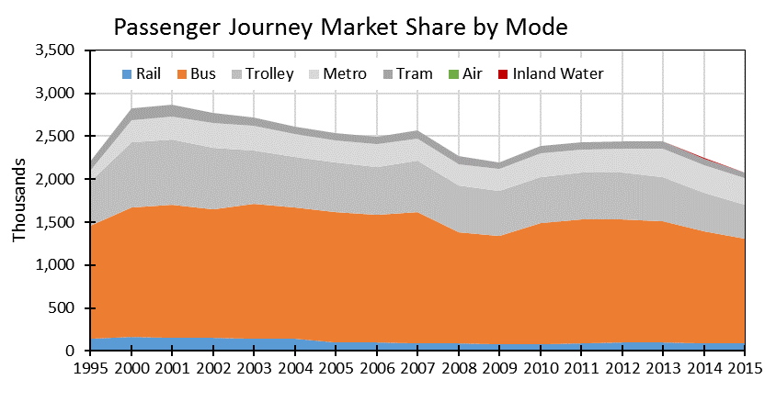
Figure 1. Passenger Journey Market Share by Mode
Factors such as motorization, economic development, highway construction, and demographic changes have contributed to the reduction in the number of passengers being transported by
public transport modes. The degree of motorization in Belarus is shown in the chart below. In summary the number of private vehicles has increased by 110 percent (or more than 5 percent per year) since 2000. The number of freight motor vehicles (trucks) has increased by 175 percent, or 7 percent per year, since 2000. At the same time, the number of buses in service has declined by about 6 percent of the same period.

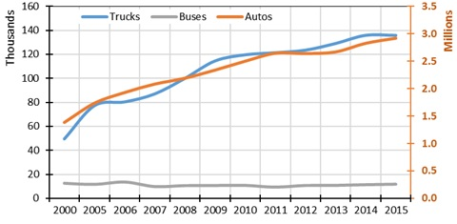
Figure 2. Number of Vehicles

The important point to reflect from the data is that the public passenger transport market is smaller now than it was before 2000. Now the railways have to provide service in a dynamic market. Furthermore, while is a more dynamic market, the size of urban and intercity transportation market is getting smaller.

A more widespread use of the automobile is perhaps the most significant development in the market but not the only one. Other market characteristics have been evolving and have important implications for the railway. The average length of trip for all passengers remained almost constant at around 11.4 kilometers for all modes but for railways. The railways’ length of trip moved from 106 kilometers to 82 kilometers. This means that more long-distance passengers are choosing an alternative mode of transport.

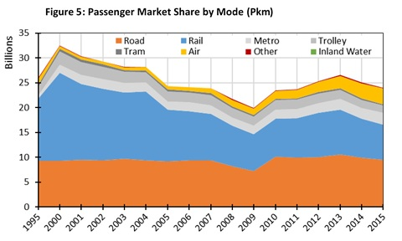
Figure 3. Passenger Market Share by Mode

As noted previously, the number of rail passengers and the length of passenger trips have declined since the year 2000 and thus BCh passenger turnover (measured by passenger-kilometers) has also declined over the period. Passenger market shares by commercial mode are shown in the chart above. Rail passenger-kilometer market share has declined from about 55 percent to about 30 percent of the overall commercial passenger transport market (rail generates about 4 percent of total commercial passenger journeys). In a nutshell, the commercial passenger transport market is smaller and the railway is getting a smaller share of it.

Freight Transport Market in Belarus
The Belarusian freight transport market grew steadily from 2000 to 2009, then grew again till 2012 when it started a slow decline till 2015. Overall, between 2000 and 2015, tons of freight transported increased by nearly 57 percent, or about 3 percent per year. Over the same period, rail share of tons transported has remained at about 30 percent. Figure 4 below shows Belarusian freight transport market measured in tons transported.

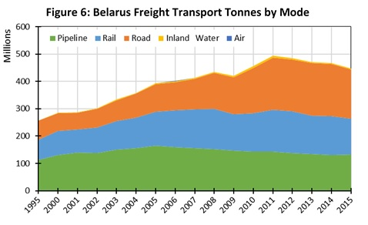
Figure 4. Freight Transport Mode by Tons (1995 to 2015)

Table 16, 17,18, and 19 in the Appendix show market figures in detail. Supported by robust public investment in highway infrastructure, road transport increased its transport volume from 64,436 tons in 2000 to 180,226 tons in 2015, nearly tripling freight volumes in the road sector. Tons moved by road transport increased by more than 7 percent per year from 2000 to 2015.

Similar to the passenger market, the freight transport market was subject to significant motorization. Figure 2 shows the rapid growth in the fleet of trucks in Belarus; Table 16 in the Appendix shows the year-by-year numbers and the relative stagnation in rail capacity.

The emergence of the road sector as a competitive force has led to a steady increase in road transport turnover (measured in ton-kilometers (tkm)) and a steady increase in its share of the overall market. Figures 4 and 5, show Belarus transport market share based on tons or tons-kilometer. Pipeline has the largest share but has been slowly declining from about 60 percent to about 48 percent of the total transport market over the last 15 years. Rail share of the total market has remained relatively constant at about 33 percent; road transport share of the total freight market has increased from about 6 percent in 2000 to nearly 20 percent in 2015. While railways still dominate the general freight market in terms of tons-kilometers, the trucking industry now moves more tonnage than railways. Table 17 in the appendix shows freight market share evolution numerically.

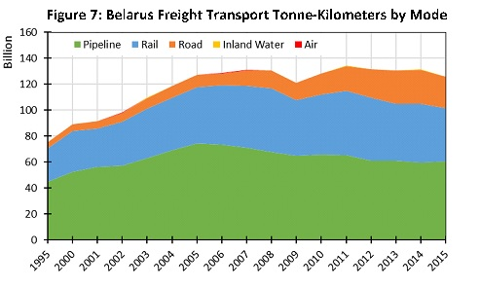
Figure 5. Mode Share of freight transport (tkm)

Railways have a predominant role if market share is measured in tons-kilometers. This reflects the railways competitive advantage in moving heavier commodities over long distances. Notwithstanding the railways advantage in this market segment, the emergence of the road sector is reflected by the rapid growth in that mode.

Figure 5, above (and Table 18, in the appendix) shows that pipelines and railroads remain the largest movers of freight in Belarus. Pipeline traffic has grown by about 15 percent over the period to about 60-billion tkm in 2015. But its market share has declined from about 60 percent in 2000 to 48 percent in 2015. Railways have been able to grow freight turnover by nearly 30 percent, from 31.4 billion tkm in 2000 to 40.8 billion tkm in 2015 – a growth rate of about 1.8 per year. Even so, fail’s share of the overall transport market has drifted from about 35 percent to 32 percent over the period. The trucking industry has grown turnover most rapidly, by about 11 percent per year, from 5-billion in 2000 to nearly 25-billion tkm in 2015. Trucking share of the market has grown from about 6 percent to nearly 20 percent from 2000 to 2015. If these industry market share trends continue, road transport would eventually become the sector leader. For rail sector, the question is what factors might help rail increase its market share?

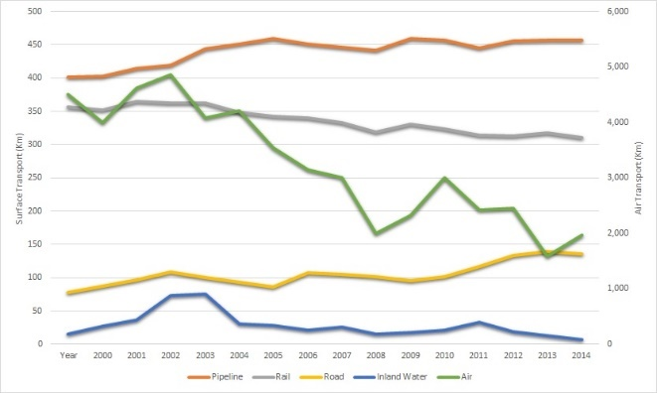  Figure 6. Average of Length of Haul per Mode | 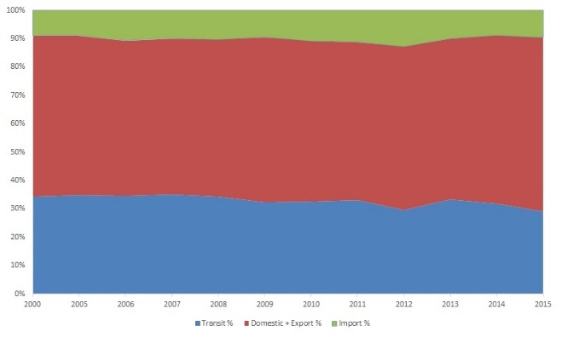  Figure 7. Share of Rail Tons Transported

The fact that railways are the mode that have lost market share to roads is reflected in the change in the average length of haul. As shown in Figure 6 and noted in Table 19, rail haul lengths have declined from 357 kilometers in 2000 to about 310 kilometers in 2015. This likely reflects a change in mix and traffic flow direction over the period, including disruptions in trade with Ukraine, the economic recession in Russia, and changes in transit traffic to and from China. International or transit traffic has the longest haul as it crosses the width of the country. Its share of tons transported declined from about 35 percent in 2000 to 29 percent in 2015. Domestic, import, and export traffic all have shorter hauls since they originate and/or terminate within Belarus. As shown in Figure 7, the share of rail transit traffic has declined while domestic traffic share has increased. These changes have resulted in a slow reduction in average haul length for rail traffic.

1.4 The Belarusian Railways

The Government of Belarus has prioritized infrastructure for each infrastructure sub-sector. This is contained in the Republican Program of Logistics System and Transit Potential Development for 2016 to 2020, which indicates that Belarusian railways will focus on four main areas: 1) improving quality and comprehensiveness in logistics services, 2) ensuring development of the logistics infrastructure, 3) enhancing efficiency of infrastructure use, and 4) improving legal and economic environment for a more extensive use of the China-Europe transit potential.

Moreover, railway transport has an enormous potential to support the development of a green logistics system. The policy wedges enumerated above are key to support systemic changes that result in a greener logistics infrastructure. The four focus areas will help Belarus take advantage of its strategic geographic position between China and Europe. Given the increased competition from other modes of transport (i.e., road transport), there is an urgency to help the railway sector to retain and increase competitive market share. Belarusian Railways is uniquely positioned to explore and develop a logistics advantage which builds on multi-modal integration combining road and railway transport and utilize railway infrastructure to its full capacity.

Institutional Framework

The railway system in Belarus is operated by BCh which is a state association with a vertically integrated system and consisting of 29 legal entities. These entities include a wide variety of functions such as information management, training center and maintenance. Each legal entity is owned by the state and has its own decision-making process, but do need approval from the BCh to make decision for investment. BCh has 7 subsidiaries dispersed regionally in the country. BCh is under supervision of the Ministry of Transport and Communications (MoTC) and the Ministry of Antimonopoly Regulation and Trade (MART). MoTC jurisdiction is related to the operation and policy of the railway system. According to MART regulations, and approved by the Resolution of the Council of Ministers of the Republic of Belarus as of September 6, 2016 No.702, MART develops the methodology for setting and applying tariffs. MART also regulates, and introduces proposals to levy, change or abolish tariffs. The BCh has an official logistics service provider - BelInterTrans that operates railway freight terminals.

The Belarusian “Law on Rail Transport” (Act) designates BCh to be the only rail operator in Belarus responsible for train operations and railway infrastructure management. Public policy in Belarus has been mainly directed towards the regulation of BCh prices and services. Until now, the railway has been performing well and has been able to generate revenue to sustain its operations. This may be the reason why public financial support for rail infrastructure investment or rail transport services has not been an area that has received attention.

The management and operation of the public railway is implemented by the Public Association Belarusian Railway, a commercial organization under MOTC supervision. MOTC is the government agency with jurisdiction over transport activity in Belarus. Railways are a state property and BCh manages both the infrastructure and railway land/property (Article 11). The revenues are managed through a centralized accounting system and allocated into each of the components of the organization based on their contribution (Article 11). BCh obtains rights to use land from the government when required for investment and railway service. This is an important factor given that it can reduce costs for land acquisition for new investments – BCh does not have to purchase land for right of way of new construction of railways. Unfortunately, this land ownership framework may reduce BCh’s opportunities to utilize real estate assets to generate more revenues. Other railways around the world are leasing assets for non-transport uses like shops or warehousing, generating an attractive revenue stream.

As a natural monopoly, BCh is regulated by the Ministry of Antimonopoly Regulation and Trade (MART). By law, rail transportation tariffs (passengers, freight, and luggage) are supposed to be set to cover maintenance and operating costs (Article 12). There is also a legal basis for the government to support rail transport. The law requires the state to support transportation of passengers with social significance and to support transportation services that have a state purpose. Law also requires the government to provide public funding to support the development of railway communication systems, modernization of railway vehicles and introduction of economic and safety technologies (Article 12). However, the support of the government has never been implemented except for small subsidies for the improvement of railway systems. While the law touches on the type of public support, it does not include a provision to set a modern contract system between the government and the railway operator to make the responsibility of the government clear.

Employment relations are regulated in accordance with Chapter 6 of the Law (Articles 33-35). According to Article 34 of the Law, the right to drive railway vehicles is provided to employees who have obtained the relevant qualifications. The right shall be confirmed by a certificate (a train driver license) which is issued in the manner established by the Ministry of Transport and Communications of the Republic of Belarus. The Order of the Ministry of Transport and Communications of the Republic of Belarus establishes the Instruction on the procedure for obtaining a driver qualification by employees of public railway transport organizations and issuing certificates to confirm the right to drive a locomotive, a multiple unit train, licenses to drive special purpose railway vehicles, as well as revocation of the right to drive railway vehicles. Requirements for the qualification for individuals who apply for positions in the railway transport organizations, including train supervisors, are established by the Decree of the Ministry of Labor of the Republic of Belarus dated August 31, 2001 No.94 "On Approval of the Job Evaluation Manual,” “Positions of Employees Engaged in the Activities of Railway Transport and Metro." The law also regulates safety, transport provision and responsibility of railway transporter. The law on rail transport does not regulate qualification or license for infrastructure management or train operation and leaves many issues on railway operation to roles of the BCh. The law guarantees the monopoly status of BCh but it also defines the roles of the government and BCh in many areas.

Organizational Structure

BCh is organized as a state association composed of 29 legal entities. Also, 7 of the legal entities are subsidiary companies. As noted above, BCh is under supervision of the MART for railway transport tariffs setting. All legal entities are owned by the state and have their own decision-making process, but each needs approval for investment decisions from BCh. Additionally, the Public Association Belarussian Railway has 7 branches (distinct from the legal entities) which are a division of a legal entity. Figure 8 shows the organizational structure of the Belarusian Railway. Under this organizational structure, the MOTC is the government agency responsible for providing policy and strategic direction to BCh. The Belarusian Railway is an association consisting of the divisions which are organizations performing railway core activities, as well as construction and other organizations.

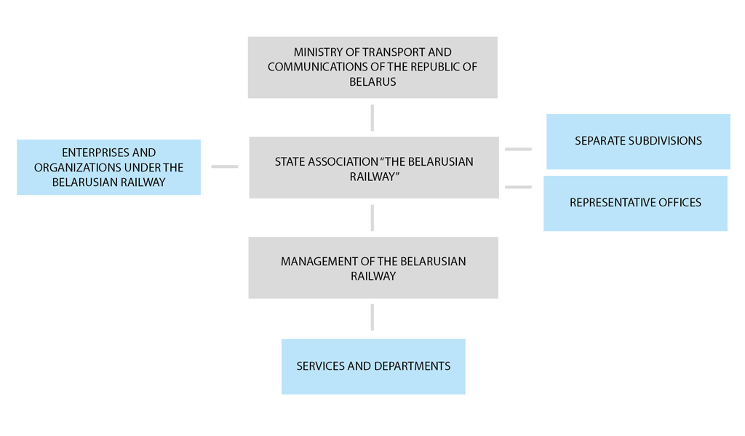
Figure 8. Organizational Structure of Belarusian Railways
The organizational units that make up the BCh State Association employ about 73,454 staff. Table 1, below, enumerates the legal entities and separate subdivisions and their staff strengths. The majority of the employees belong to core railway activities. The divisions with the largest number of employees were Minsk, Baranavicy, and Homiel. Railway employment reflects the amount of railway operations near that location due to many factors such as population density, importance of the rail line at the location, or traffic volume.

Table 1. Legal Entities and Separate Subdivisions of the Belarusian Railway
 | Name of organization | Staff
Division | Minsk division | 18,947
 | Baranavicy division | 14,385
 | Brest division | 8,940
 | Homiel division | 12,209
 | Mahiliou division | 9,369
 | Viciebsk division | 9,604
 | Total for divisions | 73,454
 | Management of Belarusian Railways | 837
International  Office | Office in Russia | 2
 | Office in Kazakhstan | 1
 | Office in Poland | 1
Legal Entities and Separate Subdivisions | Belzeldorsnab (Railway Purchasing & Supply) | 333
 | Main Data Processing Center | 555
 | Constructive and Engineering Center | 512
 | Newspaper Office | 26
 | Paramilitary Security Services | 1,618
 | Scientific and Technical Information Center | 61
 | Center for Labor Organization and Rating Standards Development | 41
 | Information Protection Center | 34
 | Center for Personnel Training, Retraining and Professional Development | 150
 | Belintertrans (Commercial BCh Warehousing & Logistics) | 992
 | Dorvodokanal (Water supply) | 796
 | Track Maintenance Train (TMT) №71 | 403
 | TMT 78 | 224
 | TMT 115 | 228
 | TMT 116 | 180
 | TMT 117 | 191
 | TMT 118 | 194
 | TMT 289 | 191
 | Rail-welding Train №10 | 148
 | Center of Mechanical Operations of Engineering Works | 389
 | Homielzeldortrans (Gomel Freight Forwarding & Warehousing) | 427
Total for core activities |  | 81,982
Legal Entities and Separate Subdivisions | Belzeldorproject (Engineering & Construction Institute) | 531
 | Beltransavtomatika (Power Supply & Telemechanical for BDZ and Metro) | 300
 | Agricultural Enterprises: | 1,539
Total for Belarusian Railways |  | 84,352

Institutional Characteristics

BCh is a vertically integrated railway. The railway implements both infrastructure and train operations under the same structure. A trend in the last 15 years in many OECD countries has been to reform the structure of railway organizations and clarify the roles of the infrastructure managers and train operators. One of the main outcomes in these reforms is the separation of infrastructure management and train operations. In general, the purpose of such reforms have been to create a competitive market for train operators. This is even more relevant for EU countries as they envision many train operators working across the infrastructure of multiple national boundaries. However, there are other important countries in the railway world that have maintained a vertically integrated structure. Among them are Russia, the United States, Canada, Kazakhstan, or India. There are many factors which influence the railways organizational structure for each country including network layout, traffic density, traffic mix, and financial performance. National railways need to carefully consider the best structure in order to have a sustainable rail system and improve operational performance. Ideally, structure design will be an ongoing process and adjusts to emerging conditions, even if the railways’ current performance is adequate. This is a strategic practice that may allow the railway to ensure its structure is well tailored to the needs of the transport system.

Table 2. Categorization of the railway organization structure
Structure model | Integrated structure | Vertically Separated structure | Group Structure | Synthesized Structure
Major Characteristics | State-owned or private railway company owns infrastructure of railway and provides transport services using their own railway infrastructure.  Sometimes other private railway operators access the infrastructure under commercial or regulatory conditions. | The infrastructure manager and the service provider are fully institutionally and organizationally independent, with the infrastructure manager undertaking infrastructure capacity allocation functions including train dispatching. Train service providers can be monopolistic or competitive. | An integrated governance structure, where the infrastructure manager allocating track capacity and the train operator are legally separate companies, but nevertheless remain within the same institutional structure, for instance within or as subsidiaries of a holding company. | This type is generally characterized by the establishment of an infrastructure manager responsible for capacity allocation functions. In some structures, functions such as infrastructure maintenance or train control are contracted to the state-owned rail operator.
Countries | Russia, US, Australia, Kazakhstan, Uzbekistan, Tajikistan, BiH  Japan | Bulgaria, Czech Republic, Denmark, Great Britain, Greece, Finland, Netherlands, Norway, Portugal, Romania, Spain, Sweden, Slovakia | Austria, Germany, Poland and Italy | Belgium, Estonia, France, Hungary, Latvia, Luxembourg, Slovenia, China

A characteristic of BCh is that 29 organizational units with a core railway function are independent legal entities. However, while each of these branches is an independent legal entity, their functions are not independent from BCh’s control on a day-to-day basis. Some of these entities are responsible for activities that are sub-contracted to outside parties in other railways. Some examples are maintenance, training and educations, information services, and data processing.

2. Railway Current Situation and Performance

BCh continues to be a key component of the Belarusian transport system. Together with a growing road system, the railways move the majority of passengers and freight in the domestic transport market. BCh is also perhaps the most competitive railway link between Europe and Asia and between the Baltic states and Ukraine (and other Black Sea destinations). As a corporation, BCh provides employment to a large number of people and also provides vital public service, making it one of the most important entities within Belarus. This section describes the performance of BCh in recent times on operational and financial terms. Performance results are compared to figures from EU and CIS railways.

2.1 Recent Trends in Passenger and Freight Rail

Belarusian Railways has been losing market share in the transportation of freight and passengers. Evidence indicates that the main reason for loss of market is due to increasing motorization in Belarus and increased competition from the road sector. Additionally, in the freight sector, the railway has been affected by the recent happenings in the Belarusian economy which has been having a marginal performance. Despite this recent trend, BCh is still a self-sufficient railway with high traffic density and is still able to operate without a public subsidy.

2.11 Passenger Transport

For the last ten years, the number of passengers transported by the railway decreased from 99.4 million in 2006 to 87.1 million in 2015, which means the passengers carried annually went down by as much as 1.26 percent on a yearly basis. Although there was a small spike in the number of passengers between 2010 and 2012, the number continued to decrease after 2012.

Passenger-kilometers decreased more rapidly from 9,968 million passenger-kilometers in 2006 to 7,117 million passenger-kilometers in 2015 with the compound annual growth rate (CAGR) of -3.67 percent. As a result, we can see that the average passenger journey distance per year has decreased from 100 kilometers in 2006 to 82 kilometers in 2015 with CAGR of -2.18 percent.

Table 3. Passenger transport performance of the BCh from 2006 to 2015
Year | 2006 | 2007 | 2008 | 2009 | 2010 | 2011 | 2012 | 2013 | 2014 | 2015
passengers (million) | 99.4 | 92.6 | 88.0 | 83.5 | 83.55 | 89.0 | 100.5 | 99.4 | 91.6 | 87.1
passenger-km (million) | 9967.6 | 9365.7 | 8188.3 | 7400.9 | 7578.3 | 7941.1 | 8976.9 | 8997.6 | 7795.8 | 7117.3
average passenger  journeys, km | 100 | 101 | 93 | 89 | 91 | 89 | 89 | 90 | 85 | 82

Figure 9. Passenger carried and passenger | Figure 10. Average passenger journey distance

The number of passengers carried in Belarus decreased by about 1.4 percent per year from 2005 to 2014. Countries in the region show similar trends in passengers rail transport. While, the average number of passengers in the European Union (EU) increased by 0.53 percent per year. Belarus’ neighbors like Poland, Romania and Ukraine saw a drop in ridership by 4.8 percent, 5.3 percent and 0.7 percent, respectively. The number of passengers carried by Temir Zholy, the railway in Kazakhstan, increased by 4.4 percent per year. Figure 11 below shows the trends on each of these countries.

Figure 11. The number of passengers carried (millions)

Figure 12 below shows that the passenger distance carried in Belarus decreased by 3.1 percent from 2005 to 2014 and Poland, Romania and Ukraine decreased by 3.75 percent, 6.08 percent and 0.75 percent respectively. On the other hand, passenger distances carried by Deutsche Banh (DB) AG of Germany increased by 1 percent every year. In Kazakhstan, passenger distances increased by 4.8 percent per year. Kazakhstan observed very rapid growth since 2011. As can be noted in these data, railways in the region are losing passenger traffic. This trend is likely to be caused by the significant road investment in the region. BCh, however, seems to have been able to compete more effectively against the road sector and attain lower passenger traffic losses.

Figure 12. Passenger distances carried (million km)

Tariffs and Change in Passenger Demand

BCh’s passenger rail traffic decreased in both the domestic and international market. The contraction of international passenger volumes was more pronounced. Table 4 shows how by 2015, the number of international passengers were merely half of 2012. Domestic passengers carried did see a net increase of 10 percent from 2010 to 2015. Domestic traffic also saw a drop since 2012, albeit more moderate.

Table 4. The number of domestic and international passengers
Year | 2010 | 2011 | 2012 | 2013 | 2014 | 2015
Domestic passengers carried  (in millions) | 76.15 | 81.6 | 92.8 | 92.3 | 86.5 | 83.1
Percent change |  | 7.16% | 13.7% | -0.54% | -6.28% | -3.93%
International passengers carried  (in millions) | 7.4 | 7.4 | 7.7 | 7.1 | 5.1 | 4.0
 |  | 0% | 4.05% | -7.79% | -28.17% | -21.57%

These trends are better illustrated in Figure 13, where the linear change for domestic and international passenger traffic is presented. What is clear from the chart in Figure 13, is that traffic levels were more stable until 2013, and even showed a positive trend in some years. It was after 2013 and onwards that both domestic and international traffic declined very rapidly.

Figure 13. Trend in domestic and international passengers carried (in million people)
In order to determine what is a possible explanation for this trend, the study looked at tariffs levels in both domestic and international passenger services. In general, this is the most important factor to influence changes in demand. BCh can adjust the tariff level with agreement of the government and it has tried to maintain revenues by adjusting tariffs in response to the change in passenger demand. As seen in the table below, due to the methodology used to set rates, BCh tariffs for international passengers increased more rapidly than for domestic passengers. Tariffs for domestic services are under closer regulatory oversight by the government and are therefore more difficult to increase. We can see the trend of tariffs during last 10 years from the table which shows the change in passenger tariffs as percentage to the previous year.

Table 5. Tariffs for passengers as % to the previous year
Year | 2005 | 2006 | 2007 | 2008 | 2009 | 2010 | 2011 | 2012 | 2013 | 2014 | 2015
International tariff index | 112.1 | 131.3 | 168.8 | 208.7 | 261.4 | 283.7 | 576.7 | 1041.5 | 1304.0 | 1589.5 | 1745.3
International tariff percent changes | 12.1% | 17.3% | 28.6% | 23.6% | 25.3% | 8.5% | 103.3 | 80.6% | 25.2% | 21.9% | 9.8%
interregional,  regional business tariff | 109.5 | 111.3 | 113.3 | 100.0 | 100.3 | 103.9 | 115.9 | 110.4 | 145.2 | 170.4 | 107.0
interregional,  regional business tariff percent change | 9.5% | 1.6% | 1.8% | -11.7% | 0.3% | 3.6% | 11.5% | -4.7% | 31.5% | 17.4% | -37.2%
regional economy,  urban tariff index | 120.0 | 120.4 | 117.9 | 100.0 | 96.8 | 97.6 | 110.2 | 113.4 | 133.5 | 153.1 | 107.2
regional economy,  urban tariff percent change | 20% | 0.3% | -2.1% | -15.2% | -3.2% | 0.8% | 12.9% | 2.9% | 17.7% | 14.7% | -30%

Figure 14 below indicates the changes in comparative tariffs for international, interregional and regional passengers with the constant value of 100 in 2005. The calculation shows that tariffs for international passenger have increased as much as about 57.5 percent per year, for interregional passenger about 30.1 percent, and for regional and local passenger about 23 percent.

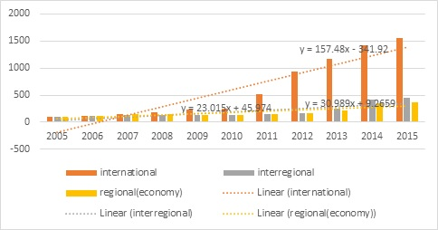
Figure 14. Changes in comparative tariffs (levels in 2005 = 100)

However, it is important to adjust for inflation because Belarus has experienced severe inflation in the last 10 years. When considering tariffs in real terms, tariffs for international passengers have increased about 26.5 percent, while the tariffs for interregional passenger and regional passenger have decreased by about 8.2 percent and about 10.1 percent, respectively. The increase in the number of passengers carried between 2010 and 2012 may be explained by the comparative decrease in tariffs, especially tariffs for domestic passengers. This may have been accentuated by the decrease in purchasing power due to the economic recession.

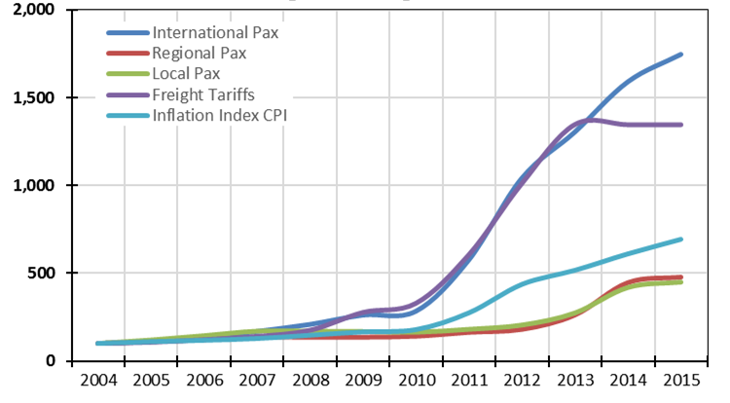
Figure 15. Passenger and Freight Tariff Index (2004 to 2015)
Table 6. Inflation rate in CPI, % in Belarus
Year | 2005 | 2006 | 2007 | 2008 | 2009 | 2010 | 2011 | 2012 | 2013 | 2014 | 2015
Inflation Rate (CPI, annual variation in %) | 10.3 | 7.0 | 8.4 | 14.8 | 13.0 | 7.7 | 53.2 | 59.2 | 18.3 | 18.1 | 13.5

Figure 16. Trends in real values of comparative tariffs

In spite of the lack of data for demand and tariffs and the short period of analysis, the WB was able to estimate the tariff elasticity of passenger demand for rail transport. Elasticity estimates in Table 7 below indicate that the demand for international passenger service is elastic to tariffs while the demand for domestic passenger is inelastic. Therefore, tariff increases in the since 2010 likely caused a decrease in the number of international passengers. This information also shows that rising tariffs for international passenger has not been an effective way to compensate for diminishing total revenues.

Table 7. Tentative Tariff Elasticity of Passenger Demand
Elasticity | 2011 | 2012 | 2013 | 2014 | 2015
International passenger | 0.00 | 0.19 | -1.13 | -7.41 | 5.83
Domestic passenger | -0.19 | -0.28 | -0.02 | -0.12 | 0.60

2.22 Freight Transport

A closer consideration of BCh freight traffic reveals that tons transported by rail have been declining since 2012. Figure 17 shows BCh tons transported by type of traffic – transit, imported, and domestic/export since 2000.
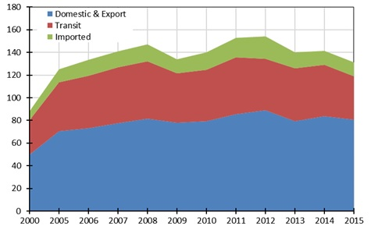
Figure 17. Freight Tons Transported by BCh (millions)
Domestic and export traffic, representing about 58 percent of all BCh tons loaded, peaked in 2012 at about 89 million tons. Transit traffic peaked in 2011 at about 50 million tons (33% at the time). Import traffic peaked in 2012 at nearly 20 million tons (13% of all BCh tons transported). The decline in transit traffic is likely influenced by changing trading relationships between Ukraine and Russia and by changes in trade between Europe and China. Figure 18 shows BCh tons loaded by commodity to 2010.

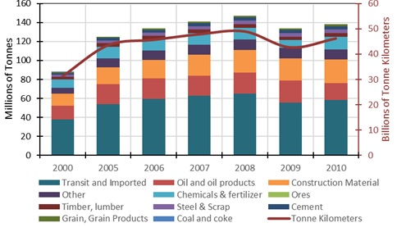
Figure 18. Freight Tons by Commodity

For domestic and export traffic, the largest commodities moving on BCh are construction materials and oil, and oil products. BCh’s oil and oil product movements are mostly to and from its two major oil refineries – one in the north in Polotsk and the other in the south in Mazyr (See map in Appendix 2). These refineries receive imported crude oil from Russia (included in Transit and Imported in the chart above). Once they process the imported oil, the refineries ship oil products throughout Belarus and back to Russia.

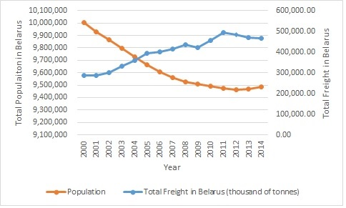
Figure 19. Population and Freight Volume in Belarus

The two factors that can be expected to drive demand for transport services are population and economic growth. Population growth and freight volumes in Belarus are depicted in Figure 19. As can be seen, freight volumes have grown and given that population has decreased, it can be expected that freight growth has been mainly driven by economic performance.

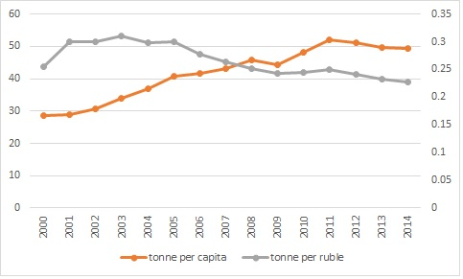
Figure 20. Freight per capita and per Ruble

More understanding of the market can be uncovered if freight volume is divided by population and by GDP. These two ratios are depicted in Figure 20, where it can be observed that in 2014, each person in Belarus required an average of nearly 50 tons but it only required an average of about 30 tons in 2000. This means that despite a loss of population, more transportation service is required on a per-capita basis. Furthermore, as the Belarusian economy has grown, the tons to GDP ratio has dropped. This means that the weight of the freight has not increased as rapidly as the value, or that higher value freight is being moved in the system. These points are important for BCh to consider because value and weight are important freight characteristics that may determine the type of transportation that is being demanded. As the ratios above show, heavier commodities did not see a large growth but value commodities did, therefore, is possible that railways found it harder to attract high value commodities on shorter lengths of haul. This could in a way be the reason why railways were not able to grow their market share since 2000.

The total amount of freight traffic carried by BCh remained around 45,000 mln tkm, with increases seen in 2011 and 2012 but back to 45,000 mln tkm in 2014. Most of the increases are in international freight traffic.

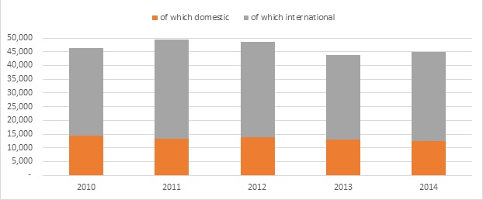
Figure 21. Freight Traffic (million tkm)
Source: UIC statistics.

Compared with neighboring European countries, the total freight traffic in Belarus is about half the size in Germany, and slightly more than Poland. However, when the size of the respective economies is factored in, Belarus moves more freight by rail than Germany and Poland. Belarus moves around 253 tkm per dollar of GDP, while Germany moves 26 tkm/$ and Poland 32 tkm/$.

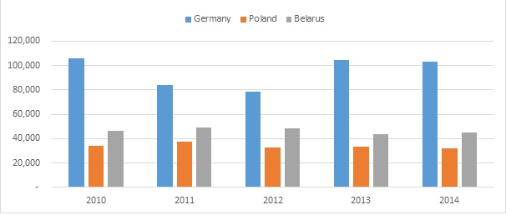
Figure 22. Total Freight Traffic of Rail Operators (million tkm)
Source: UIC statistics.

Figure 23 shows freight trends by weight and distance in domestic, international, and transit shipments. Since 2010, export rail shipments are the only traffic category that is increasing. All the other categories; imports, domestic, and transit, are seeing a decrease in tonnage and tkm.

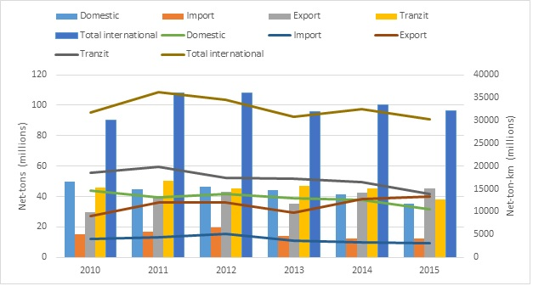
Figure 23. Rail Freight movements by weight and distance (bars = tons, lines = tkm)

The total export rail tonnage has increased since 2010. Figure 24 below shows the export commodity types moved by rail that allows a more detailed view at what is behind the increase in export rail shipments. The two main rail commodities for export are oil cargo and fertilizers, and these two commodities, together with other construction related freight such as timber and other building materials have increased.

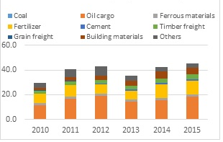  Figure 24. Commodities of Export (million tons) | 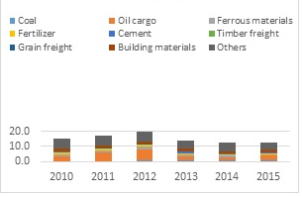  Figure 25. Commodities of Import (million tons)

Figure 25 shows the rail tonnage for imported commodities. The net decrease in rail freight imports is due primarily to lower volumes in oil shipments. However, most commodities saw a decrease since 2010. The only exception is the import of coal by rail, which started to grow in 2012. BCh’s traffic is more balanced towards exports as the total amount of exports is almost twice that of imports (see comparison graphs above).

Belarus railways carries more transit commodities, followed by exports, and then imports. Transit freight used to be the main international market for BCh but now is lower than export traffic. Currently, the main commodities in the international transit rail market are coal and oil. Coal has the largest market share among all transit commodities with around 55 percent of the total, followed by oil with 18 percent of the total transit traffic. Transit coal remained stable, while transit oil cargo has decreased over the past 6 years. Oil by rail is actually the main driver behind the decrease in transit traffic.

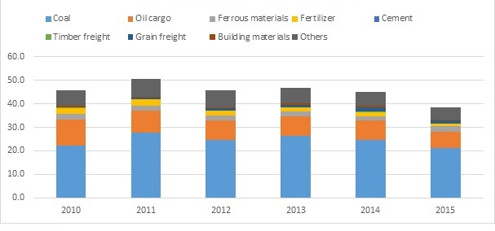
Figure 26. Transit Commodities Tonnage

Imports and Exports by country of origin

The previous section presents overall trends and characteristics of freight traffic. As noted above, international traffic is an important component of BCh’s traffic portfolio. Due to the its strategic location and its well-developed rail system, Belarus is able to serve as a transit point between Europe and all points east of Belarus. This section now describes into detail, the origin and destination of the rail freight international traffic.

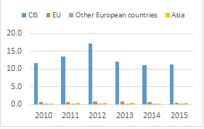  Figure 27. Imports by Region of Origin | 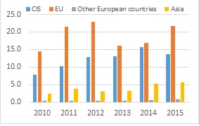  Figure 28. Exports by Region of Destination

Most imports transported by BCh are originated in the CIS region. Russia and the Ukraine are the two main countries of origin for these imports. The volume of imports originated in the CIS region remained almost constant since 2010 and showed a decrease in the last three years. Europe and Asia contribute similar import volumes. In Europe, Poland is the main country of origin for BCh’s freight imports. China is the main source of imports for Asian freight.

Figure 28 shows the exports by region of destination. EU is the main destination for exports of rail freight cargo from Belarus. Within the EU, the Netherlands, Poland and the United Kingdom are the main terminating points. For the CIS region, most exports go to Russia and Ukraine. It is important to note that the total amount of exports to CIS countries has been declining since 2012 while exports to EU countries are increasing. The volumes of exports to the EU surpassed exports to the CIS in 2014.

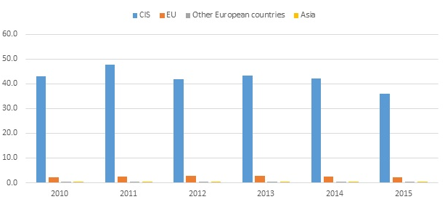
Figure 29. Transit Freight by Region of Origin (million tons)

The total amount of transit freight originated in CIS countries has been slightly declining since 2012. Transit net ton-kilometers remained stable until 2015 when it saw a 15 percent decrease. Similar to rail freight imports into Belarus, most of the transit freight through Belarus is originated in CIS countries. Russia is the main point of origin for this freight (more than 90 percent). The Ukraine is next in this category. Far behind the CIS (and Russia) is the transit freight originated in the EU. Within this region, Lithuania is the country that originates the highest volume.

Net-tons for domestic and imports have decreased steadily since 2010. Net-tons and net-ton km for export increased steadily. Total international remain relatively stable. Train-km remained stable until 2015 with an 8% decrease. In terms of freight tons carried during last 10 years, the number of Belarus shows a bit increase (CAGR 0.5%). But, the general trend since 2012 is downwards. Most countries in Eastern Europe indicate the decreasing trend in freight carried while that of Kazakhstan shows generally increasing trend since 2011 when the railway reform has been implemented.

Figure 30. Freight tons carried (millions)

In terms of freight distance, BCh saw an average reduction of 0.7 percent from 43,559 million ton-km in 2005 to 40,784 million ton-km in 2015. Ukraine saw a similar trend. Poland decreased by 4.5% annually, while Kazakhstan and Lithuania increased by 2.7% and 1.2% respectively (Figure 31).

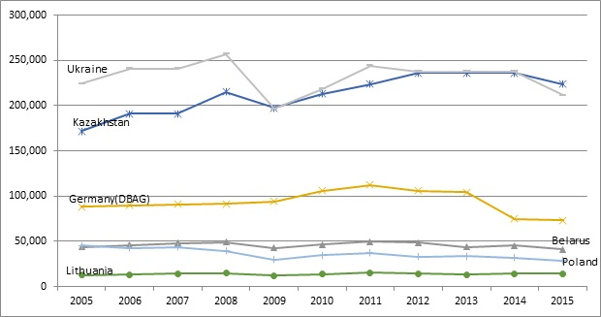
Figure 31. Freight distance carried by Country (millions km)

Figure 32 shows the average length of haul in Belarus is almost 310 kilometers in 2015 which is higher than Romania and Lithuania but lower than Kazakhstan and Ukraine. An interesting change in this indicator is a significant increase in the EU’s length of haul, which surpassed BCh’s length of haul. This is mainly a reflection of an increasingly integrated EU rail network but also of a gradual but persistent decrease in BCh’s length of haul.

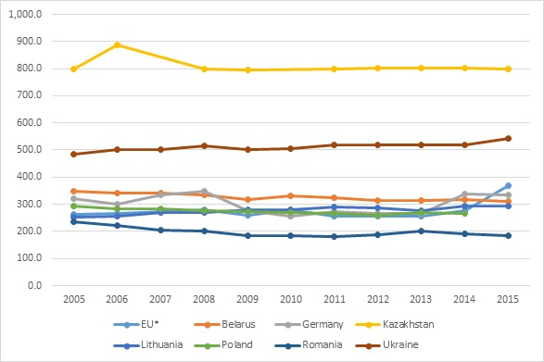
Figure 32. Average Length of Haul by Country (2005-2015)

2.23 Traffic Density

Assessment also calculated traffic densities. This measure is useful because it takes into account the fact that each country has a different railway network. Differences in network scale are not reflected by passenger ridership statistics or passenger-distance carried. In terms of railway traffic density per kilometer of railway, Belarus was almost three times the average of EU countries in 2015 but Belarus had lower traffic density than Kazakhstan and Ukraine. A high traffic density reflects a robust base on the business environment for BCh and it shows a good level in the demand for railway service. Figure 33 shows how railways in the CIS have a higher traffic density than EU railways. CIS railways were able to increase traffic density from 2009 to 2012, when it started to drop on all CIS railways in Figure 33, including BCh. It is important to note that railways in Kazakhstan and Ukraine saw a more significant drop in traffic density than BCh.

Figure 33. Traffic Density (million traffic units/km)

Railway traffic density can be calculated separately for freight and passenger. Figure 34 shows passenger traffic density. BCh’s passenger traffic density of Belarus was slightly higher than the EU average before 2006. However, this trend reversed in 2007, when EU countries started to have a higher passenger traffic density. This is due to two factors; 1) passengers carried by the railways in EU countries show a moderate increase after restructuring railway industries and rehabilitating infrastructure, and 2) rapid motorization and road construction in Belarus and other Eastern European causing a decrease in the railway’s market share.

Figure 34. Passenger Traffic Density per railway line (million pass-km/km)

In terms of freight traffic density, BCh shows a higher density than the EU average but lower than those of Kazakhstan and Ukraine (Figure 35). It is important to note that the freight traffic density of Belarus is over 6 times the EU average and similar to that of Lithuania.

Figure 35. Freight Traffic Density per railway line (million ton-km/km)

Traffic density trends show that BCh is still a high density railway. There are many advantages in having such densities in a railway. Achieving this level of traffic density, enables the railway to be sustain its infrastructure and to more closely cover its total costs. The concern in BCh’s performance on this indicator is the slow but persistent decline in freight density. In terms of passenger traffic density, BCh has been unable to maintain its previous level and has to rely more heavily on freight traffic revenues to cover its fixed and variable costs.

2.3 Productivity
Another important measure of BCh’s performance is productivity. This section presents its performance and explains how has BCh perform in the use of its labor and equipment resources to provide rail service. In other words, this indicator provides information about the efficiency of the railway in its day to day activities.

2.31 Labor Productivity

Staff productivity calculated by traffic units per employee from Figure 36 shows that productivity of BCh has been generally constant while other countries like Poland, Lithuania, Ukraine and Kazakhstan have increased continuously. BCh’s productivity was near the EU’s average since 2005 but in 2015 it dropped and is now lower than the EU average.

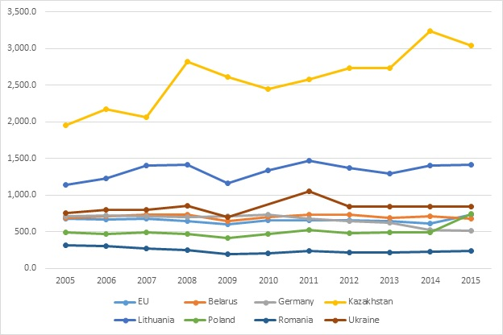
Figure 36. Labor productivity (traffic units/employee)

The productivity of Belarus in 2015 was about 584,000 TU/employee which is a bit higher than the productivity of DB AG in Germany but significantly lower than the railways in Kazakhstan, Lithuania and Ukraine. One important point in the analysis of labor productivity is the role of passenger operations regarding this measure. Passenger traffic units have decreased since 2005 from 19 percent of the total traffic units to around 14.9 percent in 2015. Therefore, the output (i.e., rail service) is primarily being produced to meet freight demand. Trend also shows that BCh has adjusted its labor input and that has resulted on a slight decrease in productivity since 2005. This adjustment may have gone farther than purely reducing its labor force, but to also modify its operations so that BCh is able to serve freight shippers that need shorter hauls. Average length of haul affects productivity significantly because long hauls are easier and more efficient generally, requiring less labor or equipment resources per traffic unit.

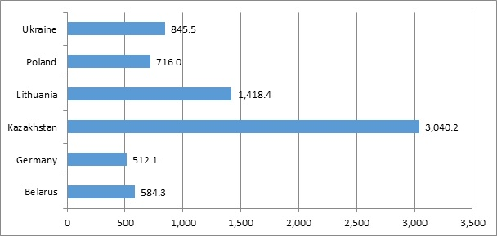
Figure 37. Labor productivity in 2015 (traffic units/employee)

Interestingly, compared trends reverse when it comes to revenue per employee. BCh’s revenue per employee in 2015 was $13.6 which is higher than the revenue per employee for the Ukrainian Railways (Figure 38). While the labor productivity in BCh was higher than in DB AG, revenue per employee in BCh was much lower than in DB AG. An area that may require attention is to first determine why BCh’s revenue per employee is lower (when compared to DB AG) and what can be done to increase revenue per employee.

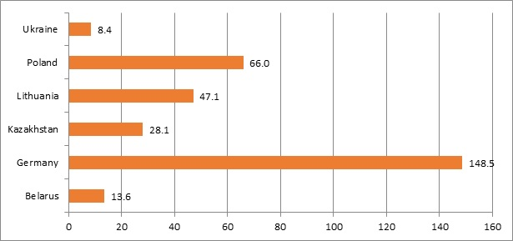
Figure 38. Revenue per employee in 2015 (000’s USD)

2.32 Passenger Coach Productivity

Coach productivity was calculated to compare the performance of BCh in terms of equipment use efficiency. Coach productivity is passenger-kilometers per coach. As we can see in the figure below, the coach productivity of BCh has decreased during last 10 years, indicating that the productivity of BCh became recently lower than that of Poland. Coach productivity in Belarus went down by 4.3 percent annually from 3.7 million-km/coach in 2005 to 2.4 million-km/coach in 2015 while that of Ukraine increased by 2.7 percent, Poland by 3.3 percent, Kazakhstan by 4.6 percent and Lithuania by 6.1 percent. The reason for lower coach productivity in Belarus is that the railway maintained coaches in service despite a decrease in passenger demand. In the other countries, the railways have rationalized their fleets, improving coach productivity and sizing their fleets based on ridership.

Table 8. Coach productivity (Passenger traffic (million kilometers)/coaches)
Year | 2005 | 2006 | 2007 | 2008 | 2009 | 2010 | 2011 | 2012 | 2013 | 2014 | 2015 | CAGR
EU | 3.8 | 4.3 | 4.5 | 4.0 | 4.1 | 4.5 | 4.2 | 4.3 | 4.2 | 4.0 | 4.7 | 2.2%
Belarus | 3.7 | 3.6 | 3.2 | 4.8 | 4.3 | 2.5 | 2.6 | 3.0 | 3.0 | 2.7 | 2.4 | -4.3%
Germany | 3.6 | 4.0 | 4.3 | 4.2 | 4.1 | 4.2 | 4.1 | 4.5 | 4.4 | 4.1 | 4.2 | 1.6%
Kazakhstan | 5.0 | 5.6 | 6.7 | 7.0 | 6.5 | 6.8 | 7.3 | 8.1 | 8.1 | 8.7 | 7.8 | 4.6%
Lithuania | 0.9 | 0.9 | 1.0 | 1.1 | 1.1 | 1.1 | 1.5 | 1.5 | 1.5 | 1.6 | 1.7 | 6.1%
Poland | 2.2 | 2.3 | 2.4 | 2.5 | 2.4 | 2.3 | 2.4 | 2.6 | 2.2 | 2.1 | 3.0 | 3.3%
Romania | 2.4 | 2.4 | 2.3 | 2.3 | 2.0 | 1.7 | 1.7 | 1.5 | 1.5 | 1.7 | 2.1 | -1.4%
Ukraine | 5.3 | 4.5 | 5.6 | 5.6 | 5.1 | 6.9 | 6.9 | 6.9 | 6.9 | 6.9 | 6.9 | 2.7%

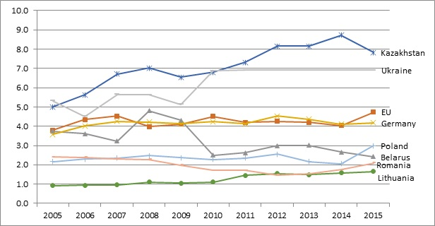
Figure 39. Coach productivity (million passenger-kilometers/coach)

Figure 40 shows how the railways in the comparison group performed in 2015. The productivity of BCh was estimated to be 2.42 million pass-km. Significantly lower than neighbor countries like Ukraine (6.91), Poland (2.99) or Germany (4.17). A fact to highlight, is that most railways in the CIS and EU, included in the comparison group, outperformed BCh on this measure.

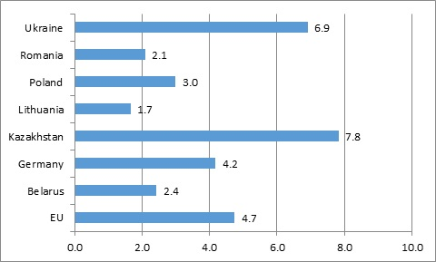
Figure 40. Coach productivity in 2015 (million passenger-kilometer per coach)

2.33 Freight Wagon Productivity

For freight, equipment productivity is measured by dividing the freight traffic units by the number of wagons. CIS countries have higher wagon productivity than EU countries. BCh is only below Kazakhstan and Lithuania, and slightly higher than the Ukraine. While BCh compares well against other regional railways, similar to other operating and financial indicators, wagon productivity shows a continuous gradual decline.
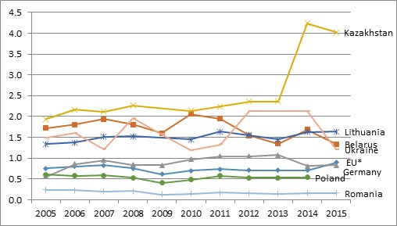
Figure 41. Freight Wagon Productivity by Country (million tons-kilometers per wagon)

As noted above, BCh’s freight density is significantly higher than in its EU comparators. As freight tkm are used to estimate productivity, it is to be expected that wagon productivity will also be larger in BCh. However, the magnitude in the difference is not as large. This means that it is likely that BCh has an oversized wagon fleet. Figure 42 below shows the number of freight wagons in BCh from 2010 to 2015. As can be seen below, the fleet remained stable at around 30,000 units, up from 25,000 in 2010. Therefore, BCh has not been able to adjust its rolling stock to the recent demand for freight and it has lost wagon productivity.

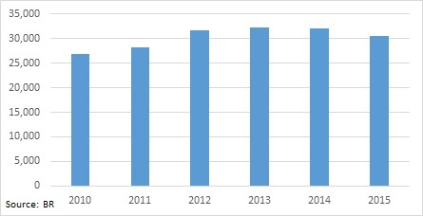
Figure 42. BCh Freight Wagons (2010-2015)

A logical inquire to derive from this finding, is whether the age of BCh’s fleet warrants a readjustment on its size and composition. It is possible that this is a good time to rationalize its fleet given the current market conditions and its productivity performance, allowing the railway to position itself for a more efficient operation. A second question to consider is whether current wagon types are well tailored for the needs of the new Belarusian transport system and whether current rolling stock allow the railway to take advantage of new multimodal opportunities.

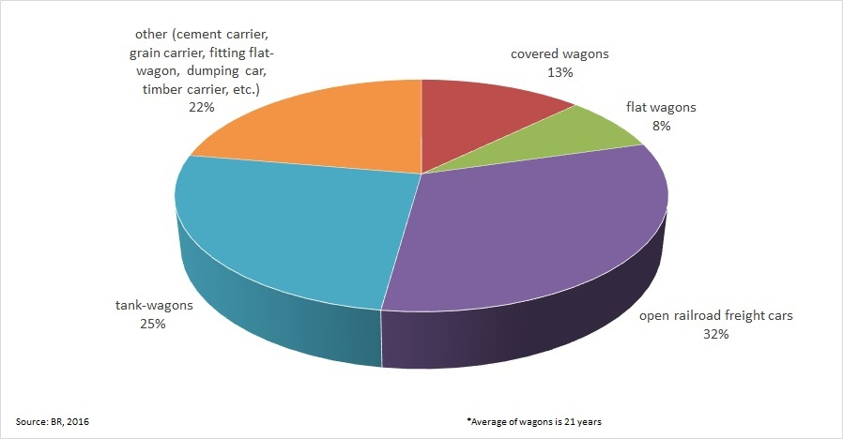
Figure 43. BCh Freight Wagon Distribution by Type (2016)

2.34 Locomotive productivity

Locomotive productivity provides information about how efficient is the railway in the utilization of its locomotive fleet. BCh currently owns around 790 locomotives, of which 79 are electromotive and 711 are diesel-powered locomotives. Also, BCh operates 286 electric multiple units and 163 diesel multiple units. Locomotive productivity estimates for all countries in the comparison group are presented in Figure 44. It should be noted that BCh's locomotive productivity is calculated only for freight traffic and is estimated as the ratio of the gross freight turnover to the operated locomotive fleet.

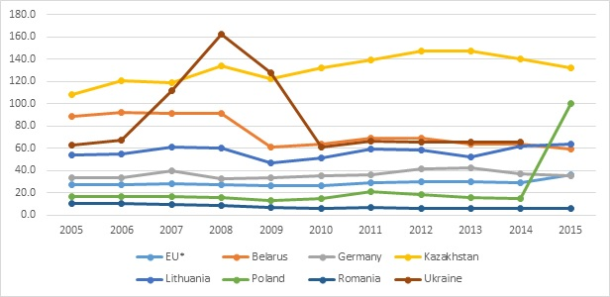
Figure 44. Locomotive productivity 2005 - 2015 (TU/locomotive)
BCh’s locomotive productivity dropped after 2008 and is now around 60 traffic units per locomotive. The reason for the loss of locomotive productivity is both the reduction in freight and passenger volumes, and a larger locomotive fleet. BCh has moved from being the railway with the second highest locomotive productivity in the comparison group to the fourth place.

2.4 Financial Performance

The third diagnostic focused on BCh’s financial performance. This section first provides a broad description of revenues and expenses. Subsection 2.42 calculates financial ratios and compares BCh’s performance to DB AB and PKP. Section closes with an analysis of the financial sustainability of BCh’s passenger operations.
Financial assessment is based on data from BCh (Table 9) and from UIC. In general, financial information indicates that BCh still makes operational profits. However, BCh is not profitable if assessment accounts for non-operating expenses. This means that BCh is not collecting enough revenues to cover its total costs (labor, infrastructure and rolling-stock) and replenish its capital. In other words, under current operational and economic conditions, BCh’s financial situation is not sustainable in the long-term.
Table 9. Financial performance of BCh in 2015 (Billion Rubles)
 |  |  | Billion Rubles
Revenue | Passenger | Ticket sales | 2,446
 |  | Other revenue | 247
 |  | PSC (from the state) | 0
 |  | Total passenger | 2,693
 | Freight | Freight transport | 16,345
 |  | Other freight revenue | 3,246
 |  | Total freight | 19,592
 | other than freight & pass |  | 82
 | Total operating revenues |  | 22,367
Expenses | Materials |  | 2,977
 | Fuel, Electricity |  | 3,484
 | Wages and salaries |  | 5,540
 | Hired servicers and others |  | 5,312
 | Depreciation |  | 2,953
 | Total operating expenses |  | 20,267
 | Non-operating expenses |  | 5,643
 | Total expenses |  | 25,910
Net income (deficit) | (3,543)
Source: International Union of Railways, 2016

2.41 Revenues and Expenses

Revenues and operational expenses have increased in both nominal and real terms since 2005. However, growth was not constant and since 2005, both revenues and expenses, have decreased on an annual basis in real terms (Table 10). It is important to note that operational profits have also increased and the railway seems to be covering operational expenses. The year with the highest operational profit was 2011 and operational profits have remained stable since then, fluctuating around 200 billion rubles.

Table 10. Operational Revenue and Expenses (2005 Billion Rubles)
Year | 2005 | 2006 | 2007 | 2008 | 2009 | 2010 | 2011 | 2012 | 2013 | 2014 | 2015
Revenues | 2,211 | 2,370 | 2,478 | 2,513 | 2,781 | 2,919 | 3,387 | 3,257 | 2,959 | 2,704 | 2,523
Operating Expenses | 2,155 | 2,293 | 2,293 | 2,302 | 2,443 | 2,845 | 2,709 | 2,945 | 2,789 | 2,480 | 2,286
Operational Profit | 56 | 78 | 185 | 211 | 338 | 74 | 678 | 312 | 169 | 224 | 237

In order to fully account for the financial sustainability of BCh, the assessment include total expenses (operating and non-operating) in the analysis. Table 11 shows that BCh is accruing a financial loss once total expenses are accounted. However, on a positive note, BCh has been reducing financial losses since 2005, when its losses reached 1,046 billion rubles. In 2015, losses were down to 400 billion rubles.

Table 11. Total Revenues and Expenses (2005 Billion rubles)
Year | 2005 | 2006 | 2007 | 2008 | 2009 | 2010 | 2011 | 2012 | 2013 | 2014 | 2015
Revenue | 2,211 | 2,370 | 2,478 | 2,513 | 2,781 | 2,919 | 3,387 | 3,257 | 2,959 | 2,704 | 2,523
Expenses | 3,257 | 3,349 | 3,371 | 3,266 | 3,283 | 3,739 | 4,023 | 3,610 | 3,523 | 3,143 | 2,923
Operational loss | -1,046 | -979 | -894 | -753 | -502 | -820 | -636 | -353 | -564 | -439 | -400

What is clear from the financial results is that BCh has indeed made an effort to bring costs under control, and partially succeeded at it. BCh has also tried to adjust tariffs to compensate for reduced revenues and to adjust for high inflation.

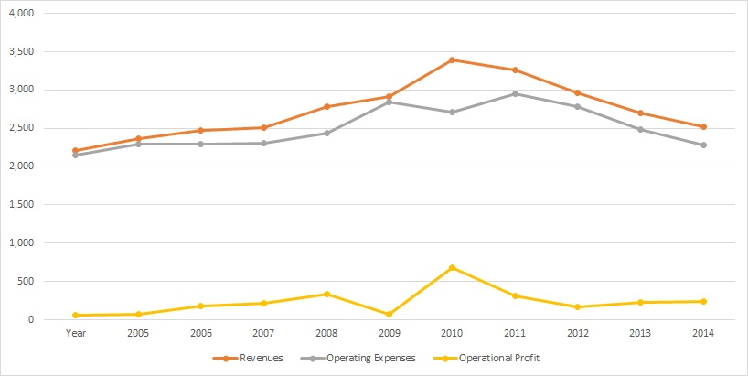
Figure 45. Operational revenues and expenses

Figures 45 and 46 show how revenues and expenses increased from 2005 to 2010, then have been subsiding, but reducing financial loss in a gradual manner since 2005.

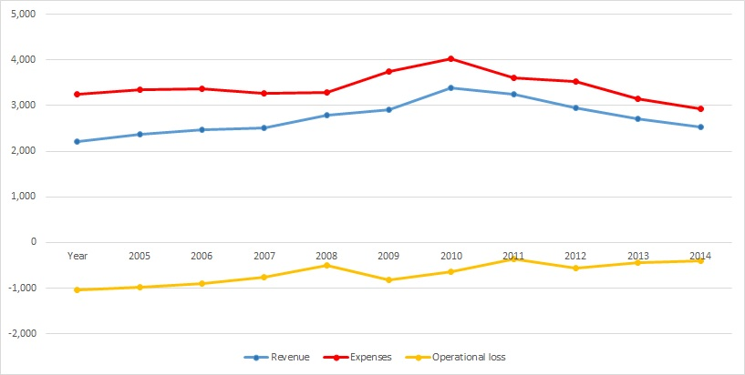
Figure 46. Total revenues and expenses

In order to better understand the trends presented above, it is useful to dissect and explain the source of revenues and the origin of the expenses. Figure 47 shows that both freight and passenger revenues have been increasing in nominal terms. Freight revenues are increasing mode rapidly, and now represent a larger share of the total. The portion of revenues from freight transport is now over 80 percent of total revenues. The portion of freight revenues increased from 81.9 percent in 2005 to 87.6 percent in 2015.

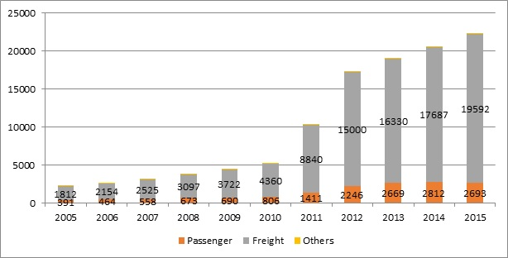
Figure 47. Revenues by Source (Nominal Rubles, billions)

Table 12. Portion of revenues
Year | 2005 | 2006 | 2007 | 2008 | 2009 | 2010 | 2011 | 2012 | 2013 | 2014 | 2015
Passenger | 17.7% | 17.7% | 18.0% | 17.7% | 15.5% | 15.5% | 13.7% | 12.9% | 13.9% | 13.6% | 12.0%
Freight | 81.9% | 82.0% | 81.5% | 81.3% | 83.6% | 84.0% | 85.7% | 86.2% | 85.3% | 85.8% | 87.6%
Others | 0.4% | 0.3% | 0.4% | 1.0% | 0.9% | 0.5% | 0.6% | 0.9% | 0.7% | 0.6% | 0.4%

As is noted above in Figures 46 and 47, BCh was able to partially bring expenses under control. Table 13 presents the source of the expenses. In the case of operational expenses in 2015, labor costs are 27.3 percent, then hired services 26.2 percent, followed by fuel 17.2 percent, materials 14.7 percent and depreciation 14.6 percent. Compared to their share of the total in 2005, only percentage of costs for hired services reduced its share while all other costs increased their share of the total. It is important to highlight that hired services is the category that is more variable and changes more widely on an annual basis. Also, labor costs do not seem to take an unreasonable high share of the operating expenses. The only concern would be if hired services are related to labor activities that could be accounted for as labor costs. If that is the case, then it may make sense to review the activities and try to reach new efficiencies that allow a lower level of expenses.

Table 13. Changes in Expenses (billion ruble, 2005 base year)
Year | 2005 | 2006 | 2007 | 2008 | 2009 | 2010 | 2011 | 2012 | 2013 | 2014 | 2015
Materials | 295 | 362.08 | 364.78 | 388.72 | 387.17 | 457.65 | 470.65 | 573.24 | 484.21 | 373.38 | 335.85
Fuel, Electricity | 334 | 346.73 | 396.78 | 390.69 | 376.55 | 443.596 | 482.15 | 491.43 | 414.95 | 390.96 | 393.04
Wages and salaries | 485 | 594.13 | 575.17 | 557.67 | 667.56 | 776.99 | 618.78 | 681.45 | 702.36 | 659.66 | 624.99
Hired servicers and others | 754 | 725.96 | 675.97 | 696.26 | 712.52 | 873.69 | 923.57 | 822.42 | 714.42 | 649.03 | 599.27
Depreciation | 288 | 263.66 | 279.98 | 269.26 | 299.12 | 294.66 | 214.14 | 376.85 | 473.24 | 406.84 | 333.14
Operating Expenses | 2155 | 2292.57 | 2292.70 | 2301.96 | 2442.93 | 2845.42 | 2709.31 | 2945.21 | 2789.35 | 2479.89 | 2286.42

Figure 48. Portion of expenses

2.42 Financial Ratios
The World Bank analyzed the performance of BCh by computing relevant financial ratios and comparing BCh performance with DB AG and PKP. The financial ratios computed were the operating ratio, traffic density (total, freight, and passenger), gearing ratio, track to rail ratio, and operating cost per unit of traffic. Based on available data, these ratios attempt to provide more insight on BCh’s performance on financial, operational, and efficiency terms.

Operating Ratio
The operating ratio measures a railroads’ ability to recover operating expenses from annual revenues. This ratio is widely used by financial analysts on every industry to assess a business performance and it provides a clear indicator on a railways financial health. The World Bank estimated the operating ratio for BCh from 2005 to 2014 and compared it to Germany’s Deutshe Banh AG and Poland’s Polskie Koleje Panstowowe (PKP). Estimated ratios are shown below on Figure 49.
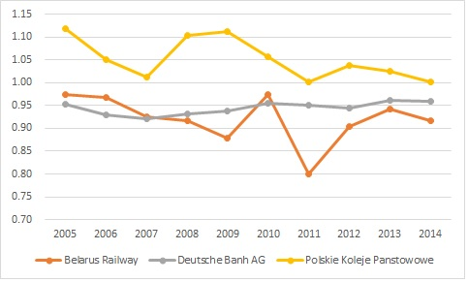
Figure 49. BCh, DB, and PKP Operating Ratios (2005 to 2014)
As can be seen above in Figure 49, BCh has been able to maintain its operating ratio below 1. This confirms that BCh collects enough revenue to cover its operating expenses. BCh has performed remarkably better than PKP and it has outperformed DB AG by the most part, except in the early 2000’s and in 2010, when the Belarusian economy was affected by economic recession and the prevailing geopolitical environment.

Gearing Ratio
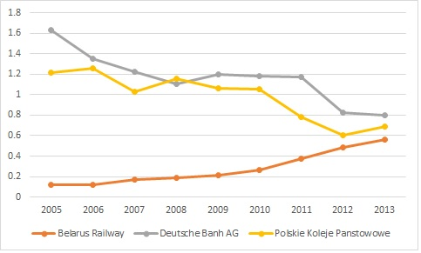
Figure 50. Gearing Ratio
Using UIC data, the Gearing ratio was computed for BCh, DB AG, and PKP. The gearing ratio is used to determine how debt levels of a company, in this case a railway, compare to its equity. A higher gearing ratio indicates that the railway is more indebted. This also increases the risk that the railway is susceptible to cyclical economic changes. This is particularly important for railways because they are a high fixed cost industry and are more susceptible to financial shocks. Railways with high gearing ratios can be in a situation where they are unable to fulfill their short-term obligations and face bankruptcy. In this case, BCh has been able to maintain a relatively low level in its gearing ratio and has historically performed better than DB and PKP. The concern is that the gearing ratio has been consistently deteriorating for BCh while it has improved for DB AG and PKP. The indicator for the three railways is now converging at the 0.6 and 0.8 range. This is not a good trend for BCh and it should be an area of attention.

Traffic Density
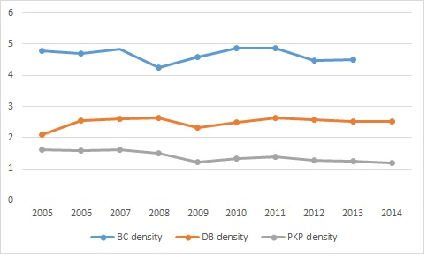
Figure 51. Traffic Density (traffic units per track kilometer)
As a general rule, and assuming tariff structure is appropriate, the basis for railway finances to be healthy is to have high traffic density. This means that when a railway moves a high number of ton-kilometers or passenger-kilometers per track kilometers and is able to price transport service correctly, the railway will cover its total costs. In order to determine how BCh is doing in this aspect, the traffic density ratios for BCh, DB AG, and PKP were estimated (Figure 51). As can be observed above, BCh has a significantly higher traffic density than DB AG and PKP. BCh’s traffic density has been consistently high in the last ten years. Therefore, if there is negative financial performance is not due to the level of traffic moving on the Belarusian rail network.
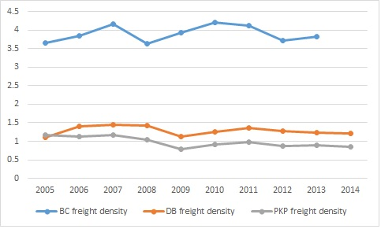
Figure 52. Freight Traffic Density
Traffic density can be dissected and further analyzed into freight and passenger traffic densities. Figure 52 above shows the freight traffic densities for BCh, DB AG, and PKP. As can be seen, BCh has a significantly higher freight traffic density than DB AG and PKP. However, it is also important to note that removal of passenger traffic units from the calculation does not have a significant impact on the indicator. This is a sign that passenger traffic does not have a meaningful contribution to a vigorous traffic density ratio.
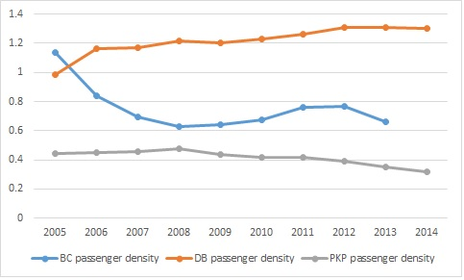
Figure 53. Passenger Traffic Density Ratio
The marginal contribution of passenger traffic to the traffic density is confirmed in Figure 45. As can be seen above, BCh’s passenger traffic density is even below DB AG’s and has been dropping since 2005. This is consistent with other findings in this analysis that indicate a significant motorization of BCh’s transport system and a loss of passenger volume from railways to roads. There are two takeaways from these results; 1) passenger traffic has evolved in the last ten years and is now significantly lower and 2) BCh needs to adjust its plan and operations to the new passenger rail market reality. Unless BCh implements the appropriate changes, passenger operations will continue to consume valuable financial resources that could be used on more productive alternatives.

Track to Line Ratio
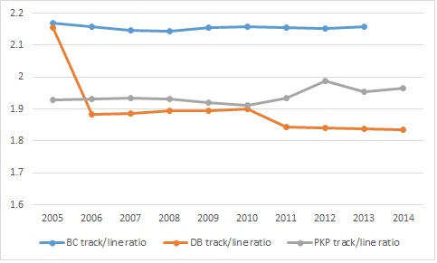
Figure 54. Track to Railroad Line ratio
The last ratio shows the kilometers of tracks divided by the kilometers of rail lines. While this a broad measure, it is a useful indicator to determine where BCh is compared to PKP and DB AG. As can be seen in Figure 46, in average BCh has slightly more than 2.1 tracks per railway line, which is higher than what DB AG and PKP have in their networks.

2.43 Passenger Transport Financial Sustainability
Financial information from the International Union of Railways (UIC) indicates that Belarus Railways supports passenger operations through freight service generated revenues. This can be concluded because BCh does not receive an operational subsidy from the government and the passenger services operate in a financial deficit. Therefore, as the freight operations generate a surplus, financial resources must come from that source. The amount of the operational cross-subsidy has grown in the last 10 years and is taking a larger share of the finances of the railway.

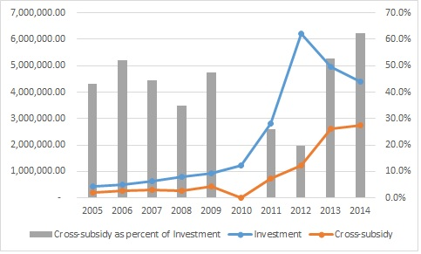
Figure 55. Belarus Railways Investment and Operational Cross-subsidies

Revenues collected by BCh are available for the railways’ best use. BCh has to decide how to best allocate revenues. These alternatives include cross-subsidies for passenger rail operations or additional capital investment. If the cross-subsidy is compared to the capital investment of the Belarus Railway, it can be seen that cross-subsidies are a significant part of the railway’s revenues. The use of this money to finance passenger operations, prevents the railway from using it to improve its system. In practical matters, the cross-subsidy crowds out an important percentage of investment funds. As can be seen above in Figure 4, since 2005, the operational cross-subsidy has fluctuated 30-40 percent of total investment. However, in 2013 and 2014, it spiked up to 50 and 60 percent respectively. This is a concern especially given the current market situation in which the railway needs financial resources to maintain its market share. Facing an energized competitor such as the road sector and sustaining a continuous financial drain will not allow railways to fulfill their role in the Belarusian transport system.

3. Main Reasons for the Deterioration of Railway Operations

All the diagnostics performed in this assessment indicate that BCh is still a viable railway. Traffic density, revenues, and costs show that BCh is still able to cover its operating costs, carry out basic investments and day-to-day operations efficiently. However, as a result of the changes in the transport system in Belarus, BCh has lost market share in the passenger and freight markets. In general, BCh is under pressure to evolve and respond to the new realities of the Belarusian transport sector. This has prompted BCh to cut costs and adjust prices, and modify some of its operations. The railway has been partially successful in these measures and lowered its operating costs. However, fare increases due to a different pricing methodology, further reduced passenger ridership of international rail service. This is because this market has a high price elasticity of demand. Furthermore, while BCh has become more efficient and has reduced its operating expenses, the lower costs have been accompanied with lower revenues and traffic volumes. In addition to the changes in the Belarusian transport system, recent deterioration of BCh’s performance indicators can be originated within its structure and operating practices. The World Bank has identified four areas where BCh may not be performing optimally.

1) BCh is increasing its use of freight cross-subsidies to finance its network and unviable passenger services. As passenger operations have lost ridership, BCh has been required to rely more heavily on its freight revenues. Passenger services are seeing a significant reduction in its revenues. As BCh continues to operate in the same manner, its existing organizational structure facilitates the use of freight operations to cover operating costs. The negative effect of this practice is the crowd-out effect of more productive capital investment. This means that funds that could be utilized to improve operations and attract more customers are utilized to subsidize financially unviable passenger services. In the long-term, this practice is not sustainable and passenger services would have to receive public support in order for the railway to grow and be successful. This would allow BCh to invest on the infrastructure and rolling stock needed to attract more freight and passengers.

2) Pricing framework may be imposing certain restrictions for BCh to either attract more customers or to collect higher revenues. As the railway system is considered a natural monopoly by the national government and for that reason closely regulated, BCh may not be able to respond to market changes in a timely and efficient manner. BCh has more flexibility in setting tariffs for international services and as consequence, the railway has been tempted to over-rely on this revenue to bring more balance into its finances. However, international market also is more competitive and has a higher price elasticity of demand. In the last ten years, data provides evidence that BCh has lost passenger traffic as a result of more aggressive pricing methodology for international passenger services.

3) Belarus has increased its multimodal transport system’s infrastructure and equipment capacity by building new roads and growing its automobile/truck stock. This means, that the transport industry as a whole increased its supply of transport services which must be cleared with higher demand or lower prices, or both. As the road sector is able to attract some of the users from the railway, BCh must be able to adjust its capacity as well. Productivity, track to line ratio, and other indicators confirm that BCh is not fully able to make the adjustments needed to compete. The main risk is that BCh reaches a point where the railway will not be able to sustain its own operations due to a lagging productivity and high fixed infrastructure cost. BCh is still in good condition currently but the trend continues to deteriorate, therefore, calling for a readjustment.

4) Similarly, it is apparent that the current service provision is no longer as appealing to users as before. Customers (passenger and freight) now have an option to use the road to reach their destination. Therefore, in order to remain competitive, the railway must redesign its service portfolio so it can focus on the markets that have the largest potential of success, or cut costs related to unviable/outdated services. Evidence presented in this assessment indicates that efficiency of measures taken until now have reduced costs. BCh is now taking steps to evolve and to meet the new preferences of its customers. It is important to continue with these efforts and reverse previous negative trends on productivity.

It is important to note that the new reality in Belarus’ transport system or the economic situation in the region are outside BCh’s control. However, the railway can position itself ensure that its role in the transport system and the region’s economy is fulfilled. The next section, presents a set of areas that require attention within BCh and the government. Taking action on these areas will enable the rail sector to recover and grow in the long-term.

4. Areas that Need Attention to Revitalize Railways in Belarus
The World Bank has identified three main areas that would enable BCh to recover its vitality and maintain or grow its market-share.

4.1 Railway Actions that will Respond to the New Belarusian Transport Market
BCh is already taking some steps for the railway to expand its service within intermodal freight. Some examples are the freight logistics activities currently carried by Belintertrans and some of the pilot trains in the Asia-Europe trade. Also, BCh recently announced the signing of an agreement of cooperation with all the railways in the China-Europe route. These are the type of steps that will allow BCh to remain relevant in the transport market and the assessment supports such measures, especially because some of the market segments formerly served by BCh are more tailored for road transportation. An important factor to consider is that freight volumes are likely to grow as the economies in the region reach higher levels of development. As volumes support multiple modes of transport, it is more optimal for BCh to find the appropriate niches that is more suitable for rail service. Given modern freight transport trends, BCh must strike agreements with partner railways to truly create a corridor connecting seamlessly and offers freight service to shippers as one entity. In the domestic market, BCh can enhance its service by developing a more responsive service. This can include wider cooperation with the trucking sector in markets that would allow both modes to efficiently provide service on certain legs.
In terms of passenger services, BCh needs to be proactive in the modification of schedules, modernization of trainsets, and discontinuance of unviable services. BCh and the MoTC need to do an extensive analysis to consider economic, transport, social, and other factors in the viability of existing passenger services. Ideally, the analysis is carried out after a permanent review process is established for the constant evolution of passenger services. Once a passenger is deemed unviable, BCh must be able to reduce or discontinue the service. While this is a difficult decision and may be unpopular, it is important to balance the viability of the railway system and the need for passenger rail service. BCh needs to review whether some of its routes are still needed because an increasing proportion of the population have access to cars and buses, which can provide comparable or lower cost service. Discontinuance of high cost/sparsely used trains would allow BCh to reduce costs, utilize valuable capital in projects with higher return on investment, and allow the railway to focus on providing the best possible service for higher yield/value rail services.

4.2 Railway Actions that will Improve Operating Performance

Action in areas presented in subsection 4.1 would enable BCh to improve its operating performance and grow the railway. Perhaps the most important action that BCh can take is to create a structure that can provide more direction in the long-term. This unit within the railway would be in charge of augmenting the capacity of the railway for strategic planning in infrastructure development, marketing, and customer relations. Increasing the organizational/business capacity of BCh in these three areas are the basis for a railway to be able to design a service that appeal to shippers and to plan the right type of infrastructure needed for such services. In the long-term, BCh may have to reconfigure its network to meet new passenger demand, increase intermodality, and cut costs related to infrastructure/rolling stock that is not utilized. Taking action on these areas would automatically improve operating indicators such as productivity, traffic density or the operating ratio.
It is possible that BCh will need to review its organizational structure and determine if it is appropriate to the new conditions of the market. BCh would have to consider whether seven branches as subsidiaries are necessary. BCh has operated about 5,500 kilometers of railways throughout the whole country by branches. Each branch is an independent legal entity but the functions of each branch is not independent. It is important to consider if it is necessary to maintain branches as legal entities or if it will be more efficient to integrate branches’ functions, especially given the availability of new information and communication technologies that allow the railway to implement business strategies.
BCh may be able to improve efficiencies and service in the management of its fleet by increasing private participation in the sector. Experience in other CIS railways is positive and show that the measure was effective within the regional context. This could result in a more business oriented mindset which would look into serving existing and emerging demand for freight wagons. As wagon productivity has lagged, it is important for BCh to more widely exploit this or other options that can increase wagon productivity and efficiency.

4.3 Public Policy Actions that will Support Railway Revitalization

The Government of Belarus needs to consider several options to ensure BCh remains a healthy railway. The main issue to consider are the existing passenger train services. As widely discussed in the assessment, these services are imposing a significant financial burden on BCh. The World Bank’s experience indicates that the best way to address this issue would be by the national or regional governments to enter into an agreement with the railway, in which the public sector agrees to provide financial support for the passenger service that benefits its jurisdiction. In the Belarusian case this is not the current practice but given the financial performance of BCh, it may make sense to implement Public Service Contracts for passenger services. This would allow BCh to reduce cross-subsidization, provide better passenger and freight service, and maintain a healthy modal distribution (between transport modes).
Existing regulatory framework has not evolved to consider the changes in the transport sector. One example, is the fact that while railways are normally a natural monopoly, in some markets, railways are in a competitive market. Therefore, it would be beneficial for the national government to consider deregulating or setting up a framework that provides full flexibility to the railway to respond and compete effectively against the road sector. Such differentiation would maintain regulatory protections for commodities or shippers that are still subject to the market power of railways, but benefit those clients that have the ability to ship by rail or truck. Detailed recommendations are further explored in Activity 2 report.

5. Conclusion
Performance indicators show that BCh is a key component of the Belarusian and regional transport system. BCh is still moving a high level of freight and passengers. It is a railway with high density and is able to cover its operating costs. Recent changes in the transport system of Belarus, economic performance and the regional geopolitical situation have impacted the railway in a negative manner. This has forced BCh to rely more heavily on freight revenues. The railway has only been able to adjust prices for transit passenger service. BCh’s efforts have been partially successful but more measures can be implemented to improve its performance.
The assessment identified three main areas that would support the long-term sustainability of BCh. These measures that could be taken by BCh to better respond to the new realities of the Belarusian transport sector. In order to be able to adjust to the new realities of the Belarus transport system and economy, BCh has to become more business oriented and increase its business planning capacity. The second group of identified actions are measure that could be taken by BCh to improve operating performance. These actions were identified because BCh’s operating ratios show it is lagging behind in certain areas of its operating performance, and taking action on this would make the railway more efficient and able to provide better passenger and freight service. The last set of identified actions are related to public policy measures that could be explored by the Belarusian Government in support of the economic, financial, and operational sustainability of BCh.
The World Bank believes these options are preliminary set of alternatives and need to be studied extensively in the near future in order to determine which would yield the highest benefits, and if there any negative implications in their implementation. Also, BCh needs to consider if there are other measures not listed in the assessment that would be a good response to its challenges. Activity 2 under this project is well aligned with findings of this assessment as it will support BCh in identifying organizational actions that need to be implemented by BCh in order to improve its planning and service development practices towards its goal of a more competitive and greener railway and logistics sector. More specifically, Activity 2 will support BCh in developing a blueprint of the policy and organizations changes needed to achieve the target.

Appendix 1: Data Tables

Table 14. Belarus Passenger Transport Market (million passengers)
 | Passengers in all Modes of transport | railway | motor road (buses) | tramway | trolleybus | Metro | air | inland water
2000 | 2830.6 | 167.8 | 1,499.60 | 139.5 | 758.5 | 258.2 | 0.3 | 0.1
2001 | 2875.1 | 154.8 | 1,547.40 | 138.4 | 758.9 | 270.2 | 0.3 | 0.1
2002 | 2780.5 | 152.9 | 1,499.80 | 117.7 | 707.8 | 298 | 0.3 | 0.1
2003 | 2718.4 | 141.6 | 1,575.00 | 94.6 | 614.8 | 289.4 | 0.4 | 0.1
2004 | 2615.7 | 142.1 | 1,525.80 | 91 | 593 | 261.2 | 0.5 | 0.2
2005 | 2540.3 | 104.5 | 1,509.90 | 90.7 | 582.6 | 250.4 | 0.5 | 0.2
2006 | 2492 | 99.4 | 1,490.30 | 84.5 | 551.8 | 264 | 0.5 | 0.2
2007 | 2572.6 | 92.6 | 1,527.30 | 96.2 | 592.4 | 262.1 | 0.6 | 0.2
2008 | 2278.4 | 88 | 1,298.80 | 96.8 | 541 | 244.2 | 0.8 | 0.2
2009 | 2209.7 | 83.5 | 1,257.00 | 82.7 | 519.9 | 254.2 | 0.8 | 0.2
2010 | 2395.8 | 83.6 | 1,410.00 | 83.7 | 535 | 273.6 | 1 | 0.2
2011 | 2438.5 | 89 | 1,440.30 | 85.3 | 546.2 | 268 | 1 | 0.3
2012 | 2453.2 | 100.5 | 1,435.80 | 89.2 | 536 | 281.4 | 1.3 | 0.3
2013 | 2451.2 | 99.4 | 1,415.50 | 84.1 | 508.2 | 328.3 | 1.6 | 0.3
2014 | 2255.4 | 91.6 | 1,304.40 | 78.7 | 447.3 | 318.5 | 2 | 0.3
2015 | 2094 | 87.1 | 1,216.40 | 66.9 | 403.6 | 305.3 | 2.1 | 0.2

Table 15. Motorization trends in Passenger Market
Year | Passenger cars (thousands) | Private Vehicle Ownership Rate | Buses
2000 | 1,385,900.00 | 13.85% | 12,518.00
2005 | 1,737,100.00 | 17.50% | 11,631.00
2006 | 1,930,600.00 | 19.57% | 13,464.00
2007 | 2,084,600.00 | 21.28% | 9,956.00
2008 | 2,191,300.00 | 22.52% | 10,695.00
2009 | 2,339,800.00 | 24.21% | 10,781.00
2010 | 2,501,200.00 | 26.04% | 10,863.00
2011 | 2,646,500.00 | 27.68% | 9,509.00
2012 | 2,640,800.00 | 27.72% | 10,799.00
2013 | 2,670,600.00 | 28.09% | 10,876.00
2014 | 2,827,200.00 | 29.79% | 11,400.00
2015 | 2,920,200.00 | 30.83% | 11,782.00
Source: National Statistical Committee of the Republic of Belarus, 2017

Table 16. Passenger Kilometers by Mode
Year | Passenger turnover of all transport types | railroad | motor road (buses) | tramway | trolleybus | metro | air | inland water
1995 | 11.74 | 84.84 | 7.13 | 4.07 | 3.35 | 5.06 | 2,046.6 | 20.00
2000 | 11.46 | 105.61 | 6.16 | 3.96 | 3.50 | 6.50 | 1,710.0 | 20.00
2001 | 10.55 | 98.60 | 6.13 | 3.92 | 3.49 | 6.57 | 1,820.0 | 20.00
2002 | 10.53 | 93.85 | 6.27 | 3.94 | 3.48 | 6.70 | 1,843.3 | 20.00
2003 | 10.36 | 93.98 | 6.20 | 4.01 | 3.53 | 6.70 | 1,412.5 | 20.00
2004 | 10.77 | 97.77 | 6.15 | 3.96 | 3.52 | 6.70 | 1,348.0 | 10.00
2005 | 9.59 | 99.05 | 6.11 | 3.88 | 3.50 | 6.70 | 1,368.0 | 10.00
2006 | 9.67 | 100.28 | 6.27 | 3.92 | 3.49 | 6.70 | 1,508.0 | 10.00
2007 | 9.29 | 101.14 | 6.12 | 3.85 | 3.49 | 6.70 | 1,625.0 | 15.00
2008 | 9.52 | 93.05 | 6.30 | 4.00 | 3.51 | 6.70 | 1,601.3 | 15.00
2009 | 9.02 | 88.63 | 5.77 | 3.60 | 3.51 | 6.70 | 1,605.0 | 15.00
2010 | 9.81 | 90.65 | 7.23 | 3.60 | 3.53 | 6.70 | 1,571.0 | 15.00
2011 | 9.71 | 89.22 | 6.89 | 3.58 | 3.54 | 6.70 | 1,643.0 | 13.33
2012 | 10.31 | 89.32 | 6.98 | 3.59 | 3.59 | 6.70 | 1,565.4 | 13.33
2013 | 10.86 | 90.52 | 7.45 | 3.57 | 3.69 | 6.70 | 1,556.3 | 10.00
2014 | 11.13 | 85.11 | 7.62 | 3.57 | 3.74 | 6.70 | 1,535.0 | 10.00
2015 | 11.49 | 81.71 | 7.80 | 3.72 | 3.74 | 7.65 | 1,506.7 | 10.00
Source: National Statistical Committee of the Republic of Belarus, 2017

Table 17. Motorization Trends in Freight Market
Year | Freight Road Transport Vehicles | % Change Freight Road transport vehicles | BCh Freight Wagon Fleet | BCh Freight Wagon Fleet  (% change) | BCh Fleet Capacity (tons)
2000 | 49,350.00 |  | 18,037
2005 | 77,091.00 | 56.21% (from 2000) | 25,966
2006 | 80,175.00 | 4.00% | 28,651 | 43.96% | 1,442,192
2007 | 86,838.00 | 8.31% | 29,248 | 10.34% | 1,459,493
2008 | 99,779.00 | 14.90% | 29,723 | 2.08% | 1,523,693
2009 | 114,288.00 | 14.54% | 27,058 | 1.62% | 1,687,860
2010 | 119,402.00 | 4.47% | 27,839 | -8.97% | 1,660,380
2011 | 121,133.00 | 1.45% | 27,792 | 2.89% | 1,658,411
2012 | 123,274.00 | 1.77% | 31,461 | -0.17% | 1,675,185
2013 | 128,805.00 | 4.49% | 27,893 | 13.20% | 1,511,078
2014 | 135,632.00 | 5.30% | 27,896 | -11.34% | 1,801,179
2015 | 135,569.00 | -0.05% | 26,379 | 0.01% | 1,721,498

Table 18. Belarus Freight Transport Market (thousand tons)
Year | Pipeline | Railway | Road  Transport | Inland  Waterway | Air | All Modes
1995 | 112,500e | 73,438 | 350,013 | 1,224 | 19 | 424,694
2000 | 131,303 | 88,000 | 64,436 | 1,672 | 4 | 285,415
2001 | 139,646 | 84,613 | 61,207 | 1,521 | 7 | 286,994
2002 | 137,451 | 93,599 | 68,603 | 1,610 | 8 | 301,271
2003 | 149,705 | 105,935 | 75,252 | 2,190 | 7 | 333,089
2004 | 156,117 | 111,244 | 88,123 | 2,403 | 12 | 357,899
2005 | 164,646 | 125,097 | 100,685 | 3,011 | 14 | 393,453
2006 | 160,113 | 133,679 | 103,653 | 3,837 | 26 | 401,308
2007 | 156,849 | 140,967 | 110,857 | 4,460 | 21 | 413,154
2008 | 152,171 | 147,172 | 130,949 | 5,120 | 19 | 435,431
2009 | 146,683 | 133,996 | 133,893 | 5,458 | 25 | 420,055
2010 | 142,992 | 139,937 | 166,862 | 6,168 | 19 | 455,978
2011 | 142,791 | 152,775 | 190,989 | 6,711 | 9 | 493,275
2012 | 137,359 | 154,221 | 189,302 | 4,023 | 14 | 484,371
2013 | 134,199 | 140,040 | 192,475 | 4,486 | 11 | 471,210
2014 | 130,589 | 141,437 | 191,660 | 3,758 | 41 | 467,486
2015 | 132,549 | 131,439 | 180,226 | 2,960 | 39 | 447,212

Table 19. Transport Mode Freight Market Shares (tons)
Year | Rail | Truck | Inland Water | Pipeline | Rail Share on Rail/Road/Water Market Only
2000 | 30.83% | 22.58% | 0.59% | 46.0% | 57.10%
2001 | 29.48% | 21.33% | 0.53% | 48.7% | 57.43%
2002 | 31.07% | 22.77% | 0.53% | 45.6% | 57.14%
2003 | 31.80% | 22.59% | 0.66% | 44.9% | 57.77%
2004 | 31.08% | 24.62% | 0.67% | 43.6% | 55.13%
2005 | 31.79% | 25.59% | 0.77% | 41.8% | 54.68%
2006 | 33.31% | 25.83% | 0.96% | 39.9% | 55.43%
2007 | 34.12% | 26.83% | 1.08% | 38.0% | 55.00%
2008 | 33.80% | 30.07% | 1.18% | 34.9% | 51.96%
2009 | 31.90% | 31.88% | 1.30% | 34.9% | 49.02%
2010 | 30.69% | 36.59% | 1.35% | 31.4% | 44.71%
2011 | 30.97% | 38.72% | 1.36% | 28.9% | 43.59%
2012 | 31.73% | 39.08% | 0.83% | 28.4% | 44.29%
2013 | 29.72% | 40.85% | 0.95% | 28.5% | 41.55%
2014 | 30.25% | 41.00% | 0.80% | 27.9% | 41.99%
2015 | 29.39% | 40.30% | 0.66% | 29.6% | 41.78%

Table 20. Belarus Freight Market Trends (tons-kilometer)
Year | Pipeline | Rail | Road Transport | Inland Water | Air | Total Freight (tkm)
2000 | 52,659 | 31,425 | 5,026 | 26 | 18 | 89,154
2001 | 56,264 | 29,727 | 5,350 | 41 | 28 | 91,410
2002 | 57,040 | 34,169 | 6,658 | 59 | 37 | 97,963
2003 | 62,733 | 38,402 | 8,181 | 160 | 34 | 109,510
2004 | 69,309 | 40,331 | 8,867 | 182 | 49 | 118,738
2005 | 74,261 | 43,559 | 9,351 | 90 | 59 | 127,320
2006 | 73,631 | 45,723 | 8,939 | 109 | 92 | 128,494
2007 | 70,835 | 47,933 | 11,941 | 93 | 66 | 130,868
2008 | 67,871 | 48,994 | 13,742 | 132 | 57 | 130,796
2009 | 64,785 | 42,742 | 13,512 | 83 | 50 | 121,172
2010 | 65,743 | 46,224 | 16,023 | 110 | 44 | 128,144
2011 | 65,258 | 49,406 | 19,436 | 143 | 27 | 134,269
2012 | 61,134 | 48,475 | 22,031 | 134 | 34 | 131,684
2013 | 61,220 | 43,818 | 25,603 | 84 | 27 | 130,752
2014 | 59,704 | 44,997 | 26,587 | 49 | 65 | 131,402
2015 | 60,552 | 40,785 | 24,523 | 21 | 77 | 125,957

Table 21. Average Length of Freight Haul by Mode (kilometers)
Year | Pipeline | Rail | Road | Inland Water | Air
2000 | 401.05 | 357.10 | 78.00 | 15.55 | 4,500.00
2001 | 402.90 | 351.33 | 87.41 | 26.96 | 4,000.00
2002 | 414.98 | 365.06 | 97.05 | 36.65 | 4,625.00
2003 | 419.04 | 362.51 | 108.71 | 73.06 | 4,857.14
2004 | 443.96 | 362.55 | 100.62 | 75.74 | 4,083.33
2005 | 451.03 | 348.20 | 92.87 | 29.89 | 4,214.29
2006 | 459.87 | 342.04 | 86.24 | 28.41 | 3,538.46
2007 | 451.61 | 340.03 | 107.72 | 20.85 | 3,142.86
2008 | 446.02 | 332.90 | 104.94 | 25.78 | 3,000.00
2009 | 441.67 | 318.98 | 100.92 | 15.21 | 2,000.00
2010 | 459.77 | 330.32 | 96.03 | 17.83 | 2,315.79
2011 | 457.02 | 323.39 | 101.77 | 21.31 | 3,000.00
2012 | 445.07 | 314.32 | 116.38 | 33.31 | 2,428.57
2013 | 456.19 | 312.90 | 133.02 | 18.72 | 2,454.55
2014 | 457.19 | 318.14 | 138.72 | 13.04 | 1,585.37
2015 | 456.83 | 310.30 | 136.07 | 7.09 | 1,974.36

Appendix 2: Map of Belarusian Railway

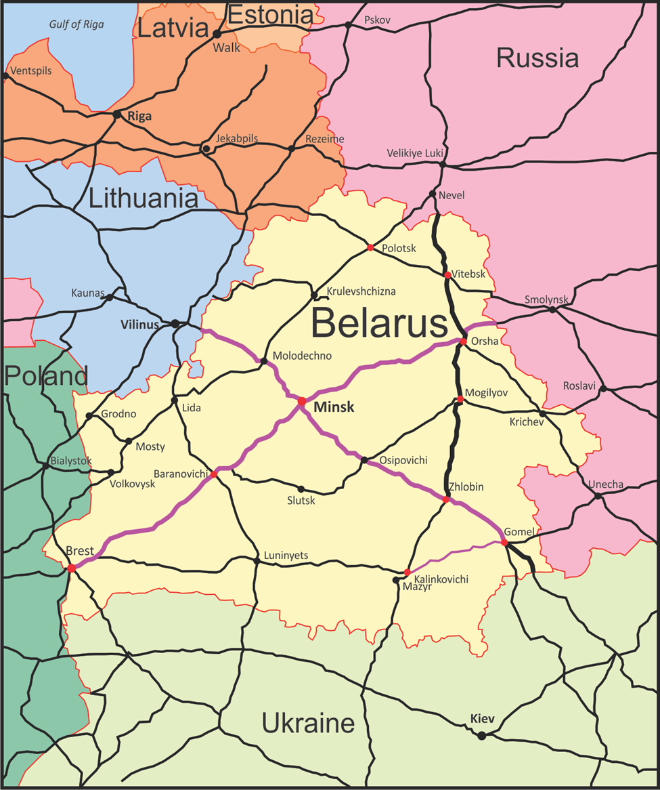

Articles refer to the Law of the Republic of Belarus dated December 31, 2014 No. 227-3.
The data of UIC in 2015 for Ukraine and Poland may be not credible as the data shows rapid decrease, So, the data from 2005 to 2014 can be used for analysis for 10 years.
Tariff cost for international passenger transportation is set in Swiss francs and the final cost of the journey is subject to change in case of fluctuations of the exchange rates. However, these increases have not been limited/capped by existing regulatory framework.
For passenger traffic, the efficiency of locomotive productivity is estimated by the average daily run of a locomotive in passenger traffic. However, these data are not available for the comparison group.
The World Bank. 2011. "Railway Reform: Toolkit for Improving Rail Sector Performance." Washington, D.C., page 59

