Ministry of Agriculture and Uzbekistan Agroindustry and Food Security Agency (UZAIFSA)

Uzbekistan Agriculture Modernization Project

STAKEHOLDER ENGAGEMENT PLAN

Tashkent, Uzbekistan
December 2019

TABLE OF CONTENTS
Acronyms and abbreviations 3
1. INTRODUCTION 4
1.1. Project background 4
1.2. Purpose of the SEP 4
1.3. Scope and Structure of the SEP 4
2. ADMINISTRATIVE, POLICY AND REGULATORY FRAMEWORK 5
2.1. Relevant National Laws and Regulations 5
2.2. State Development Programs 6
2.3. World Bank Environmental and Social Standard on Stakeholder Engagement 7
2.4. Scope of application 7
2.5. Requirements 8
3. BRIEF SUMMARY OF PREVIOUS STAKEHOLDER ENGAGEMENT ACTIVITIES 8
3.1. Key stakeholder meetings and consultations 8
3.2. Key issues emanating from these consultations and HDprevious projects 8
4. STAKEHOLDER MAPPING, SEGMENTIZATION AND ANALYSIS 9
4.1. Key stakeholder meetings and consultations 9
4.2. Stakeholder identification: project-affected parties 9
4.3. Stakeholder identification: other interested parties 13
4.4. Disadvantaged and Vulnerable Groups 15
5. STAKEHOLDER ENGAGEMENT PLAN 16
5.1. Planned stakeholder engagement activities 16
5.2. Roles and Responsibilities 20
5.3. Stakeholder Engagement Methods to be used 21
5.3.1. Proposed strategy to incorporate the view of vulnerable groups 22
5.3.2. Information disclosure 22
5.3.3. Estimated Budget 22
6. GRIEVANCE REDRESS MECHANISM (GRM) 23
6.1. Existing complaint handling mechanism in Uzbekistan 23
6.2. Objectives of GRM 24
6.3. Grievance Redress Mechanism of the project 25
6.4. Records and Documentation 26
7. ANNEXES 28
Annex 1. Example Grievance Form 28
Annex 2. Brief summary of stakeholder meetings for purposes of SEP preparation 30

Acronyms and abbreviations

CLO | - | Community Liaison Officer
ESS | - | Environmental and Social Standards
GoU | - | Government of Uzbekistan
GRC | - | Grievance Resolution Committee
GRM | - | Grievance Redress Mechanism
MOA | - | Ministry of Agriculture
MOF | - | Ministry of Finance
OIPs | - | Other Interested Parties
PAPs | - | Project-affected Parties
PDO | - | Project Development Objectives
PIU | - | Project Implementation Unit
SEP | - | Stakeholder Engagement Plan

- INTRODUCTION
  - Project background
- The World Bank (Bank) is currently engaged in assisting Government of Uzbekistan (GoU) to implement an agricultural development strategy for 2020-2030, designed to make the sector a driver of economic growth, create new jobs and increase people’s incomes. The proposed project recognizes the importance of environmental and social issues and the same is being addressed through the Bank’s new approach of Environmental and Social Safeguard Standards (ESS). One of the Standards - ESS10 - relates to stakeholder engagement. This report details the stakeholders relevant for the project and the project’s arrangements to be engaged with them during the preparation as well as during implementation. Before presenting the results of stakeholder engagement, the project development objective and components are enumerated in the following sections.
- The Project Development Objective (PDO) is to enhance productivity-supporting agricultural services and promote market-led, high-value horticulture value chains. Four components to achieve the development objective are as follows:
- Component 1: Enhancing Productivity-Supporting Agricultural Services. The objective of this component is to enhance the knowledge and human capital – to underpin the productive transformation of agriculture - by both funding directly public agricultural R&D and creating conditions to attract more private investment into agricultural R&D, in order to more effectively serve the farmers. The component will focus on: (i) agricultural research and development; (ii) seed/seedling production; (iii) land productivity enhancement; and (iv) farmer adoption support. The project will support practical mechanisms that bring research, extension, and private sector together in order to better align research and innovation priorities with local constraints faced by farmers and agribusinesses in order to develop a more productive, climate-resilient, diversified and market-led agricultural sector.
- Component 2: Supporting Investments in High-Value Horticulture Value Chains. The objectives of this component are to support investments in high-value horticulture value chains, facilitate farmers’ participation in investment opportunities created by economic liberalization and agricultural diversification, and enable productive partnerships/clusters between farm groups and agribusinesses. These objectives will be achieved through a mix of technical support provided under component 1 and two credit windows that would offer long-term financing tailored to the needs of farmers and agribusinesses.
- Component 3: Facilitating Trade and Marketing. The objective of this component is to improve access of Uzbekistan’s horticulture products on both internal and external markets through improvements in: (i) agro-logistics; (ii) plant protection and phytosanitary measures; and (iii) market information collection and dissemination.
- Component 4: Supporting Project Management. This component will support project management, coordination, monitoring and evaluation, and implementation of environmental and social measures under the World Bank Environmental and Social Framework.

  - Purpose of the SEP
- GoU recognizes that there are many stakeholders in agricultural sector and that their expectations and orientation as well as capacity to interface with the project are different. This differential necessitates systematic efforts to develop a Plan - Stakeholder Engagement Plan (SEP) - to enable identify elaborately different stakeholders and develop an approach for reaching each of the sub groups. In simpler terms, it provides an appropriate approach for consultations and disclosure. Overall, SEP serves the following purposes: i) stakeholder identification and analysis; (ii) planning engagement modalities such as effective communication tools for consultations and disclosure; (iii) enabling platforms for influencing decisions; (iv) defining the roles and responsibilities of different actors in implementing stakeholder engagement activities; and (iv) elaborating the Project grievance redress mechanism (GRM).

  - Scope and Structure of the SEP
- SEP will assess the level of stakeholder interest and support for the project, enable stakeholder views to be taken into account in project design and environmental and social performance, promote and provide means for inclusive engagement throughout the project life-cycle, ensure that appropriate project information is disclosed to stakeholders in a timely, understandable, accessible, and appropriate manner and format, provide citizens with accessible and inclusive means to raise issues and grievances and enable the project implementing entity to respond to and manage such grievances.
- This document has 10 chapters. The first chapter serves as an Introduction. It provides a brief about the project and the context in which the SEP is being prepared. Chapter 2 lists the regulatory framework in Uzbekistan which provides a legitimacy for SEP. Chapter 3 includes a summary of the consultations held so far which serve as a basis for the SEP document. Chapter 4 lays out the stakeholder mapping and institutional analysis as relevant to the Project. Chapter 5 presents project-related risks and impacts related to stakeholder engagement. Chapters 6 includes the action plan for stakeholder engagement. Chapter 7 presents details on the planned stakeholder engagement activities, implementation arrangements, and budget. The Project GRM is presented in Chapter 9. Monitoring, documentation, and reporting arrangements are presented in Chapter 10.

- ADMINISTRATIVE, POLICY AND REGULATORY FRAMEWORK

  - Relevant National Laws and Regulations
- The key legislation for this project can be subdivided into two groups:
- Constitution, Land Code, Civil Code, the Laws "On Farm Enterprise", “On Dekhkan Enterprise”, “On seed production”, "On protection of agricultural plants from pests, diseases and weeds", "On Environmental Protection" and others;
- Presidential Decrees and Resolutions, Cabinet of Ministers’ Resolutions and industry regulations.

Land Tenure
- The legal foundation for land tenure in Uzbekistan is contained in three key documents: the Constitution (Article 55), the Land Code (Chapter 4), and the Civil Code (Chapters 8, 13 and 17).
- The Land code stipulates that “land is a state-owned national treasure, it is subject to rational use and it is protected by the state as a base of life, activities and welfare of the population” (Land Code of the Republic of Uzbekistan, Chapter 4, Article 16, 1998).
- All agricultural land in Uzbekistan is owned by the state. State ownership of land is maintained to ensure the country's food security and social stability, and to better operate the state-run irrigation system. Farmers in Uzbekistan use land on the basis of long-term lease contracts with the state that give them the right to cultivate a parcel of state-owned land for up to 50 years. Lifelong inheritable land tenure is possible in the following cases and it includes Uzbekistan’s citizens only: dehkan farms, individual homestead construction and household operation, and collective orchards and vineyards.
- Land tenure in Uzbekistan can be revoked in certain cases. For example, the ownership of land plots is terminated when the land plot provided for non-agricultural needs is not used for two years. Also, for farmers it is mandatory to be a member of the Council of farmers, dekhkan (smallholder) farmers and owners of household plots (thereafter Council). So, upon termination of membership, the right to use the land plot is terminated as well. Councils have the right to monitor the rational use of land and land by dekhkan farms and give instructions to farms, dekhkan farms and owners of household lands according to the national legislation.
- Lease contracts are closely monitored by a number of state authorities - local authorities (khokimiyats), the Ministry of Agriculture (MOA), the Ministry of Water Resources, the State Committee on Land Resources, Geodesy, Cartography and Cadaster, and the Inspection for control of the agro industrial complex under the Cabinet of Ministers.
- Land use by farmers is closely monitored by the state. Farmers growing cotton and wheat have to comply with state quotas for production and are obliged to sell these crops at pre-determined prices. Farmers growing fruits and vegetables are not subject to the same scrutiny as cotton and wheat farmers, but they also have to follow instructions by local authorities in matters related to growing crops. Dehkan farmers have relatively greater freedom and can sell all their crops at market prices.
- The legal and regulatory framework of Uzbekistan provide an adequate and appropriate enabling framework for implementing the key activities to be taken up under the program. Social Protection, consumer responsiveness and public accountability are well enshrined in the legal framework at different levels. The Constitution of Uzbekistan and several laws highlight the importance of state’s commitment to serving and ensuring protection of the public, in general, and the poor and vulnerable sections.

Environment, Community Health and Safety
- Other relevant legislation includes the Law of the Republic of Uzbekistan “On Environmental Protection”, first adopted on 09.12.1992, which provides the legal basis for all environmental requirements related to the project. The Law of the Republic of Uzbekistan "On protection of agricultural plants from pests, diseases and weeds", dated 03.08.2000, provides a legal framework to ensure compliance with sanitary norms, rules and hygienic standards, ensuring sanitary and epidemiological welfare of the population, the storage, use, neutralization, recycling and disposal of chemicals, biological agents and materials.

Policy and Institutional Mandates
- In recent years, a number of important Presidential decrees and resolutions on agriculture have been enacted. These decrees and resolutions have mainly tackled institutional reorganization of agriculture. The most important of them is the decree of the President of Uzbekistan #5330 of February 12, 2018 “On measures to radically improve the system of agriculture and water sector governance”, according to which the Ministry of Agriculture and Water Resources was split into MOA and Ministry of Water Management. According to this decree, MOA will implement a unified agriculture policy for comprehensive modernization of the industry, introduction of science and technology, modern and resource-saving agricultural technologies, advanced domestic and foreign experience in the sector of agriculture and water management. The Ministry will develop comprehensive sectoral and regional programs aimed at ensuring a dynamic development of agriculture sector, food security, increase employment and rural incomes, and maintain a stable level of prices for food products in the domestic market. The Ministry of Water Resources is responsible for implementing a unified state policy in the sphere of management of water resources, ensuring their careful and rational use, reconstruction and modernization of water facilities, hydraulic structures.
- A Decree of the President dated 10.09.2018 “On Measures to improve protection of rights and legal interests of farmers, dehkan farmers and owners of household land and effective use of agricultural land” stipulates that by January 1, 2022, all farms must become a multi-profile farm and those farms which do not become multi-profile farms will be terminated.
- Another important piece of regulation was enacted by the resolution of the Cabinet of Ministers No. 14 dated January 11, 2019. The resolution seeks to optimize the use of farmland by increasing the size of farms producing wheat and cotton to the average of 100 ha, reallocating land to more efficient farmers and even clusters, and improving crop rotation options. In the last 5 years there have been three rounds of farm size restructuring/optimization.
- Perhaps the, most important document that exists in draft form is the decree of the President and accompanying strategy for the development of agriculture for 2020 – 2030. The decree and strategy was approved by the President of Uzbekistan on October 23, 2019. The strategy inter alia envisages development of intensive orchards and vineyards, vegetables and other fruits. It also envisages development of the agricultural science, education, information and consulting services, dissemination of agricultural knowledge and information.

  - State Development Programs
- In addition to the legislation, there are four major programs which support people and and communities and have a special focus on supporting women both in urban and rural areas. These are: “Obod Mahalla”, “Obod Qishloq”, “Every family – entrepreneur”, “Youth is our future”.
- “Obod Qishloq” ("Improved village") program is designed to improve villages and countryside in general by improving access to drinking water and drainage; reconstructing rural roads, construction of bus stops, sanitary facilities and irrigation systems; ensuring uninterrupted supply of liquefied gas and coal fuel to the population; and construction, reconstruction and capital repairs of kindergartens, schools, and family health centers (policlinics).
- “Every family – entrepreneur”. The program provides full support to persons who wish to be engaged in entrepreneurship, such as allocation of soft loans and provision of "systematic practical support" at each stage of the business start-up and development. This includes: Creation of mini-clusters — assigning successful businessmen to the families starting new business activity in mahallas who can provide guidance and mentorship, taking into account specialization of the area (handicrafts, sewing, cultivation of agricultural products, installation of compact greenhouses among others).
- This program has become popular due to the subsidized loans it provides to start-up businesses, including production of agricultural products on the household plots. Within this program soft loans in amount of up to 150 minimum wages — for development of family business, up to 1000 minimum wages — to the entities registered as a ‘small business’, and over 1000 minimum wages — for crediting of investment projects of entrepreneurship entities are allocated by the banks.
- “Youth is our future”. The program is aimed at employment of youth by assisting and supporting the implementation of youth business initiatives, startups, and projects, training of unemployed youth in demanded specialties and business skills, as well as increase in their social and economic activity in general. The program is implemented by the "Yoshlar — kelajagimiz" Fund which was established for this purpose under the Youth Union of Uzbekistan. Its funds will be used for allocation, through banks, of soft loans and property in leasing at 7% annual interest rate for youth business and initiatives, and issuance of credit guarantees of up to 50% of the credit amount.

  - World Bank Environmental and Social Standard on Stakeholder Engagement
- The main Bank’s ESS for Stakeholder Engagement is ESS10: Stakeholder Engagement and Information Disclosure. ESS10 recognizes the importance of open and transparent engagement between the Borrower and project stakeholders as an essential element of good international practice. Effective stakeholder engagement can improve the environmental and social sustainability of projects, enhance project acceptance, and make a significant contribution to successful project design and implementation.
- The Objectives of ESS10 are:
  - To establish a systematic approach to stakeholder engagement that will help Borrowers identify stakeholders and build and maintain a constructive relationship with them, in particular project-affected parties;
  - To assess the level of stakeholder interest and support for the project and to enable stakeholders’ views to be taken into account in project design and environmental and social performance;
  - To promote and provide means for effective and inclusive engagement with project-affected parties throughout the project life cycle on issues that could potentially affect them;
  - To ensure that appropriate project information on environmental and social risks and impacts is disclosed to stakeholders in a timely, understandable, accessible and appropriate manner and format;
  - To provide project-affected parties with accessible and inclusive means to raise issues and grievances, and allow Borrowers to respond to and manage such grievances.

  - Scope of application
- ESS 10 applies to all projects supported by the Bank through Investment Project Financing. For the purpose of this ESS, “stakeholder” refers to individuals or groups who:
- are affected or likely to be affected by the project (project-affected parties); and
- may have an interest in the project (other interested parties).

  - Requirements
- The Bank standard on Stakeholder Engagement and Information Disclosure requires that the project implementing agency engages with stakeholders throughout the project life cycle, commencing such engagement as early as possible in the project development process and in a timeframe that enables meaningful consultations with stakeholders on project design. The nature, scope and frequency of stakeholder engagement will be proportionate to the nature and scale of the project and its potential risks and impacts. The project will engage in meaningful consultations with all stakeholders. It will provide stakeholders with timely, relevant, understandable and accessible information, and consult with them in a culturally appropriate manner, free of manipulation, interference, coercion, discrimination and intimidation.
- The project implementing entity will maintain and disclose as part of the environmental and social assessment, a documented record of stakeholder engagement, including a description of the stakeholders consulted, a summary of the feedback received and a brief explanation of how the feedback was taken into account, or the reasons why it was not. This SEP is prepared taking into account these requirements.

- BRIEF SUMMARY OF PREVIOUS STAKEHOLDER ENGAGEMENT ACTIVITIES

  - Key stakeholder meetings and consultations
- The present project, Agriculture Modernization Project (AMP), follows a series of Bank projects in the agriculture sector in Uzbekistan, in the course of which a number of engagements with stakeholders in the agriculture sector, including farmers and beneficiaries, have been conducted. In this process, UZAIFSA has gathered knowledge and expertise on collecting and responding to stakeholder feedback and has diversified its channels used for communication with stakeholders. During the preparation of AMP, UZAIFSA has led and/or participated in key stakeholder discussions with MOA , agricultural research institutes, farmers and Council of farmers’ representatives, agri-business and processing enterprises, commercial banks involved in the agriculture sector, among others/ Additionally, for the purposes of AMP UZAIFSA conducted primary research in three regions to be potentially targeted by the project – Andijan, Khorezm, and Bukhara –in order to inform the present SEP. The nature and findings from these engagements are summarized below.
- In addition, a lot of relevant stakeholder engagement happened within the flagship Bank project - “Horticulture Development Project” (HDP) since its launch in 2015. HDP is designed to diversify agriculture into higher value crops, intensify agricultural yields and productivity, and foster better rural jobs. Under HDP, numerous meetings and consultations with key stakeholders have taken place.
- Public consultations in the project areas - initially 9 regions, but later upgraded to national coverage - aimed at ensuring that the physical and social environment is not changed to the detriment of local residents, and that any changes take place with their agreement. Public consultations in 2014-15, as well as in 2018-19 involved the participation of affected community members and NGOs. All public consultations have been documented and their minutes are maintained by UZAIFSA. The Environmental and Social Management Framework (ESMF) of the project, along with minutes of public consultations, have been disclosed in English and Russian language on the MOA website, and hard copies were provided to other key stakeholders such as regional state agencies of the participating regions, environmental and health authorities, environmental NGOs, scientific and/or design companies related to environmental protection on the participating oblasts.
- The project, via UZAIFSA, has also supported a number of activities on human capacity building. This included: (a) capacity building to increase compliance with national labor legislation and International Labor Organization (ILO) conventions on child and forced labor, and broader labor issues, ratified by Uzbekistan; (b) training on strengthening project environmental management capacity for sub-projects environmental assessment; (c) training and information dissemination for subproject beneficiaries and farmers on several important horticulture sector development issues, related to Integrated Pest Management, soil and water conservation.

  - Key issues emanating from these consultations and HDprevious projects
- During the implementation of HDP a number of issues have come to prominence. First, since production in the horticultural sector is significantly more labor intensive, especially in periods of crop harvest, risks of child and forced labor are not insignificant. To mitigate these risks, the project developed close collaboration with ILO. The project has also participated in the Third-Party Monitoring (TPM) and GRM set up by the Bank for the agricultural portfolio in the country to focus on issues of child and forced labor.
- Second, a portion of sub-projects showed the potential for limited adverse environmental impacts primarily due to activities related to small-scale agro-industries; small-scale rehabilitation, maintenance, and upgrading of various premises or storage facilities; and plantation of new orchards and/or vineyards. The project tried to mitigate these impacts through good project designs and best implementation practices.
- Third, there is a risk of forced separation of some horticulture farmers from their land due to the funding of sub-projects, such as intensive orchards and greenhouse. The project required in order to be eligible to become project beneficiaries, private businesses have not acquired and/or would not acquire land for the needs of activities through a process which involved and/or would involve officially supported expropriation. Additionally, project funds did not support any sub-loans used to invest in a business which would require the involuntary displacement of existing occupants or economic users of any plot of land, regardless of its current ownership, or loss of, or damage to, assets including standing crops, kiosks, fences and other.
- Fourth, the project has drawn lessons from previous engagement with relevant stakeholders and therefore came up with targeting not only direct beneficiaries, but also indirect beneficiaries such as dekhkan farmers and owners of small household plots. In addition to direct effects, such as job creation in individual project for vulnerable groups, including the poor and women, the project also explicitly targeted secondary beneficiaries and suppliers to increase the multiplier effects emanating from supporting the value chain.
- In the process of preparing the present Stakeholder Engagement Plan, consultants have visited 3 regions – Andijan, Bukhara and Khorezm regions between September 28 and October 2, 2019 and held meetings with stakeholders in the form of Focus Group Discussions (FGDs) and individual interviews.
- Overall, 68 individuals attended 6 FGDs and 15 individual interviews. The participants included medium to large horticulture farmers, large agribusiness entrepreneurs, greenhouse firm representatives, cold storage enterprise managers, Makhalla leaders and general population (the latter includes small-holder farmers – of dehkan and household plots, as well as employees of larger farms and agri-business enterprises). The FGDs were chaired by the representative of UZAIFSA. Consultants provided relevant information regarding the Bank’s ESMF for Uzbekistan agriculture modernization and competitiveness project. The main objectives of the meetings were to familiarize the participants with the scope of the upcoming project and identify appropriate mechanisms for communication and consultation throughout the life of the project.
- Annex 2 summarizes information about the location, date and attendance of these meetings and summary of the main issues that were highlighted during the discussions.

- STAKEHOLDER MAPPING, SEGMENTIZATION AND ANALYSIS
  - Key stakeholder meetings and consultations
- ESS10 classifies stakeholders in two broad categories: “Project-affected parties” and “Other Interested parties”. The former includes “those likely to be affected by the project because of actual impacts or potential risks to their physical environment, health, security, cultural practices, well-being, or livelihoods. These stakeholders may include individuals or groups, including local communities”. They are the individuals or households most likely to observe changes from environmental and social impacts of the project. Project affected parties are also described in the table below.

  - Stakeholder identification: project-affected parties
- One of the primary goals of the project is to identify stakeholders on which the project can have negative impact such as households or businesses who may be impacted by land reallocation, employees who may lose employment, etc. However, the project may influence the activities of various stakeholders in positive or negative ways. Thus, a list of key stakeholder groups can be identified as potentially affected parties. These should be engaged throughout the life of the project and impacts on them should be monitored and mitigated. Researching Banks’s previous engagement in horticulture projects in Uzbekistan and interviewing potential stakeholders, the following groups can be identified as potential project-affected stakeholders:
- Commercial farmers
- Smallholder/dekhkan farmers
- Commercial banks
- Agricultural workers
- Women
- Other vulnerable groups (minorities, disabled, poor, landless households)
- Table 1 below lays down description of PAPs, the issues they face and significance level of those issues for the project.

Table 1: Description of the project-affected parties
Name of stakeholder | Description | Issues | Significance level
Commercial farmers | Large intensive horticulture farmers  Large agribusiness entrepreneurs  Entrepreneurs engaged in greenhouse farming  Large cold-storage enterprises | Most of the commercial farmers mentioned that they have ready business plans to expand their investment in different agriculture sectors but current interest rates on operating loans from commercial banks are too high for them. Furthermore, the short-term nature of the current loans makes it increasingly difficult for agribusiness entrepreneurs and large-scale intensive orchard owners to pay back loans on time. Banks require the farmers to put their properties as a collateral. However, it takes about 6 months for horticulture products to be ready for sale, and farmers, in most cases, cannot pay credits during these 6 months.  They expect longer-term loans with lower interest rates.  These farmers are primarily expected to be beneficiaries of the project. However, they may also be indirectly affected, for example, by reallocation of land, that may render them less competitive vis-a-vis other farmers, or by indebtedness to commercial banks that may affect their livelihoods in the medium to long term. | High
Smallholder/  Dehkan farmers | Private household greenhouse owners  Private smallholder orchard owners | Lack of appropriate infrastructure including energy supply (natural gas) for horticulture practices e.g. greenhouses remains as one of the biggest constraints for Smallholder/Dehkan farmers.  In addition, they can only sell their products in the local market, as they don’t have external market information, and produce low quantity and relatively poor quality of goods.  In order to export the fruits and vegetables, farmers are required to provide certificates which confirm the originality of the plants and seeds. However, smallholder/dehkan farmers cannot buy these certificates since they are too costly for them, and thus will not be able to export their products.  They also encounter very high formalities and difficult procedures in preparing official documents for bank loan applications since they don’t have sufficient collateral and creditworthiness.  Expansion of large horticulture and greenhouse farming facilitated by the upcoming project may squeeze out the participation of the private household greenhouse and orchard owners in rural areas, especially those whose main source of income is farming. At the same time, the project focus on public services, such as extension services and credit and support to farmer cooperatives, can help smallholder farmers improve quality of production and via cooperation, access finance.  Transparent information on project activities and benefits with outreach targeted at a broad circle of potential beneficiaries, including by using different social media channels, and face-to-face support for agro-experts. | High
Commercial banks | State-owned and private commercial banks | Lack of expertise among the bank employees in evaluating the soundness of agriculture/horticulture-related business projects is one of the main obstacles for accessibility to finance by entrepreneurs and commercial farmers. Credit distributed via IFI projects puts additional requirements on commercial bank staff to prepare and adhere to internal environmental and social management systems. Proper training of bank officials is needed to ensure efficient distribution of bank loans and credits in the agriculture sector. The project will target commercial bank staff for training and capacity-building purposes to enable them to comply with Project requirements. | Medium to High
Agricultural workers | Full-time permanent workers in commercial farms  Causal, temporary and seasonal workers in commercial farms | In general, full-time, permanent workers in large commercial farms receive more job security, relatively higher wages and better-quality housing than those who work seasonally and temporarily. Overall, wages in rural enterprises – permanent or seasonal - are lower than wages in urban areas.  However, permanent contracts are the least common form of contract in this sector, and qualitative data shows that social or family connections play important role in obtaining secure full-time jobs. The majority of waged agricultural workers are employed on a seasonal and casual or temporary basis.  Casual workers are those employed on a task basis and paid at the end of each day worked. Temporary workers are those employed for a specific but limited period of time. Almost none of the seasonal, casual or temporary workers receive any form of social security or unemployment benefit, holidays with pay, or sickness or maternity leave.  The project is expected to increase overall job creation in the sector. Demand for both permanent and seasonal and causal/temporary work is expected to increase after the expansion of large commercial farmers, especially in intensive farming. Awareness raising efforts to communities and beneficiary enterprises will include information on labor standards – as per the project ESMF and LMP - to raise capacity of workers and employers to identify and comply with requirements of national legislation and Bank ESS2. | Medium
Women | Women with no skills (school education only).  Women engaged in seasonal agriculture.  Women with secondary vocational education.  Single mothers/Female headed households. | Women comprise the overwhelming majority of the casual and temporary workers in agriculture. Women are often employed in lower-skill positions; they also face additional obstacles to acquiring permanent jobs due to childcare and family obligations. Working on temporary or casual basis with no formal contractual relationships, entails they have less job security and are less socially-protected. Wage discrimination may also occur, for example, by using commonly accepted norms for wages for men and women that are not related to actual productivity. Women are more vulnerable to Sexual Exploitation and Abuse and Sexual Harassment (SEA/SH) at the workplace that can also affect their job security, productivity, health, and well-being.  In addition to mitigation measures included in the project LMP and ESMF, the project will raise awareness of labor standards, equity and non-discrimination requirements, SEA/SH risks and mitigation measures. These will also be included in project informaiotn materials, consultations and informaiotn campaigns. | Medium to high
Vulnerable groups of population | Countrywide | Rural households that are vulnerable to loss of employment opportunities in agriculture. As a result, vulnerability to poverty can increase. Forty-percent of the rural population depend on small subsistence plots of land for their livelihoods, but these plots have been adversely affected by water shortages or pollution and the rural population consequently face increasing hardship, malnutrition and illness.  Poor and landless households as well as households who live in remote communities/mahallas away from municipal centers may have less information about the project, including benefits such as employment opportunities.  Ethnic minorities or migrant workers may face language barrier. | Medium-to-high

  - Stakeholder identification: other interested parties
- “Other interested parties” (OIPs) refers to individuals, groups, or organizations with an interest in the project, which may be because of the project location, its characteristics, its impacts, or matters related to public interest.
- In identifying these groups special consideration should be given to stakeholders that may be disadvantaged or vulnerable.
- “Other interested parties” involve individuals or organizations that have an interest in the project due to the project’s impacts related to public interests. These parties may include:
- Central Government (MOA and Ministry of Investment and Foreign Trade)
- Local governments (khokimiyats, Council of farmers)
- Makhalla committees
- Civil society organizations, such as environmental NGOs
- Agriculture extension centers and scientific institutes
- Vulnerable groups of population.

Table 2: Description of the other interested parties

Name of stakeholder | Level | Description | Key role in agricultural management | Significance level
Central Government (Ministry of agriculture and Ministry of Investment and Foreign Trade) | National | The Ministry of Agriculture is an agency that implements a unified agriculture policy for comprehensive modernization of the industry, introduction of science and technology, modern and resource-saving agricultural technologies, advanced domestic and foreign experience in the sector of agriculture and water management.  The Ministry of Investments and Foreign Trade is an agency responsible for implementation of the unified state investment and foreign trade policies and international economic cooperation. | The Ministry of Agriculture develops comprehensive sectoral and regional programs aimed at development of agriculture sector, food security, increase employment and rural incomes, maintain a stable level of prices for food products in the domestic market.  The Ministry of Investments and Foreign Trade is primarily responsible for promotion of exports, including horticulture products and processed food and non-food products. | High
Local governments (khokimiyats, Council of farmers) | Regional | Khokimiyat is a local branch of executive power at district/town/city/regional levels. It is headed by khokim – an appointed state official responsible for running khokimiyat. | Among other functions and responsibilities, engages in managing agriculture by signing lease agreement with farmers and procuring cotton and wheat at pre-determined prices. Khokimiyats are also key actors in the provision of local services such as electricity, water, maintenance of road network, issuance of relevant permits and tax benefits. Responsible for socio-economic development of territories and development of business entities. | High
Mahalla committee | Mahalla | Mahalla is a neighborhood level self-governance body of people, which governs through assembly of people decisions. Mahalla is headed by an elected mahalla leader. The mahalla system in Uzbekistan plays a significant socioeconomic development role. The mahalla is a community-driven organization responsible for helping members of the community and other social work (conflict resolution, overall community upkeep, etc.). | Mahalla is a place to where ordinary people address their issues related to employment, social allowances, grievances and other issues. While in fulfilling its functions, mahalla closely interacts with local khokimiyats, farmers and employees, as well as vulnerable groups of population. | High
Civil society organizations | Countrywide | Civil society in Uzbekistan can be in various forms – government-organized NGOs (Women’s Committee and its local branches, Chamber of Commerce), professional associations (Tadbirkor Ayol – Business women association), and other NGOs, pursuing specific goals such as protecting women from domestic violence and others. | Civil society in Uzbekistan has been primarily associated with mahallas, but today is broader than the traditional mahalla system. It covers businesses, grassroots initiatives, government initiatives, and political parties, among others.

  - Disadvantaged and Vulnerable Groups
- In the context of AMP, the following groups may be particularly at risk or considered as disadvantaged and vulnerable: women, especially women engaged in seasonal agricultural work, female-headed households and women farmers who by virtue of limiting social norms and social networks may find it harder to obtain information about the benefits of the project; poor households; households involving persons with disability or ethnic/language minority groups; as well as landless households.
- The project will undertake stakeholder engagement activities to ensure that these groups are not disproportionately affected and have equal opportunity in partaking in project benefits. Such activities will include awareness and information campaigns including targeting women and mahalla-level meetings which community members of all backgrounds can join, distributing information materials through multiple channels such as media, social media, and mahalla leaders, emphasizing the rules and principles of equity and non-discrimination for example in relation to employment opportunities in all training and consultation activities. Where ethnic and linguistic minorities are present, the project will ensure that information materials and consultations are accessible in the widely-used language of the local groups. Where gender balanced consultations cannot be ensured, the project will undertake separate consultations with women in order to record and consider their feedback, questions, and concerns. Community liaison officers will identify, map, and ensure tailored outreach to women, disabled, socially or spatially isolated communities to ensure that they are aware and able to participate in project-related activities. This may include, for instance, tailored information meetings for small farmers, female farmers on benefitting from project-financed services (such as extension and advisory services), support to farmer cooperatives to link to export value chains, mahalla-level meetings on project benefits for farmers as well as the broader community, among others. Such meetings and consultations will highlight project commitments with regard to good environmental, social, labor/OHS, and stakeholder engagement practices, as well as explain the project grievance redress mechanism to raise awareness on the above among vulnerable groups and their communities.

- STAKEHOLDER ENGAGEMENT PLAN

  - Planned stakeholder engagement activities
- The project interventions are countrywide; therefore, the project team needs to be strategic in designing the SEP. The project stakeholder engagement activities need to be streamed horizontally and vertically (Figure 1). The horizontal stream implies an engagement with stakeholders on a national level. Activities on the horizontal level are assumed to improve awareness and coordination of efforts in the agriculture sector of the country. Whereas, vertical stream implies the application of cascading mode which will allow the project to establish the communication with project-affected parties. Furthermore, the cascading approach will be applicable for capacity building at each project engagement level (regional, district and mahalla). Stakeholder engagement activities need to provide specific stakeholder groups with relevant information and opportunities to voice their views on topics that matter to them. The table below presents the stakeholder engagement activities envisaged under the project.

Figure-1: Schematic visualization of stakeholder engagement process
Table 3: Planned stakeholder engagement activities—Steered by PIU
Subgroup | With whom | Channels of Engagement | Venue | Frequency | Engagement methods | Purpose
Ministry of Agriculture (MoA) | Other stakeholders | Official internal and external communications | — | Regularly | Project progress, budget and financing. | Sharing of information, reviews, clearance and seeking support.
 | UZAIFSA | Written requests via official letters and emails | Virtual, visits,  official meetings | As needed | Progress reports, official requests, and letters. | To keep informed the Financial  Guarantee of the GoU.
Project Implementation Unit at UZAIFSA (PIU) | All stakeholders | Stakeholder awareness and consultations campaigns | Internal or external event venues | Annual | Public/community meetings, seminars, face-to-face meetings with all project stakeholders. | To keep informed  about the project achievements.
 | Regional agriculture departments | Operational meetings | Meeting hall of the Ministry | Quarterly | Monitoring reports, face-to-face meetings with regional agriculture departments. | To implement the project components.
 | All stakeholders | GRM | PIU office | Regularly | The website, telephone, email, social media, leaflets, ads, posters, brochures, hand-outs. | To ensure beneficiaries are informed about the  project level GRM.
Main agricultural departments of khokimiyats (Region level) |  | Operational meetings | Meeting hall of khokimiyat | Quarterly | Monitoring reports, Face-to-face meetings with PAPs. | To implement the project components.
 | All stakeholders including PAPs | PAPs consultations and outreach campaigns | Meeting hall of khokimiyat or community premises | Semiannual | Public/community meetings, seminars, face-to-face meetings with PAPs. | To increase awareness, provide consultations and collect feedbacks.
 |  | Information desks | The information units of government agencies | Regularly | Face-to-face meetings with PAPs. Leaflets, Posters, brochures, hand-outs. | To increase awareness and provide consultations.
Agricultural departments of khokimiyats (District/ level) | Mahalla and Project-affected parties | PAPs consultations and outreach campaigns | Mahalla and community premises | Quarterly | Public/community meetings, face-to-face community meetings with mahalla representatives and PAPs. Participatory PAP needs assessment and subproject prioritization. PIU field reports on needs assessment and subproject prioritization. | To ensure inclusion of poor and vulnerable PAPs.
 | Project-affected parties | Information desks | The front office at agricultural departments | Regularly | Face-to-face meetings with PAPs. Leaflets, Posters, brochures, hand-outs. | To increase awareness and provide consultations.
 | Project-affected parties | GRM | PIU | Regularly | Face-to-face meetings, virtual and off-line. | To ensure beneficiaries are informed about the  project level GRM.
Village / Mahalla committee | Project-affected parties | Public forums campaigns | Mahalla office and community premises | Quarterly | Face-to-face community meetings, Participatory PAP needs assessment and subproject prioritization. PIU field reports on needs assessment and subproject prioritization. | To ensure inclusion of poor and vulnerable PAPs.
 | Project-affected parties | GRM | Village / Mahalla office | Regularly | Telephone, social media, leaflets, ads, brochures, hand-outs. | To ensure beneficiaries are informed about the  project level GRM.

  - Roles and Responsibilities
- A core Community Liaison Team comprised of MOA, PIU, Regional authorities will take responsibility for and lead all aspects of the stakeholder engagement. In order to implement the various activities envisaged in the SEP, the Community Liaison Team will need to closely coordinate with other key stakeholders – national and local government departments/agencies and PAPs. The roles and responsibilities of these actors/stakeholders are summarized in the Table below.
Table 4. Responsibilities of key actors/stakeholders in SEP Implementation
Actor/Stakeholder | Responsibilities
Ministry of Agriculture and Project Implementation Unit under UZAIFSA | - Planning and implementation of the SEP;  - Leading stakeholder engagement activities;  - Management and resolution of grievances;  - Coordination/supervision of contractors on SEP activities;  - Monitoring of and reporting on social performance to GOU and the World Bank.
Regional agriculture departments | - Inform PIU of any issues related to their engagement with stakeholders;  - Provide report on all complaints to the PIU GRM Focal Point;  - Transmit and resolve complaints caused by the project interventions in close collaboration with and as directed by PIU and by participating in the local Grievance Resolution Committee;  - Disclose and implement various plans (e.g. Labor Management Plan, Community Health and Safety Plan etc.).
Local authorities (district level) | - Monitor Project compliance with Uzbek legislation;  - Participate in the implementation of assigned activities in the SMP and SEP;  - Provide report on all complaints to the Regional GRM Focal Point;  - Participate in the local Grievance Resolution Committee (see Section VIII. Grievance Redress Mechanism);  - Make available the disclosed SMP, SEP documents and GRM procedures.
Project-affected parties | - Invited to engage and ask questions about the Project at Project Meetings and through discussions with Social Safeguards Specialist where it is of interest or of relevance to them;  - Lodge their grievances using the Grievance Resolution Mechanism defined in the SEP (Section VIII. Grievance Redress Mechanism);  - Help the Project to define mitigation measures;
Other project stakeholders | - Engage with PIU regarding project design;  - Raise concerns to help the project to be inclusive.

  - Stakeholder Engagement Methods to be used
Public/community meetings
- MOA, together with UZAIFSA, will organize project launch meeting on a national level as well as organize meetings in each district/city for mahalla leaders, PAPs, and other interested parties. Meetings will be open house events where PIU will present information and people will be invited to make comments and express any concerns. In locations where the project will make specific investment, for example, building of agro-logistics center or agricultural extension service center, a range of consultations with different stakeholders such as local government officials and farmers will be conducted and documented, and mahalla level meetings will also be conducted with men and women (including vulnerable households) to better understand needs, expectations, and concerns of these population groups in relation to the project. The feedback received at these meetings will be documented along with measures that the project will take to address the feedback received. Meetings in each of the district/city will also be organized on a quarterly basis.

Communication materials
- Written information will be disclosed to the public via a variety of communication materials including brochures, flyers, posters, etc. A public relations kit will be designed specifically and distributed both in print and online form. MOA and UZAIFSA will also update its website regularly (at least on a quarterly basis) with key project updates and reports on the project’s performance both in Uzbek, Russian and English. The website will also provide information about the grievance mechanism for the project (see next sub-section).

Mass/social media communication
- A community liaison officer (CLO) or social media expert (from UZAIFSA/PIU staff or an external consultant) will be engaged on the Project during the project implementation in order to remain in close communication with stakeholders including PAPs, mahalla leaders. The CLO will also be responsible for posting relevant information on the dedicated MOA/UZAFSA website, social media channels (Facebook, Telegram, etc.) and on information boards throughout the project’s lifecycle. Social media channels will be used as much as possible to disseminate information as rates of social media use (especially Telegram channels) appear to be high across users of different age and background in project-affected communities.

Information Desks
- Information Desks in each region and district will provide local residents with information on stakeholder engagement activities, project interventions, contact details of the Focal point, etc. The focal point, in turn, will set up these information desks, either in their offices or other easily accessible places where they can meet and share information about the project with PAPs and other stakeholders. Brochures and fliers on various project related social and environmental issues will be made available at these information desks.

Citizen/PAP perception survey
- A perception survey examining citizen’s experience and feedback about the project will be carried out twice during the project’s lifecycle: once around the mid-implementation phase, and once towards the end of the project’s implementation.

Training, workshops
- Training on a variety of social issues will be provided to MOA/UZAFSA, PIU, and possibly other relevant government or non-government service providers. Issues covered will include sensitization to inclusion/exclusion, labor issues, gender-based violence risks.

Grievance redress mechanism
- In compliance with the World Bank’s ESS10, a project-specific grievance mechanism will be set up to handle complaints and issues, and this will be integrated into a country system on GRM that are available to citizens. Dedicated communication materials (specifically, a GRM brochure or pamphlet) will be developed to help local residents become familiar with the grievance redress channels and procedures. Locked suggestion/complaint boxes will be posted in each agriculture department and mahalla offices, and PIU will maintain a grievance register in order to capture and track grievances from submission to resolution and communication with complainants.
- The initial effort to resolve grievances to the complainant’s satisfaction will be undertaken by mahalla or district khokimiyats. If that is not successful in resolving grievances, they will be referred to a committee at the UZAIFSA. The mechanism is described in more detail in Section VIII below, which includes a form that can be used to submit grievances. Grievances may be submitted anonymously, but in that case, it cannot be known if the complainant is satisfied with the resolution. UZAIFSA website, posters, and leaflets will include clear information on how feedback, questions, comments, concerns, and grievances can be submitted by any stakeholder. It will also provide information on the way grievances will be handled, both in terms of process and deadlines.

    - Proposed strategy to incorporate the view of vulnerable groups
- The project will take special measures to ensure that disadvantaged and vulnerable groups have equal opportunity to access information, provide feedback, or submit grievances. Training and awareness raising sessions will be conducted in villages and mahallas rather than municipal centers to ensure higher participation of the targeted population. Focus groups dedicated specifically to vulnerable groups may also be envisaged as appropriate. Where necessary (e.g., for minority or migrant population) information will be provided in the language that can be understood by them.

    - Information disclosure
- Currently UZAFSA website (http://www.uzaifsa.uz) is being used to disclose project documents in Uzbek and Russian. UZAIFSA will create a webpage on the Project on its existing website. All future project-related monitoring reports listed in the above sections will be disclosed on this webpage. Project updates will also be posted on the homepage of UZAIFSA website. An easy-to-understand guide to the terminology used in the social reports or documents will also be provided on the website. All information brochures/fliers will be posted on the website. Details about the Project Grievance Resolution Mechanism will be posted on the website. An electronic grievance submission form will also be made available on UZAIFSA website. Contact details of the Community Liaison Team will also be made available on the website. MELR will update and maintain the website regularly (at least on monthly basis). Further, UZAISA will create a dedicated project Facebook page and a Telegram channel for PAPs and other stakeholders.

    - Estimated Budget
- A tentative budget for implementing the stakeholder engagement plan over five years is reflected in Table 5. The stakeholder engagement activities featured above cover a variety of issues, which may be part of other project documents, so it is possible that they have also been budgeted in other plans. However, the table below summarizes all the stakeholder engagement activities in one place for better coordination and monitoring. MOA will review this plan every six months to determine if any changes to stakeholder classification or engagement are required. If so, the plan will be updated, and a new revision distributed. The budget will be revised accordingly.

Table 5. Stakeholder Engagement Plan – Estimated Budget (5 years)
Stakeholder Engagement Activities | Q-ty | Unit Cost, USD | № of years | Total cost (USD)
Community liaison officer (5 years x USD 500 per month) | 1 | 600 | 5 | 36,000
Information desk (PIU - 1, regional departments - 13, district -170) = 185 | 185 | 194 | 1 | 36,000
Trainings on outreach for PIU (UZAIFSA) and regional agricultural departments and the Ministry of Agriculture, other stakeholders | 6 | 6,000 | 2 | 36,000
Trainings on GRM for PIU (UZAIFSA), GBV and regional agricultural departments and the Ministry of Agriculture | 2 | 10,000 | 5 | 20,000
Communication materials (leaflets, posters, PR kits including design) |  | 10,000 | 5 | 50,000
Travel expenses of staff (cost per year) |  | 5000 | 5 | 25,000
Subtotal |  |  |  | 203,000
Contingency |  |  |  | 30,000
Total |  |  |  | 233,000

- GRIEVANCE REDRESS MECHANISM (GRM)
- The GRM will be accessible to the full range of project stakeholders, including project-affected parties, community members, civil society, media, and other interested parties. Stakeholders can use the GRM to submit complaints, feedback, queries, suggestions, or even compliments related to the overall management and implementation of the project. The GRM is intended to address issues and complaints from external stakeholders in an efficient, timely, and cost-effective manner. A separate mechanism will be used for worker grievances. The PIU at UZAIFSA will be responsible for managing the stakeholder GRM.

  - Existing complaint handling mechanism in Uzbekistan
- Any citizen in Uzbekistan has several channels to air his/ her complaints.
- On village (mahalla) level:
- Physical visit to Mahalla Citizens’ Assembly Office to meet with Chair;
- Call to President’s Virtual reception (tel number is 1000 or 0-800-210-00-00) or send message to President’s Virtual reception online (www.pm.gov.uz);
- Call to hotlines established at each district or regional Khokimiyat;
- Send written complaint (letter) to district/regional Khokim/ line Ministry/President;
- Attend meetings with district/regional Heads of Sectors on integrated socio-economic development of regions (4 sectors established in each district);
- Attend meetings with leadership of line ministries and agencies that have to regularly meet with citizens in rural areas.
If citizen is not satisfied with reply provided by Mahalla Chair, or he has received incomplete response, citizen can apply to upper level, specifically to District Khokimiyat.

- District level:
- Physical visit to Khokimiyat on citizens reception days to meet with district Khokim or deputy Khokims
- Call to hotlines established in each Khokimiyat
- Physical visit to Public reception offices under President’s Virtual reception and established in each district nationwide
- Call to President’s Virtual reception (tel number is 1000 or 0-800-210-00-00) or send message to President’s Virtual reception online (www.pm.gov.uz)
- Send written complaint (letter) to district Khokim/ line Ministry/President
- Attend meetings with district/regional Heads of Sectors on integrated socio-economic development of regions (4 sectors established in each district)
- Attend meetings with leadership of line ministries and agencies that have to regularly meet with citizens in rural areas
If citizen is not satisfied with reply provided on district level, or he has received incomplete response, citizen can apply to upper level, specifically to Regional Khokimiyat.

- Regional level:
- Physical visit to Khokimiyat on citizens reception days to meet with regional Khokim or deputy Khokims
- Call to hotlines established in each Khokimiyat
- Physical visit to Public reception offices under President’s Virtual reception and established in each regional center nationwide
- Call to President’s Virtual reception (tel number is 1000 or 0-800-210-00-00) or send message to President’s Virtual reception online (www.pm.gov.uz )
- Send written complaint (letter) to regional Khokim/ line Ministry/President
- Attend meetings with regional Heads of Sectors on integrated socio-economic development of regions (4 sectors established in each district)
- Attend meetings with leadership of line ministries and agencies that have to regularly meet with citizens in rural areas

  - Objectives of GRM
- In accordance with ESS 5: Land Acquisition, Restriction on Land Use and Involuntary Resettlement (2016), Grievance Redress Mechanism (GRM) is established during the project affectivity, the main goals of GRM are ensuring the receipt and timely redress of grievances and concerns submitted by the aggrieved project affected persons, and resolve complaints at the project level and prevent escalation to the national courts or WB Accountability Mechanism. A grievance mechanism will be established to allow affected persons appealing any disagreeable decision, practice or activity arising from land or other assets compensation. APs will be fully informed of their rights and of the procedures for addressing complaints whether verbally or in writing during consultation, survey, training and time of compensation. The grievance mechanism shall not impede access to the country’s judicial or administrative remedies. Affected persons can approach a court of law at any time and independent of the project level grievance redress process. Along with the WB requirements on development and approval of grievance redress mechanism by implementation of investment projects, grievance redress procedure in Uzbekistan is also regulated by the national legislation of Republic of Uzbekistan, in particular by the law “On Citizens’ Applications” and the “Law on the order of submission of appeals of physical and legal entities” (#378, 03 December 2014). Moreover, the UZAIFSA provides an internal grievance mechanism for physical and legal entities to raise reasonable workplace concerns. The Grievance mechanism procedure is described in the HR Regulations approved by the Agency (Decree #39/AO issued on 7.12.2018). According to the “Law on the order of submission of appeals of physical and legal entities” and Decree #39/AO, the application or complaint shall be considered within fifteen days from the date of receipt in the state authority, which is obliged to resolve the issue on the merits, as well as require additional study and (or) check, a request for additional documents - up to one month. The submission procedure for grievances and citizens’ applications has been discussed during the public consultations Tashkent.

  - Grievance Redress Mechanism of the project
- GRM for the current project takes into account the national legislation, the specificity of the project sites and results of public consultations. According to the Resolution 97 (29 May 2006) the Khokimiyats of the respective districts (cities) are obliged to notify owners of residential, production and other buildings, constructions and plantings on the made decision in writing for signature not later than six months prior to demolition, attaching to the notice copies of the relevant decisions of the khokims of districts (cities) and regions on the basis of the decision of the Cabinet of Ministers of the Republic of Uzbekistan on any land acquisition, demolition of residential, production and other buildings, constructions and plantings located in the land.
- The APs will have the right to file complaints and queries on any aspect of land acquisition compensation and resettlement. PIU UZAIFSA will be responsible for establishment of GRM during the project affectivity and act as the GRM secretary to make sure that the GRM is operational to effectively handle environmental and social concerns of project affected persons. The proposing GRM was discussed PIU’s manager and safeguard specialist and it was presented during the training on Involuntary Resettlement requirement. PIU will ensure that grievances and complaints on any aspect of the land acquisition, compensation, and resettlement are addressed in a timely and satisfactory manner. All possible avenues are made available to the APs to resolve their grievances at the project level. Under the proposed project level grievance mechanism, affected households may appeal any decision, practice or activity connected with the assessment or valuation of land or other assets, acquisition and compensation.
- In addition, the GRM was discussed with M&E Environment Team and updated into the format applicable for both aspects – environmental and social in term of environmental impact and mitigation measures. After discussion with all parties, the following multi-level GRM was proposed for the project and is described below in Table 6.
Table 6: Grievance Redress Mechanism and Levels
Level/Steps | Process
Level 1- RPCU representatives at regions, local makhalla committee, working office of Contractor project district khokimiyat | The aggrieved person applies directly to local makhalla committee or working office of Contractor. RPCU representative will be in charge for receiving and registration complaints and RPCU representative will collect information about received complaints from makhalla committee and working Contractor offices on weekly base. PFI’s ESMF coordinators in the PFIs’ branches (for Component 2 sub-projects) will have the same duties to collect complaints and to register them. PFIs’ ESMF coordinators will be responsible for reporting about received complaints RPCU representative and its resolving.  The alternative entry point for complaints will be also khokimiyats due to their obligations defined by national legislation: (i) khokimiyats of the respective districts (cities) are obliged to notify owners of residential, production and other buildings, constructions and plantings on the made decision in writing for signature not later than six months prior to demolition, (ii) there is a 1st deputy of khokim responsible for industry, capital construction communications and utilities, who is usually responsible for any issues/complaints regarding the construction and land allocation; After registration of received complaints, RPCU representative or PFIs’ ESMF coordinator will review nature/specificity of the complaint and will forward it to relevant party for resolving. In parallel, RPCU representative will inform PIU in Tashkent about received complaint and further actions undertaken for its solution. Depending on nature of complaint it may go to Contractor, Land Cadaster, Makhalla or district branch of Nature Protection Committee. For example, complaints related to resettlement issues may be forwarded to Land Cadaster, hokimiyat and makhallas. In case of environmental issue, compliant will be forwarded to Contractor or District State Committee on Ecology and Environment Protection. RPCU representative will be assisted by PIU’s Environmental Specialist in GRM implementation. At this level complaint should be resolved during 2 weeks.
Level 2 – PIU UZAIFSA in Tashkent | In case the grievance was not redressed on the first stage or applicant is not satisfied with the decision made/solution, s/he can submit the grievance directly to secretariat PIU UZAIFSA in Tashkent. In accordance with established procedure, the secretariat of PIU UZAIFSA will review the compliant and will forward complaints to respective department to made decision on its redress. In case the grievance is not related directly to the project, the further instance will be recommended to the applicant where s/he should apply for the decision making.  In case, if the compliant is required more time and resources for resolution, the PIU UZAIFSA may establish complaint handling team with following members such as representatives from secretariat PIU UZAIFSA, district kokimiyat: cadastral department and makhalla or village assembly of Citizens or/and farmer’s councils, or/and women association. All complaints will be resolved in 15 days, and in case additional details are required, a maximum of 30 days will be used to resolve and close the complaint with prior notification of complainant.
Level 3- Economic Court | If the issue was not solved or the applicant is dissatisfied with the decision/resolution, the aggrieved person may submit grievance to Economic Court (Court of Law) where decision will be made in accordance with relevant national legislation. However, APs can approach the court of law at time during the grievance redressed process independent of GRM and the grievance mechanism should not impede access to the country’s judicial or administrative remedies.

  - Records and Documentation
- Most of grievances on land acquisition and resettlement issues are redressed at 1-2 levels. All grievances received from the population will be registered in a logbook which should be available at all levels: at the site office of Contractor, makhalla committee of project area district. Besides, there are also logbooks in project district khokimiyat where the grievances from the population are usually registered. Even so, the information on received by Contractor grievances and applications from the aggregated persons, and undertook measures should be submitted to the representatives of PIU on the project site for the accounting all grievances. Thereafter the information on all received grievances will be collected at the PIU WB.

Figure 2: Grievance Redress Mechanism
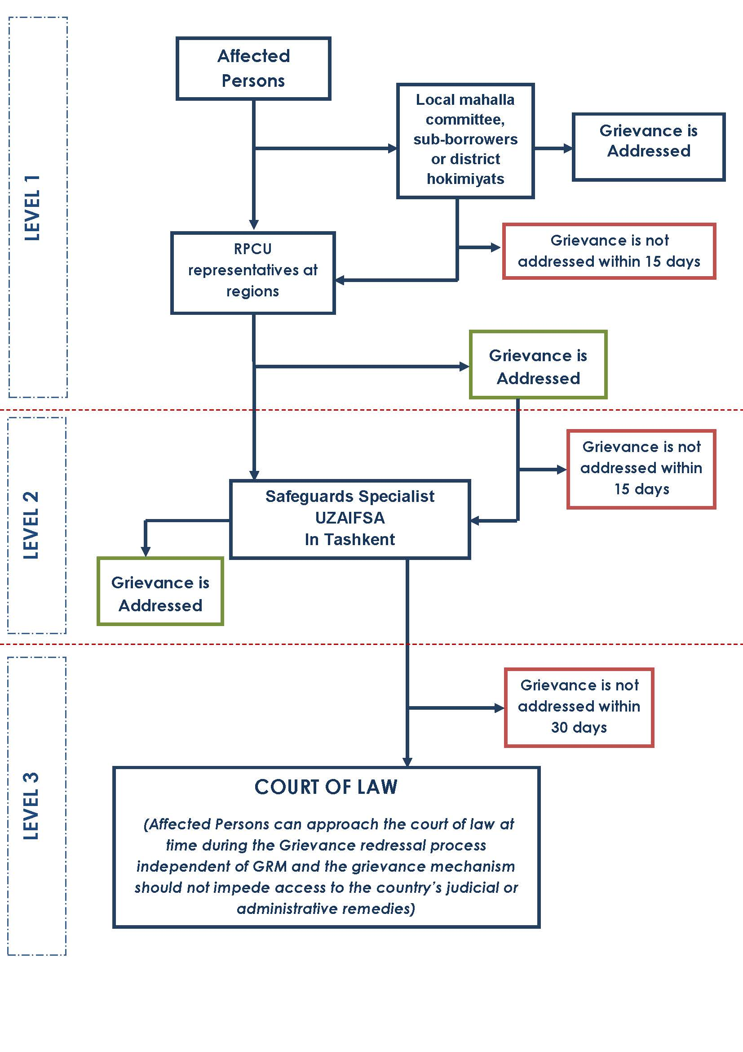

- ANNEXES

Annex 1. Example Grievance Form

Grievance Form
Grievance reference number (to be completed by GRM Focal Point):
Contact details  (may be submitted anonymously) | Name (s):
 | Address:
 | Telephone:
 | Email:
How would you prefer to be contacted (check one) | By mail/post:  ☐ |  |  | By phone:  ☐ |  |  | By email  ☐
Preferred language | ☐ Uzbek |  |  | ☐ Russian |  |  | ☐ other___________
Provide details of your grievance. Please describe the problem, who it happened to, when and where it happened, how many times, etc. Describe in as much detail as possible.
What is your suggested resolution for the grievance, if you have one? Is there something you would like khokimiyat or another party/person to do to solve the problem?
How have you submitted this form to the project? | Website  ☐ |  |  | email  ☐ |  |  | By hand  ☐
 | In person  ☐ |  |  | By telephone  ☐ |  |  | Other (specify)  ☐
Who filled out this form (If not the person named above)? | Name and contact details:
Signature
Name of Focal Point person assigned responsibility
Resolved or referred to GRC1? | ☐ Resolved |  | ☐ Referred |  | If referred, date:
Resolved referred to GRC2? | ☐ Resolved |  | ☐ Referred |  | If referred, date:
Completion
Final resolution (briefly describe)
 | Short description |  |  |  |  | Accepted? (Y/N) | Acknowledgement signature
1st proposed solution
2nd proposed solution
3rd proposed solution

Annex 2. Brief summary of stakeholder meetings for purposes of SEP preparation
FGD and individual interviews were held in Andijan, Khorezm, and Bukhara with:
Region | Date | FGD/Interview | Number of participants | Male | Female | Key points raised during meetings
Andijan | 28.09.2019 | FGD (Commercial farmers and agri-business enterpreneurs) | 10 | 10 | - | Major obstacles faced by both commercial farmers and smallholder/dehkan farmers centered on irrigation since the rise of salty water levels is creating difficulties for getting more harvests.  Local population often get involved in horticulture practices in partnership with large commercial farmers.  There is a high demand for credits with 8% interest rate in horticulture sector but the number of such credits is limited.  Fertilizers are brought from far regions, and there is a need for opening fertilizer shops in neighborhoods.
 | 28.09.2019 | 3 Individual Interviews (Commercial farmers and smallholder/dehkan farmers) | 3 | 3 | - | Farmers mentioned the difficulty of access to water in hill areas. This necessitates drip irrigation and hydroponics in horticulture production. However, smallholder/dehkan farmers cannot afford to invest in technology and the foreign specialists for running such alternatives to traditional irrigation. This can only be done by mobilizing smallholder/dehkan farmers into cooperatives.
 | 29.09.2019 | FGD (Smallholder/dehkan farmers, Mahalla officials/ | 11 | 10 | 1 | Horticulture farmers are faced with a number of difficulties while applying for bank loans. Banks require the farmers to put their properties as a collateral. However, it takes about 6 months for horticulture products to be ready for sale, and farmers, in most cases, cannot pay credits during these 6 months.  Information about concessional loans in agriculture/horticulture sector that are given by international institutions such as World Bank should be distributed in a more transparent way by using different social media channels.  The experts of research institutes should play a more important role in disseminating knowledge to farmers about new experiences in agriculture/horticulture sector. The role of social media should also be strengthened in sharing information.
 | 29.09.2019 | 2 Individual Interviews | 2 | 2 | - | In order to export the fruits and vegetables, farmers are required to provide certificates which confirm the originality of the plants and seeds. However, smallholder/dehkan farmers cannot buy these certificates, and thus will not be able to export their products.  Awarding mechanism should be established for the farmers who are producing large amounts of horticulture products and actively exporting them. This motivates farmers to be more innovative and productive.
Khorezm | 28.09.2019 | FGD (Farmers’ Union, large and small farmers, agri-business entrepreneurs) | 12 | 10 | 2 | Changes in the agriculture sector for the last 5 years  Lack of energy supply for horticulture e.g. greenhouses  Khorezm’s environmentally less advantaged position in Uzbekistan  Very high formalities and difficult procedures in preparing official documents for applying for bank credits.
 | 28.09.2019 | FGD (Makhalla representatives) | 13 | 8 | 5 | Lack of Bank’s financial resources for business projects in agriculture sector  Bankers’ lack of expertise in evaluating the soundness of business projects
 | 28.09.2019 | 2 Individual Interviews (Officials from the Farmers’ Union) | 2 | 2 | - | The role of farmers’ union in diversifying farming industry  Forming a “Dehkan” culture.  The officials of farmers' union make "door to door" visits to about 150 smallholder farmers every day in order to check their progress and learn about their needs and demands. They also help rural communities form "dehkan" culture by encouraging all households to use their plots more efficiently.  Regular consultations of farmers’ union with its members  Communication tools e.g. telegram channels, exhibitions, seminars etc.  Grievance redress mechanism –  High demand for lower credit rates from farmers with ready business plans  Suggestions:  Allowing farmers to make independent decisions regarding the types of products they grow  - Abolishing minimum plan on what farmers grow  Lack of logistics centers
 | 29.09.2019 | 3 Individual interviews (Officials from Uzbekistan Agroindustry and Food Security Agency under the Cabinet of Ministers (UZAIFSA)) | 3 |  |  | Very few applications for bank credit by individuals with small plots  Difficulty of making profit from smaller e.g. 1 hectare greenhouses  Miscalculation of business project costs by entrepreneurs  Fake documents while applying for bank credits  Issues related to collateral required by banks  Very high requirements for the extension of payment periods  Requirements of companies that can be used as guarantors  Reasons for rejections of applications for bank credits  No proper legislation for dispute settlements in case of defaults and appeals after defaults
Bukhara | 30.09.2019 | FGD (Hokimyat members, small and large farmers, agri-business entrepreneurs) | 8 | 7 | 1 | More credit is needed for greenhouse and refrigerators  1100 hectares allocated for greenhouses  Boom in agriculture/horticulture in recent years due to currency convertibility  7 years not enough for making profit from intensive gardens  Uzbek som is preferred over USD while getting bank credits  Main markets for exports – Russia and Kazakhstan  Strong need for establishing logistics centers  - to gather and export products  - to manage proportional distribution of products during different seasons  High risk of using hydroponics at the first time.
 | 01.09.2019 | 4 Individual Interviews  (Smallholder /dehkan farmers, agribusiness entrepreneurs) | 4 | 3 | 1 | Seeds  There are not experienced agronomists who understand seed and plant breeding in horticulture sector. Therefore, farmers are hiring some specialists from Korea to train their agronomists. Opening the branches of training labs for specialists is strongly recommended.  Land is being used inefficiently due to late credit supply from banks. The process of reviewing applications for bank loans should be accelerated.  Larger amount of production is needed for penetrating world agricultural commodity market.
 | 01.10.2019 | FGD (Makhalla representatives) | 6 | 6 | - | Complaints are made to hokimyats in most cases. Interestingly, both commercial and smallholder farmers prefer to make complaints to local hokimyats, although there are other institutions that have an authority to address the issues and complaints such as Farmer’s Union and the Chamber of Commerce.
 | 02.10.2019 | 1 Individual Interview (Representative of Bukhara Free Economic Zone) | 1 | 1 | - | Jobs in the agriculture sector are unequally distributed between males and females. Women are generally underrepresented in large commercial farms since majority of such farms are owned by males.

FGDs (Andijan)
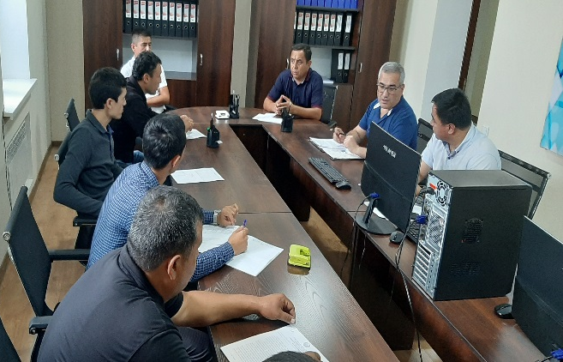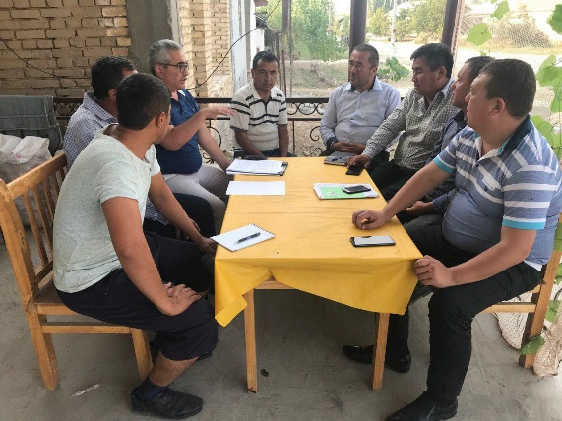

Interviews (Andijan)
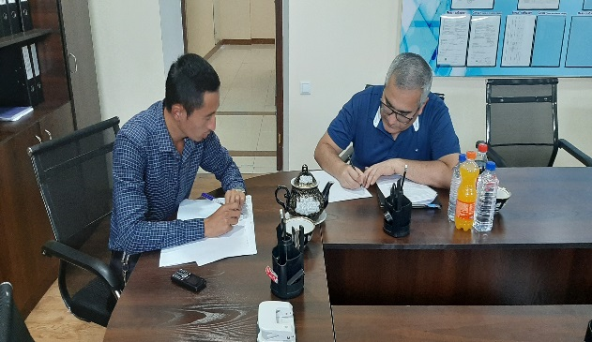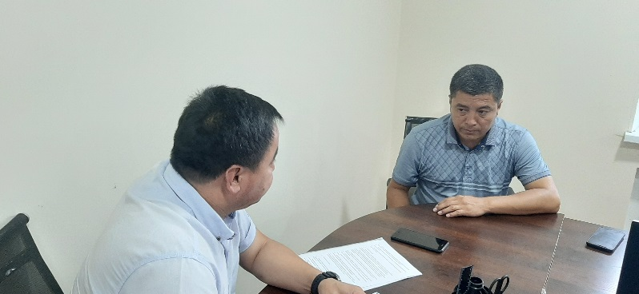

FGDs (Bukhara)
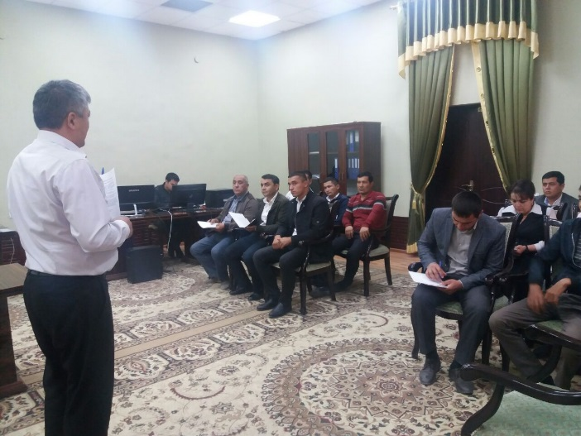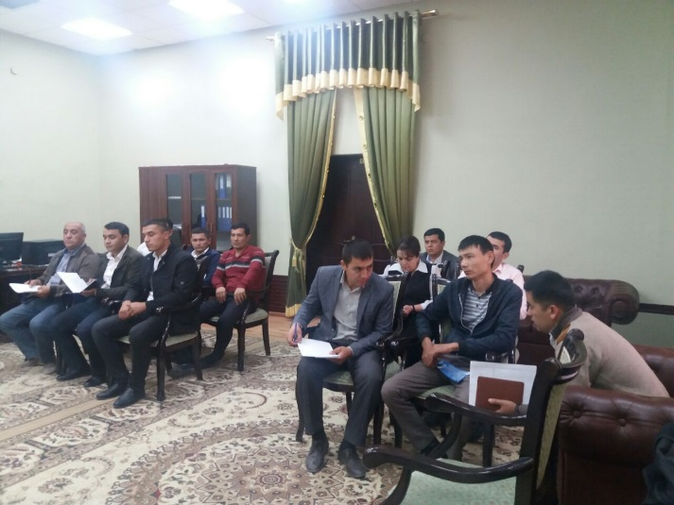
Interviews (Bukhara)
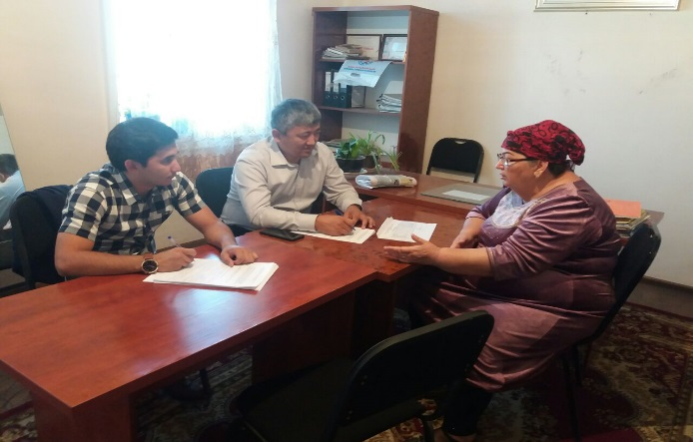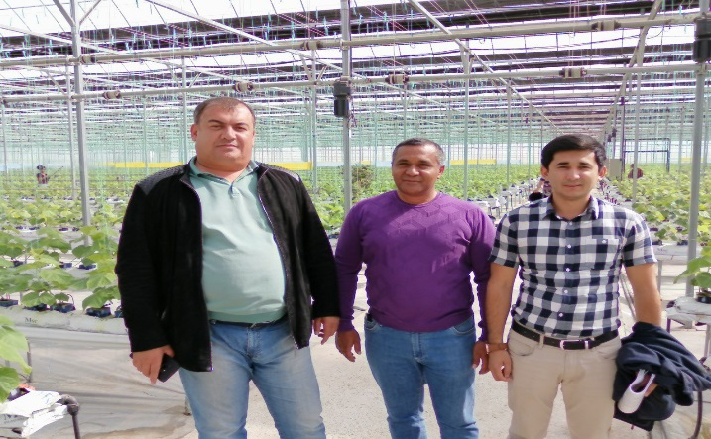

FGDs (Khorezm)
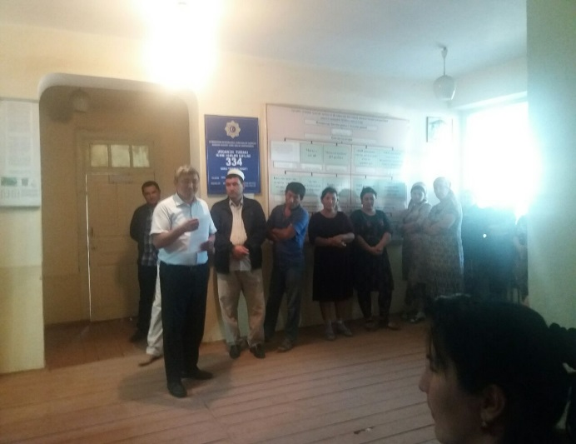

Interviews (Khorezm)

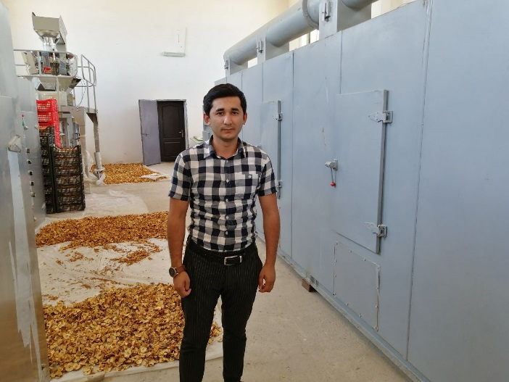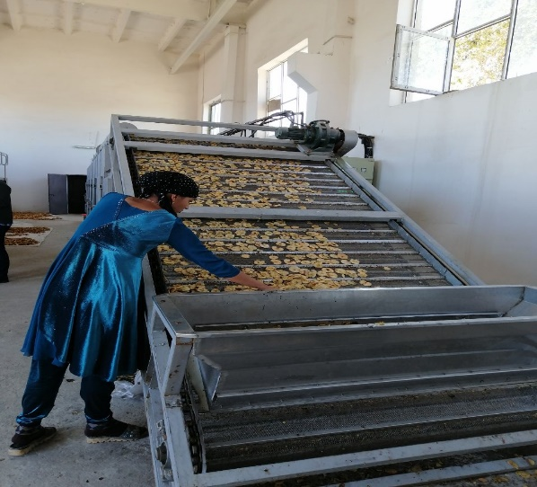

According to the Article 3 of the Law” On Farm Enterprise”, multi-profile farm is a farm that along with production of agricultural products is engaged in conversion, storage and realization of agricultural products, industrial production, performance of works, rendering services and other types of activity which are not forbidden by the legislation.
Neighborhood
The logbook should sequentially numbered and pages have been bound securely.

