ENHANCING COASTAL AND OCEAN RESOURCE EFFICIENCY (ENCORE) PROGRAM

ENVIRONMENTAL AND SOCIAL MANAGEMENT FRAMEWORK

EXECUTIVE SUMMARY
- Project Overview
The ENCORE is proposed as an eight-year Multi phase Programmatic Aproach (MPA) operation with two overlapping phases of five years each that are anchored in the umbrella India’s National Coastal Mission. The ENCORE Project (P167804), the phase I of MPA; aims to strengthen integrated coastal zone management in all coastal States and Union Territories of India through the following components.
- Component 1. Improved Capacity for Decentralized Coastal Management
- Component 2. Improved Protection and Pollution Abatement in Coastal Areas
- Component 3. Project Management, Monitoring, and Evaluation
The Program seeks to assist the Government of India (GoI) in enhancing coastal resource efficiency and resilience, by building collective capacity (including communities and decentralized governance) for adopting and implementing Integrated Coastal Zone Management (ICZM) approaches. Recognizing ICZM as a continuous process rather than a one-off investment action, ENCORE will build upon and draw from the experience of the ongoing World Bank-supported Integrated Coastal Zone Management Project (ICZMP – P 097985), including the linkages between coastal conservation, climate resilience, and poverty reduction.

During Phase I, project activities considered for implementation in Eight (08) States / and Three (03) Union Territories (UTs) of coastal India relate to improving the coastal environment; leveraging the concepts of resource efficiency. Three coastal States, namely; Gujarat, Odisha and West Bengal have prepared ICZM Plans as part of ICZMP Project. During MPA Phase I, ICZM Plans would be prepared for the selected coastal stretches in other States/UTs under the program. In addition to priority projects for coastal pollution prevention, livelihood support and coastal resilience identified in these Plans, those investments which will inform effective coastal management solutions to guide ICZM Plan preparation in these States/UTs will also be taken up for pilot / demonstration purposes during MPA Phase I.
Institutional capacity building for effective coastal management, Mapping and Database creation, and Monitoring and Research Facilities will also be supported under Phase I. Investments proposed by the States/UTs include a) mangrove afforestation / shelter beds and other infrastructure for coastal protection, b) habitat conservation activities such as restoration of seagrass meadows, eco-restoration of sacred groves, development of hatcheries, rearing and rescue centers for turtles, and other marine animals, c) environmental infrastructure works including solid (including plastics/marine litter) and liquid waste management in small coastal towns for pollution abatement and protection of marine/coastal habitats, water harvesting, restoration and recharge of water bodies, beach cleaning and development. Livelihood improvement projects include demonstration of climate-resilient saline agriculture, creation of infrastructure and facilities to support ecotourism, community-based small-scale mariculture, seaweed cultivation, aquaponics, small household industries, and value addition to other livelihood activities ranging from fish processing and preparation of value-added products, to local crafts.
Since ENCORE Program is funded under Investment Project Financing (IPF) instrument of the World Bank, its Operational Policies (OPs) and Bank Procedures (BPs) are applicable for the project. ENCORE also aims to use Development Linked Indicators (DLIs) and as under regular IPF, environmental and social requirements apply to all activities for which Bank support is sought by the Borrower, as defined in the project’s legal agreement between the Borrower and the Bank, whether they are financed by the Bank or from another source. The scope of the environmental assessment includes the ‘area of influence’ of Bank-financed activities, which may span an entire sector or region. In each case, the Bank policies are applied and compliance with them is verified at the same level. Project Concept Note Review for ENCORE program was before 01 October 2018 (cutoff date for application of World Bank’s new Environmental and Social Framework (ESF)). Hence World Bank Safeguard policies apply to Phase I of this MPA and the safeguards instruments will be reassessed in line with the ESF as and when Phase II of the project is prepared for approval by the World Bank’s Board of Directors.

- Baseline Assessment and Environment and Social Issues
It is envisaged that the project would lead to positive impacts, including marine and coastal conservation, pollution prevention and effective utilization of coastal resources, and promotion of sustainable coastal livelihoods. Rather than ad-hoc placing and implementation of project investments in time and space without adequate planning considerations, the ICZM Plan which would be prepared by each State as part of the program would set the stage for investments, with a scientific basis; considering the environmental, social and climate-related sensitivities among others. Thus, the program mandate subsumes safeguards management as an integral part of the project objectives and implementation.
The assessment reveals no large scale, significant and/or irreversible environmental or social impacts due to the proposed project interventions. The program will avoid undertaking any activities that will cause significant conversion or negative impacts on natural habitats and sensitive environmental receptors. Activities that may have cumulative/regional impacts or larger scale of construction / Operation and Maintenance (O&M) stage impacts (such as waste management, coastal protection structures) will be taken up for implementation only if its necessity is established and guided by ICZM Plans. While the overall program is thus environmentally beneficial, some activities such as construction and up-gradation of infrastructure and facilities for coastal protection and pollution prevention, and certain livelihood support activities are likely to result in low to moderate risks and impacts if designed without adequate care. These can effectively be managed across the detailed design and implementation phases of the investments.
Private land acquisition is not envisaged under the project. Mangrove plantations and small infrastructure in villages will be carried out on public land. Rehabilitation of assets will be in-situ and will not require any additional land. However, there are chances of encroachment of public land. During the construction phase, the influx of large numbers of migrant workers in the project area is also not envisaged as assets to be created will be small. Mangrove plantations and rehabilitation work will be undertaken by the local community. At the same time, the Project will benefit the community in general. The subprojects need careful planning to ensure inclusion and equity so that the project benefits reach all.

Considering the spread of project activities along multiple locations in coastal India, Safeguards Category is considered as “A” as per the World Bank’s Safeguards Policy OP 4.01 Environmental Assessment. Detailed environmental and social assessment considering cumulative impacts has been conducted by the Borrower. Impact assessment reveals that most of the likely adverse impacts could be avoided, minimized or eliminated by adopting proper design and standard mitigation measures. Also, there is ample scope to enhance some of the beneficial impacts to be generated from the proposed projects, following the Bank safeguard policies. Based on this assessment and enhancement and mitigation opportunities, a framework for the management of environmental and social aspects under the project has been prepared by the borrower, as the investments or locations for all subprojects are not finalized yet.

- Environmental and Social Management Framework
The Environmental and Social Management Framework (ESMF) prepared for the ENCORE Program acknowledges the probable impacts of the subprojects, and integrates measures for assessing, avoiding, mitigating and managing these during planning / pre-construction, construction, and operation and management (O&M) stages of the subprojects. The framework identifies the level of safeguard and due-diligence required for all categories of sub-projects and provide specific guidance on the policies and procedures to be followed for environmental and social assessment, along with roles and responsibilities of the implementing agencies to ensure effective environmental and social management.

The ESMF aims to ensure the following:
- integration of environmental and social aspects into the decision-making process at all stages of the sub-projects by identifying, avoiding and/or minimizing adverse environmental and social impacts early-on in the project cycle,
- Enhancement of positive/sustainable environmental and social outcomes through sensitive planning, design, and implementation of sub-projects,
- Avoidance or minimization of impacts on cultural properties and natural habitats and/or other direct/indirect impacts through careful planning and safeguards,
- Restoration or improvement of the livelihoods and living standards of the subproject affected people (if any) and compensate any loss of livelihood or assets, and
- Adoption of occupational and community health and safety standards including, labor/work campsite management, contract management, monitoring/supervision protocols, and capacity building.

ESMF for ENCORE Program is presented in two Volumes; Volume I and Volume II.
Volume I presents the Baseline Environmental and Social Assessment, ESMF for this project discussing the applicable regulations, the process for carrying out subproject environmental screening, assessment, preparation of environmental and social management plan including mitigation measures, and monitoring plan. It also presents the Resettlement Policy Framework, Indigenous Peoples Planning Framework (IPPF), Gender Action Plan, Labor Management Framework and Grievance Redressal Mechanism. It also presents the institutional mechanism and its budgetary requirements for implementing the ESMF, process for updating this ESMF in addition to details on Stakeholder Consultation and Information Disclosure (for ESMF and subprojects).
Volume II presents the documentation formats to be used for screening of projects, sample Terms of References (ToRs) for (i) Impact Assessment, (ii) Specialists to manage ESMF, and (iii) auditing/monitoring compliance to ESMF. It also provides guidance materials for licenses, permits, clearances under various regulations, and indicative Environmental and Social Management Plans (ESMPs) and monitoring plans for typical subprojects. It also presents a comprehensive set of Environmental Codes of Practices (ECoPs) for guiding various project activities.

- Applicable Environmental Regulations
Applicable National and State regulations, various international treaties, and the World Bank Operational Policies need to be considered for siting criteria, environmental pollution control requirements, institutional arrangements, ensuring occupational health and safety, resource utilization and considerations on cultural and social aspects. Several national and state-level environment and social laws will be applicable to ENCORE, including (but not limited to) the Environment (Protection) Act, 1986; Coastal Regulation Zone Notification 2019, Forest (Conservation) Act, 1980; Wildlife Conservation Act, 1972, Biodiversity Act 2002, Water (Prevention and Control of Pollution) Act, 1974; Air (Prevention and Control of Pollution) Act 1981; Solid waste (Handling and Management) Rules, 2016; Plastic waste Management Rules 2018, Construction and Demolition Waste Management Rules 2016, Labor laws, Right to Fair Compensation and Transparency in Land Acquisition, Rehabilitation and Resettlement Act, 2013; Street Vendors (Protection of Livelihood and Regulation of Street Vending) Act, 2014.

The following policies of the World Bank are applicable for Phase I of this Multi-Phase Program: a) Environmental Assessment (OP/BP 4.01), b) Natural Habitats (OP/BP 4.04), c) Pest Management (OP 4.09), d) Forests (OP/BP 4.36), e) Physical Cultural Resources (OP/BP 4.11), f) Indigenous Peoples Policy (OP/BP 4.10), g) Involuntary Resettlement (OP/ BP 4.12) and World Bank Policy on Access to Information and Disclosure. The ESMF also recommends World Bank Group (WBG) Environmental Health and safety (EHS) Guidelines for all projects, and WBG Industry Sector Guidelines as applicable to the sub-projects such as Waste Management Facilities, Water and Sanitation.

- ESMF Process
ESMF describes the process to be adopted to screen the subprojects to decide on including or excluding them; to categorize based on defined criteria and to manage these using either full-fledged ESIAs and ESMPs or using Generic ESMP. ESMF describes the process, institutional mechanism, and budget to undertake screening, scoping, assessing and incorporation of mitigation measures during the project cycle involving a) Sub-project Initiation, b) Sub-project Preparation, c) Sub-Project Implementation, d) Monitoring and Evaluation; presented in Figure A.
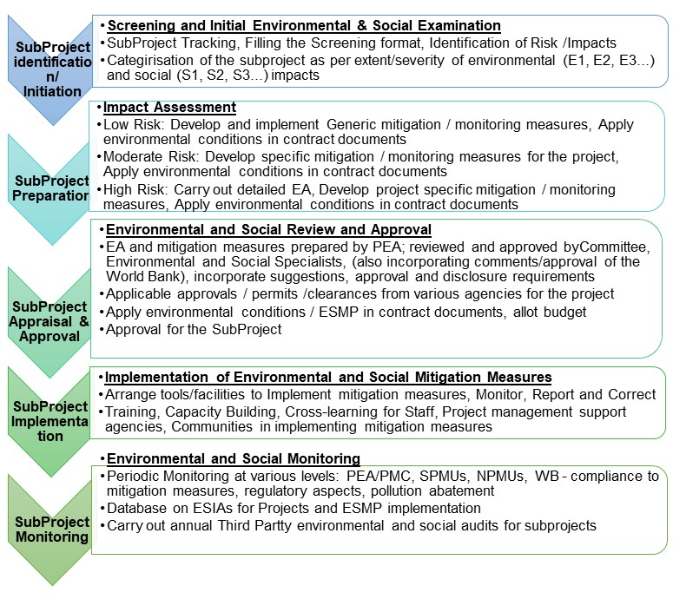

Figure A: ESMF Process

- Environmental and Social Management for ENCORE
Depending on the type of investments and nature of activities, proposed subprojects will have varying impacts on the environment. Hence, the type and extent of environmental assessment to be carried out to identify and mitigate the impacts also largely depends upon the complexities of project activities and exact locations. It is important to identify the probable impacts and plan for mitigation measures early on, to manage them effectively. To facilitate effective screening, under ENCORE Program, the subprojects are grouped into different categories – E1, E2, and E3 linked to extent and severity of impacts (depending on type of activities and locational characteristics) and regulatory requirements.

As per the ESMF, the first step will be to conduct screening exercise, where the environmental and social issues will be identified by undertaking initial environmental and social examination and the filling of Environmental and Social Screening Checklist for the potential sub-projects. The objective of filling this checklist will be to collect basic information on environmental and social baseline parameters, issues, and potential impacts. Based on this, the sub-projects will be categorized. Based on the screening process undertaken, Environmental and Social Specialists of the SPMU would undertake project categorization. They would classify subproject into E1, E2, E3 as per severity and extent of environmental impacts and S1, S2 and S3 based on social impacts.

Projects categorized as E1 will follow the requirements of Bank OP 4.01 Category A projects requirements, and E2, E3 projects will follow the requirements of Bank OP 4.01 Category B project requirements. Guidance is provided here for the indicative categorization of projects.

Table A: Environmental Categorization of Projects
Proposed Subproject Categories | Description |  | Type of project
 | Extent of Environmental impacts | Management measures
E1 | Major environmental issues expected | Project-specific EA preferably by an independent agency. In case the DPR consultant undertakes the ESIA for better alignment with project details; the ESIA will be reviewed by an independent consultant.  Specific mitigation/monitoring measures including those to improve environmental performance, ensure environmental sustainability and climate resilience/adaptation. | - Projects impacting sensitive environmental components including natural habitats  - Projects requiring CRZ Clearance (National Level) as per CRZ Notification 2019 and Environmental Clearance as per EIA Notification 2006, of MoEFCC
E2 | Moderate environmental issues expected | Project-specific EA along with the DPR. ESMP including measures to improve environmental performance, sustainability ad climate resilience/adaptation. | - Projects with impacts less adverse (in intensity and spread) than the E1 category and mostly generic.  - Projects requiring only CRZ clearance (State Level) or Environmental Clearance (State Level)
E3 | No environmental issues expected | Generic ESMP.  These will also consider measures to improve environmental performance, sustainability, and climate resilience/adaptation as part of overall design/plan | - Projects which would improve the environment without any negative impacts.  - Research and Capacity building activities
Also, in case a subproject has more than one among these subcomponents, the higher category applicable for any subcomponent would be considered as the category for the subproject as a whole. Categorization will also consider other sensitivities of the project locations such as proximity to valuable environmental features. Specialists shall apply adequate experience and expertise-based judgment to determine the category of subprojects. For projects not listed in the guidance tool, categorization will be done based on its environmental sensitivity. Any upward/ downward scaling of categories such as from E2 to E1 and vice versa requires proper justification, concurrence of Society of Integrated Coastal Management (SICOM) under MoEFCC which is the National Project Management Unit (NPMU) for ENCORE and shall follow National and State Regulations and the safeguard policies of the World Bank. In addition to addressing environmental issues, NPMU commits itself to explore opportunities for environmental enhancement in various sub-projects.

Social categorization of subprojects would be based on the following criteria.

Table B: Social Categorization of Projects
Category | Level of Issue | Management Measure | Type of Projects
S1 | Serious social issues expected | SIA and RAP | - If it involves acquisition of private land with major impacts (people lose more than 20 % of the productive assets)  - If it involves physical displacement.
S2 | Moderate social issues expected | SIA and  Abbreviated  RAP | - If impacts are limited to less than 200 Persons or about 50 families of minor nature (people lose less than 20 percent of the productive assets).
S3 | No social issues expected; hence socially benign | Social Screening Report | - No private land acquisition or no impacts to PAPs.

ESMF describes the process for managing and mitigating anticipated impacts by a) following Strategic Environmental and Social Assessments (SESA) approach as integral part of regional/sectoral plan preparation activities including ICZM Planning, b) Environmental and Social Impact Assessments (ESIA) and ESMPs for moderate-risk projects; and c) using Generic ESMPs for low-risk projects. Besides, a set of Environmental Codes of Practice are also included in the ESMF to guide the integration of environmental aspects in planning and project-related activities. ESMF also suggests the use of the World Bank Group EHS Guidelines on cross-cutting environmental and social, health, and safety issues potentially applicable to construction and other projects. Further, ESMF guides screening, assessing, planning and implementing mitigation measures, and supervising/monitoring the impacts on natural habitats, forests, physical cultural resources and pest management. ESMF will be adopted for both Plan preparation, Technical Assistance and implementation of projects. Also, it is applicable for capacity building activities including improving the research facilities. The ESMF lays out the framework to identify and address environmental and social impacts across screening, ESIA preparation, ESMP implementation, and site decommissioning.

ESMF also describes the improved institutional mechanism, capacity building and cross-learning of environmental actions at the National, State and Project levels, supervision and monitoring mechanisms and budget for ESMF implementation. Since location and design information for conducting activity-specific ESIAs for some of the project activities are likely to be available only during project implementation, the ESMF defines the detailed process for the consultations, reviews, and clearances.
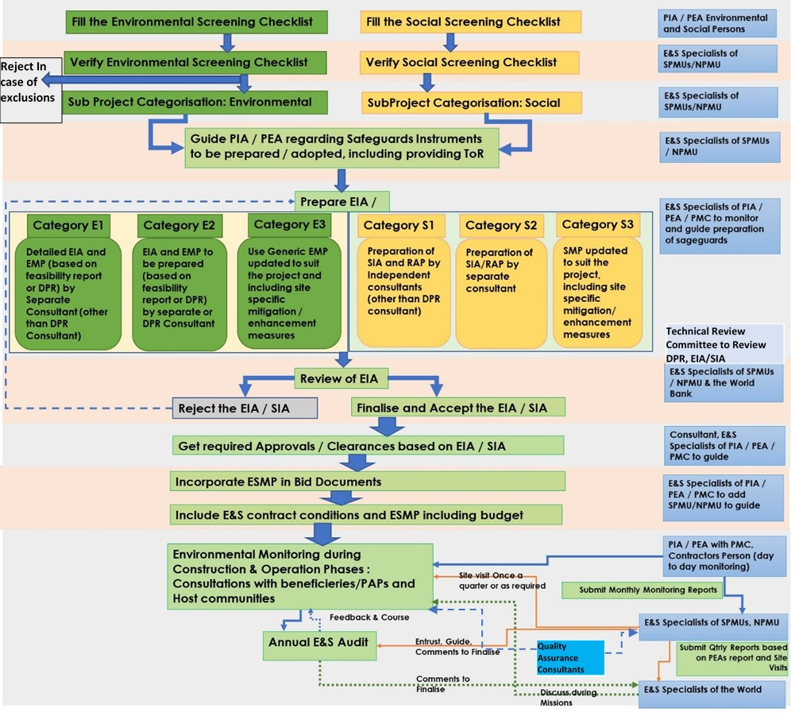
Figure B: Environmental and Social Requirements during Subproject Cycle

Guidance for Subproject ESIAs/ESMPs
ESMF provides guidance to prepare subproject ESIAs; as follows.
- Guidance on Project Screening, Impact Assessment, Institutional Framework for implementation and O&M stages, including ESMP in contract documents, supervision and reporting, and Audit for monitoring the effectiveness of subproject Environmental Management
- Indicative ESMPs are provided, which could serve as a guide for developing site-specific ESIAs when project details are finalized,
- Guidance on Chance find procedures for Physical Cultural Resources, mitigation measures to be included in ESMPs,
- Guidance on Physical Cultural Resources Management Plan if required to be prepared for physical cultural heritage areas
- Guidance to include in ESMPs site-specific measures to protect natural habitats, provision for monitoring and evaluation to provide feedback on conservation outcomes and to provide guidance for developing or refining appropriate corrective actions,
- Indicative Integrated Pest Management Plan (including expert support required) and guidance on minimizing impacts due to use of fertilizers/herbicides is also included in the ESMF,
- ECoPs in Volume II provide guidelines for environmental management of certain project activities including which are seen to be of limited extent of impacts/risk, temporary and reversible, and readily managed with good practices during the implementation of the proposed project interventions. The Contractors can use these while preparing and implementing Contractors ESMP at work start,
- Guidance is provided in Generic EMPs/ECoPs on how to minimize/avoid impacts in case of projects directly / indirectly related to Natural Habitats,
- Specific guidelines for the ESIA consultant firms to prepare (i) labor campsite and management plan, Waste and silt disposal plans, (ii) Occupational Health and Safety management plan and (iii) archaeological chance find procedure; which forms an integral part of all subproject ESIAs falling in E1, E2 category, and (iv) Physical Cultural Resources Management Framework in case of cultural/heritage interventions, (v) Integrated Pest and Nutrient Management framework for agriculture and related activities where there may be possible need to use pesticides/weedicides, fertilizers.
- Subproject ESIAs would require assessing such potential issues linked to temporary project induced labor influx, the specific impacts can only be assessed once the contractor is appointed and decides to outsource labor. ESMF also provides guidance on Labor Management procedures. Labor Management Framework will ensure that the potential impacts associated with the influx of labor on the host population and receiving environment are minimized through compliance with the national labor laws. It will also ensure the provision of safe and healthy working conditions, and a comfortable environment for migrant labor. Contractor ESMP shall include a labor management Plan. Relevant clauses shall be included in the bid documents and provisions shall be made in the subproject ESMP.
- Resettlement and Rehabilitation Action Plan (RAP): In case the project involves land acquisition against compensation or loss of livelihood or shelter, the project shall ensure that a satisfactory RAP has been prepared under the ESIA and shared with the affected persons and the local community.
- The key objective of the Indigenous Peoples Plan (IPP) is to give special attention to tribal issues and concerns during the implementation of the project. The IPP prepared based on the framework provided in the ESMF will be discussed with and disclosed to the key stakeholders. This will be adopted on a full scale in the scheduled areas and as deemed necessary in the other areas.
- The affected communities will be able to voice concerns and grievances and have them addressed through the Grievance Redressal Mechanism. Effective Grievance Redressal Mechanism gives an opportunity to the organization to implement a set of specific measures to ensure good governance accountability and transparency in managing and mitigation of environmental and social issues of a particular project. This consists of defining the process for recording/receiving complaints and their redressal in respect of environmental and social aspects.
- ESIA and Project related information will be disclosed through public consultation and making relevant documents available in public locations. The SPMUs and associated PEAs will provide relevant safeguards information on time, in an accessible place, and in a form and languages understandable to affected person and other stakeholders.

- Institutional Framework
Ever since the ICZM Project (2010), NPMU has an established organizational support structure to ensure that the policy obligations and associated procedures in the ESMF are implemented. The implementation experience of ESMF in coastal management projects necessitates extension of the responsibility to respective SPMUs and Project Agencies / Project Executing Agencies (PEAs) to enhance safeguard arrangements at the implementation level, besides capacity building for continued incorporation of environmentally acceptable measures for all future coastal development activities. Further, the National Centre for Sustainable Coastal Management (NCSCM), under MoEFCC is capacitated to support NPMU in coastal management projects through its involvement in the ICZM Project. NCSCM has a specialised CRZ Cell and Cumulative environmental Impact Assessment division to support such assessments in addition to wide pool of scientists/experts in coastal and marine biodiversity. PMC/SPMU or PEAs shall have forestry and biodiversity experts to ensure that in case project involves natural habitats or forest restoration, the project design incorporates means of addressing the potential for forest restoration to improve biodiversity and ecosystem functions and biodiversity aspects are well-considered and implemented/supervised. Proposed institutional framework at National, State and Project levels and suggested responsibilities for environmental and social safeguards are presented in the following Figure C.

Figure C: Proposed Institutional Framework for Safeguards Management for ENCORE
Preparation of Subproject Safeguards Documents
Preparation of ESIAs for subprojects will be co-ordinated by environmental and social specialists at SPMUs, based on the screening format prepared and submitted by PEAs. DPR Consultants or independent consultants would prepare ESIAs with stakeholder consultations. ESIA will be discussed and the draft final report will be prepared with inputs from the Technical Review Committee. Any clarifications on applicability of CRZ rules or technical and scientific aspects related to coastal, marine habitats and preparation of projects and / or special review of projects involving any natural habitats will be sent to NCSCM. After completion of review and finalization by SPMU, subproject ESIAs will be forwarded to NPMU. NPMU will review ESIAs to ensure compliance with ESMF and E1 / S1 projects will be forwarded to the World Bank for review and approval. NPMU will also prepare ESIAs through independent / DPR consultants for National Components. These will be sent to the World Bank for review and approval. The final version of ESIA with ESMP and RAP/IPPF reports in English with a non-technical summary in local language, shall be disclosed in the websites of the NPMU/ SPMUs/LBs/PEAs/District Collectorate/relevant departments and will be made available in notice boards or in offices easily accessible to the local people. The applicable ESMPs will be made part of the bid documents and will be updated during the subproject implementation phase, as required. This ESMF applies to all the components under the project along with its linked or associated activities irrespective of Bank financing and will be subject to Bank supervision.
Implementation of Subproject ESMPs
A multi-layered institutional structure is presented for the management of subproject environmental and social aspects during the implementation phase.
Project/ Site Level
At the Project level, the contractor is responsible for ESMP implementation on the ground and will maintain all site records. He will report on the progress of ESMP implementation to the Environmental Specialist of the PEA or Project Management Consultant (PMC) appointed in case of complex projects; both with full–time, dedicated Environmental and Social experts with appropriate qualifications and experience. PMC or PEAs shall have forestry and biodiversity experts to ensure that in case project involves natural habitats or forest restoration, the project design incorporates means of addressing the potential for forest restoration to improve biodiversity and ecosystem functions and biodiversity aspects are well-considered and implemented/supervised.
State Level
At State Level; SPMUs headed by Project Director and Assistant Project Director, will have dedicated environmental and social experts with appropriate qualification and experience for coordinating with PEAs (Urban Local Bodies / Respective Departments/others) for ensuring ESMF compliance, provide guidance, maintain records and submit the relevant documents/ reports to NPMU every quarter. SPMUs have/are already in the process of hiring the Environmental Specialist and Rural Development / Social Specialist, who will jointly manage environmental and social aspects of sub-projects. Construction Supervision and Quality Control Consultants will be hired by SPMUs, and will contain a dedicated Environment, Social, Health and Safety officer to look at ESMP implementation, labor management, and occupational health and safety risks. For projects involving Natural Habitats, Quality Assurance Consultants will also monitor the implementation of mitigation measures through their expert with specialization in biodiversity conservation and management. Specialized consultants will be hired for the preparation and supervision of projects involving Physical cultural resources or pest management.
National Level
NPMU headed by Project Director and Assistant Project Director will supervise and monitor implementation of social and environmental safeguards for select category E1, S1, E2, S2 sub-projects under ENCORE as per this ESMF through Environmental and Social Safeguard Nodal Officers already part of their team. The biodiversity officer at NPMU will also provide inputs to review and clear projects involving natural habitats. Detailed Management Information System linking project details, scheduling and documentation to the ESIA process and ESMF implementation will support the NPMU in the effective preparation of safeguard instruments, supervision, and monitoring.

- Capacity Building
ESMF envisages capacity building on safeguards and technical aspects for NPMU, and SPMUs, by organising annual sensitization programs, workshops, and training/capacity building, exposure visits in coordination with training institutions (experienced in various aspects of coastal management, infrastructure development or area development projects) and the World Bank. Cross-learning events/workshops where the States implementing the projects can learn from each other on operational issues and best practices will be organized. The proposed capacity building activities will be supported through appropriate Technical Assistance of ENCORE.
The World Bank project task team, specifically the environmental and social specialists, will provide close supervision and necessary implementation support by reviewing and providing guidance on conducting screening, and the preparation of relevant safeguard instruments as well as providing training for SPMU/NPMU specialists.

- Monitoring and Supervision
Provisions in the ESMF for supervision, monitoring, and reporting include:
- Reporting on Safeguards / ESMPs: Monthly (or as and when required) Implementation Report, by Contractor to PEA; Monthly Supervision Report by PEA / PMC to SPMU, Quarterly report by SPMU to NPMU (based on monthly report by PEAs/PMCs, Monitoring report by Quality assurance Consultants and quarterly supervision by SPMU). NPMU uses the Quarterly Progress Report submitted by SPMUs and sample site visits for progress monitoring.
- Safeguards monitoring report by Quality Assurance Consultants along with monitoring of Civil Works when the works are ongoing and at work exit/operations. For projects involving Natural Habitats, Quality Assurance Consultants will also monitor the implementation of mitigation measures through experts with specialization in biodiversity conservation and management.
- Annual Environmental and Social Audit for select projects (both National and State - all E1, S1 and select E2, S2) by independent consultants e) capacity building for Environmental and Social Management
- NPMU will undertake annual audits to review the status of ESMF compliance of all E-1/S1 projects and sample E2/S2 projects. The draft report will be forwarded to the World Bank and upon approval, the final audit report will be disclosed and compliance will be ensured.
- Detailed Management Information System linking project details, scheduling and documentation of ESIA process and ESMF implementation will support the NPMU in the effective preparation of safeguard instruments, real-time supervision, and monitoring.

- Budget for ESMF Implementation
To effectively implement the environmental and social management measures suggested as part of the ESMF, necessary budgetary provisions will be made in the DPRs for the individual sub-projects. The tentative budget for each of the projects should include the environmental management costs including good engineering practices and cost of environmental and resettlement monitoring. Where this is not possible, the provision of a minimum of 2 percent of the sub-project cost needs to be earmarked for implementing ESMP measures. Also, provision for Environmental and Social Health and Safety (ESHS) performance security as in the World Bank Procurement documents shall be made to ensure ESMP implementation.

All administrative costs for implementing the ESMF have been budgeted in program costs (as part of the budget for human resource and other facilities) while preparing the budget for PEA and PMU establishment and operations. Drawing from the project experience and current indicative costs of Category A projects a rough estimation of costs for safeguard management and ESMF implementation is expected to be Rs 170 Crores INR (23.4 million USD); around 6.5 percent of the total project cost considering the subproject locations spread along coastal States/UTs. All safeguards instruments have been inbuilt into the project modality and will be financed via the project and detailed project cost tables will include the necessary costs accordingly. Cost tables will be updated when the ESMF is updated as required. The associated cost to implement ESMPs as well as training for project staff, contractors and others as required. have been integrated into the project budget. The project will ensure that all works contracts will include the ESMP, and the cost of implementing the ESMP will be identified as an item in the Bill of Quantities.

- Public Consultation during Sub-Project Preparation and Implementation
During sub-project preparation and implementation, the Local Bodies, NGOs and the hosts/public will also be consulted in addition to primary beneficiaries and stakeholders and their opinion on environmental and social aspects will be discussed and suitably considered. Bi-annual consultation meetings shall be organized at the project site and at the local bodies during the subproject design phase. Stakeholder consultation workshops with the participating departments and other stakeholders will be held regularly during implementation. The project monitoring and progress reports should also be made available online on the websites of PEA and SPMUs.

- Consultations and Disclosure of this ESMF
The need for ESMF and its contents were presented to all participating States during various interactions during February – March 2019. The SICOM, the NPMU for the ENCORE Program also carried out one-to-one discussions on subprojects, their environmental and social aspects and ESMF procedures with the NCSCM, SPMUs, PEAs / other State representatives, academic / research institutes and the beneficiaries and host communities during the process of preparation of respective Project Reports and safeguards documents for ENCORE. A list of stakeholders who attended these meetings are provided in Annexure IV of Volume I of ESMF.

The draft ESMF was disclosed on the SICOM website and NCSCM website in June 2019, with a request to the stakeholders and the public to provide comments. The hard copies of the document are also available at their offices and SPMU offices for reference. The draft ESMF has been reviewed for clearance by the World Bank and has also been disclosed in the Internal Documents Unit (IDU) of the World Bank following applicable procedures on Aug 1, 2019. The draft ESMF was also presented to the stakeholders during various State and National Level workshops, meetings and one-to-one discussions held during May - June 2019. All comments and suggestions (mainly clarifications) have been suitably incorporated in the document. Apart from national-level consultation, state-level consultations were also carried out. The comments received from state entities and various stakeholders have also been incorporated in the ESMF. Executive Summary of ESMF has been translated into Hindi and local languages of key project states for wider discussions and disclosed in the websites of NPMU and SPMUs. The major outcomes of (final) stakeholder consultations are as follows:
- At the national level, the stakeholders expressed their willingness to implement the ESMF,
- Stakeholders agreed to ensure that implementation of project interventions will not displace any community member to the extent possible,
- Implementation of the Project and ESMF will ensure that there would be no harm to the coastal environment. The measures will enhance the life and livelihood of the community especially the fishermen who are dependent on the coastal area,
- Community will be made aware of the proposed interventions and will be made partners in implementation wherever possible,
- Community members to be trained so that they can subsequently manage the facility wherever required after completion of work.

- ESMF Performance Indicators
The key performance indicators to be monitored for successful implementation of ESMF will be the following:
- Implementation of ESMP and (other social instruments) in a time-bound manner,
- Number of accidents during the construction phase,
- Status of compliances with regulatory requirements and clearances,
- Work opportunity for willing local laborers,
- Labor management standards as per WB group guidelines,
- Number of complaints handled within the scheduled time,
- Disclosure of project information and public consensus on the project and locations/sites involved.

- Conclusion
ESMF document for ENCORE, presented in two Volumes (Volume I and II) will act as the guidance document for management of environmental and social aspects and safeguards management for all components of the MPA Phase I. This is a living document and shall be updated, if required; following the consultations, approval and disclosure requirements of the World Bank.

ESF is applicable to all project financing prepared post 01 October 2018
Given the broad geographical coverage of the project, a framework IPPF has been prepared and disclosed on precautionary basis. It is going to be used for screening of all ENCORE sub-projects and, if presence of tribal population is established in any sub-project, Free, Prior and Informed Consultations will be carried out and Indigenous Peoples Plan (IPP) will be prepared for that sub-project. Respectively, the regional safeguards unit has reviewed and cleared the IPPF but not any individual IPP.
http://sicom.nic.in/sites/default/files/ESMF-Encore%20-2019-Vol-I.pdf http://sicom.nic.in/sites/default/files/ESMF-Encore-%20Vol-%20II.pdf
http://www.ncscm.res.in/pdf_docs/ESMF%20-%20Encore%20-%202019-%20Vol-%20I.pdf http://www.ncscm.res.in/pdf_docs/ESMF-%20Encore-%20Vol-%20II.pdf

