88843

Implementing the ECOWAS Common External Tariff

Challenges and Opportunities for Nigeria

Erik von Uexkull

Lulu Shui

Africa Trade Practice Working Paper Series Number 5

June 2014



Implementing the ECOWAS Common External Tariff

Challenges and Opportunities for Nigeria[1]

# Executive Summary

This paper assesses the potential impact on Nigeria of implementing the new ECOWAS Common External Tariff (CET). It uses the World Bank’s Tariff Reform Impact Simulation Tool (TRIST) to simulate three scenarios: i) keeping in place current import bans and levies which are charged in addition to tariffs, while implementing the CET tariff rate on non-banned products ii) removing the import bans and implementing the CET rate on all products, but keeping the additional import levies in place and iii) fully implementing the CET on all products and completely removing import bans and levies. The paper suggests that implementing the CET would have significant and largely positive effects on Nigerian consumers and producers, but only under the third scenario which includes the removal of import bans and special import levies. In this case, imports could be expected to increase between 3 and 5 percent.

Tariff revenue would increase if import bans are replaced with ad valorem tariffs, but once import levies are also removed the net effect is likely to be negative, though a precise assessment is difficult given data limitations. A significant share of this loss could be offset by expected revenue gained from increased formalization of imports as the CET reduces the incentives for informal trade. Overall, tariff and other trade taxes account for just 3.7 percent of total government revenue, so the overall fiscal effect would be small.

The full CET scenario, including the removal of import bans and levies, would significantly benefit Nigerian consumers, who could expect to see the price of their consumption bundle decline by around 2.4 percent. The main channel of impact would be the removal of the levy on rice. On the contrary, if the bans and levies are kept in place under scenario i), implementing the CET on non-banned products would lead to an increase in the price of the average consumption basket that would adversely and disproportionately affect the poor.

Overall, CET implementation under all three scenarios would benefit the majority of manufacturing firms in Nigeria (between 60 and 75 percent), accounting for the majority of manufacturing jobs. Their profits are expected to be higher after the reform due to lower prices on intermediate inputs, and in some cases higher protection for these firms’ outputs. Firms that are already exporting can also be expected to gain through cheaper access to intermediate inputs, greater preferential market access in the region, and in particular trade facilitation effects associated with a simplified customs regime if bans and levies are removed.

The remaining domestic firms in the manufacturing sector could experience declines in their profitability as the domestic price of their main outputs would be lower after the CET is in force and levies and bans are removed. In most cases, they would nevertheless remain profitable. The largest negative effects are likely to be concentrated on the textile and apparel sectors, where adjustment assistance might be required. Geographical disparities could also arise, suggesting a possible rationale for adjustment assistance targeted to states with a disproportionate amount of negatively affected firms. While negative effects are likely to be concentrated on relatively few firms, benefits in terms of lower input prices are distributed rather evenly and could give a significant boost in competitiveness to the manufacturing sector as a whole.

Firm level data suggest that exporting to the regional market can be an important first step beyond the home market for Nigerian firms that may not yet be competitive in the global market. Implementation of the CET will open new opportunities for Nigerian firms in the regional market. On average, the preferential margin over competitors from the rest of the world in ECOWAS markets will increase for Nigerian firms as partner countries implement the new CET, though there are disparities across industries and partner countries. In particular, sizeable new opportunities can be expected in the food and beverage industry, and especially in Ghana, which is large in economic terms and where there will be substantial increases in the preferential margin for Nigerian firms under the CET. In addition, implementation of the CET and removal of the import bans and levies would contribute to trade facilitation at both Nigerian and regional borders by reducing complexity, diminishing the incentives for informal trade and smuggling, and promoting trade facilitation. In the future, moving towards a full Customs Union where tariffs are collected at the border of entry rather than in the country of consumption could render even greater trade facilitation benefits by removing the need for rules of origin and transit regulations.

Contents

Executive Summary 2

1. Introduction 5

2. Current Trade Profile 6

2.1. Imports 6

2.2. Exports 7

2.3. Trade Policy 13

3. Impact of CET Implementation 18

3.1. Protection, Trade and Revenue 18

3.2. Consumer Welfare 21

3.3. Competitiveness and Jobs 23

4. Market Access in ECOWAS 30

4.1. Preference Margin 30

4.2. Trade Facilitation 34

Conclusions 37

References 38

Annex 1: Methodology for simulating the effect of the CET on Nigerian firms 40

# Introduction

The Common External Tariff (CET) for ECOWAS was adopted at a Heads of State Summit in October 2013 in Dakar. Leading up to this milestone decision, which presents a significant step forward in the long history of regional integration attempts in West Africa, the public debate in Nigeria has been lively. Concerns have been expressed from various sides on a loss of protection – and ultimately jobs – in sectors where implementing the CET would expose Nigerian industries to stronger foreign competition. This note is intended to enrich the debate by presenting projections on the likely effects of CET implementation. To the extent possible with the limited available data, it gives a comprehensive overview of the effects to be expected on government revenue, the welfare of consumers, and the performance of Nigerian firms. It also discusses new opportunities for Nigerian firms to benefit from the regional market that are likely to arise if the CET is implemented.

The note is organized as follows: Section 2 describes Nigeria’s current trade profile with a particular focus on trade with the ECOWAS region. It also reviews the system of tariffs and other trade related policy measures currently in place, and discusses the effectiveness of these measures.

Section 3 makes use of the World Bank’s Tariff Reform Impact Simulation Tool (TRIST) to analyze the impact of implementing the CET in Nigeria in terms of changes in the level of protection by industry, government revenue from taxes levied at the border, consumer welfare, and the competitiveness of Nigerian firms. The purpose is to derive an order of magnitude on the costs and benefits associated with the CET, illustrate the resulting forces of structural change in the Nigerian economy, and highlight potential areas were adjustment assistance might be required to compensate those affected negatively by the reform.

Section 4 shifts the focus beyond Nigeria’s borders to look at the regional market within ECOWAS. While in principle intra-community trade is already free of tariff duties, market access conditions for Nigerian firms exporting to ECOWAS partners would be affected by a change in the preference margin that they enjoy over competitors from other parts of the world. This section therefore analyzes the change in tariff treatment towards non-ECOWAS partners that would result from ECOWAS members implementing the CET, and identifies resulting opportunities and challenges for Nigerian firms. It also discusses how simplifying Nigeria’s trade policy regime in the context of CET implementation could lead to substantial benefits in terms of trade facilitation. Section 5 concludes.

# Current Trade Profile

## Imports

The availability of detailed and reliable trade statistics for Nigeria remains a major challenge for any trade related analysis. Due to underreporting, informal trade, re-export and smuggling, officially recorded trade does not capture the full picture of cross-border transactions within the region. For instance, Hoppe (2013) estimates the non-oil trade flows between Nigeria and Cameroon are in fact over US$230 million compared to the official value of US$10 to $40 million. Even within the officially recorded trade statistics, large discrepancies are frequent, in particular for the latest available statistics in 2012. This note therefore makes use of the import data reported by Nigeria for 2010 and 2011 which is available in the UN’s COMTRADE database, and derives an average over the two years in order to reduce the potential impact of outliers. Nevertheless, the results based on trade data discussed in this and the following sections need to be viewed with caution, as it is well known that significant unofficial and thus unrecorded trade take place across Nigeria’s borders. Official data are thus likely to underreport, in particular, imports of food and other items of daily consumption.

In 2010-11, Nigeria imported, on average, about US$40 billion worth of goods annually from the world, equivalent to around 18 percent of its GDP. Its major trading partners include the US, the EU and the BRIC countries (Figure 1).

Figure

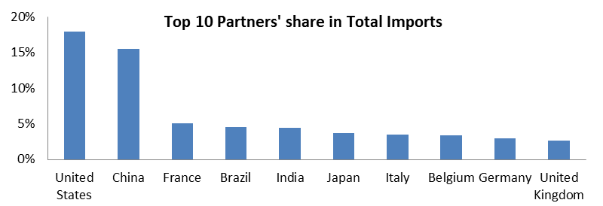

Source: COMTRADE

Processed food and beverages, motor vehicles, machinery, chemicals and refined petroleum are the main imports, together accounting for over half of total imports (Figure 2). The majority of the top 3 imports come from the BRIC countries, the EU and U.S.

Less than 1 percent of Nigeria’s imports come from ECOWAS countries, among which Ghana accounts for over 55 percent and Ivory Coast another 27 percent of the total sum. Although the total is small, imports from ECOWAS are relatively diversified and similar in composition to imports from the rest of the world (Figure 2). Over 95 percent of imported carpets come from ECOWAS, as well as over half of imported jewelry, fruits and nuts.

Figure

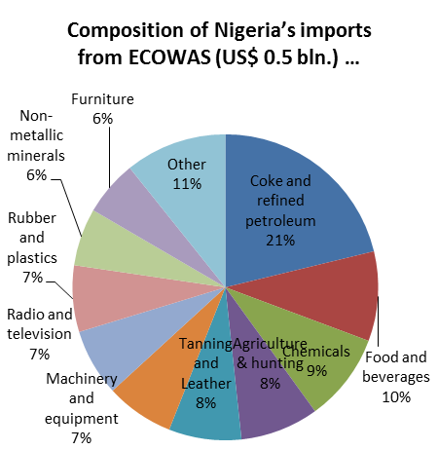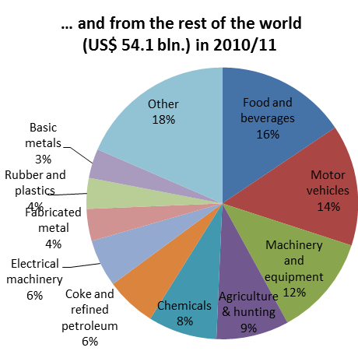

Source: COMTRADE

## 2.2. Exports

Over the past decade, regional exports have not grown in line with the strong oil driven export performance in global markets. As a result, the share of regional in total exports declined from 4.8 percent in 2000-04 to 2.6 percent in 2010-11. After growing from an annual average of US$1.1 bln in 2000-04 to US$3.5 bln in 2005-10, Nigeria’s exports to regional markets declined to US$2.8 bln in 2010-11 (Figure 3).

Figure

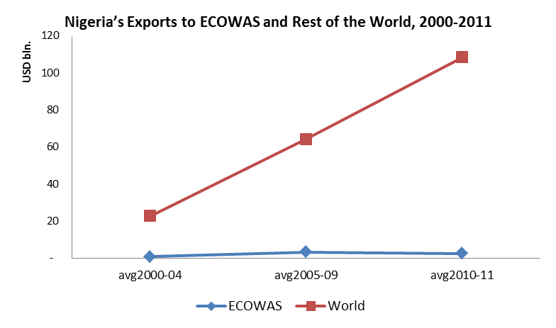

Source: COMTRADE

Exports to both ECOWAS partners and the global market are heavily dominated by oil and oil products. However, there are significant differences in the composition of non-oil exports between the regional and global markets. While global non-oil exports are dominated by agricultural products and, to a lesser extent, leather products, non-oil exports to the region are distributed more evenly across different manufacturing industries, including tobacco products, footwear, food, and chemical products (Figures 4 and 5).

Figure

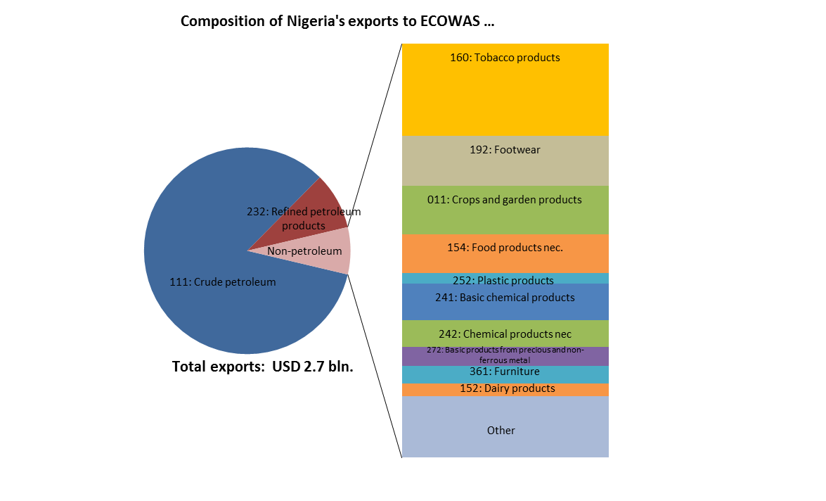

Source: COMTRADE, average over Nigeria’s exports reported for the years 2010 and 2011.

Figure

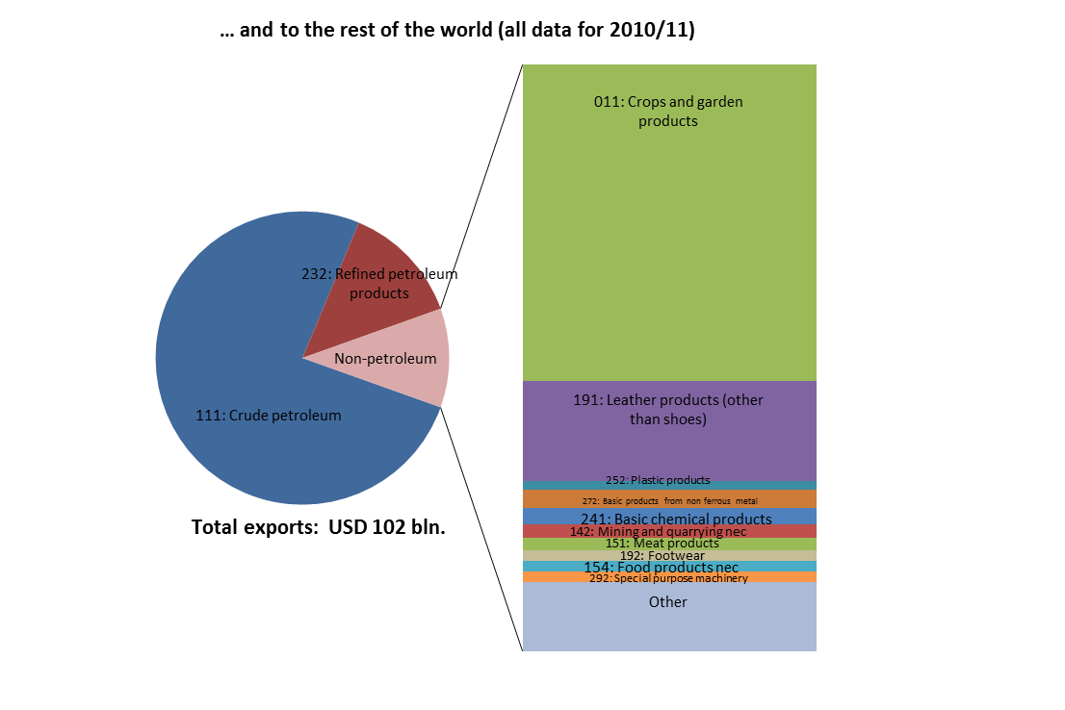

Source: COMTRADE, average over Nigeria’s exports reported for the years 2010 and 2011.

As a result, once oil exports are removed from the data, Nigeria’s regional trade reveals a significantly lower index of export concentration than trade with the rest of the world. In other words, non-oil exports to ECOWAS are more diversified than non-oil exports to the rest of the world.

Figure

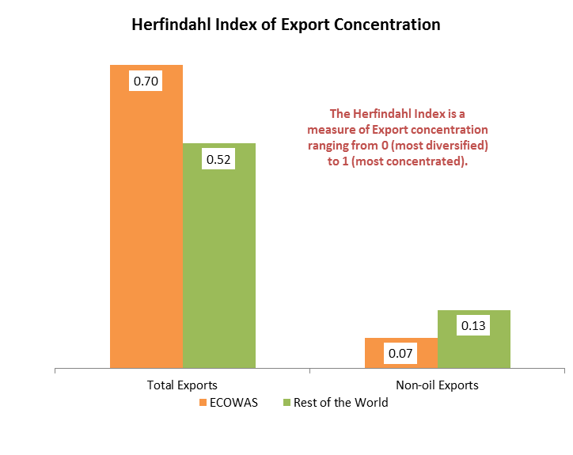

Source: Calculated by the authors using COMTRADE data on Nigeria’s exports reported for the years 2010-11.

An important strand of recent research on trade has moved beyond the concept of comparative advantage by industries and instead emphasized the importance of individual firms (Melitz, 2003). This is based on the empirical finding that usually only the more productive firms in a country are able to enter and successfully compete in foreign markets (Bernard, Eaton, Jensen, & Kortum, 2003).

In the case of Nigeria, only very few manufacturing firms are engaged in exporting (Figure 7, left panel). Consistent with findings from other countries, very profitable firms are more likely to be exporting (Figure 7, right panel). What is remarkable is that despite the relatively small share of regional markets in the total value of exports, over one third of the exporting firms in the sample report ECOWAS countries as their primary export market. In terms of their profitability, these firms tend to fall in between purely domestic firms and global exporters, suggesting that the regional market provides export opportunities for firms that are not ready to ‘go global’ yet. The data also shows that global exporters tend to be significantly larger than domestic firms and regional exporters.

Figure

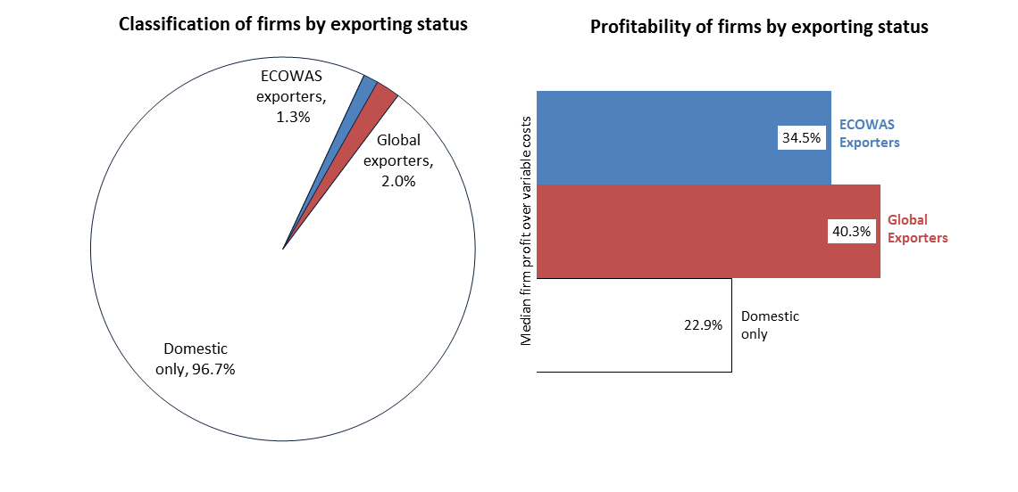

Source: Calculated by the authors using World Bank 2009 / 2007 Enterprise Survey data. Survey weights are not applied, implying that aggregates are representative of the survey sample but not the entire universe of firms in Nigeria.

While global exporters outperform both domestic and regionally exporting firms in terms of their sales growth, the regional exporters have the fastest rate of job creation of the three groups of firms (Figure 8). While this may appear counterintuitive it is, in fact, not uncommon to find that firms characterized by high growth in global markets are, at the same time, rapidly increasing their labor productivity, and thus do not create as many jobs as one might expect when observing the expansion of their sales. In this regard, regional exporters appear to be more similar to domestic firms in the sense that they create relatively more jobs per unit of output growth. Further research could address the question whether this is related to the industries these firms are engaged in, or driven by firm specific factors such as production technology or human resource strategies.

Either way, these figures suggest that regional trade can play an important role in helping Nigerian firms to establish themselves internationally, and that these firms have made a strong contribution to job creation over the past years. Further measures to facilitate market access and trade with regional partners is thus likely to encourage additional Nigerian firms which currently only operate in their home market to look beyond the borders for opportunities in their neighboring countries, and, as they do so, create more jobs.

Figure

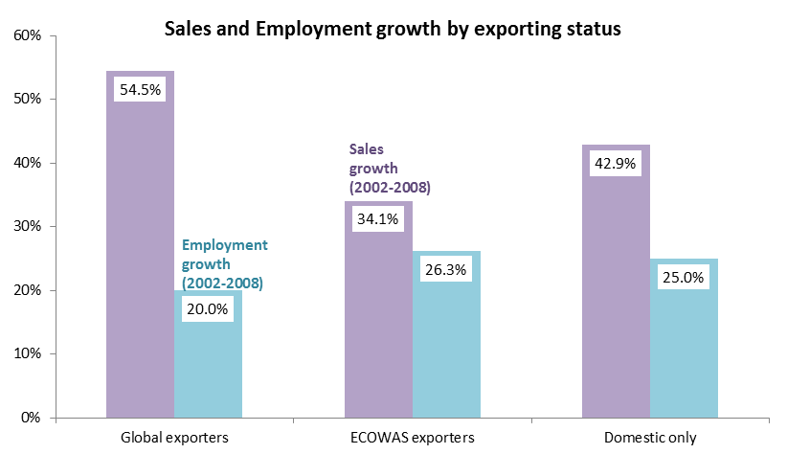

Source: Calculated by the authors using World Bank 2009 / 2007 Enterprise Survey data. Survey weights are not applied, implying that aggregates are representative of the survey sample but not the entire universe of firms in Nigeria.

## Trade Policy

Nigeria aligns its tariffs to the five duty bands under the ECOWAS common external tariff (CET), with rates ranging from 0 to 35 percent. The current trade weighted collected tariff rate is 10.5 percent, at the high end for ECOWAS members. Levels of protection are highest on consumer products like tobacco, recreational products, apparel, and furniture. Duties are also high on food items, which constitute a large share of total imports (Figure 9).

Stronger forms of protection come from additional measures such as levies, miscellaneous surcharges and outright import bans. Levies range from 5 to 100 percent and are applied mainly to rice, wheat flour, sugar, alcohol, tobacco, textiles, iron and steel.

Figure

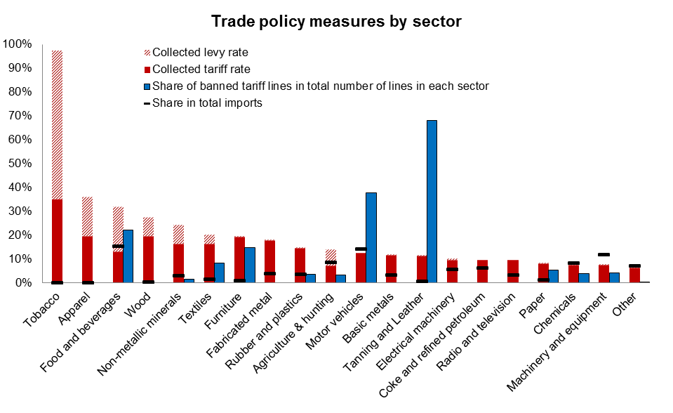

Source: Authors’ calculation based on 2013 tariff and levy rates and import bans from Nigeria customs and 2010/11 import data from COMTRADE.

In addition, Nigeria maintains a long list of products banned from importation, with 24 categories ranging from foods, textiles and footwear, to furniture, medicine and used vehicles (Figure 9). These bans are applied against all trading partners, including ECOWAS members. The list changes often and bans are sometimes lifted by special import licenses granted to a small number of importers. Treichel et al (2012) estimate that on average import prohibitions raise the domestic price of banned products by 77 percent. Recent estimates by de Melo and Ugarte (2013) also find high price markups on most banned products, though there are significant differences across product groups and it is difficult to separate out clearly the impact of import bans from other non-tariff barriers (NTBs), such as restrictive application of standards at the border.

Imports also face numerous surcharges and fees, including a port development fee of 7 percent of import tariff value, a 1 percent charge for the Comprehensive Import Supervision Scheme and the 0.5 percent ECOWAS levy, which would be raised to 1.5 under the ECOWAS customs union.

In principle, trade within ECOWAS is liberalized under the ECOWAS Trade Liberalization Scheme (ETLS). Agricultural products, livestock and handmade products are supposed to receive duty-free treatment without needing a certificate of origin. Industrial products, however, do require such documentation, and the process to obtain it is often described as cumbersome, in particular by smaller firms.

Revenue from all the taxes on imports combined accounted for 3.7 percent of total government revenue or 17 percent of non-oil revenue in 2011 (Table 1). Over half of this revenue is derived from import tariffs, with levies and other fees and taxes collected at the border accounting for the rest.

Table

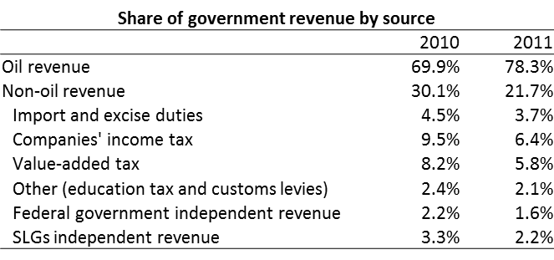

Source: IMF Art. IV Staff report for Nigeria (2012)

High and complex trade barriers present a strong incentive for smuggling across Nigeria’s borders, in particular with Benin. Raballand and Mjekiqi (2010) estimate an order of magnitude of this smuggling by comparing imports reported by Benin with exports to Benin reported by third countries, observing that a large part of the high discrepancy between these figures is likely smuggled onwards to Nigeria. These calculations are replicated in Figure 10. They suggest that indeed import bans and prohibitively high duties do not stop goods from entering Nigeria. On the contrary, smuggling appears to be highest in the most restricted categories of goods subject to import bans and levies. The total amount of potential smuggling from Benin is estimated at close to US$5 bln, nearly 10 percent of Nigeria’s official imports. If the current tariff rates and levies had been applied to these goods, this would have led to an estimated increase of US$1.2 bln in government revenue. Additional channels for informal trade and smuggling are likely to exist via other neighboring countries as well as through non- or under-reporting at Nigerian ports.

Figure

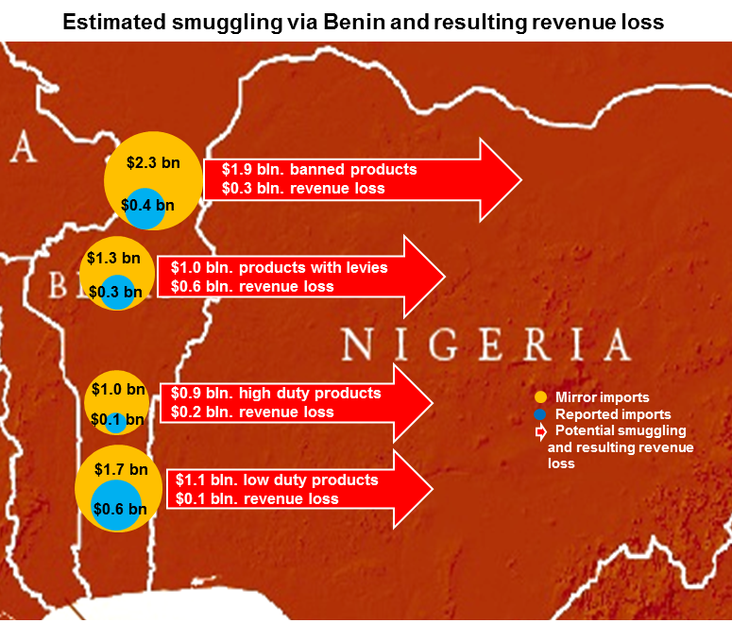

Source: Authors’ calculation based on COMTRADE and Nigeria customs data.

Smuggling also reduces the impact of import bans on domestic prices. Treichel et al. (2012) found that because prohibited items can be obtained through unofficial trade channels in regions near the border with Benin, prices of such goods in cities along Nigeria’s western border are significantly lower than in other regions.

A number of recent studies have evaluated the effect of Nigeria’s import bans and other trade policy measures aimed at protecting and stimulating domestic production. For the case of the textile industry, de Melo and Ugarte (2012) show how a combination of high but ill–designed protective measures have reduced incentives for productivity growth, prevented the industry from taking advantage of new market opportunities abroad, and encouraged informal competition with smuggled imports. Eberhard and Teal (2010) come to similar conclusions and point out that the current economic model has not led to incentives for productivity growth and the creation of high quality wage employment.

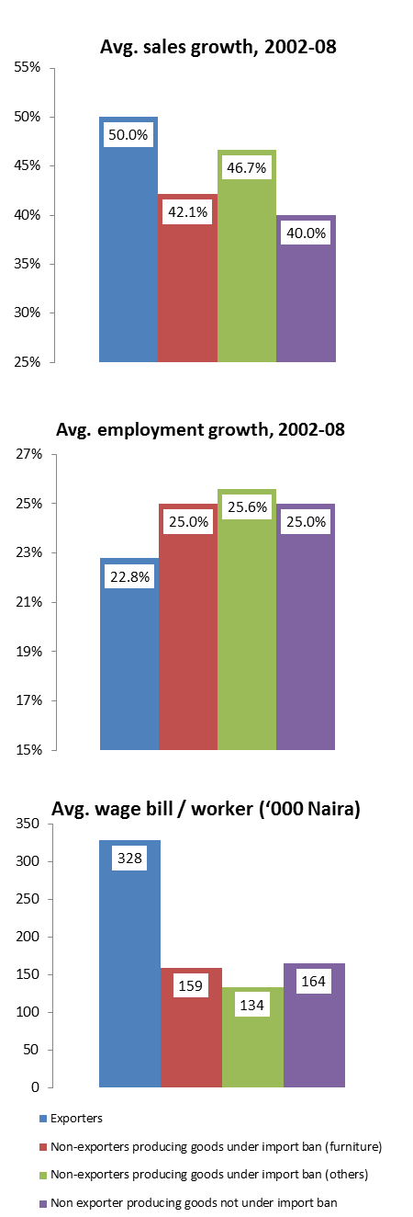Enterprise level data generally confirms these findings (Figure 11). While firms benefiting from bans on the importation of the products they produce have realized slightly higher sales growth between 2002 and 2008 than other domestic firms, this may well be driven by price effects in the domestic market rather than real output growth. More importantly, sales growth has been significantly higher for exporting firms than for any domestic producers.

Figure 11

At the same time, there is no indication that import bans have led to higher job growth in domestic firms producing these goods.

As discussed in the previous section, global exporters have created jobs at a slower pace than domestic firms despite their higher sales growth. This is not uncommon, as exporters tend to be among the firms with the strongest productivity growth. The positive flipside of this is that wages and working conditions in these firms tend to be significantly better, which is demonstrated by the fact that their spending on wages and benefits per worker is roughly twice as high as for purely domestic firms. On the other hand, there is no indication that domestic firms benefiting from protection through import bans perform better than other domestic firms in terms of the wages and benefits offered to their workers. This suggests that the rents that such protection is generating in Nigeria are being taken by the owners of the protected firms rather than their workers.

Source: Calculated by the authors using median values from World Bank Enterprise Survey 2009 / 2007 data.

An additional problem associated with Nigeria’s current trade policy is its complexity, which gives rise to significant inefficiencies at the border (de Melo and Ugarte, 2013). Delays, uncertainty and, in some cases, unofficial payments impose a significant burden on trading firms. They undermine the competitiveness of Nigerian firms and in particular exporters, who often face this burden twice as they import intermediate inputs or capital goods and export their final products. They also make it very difficult for Nigerian firms to harness the gains that can be derived from integration with global production networks that rely heavily on the ability to import and export in a quick and reliable manner.

Various international indicators reveal problems with customs efficiency in Nigeria. According to the 2012 Logistics Performance Index (LPI), Nigeria ranked 146 out of 155 countries in customs efficiency, the worst performer in ECOWAS after Sierra Leone (Figure 12). The 2013 Doing Business Report puts Nigeria at 154 out of 185 countries when it comes to trading across borders, below all but three ECOWAS members (above Cote d’Ivoire, Burkina Faso and Niger). Importing to Nigeria generally takes longer and requires more documentation. The fact that Nigeria continues to slide downward on all rankings over time makes the situation even more worrisome.

Figure

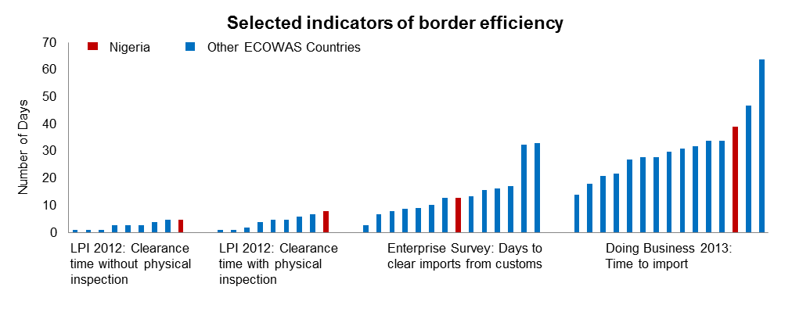

Source: Various databases as indicated by series.

Anecdotal evidence on the ground also confirms the inefficiency and complexity of customs clearance processes in Nigeria. Hoppe (2013) finds that duties and procedures are often negotiated on a case-by-case basis, depending on the location, weather, time of day, specific border crossing, scale of operation, type of product, and personalities involved. Numerous agencies cluster at the borders, not necessarily to enforce regulations, but often to collect fees while causing unnecessary delays. It is thus not uncommon to see trucks lining up at customs checkpoints for days or even weeks. Treichel (2010) shows that Nigerian ports are equally plagued by severe congestion due to the high rate of physical inspections of containers for false declarations and prohibited items.

# Impact of CET Implementation

## 3.1. Protection, Trade and Revenue

This section uses the World Bank’s Tariff Reform Impact Simulation Tool (TRIST) in order to assess the potential impact of upcoming tariff changes on trade flows and tariff and tax revenues for Nigeria. Normally, TRIST is based on detailed customs data on import transactions and revenue collected at the border and thus provides precise summary information on imports and trade related tariff and tax revenues. However, these data could not be obtained in Nigeria, and so the simulations in this paper instead rely on a combination of import data from COMTRADE for 2010/11 at the HS 6 digit level of detail, subject to the caveats discussed in section 2, and statutory rates for tariffs and levies from Nigerian Customs in the year 2013. The implicit assumption is that all tariffs are fully collected at the border with no exemptions. This is usually not the case in practice, in fact, Brenton et al. (2010) show that it is not uncommon for up to 50 percent of potential tariff revenue to be lost due to exemptions. The results derived from these simulations should thus be seen as an upper bound of the potential impact of the CET. In reality, a number of import transactions may remain unaffected by a trade policy reform because they enter the country under a tariff exemption. In addition, formalization of currently informal trade may well compensate revenue losses from lowering tariffs.

An additional complication in the case of Nigeria is the use of non-tariff measures, and in particular import bans. In order to account for these bans, the TRIST tool was calibrated with ad valorem equivalents for these products that were calculated based on a comparison between price levels in Nigeria and comparator countries. The data used for this exercise is from de Melo and Ugarte (2013), and the underlying methodology is explained in detail in their work. The highest ad valorem equivalent rates are found for poultry (132 percent), eggs (81 percent) and beverages (72 percent), with the simple average over all banned products at 57 percent. For the simulations where the bans are removed, the ad valorem equivalent for these products is replaced with the new CET rate.

TRIST uses a simple partial equilibrium trade model with imperfect substitution between imports from different trading partners and domestic production. In the absence of empirically estimated elasticities for Nigeria, the model is calibrated with different scenarios of standard elasticities of substitution between trading partners (‘exporter substitution’) and the overall effect on import demand (‘demand elasticity’). The methodology, including the standard low and high elasticities typically applied, are discussed in Brenton et al. (2010).

Three scenarios are simulated: first, Nigeria implements the ECOWAS CET on all non-banned products, and zero tariffs for ECOWAS partners, but continues to apply the bans and current levies on top of the CET; second, the import bans are removed but levies are maintained on top of the CET; and third, under full implementation of the CET, the levies are removed as well.

The weighted average tariff rate under the current tariff regime is 10.5 percent. According to TRIST results, this would increase to 11.3 percent once the CET is implemented. The only industry where a significant reduction in the tariff rate could be expected is tobacco, as for most other industries the new CET rate is similar to the current tariff structure (Figure 13). However, once import bans and levies are also removed, the sectors currently benefiting from these measures such as tobacco, apparel, textiles, food and beverages, motor vehicles, and leather products could experience significant effects.

Figure



Source: Author’s calculations based on data from Nigeria customs and COMTRADE

If both levies and import bans are kept in place with the adoption of the CET, TRIST results suggest that the overall net impact on imports is negative (Table 2). Tariff revenue would increase by between 4.4 to 5.1 percent and total imports would decrease by between 0.3 to 0.6 percent.[2] This scenario suggests that if the CET is adopted without the removal of import bans and levies, Nigeria’s trade regime would become more restrictive.

Table

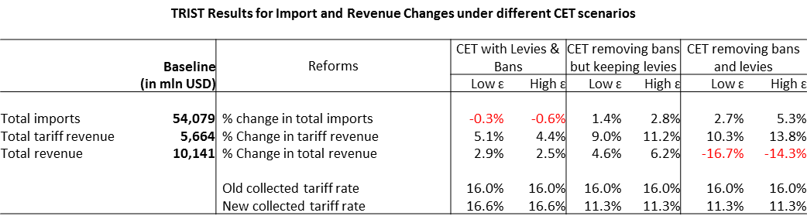

Source: TRIST simulations carried out by authors based on data from COMTRADE and Nigeria customs.

Under the scenario where import bans are removed but levies are still applied, both tariff revenue and imports would increase as non-revenue generating import bans are replaced with revenue generating tariffs. When both bans and levies are removed, imports would increase by 2.7 to 5.3 percent, more than double compared to the previous scenario. Tariff revenue would increase by between 10.3 to 13.8 percent but total revenue collected at the border would decrease by between 14.3 to 16.7 percent due to the total loss in levy collection. However, a number of qualifications apply. First, as explained above, these figures are based on the assumption that no tariff exemptions are currently granted. The true magnitude of the effect would therefore likely be smaller. Second, it is very likely that by removing levies and reducing the complexity of border procedures, substantial amounts of currently informal trade could be formalized, leading to positive revenue effects. And third, as shown in Table 1, total revenue collected at the border accounts for just 3.7 percent of total government revenue, so the overall fiscal impact would not be very significant.

## 3.2. Consumer Welfare

The most direct effect of implementing the CET on the life of Nigerians can be expected to materialize through changes in the prices of their daily consumption goods. In order to evaluate the magnitude and direction of these effects, price changes calculated at the detailed product level in the TRIST tool are matched with information on the consumption patterns of Nigerian households. These simulations are based on the assumption that reduced (increased) duties applied to imported products are fully passed through to domestic consumers in the form of lower (higher) prices, and so should be considered maximum bounds of the estimated magnitude of the impact.

The results reveal that a partial reform, which would implement the CET but leave in place the import bans and special levies, would leave consumers at all income levels worse off than before the reform as the price of their average consumption bundle would increase by up to 0.7 percent. The effect is slightly regressive as the poorest households would see the strongest price increases (Figure 14).

Removing the import bans along with implementing the CET would almost offset the negative impact on consumers, but still leave them slightly worse off than before. The positive impact of removing the import ban is less pronounced in these results than in Treichel et al. (2012) because the bans are replaced with relatively high CET rates rather than the current tariff rate.

A full reform scenario that also involves the removal of import levies would lead to a significant net benefit to consumers as the price of the average household consumption bundle would decrease between 2.3 and 2.5 percent.

Figure

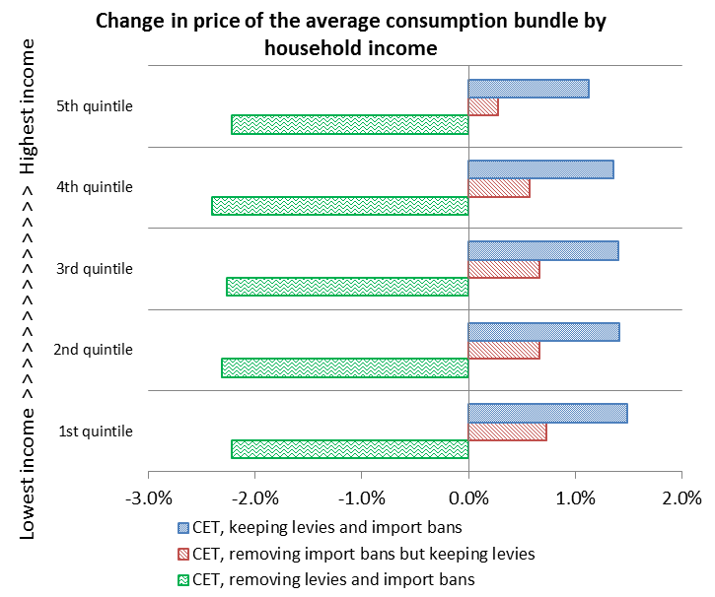

Source: Calculated by the authors using TRIST results described in the previous section and consumption data from the NHLSS 2009-10 National Harmonized Living standard survey

The figures on the impact of total spending per household mask substantial variation in the impact of the trade policy reform by product category (Figure 15). For households in the lowest income quintile the main driver of the increase in real income under the full CET scenario is the fall in prices for rice. This is due to the combination of a large price reduction from the removal of the import levy and the importance of rice in the consumption bundle of households, and in particular for the poor. An important accompanying measure would be to inform the public of the removal of the levy and effective competition in the distribution of rice to ensure that rice importers pass the price reductions on to consumers rather than absorbing them as profits. The figure also shows that the benefits of falling prices for some key consumption items is in part offset by significant increases in the prices of meat products and vegetables, for which the new CET provides higher protection than the current tariff. A review of the CET rates for these products, with a view to their reduction, is of particular importance for the poor in Nigeria.

Figure

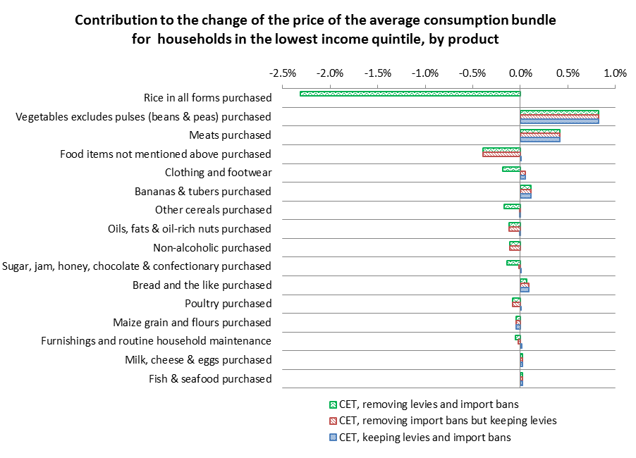

Source: Calculated by the authors using TRIST results described in the previous section and consumption data from the NHLSS 2009-10 National Harmonized Living Standard Survey.

## Competitiveness and Jobs

A tariff reform affects firms through a number of channels. In the long run, dynamic effects from lower tariff protection materialize as capital and jobs are reallocated towards more efficient sectors and firms, and integration with global value chains provides opportunities to access new knowledge, technology, and market opportunities. However, analyzing the short to medium term effects of a trade policy reform is important to understand the forces of structural change that it is likely to trigger, and prepare adjustment assistance to firms or workers where it may be required.

In the short run, firms are affected by a trade policy reform primarily through three price channels: changes in the domestic price on the output they produce, the inputs they use, and the capital goods they purchase. Typically, a lower tariff on a given good would reduce its domestic price, and thus diminish the profitability of firms producing this product. On the other hand, lower tariffs on their intermediate inputs and capital goods would increase the profitability of firms.

Ultimately, a firm’s response to these changes will also depend on its pre-reform level of profitability. Firms operating in highly protected sectors often have considerable profit margins, and may well continue or even grow their operations even if their profit margin is slightly reduced due to a tariff reform. In fact, recent research has emphasized that adjustment to trade reforms often has more noticeable effects at the firm level, with capital and labor moving from less productive firms to more productive firms within a sector, than it does in terms of movement across sectors.

In order to account for these factors, changes in prices from the reforms predicted by TRIST are matched with data on Nigerian firms. The analysis focuses on manufacturing firms and covers firms across the entire country from micro enterprises to large firms with over 1,000 employees. The exact methodology and data sources are explained in Annex 1. As in the previous section, it should be emphasized that the results represent upper bound estimated of the effects of CET implementation because they are based on the assumption that tariff changes at the border are fully passed through as changes in domestic prices. In addition, results only cover the manufacturing sector. Further assessment of the potential impact on the agricultural sector would be highly desirable, but could not be included in this paper given data and resource constraints.

For all three reform scenarios, the overall effect on profitability for the median firm in the sample is positive, though negligible for scenario i (keeping bans and levies, Figure 16). The main positive effects result from the reduction in input prices due to the removal of import bans and levies. In the full reform scenario with removal of bans and levies, the effects through output prices becomes slightly negative, but are more than offset by strong reductions in input prices. Change in the prices of capital goods do not have a significant impact in the short run due to the relatively low weight of these goods in the cost structure of firms, but access to foreign capital goods is an important driver of innovation in the longer term. For instance, Eaton and Kortum (2001) find that 25 percent of cross-country differences in productivity can be attributed to price differences for equipment, and that about half of these price differences are caused by trade barriers. In the same vein, Estevadeordal and Taylor (2008) find that lower tariffs on capital equipment (and on intemediate inputs) lead to higher economic growth.

Figure

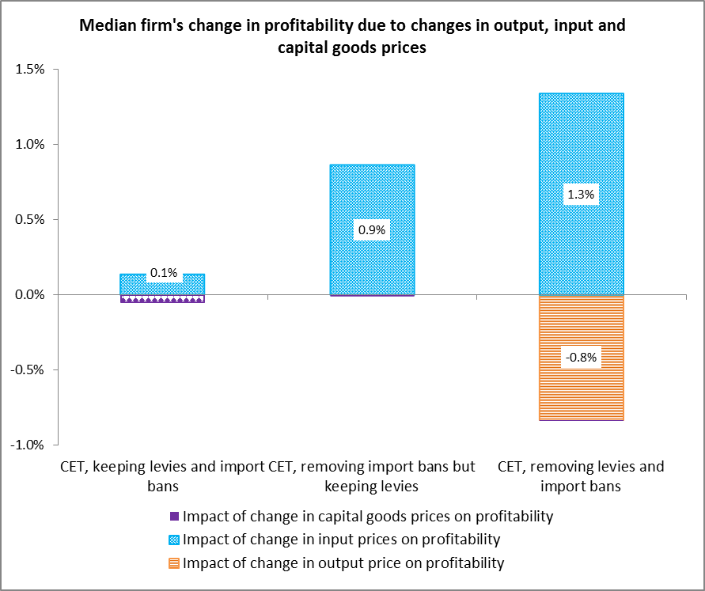

Source: Authors’ calculations using data sources and methodology explained in Annex 1.

It is important to note that the results shown in Figure 16 for the median firm mask substantial variation within the sample. For the full reform scenario, while the median effect through output prices is only very slightly negative, there are some firms at the extreme ends of the distribution for which effects could be substantial. On the negative end, this includes some of the firms that are currently protected by import bans and levies (Figure 17).

Figure

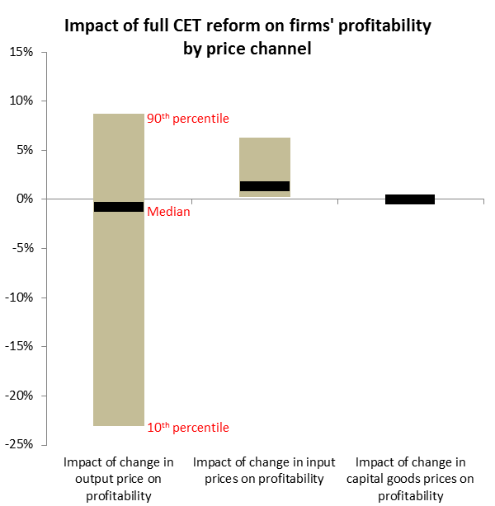

Source: Authors’ calculations using data sources and methodology explained in Annex 1.

On the other hand, the benefits resulting from reductions in the price of inputs are much more evenly distributed across the universe of firms, with virtually all firms benefiting. This has important political economy implications: firms at the lower end of the distribution for the output effect are likely to be well aware of their potential losses from the reform, and thus have a strong incentive to voice their opposition. On the other hand, the positive effects that can be expected from lower input prices are likely to materialize in a much more diffuse way that would give a boost to the competitiveness of all firms in the country. But because the benefits are spread widely, the benefitting firms are less likely to mobilize together to lobby in favor of the reforms.

Depending on whether import bans and levies are removed along with the implementation of the CET, between 60 and 75 percent of firms in the sample can be expected to see their profitability increase because of some combination of lower prices on inputs and / or more protection for the output they produce (Figure 18, upper panel). Another 3 percent of firms in the sample are exporters that can also be expected to benefit from more trade openness because their output prices do not depend on protection in the domestic market while they still benefit from lower input prices.

Figure

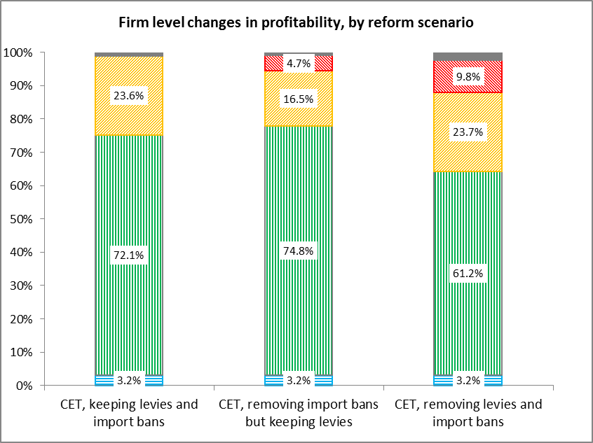

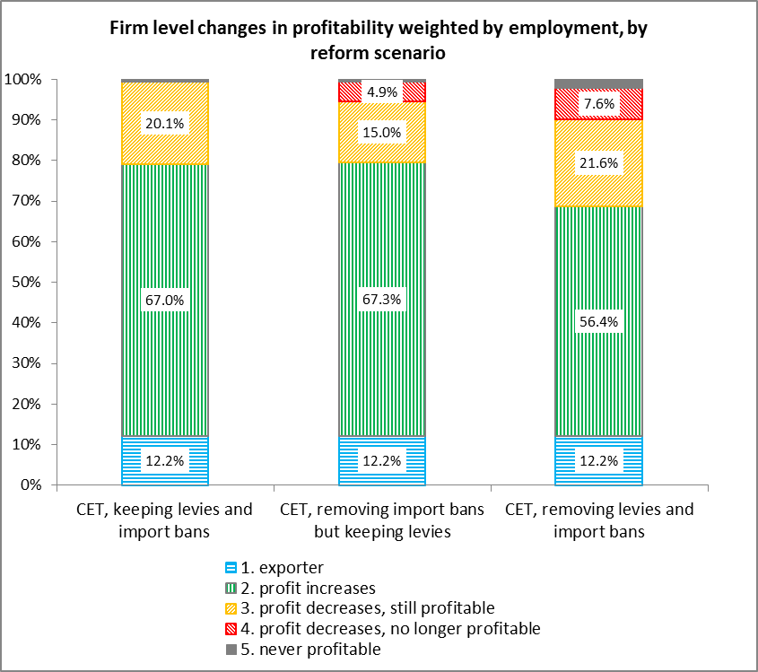

Source: Authors’ calculations using data sources and methodology explained in Annex 1.

In the full CET scenario, including the removal of all bans and levies, 33 percent of firms would experience a reduction in their profitability. While most of them would nevertheless remain profitable, 8 percent of firms could see their profit levels drop below zero in this scenario. Policy interventions that would target these firms could focus on helping them increase their productivity, rather than prolonging tariff protection at the expense of consumers and the majority of firms that stand to gain from the reform.

The most important factor in terms of the economic wellbeing of Nigerians is not the fate of individual firms, but of the jobs that these firms provide. It is often found that the best policy to facilitate adjustment to a trade shock is one that protects workers by helping them to transition into new jobs if necessary, rather than protecting individual firms. In this context, it is illustrative to weigh the firms in the sample by the number of jobs they offer (Figure 18, lower panel). The results show that while only around 3 percent of firms in the sample are exporters, they account for 12 percent of jobs. On the other hand, the 33 percent of firms that are affected adversely by the reform only account for 28 percent of jobs. In cases where labor is shed in firms that are negatively affected by the implementation of the CET, this suggests that policy measures could support workers from these firms in transitioning to firms that are benefitting from the reform.

A breakdown of the data from Figure 18 by economic sector reveals that most of the firms for which profitability may decline are in the textiles, apparel, and food industries (Figure 19). For the food industry as a whole, a large majority of workers is nevertheless employed in firms that stand to gain from the reform. There are also a number of successful exporting firms in this industry which, as discussed in section 4.1, could gain considerable new export opportunities in the region if the CET moves forward. Thus, to the extent that adversely affected firms in this industry are forced to shed labor, it is likely that new employment opportunities could be found within the same industry.

The situation for workers in the textile and apparel industries appears more problematic, as almost all firms in these sectors may be affected negatively with the exception of successful exporters. This would clearly be a priority sector for adjustment assistance that could involve a combination of programs to help strengthen the competitiveness of producers while at the same time assisting retrenched workers to find employment in other sectors. Such opportunities can be expected to arise in a number of other sectors where the effect of the reform would be positive for the majority of firms. Where assistance is provided to firms rather than individual workers, it needs to be temporary, with a clear exit strategy, and bound to objective measures of improvement.

A seemingly surprising finding is the largely positive impact of the reform on firms in the furniture sector despite the removal of the current import ban on furniture. The reason is that the data from de Melo and Ugarte (2013) used for the simulations indicates that the current price gap on furniture between Nigeria and the world market is very close to the CET rate that would apply to most furniture items. In this case, the output price for furniture producing firms would not change significantly if the ban is replaced with the CET. However, as this finding is quite sensitive to the assumptions for the price gap on furniture, it should be interpreted with caution and further research on the impact of the CET on the furniture sector and effects of the existing ban would be desirable.

Figure

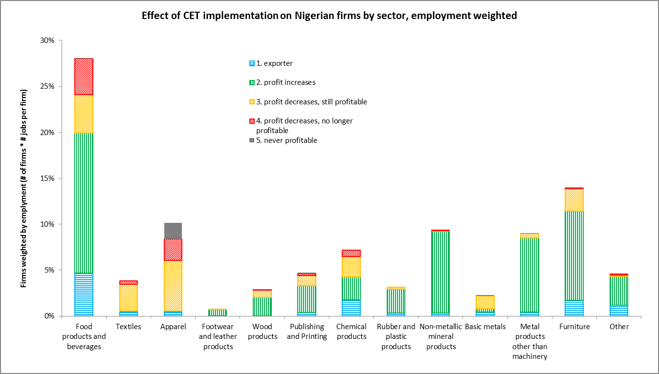

Source: Authors’ calculations using data sources and methodology explained in Annex 1.

Given Nigeria’s vast territory and federal structure, the geographic dimension of the reform’s impact is also highly relevant. To the extent that gains and losses are distributed very unevenly, they could contribute to inequality across states. This could impose rigidity in terms of the ability of the labor market to adjust to the shock and create pressure for internal migration with potentially adverse social consequences. We address this issue below, but the results should be treated with some caution as they are rather sensitive to the sampling method and survey weights by region assigned to firms in the underlying Enterprise Survey, an instrument which is not primarily intended to represent the geographical distribution of employment across the country.

While the results in Figure 18 suggest that overall impacts are relatively well balanced across most of the country, a few states with high employment in industries that stand to lose under the reform might face more significant adjustment challenges. These include Akwo Ibom, Benue, Cross River and Imo for example. There are also states (such as Jigawa, Katsina ad Taraba) that are home to more export related jobs and these stand to gain unambiguously. This suggests that further analysis would be useful to track the geographical distribution of the reform’s impact, and, if these results are confirmed, consider mechanisms to prioritize support to struggling industries and workers in states that are affected disproportionately.

Figure

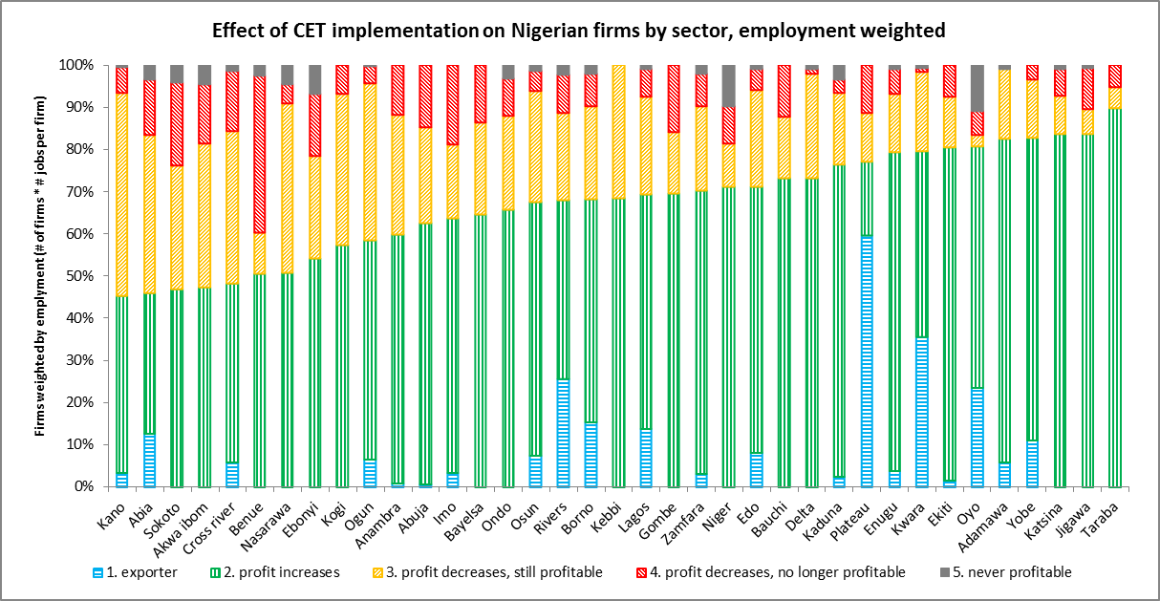

Source: Authors’ calculations using data sources and methodology explained in Annex 1.

# Market Access in ECOWAS

## 4.1. Preference Margin

Under the ECOWAS Trade Liberalization Scheme, Nigerian firms already enjoy duty free access to all ECOWAS partner countries. Thus, implementation of the new CET would not directly affect their market access conditions. However, it would affect the market access conditions of firms from other parts of the world, and thus may have an indirect impact on Nigerian firms through more or, in the case of a tariff increase, less international competition in these markets. While the latter outcome is not desirable from the point of view of the importing country, which would suffer a net welfare reduction, Nigerian firms could benefit from a higher preferential margin over international competitors once the CET has been introduced. Table 3 shows the changes in the preferential margin – the difference between the tariffs faced by competitors from the rest of the world and tariffs faced by Nigerian firms, the latter being 0 under both scenarios – that would result from ECOWAS partners implementing the CET. The most gains are visible in the food and beverage industries, for which virtually all ECOWAS partners would have to increase their levels of protection under the CET. Other industries, such as leather products, are likely to experience a decline in their preferential margin over non-ECWOAS competitors. For most industries, the picture is ambiguous, with the preferential margin for Nigerian firms increasing in some partner countries and decreasing in other.

Table

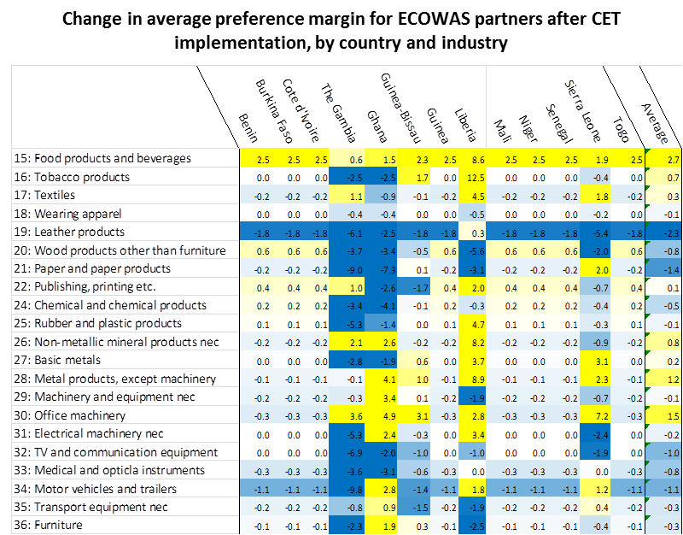

Source: Authors’ calculation based on data from Nigeria customs, COMTRADE and TRAINS. The changes in preference margins are calculated at the HS6 digit product level and unweighted averages are reported here for each sector.

To gain a better understanding of the net impact of changes in preference margins, the expected changes in the tariff levels are matched with import data for each product and trading partner. For instance, if an ECOWAS country imports a total USD 1 mln of a given product, and an external tariff of 20 percent is applied, the preferential margin for other ECOWAS producers whose imports are rated at 0 percent would be valued at (20% - 0%) * USD 1 mln = USD 200,000. If the CET for this product was now set at 10 percent, the value of the preferences would decline to (10% - 0%) * USD 1 mln = USD 100,000. In these calculations, the value of preferences is calculated over the entire import basket of ECOWAS partners, not just over imports already originating within the region. The rationale for this is to illustrate the change in opportunities resulting for Nigerian or other ECOWAS exporters resulting from these preferences, whether they are already being exploited or not, rather than just looking at existing trade. However, this information is matched in Figure 21 with information on Nigeria’s exports to verify whether Nigerian firms already have the capacity to seize these opportunities.

The combination of high imports and a significant increase in the external tariff explains a strong increase in the value of preferences for the food and beverage industries. As Nigerian firms are already active in exporting a number of food products, both globally and to the region, the increase in the preferential margin is likely to lead to considerable gains for producers in this industry. Results will, however, vary by product, as the data also shows some products in these industries for which the CET would lead to lower protection.

Considerable increases in the value of preferences can also be expected for different types of machinery, motor vehicles, and transport equipment. Nigeria has considerable exports in these industries, though it is likely that some of the exported goods reported by Nigeria are in fact re-exports of used goods. Negative net effects are expected in five sectors - leather, basic metals, chemicals, paper, and medical instruments – but they are generally small.

Figure

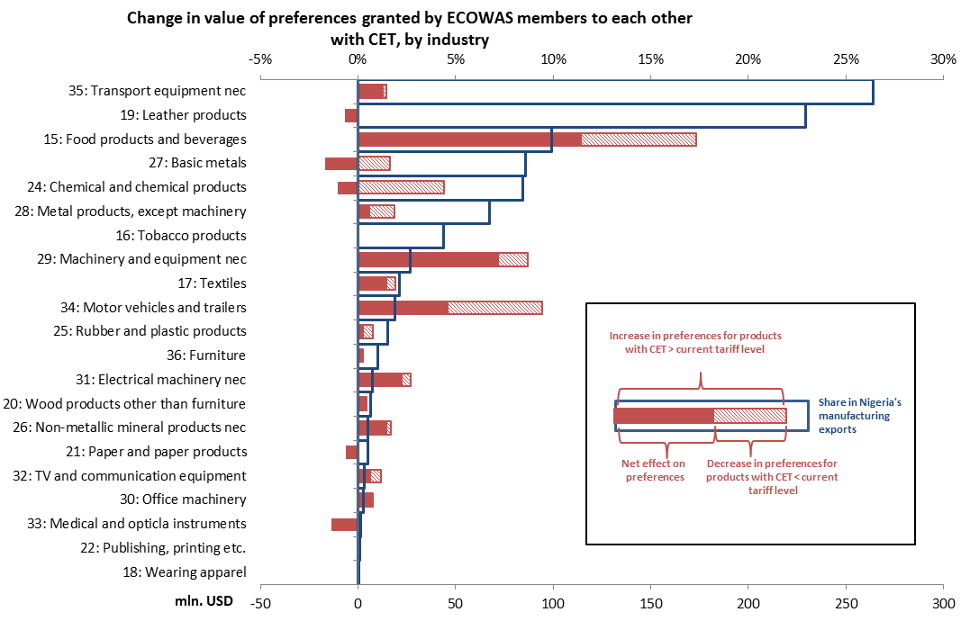

Source: Author’s calculation based on data from TRAINS and COMTRADE databases reported by ECOWAS countries as well as the ECOWAS CET schedule. The change in preference value is calculated at the HS 6 digit level for each ECOWAS country with available data available as the change in the average tariff when moving to the CET multiplied with imports of the product in question.

A breakdown of the results on changes in preferences by partner countries reveals the importance of the Ghanaian market (Figure 22). The CET would lead to considerable upward adjustments in Ghana’s tariff protection against the rest of the world, and in combination with its sizeable imports, this translates into high values of preferences. While the net effect is sizeable and positive, there are also a number of products for which Nigerian firms stand to lose part of their preferential margin, offsetting roughly half of the preferences gained in other products with an increase in protection. Tariff changes in Cote d’Ivoire and Senegal can also be expected to lead to significant gains in preference value for Nigerian firms. Net effects are positive for all countries with data availability. No recent import data at the required level of detail could be obtained for Liberia, Sierra Leone, Guinea-Bissau and Guinea.

Figure

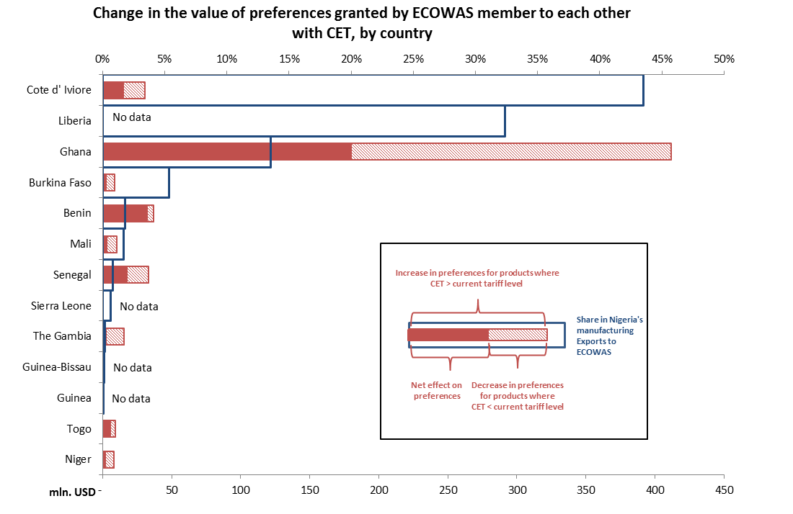

Source: Author’s calculation based on data from TRAINS and COMTRADE databases reported by ECOWAS countries as well as the ECOWAS CET schedule. The change in preference value is calculated at the HS 6 digit level for each ECOWAS country with available data available as the change in the average tariff when moving to the CET multiplied by imports of the product in question.

## 4.2. Trade Facilitation

As discussed in section 2.3, procedures at Nigerian borders can be long and cumbersome and impose a significant burden on firms. This undermines the competitiveness of Nigerian firms and prevents them from realizing gains associated with integration into global production chains that can be driver of innovation and growth. As pointed out by de Melo and Ugarte (2013), part of the reason for these problems is the complexity of the current trade policy regime. Implementing the CET and removing the current system of import bans and levies would be a significant step forward in simplifying these procedures, and could thus significantly reduce the scope for delays and uncertainty at the border.

While in principle, ECOWAS commitments have removed all trade barriers between member countries, a number of recent studies (e.g. World Bank 2012, West African Trade 2010) have documented significant remaining difficulties with their implementation. Traders often report that free trade commitments are not honored and unofficial payments are demanded at the border. Even where procedures are followed correctly, delays at the border can impose substantial costs on trading firms.

Manufacturing firms also have to go through a complex two stage licensing process to obtain a certificate of origin confirming that a given product was, in fact, manufactured in the region. While less problematic for large producers, many smaller firms find it difficult to comply with these procedures and thus end up paying customs duties. And even when firms are compliant, they lose time and money dealing with licensing procedures.

As a result, Nigerian firms exporting to the regional market are currently more likely to rank customs and other trade regulations as a major or very severe obstacle than firms exporting to the global market. This is consistent with results in von Uexkull (2012) showing that while regional exporters in ECOWAS have significant potential to create quality jobs, they are often held back by remaining high trade barriers within the region.

Figure

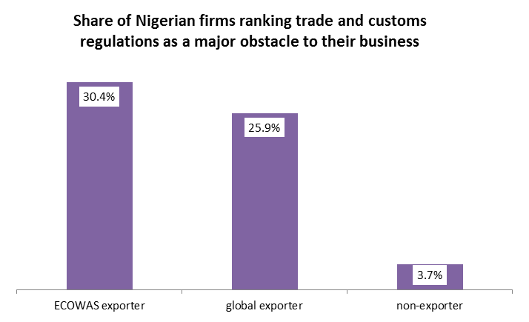

Source: Authors’ calculation based on World Bank Enterprise Survey 2009 data for Nigeria

The implementation of a customs union could render many of the processes at intra-regional borders redundant, and thus allow for significant progress in terms of trade facilitation. The CET model currently under negotiation foresees a system where tariffs on products imported from outside the region are collected in the country of final consumption. Unlike more advanced forms of customs unions where tariffs are collected at the first point of entry and then redistributed within the region, this model would still require the operation of transit and rules of origin verification systems. However, trade facilitation benefits can be expected mainly from a reduced need for the physical inspection and other measures to prevent smuggling (Table 4). This is the case because with a common external tariff, there is no longer an incentive for traders to smuggle goods imported from other parts of the world once they have entered the ECOWAS territory.

Perhaps even more importantly, Maur (2008) also points out that the political and economic dynamic resulting from the implementation of a full CET in other regions often had additional positive effects in terms of stimulating cooperation in the area of customs modernization and, more generally, trade facilitation. A lot remains to be done in this area throughout the ECOWAS region, including in the areas of border management, coordination between different agencies active at the border, removal of roadblocks and nuisance fees and taxes, and more effective implementation of the ECOWAS Trade Liberalization Scheme including a reform of the rules of origin. The CET would provide an important impulse to give momentum to a more aggressive regional trade facilitation agenda.

In the longer run, additional trade facilitation benefits could be realized if the CET was charged at the border where a good first enters the ECOWAS customs union, and tariff revenues were then distributed across member countries based on a previously agreed formula. This would eliminate the need for any certification and verification of rules of origin, as any product, once it has entered the customs union and paid the applicable CET rate, could circulate freely within its borders. Such an arrangement would remove a significant burden which is particularly burdensome for small and medium sized enterprises. In addition, such an arrangement would also render the operation of bonded transit regimes redundant and thus reduce the number of procedures and rigidities that firms engaging in transit trade have to comply with.

Table

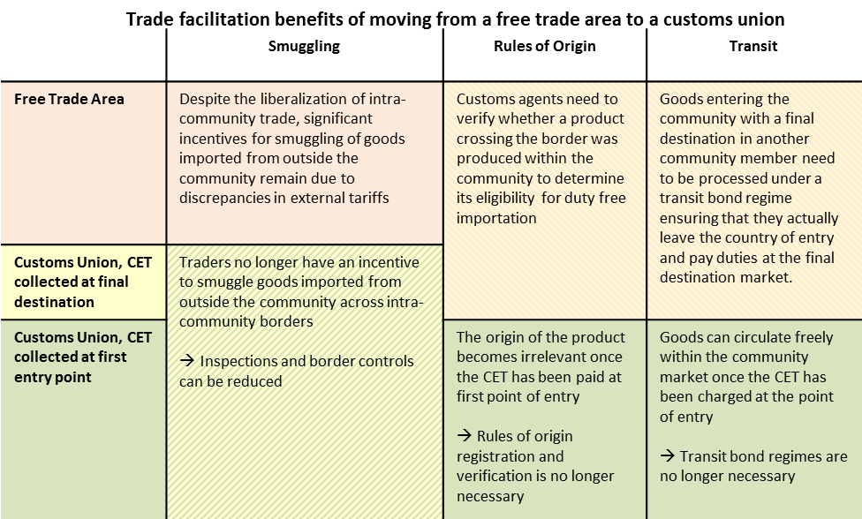

Source: Authors, partially based on Maur (2008)

# Conclusions

Nigerians are debating how to proceed with the full integration of their country into an ECOWAS Customs Union. As every policy reform, this step would generate gains and losses and so it is not surprising that there is a variety of opinions on how to proceed. This paper suggests that the benefits of Nigeria fully implementing the ECOWAS CET and removing its present system of import bans and levies would outweigh the costs, even in the short run. Nigerian consumers would benefit from lower prices for their daily necessities. Workers in most industries could expect to see their firms benefit from access to cheaper inputs, new market opportunities in the region, and fewer obstacles when they import and export their products. As more Nigerian firms would be able to take the leap to becoming exporters to the region, and perhaps eventually to the rest of the world, they would create more jobs, and they would create better jobs.

This is not to say that implementing the CET is without risks, and that those who fear negative consequences should not be heard. Effective implementation of reforms that benefits many but hurt a few need to be accompanied by remedial measures to support those who carry the burden, with assistance targeted to the poor. This can be done by helping firms in struggling industries to enhance their productivity, by giving workers who have lost their jobs social assistance and training to find a new one, and by transferring funds to support such programs to the regions that are affected the most. There are many options for such policies, and there are good examples from around the world on how they can work. Therefore, in order to support the few who might lose, it is not necessary to curtail the opportunities of the many who could gain from an integrated West Africa region.

# References

Andriamananjara, S., Brenton, P., von Uexküll, E. and Walkenhorst, P. 2009. "Assessing the Economic Impacts of of an Economic Parnership Agreement on Nigeria." Policy Research Working Paper 4920, World Bank, Washington, D.C.

Bernard, A., Eaton, J., Jensen, J., & Kortum, S. 2003. "Plants and Productivity in International Trade." *American Economic Review, 93*(4), 1268-1290.

Brenton, P., Saborowksi, C., Staritz, C., and von Uexkull, E. 2009. "Assessing the Adjustment Implications of Trade Policy Changes Using TRIST (Tariff Reform Simulation Tool)." Policy Research Working Paper 5045, World Bank, Washington, D.C.

de Melo, J. and Ugarte, C. 2013. "Nigeria: Time to Take the Lead on Regional and Global Trade Integration in West Africa." Working Paper 66, Foundation for International Development Study and Research, Clermont Ferrand, France.

Doing Business Indicators (database). <http://www.doingbusiness.org/>. World Bank, Washington, D.C.

Eaton, J. and S. Kortum 2001. “[Trade in capital goods](http://ideas.repec.org/a/eee/eecrev/v45y2001i7p1195-1235.html).” [*European Economic Review*](http://ideas.repec.org/s/eee/eecrev.html), Elsevier 45(7), pp. 1195-1235.

Eberhardt, M. and Teal, F. 2010. "Productivity Analysis in Global Manufacturing Production." Department of Economics, University of Oxford, U.K.

ECOWAS Trade Liberalization Scheme Rules for Traders. "Trading in the ECOWAS Free Trade Area." ECOWAS Commission.

Enterprise Surveys (database). <http://www.enterprisesurveys.org/>. World Bank, Washington, D.C.

Estevadeordal, A. and Taylor, A. 2008. “Is the Washington Consensus Dead? Growth, Openess and the Great Liberalization, 1970s to 2000s.” Cambridge: NBER Working Paper 14264.

Golub, S. 2013. "Informal Cross-Border Trade and Smuggling in Africa." Swarthmore College, Pennsylvania, USA.

Hoppe, M. and Aidoo, F. 2013. "Removing Barriers to Trade between Ghana and Nigeria: Strengthening Regional Integration by Implementing ECOWAS Commitments" Africa Trade Policy Notes No. 30, World Bank, Washington, D.C.

Hoppe, M. 2013. "Estimating Trade Flows, Describing Trade Relationships, and Identifying Barriers to Cross-Border Trade between Cameroon and Nigeria." Working Paper 78283, World Bank, Washington, D.C.

International Monetary Fund. 2013. "Nigeria 2012 Article IV Consultation." IMF Country Report No. 13/116, IMF, Washington, D.C.

Logistics Performance Index (database). <http://data.worldbank.org/indicator/LP.LPI.OVRL.XQ>, World Bank, Washington, D.C.

Maur, J. 2008. "Regionalism and Trade Facilitation." Policy Research Working Paper 4464, World Bank, Washington, D.C.

Melitz, J. 2003. "The Impact of Trade on Intra-Industry Reallocations and Aggregate Industry." *Econometrica, 71*(6), 1695-1725.

Nigeria Customs Administration. <https://www.customs.gov.ng/>. "Import Prohibition List."

Raballand, G., and Mjekiqi, E. 2010. "Nigeria’s Trade Policy Facilitates Unofficial Trade but not Manufacturing." In *Putting Nigeria to Work: A Strategy for Employment and Growth* Chapter 6, ed. Treichel, V., World Bank, Washington, D.C.

Treichel, V., Hoppe, M., Cadot, O. and Gourdon, J. 2012. "Import Bans in Nigeria Increase Poverty." Africa Trade Policy Notes No. 28, World Bank, Washington, D.C.

von Uexkull, E. 2012. "Regional Trade and Employment in ECOWAS." In *Policy Priorities for International Trade and Jobs* Chapter 14, ed. Lippoldt, D., OECD, e-publication, available at: www.oecd.org/trade/icite.

World Integrated Trade Solution (database). <http://wits.worldbank.org/witsweb/>. World Bank, Washington, DC.

# Annex 1: Methodology for simulating the effect of the CET on Nigerian firms

The following table illustrates the methodology and data sources used for the firm level simulations presented in section 3.3. Calculations are carried out over a sample of 2427 manufacturing firms covered by World Bank Enterprise Surveys in 2007 and 2009. The full datasets, questionnaires and methodology descriptions for these surveys can be found on the website www.enterprisesurveys.org

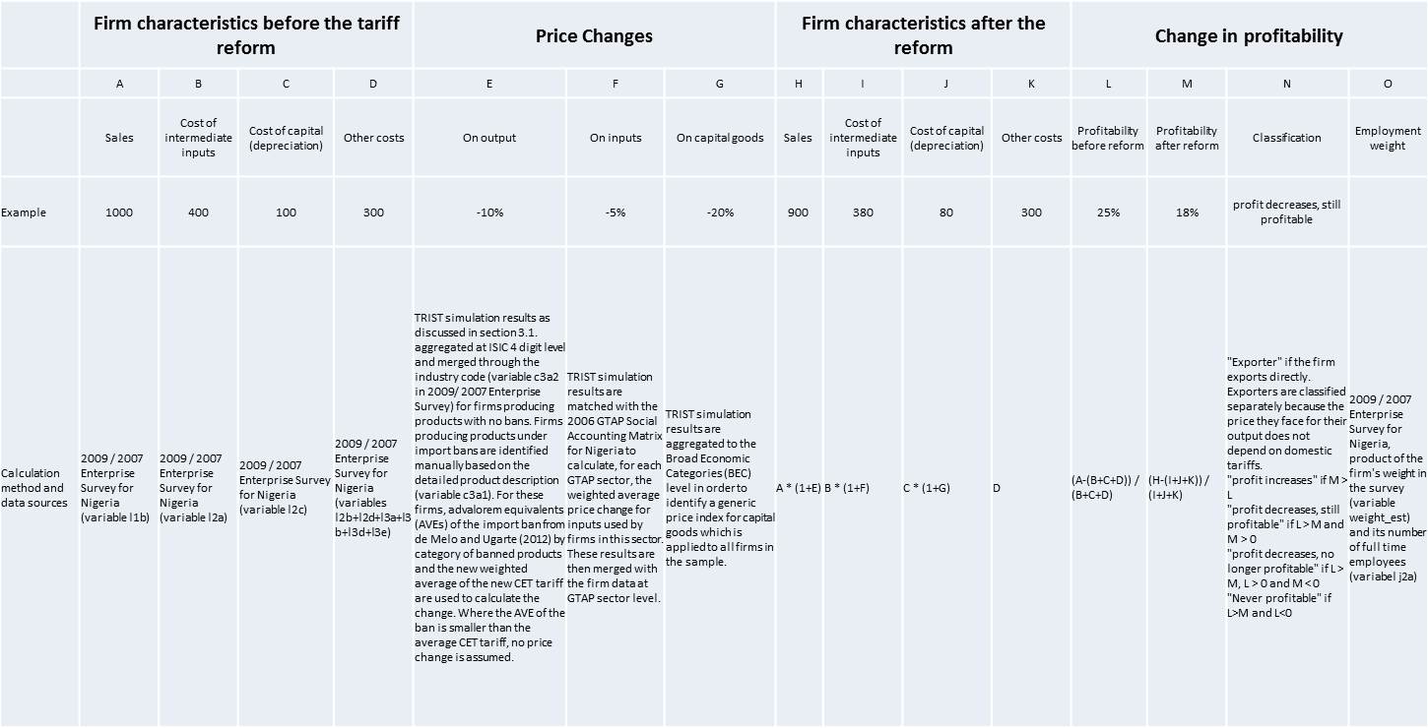

1. World Bank and Consultant, respectively. Corresponding author is Erik von Uexkull (jvonuexkull@worldbank.org). The authors are grateful for the comments and suggestions of Paul Brenton, Jim de Melo, Cristian Ugarte, Olivier Cadot, Julien Gourdon, Petra Voionmaa, Volker Treichel, Roberto Echandi, Josaphat Kweka, Jean-Christophe Maur, Mombert Hoppe, Dominique Njinkeu, Stephen Mink, Jose Daniel Reyes, and Bertram Boie.

   The views expressed in this note are those of the authors, and all errors and omissions remain entirely their responsibility.
2. The range in the simulated impact reflects different assumptions about the responsiveness of consumers and producers to changes in prices as a result of the change in tariffs. Standard elasticities shown as "low ɛ", are set at 1.5 for exporter substitution and 0.5 for demand substitution, whereas "high ɛ" are set at 5 for exporter substitution and 1 for demand substitution. See Brenton et al. (2009) for a detailed discussion of the trade model in TRIST and the meaning of these elasticities.