Ministry of Basic and Secondary Education
E1374 V2
Willy Thorpe Building
Banjul
_________________________________________________________________

DRAFT ENVIRONMENTAL AND SOCIAL AUDIT REPORT ON THE IMPLEMENTATION OF THE THIRD EDUCATION PROJECT AND EFA- FTI CATALYTIC FUND

PART 1: ENVIRONMENTAL AND SOCIAL FRAMEWORK (ESMF)

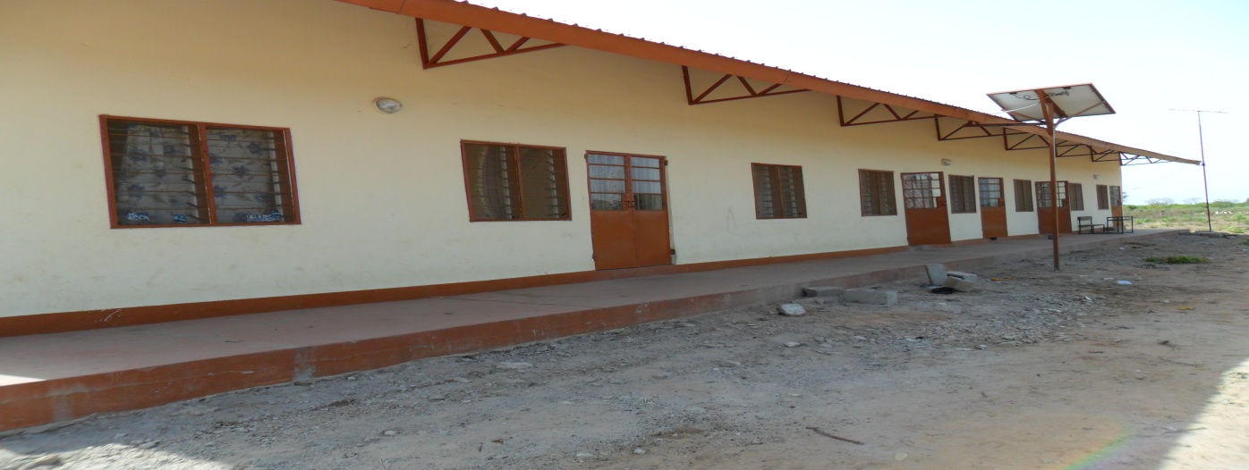
One of the newly constructed staff quarters

Bolong L. Sonko
Consultant

August 2013

Table of contents

Section Page

List of Acronyms-----------------------------------------------------------------------------------iii
Executive Summary---------------------------------------------------------------------------------iv

- INTRODUCTION--------------------------------------------------------------------------1
- PROJECT BACKGROUND-------------------------------------------------------------1
2.1 Project Components----------------------------------------------------------------1
2.2 Project Sites-------------------------------------------------------------------------2
2.3 Project Activities-------------------------------------------------------------------5
2.4 Environmental and Social Assessment of the Project-------------------------6
2.5 Objectives of the Audit -----------------------------------------------------------6
3.0 METHODOLOGY-------------------------------------------------------------------------6
4.0 POLICY AND LEGISLATIVE FRAMEWORK FOR THE ESMF------------7
4.1 National Policy and Regulatory Frameworks & Guidelines-----------------7
4.2 World Bank Safeguard Policies--------------------------------------------------7
4.3 Major Areas of Concern Identified by the ESMF-----------------------------8
5.0 FINDINGS----------------------------------------------------------------------------------10
5.1 Compliance with the ESMF-----------------------------------------------------10
5.2 Environmental and Health Concerns Arising out of the Field Visit-------12
6.0 RECOMMENDED MITIGATION MEASURES----------------------------------15
7.0 MONITORING PROGRAMME------------------------------------------------------16
8.0 RECOMMENDATIONS FO FUTURE INERVENTIONS ---------------------18

LIST OF TABLES
Table 1 Adverse Environmental Impact due to Infrastructure
Construction / Rehabilitation----------------------------------------------------11
Table 2 Assessment of ESMF Recommended Actions to be taken During Project
Implementation -------------------------------------------------------------------11
Table 3 Assessment of the Costs of Implementation of Remedial Measures
with a Timetable-------------------------------------------------------------------18

ANNEXES
Annex 1 List of Project Sites-----------------------------------------------------------------20
Annex2 Assessment forms/Discussion Point---------------------------------------------23
Annex3 List of Persons Contacted---------------------------------------------------------28
Annex4 List of schools visited During Field Trip---------------------------------------29
Annex 5 Programme for the Training Workshop---------------------------------------33
Annex6 Summary of Discussions held with Stakeholders-----------------------------35
Annexx6.5 Some Photos of Sites Visited------------------------------------------------------40
Annex 7 Bibliography--------------------------------------------------------------------------42
Annex 8 Terms of Reference for an Environmental and Social Audit of the
Implementation of the Third Education Project and
the EFA-FTI Catalytic Fund-----------------------------------------------------43

Acronyms

- EFA - Education For All
- EFP - Environment Focal Point
- EIA - Environmental Impact Assessment
- EMP - Environmental Management Plan
- ESIA - Environmental and Social Impact Assessment
- ESMF - Environmental and Social Management Framework
- FIOH - Future In Our Hands
- FTI - Fast Track Initiative
- GAMWORKS - Gambia Agency for Public Works
- GEAP - Gambia Environment Action Plan
- IDA - International Development Association
- MoBSE - Ministry of Basic and Secondary Education
- MOHERST - Ministry of Higher Education, Research, Science and Technology
- NAWEC - National Water and Electricity Company
- NEA - National Environment Agency
- NGO - Non Government Agency
- PAP - Project Affected Persons
- PCU - Projects Coordination Unit (Ministry of Basic and Secondary Education)
- RAP - Resettlement Action Plan
- RPF - Resettlement Policy Framework
- STI - Science and Technology Innovation
- WB - World Bank

EXECUTIVE SUMMARY

The Government of The Gambia, through the Ministry of Basic and Secondary Education (MoBSE), has been implementing the Third Education Sector Project with financing from International Development Association (IDA) and the Education For All-Fast Track Initiative (EFA- FTI) Catalytic Fund. The main Project objective is to improve the conditions for teaching and learning in basic education by: (i) improving performance of students, teachers and schools; (ii) strengthening capacity building and performance management, and enhancing monitoring and evaluation; and (iii) continuing expansion of effective access to under-served communities.

The three main components of the Project are: (i) Improving the conditions for teaching and learning; (ii) Strengthened capacity building, performance management, and monitoring and evaluation; and (iii) Expansion of Effective Access

The project activities that could potentially trigger the environmental and social safeguards were the civil works under Component 3 which consisted of building and furnishing a total of 252 classrooms, 35 staff quarters and 20 water points (8 boreholes and 12 concrete lined wells).

An initial environmental assessment has placed the project in Category B. As the specific subproject sites were not identified at the time of appraisal an Environmental and Social Management Framework (ESMF) and a Resettlement Policy Framework (RPF) were prepared to evaluate the potential environmental and social impacts of the project. According to these safeguard instruments all infrastructural subprojects are to be screened before implementation starts and where the results indicate adverse impacts mitigation measure should be developed to reduce, minimise or prevent the negative impacts. In cases of major negative environmental impacts the ESMF recommended a separate Environmental Impact Assessment (EIA).
The objectives of the audit are:
- Verify compliance with legal provisions, including compliance with national legislation
and safeguards policies and procedures of the World Bank;
- Identify and manage knowingly cases of non-compliance of said safeguard instruments;
- Improve communication on the management of the project safeguard requirements;
- Assess the environmental and social performance of compensatory/mitigation measures
recommended by different studies. That is, the Environmental and Social Management Framework (ESMF) and the Resettlement Policy Framework (RPF), that have been prepared to guide the implementation of the projects on environmental on safeguards grounds.

The present audit report, Part 1, deals specifically with the ESMF which examines the potential negative environmental impacts. The RPF which examines the potential social impacts as a result of land acquisition is in Part II of the audit report.
The methodology consisted of reviews of relevant background documents (both print and electronic), consultations with the various stakeholders and field visits. The consultations took the form of interviews, administration of assessment forms/questionnaires. Over 35 schools were visited spread in all the regions.

- FINDINGS

The findings relate to the question of compliance with ESMF and the outcome of the field visit.

There has been a lack of compliance with the ESMF. Subprojects were not screened, the recommended management structures such as the Environmental Focal Points were not set up and no capacity building programmes were undertaken. The National Environment Agency expected to play a key role in the environmental assessment and monitoring was not involved. Discussions on their possible involvement only started at the end of last year with the discussions on a collaborative framework. In fact many of the key stakeholders are not aware of the ESMF.

During the field visit the following points were also considered: (i) the conformity of the education subprojects with World Bank Safeguards and national legislations; (ii) Environmental and social aspects in the preparation of technical documents; (iii)Environmental and social impacts of the works; (iv) Capacity for monitoring the environmental and social aspects at the regional levels.

Conformity with the WB Safeguards Policies and Procedures and the National Legislations
Although the subprojects were not subjected to screening as required by the ESMF the small size of the infrastructure works did not have any major negative impact on the environment. Nonetheless the relatively simple nature of the works calls for an Environmental and Social Management Plan (ESMP) with environmental and social clauses included in the tender documents.

Environmental and Social aspects in the preparation and implementation of Projects
Although the tender documents and the implementation plans did not include environmental and social clauses the actual design of the schools took account of certain social concerns such as gender with many of the schools provided with separate toilets for boys and girls. All classroom buildings have handicap access facility. These measures were made possible because in the Fast-Track projects these environmental prescriptions are already included in the contract documents.

Assessment of the negative environmental and social impacts
Although no major negative environmental impacts were linked to the construction of the schools and staff quarters, there were some concerns which needed to be addressed and these include:

- Lack of water connection for the toilets
Some of the newly constructed toilets especially in the Greater Banjul Area such as Serrekunda Lower Basic were not being used because the water pressure from the National Water Supply Company(NAWEC) was said too low to allow the use of the newly constructed toilets. In Madina Kunkunding Lower Basic in Gunjur flush toilets were constructed when there is neither pipe borne water nor any indication as to when it will be available. Currently both the children and staff are using the traditional, unhygienic pit latrines.

-Poor Drainage and the Risks of Flooding
Some of the schools are also located in flood prone areas with high water table as in Tallinding Annex where, during the rainy season, access to and use of the foreground is difficult due to flooding. In addition, there are the health implications of these flood waters which become breeding grounds for mosquitoes and other vectors.
The new Brusubi Upper Basic is located in a slight depression which may also suffer flooding because the natural drainage for these waters has now been obstructed by a road constructed to the south.

Staff Quarters
With respect to the staff quarters the following observations could be made:
- Generally the rooms are considered small particularly for teachers with a family
- The position of the bed just by the window does not provide much security for the occupants particularly in areas close to conflict zones such as in Wasadun near the Casamance border. Broken louver glasses will easily expose the bed and its occupant.
- The use of louvers in remote areas presents a special challenge when it comes to repairs. Not only the chances of breakage are high as it has already started happening but repairs could take a long time to be effected because of the absence of materials and skilled workers in these villages. Another point on this issue is the quality of wire gauze used. Less than six months after occupation of the houses the wire gauzes have been torn in many houses.
- In some of the newly constructed staff houses the backyard has not been paved nor is there an outlet for the water that is likely to accumulate when it rains. This situation will certainly result in flooding with the potential of becoming breeding ground for mosquitoes.

Toilets
- With the toilets the most serious defect is the aesthetic impact in terms of the smell and bad odour that filter into the backyard and the living rooms especially in the evenings and at night. The toilets in question do not have ventilation pipes and because of the exposure to light flies can easily access it.

Kitchens
- The kitchens do not have chimneys for the evacuation of smoke even though most of the people asked about the likely fuel to be used for cooking meals said firewood. Cooking in these kitchens would be very inconvenient if not impossible if one is to use firewood.

Water Supply facilities
- For the wells with hand pumps the concern is that the two halves of the concrete slab covering the well have not been properly sealed with the result that some of the water pumped out of the well seeps back into the wells through the space between the two halves of concrete slabs.

- For the solar powered water supply systems the main concern is with drainage of the waste which collects around the tap rather than draining into the school garden where it was planned to go to.

Safety Concerns of Workers at Subproject sites
- During visits to the few sites where construction was taking place many of the workers were seen not wearing protective dresses (helmet, safety/security shoes) contrary to health and safety standards at construction sites.

Capacity for Environmental and Social Monitoring at Regional level
- Although the PCU has deployed construction monitors in each of the regions their terms of reference does not specifically include environmental monitoring even though with some training they could very well carry out this function. At present however, they concentrate more on the technical aspects of the works at the expense of environmental and social concerns. Although NEA has focal points in the regions the project has not made use of the services of these people. With some basic training the capacity of the monitors can be developed for them to carry out the monitoring.

Other Environmental Concerns
- During the field visits the consultant noted the continued presence of asbestos as roofing materials for schools even though this product is known to have serious negative impact on human health. In one of the schools visited, Serrekunda Lower Basic, the roof is old and broken in some parts and will leak in the coming rainy season.

B) RECOMMENDED MITIGATION MEASURES

On the basis of the above findings the following mitigation measures are recommended some of which require immediate action. The recommended mitigation measures together with costs, responsibilities and timeline is indicated in the table below.

Water Connection to Toilets
Serrekunda Lower Basic and other schools in similar situation should be connected to NAWEC to ensure that the toilets can be put into immediate use.
For Madina Kunkunding in Gunjur where there is no running water, improved pit latrine (ventilated pit latrines) need to be urgently constructed for the immediate use of the children instead of what is currently being used.

Water Supply facilities
For the hand pumps the space between the two halves of the concrete slabs should be properly sealed before final payment to the contractor.
Proper drainage should be prepared for the waste water around taps to avoid pools around water points.

Use of Asbestos in Schools
The Ministry should have in place and implement, on an annual basis, a policy of changing all asbestos roofs in the schools. As that of Serrekunda Lower Basic is in a deplorable condition this should be replaced immediately before schools open in September.

Staff Quarters
-Pavement of the backyard with adequate slope and an outlet for the waste water.

Flooding
The case of Tallingding Annex is complex and will require an engineering solution as in the case of Barra –Essau Upper Basic where the ground was filled and compacted before being paved. It is recommended, in the first place, to have the school premise surveyed and a design prepared to ensure that water in the school grounds has a proper drainage outlet. Fencing of the school also needs to be completed to ensure that flood waters do not enter the school grounds from outside.
As Brusubi Upper Basic is also likely to experience flooding similar intervention is required on the drainage system so that the water from the school can be drained without causing flooding problems for the neighbours to the south.

Kitchens
-For immediate action the kitchens need to be fitted with chimneys. For environmental considerations they also need to have energy saving cooking facilities such as the “sinkirikuto”. The greatest number of users of these kitchens will be women and they also deserve some improvements in their work place.

Capacity Building
-Organise training workshops to develop the stakeholders’ capacity to undertake screening and categorisation of subprojects at the decentralised levels and to undertake monitoring programmes. The NEA will coordinate these training programmes as they have already conducted similar training in the past at national level.
In addition to the national workshops it is recommended to have the official to be designated as the environmental and social focal point within the PCU to undergo further intensive environmental and social safeguards training for a better understanding of EA and monitoring approaches and procedures. One such institute is SETYM where a course on “Social and Environmental Monitoring of Projects and Programmes” will be organise in October this year.
Future Designs
Future design should review the position of the beds, the use of metal windows with metal louvers in certain geographical areas and replacement of the present type of wire gauze with stronger and more durable varieties.

Monitoring
To ensure compliance with the above recommended actions it is proposed to have a monitoring programme at regional level to be executed by the construction monitors in the regions and at national level by NEA. The objective of such a programme would be to ensure implementation of the approved mitigation measures and to check for any unforeseen adverse environmental impacts and undertake corrective measures.

Recommendations for Future Projects
The mitigation measures outlined above will go a long way in addressing the negative impacts observed during the field visit. However, for future projects the negative points raised could be avoided or strongly mitigated by implementing the following recommendations:
- Compliance with the ESMF guidelines to ensure that all subprojects are screened and environmental and social management plans are prepared for the new sites;
- Include environmental and social clauses in the tender documents and ensure NEA takes part in the tender process;
- Mainstream environmental and social safeguards guidelines in project implementation.

The effective implementation of these measures will require:

- The Designation of an environmental and Social Specialist within the PCU - who would coordinate the safeguards function of the project to ensure that environmental and social considerations are mainstreamed in project implementation. His responsibilities would entail, ensuring that: (i) subprojects are systematically screened to determine whether further environmental and/or social assessment is needed, or whether simple measures would suffice; (ii) bidding documents contain environmental and social clauses and that contractors fully implement those clauses; and (iii) compliance monitoring with Bank safeguard policies and national environmental laws and regulations is periodically carried out.
- Ensuring that project environmental and social compliance monitoring is devolved to NEA to be formalized through a Memorandum of Understanding (MOU) that clearly defines the role, modalities and frequency of intervention of the NEA in project monitoring.
Table: 3 an assessment of the costs of implementation of remedial measures with a timetable for implementation

Sr. No. | Activity | Estimated Cost | Responsibility | Timeline
1. | Pavement of the backyard | - | contractors | immediate
2. | Replacement of ware gauge | -
3. | Improvement of kitchen with improved cooking facilities and chimneys. | To be determined | PCU to contract it out and supervise | Over period of 12 months
4. | Seal the space between the two halves of the concrete slabs | - | Contractor | Immediate
5. | Construction of drainage for waste water | - | Contractor | immediate
6. | Safeguards Training Workshops | D250,000 | PCU & NEA | July/August
7. | Monitoring: Regional level | - | Construction Monitors | Start immediate
 | Familiarisation tour nationwide | D100,000 | NEA | July
 | Supervision tour nationwide | D100,000 | NEA | November
8 | Finalisation and signature of MoU between the MoBSE and NEA | - | MoBSE &NEA | Immediate
9 | Feasibility design of drainage at Tallinding Annex & Brusubi Upper Basic | 75,000 | PCU | Immediate
10 | Water Connection NAWEC | To be determined | PCU | Immediate
11 | Replacement of Asbestos Roofs | To be determined | PCU | Immediate

ACKNOWLEDGEMENTS
The Consultant wishes to express gratitude to all the staff of the Ministry of Basic and Secondary Education notably:
Mr. Baboucarr Boye – Permanent Secretary;
Mr. Sheriff Yunus Hydara – Manager, Projects Coordination Unit,
Mr. Ebou S. Gaye- Construction Manager,
Mr. Addison Gomez- Quantity Surveyor,
Mr. Sulayman Jarju- Construction Monitor, Region 6
Mr. Musa Jassy- Construction Monitor, Region 2

for their invaluable support and assistance.

1.0 INTRODUCTION

The Government of The Gambia, through the Ministry of Basic and Secondary Education (MoBSE), has been implementing the Third Education Sector Project with financing from International Development Association (IDA) and the Education For All-Fast Track Initiative (EFA- FTI) Catalytic Fund. The main Project objective is to improve conditions for teaching and learning in basic education by: (i) improving performance of students, teachers and schools; (ii) strengthening capacity building and performance management, and enhancing monitoring and evaluation; and (iii) continuing expansion of effective access to under-served communities.
Funding for the Project came from an IDA loan of US $8million which was later increased by US $5.5 million- and from the EFA- FTI Catalytic Fund support of US $ 28 million.

2.0 PROJECT BACKGROUND

2.1 Project Components
The project has three main components:

Component 1: Improved conditions for teaching and learning- This component aims to provide school-level pedagogic support through the training of pedagogic leaders and mentor teachers at the schools as well as training teachers through high quality pre- and in-service training. This component also supports the purchase of instructional materials, school improvement grants, scholarships for girls, and tertiary education strategic studies.

In 2010 additional financing was obtained from the IDA to provide additional support to in-service teacher training and to the Ministry of Higher Education, Research, Science and Technology (MOHERST) in order to enhance its capacity to provide relevant, sustainable and high quality higher education, including its ability to lead in the development of science and technology innovation (STI).

Component 2: Strengthened capacity building, performance management, and monitoring and evaluation- This component aims to provide technical assistance for functional analyses and to support the creation of a more effective organizational structure within the Ministry of Basic and Secondary Education. This component also supports improved performance monitoring by focusing on: career development plans for teachers and of education personnel in general; signature of service level agreements with all central and regional directorates; and award of team performance bonuses to those teams that have fulfilled their annual work plan commitments. Lastly, this component supports monitoring and evaluation activities, including training and technical assistance.

Component 3: Expansion of Effective Access - This component aims to build or rehabilitate 36 urban classrooms in Region 2, 16 multi-grade classrooms in each of the four outlying regions; and provide 6,000 learners with literacy training and with post-literacy support. In addition, 252 Classrooms were to be built country-wide, 35 staff quarters in Regions 2- 6 and 20 water points (8 Boreholes and 12 concrete lined wells) in Regions 2,3,4and 5.

2.2 Project Sites

The geographical spread of the project sites is country wide covering all the six educational regions. The biophysical environment of the country can be described as follows:

Geographic Location

The Gambia lies between 13.79º and 16.82º West longitude and entirely within 13º North latitude. It has an estimated area of 11,300 km² and is bounded by Senegal to the North, South and East and by the Atlantic Ocean to the West. The country is widest at its westerly end towards the ocean, narrowing to about half this width at its eastern tip, 480 km inland. The country is bisected by the River Gambia that originates from the Fouta Djallon highlands, forming the North and South banks. Banjul is the administrative centre and capital situated on an island on the southern bank at the mouth of the river.

Climate
The country has a Sudano-Sahelian type of climate characterized by a long dry season from October to early June and a short rainy season from mid-June to early October. Annual average rainfall ranges from 850mm to 1,200 mm and average temperatures range from 18 to 33ºC. Relative humidity is around 68% along the coast and 41% inland during the dry season and generally over 70% throughout the country during the wet season.

Vegetation
The Gambia’s vegetation is dominated by Savannah woodland. The Guinea Savannah, characterized by broad-leafed trees, is dominant in the west of the country. The Guinea Savannah thins into the Sudan Savannah, characterized by shrubs and grasslands, and moving east of the country. Gallery forests and mangroves dominate the coastline vegetation, with the latter extending inland to the saline limit of the estuary.
Drainage
The natural drainage in The Gambia is highly dependent on the river Gambia. As the River enters the Gambian territory, 480 kilometres from its source in the Fouta Djallon highlands in Guinea, it flows generally along an east-west axis, emptying west in the Atlantic Ocean. The major tributaries of The Gambia include the Sandougou, Nianija, Sofaniama, Bao and Bintang bolongs. Similar to the main river, a large portion of these catchments also overlie within neighbouring Senegal. Runoff generated from these catchments is however insignificant due to low gradients and permeable soils. Imperfectly drained depressions, inactive streams, and drainage channels further inhibit the runoff process.
Geology
The country occupies the south-central part of a regional sedimentary basin that extends along the coast of West Africa from Mauritania to Guinea (Conakry) usually known as the Senegal Basin or now the Mauritania, Senegal, The Gambia, Guinea Bissau and Guinea Conakry Basin (MSGBG).
The surface geology of The Gambia is entirely Upper Tertiary and Quaternary. The Upper Tertiary consists of mainly poorly consolidated sandstones, white to pink or red in colour and they are composed of quartz grains with very minor amounts of stable heavy minerals, such as ilmenite, zircon and rutile. The clay stones are commonly kaolinitic.

Soils
Four basic elements make up the landscape of The Gambia. Flat areas, comprising the floodplain, represent the recent past in which alluvial material was deposited. This landscape lies adjacent to the main river and its major tributaries. Narrow bands of similar alluvium occur in the depressions associated with the minor tributaries and subjected to water logging.
Lying above the alluvial flats occur the colluvial slopes, being very gently sloping areas covered by the colluvial deposits of eroded tertiary plateau. The remainder of the terrain comprises a tertiary plateau.
Demography
The population of The Gambia has been put at 1.36 million (2003 Census) with an estimated growth rate of 2.7% per annum. The age distribution of the population continued to skew towards the younger age bands. Those aged 0-15 years comprise about 44% of the total population. This has a lot of implications in the provision of social services and distribution of meagre resources.
Economy

The main features of The Gambian economy are its small size, a sparse natural resource endowment of exploitable mineral resources, a limited agricultural base and a nascent re-export trade with other countries in the sub region. The economy is thus dominated by services (tourism, transportation, telecommunication, etc.) and agriculture, which account for 59 and 30 percent of GDP respectively. Manufacturing and construction account for the remaining 10-11 percent. About 75% of the population depends on the agricultural sector for its livelihood, and small-scale manufacturing activity features the processing of peanuts, fish, and hides, thus underlining the heavy dependency of The Gambian economy on agriculture.

Poverty
Household surveys show poverty is found everywhere in The Gambia with major regional differences. Poverty is highest in the rural areas where the main source of income is agriculture with the worse off areas being the Central River and Upper River Regions. Poverty is highest among household heads working in the agriculture and fishing industry which employs almost 52 per cent of the working population. Poverty level in the Agriculture and Fisheries sectors is 43.6 per cent (using the less than US$1 per person per day indicator) which compares with 0.4 percent in the Financial Management sector which has the lowest poverty rate. ⁽¹⁾
Income distribution in Gambian society is highly unequal. The average per capita expenditure (consumption) in the richest quintile is about seven times higher than the average per capita expenditure (consumption) of the poorest quintile.

___________________________________________

- Source: Government of the Gambia: 2008 Poverty Assessment & 2010 Integrated Household Survey

Water resources
Fresh water is abundantly available throughout the country with supplies from two major sand aquifers, an upper or shallow aquifer at 10 m to 120m, and a deep one at depths of 250m to 450m as well as from the River Gambia which represents about 20 percent of the country’s surface area and runs the entire length of the country.
The main source of drinking water is the shallow aquifer. In general, the water quality of this aquifer is good, with pH around 5 to 6. It is recharged by lateral flow, and rainfall, hence the through flow is sensitive to rainfall.
2.3 Project Activities

The Project activities under the different components can be summarized as follows:

Component 1: Improved conditions for teaching and learning:
School-level pedagogic support: training for pedagogic leaders and mentor teachers at the schools; training and monitoring tools for tracking school-level data including: instructional time, classroom observation, attendance of school personnel and students;
- parental involvement, school-to-school cooperation; (training of 400 pedagogic leaders, 100 senior and mentor teachers)
- Teacher training activities, including increased access to high quality pre- and in-service training for all teachers. The training would focus on improved classroom instruction, with certification possibilities for unqualified teachers at par with the certification of those graduating from Gambia College. Pedagogic and logistical support would be provided to cluster monitors, subject teacher associations and teacher trainers to ensure they are able to provide high-quality in-service training. (training of cluster monitors will happen under BESPOR, so the project would train 60 members of subject teacher associations and an additional 30 teacher trainers)

- Training for head-teachers as pedagogic leaders, as school managers and community liaisons, both through regular face-to-face and through distance learning opportunities, and via peer support networks with model head-teachers from schools within their cluster; (training of 400 head-teachers)

- Purchase of instructional materials, including textbooks and supplementary readers for grades 1-6 with at least one textbook per student for each core subject. (200,000 textbooks for grades 1-6 and 80,000 for grades 7-9)
- Capacity building at WAEC with an emphasis on sampling, statistical analysis and reporting of results. WAEC would also be provided with technical and training support, as well as with adequate equipment, in order to improve the reliability and the validity of the assessment instruments it uses. (training for 10 WAEC staff, purchase of equipment)
- School grants: An evaluation of the school grant pilot in Region 5 under the BESPOR program would be conducted under this project. Based on the outcome of that evaluation, in Year 2 the project would support school grants in the other regions with clearly identified quality results for which each school and community would be accountable. ($500 per year per school for all lower-basic schools in the other four regions).
- Tertiary education strategic studies: Continuing on support provided during preparation, the project would conduct further strategic studies including those related to the integration of higher education institutions, the creation of a competitive research fund, and feasibility studies for the construction of the core building (construction of which would not be part of this project).

Component 2: Strengthened capacity building, performance management, and monitoring and evaluation:
- Technical assistance for the functional analyses and for the creation of a more effective organization; purchase of office equipment and furniture for managers
- Technical assistance for the development of management training modules, for career development of teachers and of education personnel in general.
- Support for performance bonuses based on service-level agreements.
- Training and technical assistance for monitoring and evaluation; for the creation of assessment tools at both classroom and system levels.

Component 3: Expansion of effective access:
- Construction and equipping of 36 urban classrooms (two 9-classroom streams) in Region 2 and of 16 multigrade classrooms (two 2-classroom blocks in each of 4 regions).
- Support to literacy courses through the involvement of local private-sector operators (6,000 learners provided with literacy training and with post-literacy support).

The most important activities of the project that could potentially trigger the environmental and social safeguards are the civil works which consisted of building and furnishing a total of 252 classrooms, 35 staff quarters and 20 water points (8 boreholes and 12 concrete lined wells).

The overall supervision of the implementation of the project was entrusted to the Projects Coordination Unit which has, within its structure, a Construction Management Unit which oversees the implementation of the civil works. To support the Unit a construction monitor is assigned to each region who reports to the PCU as well as the Regional Directors.

Different implementation modalities were adopted for the execution of the civil works. The construction of 35 staff quarters was contracted out and directly supervised by the PCU. Under a Delegated Management Contract, Gambia Public Works Agency (GAMWORKS) was contracted to construct and furnish 129 classrooms and to rehabilitate 129 others in regions 1 and 2. Under a framework agreement, Future In Our Hands (FIOH), a local NGO, was contracted to construct 108 classrooms, rehabilitate 144 in both urban and rural areas and rehabilitate 15 staff quarters. Similarly, another local NGO, Child Fund, was contracted to build and furnish 15classrooms. The lists of the schools that benefitted from the construction programme are attached as Annex1

2.4 Environmental and Social Assessment of the Project
An initial environmental assessment of the Project to ensure it is environmentally and socially sound and sustainable has placed the project in Category B which means that it does not potentially have major adverse environmental impacts on human populations or environmentally important areas – including wetlands, forests, grasslands, and other natural habitats. The likely impacts would be site-specific; few if any of them would be irreversible; and in most cases mitigation measures can be designed to address the situation. The mitigation measures may include adherence to certain predetermined performance standards, guidelines, or design criteria such as environmentally sound design criteria, siting criteria, construction standards, fire and life safety requirements, and inspection procedures, which are in conformity with national legislations and the World Bank guidelines.

In the absence of the identification of specific sites for the subprojects an Environmental and Social Management Framework (ESMF) and a Resettlement Policy Framework (RPF) were prepared to evaluate the potential environmental and social impacts of the proposed project and identify ways to improve it by preventing, minimizing, mitigating, or compensating for adverse impacts that could arise during project implementation.

2.5 Objectives of the Audit
The objectives of the audit are:
- Verify compliance with legal provisions, including compliance with national legislation
and safeguards policies and procedures of the World Bank;
- Identify and manage knowingly cases of non-compliance of said safeguard instruments;
- Improve communication on the management of the project safeguard requirements;
- Assess the environmental and social performance of compensatory/mitigation measures
recommended by different studies. That is, the Environmental and Social
Management Framework (ESMF) and the Resettlement Policy Framework (RPF), that have
been prepared to guide the implementation of the projects on environmental on safeguards
grounds.

The present audit, Part I deals specifically with the ESMF which examines the potential negative environmental impacts. The RPF which examines the potential social impacts as a result of land acquisition is in a separate audit report, Part II.

3.0 METHODOLOGY
The methodology consists of the review of relevant background documents (both print and electronic) and consultations with the various stakeholders and field visits.
Consultations
The consultations took the form of interviews, administering assessment forms/questionnaires for data collection. Copies of the tools used as guides in discussions and in the assessments are attached as Annex 2. The list of the people contacted is in Annex 3.

Field Visits
The visits provided the opportunity to assess the various environmental and social impacts of the subprojects; receive and assess reports of incidents or complaints of the project affected persons; and review the effectiveness of the mechanisms put in place for handling complaints. The list of schools visited and the dates is in Annex 4
National workshop
A national workshop shall be convened to discuss the draft Audit Report with the representatives of the various stakeholders. The comments/observations made at the workshop will be incorporated in the final report.

4.0 POLICY AND REGULATORY FRAMEWORK FOR THE ESMF

The ESMF was prepared in 2006 prior to the commencement of the Project with the objective of providing an environmental and social screening process for the future implementation of education infrastructure investments and activities. Where the screening of the subprojects indicates major negative environmental impacts the ESMF recommended a separate Environmental Impact Assessment (EIA) and it provided guidelines for preparing it.
The ESMF was prepared taking into account the relevant national environmental policies and regulations and the World Bank’s Safeguard guidelines as contained in OP.4.01 Environmental Assessment^{.(2)}
A summary of the relevant policy and regulatory frameworks is provided below.

4.1 National Policy and Regulatory Frameworks and Guidelines
First there is the Gambia Environmental Action Plan (GEAP) which provides the overall policy framework for national environmental management. It seeks to promote and implement sound environmental policy with special emphasis on environmental management, pollutions and nuisances, and the need to safeguard the well-being of the populations. Within this broad policy framework national legislations have been passed to support improved environmental management and they include:

4.1.1 National Environment Management Act 1994

The objective of this law is to provide the legal basis for the correct use and a viable management of the environment and its components, in order to establish a system of sustainable development in The Gambia. The Act recommends that the Government establishes environmental quality standards in order to ensure the sustainable use of the nation’s resources. The Act also addresses issues relating to environmental pollution and environmental quality standards. Article 22 of the Act requires environmental impact assessment (EIA) for projects and programmes that could potentially have negative effects on the environment or public health.
For purposes of carrying out an EIA the NEA has formulated guidelines and procedures- the Environmental Impact Assessment Guidelines 1999 and the Environmental Impact Assessment Procedures 1999- which provide details for conducting an EIA.
_____________________________
2. The project screening is to decide on the nature and extent of the environmental assessment needed for the project. It determines which activities are likely to have negative environmental and social impacts; determines appropriate mitigation measures for activities with adverse impacts; incorporates mitigation measures into the project as appropriate; reviews and approves the project’s proposals; monitors environmental parameters during the implementation of activities.

According to these Guidelines and Procedures, projects reviewed for their potential environmental impact can be classified as follows:
- Class A: where a full Environmental Impact Assessment is required – based on the information provided during the screening or after additional information has been provided, and which, in the opinion of NEA, has sufficient reason to believe that the project will cause a significant negative impact on the environment. Projects in this class will require an environmental impact assessment.

- Class B: relates to cases where additional information is necessary because doubts remain as to the significance of potential impacts on the environment. Projects in this category will be required to provide additional information before NEA makes a decision on their classification. After additional information has been provided, the Agency will reassess the proposed project to determine if it falls into Class A or C.

- Class C: in this class no full Environmental Impact Assessment required. A project may be categorised as Class C if it is determined that the proposed project will have no significant or adverse impact on the environment. The Executive Director may grant environmental approval to the project without further analysis.

4.1.2 The Public Health Act 1990
The Public Health Act was enacted to make provision for public and environmental health-connected matters. This Act empowers the Secretary of State to formulate regulations regarding the collection, removal and disposal of sanitary waste and other noxious waste. The Act also mandates the Director of Health Services who also heads the Department of Public Health Services to abate nuisances and to remove or correct any condition that may be injurious to public health. It empowers public health officers to monitor environmental and public health regulations.

4.2 World Bank Safeguard Policies
The World Bank has ten safeguard policies which are designed to help ensure that projects proposed for Bank financing are environmentally and socially sustainable. The most relevant in the case of the Third Education Sector Project are OP 4.01 Environmental Assessment and OP 4.12 Involuntary Resettlement.
The Bank’s Safeguard policy OP4.01requires that all Bank-financed operations are screened for potential environmental and social impacts, and that the required environmental work should be carried out on the basis of the screening results. The screening process must meet the following performance standards:
(I) integrated assessment to identify the social and environmental impacts, risks, and opportunities of projects;
(ii) Effective community engagement through disclosure of project related information and consultation with local communities on matters that directly affect them; and
(iii) The project owners’ management of social and environmental performance throughout the life of the project

The screening results can fall into any three of the following environmental categories:
- Category A (significant negative impacts) requiring a separate environmental impact assessment (EIA);
- Category B (impacts less significant than those of Category A) and which can be mitigated effectively by the application of simple mitigation measures by qualified staff; and
- Category C (no significant environmental impacts) and hence, no additional environmental work required.

4.3 Major Areas of Concern Identified by the ESMF
The ESMF has identified some of the potential adverse environmental impacts before, during and after construction which are summarised in the table below:

Table 1: Adverse Environmental Impacts due to Infrastructure Construction / Rehabilitation
Phase | Specific Activities | Potential adverse impacts
Prior to and during construction | Implantation of contractor and  works phase | - degradation of storage sites of construction materials and equipment,  - Loss of vegetation due to site preparation, opening and exploitation of quarries  - loss of vegetation and degradation of soils,  surface water pollution,  - deforestation for construction site access,  - air pollution due to vehicle rotation, noise,  - soil pollution from motor oil and lubricants,  - waste generated by construction work,  - pollution resulting in degradation of the living environment,  - soil erosion,  - loss of natural habitat zones and biodiversity,  - Risks of bush fires by uncontrolled burning  - River sedimentation  - Obstruction of drainage patterns  - Pollution and temporary disruption of river out-flow (by storage of construction materials)  - Accidental discharge of oils, of greases,
After construction | Operation/ Use of the facilities | - Unserviceable sanitation facilities and absence of access to water and electricity.  - Un-rehabilitated quarries and borrow pits (habitats for the malaria vector and bilharzias snail),  - Non-restoration of the landscape and regeneration of the vegetation cover.

To address these and other potential negative impacts the ESMF proposed the following:

- Screening of all subprojects to determine the likely environmental and social impacts of the specific sites and assigning the appropriate environmental categories. The screening was to be done by Environmental Focal Points (EFP) to be established in each region. Membership of EFPs was to consist of but not limited to representatives of the Commissioners, the Area Councils, the regional Directors of Education, the Project Construction Unit and Project monitors, GAMWORKS and members of the communities;
- The screening results and the environmental categorization are to be forwarded to the National Environment Agency (NEA) for consideration and approval. The NEA was given the overall responsibility to supervise the environmental measures;

- Once the categorisation has been approved and the necessary mitigation measures identified a monitoring system within the framework of a management plan is to be developed;
- In cases where the impacts are considered major (Category A) an EIA is to be prepared and an Environmental Management Plan prepared;
- Monitoring will be carried at regional level by the EFPs and at the national level by the NEA;
- Because of the limited expertise especially at regional level, the EMSF strongly recommended a training programme to build the capacity of the EFPs to carry out the screening and categorisation of subprojects in their respective regions. Such training should extend to personnel of the PCU, GAMWORKS and local government authorities.

5.0 FINDINGS

The findings of the study are based on interviews, discussions and site visits with the various stakeholders. They are divided into two parts. The first part deals with compliance with the provisions of the ESMF and the second part deals with the environmental concerns arising out of the field visits.

  - Compliance With the ESMF

5.1.1 Lack of compliance with basic Requirements of the ESMF

The discussions with the staff of the MoBSE, GAMWORKS and the NEA, all major key players in this process, showed that the recommendations of the ESMF were not followed. The necessary screening of subprojects and the environment management procedures were not adhered to nor was the recommended management plan established for the implementation of the mitigation measures. As a result of these omissions, neither the likely negative environmental impacts nor the mitigation measures were identified and in consequence no management or monitoring system was developed.

In fact, the NEA which has a key role in supporting the establishment of the management structures, the monitoring as well as the capacity building programmes was not in any way involved during project implementation. It was only on 29th November 2012 (two years after the start of the Project) that consultative meetings were held between the MoBSE and NEA ⁽³⁾ to address this situation. This came as a follow up to the observations made during one of the World Bank’s supervision missions which included an environmentalist. It could also be said that the absence of an environmentalist in earlier supervision missions had provided a missed opportunity to address these issues earlier on during project implementation.
In the draft proposal under discussion between MoBSE and NEA it is proposed that MOBSE be in charge of screening, conducting subprojects-specific Environmental Social Impact Assessment/ Environmental
_______________________

3.The Gambia education sector mission: Supervision of Existing (FTI, IDA, JSDF) Preparation of New Program (IDA, GPE)-Joint Sector Review-Aide Memoire- December 2012
Management Plans/Resettlement Action Plans and NEA will be in charge of confirming the results of the screening process, reviewing and clearing subproject-specific safeguard instruments and conducting compliance monitoring, with national laws and regulations, as well as World Bank safeguards policies and procedures. Once approved by the parties the new collaboration framework is expected to improve the project’s environmental performance and compliance assessment, thereby redressing safeguards treatment approach and procedures during project implementation.

Below is a summary table of the actions to be taken during the implementation of the project to indicate the degree of compliance with national laws and the Bank safeguard policies as embodied in the ESMF.

Table2: Assessment of ESMF Recommended Actions to be taken During Project Implementation

Action Points | Institution/organ Responsible | Action Taken/Otherwise
1.Establishment of Regional Environmental Focal Points | PCU | No Action Taken
2. Screening of Sub-project components to determine the environmental and social Impact of the infrastructure construction | Regional Environmental Focal Point | No Action Taken
3.Assigning the appropriate Environmental Categories (A, B, or C) | Regional Environmental Focal Points | No Action Taken
4. Carrying out Environmental Work, i.e. implementing simple mitigation measures (Annex 2), or, commissioning a separate EIA | REFP | No Action Taken
5. Review and Approval | NEA | No Action Taken
6. Development of Environmental Mgt Plan | REFP & PCU | No Action Taken
7. Monitoring | Environmental Focal Points, the PCU and NEA. | No Action Taken
8. Environmental and Social Indicators | The EFP in each region will ensure that the environmental and social monitoring indicators listed in the ESMF are included and adhered to in all education project construction/rehabilitation activities. | No Action Taken
9. Training on screening, EA and EIA to build capacity at the level of the regional directorates, the PCU and GAMWORKS. | PCU | No Action Taken

5.2 Environmental and Health Concerns Arising out of the Field Visits.

The discussions /interviews with key stakeholders at policy level were followed by field visits. Over thirty schools were visited where classrooms, staff quarters or a water supply system were constructed or in very few cases were under construction. The list of the schools visited is attached as Annex4. During these visits the consultant had discussion/interviews and at times group discussions with the various stakeholders including head teachers, Regional Education Directorate staff, Alkalos and community elders.
It is important to restate that because there was no screening before the start of subproject implementation there was no basic data available for the specific sites nor were the potential environmental issues assessed. Secondly, at the time of the visit most of the construction was completed so most of the impact assessment related to the post construction phase.

During the field visit the following points were also considered:
- the conformity of the education subprojects with World Bank Safeguards and national legislations;
- Environmental and social aspects in the preparation of technical documents;
- Environmental and social impacts of the works;
- Capacity for monitoring the environmental and social aspects at the regional levels.

5.2.1 Conformity with the WB Safeguards Policies and Procedures and the National
Legislations

Although the subprojects were not subjected to screening as required by the ESMF the small size of the infrastructure works on the sites visited did not have any major negative impact on the environment. Nonetheless the relatively simple nature of the works calls for an Environmental and Social Management Plan (ESMP) with environmental and social clauses included in the tender documents.
In fact, the ESMF recognises that some of the infrastructure development such as water and sanitation facilities, fencing and roofing may not create any major negative environmental impacts. Environmental assessment observations on such subprojects could simply be the subject of a contractors’ manual and embodied in their contracts and strictly monitored. Such projects could well be classified C and allowed to proceed immediately.

5.2.2 Environmental and Social aspects in the preparation and implementation of
Projects

Although the tender documents and the implementation plans did not include environmental and social clauses the actual design of the schools took account of certain social concerns such as gender with many of the schools provided with separate toilets for boys and girls. All classroom buildings have handicap access facility. These measures were made possible because in the Fast-Track projects these environmental prescriptions are already included in the contract documents.

5.2.3 Assessment of the negative environmental and social impacts

Although no major negative environmental impacts were linked to the construction of the schools and staff quarters visited however, there are some concerns which need to be addressed and these include:

- Lack of water connection for the toilets
Some of the newly constructed toilets especially in the Greater Banjul Area such as Serrekunda Lower Basic are not being used because the water pressure from the National Water Supply Company (NAWEC) is too low to allow the use of the newly constructed toilets. This is a major problem for Serrekunda Lower Basic which has a school enrolment figure of 4,127. In Madina Kunkunding Lower Basic in Gunjur flush toilet facilities were constructed where there is no pipe-borne water and no indication as to when it will be available. Currently both the children and staff are using the traditional, unhygienic pit latrines.

-Poor Drainage and the Risks of Flooding
Some of the schools are also located in flood prone areas with high water table as in Tallinding Annex where, during the rainy season, access to and use of the foreground is difficult due to flooding. In addition there are the health implications of these flood waters which become breeding grounds for mosquitoes and other vectors.
The new Brusubi Upper Basic is located in a slight depression which will receive a lot of waste water from the surrounding higher ground. The natural drainage for these waters has now been obstructed by a road constructed to the south. Unless a proper drainage is constructed the school is likely to experience flooding during the rainy season.

-Risks of Erosion
Erosion could be a serious problem in cases where measures are put in place the problem early. In one of the schools visited, which is not part of this project, Kerr Cherno Upper Basic erosion due to poor siting is now threatening the very foundation of the buildings. Nioro Jataba Upper Basic could face a similar problem even though the original site of the school had to be changed because of fears of erosion which is a major environmental hazard in the village. Although the current site is an improvement it will need to be closely monitored to ensure that protective measures are taken in time before damage occurs.

Staff Quarters
With respect to the staff quarters the following observations could be made:
-Generally the rooms were considered small particularly for teachers with a family

-The position of the bed just by the window does not provide much security for the occupants particularly in areas close to conflict zones such as in Wassadou near the Casamance border. The louver glasses can easily be broken exposing the bed and its occupant.

-The use of louvers in remote areas presents a special challenge when it comes to repairs. Not only the chances of breakage are high as it has already started happening but repairs could take a long time to be effected because of the absence of materials and skilled workers in these villages. More robust windows made of metal with the lower half completely sealed and the upper part made of metal louvers that can be opened or closed to allow in air and light should be considered. Another point on this issue is the quality of wire gauze used. Less than six months after occupation of the houses the wire gauze has been torn in many houses.
In some of the newly constructed staff houses the backyard (space between the veranda and fence) has not been paved and there is no outlet for the water that is likely to accumulate when it rains. Failure to address this situation will certainly result in flooding each time it rains with potential for the area becoming breeding ground for mosquitoes.

Toilets
- With the toilets the most serious defect is the aesthetic impacts in terms of the smell and bad odour that filter into the backyard and the living rooms. These odours and smell are said to be particularly strong in the evenings and at night. The toilets in question do not have ventilation pipes and because of the exposure to light flies can access it easily making it even more unhygienic.

Kitchens
-Attached to the staff quarters is a kitchen. The kitchens do not have chimneys for the evacuation of smoke even though most of the people asked about the likely fuel to be used for cooking meals said firewood. Cooking in these kitchens would be very inconvenient if not impossible if one is to use firewood.

Water Supply facilities
-With respect to wells with hand pumps the main concern was that the two halves of the concrete slab covering the well have still not been properly sealed with the result that some of the water pumped out of the well seeps back into the wells through the space between the two halves of the concrete slab. This situation defeats the whole purpose of safe water source. It was reported by the headmasters of the schools affected by this problem that the contractor(s) had sent workers to repair the faults but this has not been successful.

- With the newly installed solar powered water supply systems waste water collects around the tap rather than draining into the school garden where it was planned to go to. The standing pool of water around the taps poses health hazards due to the potential as a breeding ground for mosquitoes and other disease vectors.

Safety Concerns of Workers at Subproject sites
-During visits to sites where some construction was taking place many of the workers were seen not wearing protective dresses (helmet, safety/security shoes) contrary to health and safety standards at construction sites. The work sites are not always fenced off to prevent access by children.

Environmental and Social Monitoring of the Works
-Although the PCU has deployed construction monitors in each of the regions their terms of reference does not specifically include environmental monitoring even though with some training they could very well carry out this function. At present however, they concentrate more on the technical aspects of the works at the expense of environmental and social concerns. The project has not also made use of the focal points of the NEA present in the regions for advice/support.

Other Environmental Concerns
-During the field visits the consultant noted the continued presence of asbestos as roofing materials for schools even though this product is known to have serious negative impacts on human health. In one of the schools visited, Serrekunda Lower Basic, the roof is old and broken in some parts and will leak in the coming rainy season.

6.0 RECOMMENDED MITIGATION MEASURES

On the basis of the above findings the following mitigation measures are recommended some of which require immediate action. The recommended mitigation measures together with costs, responsibilities and timeline is indicated in the CAP in Table3

6.1 Water Connection to Toilets
Serrekunda Lower Basic and other schools in similar situation should be connected to NAWEC to ensure that the toilets can be used. In the case of Serrekunda it was reported that discussions are in progress between the Ministry and NAWEC on the possibility of constructing overhead tanks using bigger polyethylene pipes to convey water to the school which will ensure adequate pressure for the water to reach the toilets. These discussions need to be speeded up so that the problem can solved by September.
For Madina Kunkunding in Gunjur where flush toilets were built when there is no running water, improved pit latrine (ventilated pit latrines) need to be urgently constructed for the immediate use of the children instead of what is currently being used.

6.2 Water Supply facilities

For the hand pumps there is an urgent need for the contractors to properly seal the space between the two halves of the concrete slabs since the final payment has not been done.
Proper drainage should be prepared for the waste water around taps to avoid pools around water points.

6.3 Use of Asbestos in Schools
-the Ministry should in place a policy of changing all asbestos roofs in the schools. As that of Serrekunda Lower Basic is in a deplorable condition this needs to be urgently replaced before September when school reopens.

6.4 Staff Quarters
-Pavement of the backyard with adequate slope and an outlet for the waste water.
6.5 Flooding
The case of Tallingding Annex is complex and will require an engineering solution as in the case of Barra –Essau Upper Basic where the ground was filled and compacted before being paved. It is recommended, in the first place, to have the school premise surveyed and a design prepared to ensure that water in the school grounds has a proper drainage outlet. Fencing of the school also needs to be completed to ensure that flood waters do not enter the school grounds from outside.
As Brusubi Upper Basic is also likely to experience flooding similar intervention is required on the drainage system so that the water from the school can be drained without causing flooding problems for the neighbours to the south.

6.6 Kitchens
-For immediate action the kitchens need to be equipped with chimneys. For environmental considerations they also need to be equipped with energy saving cooking facilities such as the “sinkirikuto” ^{(4).} The greatest number of users of these kitchens will be women and they also deserve some improvements in their work place

6.7 Capacity Building
It is evident that the PCU and the Regional Directorates will be required to work more closely with NEA and its regional Focal Points in the environmental and social assessment process. It will be necessary to develop the understanding of these agencies and other Departments at central and decentralized levels to have a reasonable grasp of key environmental and social issues in order to effectively deliver on their responsibilities. Thus training workshops will have to be organized to provide the stakeholders with the capacity to undertake screening and categorisation of subprojects at the decentralised levels subject to review and approval of the NEA and also undertake monitoring programmes. An outline of the training workshops is provided in Annex 5. The NEA will coordinate these training programmes as they have already conducted similar training in the past at national level.
In addition to the national workshops it is recommended to have one official who will be identified as the environmental and social focal points within the PCU to undergo further intensive environmental and social safeguards training to gain rapid knowledge of EA and monitoring approaches and procedures.
SETYM which is one institute providing such training as already referred to elsewhere, will be conducting in October 2013 from7th- 18th October a course on “Social and Environmental Monitoring of Projects and Programmes” in Dar es Salaam, Tanzania.

6.8 Future Designs
Future designs should review the position of the beds, the use of metal windows with louvers in certain geographical areas and replacement of present types of wire gauze with stronger and more durable varieties .

7.0 PROGRAMME FOR MONITORING THE IMPLEMENTATION OF THE MITIGATION MEASURES

To ensure compliance with the above recommended actions it is proposed to have a monitoring programme as follows:

____________________________

4. It is a simple biomass stove built around an insulated, elbow-shaped combustion chamber which provides more intense heat and cleaner combustion than an open fire, meaning that it consumes less fuel than a three-rock stove, removing smoke from the house

(a) Objectives
      - Ensure implementation of the approved mitigation measures;
      - Check for any unforeseen adverse environmental impact and undertake corrective measures

(b) Process

- At the regional level construction monitors shall monitor and report on the status of implementation of the recommended actions. These monitoring reports should also be sent the NEA.
Where there are deficiencies in meeting contractual obligations the PCU and GAMWORKS should ensure compliance.
- With respect to water supply the Department of Water Resources which is responsible for monitoring the national water quality standards should monitor the water quality in the schools having problems with their well covers;
- NEA shall undertake countrywide assessment mission at least, one month before the project ends, to project sites to determine whether the recommended mitigation measures have been carried out and to determine whether further mitigation measures are required which should be implemented before the project comes to an end.

(c) Outputs

(i) Implementation of CAP as per approval
(ii) Periodic Monitoring reports

Table3: An Assessment of the Costs of Implementation of Remedial Measures with a Timetable

Sr. No. | Activity | Estimated Cost | Responsibility | Timeline
1. | Pavement of the backyard | - | contractors | immediate
2. | Replacement of ware gauge | -
3. | Improvement of kitchen with improved cooking facilities and chimneys. | To be determined | PCU to contract it out and supervise | Over period of 12 months
4. | Seal the space between the two halves of the concrete slabs | - | Contractor | Immediate
5. | Construction of drainage for waste water | - | Contractor | Immediate
6. | Safeguards Training Workshops | D250,000 | PCU & NEA | July/August
7. | Monitoring: Regional level | - | Construction Monitors | Start immediate
 | Familiarisation tour nationwide | D100,000 | NEA | July
 | Supervision tour nationwide | D100,000 | NEA | November
8 | Finalisation and signature of MoU between the MoBSE and NEA | - | MoBSE &NEA | Immediate
9 | Feasibility design of drainage at Tallinding Annex & Brusubi Upper Basic | 75,000 | PCU | Immediate
10 | Water Connection NAWEC | To be determined | PCU | Immediate
11 | Replacement of Asbestos Roofs | To be determined | PCU | Immediate

8.0 RECOMMENDATIONS FOR FUTURE INTERVENTIONS

The mitigation measures outlined above will go a long way in addressing the negative impacts observed during the field visit. However, for future programmes the negative points raised could be avoided or strongly mitigated by implementing the following recommendations:

1) Compliance with the ESMF guidelines to ensure that all subprojects are screened and environmental and social management plans are prepared for the new sites;
2) Include environmental and social clauses in the tender documents and ensure NEA takes part in the tender process;
3) Mainstream environmental and social safeguards guidelines in project implementation.
The effective implementation of these measures will require:

a) The Designation of an environmental and Social Specialist within the PCU - who would coordinate the safeguards function of the project to ensure that environmental and social considerations are mainstreamed in project implementation? His responsibilities would entail, ensuring that: (i) subprojects are systematically screened to determine whether further environmental
and/or social assessment is needed, or whether simple measures would suffice; (ii) bidding documents contain environmental and social clauses and that contractors fully implement those clauses; and (iii) compliance monitoring with Bank safeguard policies and national environmental laws and regulations is periodically carried out.
b)Ensuring that project environmental and social compliance monitoring is devolved to NEA which should be formalized through a Memorandum of Understanding (MOU) that clearly defines the role, modalities and frequency of intervention of the NEA in project monitoring.

___________________________________________________

Annex 1a
List of Project Sites for the Classrooms

- Item | School | Region | No. of Classrooms
1 | St. Theresa’s Lower Basic School (36) | 1 | 18
2 | Serrekunda Lower Basic School (45) | 1 | 27
3 | Tallinding Proper Lower Basic School (18) | 1 | 9
4 | Latrikunda Sabiji Upper Basic School | 1 | 9
5 | Charles Jaw Upper Basic School | 1 | 6
6 | Abuko Lower Basic School | 1 | 9
7 | St. Theresa,s Lower Basic School | 1 | 18
8 | Serrekunda Lower Basic School | 1 | 18
9 | Tallinding Upper Basic School | 1 | 9
10 | Wellingara Lower Basic School | 2 | 9
11 | Sinchu Baliya Lower Basic School | 2 | 9
12 | Sinchu Baliya Upper Basic School | 2 | 9
13 | Old Yundum Lower Basic School | 2 | 9
14 | Brusubi Lower Basic School | 2 | 9
15 | Gunjur Lower Basic School | 2 | 6
16 | St. Peter’s Upper Basic School | 2 | 6
17 | Brusubi Lower Basic School | 2 | 9
18 | Kanfenda Lower Basic School | 2 | 3
19 | Jamagen Lower Basic School | 3 | 3
20 | Barra Essau Upper Basic School | 3 | 6
21 | Conteh Kunda Neegi Lower Basic School | 3 | 3
22 | St. George’s Tambana Lower Basic School | 3 | 3
23 | MakaFaraFenni Lower Basic School | 3 | 3
24 | NioroJattaba Lower Basic School | 4 | 6
25 | Misera Lower Basic School | 4 | 6
26 | Firdawsi Upper Basic School | 5 | 6
27 | Changai Lower Basic School | 5 | 3
28 | Bayaaba Lower Basic School | 5 | 3
29 | Palleleh Lower Basic School | 5 | 3
30 | Lebaa Lower Basic School | 5 | 3
31 | Jamagen Lower Basic School | 5 | 3
32 | Sare Abdou Lower Basic School | 5 | 3
33 | Tankon Kunda Lower Basic School | 5 | 3
34 | Sareh Musa Lower Basic School | 6 | 3
 |  |  | 252

Annex: 1b
List of Project sites for the Staff housing

Item | School | Region | No. of Teachers Housed
1 | JakoiSibirik* | 2 | 4
2 | Bullenghat | 2
3 | Janack | 2
4 | Wassadung | 2
5 | Bambali * | 3 | 4
6 | Bali Mandinka | 3
7 | Yallal | 3
8 | Jinak | 3
9 | Jurunku | 3
10 | Kunjata | 3
11 | Sukuta* | 4 | 4
12 | MadinaSasita | 4
13 | Jail | 4
14 | Sare Samba | 4
15 | Sibito | 4
16 | Fori * | 5 | 4
17 | Misera* | 5 | 4
18 | Jawla-Ba | 5
19 | Jessadi | 5
20 | Kerewan Dumbo Kono | 5
21 | Sare Louba | 5
22 | Genji Wollof | 5
23 | Jailan | 5
24 | Keyai | 5
25 | Kerr Sat Saloum | 5
26 | Njallal | 5 | 7
27 | Sare Jawbeh | 6 | 4
28 | Sare Wollom | 6 | 4
29 | Tambasansang | 6 | 7
30 | Makamasireh* | 6 | 4
31 | Chamoi Bunda | 6 | 7
34 | Gunjur Kuta | 6 | 4
35 | Kanapeh | 6 | 7
36 | Niankui | 6 | 4
37 | Passamas | 6 | 7
38 | Perai Mamadi | 6 | 4
39 | Sare Gubu | 6 | 4

Annex: 1c
List of Project Sites for Boreholes and Concrete Lined Wells.

- Item | School | Region | Type of Water P Provided point
1 | Wassadung | 2 | Concrete lined well
2 | Sibanor | 2 | Concrete lined well
3 | Janack | 2 | Concrete lined well
4 | NgerrAngalaise | 3 | Drilling of borehole
5 | Doobo | 3 | Drilling of borehole
6 | Banni | 3 | Concrete lined well
7 | Katchang | 3 | Concrete lined well
8 | Kunjayata | 3 | Concrete lined well
9 | Kerr Jarga | 3 | Concrete lined well
10 | MadinaAngalaise | 4 | Drilling of borehole
11 | MadinaSasita | 4 | Drilling of borehole
12 | Barrow Kunda | 4 | Drilling of borehole
13 | Velengara Baa | 4 | Concrete lined well
14 | Pallelleh | 5 | Drilling of borehole
15 | Jamagen | 5 | Concrete lined well
16 | Cass Wollof | 5 | Drilling of borehole
17 | Baayaba | 5 | Concrete lined well
18 | Sare Abdou | 5 | Drilling of borehole
19 | Jahawor | 5 | Concrete lined well
20 | Tankong Kunda | 5 | Concrete lined well

Annex 2a

ASSESSMENT FORM FOR THE ENVIRONMENTAL AND SOCIAL MANAGEMENT AUDIT ON THE IMPLEMENTATION OF THE THIRD EDUCATION PROJECT
Institution--------------------------------------

Name-------------------------------

Position------------------------------
Action Points | Institution/organ Responsible | Action Taken/Otherwise
1.Establishment of Regional Environmental Focal Points | PCU
2. Screening of Sub-project components to determine the environmental and social Impact of the infrastructure construction | Regional Environmental Focal Point
3. Assigning the appropriate Environmental Categories (A, B, or C) | Regional Environmental Focal Points
4. Carrying out Environmental Work, i.e. implementing simple mitigation measures (Annex 2), or, commissioning a separate EIA | REFP
5. Review and Approval | NEA
6. Development of Environmental Mgt Plan | REFP & PCU
7. Monitoring | Environmental Focal Points, the PCU and NEA.
8. Environmental and Social Indicators | The EFP in each region will ensure that the environmental and social monitoring indicators listed in the ESMF are included and adhered to in all education project construction/rehabilitation activities.
9. Training on screening, EA and EIA to build capacity at the level of the regional directorates, the PCU and GAMWORKS. | PCU

Annex 2b

Contractors

QUESTIONNAIRE FOR THE ENVIRONMENTAL AND SOCIAL MANAGEMENT AUDIT OF THE IMPLEMENTATION OF THE THIRD EDUCATION PROJECT
Name-----------------------------------------

Agency----------------------------------

- Are you aware of the EMSF and the RPF with respect to the construction activities?

- Does your contract include any clauses relating to environmental and social aspects?

- Were there any negative environmental and social impacts that you were required to address during construction?

- How do you dispose of waste from the construction site?

- How do you secure construction side to prevent children from accessing the construction site?

- How were the noise and disturbances managed at the construction site to prevent distraction of children?

- Have you conducted your own audits to ensure conformity with the requirements of the ESMP?

Annex 2c DISCUSSION POINTS WITH SCHOOL TEAHERS ON INFRASTRUCTURE PROJECTS

INFRASTRUCTURE: WELLS & BOREHOLES

Name of School--------------------------------
Location--------------------------------------------------
Name of Headmaster--------------------------------------
Total School Enrolment----------------------------- Girls-------------- Boys-------------
Status of Works---------------------------------------------------------
Observations:
- Location of the water supply facility- Proximity to the toilets

- Operational status of the water supply facility

- State of surrounding of the water facility ( waste water management & fencing)

- Any Other Issues

General Remarks and Conclusion:

Annex 2d

TYPE OF INFRASTRUCTURE: CLASSROOMS /STAFF QUARTERS

Name of School--------------------------------
Location--------------------------------------------------
Name of Headmaster--------------------------------------
Total School Enrolment------------------------------- Girls-------------------- Boys--------------
Status of Works---------------------------------------------------------
Number of classrooms--------------------------------------------------
Observations:

- Visual impact following the disposal of construction materials from work sites ( after construction)

- Utility (water and electricity ) connections

- Status of general surrounding including fencing

- Control and cleanliness of the construction site( for projects under construction)

- Health and Security Issues

- Any Other Issues

General Remarks & Conclusion

Annex 2e

INFRASTRUCTURE CONSTRUCTION: TOILET

Name of School--------------------------------
Status of Works--------------------------------------------
Observations:
- State of cleanliness of the facility

- Proximity of the toilet to water supply facility

- Do the boys and girls have separate toilets? If yes how far are they from each other?

- Adequacy of the facility

- Any Other Issues

General Remarks & Conclusion

Annex 3
List of persons contacted
- Mr. Baboucar Bouy, Permanent Secretary, Ministry of Basic Education
- Mr. Sherif Yunus Hydara, Project Manager, Project Coordination Unit
- Mr. Ebou S. Gaye, Project Construction Manager, PCU
- Mr. Addison Gomez, Quantity Surveyor, PCU
- Ms. Ndey Sireh Bakurin, Acting Executive Director NEA
- Mr. Momodou Suwareh- Director Networks Coordinator
- Mr. Malick Bah, Environmental Impact Assessment Officer, NEA
- Mr. Ebrima Cham, General Manager, GAMWORKS
- Mr. Sulayman Jarju, Construction Monitor , Region 6, MoBSE
- Mr. Mamour A. Ceesay, Construction Monitor , Region 5, MoBSE
- Mr. Augustine Assan Jatta, Construction Monitor , Region 3, MoBSE
- Mr . Landing Sagnia, Director, Future In Our Hands
- Mr. Daniel Mendy, Foreman, Future In Our Hands
- Mr. Dembo Bah, Project Officer, Future In Our Hands
- Mr. Mustapha Kebbeh, Acting Country Director, Child Fund
- Mr. Demba Jawo- Principal Education Officer, Region 4, MoBSE
- Mr. Musa Bah-Senior Education Officer, Region 4, MoBSE
- Mrs. Lali Baldeh- Education Officer, Region 4, MoBSE
- Mr. M. G. Jallow-Principal Education Officer, Region 6, MoBSE
- Mr. Mr. Alfa Camara- Principal Education Officer, Region 5, MoBSE
- Mr. Bashirou Sagnyang, Construction Site Manager for Sarr Construction at Tintinto
- Mr . Samba Sowe, Alkali of Tintinto Village
- Mr. Omar Bah, Elder in Tintinto Village
- Mr. Babucar Suwareh- Director, Region 2, MoBSE
- Mr. Musa Jassy- Contruction Monitor, Region 1, MoBSE
- Mrs. Anna Burang John Ceesay – Director, Region 1, MoBSE

Annex 4
List of Schools Visited During the Field Trip
DATE | NAME OF SCHOOL | PROJECT | PERSONS INTERVIEWED | KEY OBSERVATIONS BY INTERVIEWEES
28/05/13 | Brusubi Lower Basic | Classrooms (9) | Sona S.M. Jobarteh( Ag. H/Teacher) | -Toilet door off the hinge -Toilets too close . Need more Toilets
28/o5/13 | Brusubi Upper Basic | New School under construction | - Mr. Daniel Mendy –Works Supervisor-FIOH | Risks of flooding during rains
28/o5/13 | St. Theresa’s Lower Basic | Classrooms (36) | Mr. Francis Njie (H/Teacher) | - Refurbish old toilets Need for water tank to improve supplies
28/05/13 | Tallinding Annex Lower Basic | Classrooms | Mrs. Fatou . A. Sagnia (H/Teacher) | Flooding ; Security to prevent theft
Thurs29/05 | Tallinding Annex Upper Basic | Classrooms | Ms. Fatou K. Sise | Flooding; Limited Toilet facilities; Risks of motor accidents involving children; Squatters during rainy season
29/5/13 | Serrekunda Lower Basic | Classrooms (45) | Mr. Bolong Touray | Lack of water for toilets; Asbestos roofing; Thefts;
30/05/13 | Tintinto Basic Cycle | 18 classrooms under construction | Mr.Basirou Sanyang- Site Manager for Sarr Construction
30/05/13 | Old yundum Lower Basic | Class rooms (9) | Ousman J. M. Jallow & Momodou Lamin Joof | Impotant to have proper demarcation of school to avoid encroachment
30/05/13 | Wellingara Lower Basic | Classrooms (9) | Mrs. Boido J. Baldeh | Toilets not functioning
30/05/13 | Abuko Lower Basic | Classrooms (9) | Ms. Angela Touray
31/05/13 | July 22 Upper Basic and Senior Secodary School | Class rooms & labs. | Mr. Alpha Khan | Failure of contractor to fence oof area during construction; water and waste connections have problems; Basket ball court damaged by contractor not repaired
5/06/13 | Sibanor Lower Basic | Well fitted with hand pump | Ms. Jeinaba Njie –Teacher
5/06/13 | Kanfenda Ahmadiyya Muslim Lower Basic | Class rooms (3) | Mr. Bakary Kujabi | Need for more classrooms
5/06/13 | Bullenghat Lower Basic | Staff Quarters | Mr.Sheikh Sanyang | Rooms are small; position of bed not good
5/06/13 | Wassadou Lower Basic |  | Mr. Ousman Janko | Finishing unsatisfactory; Rooms small for a family; windows not secured enough; position of bed not good
5/06/13 | Nioro Jattaba Upper Basic | Classrooms(6) almost complete | Mr. Cherno Sillah- Site Manager for Contractor | Erosion could be a problem in future
5/06/13 | Sare Samba | Staff Quarters | Mr. Tijan F. Bojang- Snr. Teacher | Rooms small with poor ventilation; Toilets give bad smell and attract mosquitoes & flies
5/06/13 | Misira Lower Basic Cycle | Classrooms(6) | Mr. Ousman B. Jatta-Vice Principal
5/06/13 | Wellingara Ba Lower Basic Cycle | Well with hand pump | Mr. Momodou S. Faye (H/Teacher) | Well not properly sealed-resulting in water getting back into the well. Earlier repairs unsuccessful
5/06/13 | Sukuta lower Basic | Staff Quarters | Mr. Seku Touray Dep. H/Master | Rooms are small (2.8m x 2.8m); No electricity because inverter is not working; Major infestation of bats passing through space bet. Roof and ceiling
5/06/13 | Jawiaba Kunda Lower Basic | Staff Quarters | Mrs. Jeinaba Fatty | Kitchen have no chimney;poor drainage of backyard; the windows do not close properly.
6/06/13 | Sare Musa Lower Basc | Classrooms(3) | Mr. Lamin B Ceesay Mr.Muhammadou Sowe, SMC; Mrs. Adama Sowe Mothers Club | Fencing
6/06/13 | Sare Gubu Lower Basic | Staff Quarters | Mrs. Ida Kebbeh | Some of the lights not functioning
6/06/13 | Sare Jawbeh | Staff Quarters | Mr. Amadou Jallow | Windows should be made of metal for security esp. duing the long holidays; Security at the school need to be beefed up to protect solar panels during the long holidays
6/06/13 | Kerwan Dumbokono | Staff Quarters | Mr. Ebrima Jallow | Mr. Modou Touray Dep. H/Master
6/06/13 | Tankong Kunda Lowr Basic | Well with Hand pump | Mr. Kawsu Conateh | Pump slab has a big crak in the middle; not enough toilets with teachers and pupils sharing the same facilities
7/06/13 | Firdawsy Upper Basic | Classrooms | Mr. Muhammed Secka | No solar lightening although is wired; No source water; Pillars and railings have started cracking
7/06/13 | Kass Wollof Lower Basic | Borehole with overhead tank | Mr. Yankuba Jallow-Snr. Master | System working satisfactorily
7/06/13 | Lebba Lower Basic | Classrooms (6) | Mr. Samba Ceesay, Dep. H/Teacher
7/06/13 | Kunjata Lower Basic | Staff Quarters | Kebba Sabally-H/Teacher;Ebrima Darbo Snr. Teacher | -Rooms not furnished; Evacuation of water from backyard difficult; Rooms too small for 2 people to share;  Broken door still not repaired
7/06/13 | Yallal Tankong Jala | Staff quarters | Mr. Amadou Jallow –H/Teacher | - Odour from toilets; Solar connection not functioning; no drainage for the backyard
7/06/13 | Conteh Kunda Niji | Classrooms (6) | Mr. Salifu Jallow H/Teacher | satisfactory
7/06/13 | Doobo Lower Basic | Borehole |  | Completed and operating
7/06/13 | Banni Lowe Basic | Well with Hand pump | Mr. Sorie Jabbi-Teacher | -Slab has a crack with some water going back into the well and waste water collecting around the school kitchen
11/06/13 | Latrikunda Upper Basic | Classrooms(9) | Mr. Jerreh Dampha | Need more toilets
12/06/13 | Madina Kunkunding Lower Basic -Gunjur | Classrooms (6) | Mrs. Mariama Jammeh | Flush toilet not functioning-lack of water; Currently using traditional Pit Latrines; Dispute over school land
12/06/13 | Sinchu Baliya Lower Basic | Classrooms (9) | Mr. Karamo Ceesay-H/Teacher | - Electricity is not functioning in some buildings because of poor wiring; Stagnant waters around the toilets
12/06/13 | Sinchu Baliya Upper Basic | Classrooms (9) | Mr. Abdou Bah Vice Principal | Poor finishing –ceiling fans coming off; Poor backfilling of the toilets.

Annex 5 PROGRAMME FOR THE TRAINING WORKSHOPS

- TRAINING wORKSHOP: An Environmental Assessment Seminar for Senior Managers

Target Audience:
- Senior Management of MoBSE ( Permanent Secretary, Directors, Managers); and
- Representatives of Collaborating Institutions ( Ministry for Local Government, GAMWORKS, Regional Governors, etc)

Duration: One day

Objectives:
- Appreciation/understanding of the rationale for EA especially with respect to infrastructural projects
- Familiarisation with the World Bank safeguards policies and national legislations with respect to safeguard policies and instruments with particular reference to infrastructural projects;
- Understanding the process and stages involved in EIA

Module
The module will consist of the following:
- .An overview of the E&S assessment process;
- Definition of Concepts and Instruments;
- World Bank Safeguard policies and National Legislations; and
- Presentation of Stages in the EIA process

- TRAINING WORKSHOP: An Environmental Assessment Seminar for Middle level Mangers and Technicians

Target Audience:
- Middle level managers and technical staff from PCU;
- Construction monitors;
- Contractors; and
- Staff from collaborating institutions

Duration: 3 days
Objectives:
- Create awareness and understanding of the importance of EA especially with respect to infrastructural projects;
- Be familiar with the conceptual and methodological aspects of carrying out simple
Assessment of infrastructural project; and
- Have the knowledge and skills to screen and categorise subprojects and set up simple monitoring process of the mitigation measures based on EA

Module:
The module will comprise the following:
- .An overview of the E&S Assessment process-
- Definition of Concepts and Instruments
- Presentation of Stages in the EIA process with particular reference to infrastructure projects
-National Policy and regulatory framework legislation
- World Bank Safeguard policies
iv Presentation of different environmental and social management plans in terms of
-mitigation,
-monitoring, and
- institutional arrangements

ANNEX 6

SUMMARY OF DISCUSSIONS HELD WITH STAKEHOLDERS

In preparing the environment and social audit consultations were held with various categories of stakeholders in Banjul and in the regions. Discussions specifically relating to land issues are set out in the second report dealing with involuntary resettlement.

  - Meetings with the Staff of MoBSE

6.1.1 The Project Coordination Unit (PCU): Tuesday 22nd May 2013

The Consultant had an initial briefing at the PCU of the Ministry of Basic and Secondary Education with the Projects Manager, Mr. Sheriff Yunus Hydara, the Construction Manager, Mr. Ebou S. Gaye and the Quantity Surveyor, Mr. Addison Gomez.
The meeting discussed the importance of the study and the urgent need to have it finalized in order to avoid any delay in the succeeding phase. Mr. Hydara explained that because of the limited time there was not enough time to recruit a second consultant to carry out the ESMF study as the one identified earlier was unavailable. Consequently he asked the consultant to do the two studies since, in his view, the two studies were similar. He further explained that since the Third Education Project is a Category B project no major adverse environmental impacts were likely to arise during implementation even though a systematic review of all project activities is necessary to clearly document cases of negative impact.
The whole issue of environmental safeguards, he said, was raised by the World Bank Environmentalist, Mr. Amadou Konare, during one of the Bank’s supervision missions. Mr. Konare had observed that the necessary screening and environment management procedures were not followed nor were the required structures in place for the implementation of the safeguard policies. Mr. Hydara said this situation needed to be addressed urgently and thus the present consultancy to rectify the situation.
The Quantity Surveyor, Mr. Addison remarked that an important disconnect was the missing link between the Ministry and the National Environment Agency (NEA) which has an important role in assisting in the establishment of the management structures as well as the monitoring programme. Following the visit of the Bank discussions have started with the Agency with a view to signing a memorandum of understanding between the two institutions.
In reply to the question from the consultant as to whether funds were provided for the inspection and monitoring exercise, the Project Manager replied that an amount of US$15,000 was allocated in the Project for monitoring which was never used. He concluded by insisting on the need, henceforth, to get the NEA fully involved in the environment component of the project, all construction contracts will now have an environment clause and in future NEA will be invited to sit on the Contracts Committee.
Mr Gaye also welcomed this consultancy and expressed the need to associate NEA closely with the construction works in order to avoid or mitigate any negative environment impacts. However, he explained that some of the likely environmental impacts are addressed in the construction guidelines which are reflected in the bill of quantities at the time of tender. There might, however be other cases not covered by the guidelines.
Mr. Hydara made reference to the case of land issues notably that of Tallinding Annex Lower and Upper Basic Schools, Brufut Upper Basic School and the Farafenni Senior Secondary School. He explained that in these cases land allocated to the school was encroached upon, sometimes resulting in permanent lost of part of the land. He invited the Consultant to examine these and similar cases.

    - Meeting with Permanent Secretary: Tuesday 28th May 2013

The Consultant had a meeting with the Permanent Secretary, Mr. Baboucar Bouy, with Messrs. Sheriff Yunus Hydara, and Addison Gomez in attendance.
The Permanent Secretary re-emphasized the importance of this study and its timely completion to avoid delay in the start up of other activities. From now onwards, he said the Ministry, would like to mainstream environment and social issues in its projects from the start to the implementation and post implementation phases. He made reference to the issue of land which he wanted to have examined more closely since it came up during the visit of the World Bank Supervision Mission. Generally, the Ministry intervenes only after the annual school mapping exercise that identifies access gaps. But even before them the Ministry would have received many applications for schools indicating the availability of land for a school. The mapping exercise helps to objectively determine a priority listing. The land, he said, is provided by the community and it is usually community land. Land, he said, is not an issue here in The Gambia as in other countries such as Ethiopia.
Mr. Bouy also referred to cases where land ear-marked/ allocated for school may not be built upon in time with the result that part of it may be encroached upon resulting in a reduced land for the school. He referred to the case of Farafenni Senior Secondary School where part of the original land for the school was given to Fire Brigade. In fact, in some cases the exact demarcation of the land allocated to the school is not known nor is there any documentation from the alkali to confirm ownership. These are issues which the Permanent Secretary said needs to be reviewed for the future. He requested the Consultant to sound the opinion of the local communities especially the Alkalos on this matter.
With regard to compensation for land acquisition, the Permanent Secretary said he could only recall one such case relating to Abuko Lower Basic School for which land had to be acquired from an individual because there was no community land available in the area. This happened well before the Third Education Project. However, he urged the Consultant to see for himself what is on the ground and bring up any cases of dispute or compensation relating to land.
Another issue of concern to the Permanent Secretary was the negative environmental impacts such as erosion at Ker Cherno School which, according to him, might be as result of poor siting of the building. Some schools also experience flooding because of poor drainage during the rains resulting in unhygienic conditions for the children and the teachers. Until recently Barra –Essau Senior Secondary School was in such a situation. These are also issues that the Permanent Secretary said he would like the Consultant to look into.

6.2 Meetings with the Civil Works Contractors

6.2.1 Meeting with Future In Our Hands (FIOH)-Wednesday 30th May 2013

The meeting which took place at the Headquarters of FIOH was attended by Messrs. Landing Sagnia (Director), Daniel Mendy (Works Overseer) and Bambo Bah (Project Officer). Mr. Addison Gomez was also present. FIOH is a local NGO contracted to construct 108 classrooms, rehabilitate 144 in both urban and rural areas and rehabilitate 15 staff quarters.
The contractor confirmed awareness of the ESMF. Mr. Mendy further stated that some of the environmental and safety requirements are already incorporated in their own work standards; for example all work sites are fenced off to prevent children from accessing the site; after construction the site is cleared and landscaped. The consultant remarked that the site at St. Theresa’s Lower Basic does not have any protective fencing with the result that the site is easily accessible to children with all the risks that this entails. The Contractor replied that the encing was only pulled down recently because work was almost finished and they were about to start the landscaping.
Mr. Mendy raised the issue of water shortage in the school and urged that Ministry should address this since lack of water means some of the toilets cannot be used thus reducing access to improved toilet facilities for the children. He also pointed out that Talinding Annex needs to have its own meter connection to NAWEC as the present water supply is coming from Tallinding Proper Lower Basic.
The contractor also referred to cases of poor siting resulting in serious erosion as in Nioro Jataba. If this situation is allowed to continue, he said, the school buildings may be affected, he said.
The contractor also mentioned that some of the environmental challenges they face in the Provinces include access to sand and access roads to the sites. Unlike laterite which is often found on unproductive land sand often occurs in productive lands which may sometimes be under cultivation so that siting a quarry in such cases can be problematic. Access to quarries may also be a problem as the roads are often narrow for the type of trucks used to transport sand and they sometimes pass through crop fields. In such cases the local community sometimes charges some form of “royalty” payment as in the case of Misera. In response to the question as to what they in cases like this the contractor replied that they contract out the supply of sand to a local contractor who pays any fees/levies charged by the community.
Comment: Whilst this may address the immediate needs of contractors it does not address the fundamental question of what happens to all these sand quarries used by different projects when these projects complete their construction works. What are their environmental impacts?

6.2.2 Meeting with Child Fund Friday 31st May 2013

The meeting with Child Fund took place at the headquarters of the organisation and was chaired by Mr. Mustapha Kebbeh, Acting Country Director, with Mr. Addison Gomez in attendance. Child Fund is a local NGO contracted to build and furnish 15 classrooms.
The Acting Director confirmed awareness of the ESMF. He said for all their operations Child Fund abides by a certain environmental code which is similar in many respects to the requirements of the ESMF. There are environmental guidelines with respect to accessing raw materials such as sand and as a result they only remove sand from Government designated areas.
For healthy and environment safety the Agency insists that all its workers wear protective helmets and work sites are fenced off to deny access to school children. Noise levels during construction, he said, are minimised by doing activities that generate a lot of noise either in the afternoon after school or on weekends when there is no school.
All waste generated he said are removed after construction if they cannot be used again. With respect to land issues the contractor said they were not involved in this as they only come in when land has already been acquired and given to them to build on.

6.2.3 Meeting with the GAMWORKS

The meeting with GAMWORKS took place on Monday 3rd June 2013 at the headquarters of the Agency with the Director General Mr. Ebrima Cham with Mr. Addison Gomez in attendance. After the usual welcome Mr. Cham explained that his Agency has a delegated management contract with MOBSE and under this contract they are responsible for tendering, selecting and supervising the contractors. At the start of work there is a start-up meeting with the contractor during which they discuss the key components of the contract and their expectations from the contractor in terms of performance. In addition to there are monthly meetings as well supervision visits.
In reply to the question on the ESMF and the RPF the Director General said the “documents were not shared”. With respect to land he said they were not involved in the acquisition. The sites are determined by MoBSE. To his knowledge there were no problems with the land owners. Most of the sites for the buildings are located within existing school premises so there was no land issue. It was only at Brusubi and Gunjur that construction took place on new land.
On health and safety Mr. Cham said he regularly remind contractors about them. Currently many of these things are not codified ,he said.
In conclusion Mr. Cham recommended that the ESMF and the RPF should be brought to the attention of the stakeholders and that some of the issues raised in them should be codified with guideline on their application. Finally, he said the environmental and social concerns should be included in the tender documents.

6.3 Meeting at the National Environment Agency

The meeting took place at the headquarters of the Agency on Monday 3rd June 2013. The meeting was chaired by the Acting Executive Secretary, Mrs. Ndey Sireh Bakurin, and attended by Mr. Malick Bah, the Environment Impact Assessment Officer, NEA; Mr. Modou Suwareh, Networks Director, NEA and Mr. Addison Gomez PCU, MoBSE.
The acting Executive Secretary lamented the failure, in the past, to get NEA more closely involved in the implementation of this project. She indicated that other government agencies such as the Ministry of Agriculture had used the services of NEA in preparing the EIP of their project and she saw no reason why it should not be the same Education. However, now that discussions are on for the development of a framework agreement , an MoU she said she looked forward to improved collaboration in future.
She reaffirmed her Agency’s willingness and capacity to fully execute the responsibility of guiding the screening process, and support for the monitoring, particularly since they now have Environment Focal Point in each of the regions. It was explained that in the regions it is the Agriculture and Natural Resources Working Group that functions as the EIA Working Group.
On the issue of training Mrs. Bakurin also confirmed the Agency’s ability to conduct workshops on EIA as such training programmes have already been organized before.
Before concluding Mrs. Bakurin insisted on the need to have all stakeholders sensitised about the project and the safeguard instruments.

6.4 Meeting with school Authorities during the field Visit

The meeting with the school authorities brought out certain issues of concern with respect to the buildings and water facilities. These concerns were the subject of the main body of the report. Annex 4 gives a summary of specific issues raised in each of the schools visited.

6.5 Some Photos of Sites Visited

Room in staff quarters at Wassadun Construction site at Serrekunda Lower Basic
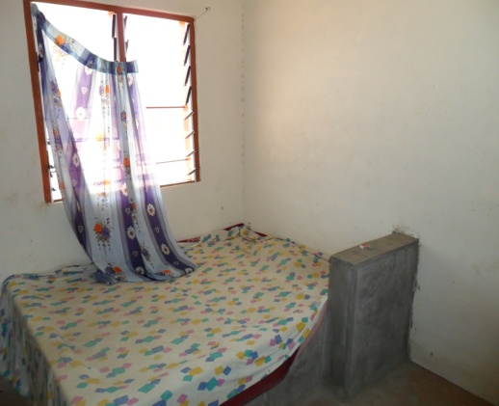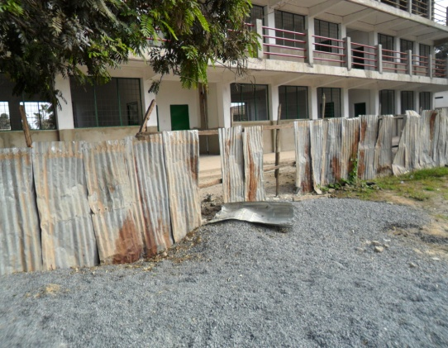

Cracked top of well with hand pump at Torn wire gauze in one of the quarters
Tankongkunda Lower Basic
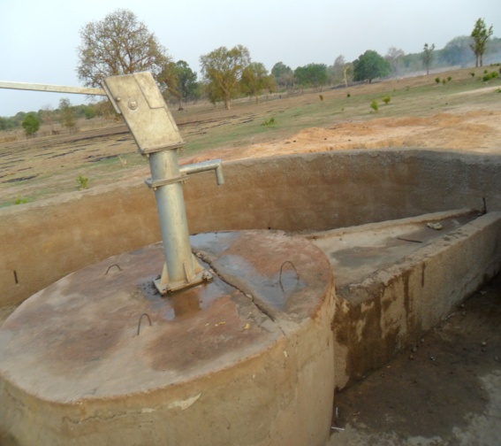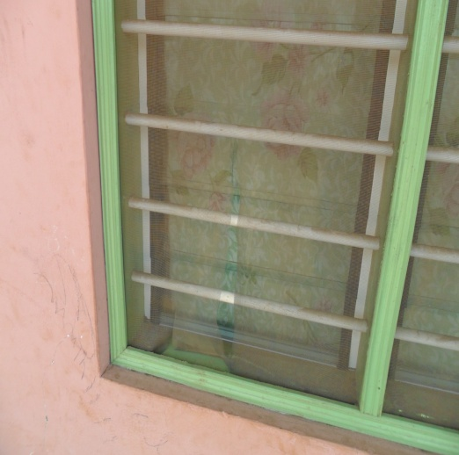

Broken asbestos roofing at Serrekunda Lower Basic Erosion of classroom building at Kerr Cherno
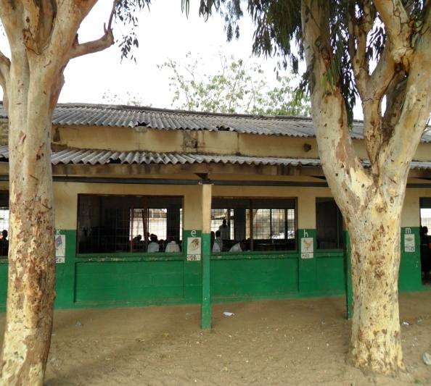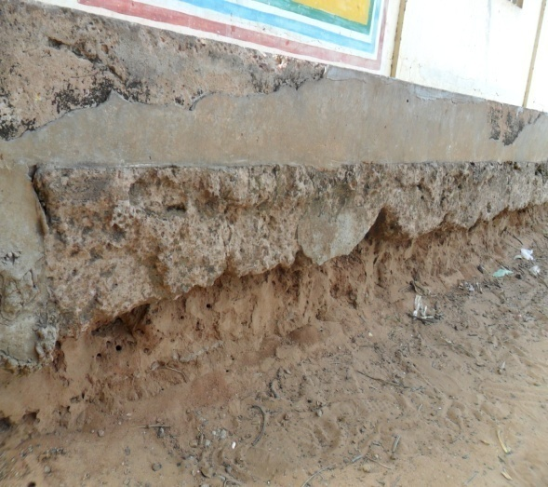

Madina Kunkunding Lower Basic School

Traditional latrine in use Modern Flush Toilets which cannot be used
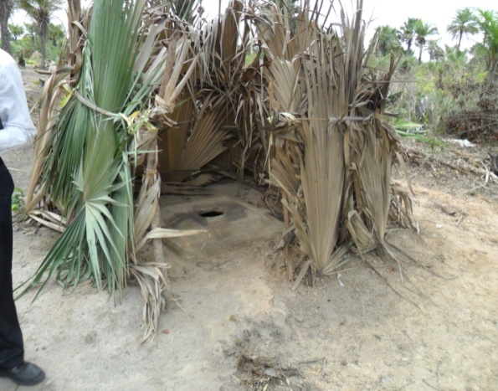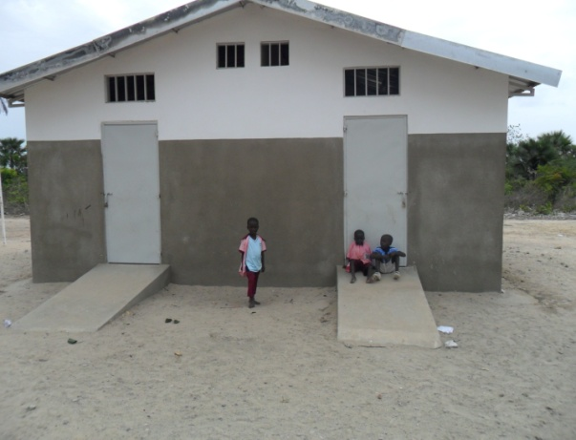

Standing water around tap at Kass Wollof Solar powered water supply system at Kass
Wollof lower Basic
Lower Basic School
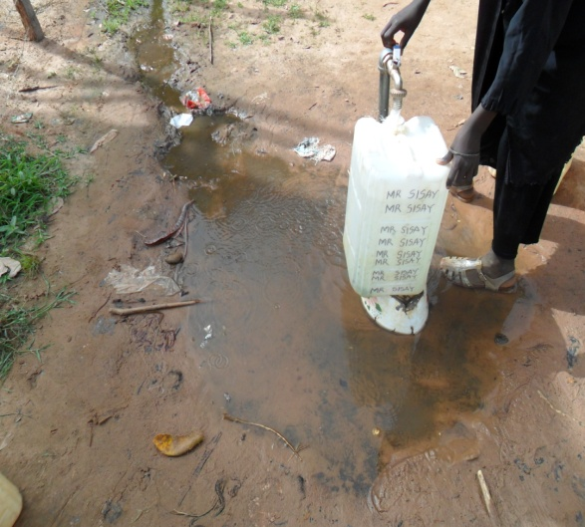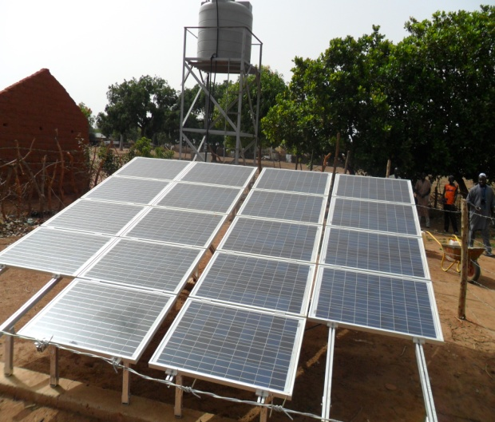

Unpaved backyard at Kunjata Lower Basic Construction site at Tallinding Annex
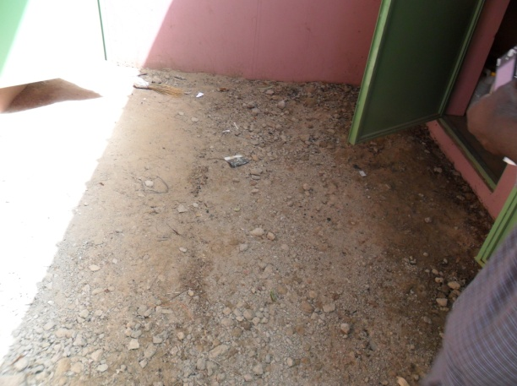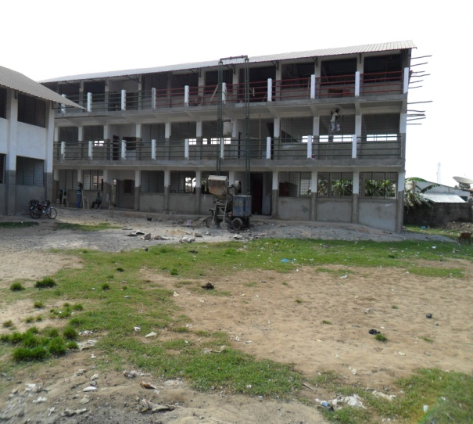
Annex 7
Bibliography

Third Education Project Environmental And Social Management Framework, MoBSEE March 2006
- The World Bank Operational Manuel Bank Procedures Environmental Assessment BP 4.01 January 1999-Revised in April 2013
- The World Bank Operational Manuel Bank Procedures Environmental Assessment BP 4.01 Annex A January 1999 -Revised February 2011
- Health care waste management plan 2005-2010, The Gambia
- National Environment Management ACT 1994, The Gambia
- EIA procedures, Banjul, July 1999 The Gambia
- EIA Guide lines, March 1990, The Gambia
- State of the Environment – Report – National Environment Agency, Banjul February2010.
- World Bank Supervision Mission Aide Memoire Ida/Gpe Pre-Appraisal Mission, Banjul,
- Project Appraisal Document For A Proposed Catalytic Fund Grant In The Amount Of Us$ 28.0 Million To The Republic Of The Gambia For A Mach 23rd - April 5th 2013 Education For All – Fast Track Initiative Program- July 16, 2009
- The Gambia Education Sector Review Aide memoire World Bank June 11-22 2012
- Project Paper on a Proposed Additional Grant to the Republic of The Gambia for the Third Education Sector Project in the amount of SDR 3.5 Million in Pilot CRW Resources (Us$ 5.5 Million Equivalent)to the Republic of The Gambia April 16, 2010
- Project Appraisal Document on a Proposed Credit in The Amount of SDR 5.5 Million (Us$ 8 Million Equivalent)to the Government of The Gambia for a Third Education Project-Phase II Project 30 May 2006
- The International Finance Corporation December 1998 Procedure for Environmental and Social Review of Projects

Annex 8

TERMS OF THE REFERENCE FOR AN ENVIRONMENTAL AND SOCIAL AUDIT OF THE IMPLEMENTATION OF THE THIRD EDUCATION PROJECT and EFA FTI CATALYTIC FUND

- BACKGROUND AND JUSTIFICATION

The Government of The Gambia, through the Ministry of Basic and Secondary Education (MOBSE), has been implementing the third phase of its education program as well as the EFA FTI Catalytic Fund aimed at improving educational standards throughout the country.

The Gambia’s education system has gone through various mutations over the years in response to changing conditions and requirements of its population as well as the international context. In this regard and in order to render the policy functional, a strategic plan was developed in order to:
- Provide access to and high quality education for all,
- Provide the appropriate services,
- Ensure gender equity in education,
- Provide life skills and
- Promote the culture of life-long learning.

2. OBJECTIVES OF THE TERMS OF REFERENCE

These Terms of Reference (ToR) aim at selecting a consultant for the implementation of an environmental and social audit (ESA) of the activities of the two ongoing projects. The objective of the ESA is to assess and monitor compliance and environmental and social performance of the project. The audit will enable to:

➢ Verify compliance with legal provisions, including compliance with national legislation
and safeguards policies and procedures of the World Bank;
➢ Identify and manage knowingly cases of non-compliance of said safeguard instruments;
➢ Improve communication on the management of the project safeguard requirements;
➢ Assess the environmental and social performance of compensatory/mitigation measures
recommended by different studies. That is, the Environmental and Social
Management Framework (ESMF) and the Resettlement Policy Framework (RPF), that have
been prepared to guide the implementation of the projects on environmental on safeguards
grounds.

The purpose of the social audit is to assess and monitor the compliance of projects with the provisions contained in the RPF. The projects supported: : (i) Construction/rehabilitation in existing schools premises, rehabilitation of classrooms to become elearning centers, (ii) Classrooms construction/rehabilitation on new sites and teacher quarters. In the former scenario, cases of involuntary resettlement seem rather unlikely. In the latter, there may be potential for involuntary resettlement, if its proven that the construction site is not a communal land and that there is clear evidence that the project activities may results in loss of assets, economic activities and/or livelihoods on the part of affected people in the project intervention areas/zones. All of this will require further social assessment on construction activities of that nature, followed adequate compensation measures, in accordance with the provisions and guidelines of the RPF. The audit will enable to:

➢ Determine whether the affected people have been fully and properly compensated in accordance with the laws and regulations in force in the country and in accordance with the Resettlement Policy Framework. The consultant will work in accordance with Policy 4.12 of the Bank's Involuntary Resettlement of Populations;
➢ Determine cases, where OP 4.12 applies, which warrants the preparation of a Resettlement Action Plan (RAP) and the cause of non-compliance;
➢ Check and ensure that there are no complaints or unresolved disputes pending;
➢ Verify and certify the existence of documents that describe the process of public consultation and disclosure of information and consensus with agreed consultations proceedings;
➢ Ensure that there are no complaints or potential conflicts pending and where they exist, evaluate the resolution mechanism set up and schedule final resolution;
➢ If there is a shortfall in the compensation process, the consultant will prepare or recommend a PAR that specifies the different scenarios to assist the Project Affected Persons (PAPs) in their efforts to improve their conditions.

4. SCOPE OF THE CONSULTANT SERVICES

The services will mainly include:
• A description of the initial state;
• A very brief summary of the main activities of the projects (IDA Third Education Sector Program and EFA FTI CF);
• The presentation of audit standards;
• The data collection;
• The data analysis;
• The development of two separate reports for each task, namely a report on the environmental audit and another on social audit.

4.1 Description of the initial state

The consultant will strive to present a brief review of the initial state of the main sites affected by the rehabilitation and reconstruction of school infrastructure funded by IDA and EFA-FTI. To this end, the consultant will use the provisions of existing safeguard instruments, in this case the ESMF and RPF, complemented by the Project Implementation Manuel (PIM).

4.2 Summary of project activities

The consultant will present the project activities according to the main implementation phases of the works, with environmental and social impacts and to this end, he (s) / her (s) may refer to various project performance reports and consider interviews with different stakeholders and witnesses of the project implementation (member/staff of the PCU, contractors, the beneficiaries and the PAPs). References of people met with the exact dates and the data must constitute annexes to the report.

4.3 Repository of the Environmental and Audit

The repository of the ESA is the basis of analysis criteria for drawing conclusions from the environmental and social audit.

Taking into account the context of funding and implementation of the projects, the repository of the audit will result from:
- Reports of Studies of Social and Environmental Impact (This is the ESMF, CPR, site-specific ESIA, ESMP and/or RAP);
- Monitoring reports by PCU etc.
- Advice and recommendations of the Ministry in charge of environment;
- Guidelines of OP 4.12 and OP 4.01of the World Bank guidelines;

4.4 Data collection

Data collection will allow the consultant to prepare the evidence to support the environmental and social audit, it will be done through:

- A form/questionnaire for data collection;
- Interviews with people involved in the projects;
-Interviews with individuals and beneficiaries of compensation and evaluation of the consultation process with the PAP;
- Field visits and observations;
- Measures or assessments of various environmental and social impacts of the projects;
- The various reports of incidents or complaints of the people;
- Mechanisms for handling complaints.

In general, the consultant will collect data or information about the projects area:
- The biophysical/ambient environment
- The socio-economic situation of affected populations;
- The various cultural sites, cultural heritage, historical sites etc.;
- Compensation Measures, training
- Communication and information on the progress of the projects

4.5 Analysis of data

The data collected will be analyzed by the use of appropriate tools to highlight among other aspects:
- The environmental and social compliance with the provisions of the ESMF and RPF;
- The non-compliances concerning the implementation of the ESMF and RPF:
o Opinions and recommendations of the ministry responsible for the environment; and
o Guidelines / procedures of the World Bank;

4.6 Conclusions of the Environmental and Social Audit

The findings of the Environmental and Social Audit include:
• A summary of compliance;
• A summary of non-compliance;
• A description of measures to remedy or mitigate the effects of non-compliance;
•An assessment of the costs of implementation of remedial measures with a timetable for implementation;
• A monitoring plan for repairs/ corrective actions/measures;
• Recommendations for measuring social impact mitigations, with detailed timeline with the roles and responsibilities of stakeholders.

The reports will be prepared in accordance with various phases of the audit and shall contain a summary of less than ten pages.

5. ORGANISATION OF THE STUDY

5.1. Sponsor and monitoring

The sponsor of the Environmental and Social Audit is the Project Coordination Unit which is coordinating the IDA and EFA-FTI projects. The various tasks of the ESA of the Audit will be monitored and verified by the PCU, NEA. The NEA will comment on all reports of a temporary nature and guide the implementation of the Environmental and Social Audit. The audit report is then submitted to the Bank for review, comments and approval.

5.2 Duration and Reports
The overall duration of the audit should not exceed six (6) weeks
The consultant will provide the following reports for each task:

- Report preparation of the audit including:
o The description of the initial state,
o The recall of project activities,
o The reference of the audit;

- Report data collection in five copies;
- The data analysis and the findings of the audit in 3-4 copies
- The summary of the audit report by 10 + 5 CD.

The environmental audit report will be written in English.

6. OBLIGATIONS OF PROMOTER
In order to ensure successful completion of this audit, the PCU shall make available to the Consultant plans and technical studies and all available information relating to the EFA-FTI and IDA project activities.

7. OBLIGATIONS OF THE CONSULTANT
As part of the implementation of this audit, the Consultant will be required to comply with confidentiality. They should do so, both during and after the mission it. Therefore, all information and documents made ​​available should be considered confidential.

8. COMPOSITION OF THE AUDIT TEAM
Achieving this environmental audit must be made by a team of a social specialist and a social specialist, both of whom should be familiar with environmental audits approach and procedures, with recognized experience in carrying out similar work in The Gambia.

6. OBLIGATIONS OF PROMOTER
In order to ensure successful completion of this audit, the Promoter shall make available to the Consultant plans and technical studies and all available information relating to the projects.

7. OBLIGATIONS OF THE CONSULTANT
As part of the implementation of this audit, the Consultant will be required to comply with confidentiality. Therefore, all information and documents made ​​available should be considered confidential.

8. COMPOSITION OF THE AUDIT TEAM
Achieving this environmental audit must, ideally, be made by a team of an environmental specialist and a social specialist, familiar with the approach, guidelines and procedures of environmental and social auditing, and with experience in carrying out similar work in the Gambia.

9. CONTENT OF THE REPORT
The content of the report should include the following elements:

- The executive summary of the audit, in English;
- Introduction;
- The description of the site (environmental and historical context);
- The environmental action plan, including the plan of environmental management, and the plan of emergency measures.
- The conclusions and recommendations;
- Recommendations for additional studies;
- Annexes:
o Terms of reference of the audit,
o List of persons interviewed/met,
o Names of the persons who carried out the audit;
o questionnaires for surveys and semi-structured interviews,
o Minutes of consultation meetings held with local communities and other stakeholders..
o Site location, drawings and photographs,
o Any other relevant information

10. DURATION OF THE ASSIGNMENT
The duration of the audit including field visits shall not exceed six weeks of service + 3-4 days of revision and finalization of report after validation workshop with stakeholders.

