

Kenya Accountable Devolution Program-Devolution and locally-led Climate and Disaster Risk Management Project (P163600)



1. EXECUTIVE SUMMARY.
The Kenya Accountable Devolution Program was established in 2012 to support the devolution process in Kenya. The KADP aims to strengthen the capacity of counties to provide services efficiently, effectively and with accountability to all citizens, including the poor. In 2015, the KADP incorporated climate change as a cross-cutting issue and a focus on strengthening the capacity of counties to address climate related vulnerability, risk management and resilience, including capacity building in environmental and social risk management and safeguards.
The locally-led climate change adaptation (CCA) and disaster risk management (DRM) project (P16300) is a sub-activity of the Programmatic Approach (PA) Social Accountability & Devolved Sectors (P160017) that is focused on devolved sectors & the social development dimension of the Kenya Accountable Devolution Program (KADP). The overall objective of the Programmatic Approach is to strengthen core devolved governance systems at both national and county level with a focus on strengthening citizen's engagement and devolved service delivery in Kenya's devolution process.
KRCS was contracted by the World Bank in April, 2019 to support the county governments of Narok, Makueni, Siaya and Kwale to strengthen their systems for Disaster Risk Management and flood Early Warning and Early Action. KRCS started implementing the project in June 2019.
2. PROJECT CONTEXT

Kenya like other developing countries, has her populace vulnerable to disaster risks resulting in deaths and loss of property worth millions. About 70% of the disasters are hydro-meteorological in nature particularly floods and drought. While the Country is exposed to a multiplicity of hazards and drought and conflicts have been drawing lots of attention, floods remain a major hazard in Kenya. While floods are generally associated with rainfall patterns being extreme in the recent past, the el nino effect has caused most severe flooding in the country including the i997/98 seasons which caused severe loss of life (human and livestock) and property, destruction of infrastructure, disruption of the communication networks and large losses to the economy. It is estimated that it caused some US $151.4 million in public and private property damage.

Beyond el-nino, rainfall patters have also caused floods in low lying areas and as such of Kano Plains in Kisumu County, Budalang’i in Busia County and the lower parts of the Tana River are historically flood prones. Floods are a result of overflow in river banks and can cause enormous damage to loss of life and property including crops and infrastructure. These are common phenomena and are costly natural disasters. In many of the dry parts of Kenya, floods are short-lived events that can happen suddenly, sometimes with little or no warning. They usually are caused by intense storms that produce more run-off than an area can infiltrate and store or a stream can carry within its normal channel. Rivers can also flood when dams fail or landslides temporarily block a channel. Flooding’s are thus traditionally associated with overflow in major rivers such as Tana, Nzoia, Athi and Nyando. In addition, the more recent past poor drainage systems has caused flooding in urban areas such as Nairobi and Mombasa.

In the more recent past, between 2016-2018, Kenya faced a prolonged drought that affected an estimated four million households. The drought was quickly followed by heavy rainfall from March 2018 and affecting an estimated 800,000 people in 32 out of the 47 counties across the country [OCHA Flash Update #6: Floods in Kenya, 7 June 2018]. Counties along the Tana and Athi River were among the 32 most affected. Out of these, about 186 people died, nearly 100 people were injured, learning was disrupted for more than 100,000 children, infrastructure including roads, classrooms and latrines were washed away. The floods also increased the risk of health emergencies including waterborne diseases such as Cholera. The first phase of recovery from the economic losses from the floods and drought were estimated by the National Treasury at more than 20 Billion [www.treasury.go.ke].

Many of those affected by the floods had also been affected by the 2016-2018 drought and flooding that follows every subsequent season of drought. In total for the 2018 floods, forty Counties were affected; Tana River, Mandera, Turkana, Kilifi, Garissa (including Dadaab refugee camp), Baringo and Kisumu with 170 people killed and more than 300,000 ps displaced. On 9th May 2018, a dam near to the town of Solai (Nakuru County) collapsed and swept away hundreds of homes downstream, killing 48 people. After 8 months from the disasters, tens of thousands IDPs still live in makeshift informal settlements. Continuous exposure to multiple hazards has compounded the vulnerability of the affected counties and communities. To deal with the multiple risks, national and county governments must allocate resources to anticipate, prepare for, respond and recover from disasters. Without proper policy and institutional mandate, these resources are not prepositioned for preparedness. The lack of predictable financing puts heavy emphasis on response rather than preparedness which has been proven to be costly.

Numerous efforts have been made to develop early warning systems and management structures for drought. However, this is not the case for floods. The lack of systems, institutional and policy frameworks has made flood management both at the national and county level ad hoc and uncoordinated. This was evident in Garissa, Kilifi and Tana River counties along the Tana River that were most affected during the 2018 floods. Systems, institutions and policies that can anticipate floods will enhance preparedness and coordinated early action to mitigate the impacts of floods. However, systems for Flood Early Warning and action do not currently exist in the two basins. Innovative tools in modelling and remote sensing and an integrated approach, can help understand and manage flood risk. This is especially critical for large or complex hydrological systems such as the Tana and Athi River Water Basin. In addition, DRM in Kenya tends to have a heavy emphasis on reactive rather than anticipatory approach. This is partially due to the lack of inclusion of anticipatory action in the policy and legislative framework. To support structured anticipatory action, related funding mechanisms need to be designed, operationalized and appropriate finances allocated.

Kenya passed a new and comprehensive National Disaster Risk Management (DRM) Policy in May 2018 which is yet to be operationalized. Whereas the National DRM policy envisages collaboration between the national and county governments, there are no clear modalities on how this collaboration is to be achieved. The policy also provides for categories of disasters, envisaging a tiered approach of disaster. It includes disasters being dealt with at the sub-county level, then at county level and finally at national level depending on magnitude. However, there is lack of clarity on the thresholds, transitions and matrix responsibilities between the two levels of government in relation to who will have mandate and under which context. In the more recent floods, there has been a debate between the counties and national government as to who had the responsibility to respond. Counties argued that the thresholds for national government involvement had been reached. This gap creates confusion, uncertainty in resource deployment and politicization of disasters. This gap requires to be urgently addressed with development of a clear framework with requisite thresholds, functions and matrix of responsibilities.
3. PROJECT RESULT AREAS
- Result 1: Establishment and Strengthening county policies and institutional architecture that supports anticipatory disaster risk management systems
- Result 2: Improved systems for EWEA in Kwale, Narok, Makueni and Siaya County.
- Result 3: Support the Development of Countywide Community Based Early Action Capability in Narok, Siaya, Kwale and Makueni.

4. KEY ACHIEVEMENTS PER RESULT AREA

Result 1: Establishment and Strengthening county policies and institutional architecture that support anticipatory disaster risk management systems.
- Revised draft Policy and Bill for Narok County developed and shared with the county government.
- Revised Bill and Policy for Makueni County developed and shared with the county government.
- First draft of DRM policy for Kwale County developed by KRCS and shared with the county government.
- Approval from Siaya County to develop a draft DRM Policy.
- Trainings on DRM and Early Warning and Early Action for flood for the county governments and key stakeholders done in all the four counties.
- Community trainings on DRM and Early Warning and Early Action conducted in all the four counties.
Result 2: Improved systems for EWEA in Kwale, Narok, Makueni and Siaya County
- Flood risk maps have been developed and validated by the county governments and by communities for all the four counties. Geographical coverage of flood early warning information and flood impacts at household level was also captured during the flood risk mapping exercise.
- A three-day Mapathon conducted to increase coverage of the flood hotspots in open street maps within the 4 counties
- Flood impact look up tables have been developed for the four counties that identify historical floods and relate them with historical impacts of the floods.
- Project learning event on Early Warning and early action conducted to share lessons learnt and best practices from the four counties
- Visit of the KRCS EOC by the Four County government’s officials to demonstrate how an EOC is set up.
- The mobile based early warning system tested in Narok during a flood event. The message was sent to 601,067 customers and successfully delivered to 322,196 customers.
Result 3: Support the Development of Countywide Community Based Early Action Capability in Narok, Siaya, Kwale and Makueni
- Early warning communication strategies that draw on multi-institutional key informant interviews have been developed for the 4 counties. They identify existing and preferred communication channels for the communication of forecasts within the counties.
5. PROGRESS OF ACTIVITIES BY RESULT AREA
This section presents the progress update as per the planned activities for each of the output areas. The activities and indicators have been numbered and discussed as per the result areas in the TOR for the consultancy.
Result 1: Establishment and Strengthening county policies and institutional architecture that support anticipatory disaster risk management systems
Activity 1.1: One training in each of the targeted counties, KRCS will work together with WRA to build the capacity of the Water Resource Users Associations (WRUAs) in Makueni, Narok, Siaya and Kwale.
These trainings were done in all 4 counties. The training brought together other key stakeholders in each of the counties including county government KMD, WRA and representatives from the WRUAs were present in the capacity building sessions on DRM. The outcomes of these trainings is increased knowledge on the DRM context internationally, nationally and within the counties.
Activity 1.2: Provide technical support to each of the targeted counties to review and develop their policy and legislation on DRM.
The review of the draft Bills and Policies on disaster risk management law is ongoing. In each of the four counties amendments have been proposed to these legislations as highlighted below:
Narok
Narok County has a draft disaster management policy. The policy was drafted in 2014. Over five years later, the draft is yet to be adopted. The County also has a draft Disaster Management Bill 2018 which is under review by the Committee and is yet to go through the first reading. The County government gave KRCS approval to make recommendations on their draft DRM Bill and Policy. The proposed changes include the mainstreaming of early warning and early actions, creation of funding mechanisms that can be activated in preparedness or in advance of the occurrence of a disaster in order to fund early action and the creation of committees cascading from the county level to the village level on DRM. KRCS has been invited to share these proposed changes to the Cabinet for their approval.
Kwale
Kwale County does not have a DRM policy but has a policy roadmap that was developed with support from Plan International. The County has requested for a write shop for the drafting of the policy followed by a wider stakeholder engagement.
Kwale County has a Disaster Management Fund Act that was passed in 2016. The Act needs revision as it focuses on response and leaves out the preparedness component of disaster risk management. KRCS facilitated the technical working group in identifying potential areas for amendment of the Bill. The key change highlighted was that the fund created by the Act could only allow for the release of disaster funds after the disaster has occurred for response. No funding could be released for preparedness or mitigation.
After the approval of the county government, KRCS facilitated the development of the first draft of the County’s DRM Policy that has been shared with the county government for further review. The first draft of the DRM policy provides a guideline for the implementation of the counties Disaster Management Fund Act. Unlike the Bill, it proposes that the Fund created by the Act should allow funds to be released for preparedness and mitigation of disasters.
Makueni
Makueni County has a draft DRM Bill and Policy, the Makueni County Fire Fighting, Emergencies and Disaster Management policy, 2019 and the Makueni County Fire Fighting, Emergencies and Disaster Management Bill, 2019. The County is most vulnerable to fires hence the title of the policy. KRCS supported the revisions of Both the Bill and Policy with the input of key stakeholders in the County. The revisions proposed by the stakeholders include: the enhancement of the County’s anticipatory systems for flood risk and to create adequate funding mechanisms for DRM. This means allowing the DRM fund created by the Act to be able to be accessed for preparedness and mitigation of disasters. The Stakeholders also proposed that early warning systems are prioritised in the Bills and policies. Both drafts localise disaster risk management by creating DRM committees at the county, sub county and ward level.
Siaya
Siaya County does not have a DRM policy. It has a draft Bill -Siaya Disaster Management Bill, 2019. KRCS facilitated a technical working group to make recommendations to the revision of the draft Bill and to discuss the areas that should be addressed in the DRM Policy. Among the recommendations made was to change the title to “Siaya Disaster Risk Management Bill, 2019”. The fund created by the fund was also proposed to be activated for preparedness and mitigation and not just for response. The county government committed to ensure that the Siaya DRM Bill will be approved at the cabinet level so that the same can be pushed to the county assessment and possibly enacted into law.
Activity 1.3: Support the counties to form/strengthen and train county, sub county and ward level DM institutions/structures (e.g. disaster committees) as shall be defined in the law and policy
Trainings on Disaster Risk Management and Early Warning and Early Action were conducted in each of the Counties. They brought together key stakeholders including various departments of the county government, The county commissioner’s office, Kenya Meteorological Department, the National Drought Management Authority, the Water Resource Users Authority, the Water Resources Authority, the Kenya Wildlife Service, Private Sector, Media, CSOs within the counties. The outcome of the training is that the flood risk maps and historical flood impacts were validated and communication channels for early warning were identified. The impact looks up tables for floods were also shared and validated.
Makueni County has recently created DRM committees until the ward level. In Kwale and Siaya the formation of committees at the sub county and ward level is underway. In Narok the formation of the committees at the sub county, ward and village level is underway and will be embedded in the county’s DRM Act and policy.
Without the creation of these committees KRCS conducted trainings on DRM at the at the Village level in each of the 4 counties. The village level trainings were done for the villages that had been identified as flood hotspot areas. The outcome of these trainings is that the communities understand DRM and EWEA, they also validated the flood risk maps, the flood impacts and the communication channels for early warnings.
Result 2: Improved systems for EWEA in Kwale, Narok, Makueni and Siaya County
Activity 2.1: Development of data sharing MOUs between counties and relevant institutions such as KMD for weather related information.
KRCS developed an MoU between itself and KMD for the sharing of flood data and other disaster related information. KRCS wrote a letter to Makueni County formally offering support on the activities within the project. In Siaya, Kwale and Narok, KRCS capitalised on the auxiliary role of the Kenya Red Cross Society to ensure engagement with the county government of the result areas.
Activity 2.2: Development of a flood risk database which will compile all river flood and historical record of past flooding incidents and impacts together with vulnerability and exposure markers.
Although flood hotspots have been identified in the four counties together with flood risk maps, the establishment of the database requires a collation of data enabled by the frameworks and MOUs, identification of a host institution, as well as procurement of software and hardware.
Activity 2.3: Development of flood risk maps through a mapping exercise which will be carried out jointly using data from the above database.
During the inception meetings, stakeholders identified the need to develop flood risks maps which will be used to better understand the flood risks in the counties. The date team carried out desk review for the four counties where they developed maps using satellite imagery on county vulnerability exposure, hazard exposure, county risk score and water shed maps as shown below. The GIS team trained KRCS volunteers on how to undertake the flood risk mapping exercise. The mapping was done together with communities in the flood hotspot areas in order to validate and ground truth the data collected from the satellites. The flood risk maps contain geographical coverage of the flood early warning information, flood impacts and buildings’ vulnerability to floods at household level.
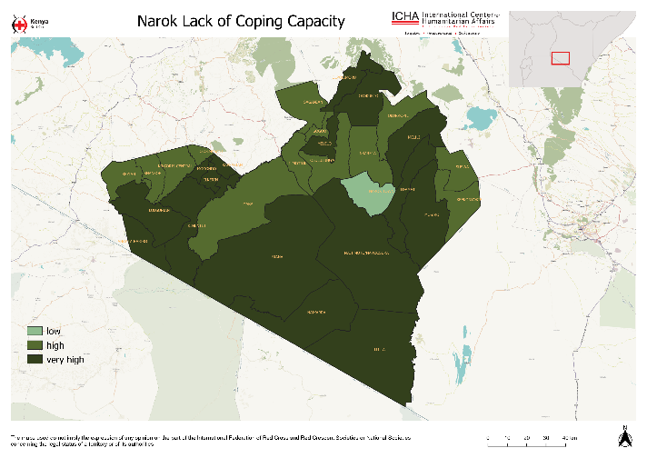
Figure 1: Lack of coping capacity - lack of resources that can alleviate the impact of a disaster.
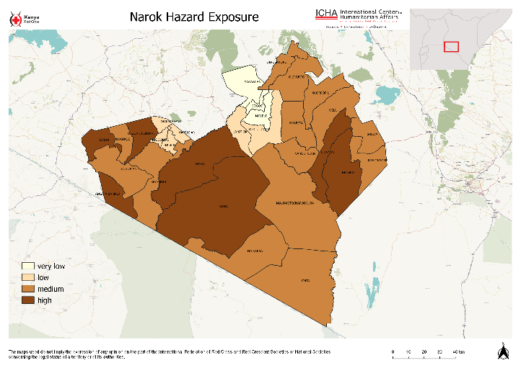
Figure 2: Weighted exposure to natural and human related disasters such as floods, earthquakes, drought, conflict
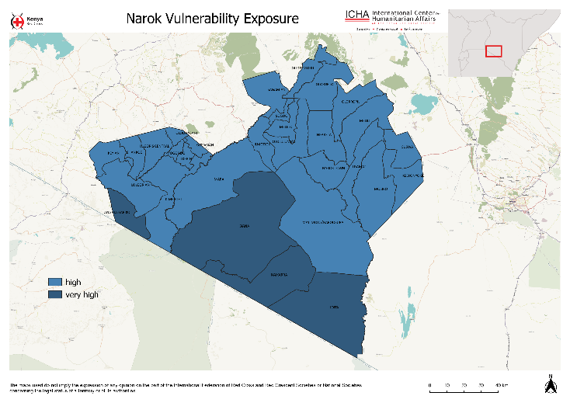
Figure 3: Vulnerability Exposure
The team used the HAND (height above nearest drainage) method in conjunction with analysis of high-resolution settlement layers and ground base validation. They also used the KOBO tool box t to carry out spatial coverage of flood early warning information, flood impacts and buildings vulnerability to floods at household level.
The maps were then presented to the county stakeholders during the inception meetings, the county trainings on DRM and EWEA, during the community trainings on DRM and EWEA and during the learning event for validation. The flood risk maps for the four counties have been attached as annexes to the report.
During the desk review of the satellite images, it was noted that the information on open street maps for the four counties was outdated. KRCS conducted a three-day mapathon to update the flood risk maps available on open street maps. The mapathon brought together 200 volunteer mappers who assisted in identifying buildings and water bodies within the counties. From the sections highlighted for mapping within the counties, the following is the progress of mapping in each county with work continuing beyond the project to achieve 100% mapping:
- Siaya- 68%
- Kwale-9%
- Makueni-7%
- Narok-8%
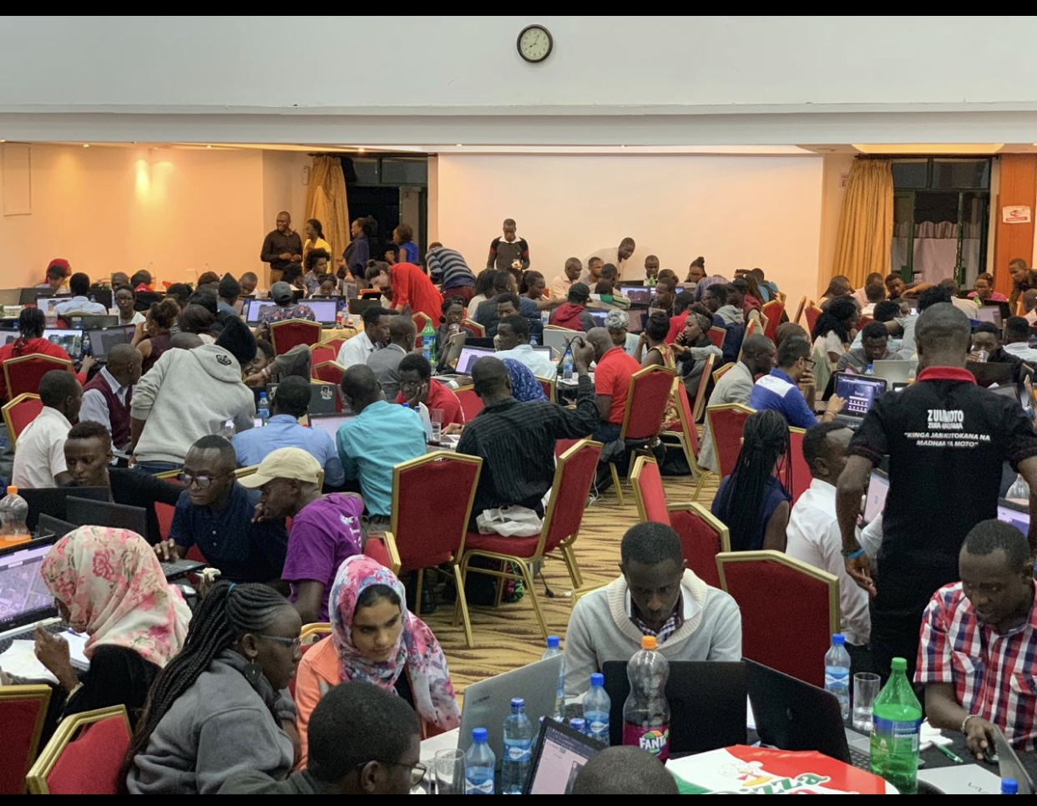
Figure4: Mapathon Exercise at the KRCS headquarters

Activity 2.4: Identify areas in urgent need of monitoring stations/ instruments using flood risk maps generated, areas in urgent need of monitoring stations/ instruments to better generate flood modelling data will be identified
In Narok, the flood risk maps were overlaid with existing KMD rainfall stations which gave a picture of the station coverage in flood prone areas. Most of these stations have been set up in catchment areas but are currently out of service. However, KMD is currently working with another project to install automatic weather stations in the same sites. The installation of these stations can be informed by the risk maps.
However, this activity has not been conducted for the remaining three counties and the project team will continue to work with the KMD directors from the remaining three counties to provide geographical coordinates of existing and functional weather stations. A spatial overlay of weather stations and flood risk maps will give an indication of areas that are in urgent need of monitoring stations. This will be done in the next phase of the project.
Activity 2.5: Demonstrate to the target counties how they can set up EOCs specific for their counties.
This activity was conducted as part of the learning event; the relevant county stakeholders were requested to remain behind for a one-day activity after the project learning event to demonstrate the Kenya Red cross EOC. The disaster directors for each county were part of this activity, we were able to demonstrate the KRCS EOC, how it operates and what is needed to set up an EOC in their counties. The stakeholders were very interested in this idea and promised to move forward the idea to the other relevant stakeholders to set up at least one EOC in their respective counties. Discussions with the county officials touched on these critical areas:
- The cost of establishing an EOC center
- Minimum standards for establishing EOC centers.
- Legal and policy framework for the establishment of EOCs
- Partnership between counties and KRCS in developing EOCs
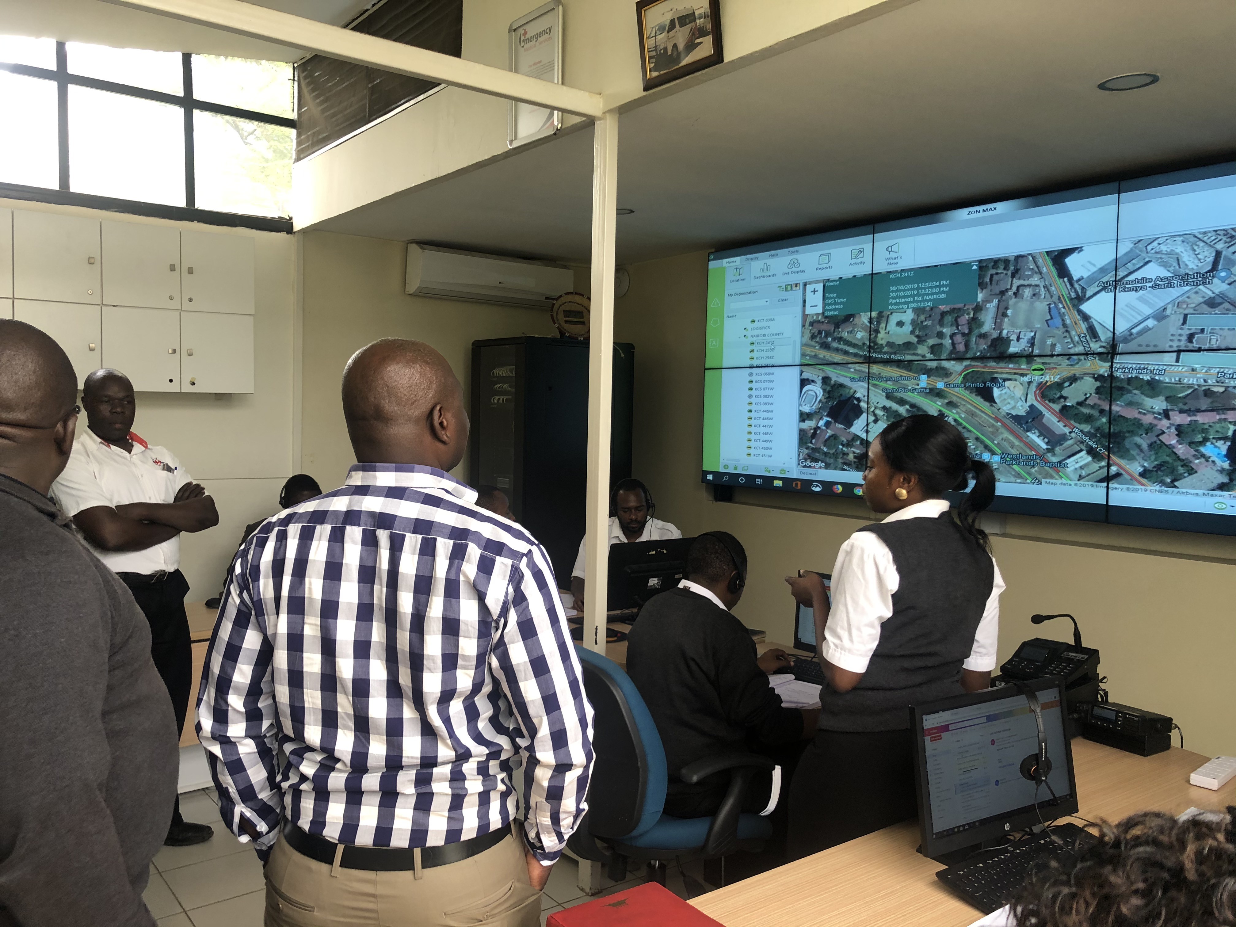
Figure 5: Directors of Disaster at the KRCS EOC

Activity 2.6: Assess rainfall forecasts at different lead times that will best be integrated into the identified hydrological models
The project developed flood look up tables linking past flood events and impacts to the different amounts of rainfall recorded in the counties by the County Metrological Department. For a county like Siaya flooding which is mostly caused by overflow of River Yala and Nzoia the look up table included the river heights for the flood events. The lookup tables were developed for all the four counties and validated during the trainings with the county governments, the trainings with the communities and during the learning event. Below is an example of the flood look up table form Siaya County.

Flood look-up table for Siaya County
Flood event date | Location in Siaya where flood occurred | Impacts | Observed Daily Rainfall |  |  |  |  |  | River Level in m  (Rwamba)
Flood event date | Location in Siaya where flood occurred | Impacts | T-4 (mm) | T-3 (mm) | T-2 (mm) | T-1 (mm) | T-0 (mm) | Total (mm) | River Level in m  (Rwamba)
05/01/2009 | Usonga | - 400 indirectly affected | 0 | 0 | 0 | 0 | 0 | 0 | 0.63%
27/12/2009 | Siaya | - 5 deaths  - 101 houses destroyed  - 500 people indirectly affected | 0 | 27 | 0 | 9 | 12 | 48 | 1.02
12/06/2011 | Usonga, Nyadorera Centre, Rwambwa Health Centre, Police Post | - 500 houses damaged  - 100 in damages | 0 | 1 | 6 | 0 | 1 | 8 | 1.32
5/12/2011 | Siaya | - Families displaced | 0 | 0 | 7 | 0 | 7 | 14 | 5.82
22/4/2013 | Siaya | - Schools disrupted | 7 | 7 | 20 | 0 | 23 | 57 | 3.78
4/4/2015 | Bondo | - 5 died | 35 | 0 | 0 | 1 | 2 | 38 | 1.26
3/05/2016 | Siaya | - Families displaced | 0 | 11 | 8 | 3 | 0 | 22 | 3.47
19/5/2016 | Nyadorera | - Displaced 150 families  - Water level risen up to 5.7 meters | 6 | 0 | 0 | 0 | 1 | 10 | 3.43
7/03/2018 | Siaya | - 2 people drowned | 0 | 13 | 0 | 0 | 0 | 13 | 0.82
18/05/2018 | Nyadorera village, Alego and Usonga | - 169 households displaced  - Livelihood items and livestock were swept away | 14 | 5 | 0 | 0 | 8 | 27 | 3.09
21/5/2018 | Alego and Usonga | - 7000 people displaced | 0 | 8 | 0 | 6 | 11 | 25 | 3.0
25/5/2018 | Bondo | - Rain chipped a portion of Bondo-Usenge-Osieko highway  - causeway on Lake Victoria was subsiding into the waters | 29 | 0 | 0 | 0 | 25 | 54 | 2.95

Table 1: Siaya Look up table

Activity 2.7: Multi-institutional strategy for communicating early warning information
From the inception workshops, the stakeholders in all four counties identified the lack of an effective flood early warning communication system as a key challenge in implementation of flood early warning early action.
The project carried out key informant interviews with key flood management stakeholders in all Counties and these included; key county ministries, county administration offices, Office of the County Commissioner, Water Resource Users Associations, NGOs, Media and Chamber of Commerce. The KIIs gave a better understanding of the flood early warning information currently being received, and, the sources and channels used to communicate the information. Additionally, the stakeholders gave guidance on the flood early warning information they would want to receive and the channels to be used.
The KIIs information has been used to develop draft communication strategies for the 4 counties. The aim of the communication strategy is to improve communication of flood early warning information to stakeholders in the Counties and to ensure the information reaches the last mile users. These communication strategies were presented to stakeholders for validation. They are now being refined to the stakeholder’s comments and observations. The communication strategies are attached as annexes.
Activity 2.8: Actors sensitized on the early warning communication strategy
In the capacity building workshops, stakeholders were presented with the draft communication strategy for sensitization and validation of the results. During the project’s learning event, the communication strategies were shared with stakeholders for validations. Their inputs have been added into the communication strategies.
Activity 2.9: A mobile based floods early warning system will be developed and simulated in the project period
Engagement with the Communications Authority of Kenya (CAK) and the mobile service providers was initiated over the mobile based communication system in Narok County. The Service providers Safaricom and Airtel have been hesitant to share bulk messages because of the restrictions highlighted in the Information and Regulation guidelines issued by the CAK. KRCS facilitated conversations to have the service providers indemnified from actions arising out of the flood early warning text messages but this has not yet been concluded. Engagements with the CAK, mobile service providers and county governments are ongoing to establish in policy the protocol between country governments and service providers in sharing bulk flood warning messages for communities.
However, on October 29th, the Kenya meteorological Department issues a heavy rain alert for counties including Narok. Utilising the protocols developed, KRCS in collaboration with county goverment activated and sent out mobile based early warning messages using the TERA platform. The message was sent to 601,067 customers and successfully delivered to 322,196 customers in Narok.
Activity 2.10: Identify predefined early actions
The conversation was started with county stakeholders during the trainings ON DRM and EWEA during discussions on the flood look up tables. Stakeholders were grouped per sectors; county government, NGOS, media, community and national government to discuss viable early actions to be taken upon the release of flood early warning information. The actions from each county were included in the revised communication strategy this was then presented to the county stakeholders during the learning event. Copies of the same have been shared with the counties for further validation.
Activity 2.11: Early Action Protocol
Development of EAPs requires comprehensive flood risk analysis, definition forecast probability thresholds and setting up triggers for early action. Although some of the early actions have been identified, the development of the early action protocols has not been done, and is not feasible in the project timeline. This is proposed for the next phase of the project.
Activity 2.12: Financing flood EAPs
Discussions on the appropriate funding mechanisms have been conducted in all four counties and proposals have been made. The activation of these funding mechanisms requires the adoption of the draft legislations on DRM. This activity is underway but not completed.
Activity 2.13: Capacity building of NDOC on EWEA
This activity will be undertaken during the next phase of the project. A concept note and a tentative training agenda has been developed and discussions held with the NDOC on the training.
Activity 2.14: Host learning events
This was the last activity that was done during the project. The main objective of the learning event was to provide a platform for inter county sharing of lessons learnt during the project timeline and some of the best practices. To achieve this, the learning event brought together representatives of key stakeholders of disaster risk management from Makueni, Siaya, Narok and Kwale including, a representative from the county government, line ministries such as the departments of Special Programmes, Agriculture, Governance, Environment, and Livestock, the National Drought Management Authority, the Water Resources Authority, Water Resources Users Association, the Kenya Meteorological Department, and the Kenya Red Cross Society. The outcomes from this event is that KRCS and the county government were able to share best practices and learnings as well as identify priority areas for scale up during the next phase of the project. The project learning event report is attached as an annex.

Results 3: Support the Development of Countywide Community Based Early Action Capability in Narok, Siaya, Kwale and Makueni
Activity 3.1: The project will work with county to community actors (Disaster committees and response teams) to identify predefined early actions that will be taken based on flood early warning information.
The conversation was started with county stakeholders in the capacity building workshops during discussions of the look up tables. Stakeholders were grouped per sectors; county government, NGOS, media, community and national government to discuss viable early action to be taken upon the release of flood early warning information. The actions from each county which were included in the communication strategies attached below.
Activity 3.2: Information from all the sections above will be put together into an Early Action Protocol (EAP) for the target counties
KRCS was able to develop a communication strategy for early warning early action which included the lookup tables, flood hotspots and impact lookup tables. The development of early action protocols requires extensive flood risk analysis and setting up triggers for early action which requires a longer timeframe. This activity is scheduled for the next phase of the project.
- SYNTHESIS ON BENEFICIARIES
(Total direct beneficiary numbers, disaggregated by sex and age group as per the beneficiary data summary)
            - Direct beneficiaries- 632 beneficiaries
462 males and 170 females
Beneficiaries per activity | Nairobi |  | Narok |  | Kwale |  | Makueni |  | Siaya
Beneficiaries per activity | M | F | M | F | M | F | M | F | M | F
Inception meetings | - | - | 25 | 4 | 23 | 7 | 21 | 4 | 34 | 10
County Trainings on DRM and EWEA | - | - | 28 | 7 | 23 | 7 | 24 | 6 | 34 | 10
Community training on EWEA | - | - | 15 | 10 | 19 | 4 | 23 | 8 | 23 | 14
Mapathon | 134 | 70 | - | - | - | - | - | - | - | -
Learning event | 36 | 9 | - | - | - | - | - | - | - | -
Total Number of beneficiaries | 170 | 79 | 68 | 21 | 65 | 18 | 68 | 18 | 91 | 34
Total | 462 | 170
            - Indirect beneficiaries
- Population of Kwale County- 649,931
- Population of Siaya County- 842,304
- Population of Makueni County- 884,527
- Population of Narok County- 1,130,703

- GENDER MAINSTREAMING AND SOCIAL INCLUSION
During the project activity implementation, gender considerations were made. Participatory planning with the county governments was conducted, to ensure inclusive representation of all genders and special interest groups. These considerations were also made in the development of policies and early warning communication strategies.
- UPDATE ON DONOR ENGAGEMENT ACTIVITIES
Continuous engagement with World Bank has been maintained on the project progress during the quarter. KRCS participated in a project meeting in Makueni, Naivasha and also participated in coordination meetings with the World Bank.
- PARTNERSHIP ENGAGEMENT AND MANAGEMENT
            - KRCS entered into an MoU with KMD to enhance the sharing of data pertinent to the implementation of the project
            - KRCS is also in the process of developing an MoU with the Kenya Law Reform Commission to help in supporting the county governments to develop laws and policies on DRM
- UPDATE ON DATA DRIVEN DECISIONS MADE
The findings from the initial satellite images on the risk prone areas helped the team determine the scope of the actions that could be achieved in the project implementation time. The distance per square kilometre that could be mapped determined how extensive the flood risk maps could be.
The unavailability of updated satellite maps on open street maps caused KRCS to host a mapathon to ensure the flood prone areas have been mapped.
The availability of data on previous flood incidences also hindered the development of the forecast probability thresholds as KMD did not have this kind of data.
- PROJECT RISK MANAGEMENT
Project risk management tailored for this project has been developed and is being used. Operational and financial risk related concerns were discussed, analysed and mitigation measures assigned against each risk.
- EXIT STRATEGY AND SUSTAINABILITY
The Flood risk maps, flood impact look up tables and communication strategies were validated and handed over to the county governments.
The integration of these early warning systems in laws and polices is underway for the sustainability of the early warning system.
- SUMMARY OF FINANCIAL PERFORMANCE
The project is at 100% of implementation.

KEY CHALLENGES AND ACTIONS TAKEN
Challenges | Action Taken
- High costs of sitting allowances for the county officials | Engagement with the county officials beforehand on the rates for perdiem/ allowance offered under the KRCS finance policy
- Community Disaster Risk Management communities at the village level have not yet been established in some of the counties | WRUAs are already established in law and engage members of the communities in early warning along river basins. WRUAs are therefore being utilised in complementarity to the village DRM systems that are proposed to be set up.  Advocacy is being conducted on the need to cascade disaster risk management initiatives to the village levels
- Illiteracy levels in the target communities is high | Proposing supplementary communication methods for early warning communication including radios
- Flash floods are not predictable using forecasts | Hydrological models will be adopted moving forward that will help anticipate flash floods.
- Bureaucracy in engaging with the county governments | Parallel advocacy conducted both with the technical staff and the decision makers at the county government on the project outcomes
- Some of the flood hotspots identified by the communities were not previously mapped as at-risk areas | The date team corroborated the data they collected to ensure that most of the flood hotspots have been identified
- Inaccessibility of houses at risk of flooding | The team had to find other routes to access these houses even though the distance was longer and the existing road network was not available on open street map.
- Some communities did not give consent to be interviewed | Through the KRCS county coordinators, the team was able to get support from the local administrative leaders for prior community sensitization that allowed most of the community members to receive the KRCS team well.
- Some of the occupants in the houses at risk of flooding were not available during the mapping exercise. | The GPS coordinates were taken for houses that were unoccupied during the flood risk mapping exercise. This information was later validated by stakeholders for accuracy
- There were some few instances where the 12.5m spatial resolution earth observation satellite couldn’t accurately geo locate houses at risk of flooding. | The project team shall explore high spatial resolution imagery acquired from remotely piloted air systems (RPAS) or commercial earth observation satellites for better mapping accuracy in terms of extracting houses at risk of flooding.

- LESSONS LEARNT
- Policy
- Funding mechanisms for disasters must be predetermined and able to be activated in advance of a disaster. The 2% emergency fund created by the PFM Act does not support preparedness and mitigation activities.
- All funds created must have a fund management committee with a fund manager who must be either the CEC finance or someone appointed by the CEC in writing. This must be applied to all the county DRM Funds
- There is some tension between the sectoral plans on DRM overlapping with the functions of the county directorates of disaster management. There is need to work with the county governments to delineate key responsibilities for the directorates and the other ministries.
- The creation of the county, subcounty, ward and village level committees has been a challenge for the counties because of allocation of funding to support these committees. Makueni has established that the best practice for now is to set up these committees until the ward level.
- County governments must work with communities in Disaster Risk Management as the communities are the first responders in a disaster

- Data
- Flood risk mapping despite being a function of exposure + vulnerability + lack of adaptive capacity, can be conducted with exposure + vulnerability, where granular data on lack of adaptive capacity is missing. This was the case for the KADP project.
- Satellite derived elevation data can be used to delineate communities vulnerable to floods based on water shed analysis models such as height above nearest drainage (HAND). The HAND methodology could be used to delineate road networks at risk of flooding. Other flood risk mapping methodologies could also be used besides the HAND methodology.
- Exposure data on buildings at risk of flooding can be obtained freely from open street map (OSM). Where such exposure data is lacking on OSM, coordinated mapathon events can be used to mobilise volunteers to map out buildings at risk of flooding using the humanitarian OSM platform.
- Due to limitations in spatial resolution from satellite derived elevation data, the project proposes the use of elevation derived from drone imagery for more detailed and accurate flood risk mapping especially in flood hot-spots.
- EWEA
  - Despite the challenges with the mobile service providers in sharing bulk early warning messages, a floods early warning system can be scaled up and extended to other counties. The dividends from the project implemented under this report has been identify key policy and legal gaps that limits a mobile based early warning system which are being addressed through legislative and policy advocacy.
  - Hydrological modelling is needed to develop better early warning for flash floods. Flood modelling will require an improved network of river and rainfall monitoring stations. KRCS will continue to work with KMD and other partners to apply and test different models.
  - Development of the early warning communication strategy highlighted the need for the development of effective flood contingency plan within the counties. The work on supporting the development of the contingency plans for the four counties under this project is underway.
  - Implementation of the early warning communication strategy should be anchored in the DRM policies and legislation. Current processes of developing legislation and policies in the target counties has factored this key requirement.
  - Collaboration between KMD, WRA Disaster committees and other key stakeholders should be enhanced to strengthen early warning communication and related actions. Whereas the current project has supported working relationship between the key stakeholders, sustaining and developing the collaboration approaches will be critical.

KEY RECCOMENDATIONS
RECCOMENDATION | TO BE ACTIONED BY | Timelines
Effective early warning information needs to use multiple tools of communication such as local radio, village barazas, social media, mobile based communications systems, etc. | - To be coordinated by KRCS  - County Government  - Mobile service providers  - CoG  - KMD | - To be tested in the OND and MAM rain seasons
There is a need to have data sharing agreements across relevant institutions (e.g. KMD, NDMA, KRCS, WRA etc) to ensure access of disaster related data. | - To be coordinated by NDOC  - KRCS  - WRA  - County Governments | - By March 2020
All the four counties have highlighted on the need for capacity building at the county level. There is need for more capacity building sessions in the counties. | - To be coordinated by CoG  - KRCS  - County Governments | By end of March 2020
Improving on the systems the county governments have in place e.g. WRUAs and CSGs is easier than proposing new structures. Policy initiatives should consider strengthening these existing systems. | - To be coordinated by CoG  - KRCS  - KMD  - WARMA  - County Governments | - To be coordinated under ongoing policy and legislative development process
Pre-allocation of funding for the stipulated early actions is key for effective early warning and early action. There is the need for the counties to develop a county DRM fund that is separate from the already existing 2%fund that is established for emergencies under the public finance management | - To be coordinated by respective county governments.  - CoG  - Ministry of Finance  - Ministry of Devolution | - To be developed during budget and planning making process for financial year 2020/2021
There is need for counties to adopt a multi sectoral approach to disaster risk management and DRR should be mainstreamed in all the programs | - To be coordinated by CoG  - County Governments  - Ministry of Finance  - Ministry of Devolution | - To be developed during budget and planning making process for financial year 2020/2021
That disaster management is shared responsibility between the national government and the county governments therefore there is need to have a proper coordination between the two levels of government and the non-state actors. A high level engagement on coordination to be organised. | - To be coordinated by CoG/National Government Ministry of Interior  - County Governments  - Ministry of Finance  - Ministry of Devolution  - UNOCHA  - KRCS  - Other stakeholder sin humanitarian sector | - To be done by end of quarter one 2020
There is need for development of multi-hazard contingency plans in the four counties and for them to be revised regularly and anchored in the county policies. | - To be coordinated by KRCS  - CoG  - County Governments  - Ministry of Devolution  - NDOC  - NDMA  - WARMA | - June 2020
There is need to have a coordination between KRCS and the COG (council of governors) in developing a coordination action plan for all the counties | - KRCS  - CoG | - December 2019
There is need for the Kenya metrological department to be part of the county disaster management committee to provide forecasts which can be used to inform on the activation of funds for disaster preparedness | - To be coordinated by CoG  - KMD  - County Governments | - March 2020

- ANNEXES:
Annex 1: County Training reports
Annex 2: Community engagement training reports
Annex 3: Learning event training report
Annex 4: EOC training report
Annex 5: Community Early Warning Communication strategies
Annex 6: Policy drafts
Annex 7: Flood risk maps
Annex 8: folder of quality photos

According to CRED EM-DAT (1990-2014), FLOOD accounts for 82% of lives losses and 88% of Average Annual Economic Loss.

