Report No: ACS12128
.
Europe and Central Asia
ASSESSMENT OF THE ROLE OF GLACIERS IN STREAM FLOW FROM THE PAMIR AND TIEN SHAN MOUNTAINS
.
May 4, 2015
.
GWADR
EUROPE AND CENTRAL ASIA
.
.
.
Standard Disclaimer:
.
This volume is a product of the staff of the International Bank for Reconstruction and Development/ The World Bank. The findings, interpretations, and conclusions expressed in this paper do not necessarily reflect the views of the Executive Directors of The World Bank or the governments they represent. The World Bank does not guarantee the accuracy of the data included in this work. The boundaries, colors, denominations, and other information shown on any map in this work do not imply any judgment on the part of The World Bank concerning the legal status of any territory or the endorsement or acceptance of such boundaries.
.
Copyright Statement:
.
The material in this publication is copyrighted. Copying and/or transmitting portions or all of this work without permission may be a violation of applicable law. The International Bank for Reconstruction and Development/ The World Bank encourages dissemination of its work and will normally grant permission to reproduce portions of the work promptly.

For permission to photocopy or reprint any part of this work, please send a request with complete information to the Copyright Clearance Center, Inc., 222 Rosewood Drive, Danvers, MA 01923, USA, telephone 978-750-8400, fax 978-750-4470, http://www.copyright.com/.

All other queries on rights and licenses, including subsidiary rights, should be addressed to the Office of the Publisher, The World Bank, 1818 H Street NW, Washington, DC 20433, USA, fax 202-522-2422, e-mail pubrights@worldbank.org.

The Role of Glaciers in the Hydrologic Regime

of the Amu Darya and Syr Darya Basins

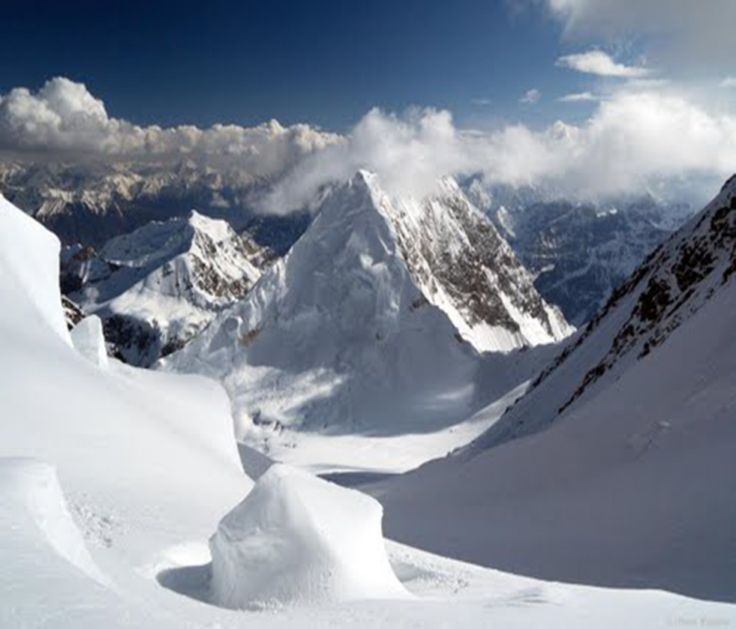
Glaciers of the Bartang Basin in the Amu Darya Headwaters

Donald Alford
Ulrich Kamp
Caleb Pan
The World Bank
May 2015
The Role of Glaciers in the Hydrologic Regime
of the Amu Darya and Syr Darya Basins

Donald Alford
Consultant – Mountain Hydrologic Systems
&
Research Affiliate
Department of Geography
University of Montana

Ulrich Kamp
Associate Professor
Department of Geography
University of Montana

Caleb Pan
Research Affiliate
Department of Geography
University of Montana

Final Report submitted to

The World Bank

Washington, D.C.
May 2015

Contents

1. | Executive Summary
2. | Introduction
 | 2.1. Background
 | 2.2. The Problem
 | 2.3. Scale and Location in Mountain Hydrology
 | 2.4. The ‘Pamir-Karakoram Anomaly’
3. | Previous Studies and Uncertainty
 | 3.1 Previous Studies
 | 3.2 Uncertainty
 | 3.2.1. Mapping Uncertainty
 | 3.2.2. Scenario Uncertainty
 | 3.2.3. Conclusion
4. | Methodology and Data
 | 4.1. Basin and Glacier Hypsometries
 | 4.2. Stream Flow
 | 4.3. Water Budget
 | 4.4. Glacier Ablation and Runoff
 | 4.5. Glacier Zones
 | 4.6. Steady-State Equilibrium Altitude
 | 4.7. Ablation Gradient
5. | Amu Darya Mountain Basins
 | 5.1. Basins
 | 5.2. Glaciers
 | 5.3. Climate
 | 5.4. Hydrology
 | 5.4.1. Seasonality of Stream Flow
 | 5.4.2. Glacier and Snow Runoff
6. | Syr Darya Mountain Basins
 | 6.1. Basins
 | 6.2. Glaciers
 | 6.3. Climate
 | 6.4. Hydrology
 | 5.4.1. Variability of Stream Flow
 | 5.4.2. Glacier, Snow, and Rainfall Runoff
7. | Stream Flow and Climate Change
 | 7.1. Amu Darya Mountain Basins
 | 7.2. Syr Darya Mountain Basins
8. | Discussion
9. | Bibliography
 | Appendix
 | Mapping Basin and Glacier Area

Executive Summary

Background

The headwaters of the Amu Darya and Syr Darya in the western Tien Shan, Pamir and Hindu Kush mountains are a major source of stream flow into the Aral Sea Basin (Figure ES-1). The water security—affecting energy and food security—of this region and the consequent regional dynamics and politics are connected to these headwaters. The Aral Sea Basin comprises of 7 countries (Kyrgyz Republic Tajikistan, Turkmenistan, Uzbekistan, Southern Kazakhstan, and small parts of Afghanistan, Iraq) with a total population of more than 60 million over an area of 4 million km². In the basin, there are large differences in water availability, from Tajikistan with an average of about 5,000 m³ available per person annually to Turkmenistan with less than 300 m³ per person annually. The upstream countries, Tajikistan and the Kyrgyz Republic, rich in water resources but poor in oil, gas and coal, energy supply rely heavily on hydropower. Hydropower accounts for 99% in Tajikistan and 93% in the Kyrgyz Republic (WDI data, 2011). Due to winter energy shortages, these countries would like to expand hydropower production. In contrast, the downstream countries, Kazakhstan, Turkmenistan and Uzbekistan, are largely dependent on inflow from the two upstream countries to secure summer irrigation supplies. Agriculture is a key component of the basin’s economy and accounts for 90% of total water withdrawal in the basin. Out of 7.4 million hectares of land being irrigated in the basin, 4.3 million hectares are in Uzbekistan and 1.6 million hectares in Turkmenistan (ICWC data, 2011). Tensions amongst the riparian countries have risen in recent years due to conflicting seasonal demands on these water resources. Climate change may have a significant impact on the overall water resource availability in the basin.
Recent concerns related to climate change, glacier retreat and stream flow from these mountains have served to illustrate the very limited understanding that exists concerning the hydrologic regimes of the mountain headwaters of these major river systems as well as of the glaciers, that are a component of those regimes. Traditional studies of the mountain water resources, based on gross aggregate means relating climate and runoff derived from macro-scale satellite imagery and global circulation models or historical records, may produce useful values information on total runoff, but cannot distinguish amongst rainfall, snow and glacier melt as components of that runoff. This decomposition has important implications for future water resource planning and management. A better understanding of these hydrologic processes is critical for assessing the amount and timing of water supply and hydropower available (both current and future) for the various countries in the Central Asia region that have headwaters originating in these mountains. Such an understanding is also critical in making estimates of runoff changes under a climate change future. This is the main objective of this study.
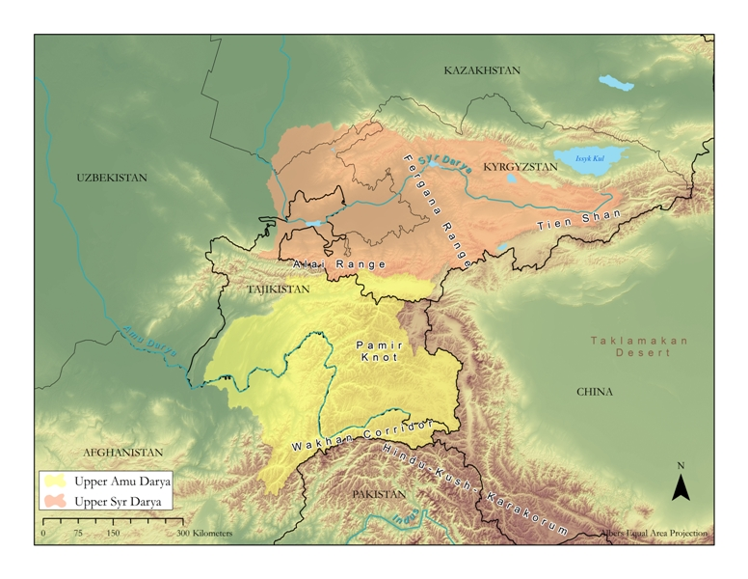
Figure ES-1. The mountain headwaters of the Aral River Basin in Central Asia.

This study expands the knowledge on the role of glaciers (both present and in the future) on the Amu and Syr Darya rivers by adopting a methodology developed recently for the nearby Ganges and Indus systems (e.g., World Bank., 2010; World Bank, 2011; Immerzeel, et. al., 2010). Based on historical records and analyses of GIS hypsometry and satellite imagery, this study presents the general baseline hydrology of the mountain basins at the headwaters of these two river systems and evaluates the role of glaciers and snow melt as components of the flow of these rivers. This melt model and data provide the fundamental organized information bases needed to assess potential impact of various climate change scenarios of the Amu and Syr Darya River basins. This will help to prioritize areas of most concern from the water resource management and planning perspectives and potential solutions. To the governments of Central Asian countries, this study will be an important contribution to the overall discussion of climate change impacts on water in Central Asia.

Methodology

This assessment is based on available period-of-record stream flow data, a digital elevation model derived area-altitude distribution of the glaciers of each basin, satellite imagery-derived basin and glacier extents, and an ablation gradient model. Regional values from studies in the high mountains of Asia are used to estimate values for the ablation gradient, equilibrium line altitude, and glacier net balance. The non-glacier components of runoff were approximated based on the seasonality of precipitation.

For this study, elementary water and energy budget principles are combined with these area-altitude digital elevation models to reflect the dominant influence of altitude and surface area in determining variations in mass and energy exchange in the mountains of the region. The meso-scale models developed as a result of this study are designed to reflect a fundamental characteristic of mountain ranges or regions – virtually all properties and processes vary with altitude, and area is the most useful factor in assessing total runoff volumes.

Model Results

The Amu Darya: The Amu Darya is formed by the confluence of the Panj and Vakhsh rivers in southwestern Tajikistan. The two principal sources of runoff on the basin are: (i) winter precipitation as snow that melts during the succeeding summer-season, and (ii) glacier melt during a summer-season. These two sources respond very differently to variations in temperature and precipitation. Timing and volume of runoff from the seasonal snowpack will be determined by the snow depth—in water-equivalent terms—of the winter precipitation. All snow below the regional snowline, which in the Pamirs is at an altitude of c. 5,000 m a.s.l., will become runoff during the spring and early summer months as the 0°C isotherm migrates upward to a maximum altitude between 5,000-6,000 m a.s.l., and then migrates to lower altitudes with the onset of fall and winter. Precipitation above the regional snowline will become incorporated in the glaciers or perennial snowfields to serve as a secondary storage exploited during years of drier and warmer conditions than the average.
Timing and volume of runoff from glaciers represent a combination of melt of the seasonal storage of water, as snow, and the melt of the total ice reserves of the glaciers of a basin. Since there is no realistic upper limit to the amount of water than can be produced by melting during the summer season each year at the surface of a glacier that may be hundreds of meters thick, the limit on runoff from this process is determined largely by the mean air temperature of the summer-season. The primary limiting factor in a mountain range such as the Pamirs is the upper altitude reached each summer by the mean 0ºC isotherm during the melt season. Glacier melt water is produced from below this altitude, in the ablation zone. A major complication in viewing the glaciers of a mountain basin as simply large, isothermal snowdrifts, as is sometimes done, is that the snow deposited on the accumulation zone is converted to glacier ice, and transferred by plastic flow down-glacier into the ablation zone. It is the two processes of storage of the seasonal snow above the regional snowline each year, and the slow transfer of this snow, by plastic flow, to the altitudes of the glacier ablation zones that complicates both estimates of snowmelt and glacier runoff in the high mountains of Asia. In the Pamirs, as much as 25% of the total basin surface area will be above the mean 0°C isotherm in the summer season, and therefore experience no melt. Modeling procedures developed without consideration of this fact can be expected to be in error by approximately this amount. Results of the modeling show that:

- The total annual runoff in the Upper Amu Darya Basin is 39 km³. Of this, 22 km³ come from the Upper Panj Basin and 17 km³ from the Upper Vakhsh Basin.
- The glacier component of the total annual runoff in the Upper Amu Darya Basin is estimated to be 9 km³ (24% of total runoff). Of this, 4 km³ originate in the Panj Basin and 5 km³ in the Vakhsh Basin.
- The snowmelt component of the total annual runoff in the Upper Amu Darya Basin is estimated to be 29 km² (76% of total runoff). Of this, 18 km³ come from the Panj Basin and 11 km³ from the Vakhsh Basin. Snowmelt is the main component of runoff from the mountain basins.

The Syr Darya: The Syr Darya is formed by the confluence of the Naryn and Kara rivers in the Fergana Valley, and flows westward through Kirghizstan, Tajikistan and Uzbekistan to the Aral Sea. The Syr Darya receives additional input from basins along the north slopes of the Alai Mountains as it flows through the Fergana Valley, and from the Chirchik River near Tashkent, Uzbekistan. The mountain headwaters of the Syr Darya are primarily in the western Tien Shan and Alai mountains. While glacier ablation contributes to the runoff in the Syr Darya Basin, it is apparent that a combination of snow melt and summer precipitation is the major component in the runoff from glacierized basins in the western Tien Shan Mountains. A potential complete disappearance of the glaciers will have a minimal impact on the water resources of the Upper Syr Darya Basin. The role of precipitation is far more important here. The results of the modeling show that:

- The total annual runoff in the Upper Syr Darya mountain basins as measured in the Fergana Valley is 18 km³: 12 km³ in the Naryn Basin, 5 km³ in the Kara Basin, and 1 km³ in the small basins on the north slope of the Alai Range. An additional 7 km³ of the runoff in the Upper Syr Darya is contributed by the Chirchik River flowing into the Syr Darya from a glacierized basin north of the city of Tashkent.
- The glacier component of the total annual runoff in the Fergana Valley is estimated to be 1.4 km³ (6% of total runoff), from small cirque glaciers primarily located in the Naryn and Kara basins. Available data indicate there is considerable summer rain at the altitude of the glacier ablation zones. This will tend to mask the role of glacier melt water in the Upper Syr Darya tributaries.
- It is assumed that the decrease in runoff from 18 km³ to 7 km³ within the Fergana Valley reflects consumptive use. This suggests that the importance of glacier runoff in the Syr Darya system will be restricted to the Fergana Valley.

Table ES-1 summarizes total runoff and glacier and snow melt components in Amu and Syr Darya Basins.

Table ES-1. Summary of total annual runoff and melt water components from glaciers, snow and ‘others’ (snow/rain) in the Upper Amu Darya and Upper Syr Darya basins.

Basin | Total Runoff | Glacier Melt Water |  | Snow Melt Water
 | (km³) | (km³) | (%) | (km³) | (%)
Amu Darya | ≈79 | --- | --- | --- | ---
Upper Amu Darya | 38.7 | 9.3 | 24 | 29.4 | 76
Upper Panj | 21.7 | 3.7 | 17 | 18.0 | 83
Upper Vakhsh | 17.0 | 5.6 | 33 | 11.4 | 67
Basin | Total Runoff | Glacier Melt Water |  | ‘Others’
 | (km³) | (km³) | (%) | (km³) | (%)
Syr Darya | ≈37 | --- | --- | --- | ---
Upper Syr Darya | 25.4 | 1.5 | 6 | 23.9 | 94
Chirchik | 6.9 | 0.1 | 2 | 6.8 | 98
Upper Fergana Valley | 18.5 | 1.4 | 8 | 17.1 | 92
Alai Range | 1.0 | 0.1 | 10 | 0.9 | 90
Kara | 5.2 | 0.3 | 6 | 4.9 | 94
Naryn | 12.3 | 1.0 | 8 | 11.3 | 92

Figure ES-2. Components of runoff in the mountain basins of the upper Amu Darya Basin representing the diversity of hydro-meteorological environments. While aggregated mean data provide useful forecasts of total runoff into the rivers of the adjacent lowlands, they provide little insight into the role of individual water budget components, such as glaciers, in stream flow formation. (BQ: total basin runoff; GQ: glacier melt runoff; SQ: snowmelt runoff; MCM: million cubic meters). (The Panj is here the Upper Panj = Shidz).

Figure ES-3. Components of runoff in the mountain basins of the Upper Syr Darya Basin representing the diversity of hydro-meteorological environments. While aggregated mean data provide useful forecasts of total runoff into the rivers of the adjacent lowlands, they provide little insight into the role of individual water budget components, such as glaciers, in stream flow formation. (Q: runoff; ‘Other’: undifferentiated runoff from snowmelt and rain; MCM: million cubic meters).

The Impact of Climate Change

Most problems dealing with the climate and hydrology of high mountain glacier basins can be reduced to the interaction of topography (altitude, aspect, slope) and meteorology (the properties and processes of the surrounding air mass). Large mountain ranges may project upward from a warm, humid climate at the mountain base into the mid-troposphere in a horizontal distance of a few tens of kilometers. The mountains of Asia all project into this cryosphere, the accumulation zone of glaciers and perennial snowfields. Immediately below the cryosphere is the periglacier zone, the ablation zone of glaciers and seasonal snowfields. There is no sharp transition between the two, but rather a zone that fluctuates up and down seasonally, depending upon the changing balance between mass (as snow) gain and loss as a result of changes in precipitation and temperature. This is the zone of the equilibrium line altitude (ELA) of a glacier. The application of climate change forecast projections such as CMIP5 to high mountain hydro-meteorological environments presents a number of challenges related to this topo-climatological complexity.
It is now generally agreed (e.g., IPCC, 2014) that the effect of the temperature increase associated with climate change will result in the upward migration of the glacier ELA. For this study, the air temperature gradient has been assumed to have a lapse rate of 0.65°C/100 m. All other factors being equal, for each 1°C air temperature increase, the glacier ELA will move upward on the glacier by 130 m. The CMIP5 temperature projections range from ±0°C to +6.1°C implying either no change in the ELA at all or an upward migration of 900 m from its current altitude of between 4,500 and 5,000 m a.s.l. Under all options, except the no-change option, the volume of glacier melt water will decrease.
Based on an intermediate CMIP5 temperature scenario of a temperature increase of +2.5°C during the period 2011-2070, it is estimated that the Equilibrium-Line Altitude on all glaciers in the Aral Basin headwaters will rise by c. 400 m. This will result in an estimated decrease of 5 km³ in the annual stream flow of the Amu Darya Basin by 2070, with a 3 km³ decrease in the Panj Basin and a 2 km³ decrease in the Vakhsh Basin. For the Syr Darya, this will reduce the glacier component of annual stream flow to zero.
The precipitation amounts in the CMIP5 projections present a different problem. In the water cycle, precipitation may follow three different paths: (i) immediate runoff as quick flow, (ii) seasonal storage as snow and ground water, or (iii) long-term storage in perennial snow fields and glaciers. In the high mountains of Asia, as a result of the extreme relief of the mountains, it is not uncommon to find characteristics of climates ranging from humid, sub-tropical to arid, cold deserts existing simultaneously within a single catchment basin. At any given moment, precipitation may be occurring as rain in the lowland piedmont, as a rain-snow mix at the mid-altitudes in the montane belt, and as perennial snow and ice in the alpine. The resulting partition of this precipitation as runoff, seasonal or perennial storage—reflected by runoff timing and volume at the mouth of the basin—will vary among mountain basins depending on the basin hypsometry and the existing hydrologic regime. The CMIP5 scenarios give no guidance on this matter. As a first approximation in evaluating the CMIP5 precipitation scenarios, it has been assumed that the intent is that all precipitation becomes quick flow runoff.
Precipitation occurs during the winter months as snow in the headwater basins of the Amu Darya. For the Panj River, with an area of c. 61,000 km² in the mountain basins, an increase of the maximum CMIP5 precipitation forecast of 240 mm will almost double the normal snow pack water equivalent depth. This will become summer runoff with the potential of doubling the flow of the Panj River. For the Vakhsh River, with an area of c. 20,000 km² in the mountain basins, an increase in the winter snow of 240 mm will have much less impact, resulting in an only 25% increase in summer runoff volume. In both cases, the timing of the runoff will depend on the summer temperatures.
For the Syr Darya, the available precipitation data indicates that 50-60% of the annual precipitation in the mountain basins falls as rain during the months of June to September. It is assumed that this will become quick flow. The remainder will be winter snow that will be melting at the same time, resulting in roughly a doubling of runoff volumes largely independent of any temperature changes.
From the standpoint of hydrological analyses, a problem presented by the CMIP5 forecast projects is the large number of combination and permutations of temperature and precipitation involved. The maximum decreases in precipitation projected by CMIP5 will result in a major decrease in stream flow volumes in the headwaters of both the Amu Darya and Syr Darya basins. The maximum increases in values will result in serious flooding. At least two CMIP5 combinations—of maximum precipitation with average or minimum temperature changes—may result in rapid glacier growth and advance throughout the Pamir-Karakoram-Himalaya mountains similar to that of the Little Ice Age as a result of increase snow fall in the accumulation zones of the glaciers. The hydrological consequences of such an advance are beyond the scope of this study.

Discussion

To meet the immediate needs of water resources planning and management for the mountain rivers of Asia, the primary need at the present time is the development of short-term, seasonal, runoff forecast procedures for the mountain basins to permit some quantification of the ongoing debates concerning questions of water supply and use. This will require the establishment of monitoring program involving satellite imagery analysis and field measurements of the crucial variables defining the hydrometeorology of these complex high mountain systems. The monitoring program will need to consider the interactions of climate, glaciers, and stream flow in the Amu and Syr Darya headwater catchment basins as a factor in monitoring network design. From the standpoint of the findings of this study, the most important, and perhaps the simplest to implement, is a network of sites for the measurement of snow water-equivalent depth in the headwater basins of both the Amu Darya and Syr Darya.
Some key design elements for building a hydrometeorological monitoring program in these headwaters and to enhance availability of data for climate impact predictions include the following (from World Bank, 2014):

Monitoring Site and Instrument Selection
- A representative site location (the primary altitudinal zone of specific and total volume runoff, ice cover area and glacier ablation is generally 3,000-6,000 m);
- Refurbishment or upgrading of existing sites to a working condition to allow continuity of earlier data collection programs;
- Simpler setups and devices, which are more reliable than the advanced setups and devices that are scattered—and often broken or unmaintained—across the region;
- Locations in the glacierized headwaters of streams that have importance for water management (for hydropower, irrigation and water supply);
- Sites that are accessible for as long as possible throughout the year, with the exception of satellite stations;
- En route support from villages and establishment of telecommunication links.

Personnel / Training and Safety
- Local, well-trained technical personnel for observations, maintenance and station surveillance to reduce travel and mission costs and time lags (this is technically feasible through adequate capacity-building programs that enable local personnel to perform essential technical functions based on well-defined, station-specific standard operating procedures);
- Respect for mountain communities as able stakeholders and disaster management professionals;
- Teaming of community elders with disaster preparedness specialists to further create a holistic and trusting venue for conveying data and information;
- Planning and training for the specific kinds of safety issues that arise with crevasses, avalanches, icefalls and accumulation zones where there is deep snow, with the help of qualified and experienced mountaineers.

Data Collection and Management
- An agreed data policy covering the different data streams the program will monitor; data lose value if not managed in a transparent and replicable manner (general guiding principles are outlined here);
- Emphasis on acquisition and analysis of existing climate data over further development of the monitoring network;
- Equal, nonhierarchical access to all program data for all partners and the establishment of a web-based metadata catalog and archiving system;
- Designation of data providers as the owners and custodians of the data they generate, even if the data are pooled or aggregated in program-related databases and data management systems;
- Publication of selected data for the general public in a fashion agreed to by program partners;
- Design and implementation of a rigid data quality control procedure that all data must undergo.

Implementation
- A program consortium group of partners that meets for the program commencement and periodically thereafter, when major program milestones have been achieved and consensus is needed;
- A dedicated group to provide governance of the program (identified national focal points; international organizations; donors and representatives of the hosting regional organization; and invited experts on an ad hoc basis), meeting twice per year;
- Implementation and day-to-day monitoring management facilitated through a regional institution or other dedicated center of excellence in one of the participating countries;
- A management unit housed within the principal regional organization to ensure day-to-day execution of the program, comprising a scientific officer, technical officer, asset management officer, financial controller and administrative support.

2. Introduction

This report describes the role of glaciers in the stream flow of the rivers of the Aral Basin. The study area contains the mountain basins at the headwaters of the Amu Darya and Syr Darya, located primarily in the Pamir, Hindu Kush, Karakoram and western Tien Shan mountains (Figure 1). The Amu Darya study area includes the mountain basins of the Vakhsh and Panj rivers; the Syr Darya study area includes the mountain basins of the Naryn, Kara, and Chirchik rivers, and a number of small basins on the north-facing slopes of the Alai Range.
Figure 1. The mountain headwaters of the Aral River Basin in Central Asia.

The high mountains of Asia are the source of c. 50% of the annual stream flow of the major rivers of the region. The association of high mountains, rivers, and glaciers has led many to assume, a priori, that the glaciers are a major source of the mountain runoff, and that the current general global retreat of glaciers will adversely impact the volume and timing of the major rivers of Asia (e.g., IPCC, 2007). Major problems have been encountered in testing this assumption. There are presently no credible conceptual models describing the hydro-meteorological environments of the high mountains of Asia that quantify the glacier melt component. Furthermore, there is a general lack of sufficient data to test hypotheses that relate glaciers and rivers, either as a result of a lack of a current monitoring program, or as a result of a reluctance to share these data on the part of some governments.
For mountain headwater regions such as the Pamir or Tien Shan mountains, the two most common approaches in assessing the role of glaciers in stream flow are:

- The application of macro-scale climate modeling procedures using global circulation models (GCMs). These GCMs have a resolution of 100-200 km that is much too coarse to evaluate the mountain topo-climates. Furthermore, imagery at a pixel size of 500-1000 m does not distinguish between snowfields and glaciers, or map glacier boundaries with any precision (e.g., Immerzeel et al., 2012).

- The application of the results from a single glacierized basin for which some data are available, to the entire headwater region, on the assumption of regional uniformity in the mountain hydro-meteorological environment (e.g., Hagg et al., 2013).

The primary impetus for the development of the methodology used in our study was a perceived need to develop an approach to the assessment of the hydrology of Himalayan glaciers, based on the available data, satellite imagery, and hypsometries derived from SRTM data that was at the scale of the individual glacierized basin, rather than at the scale of an entire mountain range, and that reflected the role of the extreme three-dimensional topography of these mountains. These mountains extend upwards into the middle troposphere, with the glaciers commonly above the 600 mb-altitude, while most climate data are from altitudes below the 700 mb-altitude. We here assumed that both processes of water and energy exchange vary with altitude in catchment basins within the Asian mountains. The total volume of water passing through a catchment basin as a result of glacier ablation and runoff will be determined largely by a relationship between the intensity of those processes and the surface area over which they act. Hence, our methodology includes an area-altitude distributed process (Alford et al., 2009; Racoviteanu et al., 2013) that computes volume of melt water produced annually by glacier ablation and runoff as the product of the altitudinal distribution of glacier surface area in the ablation zone and the gradient of ablation from a maximum value at the glacier terminus to zero at the altitude of the equilibrium line altitude (ELA). Stream flow for each glacierized mountain basin is taken from the best available period-of-record hydrometric data (Tajik Hydrometeorological Department, 2013; Global Runoff Data Centre, 2013) and glacier areas derived from Landsat 5 satellite imagery analysis. The two are connected by a digital elevation model (DEM) based on SRTM data and generally accepted glacier theory (Haefli, 1962; Benn and Lehmkuhl, 2000). The results must be viewed as first-order hypotheses.
The purpose of this study was to assess the role of the glaciers in the Pamir, Hindu Kush, Karakoram, Alai and Tien Shan mountains in the volume and timing of stream flow of the Amu Darya and Syr Darya, and, in terms of these finding, to discuss the implications of the general retreat of glaciers for the water resources. Methodologically, it is a continuation of similar studies in the tributaries of the Ganges River from the Nepal Himalaya (Alford et al., 2009), and the western Himalaya, Karakoram and Hindu Kush mountains of the upper Indus Basin (Alford, 2011; Yu et al., 2013). Results are presented primarily in graphical and tabular form, and only the most salient conclusions are drawn.

2.1. Background

Traditionally, the study of mountain environments and resources has been undertaken from a lowland perspective. Mountains are viewed as a resource base, providing necessities such as water, timber, and minerals, and creating major barriers to surface travel. From this perspective, the most common definition of a mountain is an elevated landform, and the most definitive measure of a mountain is altitude above sea level (e.g., UNEP, 2002). Analyses of mountain resources, such as water, have traditionally been based on statistical ‘black box’ models in which stream flow, as measured at the mouth of a mountain basin, may be indexed to climate data as measured at a nearby, lowland station. This type of model produces useful results, but is dependent for historical databases describing both stream flow and climate. Additionally, as the term ‘black box’ implies, the model output provides stream flow timing and volume, with no indication of the contribution of individual components of the water budget. While the results produced by this approach have proven useful for the purposes of water resources planning and management that are generally concerned only with variations in timing or volume of lowland water resources, attempts to apply variations of these statistical models to the problems of glaciers and stream flow have been generally unsatisfactory, unless it is assumed that all stream flow from a basin is glacier melt.
It is apparent that mountains are defined by a complex, three-dimensional diversity of biophysical environments, produced by interactions among terrain, geology and meteorology. The homogeneity seen from the distant lowlands reflects a complex mosaic of environments. Altitude determines the properties of an atmospheric column extending upwards from a point within the mountains. These atmospheric properties determine the potential water and energy budgets at a point, or within a basin, in the mountains. Relief defines local topography, i.e., slope aspect and angle. These terrain properties, in turn, create the three-dimensional spatial mosaic of water and energy budgets that characterize mountain catchment basins—the mountain topo-climatology (Thornthwaite, 1953; Geiger, 1966).
Much of the literature describing the hydrology and glaciology of the high mountains of Asia are from single or discontinuous visits to particular locations, or is based on the extrapolation of lowland, gross aggregate data bases. There are few continuous records other than low altitude stream flow and climatological data for the hydro-meteorological or glaciological environments of these mountains, and fewer models that would permit the synthesis and analysis of these data. But even these existing data are not readily available. Of necessity, much of the literature is speculative, and based upon relationships developed from other mountain regions in Asia, Europe and North America. This problem is reflected in a section of the ‘Bishkek Platform’, produced at the Bishkek Global Mountain Summit, at the conclusion of the United Nations International Year of the Mountains 2002 (IYM, 2002):

“Mountain-specific data: We recognize that the lack of spatially disaggregated socio-economic and environmental data hampers the recognition and specific analysis of mountain livelihood issues. We encourage governments to produce, publish and use mountain-specific data to improve policies for sustainable mountain development, especially in relation to dominant lowland economies.”

This report presents an analysis of the meso-scale hydro-meteorological environments of the Pamir, Hindu Kush and western Tien Shan mountains. The topographic variables of basin and glacier area and their hypsometries have been determined with Landsat 5 and SRTM measurements. The scale of this study is that of the gauged mountain sub-basins of the Amu Darya and Syr Darya. The findings describing the role of glaciers in the stream flow of these rivers are at the scale of these sub-basins, an intermediate, or meso-scale, between that of the macro-scale Aral Basin and of the micro-scale of the climate, and hydrometric stations that provided data for the study. The primary locations are those of the hydrometric stations and of the glaciers that are generally separated horizontally by tens of kilometers and vertically by thousands of meters. We recognize that a change in scale and location could alter the findings presented here. A stream gauge located immediately downstream from a glacier terminus will show a much different relationship between glacier runoff and stream flow than one located in the foothills of the mountains.
This report deals only in passing with questions related to the physical interactions involved in glacier response to climate change and global warming. Similarly, the complexities of mass and energy exchange in a glacier environment and ice dynamics as they relate to the flow of ice from an area of accumulation to an area of melt are recognized, but not described in detail. Values used to describe the equilibrium line altitude (ELA) and ablation gradient are considered generally representative of the mountains of Asia, but may vary with location in these mountains. It is the purpose of this report to assess the role of glaciers in stream flow formation primarily from the perspective of the relationship between glacier changes and potential changes in the volume and timing of water resources availability. This has involved:

- A review of the literature to determine current status of understanding of the glaciers and hydrology of the mountains of South and Central Asia and the role played by glaciers in determining the volume and timing of stream flow from these mountains.

- The development of methodologies to provide realistic estimates of the historical contribution of ice melt to the flow of the rivers originating in the Nepal Himalaya, as well as evaluate the potential changes in the timing and volume of stream flow in these rivers with both increases and decreases in the contribution of snow- and ice-melt.

- The assessment of potential variations in stream timing and volume resulting from projected CMIP5 climate change scenarios.
An emphasis is placed on those concepts and methodologies that may be of most use in the continuing assessments of water resources planning and development in the complex Himalayan environments. For this study, the hydrological and glaciological environments of the mountain basins are considered linked by simple gradients describing the variation of water and energy exchange with altitude in mountain catchment basins. The meso-scale models developed as a result of this study are designed to reflect a fundamental characteristic of mountain ranges or regions—virtually all properties and processes vary with altitude. At the same time, the bulk of the data available for these mountains or regions are commonly gross aggregate means, obtained from lowland stations or, more recently, from ‘down-scaling’ of GCMs. The methodologies discussed here are designed to disaggregate available data sets, and to reflect the altitudinal gradients that define the mountain hydrologic regime. They are designed to provide estimates of the hydrology and glaciology of mountain regions with data that are, for the most part, readily available from the general literature. The critical variables in the methodologies developed from this study are:

- The surface area of both basins and glaciers.
- The area-altitude distribution (= hypsometry) of glaciers, or glacierized portions of basins.
- The equilibrium line altitude (ELA) of glaciers.
- The slope of the ablation gradient for the glaciers.
- The mean summer altitude of the 0°C isotherm, and the altitudinal range through which it moves annually.

2.2. The Problem

The glaciers of the mountains of Asia have been the subject of sporadic study since at least the mid-1800s, primarily by expatriate scientists. Most Asian glaciers have been retreating during this period, and it has been generally assumed that without a major shift in the global climate, the existing glaciers will be largely gone within a century, or so. Recent concerns that this retreat will cause the rivers of Asia to become intermittent (IPCC, 2007), or will result in a period of unprecedented flooding, followed by severe drought (Rees and Collins, 2004; World Bank, 2005) has led to an increase in studies designed to assess the potential impact of this retreat on the rivers of the region.
Several approaches have been used in these studies to estimate the potential impacts of climate change on glaciers, and of the resulting impacts of glacier retreat on mountain runoff. All have been based on the use of satellite imagery, data from various sources, and differing conceptual approaches. The scale of these approaches has varied from downscaled climate data derived from GCMs combined with MODIS or GRACE satellite imagery to intermediate-scale Landsat and ASTER imagery combined with available climate and hydrologic data from ground-based monitoring. Conceptual approaches have generally been those of traditional climate and engineering hydrology, combined with glacier models developed for the European Alps, and involving a reliance on statistical analyses. Regardless of scale or conceptual approach, most recent studies have provided estimates of the potential impact of glacier retreat on stream flow volume and timing resulting from climate change, but have provided no procedure for separating the resulting runoff into the water budget components of glacier melt, rain or snow melt in the basins studied.
Hydrology, glaciology and climatology are primarily field sciences, dependent upon empirical data for their analyses. Relating glacier runoff to glacier dynamics requires measurement of both the glacier mass balance and resulting stream flow at a glacier terminus in order to quantify the interrelationships. No studies of this problem within the Asian mountains have been found in the literature. At least for the near term, the extreme inaccessibility of a majority of the glaciers of Asian mountains makes the availability of such definitive studies of this relationship highly unlikely. To compensate for this lack, a range of scales, procedures, data sources and assumptions have been used in the recent studies of the climate-glacier-runoff interrelationships in the mountains of Asia. These studies have resulted in a range of findings, but a general consensus is today that the disappearance of the glaciers, if it happens, will not be as catastrophic as projected by the earlier studies.
The primary problem remains the development of solutions to the water planning and management needs of the countries of Asia dependent upon the mountain water. Traditional engineering approaches to the estimation of water supply in the lowlands adjacent to the mountain basins should be sufficient. The extreme topography and climate of the mountains basins pose a problem for the development of water resources within the mountain basins, such as hydroelectric reservoirs, and will require more detailed study and monitoring. This is the challenge for both the countries of the region and the development assistance community that provide much of the support for these activities.

2.3. Scale and Location in Mountain Hydrology

In considering scale as a factor in hydrological studies, it has been held by Klemes (1983) that

“(…) levels of scale at which a meaningful conceptualization of physical processes is possible are not arbitrary and their range is not continuous. Formulations appropriate at a given level usually are not applicable at the immediately adjoining levels. This is seen as one of the important reasons for the slow progress of hydrological science on basin scale.”

The scale of this study is that of the gauged sub-basins of the high mountains of Asia, and of the glaciers that are located within them. For the purposes of this assessment, the glaciers of each basin are treated as a single geographic component of the hydrology of these basins, rather than as individual glaciers as is the more common approach for glacier mass balance studies. It is to be expected that the glaciers of a catchment basin will vary in terms of topographic factors other than altitude, such as aspect. This may produce local variations in factors such as the ELA, or the ablation gradient among the glaciers in the basin. Values in this study are considered to be an average for any variability that is present within basins. Here, the emphasis is on the hydrologic output of the glacier, and only secondarily with the mass balance measurements that would be required for a standard glaciological assessment of the glacier’s ‘health’.
General models and GCMs with a resolution of 100-200 km, a common tool of climate change evaluations, are clearly at a scale several orders of magnitude larger than that necessary to define the temperature or precipitation field over a typical mountain glacier. Even ‘downscaled’ data from a GCM will still have a resolution of c. 50 km. For mountain hydrology or glaciology, most problems are at an intermediate, meso-scale, of the gauged catchment basin, with a scale of meters, rather than kilometers. The regional, macro-scale, approach substitutes a satellite image of the area of the snow cover of a mountain range, for the water equivalent depth of this snow cover. In this case, the analyst is left with a single mean value to describe the complex, three-dimensional mountain catchment environment as either a one dimensional point, or a two-dimensional plain. This approach is typical of the statistical, ‘black box’ hydrologic models in general use today. While they generally produce useful values for planning and management purposes, they cannot quantify the various components of stream flow such as glacier melt water. After Klemes (1990), to do this requires combined hydrologic-glaciologic models:

“(…) mountain hydrology modeling makes painfully obvious (…) the importance of areal mapping of hydrological and other geophysical variables and the inadequacy of the traditional point measurements which are the legacy of the century old technology (…).”

The primary locations of this study are those of the hydrometric stations and of the glaciers that are separated horizontally by tens of kilometers and vertically by thousands of meters. At the terminus of the glacier, a maximum percentage of stream flow is a result of glacier melt. As this distance increases, the glacier contribution is diluted by other sources of input, such as snow melt or rain fall. Seen in this context, it is easier to understand why recent statements that some fixed percentage of the volume of flow of a given river is the result of glacier melt may contain substantial error.

2.4. The ‘Pamir-Karakoram Anomaly’

Virtually all recent assessments of glaciers and stream flow in the mountains of Asia have been based on an assumption of retreating glaciers throughout the region. Hewitt (2005), however, has pointed out that the glaciers of the Karakoram Mountains, immediately south of the Pamirs, may be advancing. Hewitt (2005) referred to this as the ‘Karakoram anomaly’ that, he suggested, is produced by the extremely high altitudes of the glaciers and perennial snowfields of the Karakoram Mountains, or what he called the ‘elevation effect’. A similar situation has been described for the Pamir glaciers (Gardelle et al., 2013), who suggested that it be renamed the ‘Pamir-Karakoram anomaly’. Very recently, a study in the Nepal Himalaya by Bajracharya et al. (2014) showed a decrease in glacier surface area during recent decades, while a comparable study in the adjacent Indian Himalaya by Bahguna et al. (2014) showed no significant retreat during the past twenty years, with a small number advancing.
While a majority of the earth’s glaciers are indeed retreating, the anomalous glacier activity in the Karakoram and Pamirs and the lack of a consensus on the glacier activity in the Himalaya present an additional complication to the already complex problem of predicting the future of these glaciers, or of the impact of the glaciers on future stream flow in the rivers of the region. In these circumstances, it is reasonable to suggest that a primary goal could be a continuation of the development of methodologies to evaluate the glacier hydrology of Asian mountains, and expanded monitoring programs to provide the information necessary to drive these methodologies.

3. Previous Studies and uncertainty

3.1. Previous Studies

Glaciological studies in the Pamir and Tien Shan mountains begun during the second half of the 19th century and were initially undertaken by geographers, geologists, and botanists like A.P. and B.A. Fedchenko, I.V. Mushketov, V.F. Oshanin, G.E. Grum-Grzhimailo, and V.I. Lipskiy. The first systematic data on the glaciers were obtained by N.L. Korzhenevskii, who began studying them in 1903 and published the first inventory of Central Asian glaciers in 1930. Field studies conducted during the Soviet-German expedition of 1928 and later during the Tajik-Pamirian expedition of the USSR Academy of Sciences from 1929-1932 resulted in the compilation of a topographic map of the alpine area of the Central Pamirs, a region previously unknown. The expeditions also resulted in the discovery of the highest peak in the USSR, Communism Peak (7,495 m a.s.l.; Pik Kommunizma, now named Pik Imeni Ismail Samani), and the describing of numerous glaciers on many Pamirian ranges. During the Second International Polar Year (1932-1933), the primary glaciological studies were concentrated around the area of Fedchenko Glacier (Lednik Fedchenko). Here, at an elevation of 4,200 m a.s.l., an observatory was constructed and repeated phototheodolite surveys of the Tanymas group of glaciers and Fedchenko Glacier were carried out (Committee of the Second International Polar Year, 1936a).
During the post-World War II years, complete aerial photography of the area was acquired, and the compilation of a large-scale topographic map was completed. Using these data, Zabirov (1955) compiled an inventory of glaciers of the Pamirs that lists 1,085 glaciers longer than 1.5 km, covering a total area of about 8,041 km². Since 1962, the Institute of Geography at the USSR Academy of Sciences (now the Russian Academy of Sciences) has been responsible for investigations of Pamirian glaciers. From 1968 to 1978, it carried out a series of comprehensive field studies connected to the inventorying of glaciers. The new glacier inventory of the Pamirs and the Alai Range (Alayskiy Khrebet) was compiled on the basis of interpretation of aerial photographs complemented by analysis of space images (e.g., Dreyer et al., 1982; Kotlyakov, 1978). General reviews of the glacier problems and literature reviews have been produced (e.g., Kotlyakov, 1978; Konovalov, 2011; Savoskul and Smakhtin, 2013; Kayamov, undated). While the Russians stream gauging network was abandoned with the collapse of the Soviet Union at c. 1990, there are historical records available for the period c. 1965-1990 for an estimated ten hydrometric stations in glacierized basins of the Pamirs (GRDC, 2013), with data comparable in duration to that used in recent studies of the Nepal Himalaya and Karakoram (World Bank, 2010; World Bank, 2011; DHM, 1988; WAPDA, unpublished).
Studies of glaciers as a component of stream flow from the high mountains of Asia were relatively rare until the IPCC stated in 2007 that the disappearance of the glaciers of the Himalaya by 2035 would lead to the Indus and Ganges rivers becoming intermittent. Following this assertion, that has since been withdrawn, a number of studies of the hydrology of the Hindu Kush-Himalaya Mountains were undertaken to define the relationships existing among climate, glaciers, snowmelt and stream flow in the headwater catchment basins, and to evaluate the role of glaciers in the stream flow of Asian rivers (e.g., Rees and Collins, 2006; Alford, 2010; Immerzeel et al., 2010; Kaser et al., 2010; Alford et al., 2011; Racoviteanu et al., 2013). Much of this work has been based on the use of digital elevation models (DEMs) and satellite imagery, and the extrapolation of concepts from North America and the European Alps (e.g., Haefli, 1964; Ohmura, 2001). It is now generally accepted that the role of snow and glacier melt in determining stream flow volume from the mountain basins along the southern margin of the Tibetan Plateau is generally less important than previously had been suggested by the IPCC (2007), and that this role increases from east to west as the influence of the southeast summer monsoon in the Nepal and Indian Himalaya is replaced by winter westerly lows in the Karakoram (e.g., NRC, 2012).
Studies of postulated climate change and stream flow have recently begun in the headwaters of the Amu and Syr Darya in the Pamir and Tien Shan mountains (e.g., Savoskul et al., 2003; Wagner and Hoelzle, 2010; Hagg et al., 2011; Chevalier et al., 2012; Immerzeel et al., 2012; Klemm and Hagg, 2012; Hagg et al. 2013). For the most part, these studies are similar to early studies of the relation between climate and glaciers of the Nepal Himalaya, primarily a review of the literature, with statistical analyses of mean temperatures and terminus retreat used as a proxy for stream flow and the impact of climate change. Most have followed the procedure represented by the ‘U.B.C. Watershed Model’ (Quick and Pipes, 1977), treating the glacierized basins as ‘black box’ problems, represented by gross aggregate mean of precipitation, temperature, and runoff. A few glacier studies in the Pamir and Tien Shan mountains (Aizen and Aizen, 1992; Aizen et al., 1996, 1997) have involved studies of glaciers, climate, and stream flow from a basis of the area-altitude distribution of each. General reviews of the glacier problems and literature reviews have also been produced (e.g., Kotlyakov, 1978; Konovalov, 2011; Savoskul and Smakhtin, 2013; Kayamov, undated).
The approach described by Immerzeel et al. (2012) will ultimately produce forecasts of stream flow volumes from the mountain basins similar to those produced by the UBC model, but will not distinguish between snow and glacier runoff, an essential factor in any assessment of the potential impact of climate change on the respective roles of snow and glaciers in stream flow formation, or for the development of engineering models for project design and management at the sub-basin scale. Studies of the hydrology of the Nepal Himalaya and upper Indus Basin (Alford, 1992, 2009, 2010) suggested that the relative contribution of snow and glacier melt could be separated using hydrograph analysis, and varied measurably among basins considered studied. Racoviteanu et al. (2013) evaluated the methodology used in the Nepal Himalaya study and found that, while the results from the earlier studies were modified slightly by the use of more precise data inputs, they were generally correct.

3.2. Uncertainty

Much has been made of ‘uncertainty’ in assessing the nature of the Himalayan environment (e.g., Thompson and Warburton, 1985; Bolch et al., 2012). With respect to the high mountains of Asia, the term, and concept, originated with Thompson and Warburton as ‘Himalayan Uncertainty’, and referred primarily to results of socioeconomic studies conducted in the Nepal Himalaya by individuals defined as ‘bean counters’ (without elaboration). Bolch et al. (2012) used the term to refer specifically to the proliferation of conflicting estimates of glacier surface areas for the Himalaya.
Describing uncertainty in a study is not an easy task, and communication issues exist across disciplines. Rauser and Geppert (in review) define as follows:

“In a very simplistic and basic understanding, uncertainty characterizes the degree to which we trust a scientific statement.”

According to these authors,

“(…) explicit uncertainty arises from sources of imperfections in our understanding and our description of Earth system components that we are actually aware of […while…] implicit uncertainty’ arise from processes and properties of the Earth system that we do not (yet) know. [It is] the difference to the infinite amount of potential processes in reality that we cannot cover with our modeling.”

As the authors further explain, explicit uncertainty might origin in errors from, for examples, instrument calibration, data conversion, or limited measurement resolution; it can be described quantitatively or qualitatively as it describes the known unknowns. On the other hand, implicit uncertainty cannot be quantified as it describes the unknown unknowns. Rauser and Geppert (in review) conclude that

“All authors of climate change papers should make very clear and explicit as to what they think the type and characteristics of their uncertainty is, to make sure that our growing body of knowledge of the Earth system is not blemished by misconceptions of what we know—and what we do not know.”

In our study, uncertainty is assumed to result from

- The need to introduce approximations as proxies for the very complex physical processes involved in water and energy balance processes of hydrology and glaciology.
- A lack of empirical measurements of the hydrological and glaciological variables used to drive the analyses.
- Differences in surface area measurements resulting from satellite imagery and mapping methodology employed.
- The temporal and spatial variability of the glacier and hydrological environments being studied.

Some explicit uncertainties in our study are:

- The internal vertical error of the SRTM digital elevation model data has been put at up to 16 m (Jarvis et al. (2008).
- The error in delineating glaciers for estimating the glacierized area using band ratios from Landsat satellite imagery has been put at ±2% (e.g., Paul et al. 2003; Bolch and Kamp 2006; Bolch et al. 2010).
- In our accuracy assessment, we tested the impact of an error in the measurement of the glacierized area on the glacier melt runoff: a 10% error in estimating the glacier ablation surface area would result in a 10% change in glacier melt water at the glacier terminus, which itself would then result in a change in runoff of 2-3% at the confluence of the Panj and Vakhsh rivers and of 1% in the Lower Aral River. While this is not an unreasonable estimate, it assumes that the location of the ELA is known with considerable precision. But every cryosphere scientist knows about the various methods and their uncertainties in calculating the ELA. (It is important to mention that in our study, we calculated the total runoff as a sum of all runoffs from individual glaciers).

Some other uncertainties in our study are:

- The error in the estimates of the accumulation zone area. While this does not enter into runoff estimates, it is a factor in estimates of the steady-state equilibrium as an element of the climate change estimates. However, the ablation gradient was not intended to provide annual values of mass gain or loss.
- The error in defining the ablation gradient value. There is no field data available from the mountains in Asia on which to base an error estimate. We used a gradient of 10 mm/m. Also for the Pamirs, Hagg et al. (2011) used 9 mm/m and Gardelle et al. (2013) used 10 mm/m.
- The error in estimates of precipitation. Precipitation data are needed in estimating snowmelt runoff, but the availability of climate data is poor for the Pamirs.
- The error in estimates of runoff. In the study area, stream flow measurements ceased in 1989 with the collapse of the Soviet Union; prior to that, we had observed in the field that all gauging stations were cableways over uncontrolled cross sections.

There has always been an unstated sense among many undertaking biophysical studies in the Asian mountains that the existing data bases of climate and stream flow may contain errors, and there are many other errors than the ones listed above in any study of mountain hydrology. Many are a result of limited studies, and some result from the fact that the mountain water and energy budgets are not quite the same as those of the lowlands. However, analyses of these available data sets have shown that in general they present a clear and consistent picture of the elements of the physical environments they describe (e.g., Bruijneel and Bremmer, 1989; Alford, 1992; Archer and Fowler, 2004; Alford et al., 2009). In our study, some errors are the result of the fact that we are involved with research that is looking for a substitute for the traditional ‘black box’ or canned-software models that cannot differentiate among the various stream flow-generating components within the mountain basin.

3.2.1. Mapping Uncertainties

To illustrate the ‘uncertainty’ in stream flow modeling studies, we here describe exiting issues in carrying out the first two steps: calculating the catchment basin area and the glacierized area.
Both Wagner and Hoelzle (2010) and Klemm and Hagg (2012) use identical areas for the Amu Darya, Panj and Vakhsh basins, however, without mentioning their source (Table 2). We mapped the areas of all basins and sub-basins ourselves from Landsat 5 satellite imagery and the SRTM DEM and received higher numbers. The problem is that using differing basin areas in the first place might produce differing glacierized areas that then are used as input data for the stream flow modeling. It is also worth mentioning that mapping catchment basins is not as easy task: when we analyzed watersheds from the SRTM DEM, the result was a flow of streams in the Upper Gudara Basin westward into the Lower Gudara Basin. However, from our field experience and the literature we know that these streams actually drain eastwards into Kara Lake. Therefore, we manually had to correct the watershed delineation and excluded the Upper Gudara Basin from our analysis. The error in watershed delineation probably resulted from the internal vertical error in SRTM data of up 16 m (Jarvis et al. 2008).

Table 2. Areas of the Amu Darya Basin and selected sub-basins from selected references (see Figure 1 for location and naming of sub-basins).

Reference | Source Data |  |  | Basin Area (km²)
 | Type | Year | Model | Amu Darya | Upper Amu Darya¹ | Panj | Upper Panj² | Vakhsh | Upper Vakhsh³
Wagner and Hoelzle (2010) | ? | ? | ? | 143,100 | --- | 114,000 | --- | 39,100 | ---
Klemm and Hagg (2012) | ? | ? | ? | 143,100 | --- | 114,000 | --- | 39,100 | ---
This Study | Landsat 5 + SRTM DEM | 2009-11 | vector | 158,211 | 81,794 | 118,330 | 61,484 | 39,880 | 20,310

¹ The Upper Amu Darya basin excludes the Lower Panj and Lower Vakhsh basins, and the Upper Gudara basin that drains internally into Lake Kara.
² The Upper Panj basin includes seven sub-basins but excludes the Lower Panj basin and the Upper Gudara basin that drains into Lake Kara.
³ The Upper Vakhsh basin includes three sub-basins but excludes the Lower Vakhsh basin.

Furthermore, no general agreement on the areal extent or surface area of Pamir glaciers exists: the total surface area of glacier ice in the Pamirs has been estimated at between 7,116 and 16,000 km² (Table 3). For example, the latter is number has been presented by Immerzeel et al. (2012) who apparently did not distinguish between glaciers and the perennial snowfields that border them.

Table 3. Glacierized area in the Pamir Mountains from different sources.

Reference | Glacier Area (km²)
Immerzeel et al. (2012) | 16,000
Dyurgerov and Meier (2005) | 12,260
Von Wissman (1959) | 11,738
USGS (2010) | 10,200
Zabirov (1955)¹ | 8,041
Kayumov (undated) | 8,000
Kotlaykov and Varnakovas / USGS (undated, recently) | 7,500
UNESCO (1998) | 7,116
¹ Zabirov (1955) mapped only glaciers longer that 1.5 km.

Similar mapping issues surface after a review of databases and studies on glacier coverage in the Amu Darya Basin (Table 4).

Table 4. Glacierized area within the Amu Darya Basin and selected sub-basins from studies discussed in the text.

Reference | Source Data |  |  | Glacierized Area (km²)
 | Type | Year | Model | Amu Darya | Upper Amu Darya¹ | Panj | Upper Panj² | Vakhsh | Upper Vakhsh³
WGI⁴ | aerial, maps | 1940s-1960s | Point/Circle | 7,588 |  | 3,913 |  | 3,675
GLIMS⁵ | various | 1960-2004 | Vector | 3,008 | 2,905 | 1,055 | 1,003 | 1,953 | 1,914
RGI⁶ | various | ? | Vector | 9,914 | 8,568 | 5,513 | 4,730 | 4,401 | 3,838
Wagner & Hoelzle (2010)⁷ | GLIMS; own mapping | 2000-2003 | Vector | 6,991 |  | 3,592 |  | 3,399
Lutz et al. (2013) | GLIMS; own mapping | ? | Vector | 10,289 |  | --- |  | ---
This Study | Landsat 5 TM | 2009-2011 | Vector | 11,664 | 10,258 | 6,889 | 6,083 | 4,776 | 4,176
 |  |  | Raster | 11,887 | 10,461 | 6,960 | 6,043 | 4,928 | 4,307

¹ The Upper Amu Darya Basin excludes the Lower Panj and Lower Vakhsh basins, and the Upper Gudara Basin that drains internally into Lake Kara.
² The Upper Panj Basin excludes the Lower Panj Basin and the Upper Gudara Basin that drains into Lake Kara.
³ The Upper Vakhsh Basin excludes the Lower Vakhsh Basin.
⁴ World Glacier Inventory; as presented in Wagner and Hoelzle (2010). It is not clear if the areas are representative for the entire Amu Darya Basin or only the Upper Amy Darya Basin.
⁵ Global Land Ice Measurements from Space.
⁶ Randolph Glacier Inventory.
⁷ It is not clear if the areas are representative for the entire Amu Darya Basin or only the Upper Amu Darya Basin.

The WGI puts the glacierized area at 7,588 km²; data are retrieved from maps and aerial photographs from the 1940s to 1960s. The inventory contains only point and circle data, i.e. only the area for individual glaciers rather than exact glacier shape polygons. The glacier data from the Global land Ice Measurement from Space (GLIMS) initiative are still incomplete and total to only 3,008 km² of glacierized area in the Amu Darya Basin and to only 2,905 km² in the Upper Amu Darya Basin. Some of the source material dates back to 1960. The Randolph Glacier Inventory (RGI) contains 8,568 km² of glacierized area in the Upper Amu Darya Basin. Since RGI is a database that was merged from other existing inventories, information about the data type and source year is lacking. Both GLIMS and RGI data sets include debris-covered glaciers. Wagner and Hoelzle (2010) used data from the World Glacier Inventory (WGI) from the 1940s-1960s, and from GLIMS and additional manual mapping using sources from 2000-2003; they put the glacierized area at 7,588 km². Unfortunately, Wagner and Hoelzle (2010) missed to deliver additional important information about the glacier mapping approach and the extent of their own mapping. This is also true for Lutz et al. (2013), who used a RGI version 2.0 dataset that had been manually updated by a GLIMS expert; they calculated a glacierized area of 10,289 km².
Owing to the uncertainty issues with data from available glacier inventories, we mapped the entire glacierized area in the Amu Darya Basin (excluding the upper Gudara) using Landsat 5 TM satellite imagery from 2009-2011, following a GLIMS-approved methodology with a mapping error of ±2% (e.g., Paul et al. 2003; Bolch and Kamp 2006; Bolch et al. 2010). In the entire Amu Darya Basin, glaciers and ice cover 11,887 km²; in the Upper Amu Darya, it is 10,461 km². We used the latter number in our hydrologic analyses, since no stream-gauging stations exist in the Lower Panj and Lower Vakhsh. A downside of the employed mapping approach is that it does not allow for identifying debris-covered ice. However, based on personal communications and existing travel reports, we assume here that the debris-covered glacier area is relatively small. Consequently, all glacier areas and hypsometries, stream flows, and other data produced by our study represent only minimums leading, without doubt, to some uncertainty. However, by utilizing GLIMS mapping approaches both Lutz et al. (2013) and we calculated almost identical glacierized areas (it is assumed that also Lutz et al. 2013 mapped only clean-ice).
The following comparison is a good example for demonstrating the differences in glacier inventories and mapping approaches. The GLIMS database lacks coverage in the Muksu Basin due to a missing flight pass and in the southern range that separates the Shidz Basin from Afghanistan (Figure 2a). While the RGI shows higher glacier coverage in the Muksu Basin than GLIMS does, also RGI shows no glacier coverage in the range that separates the Shidz Basin from Afghanistan (Figure 2b). Our study presents a larger total glacierized area than both GLIMS and RGI, because we calculated larger areas for many individual glaciers and identified additional glacierized mountain ranges—for example, the Wakhan Corridor that separates the Shidz Basin from Afghanistan (Figure 2c). Glaciers in the Wakhan Corridor can be identified already during a first visual inspection (Figure 2d).

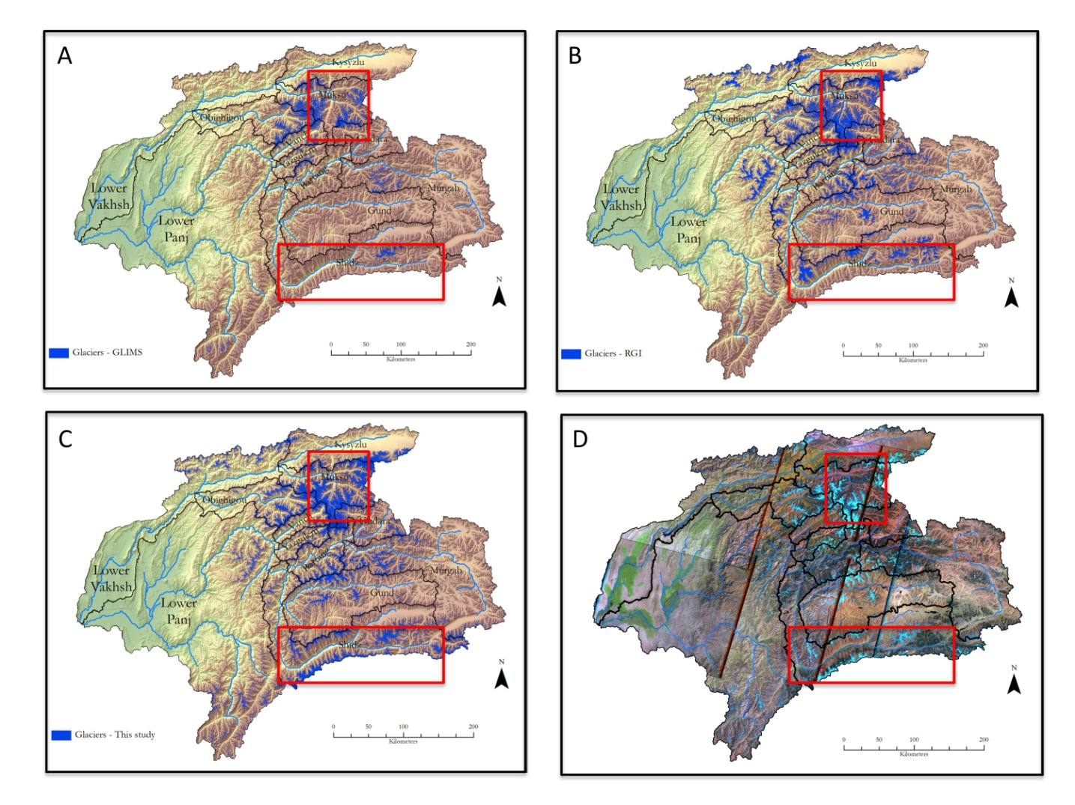
Figure 2. Comparison of glacierized area in the Amu Darya Basin derived from three different sources: (A) Global Land Ice Measurements from Space (GLIMS) inventory including data from 1960-2004; (B) Randolph Glacier Inventory (RGI) including data from an unknown time period; (C) this study that utilized (D) Landsat 5 TM satellite imagery from 2009-2011. The red boxes show two examples for differing mapping results. Upper box: the GLIMS inventory (A) and the RGI (B) present very different glacier coverage. Lower box: only the band ratio approach used in this study (C) mapped the glaciers in the Wakhan Corridor that separates the Shidz Basin from Afghanistan.

3.2.2. Scenario Uncertainties

Recent studies of the potential impact of climate change on the glaciers and stream flow of the Amu Darya mountain basins have generally involved analyses of (i) macro-scale hydro-meteorological data, based on the use of macro-scale GCM projections and MODIS satellite imagery to measure glacier extent (Immerzeel et al., 2012), or (ii) GCM models and stream flow measurements to project future stream flow volumes, based on World Climate Research Programme's (WCRP's) Coupled Model Intercomparison Project phase 3 (CMIP3) to assess climate changes in the Tien Shan Mountains, with some limited extrapolation to the Pamirs (Siegfried et al., 2013). Both the approaches of Immerzeel et al. (2013) and Siegfried et al. (2013) are plausible empirical engineering ‘black box’ stream flow forecast models, driven by aggregate means of the pertinent climate variables, and can be expected to produce results reflecting the reliability of the data and climate scenarios used.
Other approaches to the problem of climate change and stream flow specifically focused on the Amu Darya basins are those by Chevalier et al. (2012) and Hagg et al. (2012). Both focus on basin-scale analyses of the relationships of snow cover, glaciers and stream flow, and both project a shift to an earlier onset of the spring runoff and a decrease in the late summer runoff, resulting from decreased stream flow from retreating glaciers that supply all of the late summer runoff. Their primary drawback is that both are focused on a limited sample of basins in the upper Amu Darya headwaters, and are therefore difficult to extrapolate to the entire upper basin. The study by Chevalier et al. (2012) used data from basins with headwaters in the northern Pamirs, the most humid portion of the entire Amu Darya Basin. The study by Hagg et al. (2012) is based on a single basin (Gudara Basin) that is typical of the extreme aridity of basins in the southern Pamirs, with a portion of the catchment area east of the main Pamirs.
As a result of the employment of very differing (assumed) input data sets and scenario modeling approaches, resulting numbers for glacier changes and runoff vary widely making comparisons impossible (Tables 5-8). For the Panj and Vakhsh basins, Wagner and Hoelzle (2010) assumed a temperature increase of 2°C from 2003 to 2050 reducing the glacier volume by between 75.5% and 53%, respectively, which then leads to an increase in total runoff owing to higher volumes from the melting glaciers. In contrast, for the larger Amu Darya and Syr Darya basins, Immerzeel et al. (2012) calculated a decrease in total runoff of between 22% and 35% from 2010 to 2050.

Table 5. Results for basin area, glacierized area, runoff and projected changes from 2003 to 2005 in the Amu Darya Basin after Wagner and Hoelzle (2010).

 | Panj |  | Vakhsh
 | (km²) | (%) | (km²) | (%)
Basin Area | 114,000 | --- | 39,100 | ---
Glacierized Area 2003 | 3,592 | 3.2 | 3,399 | 8.7
Change from 2003 to 2050*
Glacier Volume | --- | −75.5 | --- | −53.0
Total Runoff | --- | increase | --- | increase
* Assumed temperature change: +2.0°C.

Table 6. Results for basin area, glacierized area, runoff and projected changes from 2010 to 2050 in the Amu Darya and Syr Darya basins after Immerzeel et al. (2012).

 | Amu Darya & Syr Darya |  | Amu Darya |  | Syr Darya
 | (km²) | (%) | (km²) | (%) | (km²) | (%)
Basin Area | 2,000,000 (?) | --- | 800,000 (?) | --- | 1,200,000 (?) | ---
Glacierized Area | c. 17,800 | 0.9 | c. 16,000 | 2 | c. 1,800 | 0.15
Glacier Melt Runoff | --- | --- | --- | 38 | --- | 11
Snowmelt Runoff | --- | --- | --- | 27 | --- | 35
Rain Runoff | --- | --- | --- | 35 | --- | 54
Change from 2010 to 2050
Glacierized Area | --- | −53 | --- | --- | --- | ---
Total Runoff | --- | --- | --- | −26 to −35 | --- | −22 to −28

Table 7. Results for basin area, glacierized area, runoff and projected changes from 2003 to 2050 in two smaller sub-basins within the Amu Darya Basin after Klemm and Hagg (2012).

 | Abramov (in the Panj) |  | Kudara (in the Vakhsh)
 | (km²) | (%) | (km²) | (%)
Basin Area | 55.5 | --- | 1,575 | ---
Glacierized Area | 28.3* | 51 | 520** | 33
Change from 2003 to 2050***
Glacierized Area | --- | −49 to −99 | --- | −18 to −45
Total Runoff | --- | +20 to +33 | --- | +0.5 to +15
* In 1986.
** Source year unknown.
*** Assumed temperature change: +1.8°C (first number) and +2.8°C (second number).

Table 8. Results for basin area, glacierized area, runoff and projected changes from 1985-89 to 2050 in the Rukhk sub-basins within the Amu Darya Basin after Hagg et al. (2013).

 | Rukhk (in the Panj)
 | (km²) | (%)
Basin Area | 4,306 | ---
Glacierized Area | 431 | 10
Glacier Melt Runoff | --- | 32
Change from 1985-1989 to 2050*
Glacierized Area | --- | −36 to −45
Total Runoff | --- | −5
Glacier Melt Runoff | --- | −11 to −8

3.2.3. Conclusion

Clearly, there is no consensus on the amount of glacier ice at the headwaters of the Amu Darya, a very fundamental factor in any attempt to assess the potential impact of their retreat on the water resources from the rivers. Some of the reasons for these discrepancies are: differing definitions of the ‘Pamirs’; incomplete inventories; inventories containing merged data of different quality; differing definitions of ‘glacier’ and what is mapped in the first place; and differing glacier mapping methodologies. Without doubt, an erroneous glacierized area would negatively impact all following steps in modeling past, present, and future stream flows. We, therefore, conclude that (i) caution is necessary when simply downloading and using data from existing glacier inventories or when merging data without communicating what exactly has been done; and (ii) if experts carry out the glacier mapping, very similar results can be re-produced.
Furthermore, it is reasonable that the glacierized area is only a single example of the lack of an organized, generally available data set describing the baseline conditions of climate, stream flow, and glacier mass balance characteristics. Without such a data set, operational forecast modeling is probably not possible. Solutions to this problem are, for example, the allocation of stream-gauging data for the Lower Panj and Lower Vakhsh basins, which would prevent their exclusion from the analysis, or the application of the morphometric glacier mapping (MGM) approach after Bolch and Kamp (2007) that—while being more time-consuming—allows for identifying debris-covered ice.

4. Methodologies and Data

This assessment of the role of glaciers in the stream flow of the Amu Darya and Syr Darya was based on three primary databases:

- Basin and glacier surface areas and hypsometries (area-altitude distribution) derived from Landsat 5 TM satellite imagery and SRTM DEM data.

- Stream flow records for the mountain catchment basins from the Tajik Department of Hydrology and Meteorology and from the Global Runoff Data Centre, Koblenz, Germany.

- Glacier data describing the equilibrium line altitude (ELA) and the ablation gradient taken from the literature.

4.1. Basin and Glacier Area and Hypsometry

Mapping glacier extent has always been a challenge. To begin with, there is often not even an agreement on the area extent of the river basins under investigation, and as a result variations exist in available data for glacier coverage. This is partly due to the fact that there is no single definition of the Pamir Mountains and their boundaries. Specifically with regard to the mountains of the Amu Darya Basin, the problem of glacier surface area has had an impact on the results of most recent studies, as well as the unresolved question of whether or not General Circulation Models (GCMs) are useful for glacier-related studies.
The individual catchment basins (entire Amu Darya and Syr Darya basins and sub-basins) were determined using the 90-m SRTM DEM; their boundaries were delineated using the ‘Watershed’ tool in the ‘Hydrology’ toolset of Spatial Analyst Tools in ArcMap 10.01. The derived watersheds were then converted to vector polygon shape-files, and basin surface areas were calculated. This process of converting raster into vector data comes with a change of area (km²), because the software draws the catchment polygon by ‘cutting through’ each individual square raster pixel, i.e. the sub-pixel area outside of the polygon line is excluded from further analysis when using vector data. As a result, the raster-derived area is always larger than the vector-derived area. Glacier inventories such as that of GLIMS contain glacier outlines as polygons that represent vector data. When such glacier polygons are draped over raster data, for example, satellite imagery or SRTM DEM, and area–altitude distributions are calculated, the vector data are converted back to raster data.
This study utilized imagery (L1T product) from Landsat 5 from 2009-2011 (one scene is from 2000). Landsat 5 was launched in 1984 and was recently decommissioned on June 5, 2013. The L1T product provides radiometric and geometric corrections based from ground control points or a SRTM DEM (Bolch et al., 2010). Landsat imagery has been extensively and successfully used in glacier mapping and monitoring studies, particularly for band ratio analysis and land cover classification. Landsat 5 carries the Thematic Mapper (TM) and Multi-Spectral Scanner (MSS); however, the MSS was powered down in 1995. A Landsat 5 TM image covers an area of 170 x 185 km² and comes at 30 m spatial resolution for bands 1-5 and 7, while the thermal band 6 has a spatial resolution of 120 m. For this study, Landsat 5 TM imagery was selected based on the following criteria: date availability; end of melt season (all scenes are from either August or September except one from early October); percent of cloud cover (in all scenes <5%); and atmospheric noise. Scenes were downloaded free-of-charge from the USGS imagery archive (USGS Earth Explorer website: http://earthexplorer.usgs.gov/).
In our study, the glacier surface area and glacier hypsometries were determined for the compound glaciers of the gauged catchment basins rather than for individual glaciers, as is more commonly the case. This was done in order to facilitate the comparison of calculated glacier melt volumes with measured stream flow volumes. At a very fundamental level, this has involved development of a definition of what constitutes a glacier in the Pamirs. In the upper portion of the accumulation zone, the large glaciers of these mountains merge with the perennial snowfields to form a continuous snow-covered high altitude surface. The debris cover of the lower portions of the ablation zone of many glaciers merges with terminal, lateral, and medial moraines, making the identification of glacier ice difficult in most imagery. At the lowest altitudes, periodic snow depositions make the precise location of the terminus problematical.
Most of the glaciers in the Pamirs and western Tien Shan are debris-free, clean ice glaciers. Clean glacial ice has a distinct spectral signature, with uniqueness in the visible and near-infrared part of the electromagnetic spectrum, which makes it relatively easy to map debris-free glaciers. Snow and ice are characterized by high reflectivity (albedo) in the visible wavelengths (0.4-0.7 μm); medium reflectivity in the near infrared (0.8-2.5 μm); low reflectivity and high emissivity in the thermal infrared (2.5-14 μm); and low absorption and high scattering in the microwave. While in clear weather the high albedo of snow and ice make them easily distinguished from surrounding terrain using visible infrared (VIR), optically thick clouds are also highly reflective in VIR, hence they confound the classification. However, they are reflective in the near infrared (NIR), thus, discriminated from snow and ice.
For more detailed information on the methodology used here in mapping catchment basins and the glacierized areas see the Appendix.

4.2. Stream Flow

For the Amu Darya, mean monthly stream flow records for thirteen hydrometric stations in the headwater basins of the Panj and Vakhsh tributaries to the Amu Darya were obtained from the Tajik Department of Hydrology and Meteorology. These records are from stations established during the 1930s and 1940s, and abandoned at the time of the end of the Soviet era, between 1985 and 1990. They are primarily cableways, with uncontrolled cross sections. No discussion of the gauge accuracy for these stations was found in the literature.
For the Syr Darya, mean annual stream flow values for eighteen hydrometric stations in the headwater tributaries of the Naryn Basin, Kara Basin, Alai Range and the Chirchik Basin were obtained from the Global Runoff Data Centre, Germany. Records for mean monthly stream flow data for stations at the headwaters of the Naryn Basin were obtained from a database maintained by the University Corporation for Atmospheric Research (UCAR), Boulder, Colorado. These data were also from stations established during the Soviet era and were discontinued at the end of that era. Again, no error estimate is available.

4.3. Water Budget

Assessments of the role of glaciers in stream flow formation in the high mountains of Asia must involve both the hydrology of the basins, as well as that of the glaciers within those basins. This study is concerned with the glacier melt component of the annual stream flow, so the hydrologic continuity equation describing the relationship between the glaciers and stream flow volumes is:

Q_{t} = R + M_{s} + M_{i} - E_{t} ± ∆_{s} (1)

where:
Q_{t} : Total runoff
R: Input as rain
M_{s:} Snowmelt runoff
M_{i:} Glacier melt runoff (ablation)
E_{t}: Evaporation
∆_{s}: Change in storage, as snow, glacier ice, or groundwater.

In practice, there are reported instances of rainfall on the ablation zones of glaciers in the western Tien Shan Mountains, at the headwaters of the Syr Darya. In the altitudes of the glacier ablation zones evaporation may be assumed to be minimal, and the change in groundwater storage for the hydrologic year is assumed to be zero (e.g., Rasmussen and Tangborn, 1976). As a first approximation, Eq. 1 reduces to a determination of the relative importance of snow melt and glacier ablation in the regime of most Asian rivers:

Q_{t} = M_{s +} M_{i} (2)

4.4. Glacier Ablation and Runoff

Measurements of runoff from immediately downstream from a glacier terminus in Asian mountains were neither found in the literature nor expected. It is unlikely that such measurements have yet been made. Glacier ablation estimates were based on net balance measurements reported for glaciers in the Himalaya and Karakoram mountains (e.g., Fujita, 1998; Mayer, et al., 2006; Wagnon, 2007). These values ranged from 1-3 m.

4.5. Glacier Zones

Glaciers are divided into two zones, a lower ‘ablation zone’, and an upper ‘accumulation zone’. Melt water resulting in runoff is produced primarily in the ablation zone. While there may be some melt above the ELA, the resulting melt water will generally percolate downward in the firn and be refrozen at depth (Figure 3).

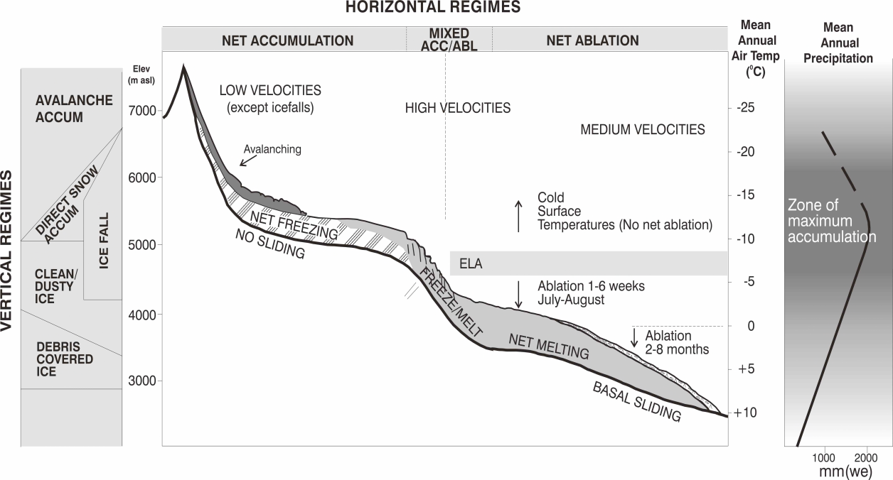
Figure 3. Glacier zonation (from Hewitt, 2014).

In assessing the role of glacier melt in the rivers of Asia, it is useful to remember that there is an altitude, at c. 6,000 m a.s.l., above which snow is deposited and never melts. While many analyses of glacier melt and stream flow in the high mountains of Asia have considered glaciers to be essentially large snow drifts, with spatially uniform patterns of melt to the highest altitudes, they are not. These glaciers exist through a range of altitudes from the lowest, where melt may occur continuously throughout the year, to the highest, where it never occurs. Assessments of the role of glaciers in the stream flow of the rivers of south Asia that do not recognize this fact are not credible.

4.6. Steady-State Equilibrium Line Altitude

Application of the ablation gradient concept for calculating measurable runoff resulting from ice melting requires a knowledge, or estimate, of the altitude above which this runoff ceases. In virtually every large mountain range a high amount of the annual precipitation falls during the winter months, as snow. At the lower altitudes, this snow is transient, and is removed during each summer season, forming a major portion of the stream flow from mountain catchment basins. At higher altitudes in most major mountain ranges, perennial snowfields and glaciers often result. The annual altitude separating the accumulation zone from the ablation zone at the end of the ablation period is called the firn line, while the mean of all firn line altitude is called the equilibrium line altitude (ELA), which is considered to be a feature of the general climate. Since the firn line fluctuates annually on the glacier, and over time, it produces a characteristic area-altitude distribution over the glacier, with the median altitude of a glacier defining a steady-state ELA separating accumulation and ablation into zones of equal volume (Figure 4).

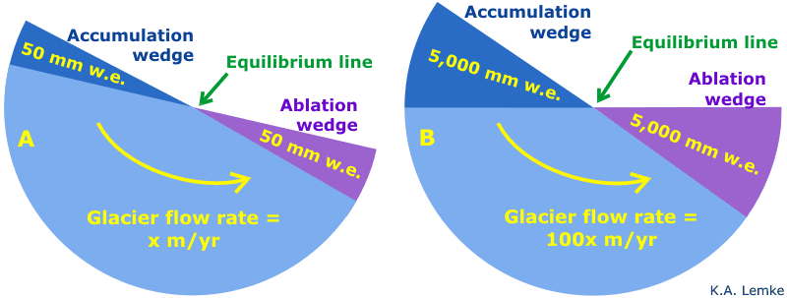
Figure 4. Glacier steady-state equilibrium, in which annual accumulation and ablation volumes are equal and are just balanced by a volume transfer from the accumulation zone.

It is possible to estimate the altitude of the steady-state ELA from

- estimates of the mean altitude of the summer-season 0°C isotherm,

- from the glacier area-altitude balance ratio method as outlined by Benn and Gemmell (1997) and Osmaston (2005), or

- from median glacier altitude as determined by hypsometry.

Braithwaite and Raper (2009) stated that

”(…) the balanced-budget ELA is approximately equal to median glacier altitude, although generally somewhat lower. Data for median glacier altitude are compiled as part of the WGI, and ELA can therefore be estimated for those regions covered by the inventory. If data are not available for median glacier altitude, the mid-range altitude can be used as a less accurate proxy for ELA.”

For this study, the median altitude method was used, in conjunction with the altitude of the summer-season 0°C isotherm.

4.7. Ablation Gradient

Factors contributing to the ablation gradient vary complexly over a mountain region such as the Pamir Mountains. Energy exchange over the surface of a mountain glacier involves a mix of short-wave and long-wave energy sources, and the turbulent transfer of sensible heat. Short-wave solar energy is generally the dominant source of input to the melt process, but its impact is limited to daylight hours and un-shaded surfaces. The energy available from solar radiation is dependent upon the degree of cloudiness, and the surface albedo of the glacier—the reflectivity of the ice. Clean ice reflects most of the short-wave energy it receives. Short-wave radiation intensity varies primarily with altitude and slope aspect. As the albedo decreases with a build-up of dust or other contaminants, the absorption of solar radiation increases. Long-wave radiation is emitted primarily by the water vapor in the atmosphere immediately above the glacier surface at any time when the air temperature is above 0ºC. Glacier ice acts as a ‘black-body’ to long-wave radiation. The long-wave energy exchange process is driven by the relative temperatures of the ice surface and by the atmospheric water vapor content. Long-wave radiation is largely independent of aspect, but decreases as atmospheric water vapor decreases with increasing altitude. In practice, few of these exchange processes is measured on the Asian glaciers. A degree-day index serves as a proxy for all sources of energy, and has proven to be useful for long-term estimates of melt, but less so for daily or weekly values. Ohmura (2001.
In this study, the primary challenge remaining was development of a methodology that would make possible the extrapolation of the degree-day concept to the entire melting surface of a glacier. Hock (2003) stated that

“While temporal variability of degree-day factors has received considerable attention, it is surprising how little research has focused on the development of spatially distributed temperature-index models specifically accounting for the large spatial variability in degree-day factors in mountain regions, in particular in steeply sided terrain. A reason might be that degree-day melt modeling has traditionally been driven by the need for operational runoff modeling with primary interest in basin runoff response and not in snow line retreat or spatially distributed melt estimates. However, in recent years an increasing need for spatially distributed estimates of melt rates has been identified. To cater to this demand, while retaining simple data input requirements, distributed temperature-index models need to be developed”.

It was in recognition of this need that lead to the development of the area-altitude distribution process model for estimating the ablation of the glaciers of the Nepal Himalaya (World Bank, 2010). A primary attribute of this procedure is the ablation gradient concept.
The ablation gradient—the variation of glacier melt on a glacier with altitude above the terminus—was proposed by the Swiss glaciologist Richard Haefeli (1962) specifically to describe the response of a glacier terminus to variations of the annual firn limit, or ELA, that marks the altitude at which the summer melt is just sufficient to remove all of the winter snow deposit (Figure 5). Haefeli (1962) postulated that changes in the location of the glacier terminus were primarily the result of basal sliding and an ablation gradient through the altitudinal interval between the terminus and the ELA. He described the ablation gradient between the terminus and the firn limit as being analogous to the air temperature lapse rate, with similar implications. According to Haefeli (1962)

“The ablation gradient is analogous to the well-known gradient of the average annual temperature of the air. The analogous phenomenon in the ablation would mean that the ablation gradient for a given glacier within a given climatic period remains approximately independent of the yearly fluctuations of the firn line.”

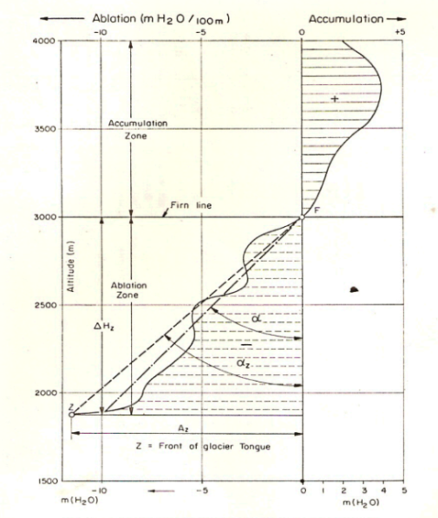

Figure 5. The ablation gradient (from Haefli, 1962).

The ablation gradient concept has been described by a number of workers, however, using differing terminology, for examples, ‘energy of glacierization’ (Shumskiiy, 1947), ‘activity index’ (Meier and Post, 1961; Meier and Tangborn, 1965), ‘ablation gradient’ (Haefeli, 1963), ‘vertical budget gradient (VBG)’ (Kaser, 2001; Kaser and Osmanston, 2002), or ‘mass balance gradient’ (Konz et. al, 2006). The concept has been either applied (e.g., Pelto, 1987, 1988) or elaborated (e.g., Tangborn, 1980; Kotlyakov and Krenke, 1982; Braithwaite, 1984). While each of these workers places slightly different conditions on the nature of this gradient and its universality, there is a general agreement that the slope of this gradient—defined by the net budget of a series of points spanning the firn limit or ELA—is determined by the gradient of energy exchange processes, as they vary with altitude over the surface of a glacier, and the duration of the annual melt period that decreases upward from the terminus to the ELA. For any glacier it is assumed that the slope of this gradient—defined as melt/meter (mm/m)—is a constant determined by the response of a glacier to climate variations. All workers agree that the slope of the gradient remains constant from year to year, while the ELA moves vertically on the glacier in response to annual or long-term variations in climate.
A primary challenge lies in assigning a value to the gradient for any given mountain region. Haefeli (1962) proposed gradient values ranging from 0 mm/m at the Poles to 14 mm/m near the equator. Kaser and Osmanston (2006) presented a model based on a vertical budget gradient of 20 mm/m for tropical glaciers. The value of 14 mm/m was used when applying the glacier ablation model to glacierized basins in the Nepal Himalaya (World Bank, 2010) based largely on studies of the Yala Glacier (Fujita, 1998). Alford (2012) used 10 mm/m for the Karakoram Himalaya based on four years of data from the Chhote Shigri Glacier in the western Himalaya provided by Wagnon et al. (2007) and from the Baltoro Glacier in the Karakoram provided by Mayer et al. (2006). Long-term ablation losses for glaciers in the Himalaya, Karakoram and Pamir mountains based on analysis of satellite imagery yielded values ranging from 5-10 mm/m. For the Pamirs, Gardelle et al. (2013) used 10 mm/m, and for their study of the Tanimas glaciers in the Pamirs, Hagg et al. (2012) used 9 mm/m. Racoviteanu et al. (2013) found that variation of the ablation gradient exists in a region like the eastern Himalaya, but that a regional average of 8 mm/m based on all measured values produced results comparable to those from earlier studies based on Haefeli’s (1962) estimated gradient at the latitude of the Nepal Himalaya (NRC, 2012). It is clear that errors related to the estimation of runoff in the immediate vicinity of a glacier based on assumed ablation gradients are possible, but sensitivity analyses indicate that these become minor when viewed as a component of the regional stream flow.
Parameterization of the AGM relies on the following four key glacier variables: ice area, hypsometry, the basin-wide ELA, and an ice ablation gradient. General steps in the AGM involved:

- delineating the glacier boundaries,

- calculating the basin-wide ELA and ice ablation gradient,

- computing the ice hypsometry for 100-m altitudinal bands below the ELA using the glacierized area and the DEM,

- multiplying the area of each altitudinal band by the ablation gradient values to obtain the ice melt volume per elevation band, and

- summing up the ice melt volumes to obtain the basin-wide runoff volume as follows:

Bs = bs₁A₁ + bs₂A₂ + bs₃A₃,…+ bs_{n}A_{n} (3)
where
Bs : Glacier ice melt (MCM)
bs_{1,2,…n} : Specific ice melt (m) for each altitudinal belt
A_{1,2,…n} : Area of altitude belt (km²) in the ablation zone

These values, summed for all the altitudinal belts on the ablating portion of the glaciers, were assumed to represent the annual glacier ice melt (Bs) for the combined glaciers of each catchment basin. Similarly, the annual snow accumulation (Bw) was calculated as follows:

Bw = bw₁A₁ + bw₂A₂ + bw₃A₃, …+ bw_{n}A_{n} (4)

where:
Bw : Glacier snow accumulation (MCM)
bw_{1,2…n} : Specific snow accumulation (m) for each altitudinal belt
A_{1,2…n} : Area of altitude belts (km²) in the accumulation zone

A state of quasi-stable equilibrium for a glacier, used to estimate the location of the ELA, is defined here as:
Bs + Bw = 0

The application of this model requires certain assumptions:

- It was assumed that the properties of the cryogenic zone in the mountains circling the Tibetan Plateau varied primarily with altitude in any single mountain range, and with latitude between the southern and northern extremes of these mountains (Cogley, http://www.iop.org/mt4/mt-tb.cgi/3820).

- The summer-season freezing level, used to approximate the ELA, is assumed to drop c. 1,000 m from c. 5,000 m to 4,000 m a.s.l. between the Nepal Himalaya and the Tien Shan mountains.

- A mean slope of c. 10 mm/m for the ablation gradient is a reasonable estimate in glacier studies in the circum-Tibetan Mountains (e.g., Fujita et al., 1998; Wagnon et al., 2007; Hagg et al., 2012; Racoviteanu et al., 2013; Gardelle et al., 2013).

- Glacier melt and runoff volumes were estimated using representative mass balance data from the Himalaya and Karakoram mountains (e.g., Kulkarni, 1992; Mayer et al., 2006; Wagnon et al., 2007).

- The ELAs have been estimated from the altitude of the summer-season 0°C isotherm, from the summer-season freezing level, median glacier altitude, and from analyses of the quasi-stable equilibrium altitude (Hoinkes, 1970), as well from extrapolations of the altitudes reported from glacier studies in the Nepal and Indian Himalaya and the Karakoram mountains.

The hydro-meteorological input data for this study represent historical period-of-record values from the literature, from the Global Runoff Data Centre, Germany, the Asian Data Base at the University of Idaho, or from the Tajik Department of Hydrometeorology:

- Data for twenty-seven gauged catchment basins in the upper Syr Darya Basin were available from the Global Runoff Data Centre files (GRDC, 2013). Historical period-of-record stream flow data for twelve glacierized basins in the headwaters of the Amu Darya in the Pamir and Hindu Kush mountains were provided by the Tajik Department of Hydrometeorology.

- Surface areas and area-altitude distributions of basins and glaciers were determined from Shuttle Radar Topography Mission (SRTM) data at 90 m spatial resolution and Landsat satellite imagery at 30 m spatial resolution. The SRTM was flown in February 2000, and its data represent the currently most readily available source of remote sensing-derived elevation data. Various versions of the SRTM data are available at no cost over the Internet.

- Temperature and precipitation estimates for the Syr Darya Basin were based on data from the Central Asia Data Base (CADB) at the University of Idaho.

All these parameters are considered averages of the range of values characterizing individual mass balance studies on discrete mountain glaciers, and are used here to define the conditions existing on the compound glacier systems found in each glacierized mountain basin analyzed.
This procedure is not intended as a substitute for traditional glacier mass balance studies. It is intended to be a reconnaissance tool, developed to permit an assessment of the relative importance of glacier melt in the rivers of Asia in the almost complete absence of glacier mass balance data, and the potential impact of receding glaciers on regional water supplies. It is emphasized that both glacier and snowmelt runoff are empirical, driven by field measurements. Where these measurements are not available, as is the case in much of central Asia, any value of snow or glacier melt as runoff components must be considered an estimate. For this study, the volume of the snowmelt (SQ) component is derived as a residual, the difference of the respective volumes of measured basin runoff (BQ) at a stream flow gauging site and the calculated glacier melt volume (GQ).

5. Amu Darya Mountain Basins

The mountain headwaters of the Amu Darya are located primarily in the Pamir and Hindu Kush mountains in eastern Tajikistan and northern Pakistan. The Pamirs are among the world’s highest mountains, and since Victorian times, they have been known as the ‘Roof of the World’, presumably a translation from Persian. Although the precise extent of the Pamirs is debatable, it is agreed that they lie mostly in the Gorno-Badakhshan Province of Tajikistan and the Badakshan Province of Afghanistan. To the north they join the Tien Shan Mountains along the Alai Valley of Kyrgyzstan. To the south they join the Hindu Kush Mountains along the Wakhan Corridor in Afghanistan and the Gilgit-Baltistan Province in Pakistan. To the east they may end on the Chinese border or extend to the range that includes Kongur Tagh that is sometimes included in the Kunlun Mountains.
The Amu Darya is formed by the confluence of the Panj and Vakhsh rivers in southwestern Tajikistan and then flows through Uzbekistan and Turkmenistan, before discharging into the remnants of the Aral Sea (Figure 6). While the estimated flow of the Amu Darya is 79 km³, this value must be viewed with some skepticism, since all indications are that the river contains little, or no water at its mouth at the Aral Sea. To this total flow of the Amu Darya, the Vakhsh River contributes 20 km³ and the Panj River 34 km³ at the confluence (e.g., Chevalier et al., 2012). The water resources situation in the Aral Basin, to which the Amu Darya is one of two major contributors, has been studied extensively and is well documented in the literature (e.g., McKinney, 2003; Lutz et al., 2012).

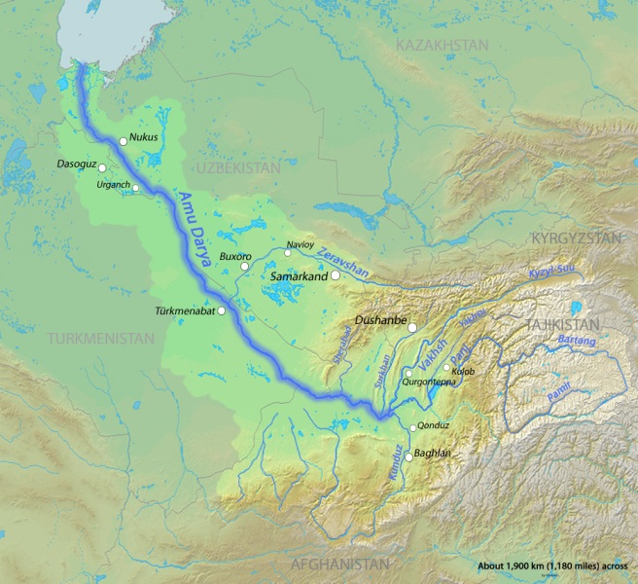

Figure 6. The Amu Darya, in the Aral Basin, stretches from its headwaters in the Pamirs to its mouth in the Aral Sea.

5.1. Basins

The study area consists of ten glacierized sub-basins within the Pamir and Hindu Kush mountains for which stream flow data were available: seven at the headwaters of the Panj River, and three at the headwaters of the Vakhsh River (Figure 7). These basins represent a majority of the mountain surface area contributing runoff to the Vakhsh and Panj rivers. While the drainage basin of the entire Amu Darya totals 534,739 km², this study focused only on the part of the basin that lies within the mountains and foothills of the Pamir and Hindu Kush Mountains and includes 158,201 km². Owing to the lack of gauge data for the Lower Panj and Lower Vakhsh basins, our glacier area and stream flow calculations focus exclusively on the Upper Amu Darya Basin with an area of 81,794 km²; it consists of the Upper Panj Basin with an area of 61,484 km² (75%) and the Upper Vakhsh Basin with an area of 20,310 km² (25%) (Figure 8).

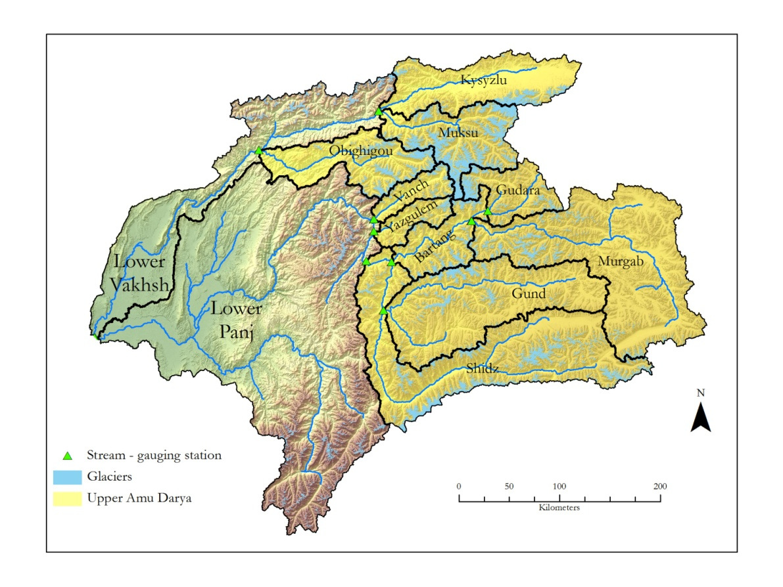
Figure 7. Locations of glaciers and stream gauging stations in the mountain basins of the Upper Amu Darya.

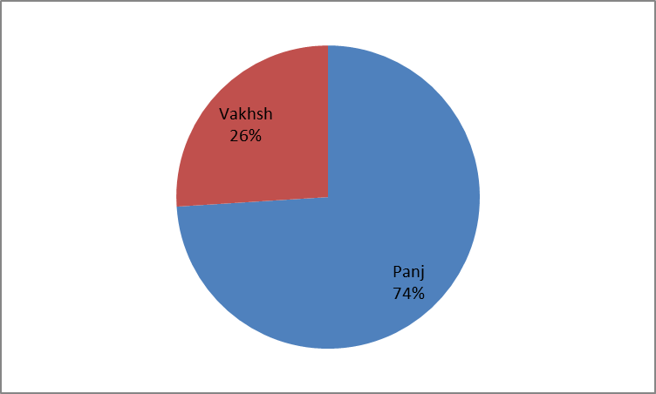

Figure 8. Areas of the Panj and Vakhsh basins that constitute the Upper Amu Darya Basin.

Most of the surface area in the Upper Amu Darya Basin lies within 3,000-5,000 m a.s.l., and therefore provides an extensive platform for the deposition of the winter snowfall (Figure 9). Beginning in the early spring, the freezing level gradually rises to the upper portion of this altitudinal belt, providing a large fraction of the summer-season stream flow volume, initially as snow melt and as glacier melt in later months.

Figure 9. The hypsometry of the mountain basins of the Amu Darya. Note the concentration of surface area between 3,000-5,000 m a.s.l.

Within the mountain headwaters of the Amu Darya, the scale of vertical altitude differences and local relief has few analogues elsewhere in the world. Altitudes range from below 1,000 m a.s.l., where the river emerges on the plains, to several mountain peaks above 7,000 m a.s.l. The median altitude of the catchment above Shidz, a gauging station on the upper Panj River, is more than 5,000 m a.s.l. (Figure 10). This means that the greater part of the catchment surface is thrust up into the middle troposphere (ground level atmospheric pressures approaching 500 mb). In lowland areas, the behavior of climate variables such as diurnal variations in air temperature, specific and relative humidity, wind strength and direction, and cloud formation are significantly different at these pressure levels than near to the ground surface. Most climate change scenarios, either explicitly or implicitly, reflect changes that are expected below the 700 mb level.

Figure 10. Area-altitude distribution (hypsometry) of the Shidz Basin at the headwaters of the Amu Darya. The altitude of the 700 mb, 600 mb, and 500 mb levels (vertical green lines, left to right, respectively) demonstrate the extreme altitude reached by these mountains, extending into the middle troposphere. Most climate change scenarios, either explicitly or implicitly, reflect changes that are expected below the 700 mb level.

The variation of hypsometries between the Upper Vakhsh and Upper Panj basins document that not only is the Upper Vakhsh Basin considerably smaller than the Upper Panj Basin, but the relative distribution of surface area with altitude varies as well (Figure 11). In the Panj Basin the area between 3,000 and 5,000 m a.s.l. is extensive because of the inclusion of the ‘pamirs’—high altitude plains—for which the Pamir Mountains are named. These ‘pamirs’ are major features of the Murgab, Gund and upper Panj basins, but are not a significant feature of the Vakhsh headwater basins.

Figure 11. Comparative area-altitude distribution (hypsometry) for the mountain basins of the Panj and Vakhsh rivers.

5.2. Glaciers

In the Upper Amu Darya basin, glaciers cover 10,461 km² (12%) of its area, of which 59% is to be found in the Upper Panj Basin and 41% in the Upper Vakhsh Basin (Table 9, Figure 12). Glaciers cover 19% of the Upper Vakhsh Basin and 10% of the Upper Panj Basin.

Table 9. Basin area and glacier area in the headwaters of the Amu Darya Basin.

Basin | Basin Area  (km²) | Glacier Area  (km²) | Glacier Area  (%)
Amu Darya (this study) | 158,210 | 11,887 | 7
Panj (entire) | 118,330 | 6,848 | 6
Vakhsh (entire) | 39,880 | 4,928 | 12
Upper Amu Darya | 81,794 | 10,461 | 12
Upper Panj | 61,484 | 6,043 | 10
Bartang | 4,345 | 702 | 16
Gudara | 4,067 | 648 | 16
Gund | 13,853 | 800 | 6
Murgab | 16,700 | 1,020 | 5
Shidz | 18,519 | 2,263 | 12
Vanch | 2,060 | 332 | 16
Yazgulem | 1,940 | 278 | 14
Upper Vakhsh | 20,310 | 4,307 | 19
Kysyzlu | 8,370 | 758 | 9
Muksu | 6,550 | 2,551 | 36
Obighigou | 5,390 | 997 | 15

A | B
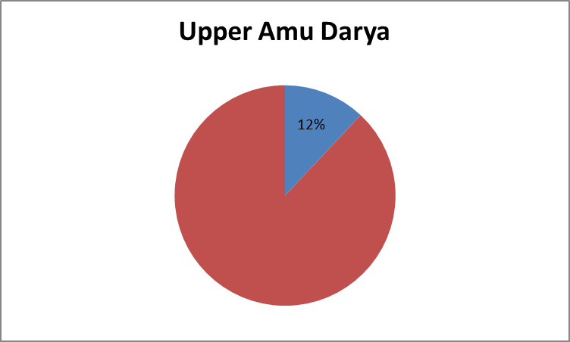 | 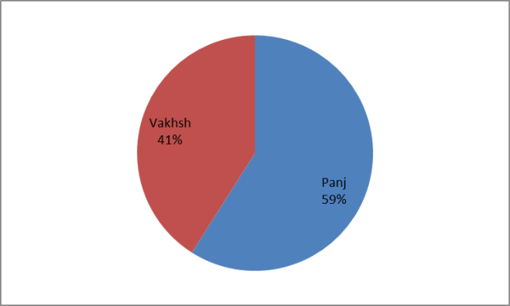
C | D
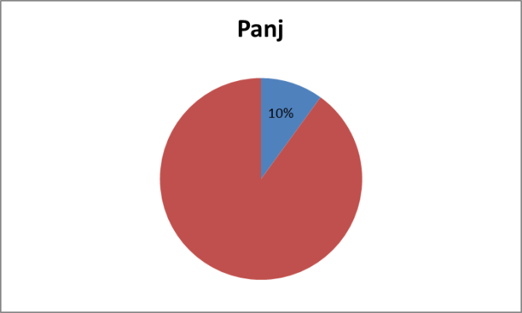 | 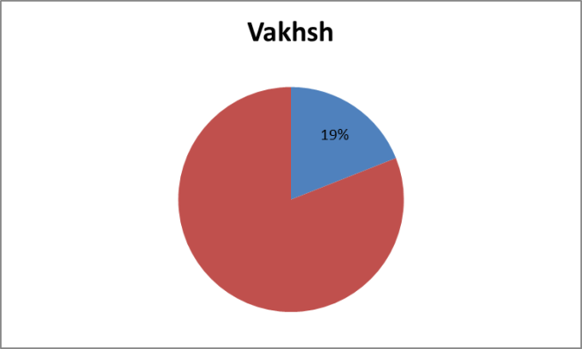

Figure 12. Glacierized area in the (a) Upper Amu Darya Basin; (c) Panj Basin; and (d) Vakhsk Basin; and (b) share of glacierized area in the Panj and Vakhsh basin in the total glacierized area.

The hypsometry of the Pamir glaciers shows an altitudinal range of 3,000 m from 3,500-6,500 m a.s.l., with a maximum surface area at c. 5,000 m a.s.l. (Figure 13).

Figure 13. The hypsometry of glaciers in the gauged mountain basins at the headwaters of the Amu Darya. The median altitude is indicated by a red line. In this study, the median altitude approximates the equilibrium line altitude (ELA) and represents the approximate altitude, at which the ablation gradient is assumed to be zero, for the purpose of ablation gradient calculations.

Median glacier altitudes are used here to define the steady-state ELA, assumed to be the altitude of zero annual ablation for the ablation gradient calculations, and the altitude dividing the glaciers into zones of accumulation and ablation of equal volume for estimating glacier volume adjustments to climate change scenarios. For example, for the Muksu Basin the median glacier altitude of 5,064 m a.s.l. is used as the ELA in this study (Table 10; Figure 14). For the glaciers of the Amu Darya headwaters, these median altitudes range over 500 m from 4,491 to 5,111 m a.s.l. This range of altitudes is not random: the glaciers of those basins on the windward slopes of the northern Pamir Mountains—the Obighigou, Yazgulem, Kysyzlu and Vanch—all have median altitudes near 4,500 m a.s.l., while the remainder, located primarily on the lee side of the main Pamir Range and sub-basins in the south, have values near 5,000 m a.s.l.

Table 10. Comparison of the median glacier altitude (MGA) in the basins considered in this study, and the ELA as estimated from the assumption of glacier quasi-stable equilibrium.

Basin | MGA  (m a.s.l.) | ELA  (m a.sl.)
Amu Darya | 4,847 | 4,795
Bartang | 4,868 | 4,750
Gudara | 5,089 | 5,050
Gund | 4,933 | 4,850
Kysyzlu | 4,574 | 4,550
Muksu | 5,064 | 4,950
Murgab | 5,106 | 5,100
Obighigou | 4,491 | 4,450
Shidz | 5,111 | 5,100
Vanch | 4,579 | 4,500
Yazgulem | 4,680 | 4,650

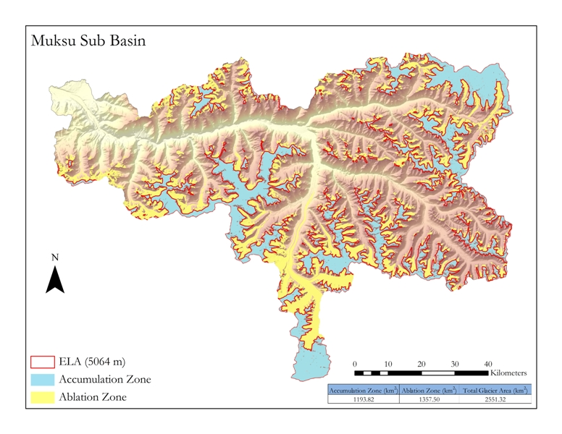
Figure 14. Accumulation zone, ablation zone, and ELA—as defined by the median glacier altitude—in the Muksu Basin.

It is a primary assumption associated with ablation gradient analysis that the hypsometry of glacier ice is a major determinant of the way in which the basin glaciers are in balance with a regional climate, and how they will respond to changes in that climate. When comparing the glacier hyspometries for the Panj and Vakhsh basins, the primary difference is the extensive glacierized area at lower altitudes in the Vakhsh Basin in the north, which may reflect more active and advancing glaciers here– the ‘Pamir anomaly’ (Figure 15).

Figure 15. Comparison of the glacier hypsometries in the northern (Vakhsh) and southern (Panj) portions of the Pamirs. The primary difference is the extensive glacierized area at lower altitudes in the north, which may reflect more active and advancing glaciers here– the ‘Pamir anomaly’?

5.3. Climate

There are few climate data available for the headwaters of the Amu Darya. Those used for this study are from the city of Khorog (2,077 m a.s.l.), the administrative center of Gorno-Badakhshan Autonomous Province in the Pamirs of Tajikistan. The temperature data are from the website ‘climatebase.ru’, and are monthly mean values for Khorog.
The primary need for applying the ‘Ablation Gradient Model’ (AGM) is a determination of the approximate freezing level during the summer season (May to September). These mean monthly temperatures were used to define an approximation of the altitude of the mean monthly freezing temperature by assuming an air temperature lapse rate of 6.5°C/1,000 m. Archer (2004) explained that

“(…) from a hydrological point of view the upper zone of the freezing level is one of continuous frost, where precipitation falls as snow and where there is virtually no contribution to river runoff. However, it provides nourishment to lower zones through snow avalanching and glacier flow. The middle zone is one with frequent freeze–thaw cycles, where precipitation may fall as rain or snow, melt of lying snow occurs during daylight hours and refreezing occurs at night. In the lower zone with continuous above-freezing temperatures, precipitation is expected to fall as rain and melt is continuous, though enhanced during daylight hours.”

The monthly freezing levels, based on extrapolation of the Karakoram temperature values (Archer, 2004), are: 4,500 m a.s.l. in May, 5,100 m a.s.l. in June, 5,600 m a.s.l. in July, 5,600 m a.s.l. in August, and 4,970 m a.s.l. in September, with a mean or summer-season altitude of 5,170 m a.s.l. (Figure 16).

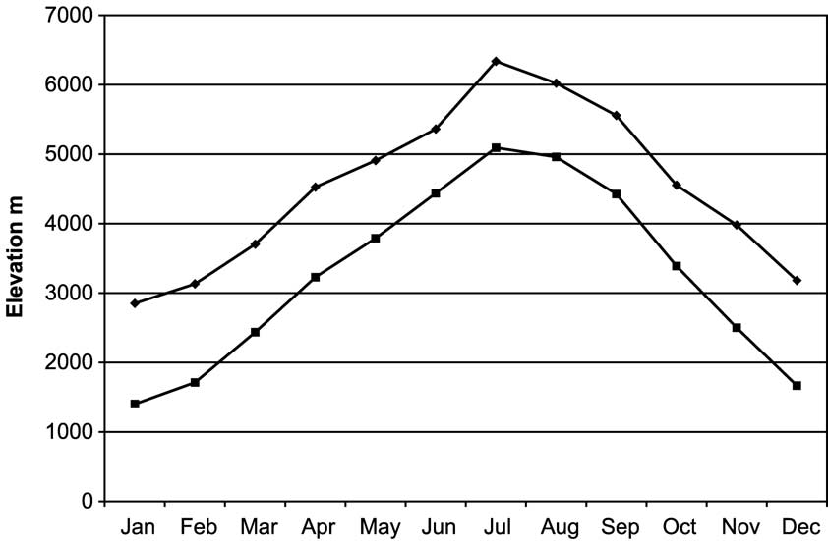

Figure 16. Elevation of the freezing level for monthly maximum and minimum temperatures, Karakoram Himalaya (after Archer, 2004).

Based on these data, it is assumed that the average summer-season altitude of the 0ºC isotherm, at which sufficient snow and ice melt is possible to produce measureable runoff from a basin in the Pamirs, is c. 5,000 m a.s.l. A few valley glaciers in the Pamirs have terminal altitudes below 3,000 m a.s.l. At this altitude, ice melt is assumed to be occurring during most months of each year. This represents a very small fraction of the glacier cover, however, and produces only an insignificant amount of runoff. The primary altitude of runoff volume produced by ice melt is immediately below the annual freezing level, where the surface area of the ablation zone is greatest.
Precipitation data for the Pamir region is quite limited. Data were available for only two sites: Dushanbe and Khorog. Both data sets indicate that precipitation occurs primarily during winter months (Figure 17). These two stations are representative of the seasonal pattern of precipitation in eastern Tajikistan, with snow during the winter months and very dry summers, but there are insufficient data to permit development of orographic trend estimates. Snow pit measurements on the upper Fedchenko Glacier indicate precipitation may exceed 2,000 mm at 4,000-5,000 m a.s.l., at least in the Muksu Basin. At c. 4,000 m a.s.l. on the Murgab Plateau, annual precipitation is less than 100 mm. Specific runoff estimates, based on available stream flow measurements (Tajik DHM, 2013) serve as a useful proxy of basin precipitation. The specific runoff depths are in general agreement with the limited high altitude data from snow pits and the station at Murgab.

Figure 17. Mean annual precipitation in Dushanbe (blue) and Khorog (green), Tajikistan.

As a first approximation, it is assumed that the general glacier environment of the Pamirs is similar to that of the adjacent Karakoram Range as described by Archer (2004), Archer and Fowler (2004, 2006), and Hewitt (2006). Snow pit data from the accumulation basins of the Fedchenko, Tanimas and Medvedev glaciers at c. 5,000 m a.s.l. (e.g., Bashev et al., 1975; Savoskul and Smakhtin, 2013) are in general agreement with snow depths at similar altitudes in the Karakoram as reported by Archer and Fowler (2004) and Wake (1987). Snow pit measurements from the upper Fedchenko Glacier, indicating an annual glacier accumulation depth of 2,000 mm, are the only data found related to precipitation at the altitude of the Pamir glaciers. This climatological difference was apparent with other climate indicators. The median altitude of the glaciers of the Upper Amu Darya Basin, often suggested as an approximation of the ELA, where annual depths of accumulation and melt are equal, varied by an average of 500 m between the Vakhsh glaciers at 4,581 m a.s.l., and the Panj glaciers at 5,021 m a.s.l. Based on the steady-state net budget calculations using the ‘Ablation Gradient Model’ (AGM) , and the Balance Ratio approach for determination of the steady-state ELA, the ELA difference between the Vakhsh and Panj basins was reduced to 300 m, and the best fit for the winter balance (Bw) was a specific accumulation of 2,000 mm for the Vakhsh glaciers, and 1,000 mm for the Panj glaciers.

5.4. Hydrology

The hydrology of the Upper Amu Darya Basin has the following characteristics:

- The mean annual runoff of the Amu Darya is estimated to be 79 km³; the Upper Amu Darya at the confluence of the Panj and Vakhsh Rivers is estimated to be c. 39 km³, with c. 22 km³ (56%) from the Panj River, and c. 17 km³ (44%) from the Vakhsh River (Tables 11 and 12).

- The two principal sources of runoff are: (a) winter precipitation as snow that melts during the succeeding summer season; and (b) glacier melt during a summer-season. From a climate perspective, the volume of runoff from the seasonal snow pack is determined primarily by winter precipitation, while the volume of glacier melt is some function of the temperature during the summer season.

Table 11. Stream flow and runoff data from 2013 for basins of the Panj River, received from the Tajik Department of Hydrometeorology. (BQ: total basin runoff; Bq: specific basin runoff; MCM = million cubic meters).

Basin | Area  (km²) | Stream Flow  (m³/s) | BQ  (MCM) | Bq  (mm)
Murgab (Barchidev) | 16,700 | 47 | 1,449 | 90
Gund (Khorog) | 13,853 | 104 | 3,276 | 240
Bartang (Shojand) | 4,345 | 140 | 1,349 | 310
Gudara | 4,067 | 50 | 1,544 | 380
Shidz | 18,519 | 479 | 9,771 | 530
Vanch | 2,060 | 79 | 2,491 | 1,210
Yazgulem | 1,940 | 54 | 1,693 | 870
Total | 61,484 | --- | 21,573 | 300

Table 12. Stream flow and runoff data from 2013 for the basins of the Vakhsh River, received from the Tajik Department of Hydrometeorology. (BQ: total basin runoff; Bq: specific basin runoff; MCM = million cubic meters).

Basin | Area  (km²) | Stream Flow (m³/s) | BQ  (MCM) | Bq  (mm)
Kysyzlu (Dombrachi) | 8,370 | 100 | 3,150 | 380
Muksu | 6,550 | 210 | 6,615 | 1,010
Obighigou (Tavildara) | 5,390 | 235 | 7,403 | 1,370
Total | 20,310 | --- | 17,168 | 850

The impact of climate change on the source, timing and volume of runoff from the headwater basins of the Amu Darya will be greatly influenced by location within the basin. Stream flow is an integration of all climatic factors in a mountain basin, and is an index of comparable mountain topo-climates. A primary indicator of the regional range of topo-climates in the mountain basins considered in this study was the annual discharge depth of stream flow—the specific runoff in millimeters—measured at the gauging stations in each basin. This varied from less than 100 mm in the Murgab Basin, with most of its area east of the mountains, to more than 1,300 mm in the Obighigou Basin in the northern Pamir. This order-of-magnitude difference in specific runoff illustrates the extreme variation in at least one of the climate variables affecting these mountain basins. In general, the southern basins, primarily the source of the Panj River, are much more arid, as indicated by specific runoff, than the northern basins of the Vakhsh River. The Panj River headwaters have an average specific discharge of 300 mm, while it is 850 mm in the Vakhsh River headwaters—almost three times higher. Specific runoff exceeds 1 m in the Obighigou and Muksu basins within the Vakhsh Basin of the northern Pamirs, and in the Vanch Basin within the Panj Basin in the southern Pamirs (Figure 18).

Figure 18. Specific runoff (q) in the glacier basins of the Upper Amu Darya. The specific runoff from the northern portion of the upper Amu Darya Basin is significantly higher than from the southern portion. The northern basins are also the site of higher glacier cover than those in the south, as well as a lower area-altitude distribution of glacier ice. (“Panj” is here the upper Panj = Shidz).

Some idea of the climate variability can be developed from the year-to-year fluctuation in mean flow of the rivers in the basins. The recent past has been characterized by decade-long swings of flow volume of 20-40% of the period-of-record mean in the both the Panj and Vakhsh rivers, which is a greater swing in any ten-year period in the recent past than will be experienced by a complete disappearance of the glaciers at the headwaters of these rivers. The interannual variability of the Panj River, based on the flow at Shidz from 1967-1986, ranges between 140% and 75% of the period-of-record mean of 479 m³/s (Figure 19), and shows no apparent trend for either decreasing of increasing flow at this gauge station during this period of observations. Flow volume appears to be determined by cycles, most probably involving the depth of the winter snow deposits. This is similar to the annual variability of the upper Indus River, immediately to the south of the Amu Darya Basin. The interannual variation of the Vakhsh River at Garm is between 122% and 76% of the long-term mean of 327 km³/s (Figure 20). As for the Panj River, also for the Vakhsh River there is no trend of either decreasing or increasing flow at this gauge station during this period of observations.

Figure 19. Stream flow of the Panj River at Shidz from 1967-1986.

Figure 20. Stream flow of the Vakhsh River at Garm from 1941-1985.

5.4.1. Seasonality of Stream Flow

Runoff in the upper Amu Darya Basin results primarily from glacier and snowmelt. In water budget analyses, both are treated as storages that produce runoff at temperatures above the freezing point. The runoff from the seasonal snow is determined from the water equivalent depth of the winter snow. Since the mountain snows are generally deposited at all altitudes in a mountain basin, measureable snowmelt runoff begins as soon as air temperatures reach 0°C or above in the spring at the altitude of the gauging station, and continues until the snowpack is completely removed, up to the altitude of the regional snowline. At this time, the seasonal snowmelt flood occurs, and, without additional input, the stream flow hydrograph begins the recession phase. In the Upper Amu Darya Basin, the snowmelt peak flow commonly occurs in July, and hence snowmelt runoff is interpreted as the primary component of the rising limb of the annual hydrograph (Figure 21).

Figure 21. Annual hydrographs of the Panj and Vakhsh rivers at gauging points downstream from the mountain basins. For both rivers, annual peak flow occurs in July, with a general decrease—‘recession’—to seasonal low flows during winter months.

Since glaciers are located at higher altitudes in the mountain basin, glacier melt does not begin until the freezing level has migrated up to those altitudes, but will then continue until the freezing level migrates downward with the onset of fall. The glacier annual peak flow occurs in August. In the Upper Amu Darya Basin virtually all glacier runoff occurs during the peak melt season of July to September, while snowmelt is more evenly distributed over the period April to July. Glacier melt is a major component of the falling limb of the annual hydrograph.
In mountain catchment basins, as generalities, water retention in the basin as groundwater storage is generally minimal (Todd, 1980), as a result of high rates of erosion of the products of mechanical weathering, and low rates of chemical weathering, evapotranspiration losses are low (Barry and Chorley, 1970), stream gradients are high, promoting rapid runoff, storage is mainly as winter snow or glaciers, so runoff timing is linked to summer season temperatures, while volumes are related to winter snow deposition or glacier ablation surface area. The precise form of the annual hydrograph will be strongly influenced by location, as well as the time period used in data aggregation. Those based on daily values in close proximity to a glacier or the snow line during the melt season, will reflect the diurnal freeze-thaw cycle that is characteristic of both snow- and glacier melt during summer months, while those at increasing distances will be increasingly subdued as dilution—primarily from the seasonal increase of water in the unconfined aquifers in the river channel—with distance downstream in a basin occur.
Based on the period of record data, stream flow at the headwaters of the Amu Darya Basin begins to increase in April, with maximum runoff occurring in July or August in all sub-basins. This is consistent with what would be expected as the air temperatures increase and the freezing level migrates upward over the winter snow accumulation each spring. The July peak flow represents the end of snowmelt as a major source of surface runoff, when the rising freezing level removes the winter snow deposit. A seasonal peak flood persisting into August is interpreted as an indication of the significance of glacier melt in a basin. The annual hydrographs for the upper Panj River at Ishkashim, with a glacier area of 25% of the contributing basin primarily in the Hindu Kush Mountains, and for the Muksu Basin, with a glacier area of 36%, show a seasonal peak in August for both rivers (Figure 22). The two hydrographs also show that there are approximately two orders of magnitude between peak and low flows, an indication of virtually no groundwater reserves, typical of the ‘flashy’ nature of Pamir rivers in general.

Figure 22. Seasonal variation in the annual hydrographs for the two most heavily glacierized basins in the upper basin: Muksu is in the northern Pamirs, and Ishkashim is on the Panj in the Hindu Kush Mountains.

Based on what that is known concerning the nature of the hydrometeorology of the Amu Darya mountain basins, the most logical explanation for two distinct hydrograph types from the Gund Basin in the southern Pamirs and from the Muksu Basin in the northern Pamirs is that they are reflections of the differing roles of snow and glacier melt in the hydrology of the main stem of the Amu Darya (Figure 23). Both hydrographs follow a similar trend during the period of base flow from November to March and—as indicated by the rising limb—the spring snowmelt from April to July. The primary difference, other than volume, is the peak of summer flow in July for the Gund Basin, with only 6% of glacier area, compared with a peak flow in August from the Muksu, with a 36% glacier area. In conclusion, snowmelt ends in July with the onset of recession for minimally glacierized basins, while glacier melt produces a seasonal peak flow in August, as the summer melt season comes to an end.

Figure 23. Comparison of the annual hydrographs from the Gund Basin in the southern Pamirs and from the Muksu Basin in the northern Pamirs.

The recession segments of the gauged sub-basins in the Amu Darya Basin show two distinct recession types that appear to be related to percent glacier area in each sub-basin (Figure 24). The Gund and Bartang basins, with a glacier cover of 10% or less, have a single peak in July, followed by a normal recession curve. In contrast, while the Panj/Shidz, Muksu and Obighigou basins with glacier areas ranging from 20-50% also have the main summer peak flow in July, their peak flows continue into August at a slightly lower level before they begin the recession.

Figure 24. Monthly variation between June and December in the recession flow of the annual hydrograph for selected basins in the Pamirs. The recession curves of basins at the headwaters of the Amu Darya provide a tool for separating basins with a large glacier runoff component (Panj/Shidz, Obighigou, and Muksu) from those that are primarily snow melt (Murgab, Gudara,and Kysyzlu).

Recent concerns about potential increases or decreases in the runoff of the rivers of Asia have focused on the mountain glaciers of the headwater basins. However, the examples of the Obighigou and Muksu basins illustrate the importance of the snowmelt component (Table 13). Total runoff is approximately equal from both basins. Both basins contain glaciers, and glacier melt is a component of the total runoff volume. Based on identical assumptions and procedures, the ablation gradient analysis of both basins yielded estimates of glacier runoff that differ by a factor of three: 35% for the Muksu Basin, and 17% for the Obighigou Basin. Since there is no indication of a rain component of runoff during the summer melt season, it is assumed that the remainder of runoff from each basin is a result of melting winter snow, which varies by a factor of two: 65% in the Muksu Basin, and 83% in the Obighigou Basin. An understanding of the build-up of the winter snow pack is as essential as glacier mass balance studies when anticipating possible future stream flow fluctuations of the Amu Darya.

Table 13. Runoff characteristics of the Muksu and Obighigou basins. Total basin runoff (BQ) is composed of a glacier component (GQ) and a snowmelt component (SQ). While in the Muksu Basin GQ and SQ are almost evenly balanced, the runoff in the Obighigou Basin is almost completely snowmelt. Both basins contribute to the flow of the Vakhsh River, but neither can be used, alone, as a credible index of the relative role of snow and ice as components of the flow of the Vakhsh River. At the same time, an average value for the two basins, as would be used in a traditional stream flow forecast model, will mask the role of each. (MCM: million cubic meters).

Basin | BQ  (MCM) | GQ  (MCM) | GQ  (%) | SQ  (MCM) | SQ  (%)
Muksu | 7,615 | 2,685 | 35 | 4,930 | 65
Obighigou | 7,403 | 1,264 | 17 | 6,139 | 83

While the volume of runoff from glacier melt is related to summer season temperatures, the volume of runoff from snowmelt is dependent upon the previous winter’s snow water equivalent snow fall depth. No useful snow water equivalent depth data were found for this study outside a few pit studies on the glaciers. Snowmelt runoff was treated as a residual in the water budget calculations, expressed as the difference between total runoff, as measured at the Tajik hydrometric stations, and the estimated glacier runoff. There is no indication of rainfall in the basins of the Pamirs in the summer months.
In the most general terms, the seasonality of runoff can be expected to vary among basins, depending on hypsometry and glacier extent. Any increase in temperature will produce an earlier beginning of spring runoff with no other change in the snowmelt component of runoff. Glacier retreat will result in a decrease of the stream flow peak in August/September, with a general decrease in total annual volume. It has been found in the hydrograph analyses of runoff from the Karakoram (Alford, 2011) and those of the Pamirs that glaciers with a glacier cover exceeding 10% generally do not begin recession flow until August, while in the only snow-fed basins they begin their recession early in July.

5.4.2 Glacier and Snow Runoff

The runoff from the mountain basins of the Amu Darya is mainly a result of the melting of glaciers and winter snow. While runoff from glaciers and the seasonal snowpack, where both are present in a mountain basin, are often treated as a single problem involving surface area and air temperature, the two respond very differently to variations in temperature and precipitation. Timing and volume of runoff from the seasonal snowpack will be determined by the snow depth—in water-equivalent terms—of the winter precipitation. All snow below the regional snowline, which in the Pamirs is at an altitude of c. 5,000 m a.s.l., will become runoff during the spring and early summer months as the 0°C isotherm migrates upward to a maximum altitude between 5,000-6,000 m a.s.l., and then migrates to lower altitudes with the onset of fall and winter. Precipitation above the regional snowline will become incorporated in the glaciers or perennial snowfields to serve as a secondary storage exploited during years of drier and warmer conditions than the average.
Timing and volume of runoff from glaciers represent a combination of melt of the seasonal storage of water, as snow, and the melt of the total ice reserves of the glaciers of a basin. Since there is no realistic upper limit to the amount of water than can be produced by melting during the summer season each year at the surface of a glacier that may be hundreds of meters thick, the limit on runoff from this process is determined largely by the mean air temperature of the summer-season. The primary limiting factor in a mountain range such as the Pamirs is the upper altitude reached each summer by the mean 0ºC isotherm during the melt season. Glacier melt water is produced from below this altitude, in the ablation zone. A major complication in viewing the glaciers of a mountain basin as simply large, isothermal snowdrifts, as is sometimes done, is that the snow deposited on the accumulation zone is converted to glacier ice, and transferred by plastic flow down-glacier into the ablation zone. It is the two processes of storage of the seasonal snow above the regional snowline each year, and the slow transfer of this snow, by plastic flow, to the altitudes of the glacier ablation zones that complicates both estimates of snowmelt and glacier runoff in the high mountains of Asia. In the Pamirs, as much as 25% of the total basin surface area will be above the mean 0°C isotherm in the summer season, and therefore experience no melt. Modeling procedures developed without consideration of this fact can be expected to be in error by approximately this amount.
Based upon this procedure, the runoff components for the Upper Amu Darya Basin and its sub- basins were estimated (Tables 14 and 15; Figures 25 and 26). Of the total runoff of c. 39 km³ in the Upper Amu Darya Basin, 76% are from snowmelt and 24% from glacier melt. In the Upper Panj Basin, snow contributes 83% to the total runoff, while glaciers contribute 17%. In the Upper Vakhsh Basin, 67% of the total runoff comes from snow and 33% from glaciers. Of all glacier melt, 40% comes from the Panj Basin and 60% from the Vakhsh Basin. Of all snowmelt, 61% comes from the Panj Basin and 39% from the Vakhsh Basin.

Table 14. Components of runoff in the mountain basins of the Upper Amu Darya Basin (UADB).

 | Upper Amu Darya |  | Upper Panj |  | Upper Vakhsh
 | (km³) | (%)* | (km³) | (%)* | (km³) | (%)*
Total Runoff (BQ) | 38.7 | --- | 21.7 | --- | 17.0 | ---
Contribution to UADB | --- | --- | --- | 56 | --- | 44
Glacier Melt Runoff (GQ) | 9.3 | 24 | 3.7 | 17 | 5.6 | 33
Contribution to UADB GQ | --- | --- | --- | 40 | --- | 60
Contribution to UADB BQ | --- | --- | --- | 10 | --- | 14
Snowmelt Runoff (SQ) | 29.4 | 76 | 18.0 | 83 | 11.4 | 67
Contribution to UADB SQ | --- | --- | --- | 61 | --- | 39
Contribution to UADB BQ | --- | --- | --- | 46 | --- | 29
* Rounded numbers might lead to erroneous sums.

A | B
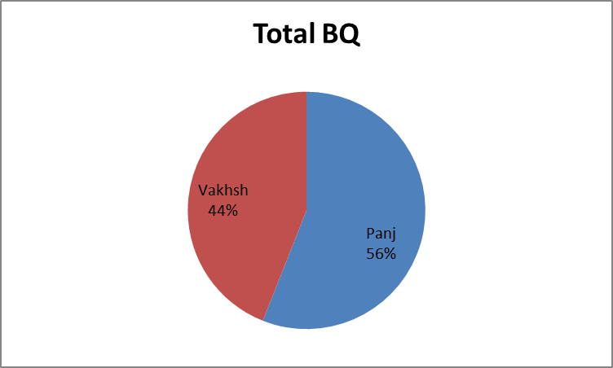 | 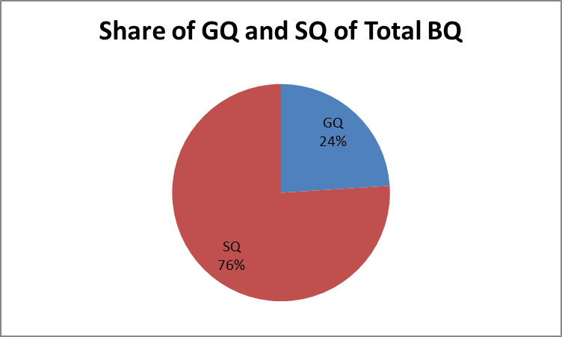
C | D
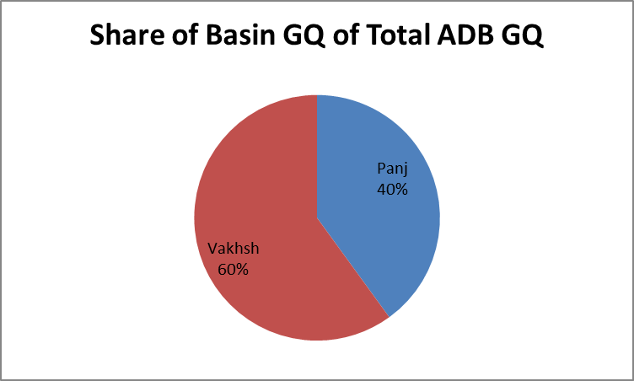 | 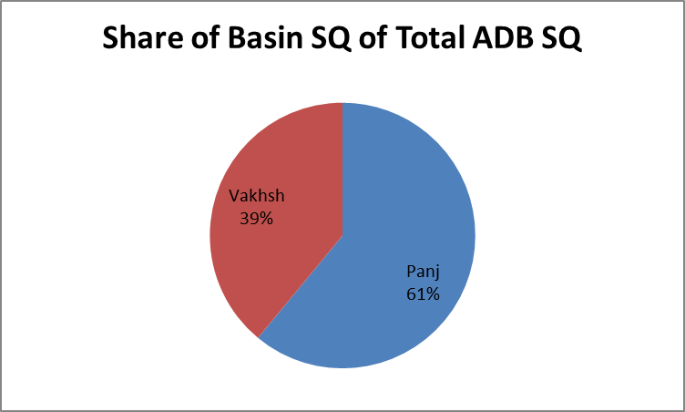
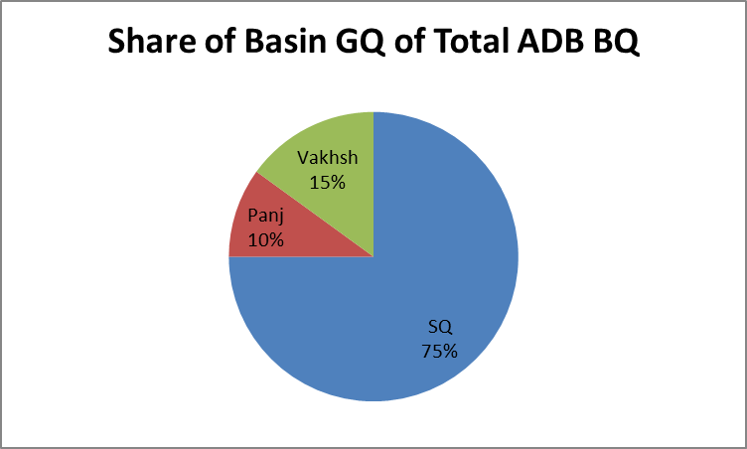E | F
 | 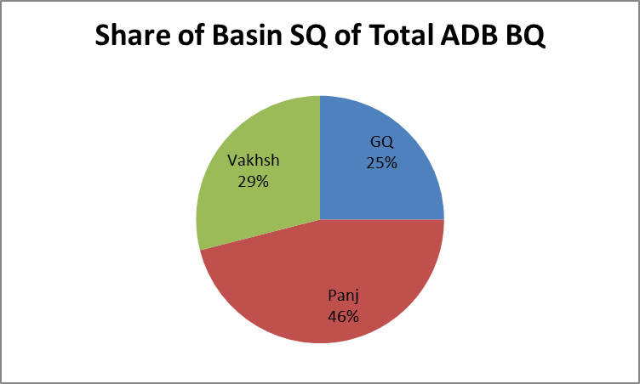

Figure 25. Components of runoff in the mountain basins of the Upper Amu Darya Basin. (A) Share of BQ in Panj and Vakhsh basins in ADB BQ. (B) Share of GQ and SQ in ADB BQ. (C) Share of GQ in Panj and Vakhsh basins in ADB GQ. (D) Share of SQ in the Panj and Vakhsh basins in ADB SQ. (ADB: Upper Amu Darya Basin; BQ: total basin runoff; GQ: glacier melt runoff; SQ: snowmelt runoff).

Table 15. Summary of the hydrological components of runoff and stream flow in the sub-basins of the Vakhsh and Panj rivers showing the relative contribution of snow and glacier melt among the mountain basins at the present time. (BQ: total basin runoff, GQ: glacier melt runoff, SQ: snowmelt runoff, Bq: specific basin runoff, Sq: specific snowmelt runoff; MCM: million cubic meters).

Basin | Area  (km²) | BQ  (m³/s) | BQ  (MCM) | Bq  (mm) | Glacier Area  (km²) | GQ  (MCM) | SQ  (MCM) | Sq  (mm)
Panj
Murgab | 16,700 | 47 | 1,449 | 90 | 1,020 | 915 | 534 | 30
Gund | 13,853 | 104 | 3,276 | 240 | 800 | 507 | 2,769 | 200
Bartang | 4,345 | 135 | 1,630 | 380 | 702 | 980 | 650 | 150
Gudara | 4,067 | 50 | 1,544 | 380 | 648 | 403 | 1,141 | 280
Shidz | 18,519 | 479 | 9,771 | 530 | 2,263 | 3,470 | 6,301 | 340
Vanch | 2,060 | 79 | 2,491 | 1,210 | 332 | 480 | 2,011 | 980
Yazgulem | 1,940 | 54 | 1,693 | 870 | 278 | 372 | 1,321 | 680
Total | 61,484 | --- | 21,854 | 300 | 6,043 | 5,185 | 15,669 | 210
Vakhsh
Kysylsu | 8,370 | 100 | 3,150 | 380 | 758 | 1,130 | 2,020 | 240
Muksu | 6,550 | 210 | 6,615 | 1,010 | 2,551 | 2,685 | 4,930 | 740
Obighigou | 5,390 | 235 | 7,403 | 1,370 | 997 | 1,269 | 6,139 | 1,140
Total | 20,310 | --- | 17,168 | 850 | 4,306 | 5,685 | 11,383 | 540

Figure 26. Components of runoff in the mountain basins of the upper Amu Darya Basin representing the diversity of hydro-meteorological environments. While aggregated mean data provide useful forecasts of total runoff into the rivers of the adjacent lowlands, they provide little insight into the role of individual water budget components, such as glaciers, in stream flow formation. (BQ: total basin runoff; GQ: glacier melt runoff; SQ: snowmelt runoff; MCM: million cubic meters).

6. Syr Darya Mountain Basins

The Syr Darya is formed by the confluence of the Naryn and Kara rivers in the Upper Fergana Valley of Uzbekistan. Its headwaters are in the western Tien Shan Mountains, the Fergana Range and the Alai Mountains of Kyrgyzstan (Figure 27). The river flows through both the Uzbek and Tajik portions of the Fergana Valley before exiting into Uzbekistan and flowing into the Aral Sea. There are major differences between the topography and glaciers of the Amu Darya and Syr Darya basins. While terrain elevations reach 7,000 m a.s.l. in the northern Pamirs, maximum elevations are only slightly above 5,000 m a.s.l. in the western Tien Shan. These altitudinal differences have a profound effect on the nature of the glaciers in the western Tien Shan, when compared to the Pamirs, and on the hydrologic regime at the headwaters of the Syr Darya.

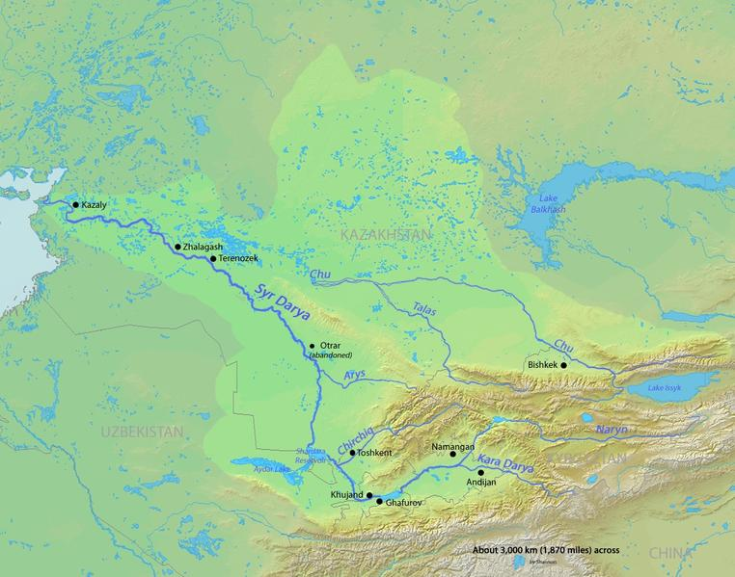

Figure 27. The headwaters of the Syr Darya are in the mountains of Kyrgyzstan, from where the river flows westward through Tajikistan and Uzbekistan in the Fergana Valley and subsequently through Kazakhstan to the Aral Sea.

The glacierized headwaters of the Syr Darya are located in the western Tien Shan Mountains, the Fergana and Alai ranges, and the Chirchik River Basin. The Naryn, Kara, and Alai Mountains basins encircle the Upper Fergana Valley and drain into it (Figures 28 and 29). The Chirchik River flows through the city of Tashkent, and is considered here as being outside the Upper Fergana Valley.

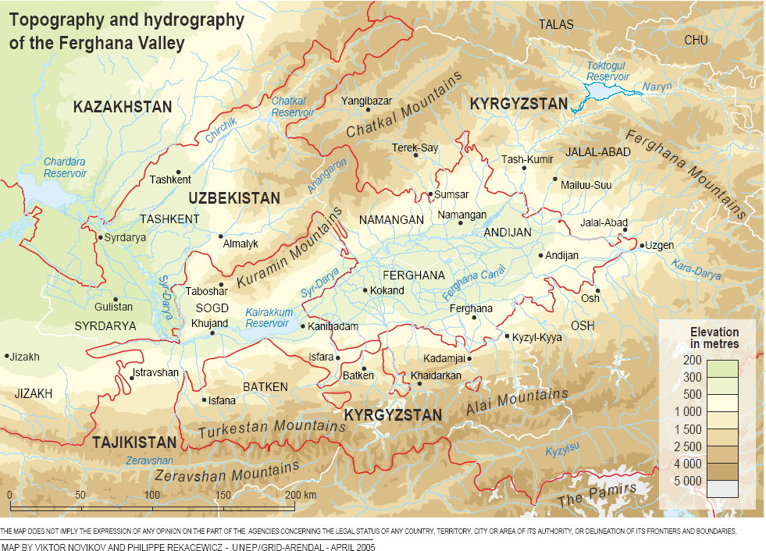

Figure 28. The Fergana Valley is enclosed by three mountain ranges: the western Tien Shan Mountains in the north, the Fergana Range in the east, and the Alai Mountains in the south.

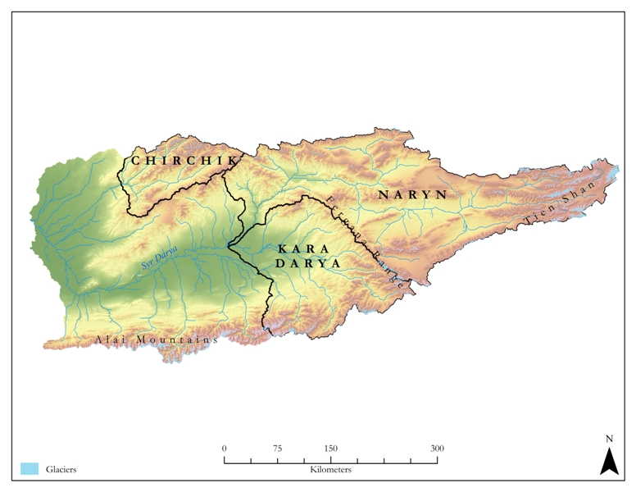
Figure 29. The headwaters basins of the Syr Darya. The river is formed by the confluence of the Naryn and Kara rivers, receives additional input from basins along the north slopes of the Alai Mountains as it flows through the Fergana Valley, and from the Chirchik River near Tashkent, Uzbekistan.

The assessment of the role of the glaciers in the flow of the Syr Darya is complicated by what are assumed to be consumptive agricultural water withdrawals for irrigation purposes in the Fergana Valley. While conflicts between water supply and water use complicate the assessment of the glacier—runoff relationship in all the rivers with headwaters in the glacierized basins of the Himalaya, Karakoram, Pamir, and Tien Shan mountains, they are nowhere as evident as in the upper Syr Darya Basin.

6.1. Basins

While the total surface areas of the upper Amu Darya and Syr Darya basins are of the same magnitude (Table 16; Figure 30), the hypsometries (area-altitude distributions) differ greatly (Figure 31). In particular, altitudes above 5,000 m a.s.l.—the general snowline altitude above which glaciers in this region form—are almost completely absent in the Upper Syr Darya Basin, while the larger area at these higher altitudes allows for the existence of more extensive glaciers and snowfields in the Upper Amu Darya Basin.

Table 16. Areas of sub-basins and glacier areas in the Upper Syr Darya Basin. (Q: stream flow or discharge; BQ: total basin runoff; Bq: specific basin runoff).

Basin | Area (km²) | Glacier Area (km²) | Q  (m³/s) | BQ  (MCM) | Bq  (mm)
Chirchik | 11,714 | 181 | 218 | 6,867 | 570
Fergana Valley | 90,543 | 2,115 | --- | 18,450 | ---
Alai Range | 11,106 | 489 | --- | 1,040 | 190
Kara | 15,589 | 416 | --- | 5,161 | 330
Naryn | 63,848 | 1,226 | 75 | 12,249 | 190
Total | 102,257 | 2,296 | --- | 25,317 | 260

A | B
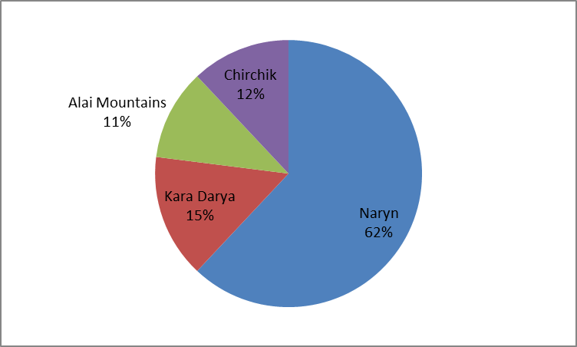 | 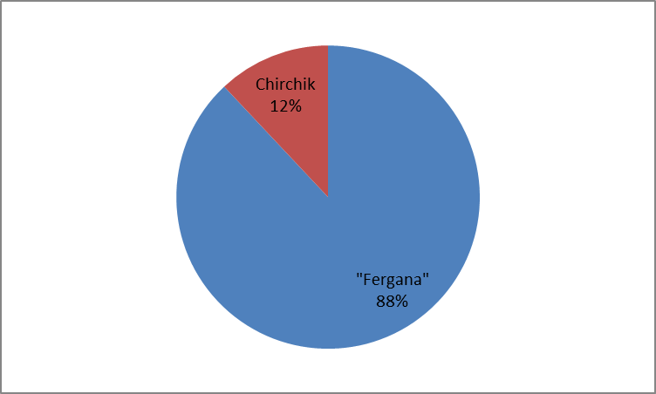

Figure 30. (A) Surface area of sub-basins within the Upper Syr Darya Basin. (B) Surface area of the Fergana Valley catchment that combines the Naryn and Kara basins, and the Alai Mountains.

Figure 31. The hypsometry of the Upper Syr Darya Basin is strongly influenced by the low altitudes of the Fergana Valley west of the Fergana Mountains, similar to the hypsometry of the Nepal Himalaya. In both cases, with a limited amount of the total surface area at high altitudes, there is insufficient area on which glaciers may form, regardless of the high altitude climate. The Upper Amu Darya Basin has a larger area at higher altitudes, which allows for the existence of more extensive glaciers and snowfields.

The hypsometry of the Upper Naryn Basin, which has a surface area of c. 2,000 km² above an altitude of 4,000 m a.s.l. and a glacier surface area of 1,226 km², provides a better indication of the high altitude hypsometry of the glacierized portions of the Syr Darya mountain basins (Figure 32). In the case of the Syr Darya glaciers, the location of glaciers appear to be primarily determined by the presence of cirques basins that provide traps to concentrate local accumulation of wind-blown snow. These cirques are erosional features left behind by previous cycles of glacier growth and retreat.

Figure 32. The Upper Naryn Basin shows the typical hypsometry of an individual mountain basin within the Upper Syr Darya Basin.

6.2. Glaciers

The headwaters of the Syr Darya in the western Tien Shan and Alai mountains have only a few peaks above 5,000 m a.s.l., and the glaciers are primarily small cirque glaciers. The total surface area of the glaciers at the headwaters of the Syr Darya is 2,296 km², slightly greater than the 1,658 km² estimated by Kotlyakov (1996) (Table 16). The glaciers are not uniformly distributed among the glacierized basins. The mountains surrounding Fergana Valley contain 93% of all glaciers: 54% of them can to be found in the Naryn Basin, 21% in the Alai Mountains, and 18% in the Kara Basin (Figure 33). Only 7% of the glaciers are in the Chirchik Basin. Representative hypsometries are shown in Figure 34. There are c. 300 km² of glacier area that has been catalogued as ‘ungauged’ and, hence, has not been included in the analysis.

A |  | B
 | 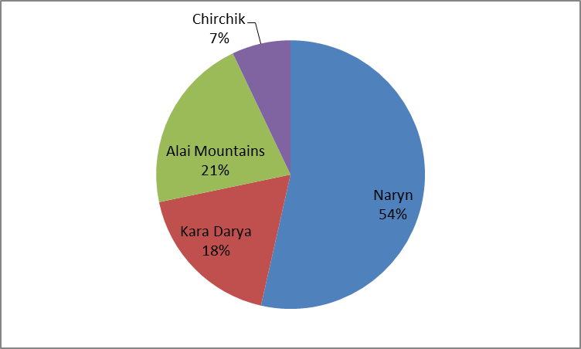 |  | 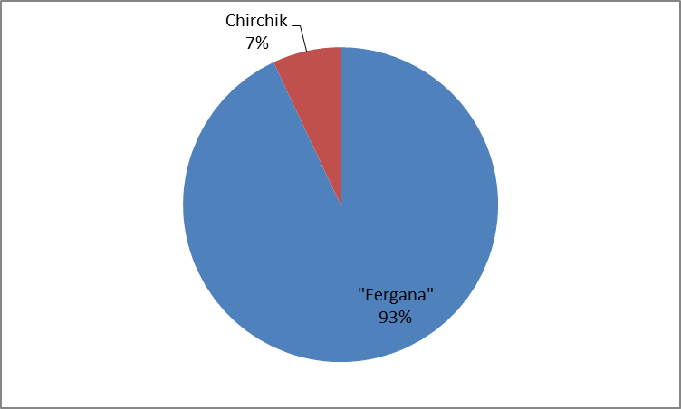

Figure 33. (A) Share of glacierized area in sub-basins of the total glacierized area in the Upper Syr Darya Basin. (B) Combined share of the Naryn and Kara basins and Alai Mountains (Fergana Valley catchment) and of the Chirchik Basin in the total glacierized area in the Upper Syr Darya Basin.

Figure 34. Representative hypsometries for the Naryn and Kara basins, and Alai Range within the Upper Syr Darya Basin. Maximum area-altitude values vary slightly among these glaciers, but are generally between 4,100 and 4,300 m a.s.l.

The following two figures are examples for the glacierized portions of the Naryn Basin (Figure 35) and the Alai Mountains (Figure 36).

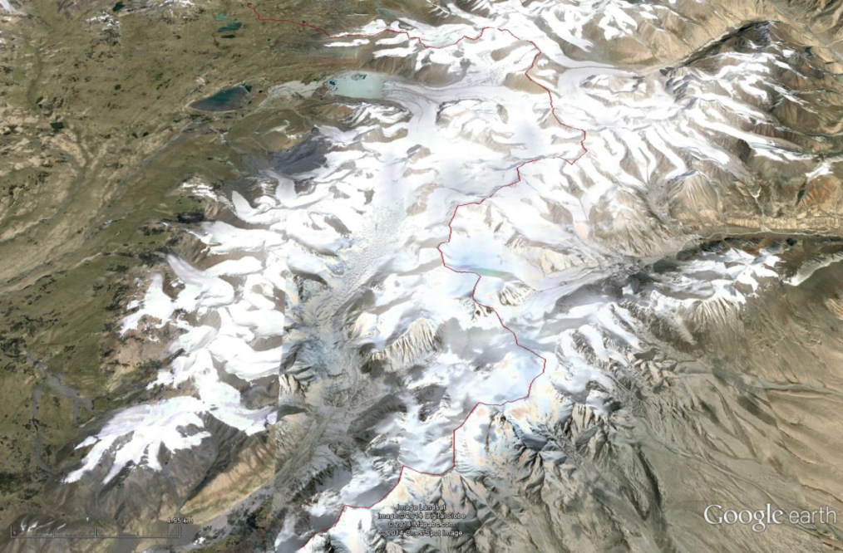

Figure 35. Cirque glaciers at the headwaters of the Naryn River. The boundary of the catchment basin is shown by a red line; the Naryn River flows to the west from these glaciers. At >800 km² this is the most extensive glacier field in the Alai Mountains.

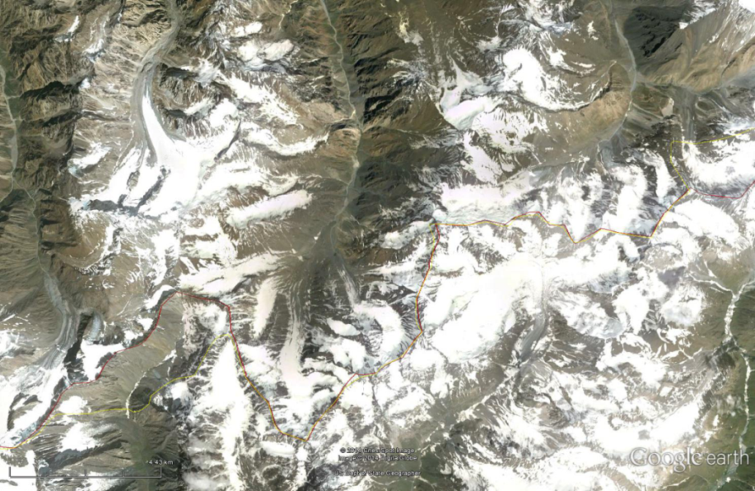

Figure 36. Cirque glaciers in the Alai Mountains. The catchment boundary is shown by the red line; the Syr Darya drainage is to the north. It is assumed that these small cirque glaciers are maintained primarily by wind-blown snow and summer precipitation and, hence, are very susceptible to small increases in temperature or decreases in accumulation.

Perhaps the most striking difference between the glaciers of the Upper Syr Darya Basin and those of the Upper Amu Darya Basin is in their area-altitude distributions (Figure 37). While in the Upper Syr Darya Basin glaciers exist between c. 3,200 and 5,000 m a.s.l. with a median altitude of c. 4,100 m a.s.l., they exist in the Upper Amu Darya Basin between 3,400 and 7,000 m a.s.l. with a median altitude of c. 5,000 m a.s.l. As outlined in the section above, these differences in glacier properties are ascribed as much to differences in topography as to differences in the main climate controls.

Figure 37. Glacier hypsometries in the Upper Syr Darya Basin (blue) and the Upper Amu Darya Basin (red). The difference between the glacier hypsometries in both basins is expected to produce a difference in the response of the glaciers to any climate change.

While the shrinkage of glaciers may be related to climatic factors, the growth of glaciers is largely determined by the surface area available at altitudes at which a favorable climate—precipitation and temperature—exists. In the Pamir Mountains, the surface area above 4,000 m a.s.l. is c. 60,000 km², with a glacier surface area of over 10,000 km². In the western Tien Shan Mountains, the surface area above 4,000 m a.s.l. is c. 6,000 km², with a glacier surface area of c. 1,700 km².

6.3. Climate

The climate data for the Syr Darya Basin consist of an extensive database containing period-of-record measurements of both temperature and precipitation for the river’s headwater basins available in the ‘Central Asia Data Base’ (CADB) at the University of Idaho compiled by Vladimir Aizen. A more-detailed analysis of these data is beyond the scope of this study, but would undoubtedly provide useful insights into the climates of the western Tien Shan Mountains.
Based on a regression of the CADB temperature data, the mean summer season 0ºC isotherm is estimated to be slightly above 4,000 m a.s.l., a first approximation of the altitude that separates the zones of ablation and accumulation on the mountain glaciers and is assumed to define the regional snow line in the western Tien Shan Mountains (Figure 38). Any precipitation falling above this altitude is assumed to fall as snow, and enter into either seasonal storage as snow, or become perennial snowfields and glaciers. It is a useful baseline against which estimates of climate change may be tested. As the climate warms, the altitude of the 0°C isotherm is assumed to move upwards on the glaciers, causing melt affecting both the periglacier snowfields, as well as he glaciers (Alford et al., 2009; IPCC, 2014).

Figure 38. Air temperature lapse rate during the summer season (June to September) in the Syr Darya Basin. Visual extrapolation indicates that the altitude of the summer-season 0°C isotherm is slightly above 4,000 m a.s.l.

Seasonal temperatures at the altitude of the projected summer-season 0°C isotherm reflect the temperature environment at an altitude only a few hundred meters below this line (Figure 39). These data, from the CADB station ‘Tien Shan’ at an altitude of c. 3,600 m a.s.l. have been separated into a ‘winter season’ from October to March and a ‘summer season’ from April to September. Even at this altitude, several hundred meters below the Syr Darya glaciers, average summer temperatures are only slightly above the freezing level.

Figure 39. Long-year record of mean winter and summer temperatures for the climate station ‘Tien Shan’ at 3,600 m a.s.l. in the western Tien Shan.

An assessment of the role of glaciers in the stream flow of the Syr Darya is complicated by the fact that, similar to the seasonal monsoon and the glaciers of the Nepal Himalaya, the season of maximum precipitation in its headwaters occurs during the summer months, coincident with the ablation season. In general, annual precipitation is at a maximum at low altitudes in the basin from April to May, and gradually increasing upward to maximum values in June and July at the highest altitudes for which data are available (Figures 40 and 41). As much as 50-60% of the total annual precipitation during the summer season occurs during the period of maximum stream flow, when it is assumed glacier melt and runoff is at a peak.

Figure 40. Monthly precipitation at different locations in the Syr Darya Basin. The seasonal maximum values of precipitation are between 3-4 months earlier at low altitudes than in the mountain basins. The seasonal precipitation maximum at the higher altitude stations during the ablation period in the summer season suggests that a portion of annual glacier melt water runoff is produced by summer precipitation by both rain and snow melt.

Figure 41. Variation of the fraction of summer season (June to August) precipitation of the total annual precipitation in the upper Syr Darya Basin. Precipitation during the summer season, which is assumed to be the period of maximum glacier melting, is also the season of maximum precipitation at the general altitude of the glaciers above 3,000 m a.s.l.

This orographic gradient of precipitation complicates the application of basic glacier mass balance concepts to an analysis of the annual runoff resulting from melting below the glacier ELA. It appears that there is rain during the ablation season either on, or very near, the glacier ablation zone. This means that the runoff immediately downstream from the glacier terminus, as well as at the mouth of the glacierized basin, is a result of both glacier melt and rain, with no obvious procedure available to separate the two.

6.4. Hydrology

Mean annual stream flow data were available from the global Runoff Data Centre (GRDC, 2014). Twenty-two of these stations were within or immediately adjacent to the upper Syr Darya Basin. Data from these twenty-two monitoring stations are used as the basic hydrological database of this study. Data describing the mean monthly values for two stations in the Naryn Basin—Naryn and Uch Kurgan (UCAR, 2014)—were found a limited consideration of the annual hydrograph of a glacierized basin.

The hydrology of the upper Syr Darya has the following characteristics:

- The mean annual flow volume of the Syr Darya is estimated to be 37 km²; in the Upper Syr Darya Basin it is estimated to be 25 km³.

- The mean annual flow of the Naryn River at Uch Kurgan below the Fergana Cascade is 12 km³.

- The mean annual flow of the Kara at the confluence with the Naryn River forming the Syr Darya is 5 km³.

- The mean annual flow from the small basins on the north side of the Alai Mountains is 1 km³.

- Specific runoff (runoff depth per unit area) varies from less than 50 mm at Bekabad, where the Syr Darya leaves the Fergana Valley, to 700 mm on the south flank of the Fergana Range. Most mountain stations have values near 200 mm.

- The total volume of water entering the Upper Syr Darya in the Fergana Valley from all sources (Naryn, Kara, and Alai Mountains) is 18 km³, while outflow from the Fergana River at Bekabad at the western end of the Fergana Valley is 7 km³, which is a decrease in volume of 11 km³.

A useful comparison of the importance of precipitation in the hydrology of a basin is specific runoff (Bq), the mean depth of runoff from a basin, in millimeters. Specific runoff is determined by dividing the runoff volume by the surface area of the basin. Specific runoff provides an indicator of the potential impact of projected increases or decreases of precipitation on the stream flow of a basin. In general, the runoff efficiency (Q/P) is high for mountain catchment basins, i.e. specific runoff serves as a useful index of precipitation as well as of any changes in that precipitation. The specific runoff in the headwater basins of the Syr Darya ranges from slightly over 100 mm to over 700 mm (Figure 42).

Figure 42. Specific runoff (mm) for the gauged basins at the headwaters of the Syr Darya.

Runoff volume in the Upper Syr Darya is primarily from the Naryn Basin. At the confluence with the Kara, both rivers contribute a combined c. 17 km³ to the Syr Darya (Table 17). An additional c. 1 km³ flow volume is added from the small basins on the north slopes of the Alai Mountains, for a total flow volume of c. 18 km³ within the Fergana Valley.

Table 17. Mean values for the period-of-record for stream flow and glacierized area for nineteen basins within the Tien Shan, Alai, and Fergana mountains, together with glacier area. Data have been downloaded from the Global Runoff Data Center (GRDC) in Koblenz, Germany, and are sufficient for calibrating early tests of the Ablation Gradient Model. (Q: stream flow or discharge; BQ: total basin runoff; Bq: specific basin runoff; MCM: million cubic meters).

Basin | Area  (km²) | Mean Altitude  (m a.s.l.) | Glacier Area  (km²) | Q  (m³/s) | BQ  (MCM) | Bq  (mm)
Naryn River
Naryn | 11,009 | 3,553 | 822 | 86 | 2,715 | 260
Ust Kekerim | 17,671 | 3,054 | 100 | 118 | 4,202 | 190
Ust Kairagash | 6,121 | 3,035 | 144 | 9 | 279 | 590
Ust Djumbol | 8,896 | 2,818 | 104 | 79 | 2,475 | 470
Toktugul Reservoir | 12,101 | 2,847 | 50 | --- | --- | ---
Uch Kurgan | 5,863 | 1,777 | 0 | 75 | 2,263 | 390
Aflatun | 2,179 | 2,042 | 5 | 10 | 315 | 150
Total | 63,848 | --- | 1,226 | --- | 12,249 | ---
Kara River
Ust Karakol | 1,724 | 2,579 | 52 | 9 | 284 | 170
Tuleken | 2,557 | 3,026 | 128 | 20 | 630 | 260
Gulcha | 2,122 | 3,012 | 30 | 16 | 504 | 180
Chalma | 4,174 | 3,115 | 156 | 47 | 1,481 | 430
Aktash | 942 | 3,118 | 39 | 21 | 655 | 720
Salamalik | 2,709 | 2,081 | 5 | 22 | 693 | 590
Charvak | 1,301 | 2,219 | 6 | 29 | 914 | 700
Total | 15,589 | --- | 416 | --- | 5,161 | ---
Chirchik River
Chirchik | 11,714 | 2,577 | 181 | 218 | 6,867 | 570
Total | 11,714 | --- | 181 | --- | 6,867 | ---
Syr Darya (Alai)
Paulgan | 1,493 | 2,733 | 39 | 10 | 315 | 240
Tash-Kurgan | 3,439 | 2,266 | 111 | 14 | 441 | 290
Andrahan | 2,220 | 2,222 | 28 | 6 | 189 | 110
Dazgon | 755 | 2,808 | 9 | 3 | 95 | 130
Ungauged* | 3,199 | 3,205 | 302 | --- | --- | ---
Total | 11,106 | --- | 489 | --- | 1,040 | ---
*This ungauged sub-basin was excluded from the hydrologic modeling.

6.4.1. Variability of Stream Flow

The Naryn gauging station at 2,039 m a.s.l. provides the only data source available for this study for assessing the relationship between stream flow and glacier melt in the Syr Darya Basin. The station is located immediately downstream from the main concentrations of glacier ice in the Naryn Basin, and can therefore be expected to respond most directly to glacier melt water.
The interannual variability of stream flow at this station is c. 25-35% of the long-term mean flow (Figure 43). There is no indication that any increase or decrease in the mean or extreme flows have occurred during the period-of-record, 1940-1985.

Figure 43. The interannual variability of stream flow at the Naryn gauging station near the headwaters of the Naryn River between 1940 and 1985.

The primary problem in analyzing the annual hydrograph from Naryn involves the summer-season precipitation peak at high altitudes in the basin discussed above. Since both precipitation maximum and summer-season glacier melt occur during the summer months, separation of the two as components of the annual runoff is a more difficult matter than in the nearby Pamirs. The hydrograph has a seasonal peak flow in July, with a secondary, lower, peak in August, before the recession phase begins (Figure 44). A comparison of the monthly precipitation in the Upper Naryn Basin with the monthly specific runoff at the Naryn gauging station provides some indication of the relationship between the two (Figure 45). Monthly precipitation reaches maximum values during May and June, while runoff peaks in June to August. It is assumed that all runoff prior to the beginning of glacier melt is a result of precipitation input. The July peak is assumed to represent both precipitation and glacier melt, while the secondary peak in august is largely glacier melt.

Figure 44. Mean period-of-record monthly stream flow volume at the Naryn gauging station. The two summer peaks reflect the joint contribution of summer-season precipitation in the basin, together with glacier melt.

Figure 45. The annual trend of precipitation and specific runoff. The excess of runoff over precipitation during the months of August and September is assumed to be largely glacier melt runoff.

Based on hydrograph analysis, it is estimated that the total volume of stream flow during the months of July to September at Naryn is 1.4 km³. Based on the ablation gradient analysis it is estimated that the summer-season glacier runoff is 0.8 km³. The approximate recession volume for the period June to September from a peak flow in June is on the order of 0.7 km³. Both numbers give a total volume of 1.5 km³, which provides a rough estimate of the relatively equal contribution of precipitation and glacier melt of the summer stream flow at this station. With increasing distance downstream from the glaciers, as a result of dilution by precipitation, the glacier fraction of total stream flow decreases to c. 10% of the total flow volume where the Naryn River reaches the Fergana Valley.

6.4.2. Glacier, Snow, and Rainfall Runoff

The glaciers at the headwaters of the Syr Darya—in the Naryn and Kara basins and the small basins on the north slopes of the Alai Mountains—contribute 1.4 km³ to the mean annual stream flow volume of 18 km³ in the Fergana Valley (Tables 18 and 19; Figure 46). The primary source of the glacier runoff is the Naryn Basin contributing almost 1 km³. The contribution attributed to ‘Other’ is intended to include both rainfall and snow melt. Figure 47 illustrates graphically the relative glacier contribution of each of the tributaries to the upper Syr Darya.

Table 18. Components of runoff in the mountain basins of the upper Syr Darya Basin (SDB).

 | Syr Darya |  | Chirchik¹ |  | Naryn |  | Kara |  | Alai Mountains |  | ‘Fergana’²
 | (km³) | (%) | (km³) | (%)* | (km³) | (%)* | (km3) | (%)* | (km³) | (%)* | (km³) | (%)*
Total Runoff (BQ) | 25.4 | --- | 6.9 | --- | 12.3 | --- | 5.2 | --- | 1.0 | --- | 18.5 | ---
Contribution to SDB | --- | --- | --- | 27 | --- | 48 | --- | 21 | --- | 4 | --- | 73
Glacier Melt Runoff (GQ) | 1.5 | 5.9 | 0.1 | 2 | 1.0 | 8.1 | 0.3 | 5.8 | 0.1 | 10.0 | 1.4 | 8
Contribution to SDB GQ | --- | --- | --- | 7 | --- | 67 | --- | 20.0 | --- | 6.7 | --- | 93
Contribution to SDB BQ | --- | --- | --- | >0 | --- | 4 | --- | 1.2 | --- | 0.4 | --- | 6
“Other”³ Runoff (SRQ) | 23.9 | 94.1 | 6.8 | 98 | 11.3 | 92 | 4.9 | 94 | 0.9 | 90 | 17.1 | 92
Contribution to SDB SRQ | --- | --- | --- | 28 | --- | 47 | --- | 21 | --- | 4 | --- | 72
Contribution to SDB BQ | --- | --- | --- | 27 | --- | 45 | --- | 19 | --- | 4 | --- | 67
¹ The Chirchik Basin is downstream from the confluence of the Naryn and Kara rivers.
² The Naryn, Kara, and Alai Mountain basins in the Fergana Valley catchment are upstream from the confluence of the Naryn and Kara rivers.
³ “Others” combines runoff from snowmelt and rain.
* Rounded numbers might lead to erroneous sums.

A | B
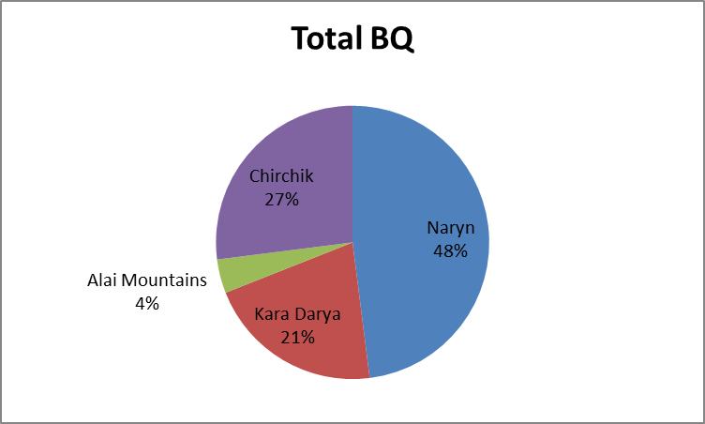 | 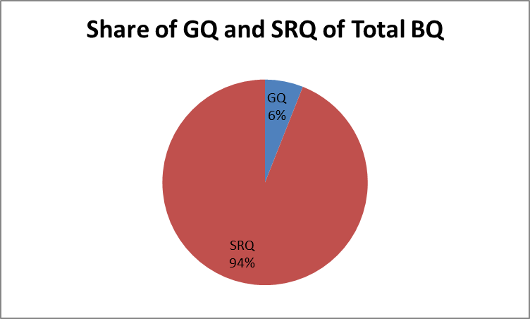
C | D
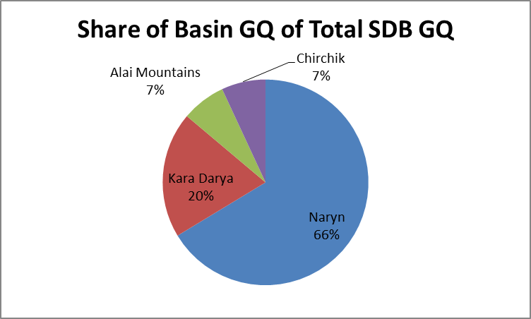 | 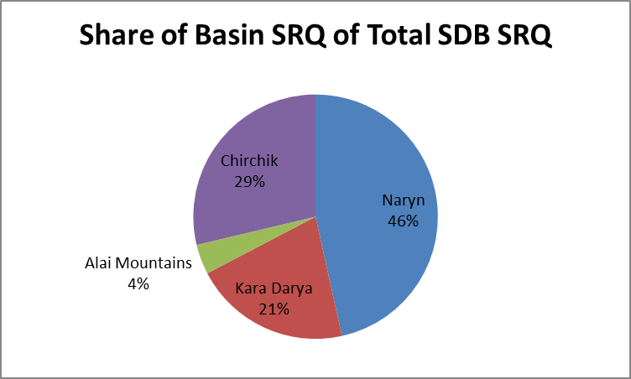
E | F
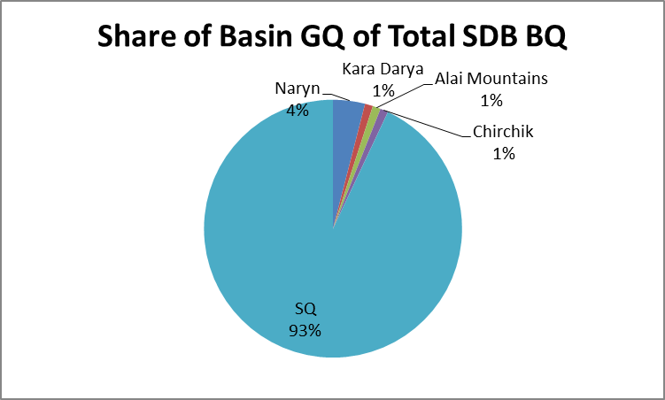 | 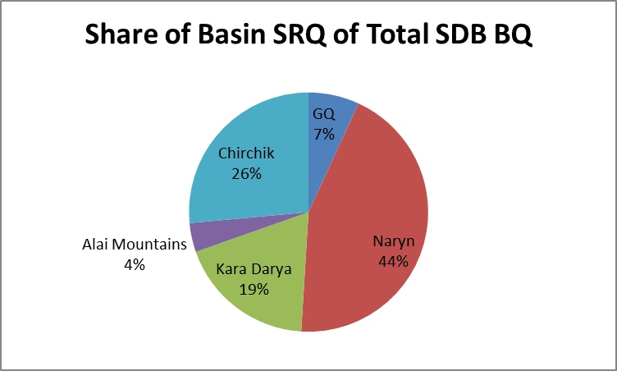

Figure 46. Components of runoff in the mountain basins of the Upper Syr Darya Basin. (SDB: Upper Syr Darya Basin; BQ: total basin runoff; GQ: glacier melt runoff; SRQ: snowmelt AND rain runoff = “Other”).

Table 19. Annual volumes of total basin runoff (BQ), glacier melt runoff (GQ), and runoff from both snow melt and rain (‘Other’) in basins in the Syr Darya headwaters. (MCM: million cubic meters).

Basin | BQ (MCM) | GQ (MCM) | ‘Other’ (MCM)
Naryn | 2,715 | 822 | 1,893
Ust. Kairagach | 279 | 144 | 135
Chalma | 1,486 | 156 | 1,330
Gulcha | 502 | 30 | 472
Tuleken | 645 | 128 | 517
Uch-Korgon | 669 | 82 | 587
Paulgan | 305 | 39 | 266
Tash-Kurgan | 435 | 111 | 324
Dazgon | 98 | 9 | 89
Ust-Djumgol | 2,475 | 104 | 2,371
Charvak | 903 | 6 | 897
Afluntun | 326 | 5 | 321
Ust Karakol | 284 | 52 | 232
Andrahan | 297 | 28 | 269
Charvak | 903 | 6 | 897

Figure 47. Components of runoff in the mountain basins of the Upper Syr Darya Basin representing the diversity of hydro-meteorological environments. While aggregated mean data provide useful forecasts of total runoff into the rivers of the adjacent lowlands, they provide little insight into the role of individual water budget components, such as glaciers, in stream flow formation. (Q: runoff; ‘Other’: undifferentiated runoff from snowmelt and rain; MCM: million cubic meters).

While glacier ablation contributes to the runoff in the Syr Darya Basin, it is apparent that a combination of snow melt and summer precipitation is the major component in the runoff from glacierized basins in the western Tien Shan Mountains. A potential complete disappearance of the glaciers will have a minimal impact on the water resources of the Upper Syr Darya Basin. The role of precipitation is far more important here.

7. Stream flow and Climate Change

Most problems dealing with the climate and hydrology of high mountain glacier basins can be reduced to the interaction of topography (altitude, aspect, slope) and meteorology (the properties and processes of the surrounding air mass). Large mountain ranges may project upward from a warm, humid climate at the mountain base into the mid-troposphere in a horizontal distance of a few tens of kilometers. The mountains of Asia all project into this cryosphere, the accumulation zone of glaciers and perennial snowfields. Immediately below the cryosphere is the periglacier zone, the ablation zone of glaciers and seasonal snowfields. There is no sharp transition between the two, but rather a zone that fluctuates up and down seasonally, depending upon the changing balance between mass (as snow) gain and loss as a result of changes in precipitation and temperature. This is the zone of the equilibrium line altitude (ELA) of a glacier. The application of climate change forecast projections such as CMIP5 to high mountain hydro-meteorological environments presents a number of challenges related to this topo-climatological complexity.
It is now generally agreed (e.g., IPCC, 2014) that the effect of the temperature increase associated with climate change will result in the upward migration of the glacier ELA. For this study, the air temperature gradient has been assumed to have a lapse rate of 0.65°C/100 m. All other factors being equal, for each 1°C air temperature increase, the glacier ELA will move upward on the glacier by 130 m. The CMIP5 temperature projections range from ±0°C to +6.1°C implying either no change in the ELA at all or an upward migration of 900 m from its current altitude of between 4,500 and 5,000 m a.s.l. Under all options, except the no-change option, the volume of glacier melt water will decrease.
The precipitation amounts in the CMIP5 projections (Tables 20 and 21) present a different problem. In the water cycle, precipitation may follow three different paths:

- immediate runoff as quick flow,

- seasonal storage as snow and ground water, or

- long-term storage in perennial snow fields and glaciers.

Table 20. Projections covering all GCMs (included in CMIP5) and 4 scenarios for radiative forcing (‘emissions’) scenarios for 2011-2040 (against 1976-2005 baseline).

P (mm) | JAN | FEB | MAR | APR | MAY | JUN | JUL | AUG | SEP | OCT | NOV | DEC | YEAR | MEAN
Max | 8.2 | 9.7 | 13.4 | 20.1 | 34.2 | 19 | 12.6 | 12 | 11.7 | 16.6 | 12.5 | 12 | 182 | ---
Min | -5.5 | -8.5 | -11 | -10.8 | -13.8 | -13.1 | -12.5 | -13.3 | -11.7 | -11.4 | -11.4 | -11.8 | -135 | ---
Mean | 2.1 | 1.5 | 3.2 | 4.6 | 3.2 | 1.6 | 0.7 | 0.2 | -0.4 | 0.9 | 1.7 | 2.6 | 21.9 | ---
T (°C) | JAN | FEB | MAR | APR | MAY | JUN | JUL | AUG | SEP | OCT | NOV | DEC | YEAR | MEAN
Max | 2.7 | 2.6 | 3.6 | 2.5 | 2.6 | 2.3 | 2.8 | 3.4 | 2.9 | 3.5 | 2.4 | 3.2 | 34.5 | 2.9
Min | -0.2 | -1.5 | 0.1 | 0.1 | 0 | 0.1 | 0.3 | 0.2 | 0.2 | -0.2 | 0.2 | 0.3 | -0.4 | 0
Mean | 1.2 | 1.3 | 1.3 | 1.1 | 1.2 | 1.2 | 1.3 | 1.4 | 1.5 | 1.4 | 1.3 | 1.4 | 15.6 | 1.3

Table 21. Projections covering all GCMs (included in CMIP5) and 4 scenarios for radiative forcing (‘emissions’) scenarios for 2041-2070 (against 1976-2005 baseline).

P (mm) | JAN | FEB | MAR | APR | MAY | JUN | JUL | AUG | SEP | OCT | NOV | DEC | YEAR | MEAN
Max | 17 | 14.2 | 18.8 | 32.3 | 44.4 | 20.6 | 14.7 | 14.7 | 9.7 | 22.6 | 16 | 15.7 | 240.7 | ---
Min | -8.2 | -19.2 | -18.4 | -16.4 | -18 | -22.3 | -21.8 | -19.5 | -15 | -11.1 | -15.3 | -11.6 | -197 | ---
Mean | 3.4 | 3.1 | 4.5 | 7.6 | 4.6 | 1.4 | -1.6 | -1.4 | -1.6 | 0.9 | 3.1 | 3.9 | 27.9 | ---
T (°C) | JAN | FEB | MAR | APR | MAY | JUN | JUL | AUG | SEP | OCT | NOV | DEC | YEAR | MEAN
Max | 5.1 | 4.9 | 6.4 | 5.9 | 5.4 | 5.5 | 6.7 | 8.1 | 7.3 | 6.2 | 5 | 6.4 | 72.9 | 6.1
Min | 0.4 | 0.1 | 0 | 0.3 | 0.1 | 0.2 | 0.6 | 0.4 | -0.1 | 0.4 | 0.4 | 0.4 | 3.2 | 0.3
Mean | 2.4 | 2.4 | 2.4 | 2.2 | 2.3 | 2.3 | 2.6 | 2.8 | 2.7 | 2.6 | 2.5 | 2.7 | 29.9 | 2.5

In the high mountains of Asia, as a result of the extreme relief of the mountains, it is not uncommon to find characteristics of climates ranging from humid, sub-tropical to arid, cold deserts existing simultaneously within a single catchment basin. At any given moment, precipitation may be occurring as rain in the lowland piedmont, as a rain-snow mix at the mid-altitudes in the montane belt, and as perennial snow and ice in the alpine. The resulting partition of this precipitation as runoff, seasonal or perennial storage—reflected by runoff timing and volume at the mouth of the basin—will vary among mountain basins depending on the basin hypsometry and the existing hydrologic regime. The CMIP5 scenarios give no guidance on this matter. As a first approximation in evaluating the CMIP5 precipitation scenarios, it has been assumed that the intent is that all precipitation becomes quick flow runoff, with the following caveats.
Precipitation occurs during the winter months as snow in the headwater basins of the Amu Darya. For the Panj River, with an area of c. 61,000 km² in the mountain basins, an increase of the maximum CMIP5 precipitation forecast of 240 mm will almost double the normal snow pack water equivalent depth. This will become summer runoff with the potential of doubling the flow of the Panj River. For the Vakhsh River, with an area of c. 20,000 km² in the mountain basins, an increase in the winter snow of 240 mm will have much less impact, resulting in an only 25% increase in summer runoff volume. In both cases, the timing of the runoff will depend on the summer temperatures.
For the Syr Darya, the available precipitation data indicates that 50-60% of the annual precipitation in the mountain basins falls as rain during the months of June to September. It is assumed that this will become quick flow. The remainder will be winter snow that will be melting at the same time, resulting in roughly a doubling of runoff volumes largely independent of any temperature changes.
From the standpoint of hydrological analyses, a problem presented by the CMIP5 forecast projects is the large number of combination and permutations of temperature and precipitation involved. The maximum decreases in precipitation projected by CMIP5 will result in a major decrease in stream flow volumes in the headwaters of both the Amu Darya and Syr Darya basins. The maximum increases in values will result in serious flooding. At least two CMIP5 combinations—of maximum precipitation with average or minimum temperature changes—may result in rapid glacier growth and advance throughout the Pamir-Karakoram-Himalaya mountains similar to that of the Little Ice Age as a result of increase snow fall in the accumulation zones of the glaciers. The hydrological consequences of such an advance are beyond the scope of this study.

7.1. Amu Darya Mountain Basins

Current conditions of stream flow volume, together with glacier melt and snowmelt volumes are shown in Tables 22 and 23 on the line marked ‘base line’. Below that line are the average values of temperature increase, or precipitation increase/decrease derived from the GCM scenarios in Tables 20 and 21. It is assumed that the change in temperature or precipitation will not be instantaneous at the beginning of the period, but will occur gradually, reaching the value given in the GCM scenario at the end of the period. Furthermore, it is assumed that precipitation increases in climate change scenarios will involve snow that contributes to runoff without losses as snowmelt during the summer season. The stream flow volumes resulting from the combinations and permutations of air temperature and precipitation scenarios from GCM scenarios are illustrative and not inclusive. The total range of values for glacier runoff and snowmelt runoff are included, making it possible to evaluate any change combination of interest.

Table 22. Forecasts of changes in basin stream flow volume, glacier component of stream flow, and snow melt component of stream flow for the Panj River based on the scenarios taken from Tables 20 and 21. (BQ: total basin runoff; GQ: glacier melt runoff; SQ: snowmelt runoff; MCM: million cubic meters).

2011-2040 Scenarios
Parameter | Change | BQ  (MCM) | GQ  (MCM) | SQ  (MCM)
‘Baseline’ | --- | 23,251 | 4,871 | 18,380
T (°C) | +1.3 | 21,594 | 3,214 | 18,380
T (°C) | ±0 | 23,251 | 4,871 | 18,380
T (°C) | +2.9 | 20,446 | 2,066 | 18,380
P (mm) | +182 | 36,230 | 4,871 | 31,359
P (mm) | -135 | 13,623 | 4,871 | 8,752
P (mm) | +21.9 | 23,653 | 4,871 | 18,782
2041-2070 Scenarios
Parameter | Change | BQ  (MCM) | GQ  (MCM) | SQ  (MCM)
‘Baseline’ | --- | 23,251 | 4,871 | 18,380
T (°C) | +0.3 | 23,351 | 4,971 | 18,380
T (°C) | +2.5 | 20,441 | 2,061 | 18,380
T (°C) | +6.1 | 18,562 | 182 | 18,380
P (mm) | +240.7 | 40,343 | 4,871 | 35,472
P (mm) | -197 | 9,206 | 4,871 | 4,335
P (mm) | +27.9 | 24,819 | 4,871 | 19,948

Table 23. Forecasts of changes in basin stream flow volume, glacier component of stream flow, and snow melt component of stream flow for the Vakhsh River based on the scenarios taken from Tables 20 and 21. (BQ: total basin runoff; GQ: glacier melt runoff; SQ: snowmelt runoff; MCM: million cubic meters).

2011-2040 Scenarios
Parameter | Change | BQ  (MCM) | GQ  (MCM) | SQ  (MCM)
‘Baseline’ | --- | 17,168 | 5,620 | 11,548
T (°C) | +1.3 | 15,642 | 4,094 | 11,548
T (°C) | ±0 | 17,168 | 5,620 | 11,548
T (°C) | +2.9 | 14,881 | 3,333 | 11,548
P (mm) | +182 | 20,864 | 5,620 | 15,244
P (mm) | -135 | 14,426 | 5,620 | 8,806
P (mm) | +21.9 | 17,613 | 5,620 | 11,993
2041-2070 Scenarios
Parameter | Change | BQ  (MCM) | GQ  (MCM) | SQ  (MCM)
‘Baseline’ | --- | 17,168 | 5,620 | 11,548
T (°C) | +0.3 | 17,168 | 5,320 | 11,548
T (°C) | 2.5 | 14,920 | 3,372 | 11,548
T (°C) | 6.1 | 11,966 | 418 | 11,548
P (mm) | +240.7 | 22,057 | 5,620 | 16,310
P (mm) | -197 | 14,893 | 5,620 | 9,273
P (mm) | +27.9 | 17,500 | 5,620 | 11,880

7.2. Syr Darya Mountain Basins

The glaciers in the Upper Syr Darya Basin cover 2,296 km² and consist of several hundred small cirque glaciers, located in basins adjacent to the local ridge crest in the Alai and Fergana mountains and in the Naryn Basin. Results from the ‘Ablation Gradient Model’ (AGM) analysis indicate that these glaciers produce 1.5 km³ of runoff annual under the current climate. For this analysis, the ELA, an indicator of the current glacier climate, was at 4,100 m a.s.l. A primary indicator of increasing temperatures as a result of climate change in the mountains is the upward migration of the ELA with increasing temperature. This is the primary indictor of the impact of the CMIP5 climate change scenarios used in the analyses with the AGM (Table 24). A problem with this approach involves the scale of the AGM at 100 m altitudinal bands. This restricts the temperature increases in the climate change scenarios to multiples of the air temperature lapse rate of -0.65°C/100 m. While any of the temperatures considered in CMIP5 can be rounded off to a corresponding altitudinal increase in the ELA, this may result in an altitudinal increase of, for example, 150 m, which then must be rounded off to the nearest 100 m increment to be used in the calculations. This procedure can result in an error in the estimated loss of area. The magnitude of this ‘area error’ will be determined by the hypsometry of the glaciers at the altitude of the ELA. In the case of the glaciers in the Syr Darya Basin, it will vary initially from c. 100 km², for the glaciers in the Naryn Basin to c. 10 km² for the glaciers in the Chirchik Basin. As the ELA moves upward, the error will diminish with the decrease in the areas of the altitudinal bands.

Table 24. Forecasts of changes in basin stream flow volume, glacier component of stream flow, and snow melt component of stream flow for the Syr Darya Basin based on the scenarios taken from Tables 18 and 19. (BQ: total basin runoff; GQ: glacier melt runoff; ‘Other’ Q: snowmelt and rain runoff; MCM: million cubic meters).

2011-2040 Scenarios
Parameter | Change | BQ  (MCM) | GQ  (MCM) | ‘Other’ Q (MCM)
‘Baseline’ | --- | 17,410 | 1,738 | 16,100
T (°C) | +1.3 | 17,035 | 935 | 16,100
T (°C) | ±0 | 17,410 | 1,738 | 16,100
T (°C) | +2.9 | 16,100 | 0 | 16,100
P (mm) | +182 | 34,196 | 1,738 | 32,458
P (mm) | -135 | 5,758 | 1,738 | 4,020
P (mm) | 21.9 | 18,192 | 1,738 | 17,967
2041-2070 Scenarios
Parameter | Change | BQ  (MCM) | GQ  (MCM) | ‘Other’ Q (MCM)
‘Baseline’ | --- | 17,410 | 1,738 | 16,100
T (°C) | +0.3 | 17,410 | 1,738 | 16,100
T (°C) | +2.5 | 16,245 | 145 | 16,100
T (°C) | +6.1 | 16,100 | 0 | 16,100
P (mm) | +241 | 39,392 | 1,738 | 37,654
P (mm) | -197 | 1,728 | 1,738 | 0
P (mm) | +27.9 | 17,388 | 1,738 | 15,650

An interesting characteristic of the glaciers in the Syr Darya Basin is that a significant amount of the measured annual precipitation at altitudes near the glacier ablation zones occurs during the summer months. For traditional mass balance calculations, the summer months are assumed to being dominated by melt, and that the major component of summer season runoff is glacier melt. In the Syr Darya mountain basins, this does not appear to be the case. It is assumed that the cirque glaciers of the western Tien Shan Mountains exist as the result of wind redistribution of the winter snow into the cirque basins, while runoff from these basins is primarily from summer rain. All estimates of the climate change scenarios in CMIP5 for the Syr Darya must be considered in terms of these caveats. The implications of the climate change scenarios in CMIP5 are that projected temperature increases will have a relatively small impact on annual stream flow, while projected precipitation variations

8. Discussion

The interest that has been expressed in the potential impact of the glaciers on stream flow in the high mountains of Asia may be interpreted as a tacit recognition of the important role of mountains in determining the water availability for much of Asia. At the same time, recent concerns related to climate change, retreating Himalayan glaciers, and potential impacts on stream flow have served to illustrate the very limited understanding that exists in the scientific and water management communities of the hydrologic regimes in the headwaters of many major river systems, and the supply-use problems faced by the countries of the region. Recent studies of the Asian glaciers have emphasized a number of basic problems involving the reliability of the procedures being used in analyses.
The hydro-meteorological monitoring program in the Pamir and Tien Shan mountains headwater basins that involved the collection of data describing the climate, stream flow and glacier environments, came to an end with the breakup of the Soviet Union in 1989. This appears to have resulted in no or only very limited data collection for c. 25 years. Those data that do exist have not been digitized, and may be available only by meeting with the appropriate government agency in each river basin. At the same time, those that are available, such as historical stream flow records from Nepal, Pakistan and Tajikistan, are commonly being ignored.
Because of an apparent lack of immediately useable ‘ground-truth’ information, a number of investigators have begun using data from accessible global databases, GCMs, and satellite imagery of a comparable scale, such as MODIS or GRACE. This shift has meant the introduction of procedures for generating regional components of climates—at the macro-scale with a grid spacing of 50 km or a pixel resolution of 500 m—that can then be tested statistically against monthly or annual values of runoff volume. These procedures generally produce stream flow estimates that are consistent with measured values, but cannot differentiate among the various components of the basin water budget—glaciers, snow melt and rainfall—that may be present.
Glacier area, and the division of that area into zones of accumulation and ablation, is basic to any assessment of glacier runoff. At the present time, there is no generally accepted value for these parameters in any of the high mountains of Asia, or of individual river basins in any of those mountain ranges. For the moment, at least, each study must choose from among a range of conflicting values, and scales. At a minimum, criteria could be developed, defining such factors as source, scale, date, of the imagery and procedures used in estimation of glacier area that would permit users without a background in GIS to evaluate the data.
It has been an accepted practice in many of the evaluations of the relationship between climate change and glacier retreat to consider the glacier retreat to be solely a response to an increase in air temperature. Basic glacier dynamics require that any change in a glacier terminus must be interpreted as the interaction among accumulation, ablation and ice dynamics. Of the three, only ablation can be related directly to changes in air temperature. Even then, this relationship is actually a proxy of a complex energy budget involving both radiation, and sensible heat exchange. Some success in quantifying all three factors has been achieved in studies of the glacier-climate relationship in the European Alps. The challenge is to develop estimation techniques for accumulation and glacier dynamics for the high mountains of Asia that would serve the same purpose as the ablation gradient model. This will necessitate the development of procedures that will permit the scaling up of the critical parameters defining accumulation and flow processes from the mid-altitude range of Alpine glaciers to the extreme altitudes of those in Asia.
To meet the immediate needs of water resources planning and management for the mountain rivers of Asia, the primary need at the present time is the development of short-term, seasonal, runoff forecast procedures for the mountain basins to permit some quantification of the ongoing debates concerning questions of water supply and use. This will require the establishment of monitoring program involving satellite imagery analysis and field measurements of the crucial variables defining the hydrometeorology of these complex high mountain systems. The monitoring program will need to consider the interactions of climate, glaciers, and stream flow in the Amu and Syr Darya headwater catchment basins as a factor in monitoring network design. From the standpoint of the findings of this study, the most important, and perhaps the simplest to implement, is a network of sites for the measurement of snow water-equivalent depth in the headwater basins of both the Amu Darya and Syr Darya.
Some key design elements for building a monitoring program in these headwaters and to enhance availability of data for climate impact predictions include the following (from World Bank, 2014):

Monitoring Site and Instrument Selection
- A representative site location (the primary altitudinal zone of specific and total volume runoff, ice cover area and glacier ablation is generally 3,000-6,000 m);
- Refurbishment or upgrading of existing sites to a working condition to allow continuity of earlier data collection programs;
- Simpler setups and devices, which are more reliable than the advanced setups and devices that are scattered—and often broken or unmaintained—across the region;
- Locations in the glacierized headwaters of streams that have importance for water management (for hydropower, irrigation and water supply);
- Sites that are accessible for as long as possible throughout the year, with the exception of satellite stations;
- En route support from villages and establishment of telecommunication links.

Personnel / Training and Safety
- Local, well-trained technical personnel for observations, maintenance and station surveillance to reduce travel and mission costs and time lags (this is technically feasible through adequate capacity-building programs that enable local personnel to perform essential technical functions based on well-defined, station-specific standard operating procedures);
- Respect for mountain communities as able stakeholders and disaster management professionals;
- Teaming of community elders with disaster preparedness specialists to further create a holistic and trusting venue for conveying data and information;
- Planning and training for the specific kinds of safety issues that arise with crevasses, avalanches, icefalls and accumulation zones where there is deep snow, with the help of qualified and experienced mountaineers.

Data Collection and Management
- An agreed data policy covering the different data streams the program will monitor; data lose value if not managed in a transparent and replicable manner (general guiding principles are outlined here);
- Emphasis on acquisition and analysis of existing climate data over further development of the monitoring network;
- Equal, nonhierarchical access to all program data for all partners and the establishment of a web-based metadata catalog and archiving system;
- Designation of data providers as the owners and custodians of the data they generate, even if the data are pooled or aggregated in program-related databases and data management systems;
- Publication of selected data for the general public in a fashion agreed to by program partners;
- Design and implementation of a rigid data quality control procedure that all data must undergo.

Implementation
- A program consortium group of partners that meets for the program commencement and periodically thereafter, when major program milestones have been achieved and consensus is needed;
- A dedicated group to provide governance of the program (identified national focal points; international organizations; donors and representatives of the hosting regional organization; and invited experts on an ad hoc basis), meeting twice per year;
- Implementation and day-to-day monitoring management facilitated through a regional institution or other dedicated center of excellence in one of the participating countries;
- A management unit housed within the principal regional organization to ensure day-to-day execution of the program, comprising a scientific officer, technical officer, asset management officer, financial controller and administrative support.

9. Bibliography

Aizen, V, and Aizen, M. 1993. Glacier Runoff Estimation and Simulation of Stream flow in the Peripheral Territory of Central Asia. Proceedings of the Snow and Glacier Hydrology Symposium, Kathmandu, Nepal, November 1992, IAHS Publication, 218, 1993.
Aizen, V., Aizen, M., and Melack, J. 1995. Precipitation, melt and runoff in the northern Tien Shan. Journal of Hydrology, 186, 229-251.
Aizen, V., Aizen, M., and Dozier, J. 1997. Climatic and hydrologic changes in the Tien Shan, Central Asia. Journal of Climate, 10.
Aizen, V., 2014, Central Asia Data Base, CADB, Dep’t of Geography, University of Idaho, Moscow.
Alford, D. 1985. Mountain hydrologic systems. Journal of Mountain Research and Development, 5, 349-363.
Alford, D. 1992. Hydrological Aspects of the Himalayan Region. International Centre for Integrated Mountain Development (ICIMOD), Occasional Paper, 18, Kathmandu, 68 pp.
Alford, D. 2011. Hydrology and Glaciers in the Upper Indus Basin. The World Bank, Technical Report, Washington, D.C.
Alford, D. 2012. Hydrology and glaciers in the Upper Indus Basin. In: Yu, W. (Ed.), Climate Risks on Water and Food Security in the Indus Basin of Pakistan, Directions for Development. The World Bank, Washington, D.C.
Alford, D., and Armstrong, R. 2010. The role of glaciers in stream flow from the Nepal Himalaya. The Cryosphere, 4, 469-494.
Alford, D., and Kamp, U. 2013. The Role of Glaciers in the Hydrologic Regime of Asian Mountains: Developing Baseline Estimates. Presentation at The Impact of Glacier Melting on National and Trans-boundary Water Systems in Central Asia, United Nations Regional Centre for Preventive Diplomacy for Central Asia Seminar, Almaty, Kazahkstan, 11-12 April, 2013.
Alford, D., Archer, D., Bookhagen, B., Grabs, W., Halvorson, S., Hewiit, K., Immerzeel, W., Kamp, U., and Krumwiede, B. 2014. Monitoring of Glaciers, Climate, and Runoff in the Hindu Kush–Himalaya Mountains. The World Bank, Technical Report, Washington, D.C.
Alford, D., Armstrong, R., and Racoviteanu, A. 2010. Glacier Retreat in the Nepal Himalaya: The Role of Glaciers in Stream Flow From the Nepal Himalaya. The World Bank, Technical Report, Washington, D.C.
Archer, D., and Fowler, H. 2004. Spatial and temporal variations in precipitation in the Upper Indus Basin, global teleconnections and hydrological implications. Hydrology and Earth System Sciences, 8, 47-61.
Badenkov, Y. 1990. Sustainable development of the mountainous regions of the USSR. The realities, the role of science, and research orientations. Mountain Research and Development, 10, 129-139.
Bagla, P. 2009. No sign yet of Himalayan meltdown, Indian report finds. Science, 326(5955), 924-925.
Bahuguna, M., Rathore, B., Brahmbhatt, R., Sharma, M., Dhar, S., Randhawa, S., Kumar, K., Romshoo, S., Shah, R., and Ganjoo, R. 2014. Are the Himalayan glaciers retreating? Current Science, 106, 10.
Bajracharya, S., Mehra, S.,Shrestra, F., Bajeracharya, O., Baidya, S. 2014. Glacier Studies in Nepal and decadal Change from 1908 to 2010 Based on Landsat Data. International Centre for Integrated Mountain Development (ICIMOD), Research Report 2014/2, Kathmandu.
Batura Glacier Investigation Group. 1979. The Batura glacier in the Karakoram Mountains and its variations. Scientia Sinica, 22, 958-974.
Benn, D., and Gemmell, A. 1997. Calculating equilibrium-line altitudes of former glaciers by the balance ratio method: a new computer spreadsheet. Glacial Geology and Geomorphology. (http://ggg.qub.ac.uk/papers/ full/1997/tn011997/tn01.html).
Benn, D., and Lehmkuhl, F. 2000. Mass balance and equilibrium-line altitudes of glaciers in high-mountain environments. Quaternary International, 65/66, 15-29.
Bennett, T., Adams, J., and Lettenmaier, D. 2005. Potential impacts of a warming climate on water availability in snow-dominated regions. Nature, 438, 17.
Benson, C. 1963. Reconnaissance Snow Studies on Mt. Wrangell, Alaska. Geophysical Institute, University of Alaska, Final Report prepared for CRREL under Contract No. DA ll-190-ENG-131, 38 pp.
Bolch, T., Menounos, B., and Wheate, R. 2010a. Landsat-based glacier inventory of western Canada, 1985-2005. Remote Sensing of Environment, 114, 127-137.
Bolch, T., Yao, T., Kang, S., Buchroithner, M., Scherer, D., Maussion, F., Huintjes, E., and Schneider, C. 2010b. A glacier inventory for the western Nyainqentanglha Range and Nam Co Basin, Tibet, and glacier changes 1976-2009. The Cryosphere, 4, 419-433.
Bolch, T., Kulkarni, A., Kääb, A., Huggel, P., Cogley, J., Frey, S., Kargel, J., Fujita, K., Scheel, M., Bajracharya, M., and Stoffel, T. 2012. The State and Fate of Himalayan Glaciers. Science, 335(6079), 310-314.
Braithwaite, R., and Raper, S. 2002. Glaciers and their contribution to sea level change. Physics and Chemistry of the Earth, 27, 1445–1454.
Braithwaite, R. 2008. Temperature and precipitation climate at the equilibrium-line altitude of glaciers expressed by the degree-day factor for melting snow. Journal of Glaciology, 54, 437-444.
Bruijnzeel, L., and Bremer, C. 1989. Highland-Lowland Interactions in the Ganges Brahmaputra River Basin: A Review of Published Literature. International Centre for Integrated Mountain Development (ICIMOD), Occasional Paper, 11, Kathmandu, 135 pp.
Central Asia Data Base (CADB). 2014. Aizen, V., University of Idah, Moscow, Idaho, U.S.A.
Chevalier, B., Pouyard, B., Mojaisky, M., Bolgov, M., Olsson, O., Bauer, M., and Froebrich, J. 2012. Trends for snow cover and river flows in the Pamirs (Central Asia). Hydrology and Earth Sciences Discussions, 9, 29-64.
Cogley, J.G. 2005. Extended Format for the World Glacier Inventory. Trent Technical Note 2005-1, Department of Geography, Trent University, Peterborough, Canada.
Cogley, J.G. 2010. A more complete version of the World Glacier Inventory. Annals of Glaciology, 50, 32-38.
Department of Hydrology and Meteorology (DHM). 1988. Hydrological Records of Nepal, Stream flow Summary, Updated Version, His Majesty’s Government of Nepal, Ministry of Water Resources, Kathmandu.
Dreyer, N., Nikoklayeva, G., and Tsigelnaya, I. 1982. Maps of stream flow resources in some high-mountain areas in Asia and North America. In: Glen, J. (Ed.), Hydrological Aspects of Alpine and High-Mountain Area, International Association of Hydrological Sciences, 138, 11-20.
Dyurgerov, M., and Meier, M. 2004. Glaciers and the Changing Earth System: A 2004 Snapshot. INSTAAR, University of Colorado at Boulder, Boulder, U.S.A.
Focus Humanitarian Assistance. Unpubished. Village-scale Risk Management in the Pamir Mountains, Tajikistan: The Lake Sarez Management Project Component II – The Social Component. Focus Humanitarian Assistance, The Aga Khan Development Network, Dushanbe, Tajikistan.
Frey, H., Paul, F., and Strozz, T. 2012. Compilation of a glacier inventory for the western Himalayas from satellite data: methods, challenges, and results. Remote Sensing of Environment, 124, 832–884.
Fujita, K., Takeuchi, N., and Seko, K. 1998. Glaciological observations of Yala Glacier in the Langtang Valley, Nepal Himalayas, 1994 and 1996. Bulletin of Glacier Research, 16, 75-81.
Furbish, D.J., and Andrews, J.T. 1984. The use of hypsometry to indicate long-term stability and response of valley glaciers to changes in mass transfer. Journal of Glaciology, 30, 199-211.
Gardelle, J., Berthier, E., Arnaud, Y., and Kääb, A. 2013. Region-wide glacier mass balances over the Pamir-Karakoram-Himalaya during 1999–2011. The Cryosphere, 7, 975-1028.
Geiger, R. 1966. The Climate Near the Ground. Harvard University Press, Cambridge, 611 pp.
Giece, E., Sebring, J., and Tronchine, A. 2004. Wassernutzungs-Konflikte in Zentralasien. Zentrum fuer International Entwicklungs- und Umweltforschung (ZEU), Discussion Paper, 18, Giessen, Germany.
Global Runoff Data Center (GRDC). 2013. WMO, Koblenz, Germany.
Gross, G., Kerschner, H., Patzelt, G. 1976. Methodische Untersuchungen ueber die Schneegrenze in alpinen Gletschergebieten. Zeitschrift fuer Gletscherkunde und Glazialgeologie, 12, 223-251. (In German).
Haeberli, W., and Hoelzle, M. 1995. Application of inventory data for estimating characteristics of regional climate-change effects on mountain glaciers: a pilot study with the European Alps. Annals of Glaciology, 21, 206-212.
Haeberli, W., Bösch, H., Scherler, K., Østrem, G., and Wallén, C.C. (Eds.). 1989. Status 1988. World Glacier Monitoring Service (WGMS), IAHS (ICSI)/UNEP/UNESCO, Zurich, 458 pp.
Haefli, R. 1962. The ablation gradient and the retreat of a glacier tongue. International Association of Hydrological Sciences, 58, 49-59.
Hagg, W., Hoezle, M., Wagner, S., and Klose, Z. 2011. Estimation of future glaciation and runoff in the Tanimas Basin, Eastern Pamirs. Hydrology and Earth System Sciences Discussions, 8, 1507-1540.
Hagg, W., Hoelzle, M., Wagner, S., Mayra, E., and Klose, Z. 2013. Glacier and runoff changes in the Rukhk catchment, upper Amu-Darya basin until 2050. Global and Planetary Change, 110, 62-73.
Hewitt, K. 2005. The Karakoram Anomaly? Glacier expansion and the “elevation effect”, Karakoram Himalaya. Mountain Research and Development, 25, 332-340.
Hewitt, K. 2007. Tributary glacier surges: an exceptional concentration at Panmah Glacier, Karakoram Himalaya. Journal of Glaciology, 53, 181-188.
Hewitt, K., Wake, C., Young, G. J., and David, C. 1989. Hydrological investigations at Biafo Glacier, Karakoram Himalaya, Pakistan: an important source of water for the Indus River. Annals of Glaciology, 13, 103-108.
Hoelzle, M., Chinn, T., Stumm, D., Paul, F., Zemp, M., Haeberli, W. 2007. The application of glacier inventory data for estimating past climate change effects on mountain glaciers: a comparison between the European Alps and the Southern Alps of New Zealand. Global and Planetary Change, 56, 69-82.
Hock, R. 2003. Temperature index melt modelling in mountain areas. Journal of Hydrology, 282, 104–115.
Hoinkes, H. (1970) Methoden und Moeglichkeiten von Massenhaushaltsstudien auf Gletschern. Zeitschrift fuer Gletscherkunde und Glazialgeologie, 6(1-2), 37-89.
Hopkins, P. 1990. The Great Game: The Struggle for Empire in Central Asia. John Murray Publishers, London.
Immerzeel, W., Lutz, A, and Droogers, P. 2012. Climate Change Impacts on the Upstream Water Resources of the Amu and Syr Darya. Technical Report for the Asian Development Bank.
Immerzeel, W., van Beek, L.P.H., and Bierkens, M.F.P. 2010. Climate change will affect the Asian Water Towers. Science, 328, 1382-1385.
Intergovernmental Panel on Climate Change (IPCC). 2007. Chapter 10.6 (Case studies) of the IPCC report of the Working Group II.
Intergovernmental Panel on Climate Change (IPCC). 2013. Fifth Assessment Report, Climate Change, 2013, The Physical Science Basis, Fig FAQ 1, p. 346.
Jenson, I., and Marker, K. 2010. River Basin Modeling of the Amu Darya Basin, Central Asia. Bachelor Project, Technical University of Denmark, Copenhagen.
Kaser, G., and Osmaston, H. 2002. Tropical Glaciers. Cambridge University Press, Cambridge, 207 pp.
Kayumov, A. Undated. Glaciers Resources of Tajikistan: Conditions of the Climate Change. State Agency for Hydrometeorology, Dushanbe, Tajikistan.
Klemes, V. 1983. Conceptualization and scale in hydrology. Journal of Hydrology, 65, 1-23.
Klemes, V. 1990. The modeling of mountain hydrology: the ultimate challenge. In: Hydrology of Mountainous Areas, IAHS Publication 190.
Klemm, W., and Hagg, W. 2012. Climate Impact on Stream Flow in the Amu Daria Basin. Technical Report for the FAO Investment Centre, Food and Agricultural Organization (FAO) of the United Nations, Rome.
Kotlyakov, Y., and Krenke, A. 1982. Investigations of the hydrological conditions of alpine area by glaciological methods. In: Roots, F., and Glen, J. (Eds.), Hydrological Aspects of Alpine and High-Mountain Area, International Association of Hydrological Sciences, 138.
Kotlyakov, V. 1996. Variations of Snow and Ice in the Past and at Present on a Global and Regional Scale. International Hydrological Programme, IHP-IV, Project H-41, UNESCO, Paris, 78 pp.
Kotlyakov, V., and Varnakova, G. Undated. Glaciers of Asia: Glaciers of the Former Soviet Union. In: Williams, R., and Ferrigno, J. (Eds.), Satellite Image Atlas of Glaciers of the World, U.S. Geological Survey, Professional Paper, 1386-F-1, Washington, D.C.
Konovalov, V. 1982. On methods of regional computation of glacier melting intensity in Central Asia. In: Roots, F., and Glen, J. (Eds.), Hydrological Aspects of Alpine and High-Mountain Area, International Association of Hydrological Sciences, 138.
Kotlyakov, V. 1978. Problems and results of studies of mountain glaciers in the Soviet Union. World Glacier Inventory, IAHS-AISH Publication, 126.
Kulkarni, A. V. 1992. Mass balance of Himalayan glaciers Using AAR and ELA methods. Journal of Glaciology, 38, 101-104.
Lutz, A., Droogers, P., Immerzeel, W. 2012. Climate change impact and adaptation on the water resources in the Amu Darya and Syr Darya River Basins. Technical Report for the Asian Development Bank.
Mayer, C., Lambrecht, A., Belo, M., Smirglia, S., and Diolauti, G. 2006. Glaciological characteristics of the ablation zone of Baltoro glacier, Karakoram, Pakistan. Annals of Glaciology, 43, 123-131.
McKinney, D. 2004. Cooperative management of transboundary water resources in Central Asia. In: Burghart, D., and Sabonis-Helf, T. (Eds.), In the Tracks of Tamerlane, Central Asia’s Path into the 21st Century, National Defense University Press, Washington DC, 187-220.
Meier, M.F., and Post, A.S. 1962. Recent variations in mass net budgets of glaciers in western North America. International Association of Hydrological Sciences, 58, 63-77.
Middleton, R., and Thomas, H. 2011. Tajikistan and the High Pamirs. Odyssey Illustrated Guides, 704 pages.
National Center for Atmospheric Research and University Cooperation for Atmospheric Research (NCAR/UCAR) 2013. Randolph Glacier Inventory Data Base of Global Glacier Outlines. https://climatedataguide.ucar.edu/ climate-data/randolph-glacier-inventory-data-base-global-glacier-outlines (accessed November 2013).
NRC. 2012. Himalayan Glaciers: Climate Change, Water Resources, and Water Security. The National Academy Press, Washington, D.C.
Ohmura, A. 2001. Physical basis for the temperature-based melt-index method. Journal of Applied Meteorology, 40, 753-761.
Paul, F., Maisch, M., Rothenbühler, C., Hoelzle, M., Haeberli, W. 2007. Calculation and visualization of future glacier extent in the Swiss Alps by means of hypsographic modeling. Global and Planetary Change, 55, 343-357.
Porter, S.C. 1975. Equilibrium line altitudes of late Quaternary glaciers in the Southern Alps, New Zealand. Quaternary Research, 5, 27-47.
Quick, M., and Pipes, A. 1977. U.B.C. Watershed Model. Hydrological Sciences Bulletin, 22, 1-3.
Rabus, B., Eineder, M., Roth, A., and Bamler, R. 2003. The shuttle radar topography mission: a new class of digital elevation models acquired by spaceborne radar. Journal of Photogrammetry and Remote Sensing, 57, 241-262.
Racoviteanu, A., Arnaud, Y., Williams, M., and Ordonez, J. 2008. Decadal changes in glacier parameters in the Cordillera Blanca, Peru, derived from remote sensing. Journal of Glaciology, 54, 499-510.
Racoviteanu, A., Armstrong, R., and Williams, M. 2013. Evaluation of an ice ablation model to estimate the contribution of melting glacier ice to annual discharge in the Nepal Himalaya. Water Resources Research, 49, 1-17.
Raina, V. 2009. Himalayan Glaciers: A State-of-Art Review of Glacial Studies, Glacial Retreat and Climate Change. Ministry of Environment and Forests, Government of India, Discussion Paper, Kosi-Katarmal, Almora.
Rasmussen, A., and Tangborn, W. 1976. Hydrology of the North Cascades region, Washington: 1. runoff, precipitation and storage characteristics. Water Resources Research, 12, 203-216.
Rauser, F., and Geppert, G. (in press). Understanding uncertainty as a key interdisciplinary problem in Earth system science. In: Webley, P., Riley, K., and Thompson, M. (Eds.), Characterizing Uncertainties in Natural Hazard Modeling, American Geophysical Union (AGU) Books in Earth and Space Sciences.
Rees, G., and Collins, D. 2004, SAGARMATHA: Snow and Glacier Aspects of Water Resources Management in the Himalayas. DFID Project No. R7980, An assessment of the potential impacts of deglaciation on the water resources of the Himalaya, Centre for Ecology and Hydrology, Crowmarsh Gifford, Wallingford, U.K.
Savoskul, O., Chevnina, E., Perziger, F., Vasilina, L., Baburing, B., Danshin, A., Matyakubov, B., and Murakayev, R. 2003. Water, Climate, Food and Environment in the Syr Darya Basin. Contribution to the Project ADAPT, Dutch Ministry of Foreign Affairs and International Water Management Institute, (IWMI).
Sharma, C. 1977. River Systems of Nepal. Navana Printing Works, Kathmandu, 214 pp.
Sharma, C. 1983. Water and Energy Resources of the Himalayan Block. Navana Printing Works, Kathmandu, 477 pp.
Siegfried, T., Yakolev, A., and Stoll, S. 2013. Climate Change and Impacts in Central Asia: An Overview. Technical Report to the World Bank.
Tangborn, W., and Rasmussen, L. 1976. Hydrology of the North Cascades region, Washington: 2. a proposed hydrometeorological stream flow prediction model. Water Resources Research, 12, 187-202.
Tangborn, W., and Rasmussen, L. 1977. Application of a hydrometeorological model to the south-central Sierra Nevada of California. Journal of Research, U.S. Geological Survey, 5, 33-48.
Thayyen, R., and Gergan, J. 2009. Role of glaciers in watershed hydrology: “Himalayan catchment” perspective. The Cryosphere, 3, 443-476.
Thompson, M, and Warburton, M, 1985, Uncertainty on a Himalayan Scale, Mountain Research and Development, 5, pp. 115-135.
Thornthwaite, C. 1953. Topoclimatology. Symposium on Microclimatology and Micrometeorology, Toronto Meteorological Conference, Toronto, Canada, September 15, 1953.
Torsnes, I., Rye, N., and Nesje, A. 1993. Modern and Little Ice Age equilibrium-line altitudes on outlet valley glaciers from Jostedalsbreen, western Norway: an evaluation of different approaches to their calculation. Arctic and Alpine Research, 25, 106-116.
Unger-Shayesteh, K., Vorogushyn, S., Farinotti, D., Gafurov, A., Duethmann, D., Mandychev, A., and Merz, B. 2013. What do we know about past changes in the water cycle of Central Asian headwaters? A review. Global and Planetary Change
UNEP, 2002, United Nations Environmental Programme, Mountain Watch: Environmental Change and Sustainable Development in Mountains, UNEP World Conservation Monitoring Centre, Cambridge, U.K.
University Corporation for Atmospheric Research (UCAR). 2013. Naryn River Stream Flow Records.
Wagnon, P., Linda, A., Arnaud, Y., Kumar, R., Sharma, P., Vincent, C., Pottakkal, J., Berthier, E., Pamanathan, A., and Hasnain, S. 2007. Four years of mass balance on Chhota Shigri Glacier, Himachal Pradesh, India, a new benchmark glacier in the western Himalaya. Journal of Glaciology, 53.
Wagner, S., and Hoelzle, M. 2010. Glacier Volume Changes in the Panj and Vakhsh Basins: Application of Simple Parameterizations to Estimate Past and Future Glacier Change in the Panj and Vakhsh River Basins. Technical Report, ITos, Ebnat‐Kappel, Switzerland.
Wake, C. 1987. Spatial and temporal variation of snow accumulation in the central Karakoram, northern Pakistan. Theses and Dissertations (Comprehensive), Paper 304, Wilfrid Laurier University, Waterloo.
Ward. R. 1975. Principles of Hydrology. McGraw-Hill, London.
Water and Power Development Authority (WAPDA), Islamabad, Pakistan.
Williams, R., Hall, D., and Benson, C. 1991. Analysis of glacier facies using satellite techniques. Journal of Glaciology, 37, 120-127.
World Bank, 2005, Pakistan: Country Water Resources Assistance Strategy, Water Economy: Running Dry, Report No. 34081-PK, Agriculture and Rural Development Sector, South Asia Region.
World Bank, 2014, Monitoring of Glaciers, Climate and Runoff in the Hindu Kush-Himalaya Mountains, South Asia Sustainable Development (SASDN), Environment and Water Resources Unit. Report prepared by Donald Alford, David Archer, Bodo Bookhagen, Wolfgang Grabs, Sarah Halvorson, Kenneth Hewitt, Walter Immerzeel, Ulrich Kamp, and Brandon Krumwiede
Young, G. 1982. Hydrological relationships in a glacierized mountain basin. In: Roots , F., and Glen, J. (Eds.), Hydrological Aspects of Alpine and High-Mountain Area, International Association of Hydrological Sciences, 138, 1.

Appendix

Mapping Basin and Glacier Areas

1. Data Sources

1.1. Satellite Imagery

In studies of the cryosphere, satellite imagery analysis has been popular since the early 1970s with the introduction of medium-resolution (10-90 m) optical sensors such as Landsat Multispectral Scanner (MSS), Landsat Thematic Mapper (TM), System Pour l’Observatoire de la Terre (SPOT), Indian Remote Sensing (IRS) including Cartosat and Resourcesat, Landsat 7 Enhanced Thematic Mapper Plus (ETM+), Advanced Spaceborne Thermal Emission and Reflection Radiometer (ASTER), and Advanced Land Observing Satellite (ALOS). Today, large-scale (<10 m) imagery suitable for detailed glacier studies at basin scale is available, for example, from IKONOS, Quickbird, and GeoEye-1. Despite this great variety of available satellite imagery—and this also at large-scale resolution—in their review of the use of optical remote sensing in glacier characterization, Racoviteanu et al. (2008) concluded that medium-scale (10-90 m) resolution optical sensors in multispectral mode, with relatively large swath widths and short revisit cycles, are useful for regular glacier mapping over extensive areas. However, sensors operating in the visible and near-IR (VNIR) ranges, such as Landsat, ASTER and ALOS, are limited to daylight and cloud-free conditions, which are difficult to obtain in some regions (Racoviteanu et al., 2008).
Our study utilized satellite images (L1T product) from Landsat 5 from 2009-2011 (one scene is from 2000) that were downloaded free-of-charge from the USGS imagery archive (USGS Earth Explorer website: http://earthexplorer.usgs.gov/) (Table 1). Landsat 5 was launched in 1984 and was recently decommissioned on June 5, 2013. The L1T product provides radiometric and geometric corrections based from ground control points or a SRTM DEM (Bolch et al., 2010). Landsat imagery has been extensively and successfully used in glacier mapping and monitoring studies, particularly for band ratio analysis and land cover classification. Landsat 5 carries the Thematic Mapper (TM) and Multi-Spectral Scanner (MSS); however, the MSS was powered down in 1995. A Landsat 5 TM image covers an area of 170 x 185 km² and comes at 30 m spatial resolution for bands 1-5 and 7, while the thermal band 6 has a spatial resolution of 120 m. For this study, Landsat 5 TM imagery was selected based on the following criteria: date availability; end of melt season (all scenes are from either August or September except one from early October); percent of cloud cover (in all scenes <5%); and atmospheric noise.

Table 1. Landsat 5 TM Data (L1T product) acquired from the USGS used in this study.

Image ID | Path/Row | Date
LT51520332011234KHC00 | 152/033 | 08/22/2011
LT51540332011248KHC00 | 154/033 | 09/05/2011
LT51520322011250KHC00 | 152/032 | 09/07/2011
LT51520332011250KHC00 | 152/033 | 09/07/2011
LT51520342011250KHC00 | 152/034 | 09/07/2011
LT51510332009253KHC00 | 151/033 | 09/10/2009
LT51540322011248KHC00 | 154/032 | 09/05/2011
LT51530332000259XXX02 | 153/033 | 09/15/2000
LT51480352009216KHC00 | 148/035 | 08/04/2009
LT51530352009219KHC00 | 153/035 | 08/07/2009
LT51510352010240KHC02 | 151/035 | 08/28/2010
LT51480352010235KHC00 | 148/035 | 08/23/2010
LT51500342011236KHC00 | 150/034 | 08/24/2011
LT51520322010247KHC00 | 152/032 | 09/04/2010
LT51500352011236KHC00 | 150/035 | 08/24/2011
LT51540362009258KHC00 | 154/036 | 09/15/2009
LT51530342011273KHC00 | 153/034 | 09/30/2011
LT51510342009237KHC00 | 151/034 | 08/25/2009
LT51520352011234KHC00 | 152/035 | 08/22/2011
LT51510332011275KHC00 | 151/033 | 10/02/2011
LT51500332009262KHC00 | 150/033 | 09/19/2009

1.2. Digital Elevation Model

Digital elevation models (DEMs) are digital representations of the Earth’s surface. In glacier monitoring they are required, for example, for glacier ice-volume loss/mass balance estimates, glacier area-altitude distributions (or hypsometries), and equilibrium line altitude estimation. DEMs are generated from digitized topographic maps, satellite stereo-imagery (e.g., ASTER, IRS, SPOT), and data derived from radar interferometry (e.g., SRTM, TerraSAR-X) and laser altimetry (e.g., LiDAR).
SRTM provides near-global elevation data at 90 m spatial resolution. Jarvis et al. (2008) found the vertical error of SRTM DEM’s to be less than 16 m, and, for the Swiss Alps, Frey and Paul (2012) described the vertical and horizontal error of SRTM data to be approximately 10 m based on ground control points. While SRTM DEMs are widely used in glacier mapping, they also have some disadvantages. The slope-induced errors characteristic of InSAR data make SRTM unsuitable for glacier change detection at small timescales and over small glaciers (Racoviteanu et al., 2008). Furthermore, for the mid-latitudes and the outer tropics SRTM’s acquisition month overlapped with the accumulation season resulting in possible over-estimations of SRTM-derived elevations over glaciers (Racoviteanu et al., 2008). Bishop et al. (2008) noticed that SRTM data were greatly affected by shadows caused by high topographic relief. Quincey et al. (2012) summarized systematic errors in SRTM data reported by a number of authors who found a nearly linear elevation bias for parts of the Alps, Patagonia, the Himalaya, and British Colombia, and reported regional patterns of the bias. Despite these disadvantages, SRTM data are often used simply because of their coverage and easy handling. Furthermore, the relatively low resolution of 90 m has another advantage: when describing and classifying glaciers using geomorphometric parameters, the quality depends on the accuracy of the input DEM, and studies have shown that for many applications increased DEM resolution only introduces disruptive noise (Quincey et al., 2012).
ASTER imagery has the capability to generate DEMs from satellite stereo-pairs at a higher spatial resolution of 30 m. The ASTER Global Digital Elevation Model (GDEM) project website (http://gdem.ersdac.jspacesystems .or.jp/) provides data free of charge for most areas of the world. Kääb (2002) found the vertical accuracy of ASTER GDEM to be as high as 60 m in rugged terrain. Yet, for topographically less complex regions Toutin (2008) presented a vertical accuracy of 15-30 m.
Comparative studies of DEMs from different sources demonstrated that still some uncertainty exists about reliability of extracted elevations. For the Tien Shan at the border between Kazakhstan and Kyrgyzstan, Bolch et al. (2005) compared elevations from (i) the SRTM DEM and a DEM derived from contour lines (‘reference DEM’) and (ii) the SRTM DEM with an ASTER DEM, concluding that for the former the average difference between elevations was only about 6 m on average, while for the latter the difference was up to 100 m, particularly at SE- and N/NW exposed steeper slopes. For Cerro Sillajhuay in the Andes at the border between Bolivia and Chile, Kamp et al. (2005) compared an ASTER DEM with a DEM from contour lines (‘reference DEM’) and found that the ASTER DEM showed increasingly lower elevations with increasing elevation. For the Bernina Group in the Swiss Alps, Bolch and Kamp (2006) compared an ASTER DEM and a SRTM DEM with a DEM derived from contour lines (‘reference DEM’) and found that ASTER elevations were generally too high (8.3 m on average), and SRTM elevations were generally too low (9.8 m on average). Fujita et al. (2008) compared SRTM DEM elevations and ASTER DEM elevations with ground survey data in the Bhutan Himalaya and reported a mean elevation difference of 11.3 m for the SRTM DEMs and 11 m for the ASTER DEMs. Berthier et al. (2007) compared SRTM DEM elevations with SPOT 5 DEM elevations for non-glaciated terrain in the Khumbu Himalaya and found a mean difference of 0.43±16.7 m. Frey and Paul (2012) found that glacier parameters derived from SRTM yielded more accurate results than parameters derived from the ASTER GDEM.
Although they have also their disadvantages, at this point, ASTER GDEM and SRTM data provide the best (or only) available and least expensive sources for a region/country-wide glacier mapping. We here utilized SRTM data that were acquired free-of-charge from Consultative Group for International Agriculture Research (CGIAR-CSI; http://www.cgiar-csi.org/). Ground control point (GCP) data were not available for quality assessment of the SRTM data.

2. The Catchment Basins

2.1. Delineation

The first step in watershed analyses is the definition and delineation of the catchment area. In our study, ‘catchment basin’ was defined as the drainage area upstream from the primary hydrometric gauging station.
The individual catchment basins (entire Upper Amy Darya and Upper Syr Darya basins and their sub-basins) were determined using the 90-m SRTM DEM; boundaries were delineated using the ‘Watershed’ tool in the ‘Hydrology’ toolset of Spatial Analyst Tools in ArcMap 10.01. The derived watersheds were then converted to vector polygon shape-files, and basin surface areas were calculated. This process of converting raster into vector data comes with a change of area (km²), because the software draws the catchment polygon by ‘cutting through’ each individual square raster pixel, i.e. the sub-pixel area outside of the polygon line is excluded from further analysis when using vector data. As a result, the raster-derived area is always larger than the vector-derived area. Glacier inventories such as GLIMS contain glacier outlines as polygons that represent vector data. When such glacier polygons are draped over raster data, for example, satellite imagery or SRTM DEM, and area–altitude distributions are calculated, the vector data are converted back to raster data.

In this study, the organization of the headwaters of the Amu Darya Basin and the surface areas of basins and sub-basins are as follows:

- The headwaters of the Amu Darya Basin include 12 sub-basins and contain an area of 158,211 km² (Figures 1 and 2).

- The Panj Basin contains 118,330 km² or 75% of the Amu Darya Basin and is divided into Lower Panj and Upper Panj basins.

- The area upstream from the Lower Panj and Lower Vakhsh basins is referred to as Upper Amu Darya Basin that includes the Upper Panj and Upper Vakhsh that together contain ten sub-basins covering an area of 81,794 km² or 52% of the entire Amu Darya Basin.

- The Upper Panj Basin includes the Shidz, Vanch, and Yazgulem basins. The Shidz Basin includes the Bartang and Gund basins. The Bartang Basin includes the Gudara and Murgab basins. In total, the Upper Panj Basin includes seven sub-basins (Shidz, Vanch, and Yazgulem; Bartang and Gund; Gudara and Murgab) and contains 61,484 km² or 39% of the entire Amu Darya Basin.

- The Vakhsh Basin contains 39,880 km² or 25% of the Amu Darya Basin and is divided into Lower Vakhsh and Upper Vakhsh basins. The Upper Vakhsh Basin includes the Kyzyslu, Muksu, and Obighigou basins. In total, the Upper Vakhsh Basin includes three sub-basins (Kyzyslu, Muksu, and Obighigou) and contains 20,310 km² or 13% of the entire Amu Darya Basin.

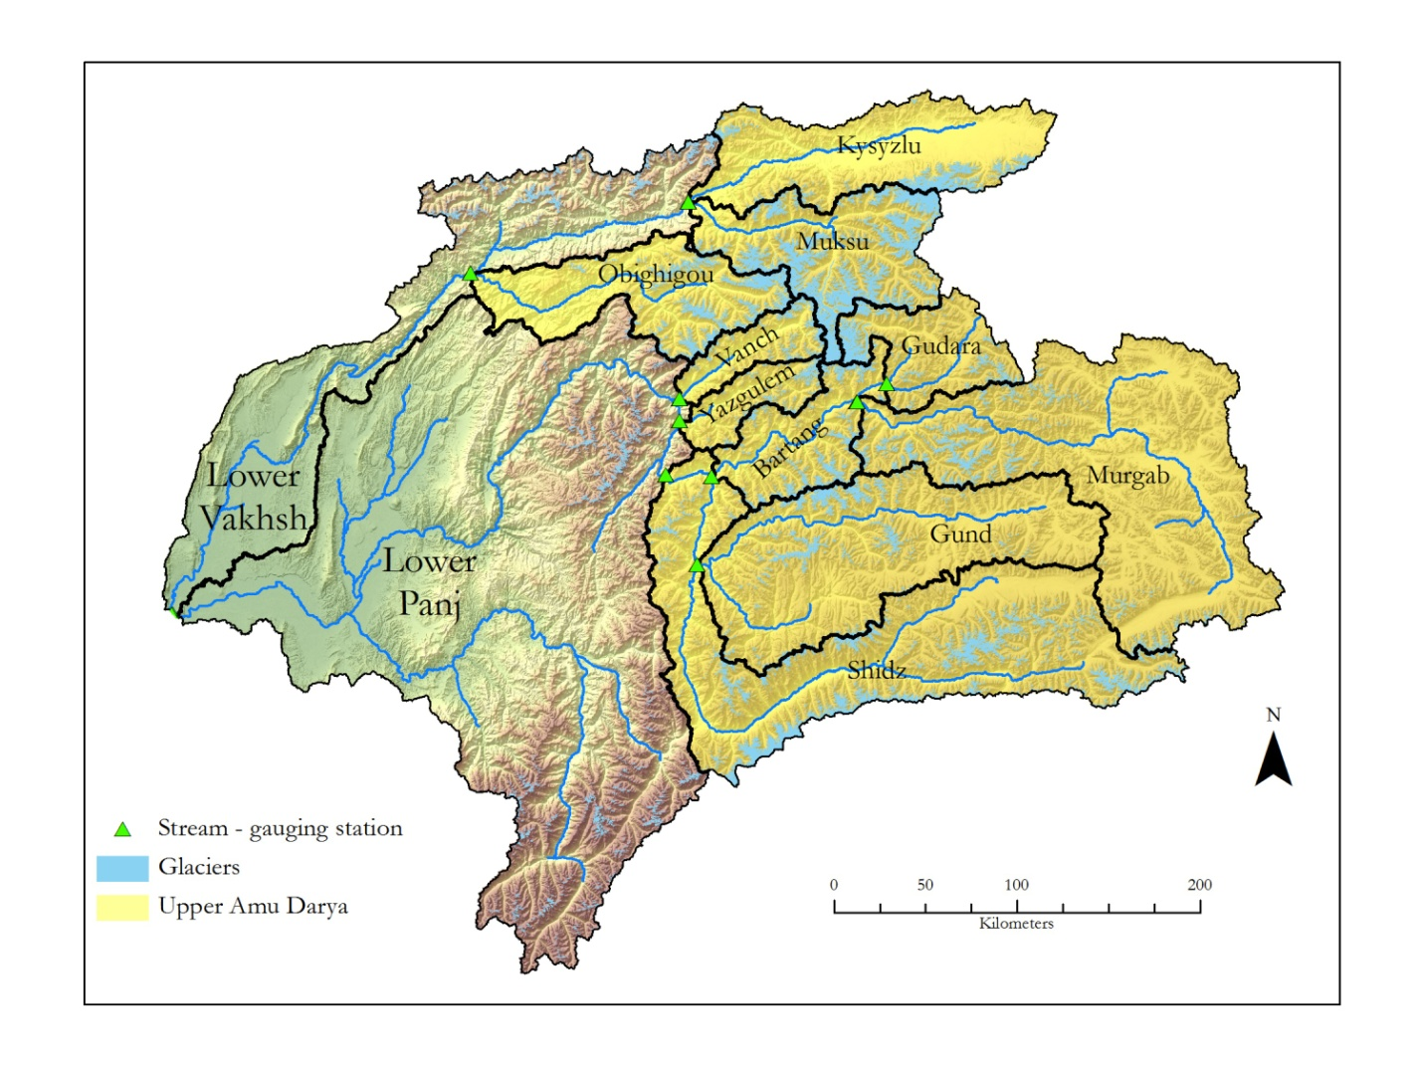
Figure 1. The Amu Darya Basin and its twelve sub-basins. In this study, a basin contains the area upstream from a stream-gauging station. Since no data was available from stream-gauging stations in the Lower Panj and the Lower Vakhsh basins, these two basins were excluded from the analysis. The ten (sub-)basins upstream from the Lower Panj and Lower Vakhsh basins are referred to as the Upper Amu Darya Basin.

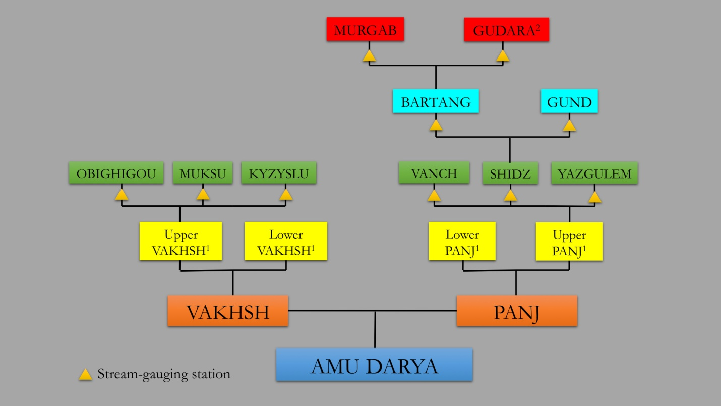

Figure 2. Organization of (sub-)basins within the headwaters of the Amu Darya Basin.

¹ Since no data was available from stream-gauging stations in the Lower Panj and the Lower Vakhsh basins, these two basins were excluded from the analysis.
² In the Upper Gudara Basin streams drain internally into Lake Kara; hence, it is not even considered a part of the Amu Darya Basin. The ten (sub-) basin—including the Lower Gudara Basin—upstream from the Lower Panj and Lower Vakhsh basins are referred to as the Upper Amu Darya Basin.

Since for the Lower Panj and Lower Vakhsh basins no stream-gauging station data for calibration of hydrological modeling results were available, they were excluded from the analysis. In other words: the here presented hydrologic modeling results are representative only for the combined Upper Panj and Upper Vakhsh basins (= Upper Amu Darya Basin) rather than for the entire headwaters of the Amu Darya Basin.
Two facts complicate the basin organization. First, the Shidz basin is actually the upper portion of the main Panj river; however, it includes its own stream-gauging station and, hence, following the applied definition of ‘basin’ in this study, it qualified as an individual basin. Second, in the Upper Gudara basin (not part of Figure 1) streams drain internally into Lake Kara (Kara Kul) in the basin’s center; hence, the Upper Gudara basin is not even considered a part of the Amu Darya Basin. The latter is a good example for the facts that computer-based mapping results must be seen with caution and that in cases of doubtful results the user has to carry out a manual correction: when analyzing the flow direction from the SRTM DEM using the standard ArcHydro toolset in ArcMap 10, the results revealed a flow direction from Lake Kara into Gudara River. However, based on the literature and own field observations, the flow direction is in the opposite direction, i.e. into Lake Kara. As a result, in our map the Gudara River abruptly terminates at the border to the Upper Gudara Basin (Figure 1).
The hydrological organization of the headwaters of the Syr Darya is much easier: it includes the three sub-basins Chirchik, Kara and Naryn, and the headwaters in the Alai Mountains in the south (Figure 3).

Figure 3. The headwaters of the Syr Darya Basin contain three sub-basins (Chirchik, Kara, and Naryn) and the headwaters of the Altai Mountains.

In conclusion, when comparing studies of one specific river basin, it is important to note that there is a chance that not one single definition exists of what exactly constitutes its boundary. Since available data sets present differing catchment areas for the Amu Darya and Syr Darya basins and their sub-basins, we here carried out our own mapping of catchment areas.

2.2. Hypsometric Analysis

The altitude–area distribution (or hypsometry) offers information about the topography of a catchment basin. The hypsometric curve is the empirical cumulative distribution function of elevations in a catchment; it allows hydrologists and geomorphologists for assessing the similarity of watersheds. In our study, hypsometry plots, and hypsometric curves at 1000-m belt intervals have been produced for the entire headwaters of the Amu Darya and Syr Darya basins and all their sub-basins (Figures 4 and 5).

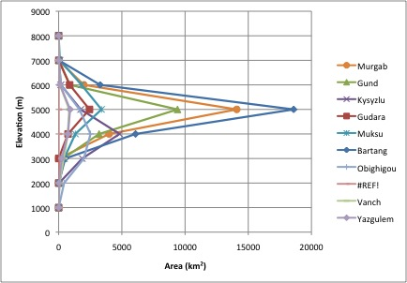

Figure 4. Hypsometries of all (sub-)basins within the Upper Amu Darya Basin (excluding Lower Panj and Lower Vakhsh basins).

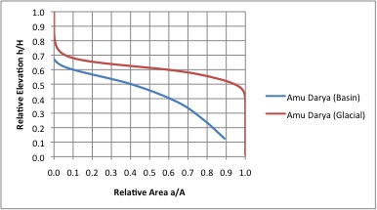

Figure 5. Hypsometric curves of the catchment basin and the glacierized area in the Upper Amu Darya Basin (excluding Lower Pani and Lower Vakhsh basins).

3. The Glaciers

3.1. World Glacier Inventory (WGI)

The World Glacier Inventory (WGI) was conceived half a century ago as an activity to be completed during the International Geophysical Year, 1957-1958. Today, WGI is housed at the National Snow and Ice Data Center (NSIDC) in Boulder, Colorado; it is based on the original WGI from the World Glacier Monitoring Service (WGMS) (Haeberli et al., 1989). WGI consists today of nearly 70,000 glacier records and can be viewed as a snapshot of the glacier distribution in the second half of the 20th century. The database is based primarily on aerial photographs and maps with most glaciers having one data entry only. Glaciers are represented by point data that have to be converted to polygons based on the glacier area attribute, which is a significant generalization in glacier modeling.
In 2005, a more complete version, called WGI-XF (XF for Extended Format) was introduced (Cogley, 2005). By 2010, it contained information for over 130,400 glaciers and nearly half of the global extent of ice (Cogley, 2010). The additional glaciers came mainly from the assimilation of existing regional inventories but also from rescuing inventories that have been lost and from some new inventories. Inventory parameters include geographic location, area, length, orientation, elevation, and classification. Cogley (2010) conceded that the incomplete information about the dates of imagery and maps is a hindrance to analysis and, hence, WGI-XF is not assuredly reliable as a source for detailed studies of single glaciers. However, Cogley (2010) also stated that there are several other subjects in which less detail would be a price worth paying for more complete coverage.

3.2. Global Land Ice Measurements from Space (GLIMS)

The international project Global Land Ice Measurements from Space (GLIMS), established in the late 1990s, was designed to monitor the World’s glaciers using data from optical satellite instruments, such as ASTER. Compared to other glacier inventories, GLIMS is the first attempt to building a globally complete, high-resolution map of glacier extents. So-called regional centers and affiliated stewards are responsible for a specific region; for the Pamir Mountains it is the Russian Academy of Sciences. Currently, the GLIMS database contains >122,000 snapshots of glaciers worldwide.
GLIMS analysis results include digital glacier outlines and related metadata, and they can also include snow lines, center flow lines, hypsometry data, surface velocity fields, and literature references. The program also develops tools to aid in glacier mapping and for transfer of analysis results for archiving to the National Snow and Ice Data Center (NSIDC). These include GLIMSView, documented procedures for GLIMS analysis, and web-based tools for data formatting and quality control.

3.3. Randolph Glacier Inventory (RGI)

The Randolph Glacier Inventory (RGI) is a global inventory of glacier outlines and intended for estimates of ice volume and glacier mass at global and large-regional scales. RGI is supplemental to the GLIMS and first data were released in 2012. Its production had been motivated by the Fifth Assessment Report of the Intergovernmental Panel on Climate Change (IPCC AR5).
RGI is a combination of both new and existing published glacier outlines. New outlines were provided by the glaciological community in response to requests for data on the GLIMS and Cryolist e-mail listservers. RGI visualizes the data in a GIS by overlaying outlines on modern satellite imagery, and assessed their quality relative to other available products. Data are organized into 19 large regions, with a shape-file provided for each region. In several regions the outlines already in GLIMS were used for RGI. Data from the World Glacier Inventory (WGI, 1989) and the related WGI-XF (Cogley, 2010) were used for some glaciers in northern Asia, with outlines approximated by circles of area equaling those reported in the source. Where no other data were available, the RGI relies on data from the Digital Chart of the World (DCW) that is based on the United States Defense Mapping Agency’s Operational Navigational Charts (Danko, 1992). Currently, RGI contains >682,500 km² of glacierized area (NCAR/UCAR, 2013). The glacier outlines can be combined with DEMs to give areas, area distributions, and hypsometries.
While one of the RGI’s advantages is that it also includes debris-covered parts of glaciers, it has its limitations. For example, it lacks glacier IDs and other metadata found in other inventories. Furthermore, at this point, RGI data are not to be used for reporting that focuses on the properties of the inventory itself, such as global size distribution, or glacier hypsometry (Arendt et al., 2013; GLIMS, 2013).

3.4. Defining ‘Glacier’

In the upper portion of the accumulation zone, the large glaciers of these mountains merge with the perennial snowfields, to form a continuous snow-covered high altitude surface. The debris cover of the lower portions of the ablation zone of many glaciers merges with terminal, lateral and medial moraines, making the identification of glacier ice difficult in most imagery. These problems are not insoluble, but require more time than was available for this reconnaissance assessment.
Before glaciers can be mapped using satellite imagery, it is important to define what constitutes a glacier in the Pamir Mountains. Unclear glacier definitions in the literature are one of the reasons, why comparisons of mapping results are difficult. GLIMS defined a glacier in terms of remote sensing, thus, this definition does require the motion of ice; a glacier is “a body of ice and snow that is observed at the end of the melt season” (Raup et al., 2007). Paul et al. (2009) set the lower limit of what constitutes a glacier at 0.01 km², because a glacier any smaller would be too difficult to accurately identify through a platform with a spatial resolution of 15-30 m. When inventorying glaciers in the western Nyainqentanglha Range and Nam Co basin, Tibet, Bolch et al. (2010b) mapped glaciers >0.01 km², but then only compared glacier parameters for glaciers >0.1 km². When generating the glacier inventory for western Canada, Bolch et al. (2010a) mapped only glaciers >0.05 km². Frey et al. (2012) defined a glacier as being >0.2 km². Krumwiede et al. (2014) mapped only glacier >0.1 km² in the Mongolian Altai, believing anything smaller represents only transient snow patches. However, for water resource management it is important to map even transient snow patches because they contribute to the local hydrology. Further, it is assumed that when mapping glaciers through a remote sensing platform, the implemented image is obtained at the absolute end of the melt season. Therefore, any snow patches in the image will remain until the first season’s snow. In the study at hand, all glaciers ≥0.01 km² were mapped.

3.5. Glacier Mapping Methodology

For the purposes of this study, glacier surface area and glacier hypsometries were determined for the glacierized portions of the gauged catchment basins rather than for individual glaciers, as is more commonly the case. This was done in order to facilitate the comparison of calculated glacier melt volumes with measured stream flow volumes.
Most of the glaciers in the Pamirs are debris-free, clean ice glaciers. Clean glacial ice has a distinct spectral signature, with uniqueness in the visible and near-infrared part of the electromagnetic spectrum, which makes it relatively easy to map debris-free glaciers. Snow and ice are characterized by high reflectivity (albedo) in the visible wavelengths (0.4-0.7 μm); medium reflectivity in the near infrared (0.8-2.5 μm); low reflectivity and high emissivity in the thermal infrared (2.5-14 μm); and low absorption and high scattering in the microwave. While in clear weather the high albedo of snow and ice make them easily distinguished from surrounding terrain using visible infrared (VIR), optically thick clouds are also highly reflective in VIR, hence they confound the classification. However, they are reflective in the near infrared (NIR), thus, discriminated from snow and ice.
Raup et al. (2007) identified the five most commonly used methods in glacier identification from satellite imagery: manual digitization, spectral band ratio (VIS/NIR) and threshold, Normalized Difference Snow Index (NDSI = TM2 – TM5 / TM2 + TM5), geomorphometric-based, and thermal band methods. Single band ratios and NDSI are commonly used to separate the bright snow and ice from darker landscape features. NDSI is an unsupervised classification method that utilizes the brightness of snow and ice in Landsat’s visible band 2 and is contrasted against the low reflectivity in the SWIR band 5 (Hall et al., 1995; Bishop et al., 2008). When mapping glaciers in the Cordillera Blanca, Peru, Racoviteanu et al. (2008) found that NDSI was superior to other band ratios based on visual inspection. However, the NDSI method is still susceptible to erroneously mapping in shadowed regions (Bishop et al., 2008). When inventorying the glaciers in the Southern Alps of New Zealand, Gjermundsen et al. (2011) tested a supervised classification method and described the results as not promising: bright rocks and small disconnected snow patches classified as glacier area resulted in high error percentage. In order to classify debris-covered glaciers, Raup et al. (2007) suggested geomorphometric-based methods. Such automated delineation methods have been implemented by many author groups (e.g., Bolch and Kamp, 2006; Bolch et al., 2007; Bhambri et al., 2011; Kamp et al., 2011); however, these studies discussed errors of >5%, which required a manual editing during post-processing. Geomorphometric methods also require a DEM of sufficient accuracy. Both Paul et al. (2011) for the European Alps and Racoviteanu et al. (2008) for the Cordillera Blanca of Peru manually edited glacier outlines to include debris-covered glaciers using contrast-enhanced false-color composite satellite images. However, Paul et al. (2010) discussed that human, as opposed to automated, delineation of glacier outlines tended to digitize only parts of glaciers.
Identifying the correct threshold when using automated mapping methods is important: if a too small threshold was chosen, more manual editing might be necessary; if a too large threshold was chosen, glaciers will be underrepresented. Identifying the threshold when applying the band ratio method is most sensitive in regions with ice in shadows, and a threshold of 2 has been suggested (Bishop et al., 2008; Bolch et al., 2010; Gjurmendsen et al., 2011). When using NDSI a threshold of 0.4 was found to best differentiate snow from non-snow, and thresholds of 0.5-0.6 proved successful in delineating glacier ice in the Andes of Peru (Racoviteanu et al., 2008). Both band ratios and NDSI methods produced satisfactory mapping results for shaded glacier parts, and have the advantage of being fast and robust, thus relatively easy to automate over extensive areas (Bolch and Kamp, 2006; Paul et al., 2007; Bishop et al., 2008; Racoviteanu et al., 2008). However, using band ratios has some problems in mapping glaciers due to the presence of fresh snow on the glacier surface, supra-glacial debris, and pro-glacial and supra-glacial lakes (Racoviteanu et al., 2008). Paul et al. (2013) recommended using the smallest threshold available when applying an automated method such as a band ratio or NDSI, because a small threshold will include most of the slightly dirty glacier ice surrounding the glacier margins.
Determining which spectral band to use in the band ratio technique is important in order to understand the relationship between the glacier and its associated spectral signature. Rees (2006) described that the concept of a spectral signature is the association between specific land cover and the variation of pixel values representative across different bands of an image. Clean glacier ice is highly reflective in the visible and NIR wavelengths (0.45-0.90 μm). On the contrary, high absorption occurs in SWIR between the ranges of 0.6-0.7 μm and 2.08-2.35 μm in the electromagnetic spectrum. Identifying bands with high and low reflectance is the key to select the bands for the band ratio analysis: the greater the difference in pixel values, the higher the contrast between glacier ice and other land covers (Dozier, 1989; Lillesand et al., 2007; Paul et al., 2011).
Most of the studies on glacier mapping use Landsat TM imagery and apply the band ratios TM3/TM5 and TM4/TM5 (e.g., Paul et al., 2002; Bolch et al., 2006; Bhambri et al., 2011; Gjermundsen et al., 2011). Bolch et al. (2010a, b) used TM3/TM5 when creating an inventory for western Canada and the western Nyainqentanglha Range and the Nam Co Basin. Paul et al. (2002) compared TM3/TM5 and TM4/TM5 and found that TM4/TM5 was the only combination that did not have problems in shadow regions. Yet, Paul et al. (2011) used TM3/TM5 to map glaciers in the Alps, and the authors then applied an additional threshold in TM1 to improve the classification in shadow regions. Bishop et al. (2008) and Frey et al. (2012) found that at low sun angles TM3/TM5 produced better results for glacier areas in shadow, yet more turbid lakes were incorrectly identified as glacier ice. TM4/TM5 has been proven to be effective in mapping thin debris-covered glaciers (Paul et al., 2002; Bolch et al. 2010b). On the other side, also TM4/TM5 often incorrectly identifies turbid lakes and vegetation as glacier ice. Bolch (2006) suggested using the Normalized-Difference Water Index (NDWI) to correct band ratio mapping errors. Despite such still existing difficulties, the methodology of using Landsat imagery band ratios comes with a relatively low mapping error of ±2% (e.g., Paul et al. 2003; Bolch and Kamp 2006; Bolch et al. 2010).
Kamp et al. (2013) and Krumwiede et al. (2014) argued for a simple threshold ratio mapping approach, allowing for faster processing time by using an unsupervised classification scheme. This scheme uses bands 4 and 7 from the Landsat 5 TM and Landsat 7 ETM+ sensors and performs simple raster math calculations. This approach can be incorporated directly into satellite imagery processing methods and can generate output datasets including raster overlays and glacier outline shape files with area calculations. These output datasets can then be incorporated with DEMs to determine glacier hypsometric areas and glacier area with respect to aspect. Using this simple method makes it is easier to analyze several images in a shorter amount of time and allow for multi-temporal change detection and analysis.
These findings from Kamp et al. (2013) and Krumwiede et al. (2014) are supported by Kamp and Pan (in press), who describe that band ratio TM4/TM7 produced the most accurate results when compared to results from visual interpretation and from other frequently used band ratios (TM3/TM5, TM5/TM3, TM5/TM4) and NDSI, because it is the only approach that did not erroneously map shadowed terrain and pro-glacial lakes (Figure 6). In the Kamp and Pan (in press) study in the Ikh Turgen Range in the northeastern Mongolian Altai at the Russian border, using band ratio TM4/TM7 identified 52 glaciers, while it was 59 glaciers using band ratio TM5/TM3, 61 glaciers using NDSI, and 62 glaciers using band ratio TM5/TM4. The ‘over-prediction’ of glacier numbers for the latter three approaches occurred in particular in the glacier class of < 0.05 km² and was due to erroneous identification of shadows as glaciers. TM4/TM7 is the only band ratio that did not erroneously map shaded terrain, and that produced the best results when mapping disconnected glaciers. Kamp and Pan (in press) also compare glacier-mapping results using thresholds of 2, 3, and 4, and conclude that a threshold of 2 produced the most accurate results. However, the mapping using band ratio TM4/TM7 also still has problems when differentiating between clean ice and debris-covered ice.

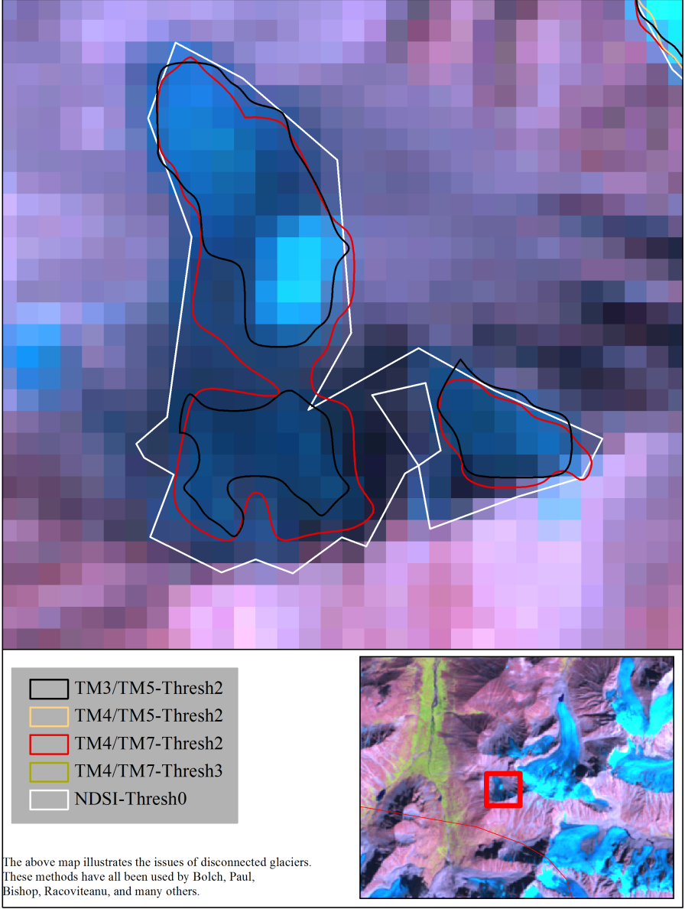

Figure 6. Comparison of results from different band ratios and NDSI applied to Landsat 5 TM imagery when mapping glaciers in the Mongolian Altai. TM4/TM7 produced the most reliable mapping results. (From Kamp and Pan, in press).

In our study, we used a band ratio TM4/TM7 with a threshold of 2 (Figure 7). Furthermore, the implementation of a NDVI mask improved glacier mapping results, although manual editing, particularly the removal of misclassified vegetation and water pixels as glaciers, was necessary. Since debris-covered glacier parts cannot be mapped with the TM4/TM7 method, the presented glacierized areas in the Amu Darya Basin and all its sub-basins represent only minimum extents. While it is assumed that debris-covered glacier parts do exist, it has been reported that most of the ice in the study area is debris-free.
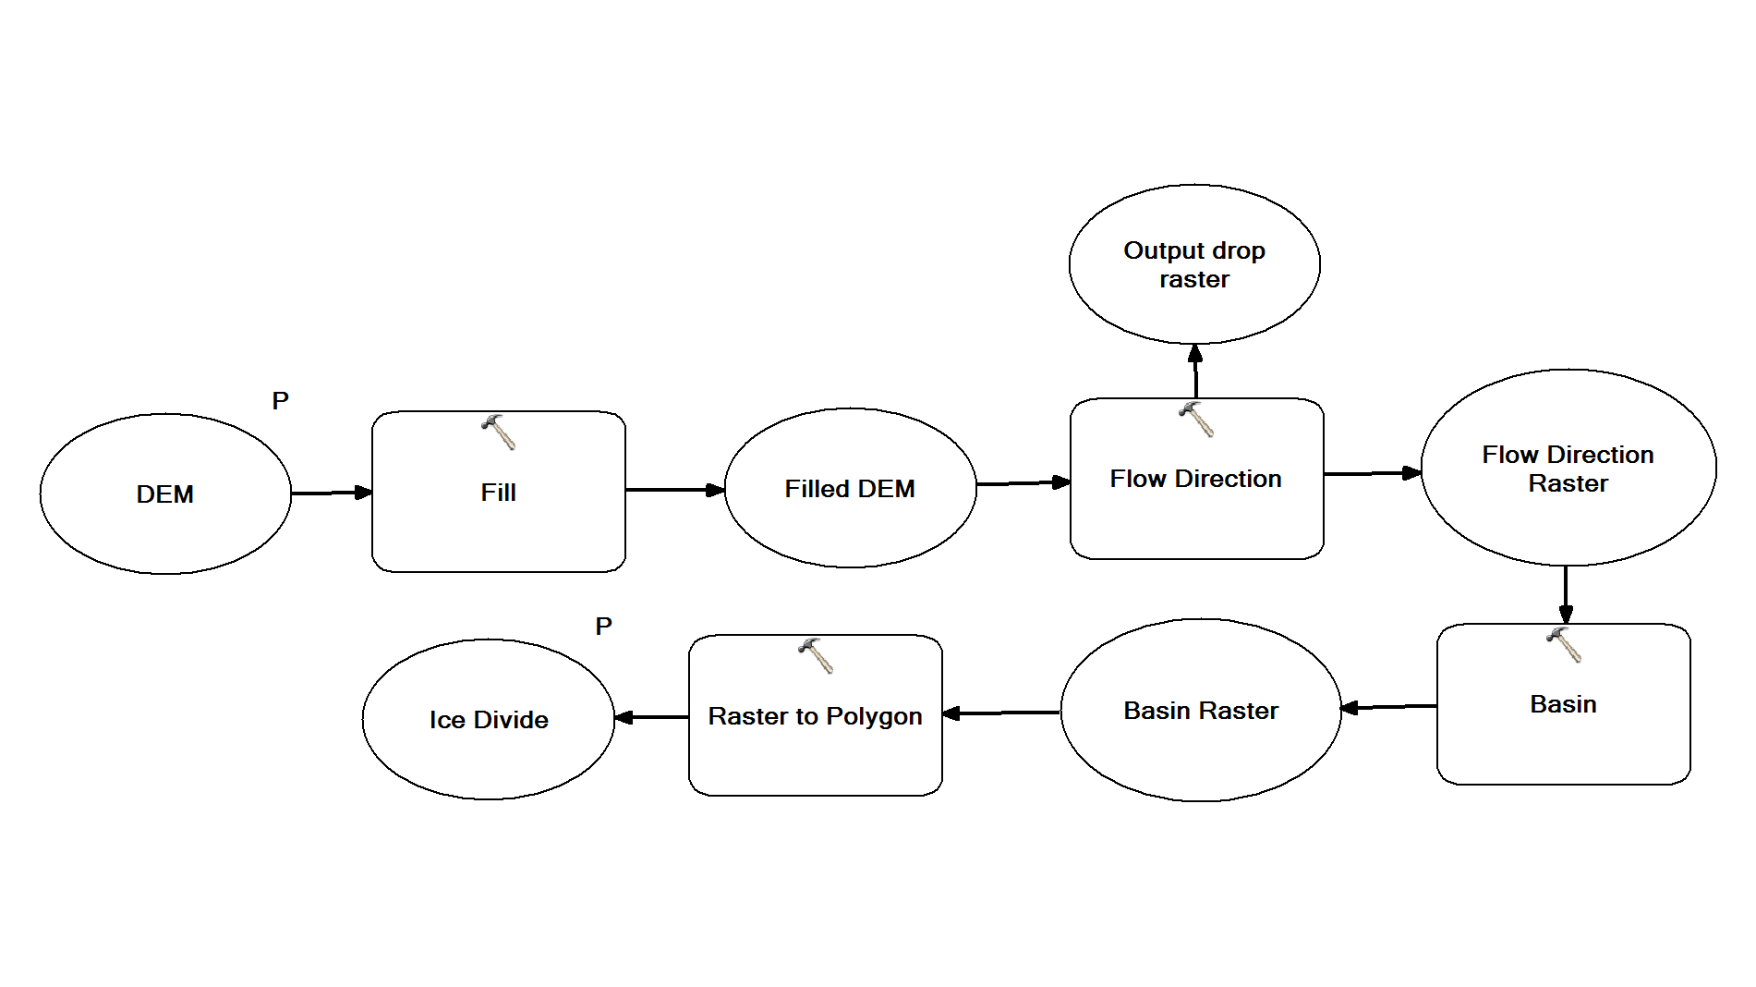

Figure 7. Model approach to delineate glacier outlines used in this study.

3.6. Hypsometric Analysis

Elevation is one of the most important factors responsible for variations in glacier characteristics, and the most fundamental altitude is the equilibrium-line altitude (ELA) that separates ablation and accumulation areas of the glacier. In glacier monitoring it is usually assumed that the ELA is equal to the snowline position at the end of the melting season (Quincey et al., 2012). ELA calculations are fundamental for estimating the mass balance of a glacier and, thus, serve as indicators for climate variations.
This study used the Toe-to-Summit Altitude Method (TSAM) that—although a relatively simple method to extract the ELA using DEM elevation values—can be performed efficiently, especially at well-defined valley glaciers (Lehmkuhl, 1998; Benn and Lehmkuhl, 2000). TSAM goes back to Louis (1955) who proposed that the ELA can be estimated from the arithmetical average of the elevation of the highest peak in the catchment and the terminal moraine. After examining the minimum and maximum elevation of a glacier, the mean and median elevations are calculated; both such elevations can be used to represent the ELA. ELAs were calculated for the Upper Amu Darya and Upper Syr Darya basins and all their sub-basins.
The glacier hypsometry describes the distribution of glacierized area per elevation belt. Changes in the glacier hypsometry over time are used to document climate changes and their impacts on glaciers. In the study at hand, glacier hypsometry plots and hypsometric curves at 100-m belt intervals were produced for the Upper Amu Darya and Upper Syr Darya basins and all their sub-basins.

4. References

Arendt, A., Bolch, T., Cogley, J.G., Gardner, A., Hagen, J.-O., Hock, R., Kaser, G., Pfeffer, W.T., Moholdt, G., Paul, F., Radić, V., Andreassen, L., Bajracharya, S., Beedle, M., Berthier, E., Bhambri, R., Bliss, A., Brown, I., Burgess, E., Burgess, D., Cawkwell, F., Chinn, T., Copland, L., Davies, B., de Angelis, H., Dolgova, E., Filbert, K., Forester, R., Fountain, A., Frey, H., Giffen, B., Glasser, N., Gurney, S., Hagg, W., Hall, D., Haritashya, U.K., Hartmann, G., Helm, C., Herreid, S., Howat, I, Kapustin, G., Khromova, T., Kienholz, C., Koenig, M., Kohler, J., Kriegel, D., Kutuzov, S., Lavrentiev, I., LeBris, R., Lund, J., Manley, W., Mayer, C., Miles, E., Li, X., Menounos, B., Mercer, A., Moelg, N., Mool, P., Nosenko, G., Negrete, A., Nuth, C., Pettersson, R., Racoviteanu, A., Ranzi, R., Rastner, P., Rau, F., Rich, J., Rott, H., Schneider, C., Seliverstov, Y., Sharp, M., Sigurðsson, O., Stokes, C., Wheate, R., Winsvold, S., Wolken, G., Wyatt, F., and Zheltyhina, N. 2012. Randolph Glacier Inventory [v2.0]: A Dataset of Global Glacier Outlines. Global Land Ice Measurements from Space, Boulder Colorado, USA. Digital Media.
Benn, D.I., and Lehmkuhl, F. 2000. Mass balance and equilibrium line altitudes of glaciers in high mountain environments. Quaternary International, 65/66, 15-29.
Berthier, E., Arnaud, Y., Rajesh, K., Sarfaraz, A., Wagnon, P., and Chevallier, P. 2007. Remote sensing estimates of glacier mass balances in the Himachal Pradesh (Western Himalaya, India). Remote Sensing of Environment 108, 327-338.
Bhambri, R., Bolch, T., Chaujar, R.K. and Kulshreshtha, S.C. 2011. Glacier changes in the Garhwal Himalaya, India, from 1968 to 2006 based on remote sensing. Journal of Glaciology, 57, 543–556.
Bishop, M.P., Olsenholler, J.A., Shroder, J.F., Barry, R.G., Raup, B.H., Bush, A.B.G., Copland, L., Dwyer, J.L., Fountain, A.G., Haeberli, W., Kääb, A., Paul, F., Hall, D.K., Kargel, J.F., Molnia, B.F., Trabant, D.C. and Wessels, R. 2008. Global land ice measurements from space (GLIMS): remote sensing and GIS investigations of the Earth's cryosphere. Geocarto International, 19, 57–84.
Bolch, T., and Kamp, U. 2003. Evaluation of digital elevation models from ASTER data for high mountain regions (Cerro Sillajhuay, Chile/Bolivia). Kartographische Nachrichten, 53, 224-230. (In German).
Bolch, T., and Kamp, U. 2006. Glacier mapping in high mountains using DEMs, ASTER and Landsat data. Proceedings of the 8th International Symposium on High Mountain Remote Sensing Cartography, March 20–27, 2005, La Paz, Bolivia. Grazer Schriften der Geographie und Raumforschung, 41, 13-24.
Bolch, T., Kamp, U., and Olsenholler, J. 2005. Using ASTER and SRTM DEMs for studying geomorphology and glaciation in high mountain areas. In: Oluic, M. (Ed.), New Strategies for European Remote Sensing, Proceedings of the 24th Meeting of the European Association of Remote Sensing Laboratories (EARSeL), 25–27 May 2004, Dubrovnik, Croatia, Millpress, Rotterdam, 119-127.
Bolch, T., Buchroithner, M., Kunert, A., and Kamp, U. 2007. Automated delineation of debris-covered glaciers based on ASTER data. In: Gomarasca, M.A. (Ed.): GeoInformation in Europe, Proceedings 27th Annual Symposium European Association of Remote Sensing Laboratories (EARSeL), June 4-7, 2007, Bozen, Italy, Millpress, Rotterdam, 403-410.
Bolch, T., Menounos, B., and Wheate, R. 2010a. Landsat-based glacier inventory of western Canada, 1985-2005. Remote Sensing of Environment, 114, 127-137.
Bolch, T., Yao, T., Kang, S., Buchroithner, M., Scherer, D., Maussion, F., Huintjes, E., and Schneider, C. 2010b. A glacier inventory for the western Nyainqentanglha Range and Nam Co Basin, Tibet, and glacier changes 1976–2009. The Cryosphere, 4, 419-433.
Cogley, J.G. 2005. Extended Format for the World Glacier Inventory. Trent Technical Note 2005-1, Department of Geography, Trent University, Peterborough, Ontario, Canada.
Cogley, J.G. 2010. A more complete version of the World Glacier Inventory. Annals of Glaciology, 50, 32-38.
Danko, D.M., 1992. The digital chart of the world. GeoInfo Systems, 2, 29-36.
Dozier, J. 1989. Spectral signature of alpine snow cover from the landsat thematic mapper. Remote Sensing of Environment, 28, 9-22.
Dyurgerov, M., and Meier, M.F. 2005. Glaciers and the Changing Earth System: A 2004 Snapshot. Institute of Arctic and Alpine Research, Occasional Paper, 58, 117 p.
Frey, H., and Paul, F. 2012. On the suitability of the SRTM DEM and ASTER GDEM for the compilation of topographic parameters in glacier inventories. International Journal of Applied Earth Observation and Geoinformation, 18, 480-490.
Frey, H., Paul, F., and Strozzi, T. 2012. Compilation of a glacier inventory for the western Himalayas from satellite data: methods, challenges, and results. Remote Sensing of Environment, 124, 832-843.
Fujita, K., Suzuki, R., Nuimura, T., and Sakai, A. 2008. Performance of ASTER and SRTM DEMs, and their potential for assessing glacial lakes in the Lunana Region, Bhutan Himalaya. Journal of Glaciology, 54, 220-228.
Gjermundsen, E.F., Mathieu, R., Kääb, A., Chinn, T., Fitzharris, B. and Hagen, J.O. 2011. Assessment of multispectral glacier mapping methods and derivation of glacier area changes, 1978–2002, in the central Southern Alps, New Zealand, from ASTER satellite data, field survey and existing inventory data. Journal of Glaciology, 57, 667–683.
Global Land Ice Measurements from Space (GLIMS) Program. 2013. http://www.glims.org.
Haeberli, W., Bösch, H., Scherler, K., Østrem, G., and Wallén, C.C. (Eds.). 1989. World Glacier Inventory: Status 1988. World Glacier Monitoring Service, Zurich, 458 pp.
Hall, D.K., Riggs, G.A., and Salomonson, V.V. 1995. Development of methods for mapping global snow cover using moderate resolution imaging spectrometer data. Remote Sensing of Environment, 54, 127-140.
Immerzeel, W., Lutz, A, and Droogers, P. 2012. Climate Change Impacts on the Upstream Water Resources of the Amu and Syr Darya. Technical Report for the Asian Development Bank, 103 p.
Jarvis, A., Reuter, H.I., Nelson, A., and Guevara, E. 2008. Hole-filled SRTM for the Globe Version 4. http://srtm.csi.cgiar.org.
Kääb, A. 2002. Monitoring high-mountain terrain deformation from repeated air- and spaceborne optical data: examples using digital aerial imagery and ASTER data. ISPRS Journal of Photogrammetry and Remote Sensing, 57, 39-52.
Kamp, U., and Pan, C.G. (in press): Inventory of clean-ice glaciers in Mongolia, derived from Landsat imagery from 1989 to 2011. Geografiska Annaler A – Physical Geography.
Kamp, U., Bolch, T., and Olsenholler, J. 2005. Geomorphometry of Cerro Sillajhuay (Andes, Chile/Bolivia): comparison of digital elevation models (DEMs) from ASTER remote sensing data and contour maps. Geocarto International, 20, 23-34.
Kamp, U., Byrne, M. and Bolch, T. 2011. Glacier fluctuations between 1975 and 2008 in the Greater Himalaya Range of Zanskar, southern Ladakh. Journal of Mountain Science, 8, 374-389.
Kamp, U., Krumwiede, B.S., McManigal, K.G., Pan, C.G., Walther, M. and Dashtseren, A. 2013b. The Glaciers of Mongolia. Institute of Arctic and Alpine Research (INSTAAR) Occasional Papers, 61, Boulder.
Krumwiede, B.S., Kamp, U., Leonard, G.J., Kargel, J.S., Dashtseren, A. and Walther, M. 2014. Recent glacier changes in the Mongolian Altai Mountains: case studies from Munkh and Khairkhan Tavan Bogd. In: Kargel, J.S., Leonard, G.L., Bishop, M.P., Kääb, A. and Raup, B. (Eds.), Global Land Ice Measurements from Space: Satellite Multispectral Imaging of Glaciers, Praxis-Springer, Berlin, 481-508.
Lehmkuhl, F. 1998. Quaternary glaciations in central and western Mongolia. Quaternary Proceedings, 6, 153-167.
Lillesand, T.M., Kiefer, R.W., and Chipman, J.W. 2007. Remote Sensing and Image Interpretation. John Wiley and Sons, Hoboken.
NCAR/UCAR (National Center for Atmospheric Research and University Cooperation for Atmospheric Research). 2013. Randolph Glacier Inventory Data Base of Global Glacier Outlines. https://climatedataguide.ucar.edu/ climate-data/randolph-glacier-inventory-data-base-global-glacier-outlines.
Paul, F., Kääb, A., Maisch, M., Kellenberger, T., and Haeberli, W. 2002. The new remote-sensing-derived Swiss glacier inventory: I. Methods. Annals of Glaciology, 34, 355-361.
Paul, F., Barry, R., Cogley, G., Frey, H., Haeberli, W., Ohmura, A., Ommanney, S., Raup, B., Rivera, A., and Zemp, M. 2009. Recommendations for the compilation of glacier inventory data from digital sources. Annals of Glaciology, 50, 119-126.
Paul, F., Barry, R.G., Cogley, J.G., Frey, H., Haeberli, W., Ohmura, A., Ommanney, C.S.L., Raup, B., Rivera, A., and Zemp, M. 2010. Guidelines for the compilation of glacier inventory data from digital sources. Technical Report, World Glacier Monitoring Service, Zurich, 23 pp.
Paul, F., Frey, H., and Le Bris, R. 2011. A new glacier inventory for the European Alps from Landsat TM scenes of 2003: challenges and results. Annals of Glaciology, 52, 144-152.
Paul, F., Barrand, N.E., Baumann, S., Berthier, E., Bolch, T., Casey, K., Frey, H., Joshi, S.P., Konovalov, V., Le Bris, R., Molg, N., Nosenko, G., Nuth, C., Pope, A., Racoviteanu, A., Rastner, P., Raup, B., Scharrer, K., Steffen, S., and Winsvold, S. 2013. On the accuracy of glacier outlines derived from remote-sensing data. Annals of Glaciology, 54, 171-182.
Quincey, D., Bishop, M.P., Kääb, A., Berthier, E., Flach, B., Bolch, T., Buchroithner, M., Kamp, U., Khalsa, S.J.S., Toutin, T., Haritashya, U., Racoviteanu, A.E., Shroder, J.F., and Raup, B. 2013. Digital terrain modeling and glacier topographic characterization. In: Kargel, J.S., Leonard, G.J., Bishop, M.P., Kääb, A., and Raup, B. (Eds.), Global Land Ice Measurements from Space: Satellite Multispectral Imaging of Glaciers, Praxis-Springer, Berlin, 113-143.
Racoviteanu, A., Arnaud, Y., Williams, M., and Ordonez, J. 2008. Decadal changes in glacier parameters in the Cordillera Blanca, Peru, derived from remote sensing. Journal of Glaciology, 54, 499-510.
Raup, B., Kääb, A., Kargel, J.S., Bishop, M.P., Hamilton, G., Lee, E., Paul, F., Rau, F., Soltesz, D., Khalsa, S.J.S., Beedle, M. and Helm, C. 2007a. Remote sensing and GIS technology in the global land ice measurements from space (GLIMS) project. Computers and Geosciences, 33, 104-125.
Rees, W.G. 2006. Remote Sensing of Snow and Ice. Taylor and Francis/CRC Press, Boca Raton.
Toutin, T. 2008. ASTER DEMs for geomatic and geoscientific applications: a review.” International Journal of Remote Sensing, 29, 1855-1875.
Wissmann, H. von, 1959. Recent glaciation and snowline in High Asia, with indications for glaciation during the last ice age. Akademie der Wissenschaften und der Literatur in Mainz, 14, 1103-1431. (In German).

World Climate Research Programme's (WCRP's) Coupled Model Intercomparison Project Phase 5

