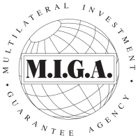
MULTILATERAL INVESTMENT GUARANTEE AGENCY
COUNCIL OF GOVERNORS
Resolution No. 73

Financial Statements and Accountants’ Report

RESOLVED:

THAT the Council of Governors of the Agency consider the Financial Statements and the Report of Independent Accountants included in the 2005 Annual Report, as fulfilling the requirements of Article 29 of the MIGA Convention and of Section 16(b) of the By-Laws of the Agency.

(Adopted on September 24, 2005)

