January 2016
The Bank’s First Development Loans

number 022
originally published: May 2003
The World Bank Group Archives Exhibit Series contains exhibits originally published on the Archives’ external website beginning in 2002. When the Archives’ website was transferred to a new platform in 2015, it was decided that older exhibits would be converted to pdf format and made available as a series on the World Bank’s external database, Documents & Reports.

These exhibits, authored by World Bank archivists, highlight key events, personalities, and publications in the history of the World Bank. They also bring attention to some of the more fascinating archival records contained in the Archives’ holdings.

To view current exhibits, visit the Exhibits page on the Archives’ website.

The Bank’s First Development Loans
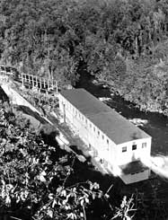
The World Bank’s official name upon its establishment was (and with the addition of IDA still is) the International Bank for Reconstruction and Development. As the name indicates, reconstruction came first: On May 9, 1947, an agreement was signed granting a reconstruction loan to France in the amount of $250 million. In August 1947 there were additional reconstruction loans: to the Netherlands, Denmark and Luxembourg. These were important sources of funds for Western Europe until the Marshall Plan took over the burden of reconstruction in 1948. This freed the Bank to turn its attention more fully to development.
On September 30, 1946, the Corporacion de Fomento de la Produccion and the Chilean State Railways applied to the Bank for a loan of $40 million to finance the foreign-exchange costs of various projects in the fields of electric power, forest industries, railway electrification, urban and suburban transportation and port mechanization. On November 21, 1947, the original application was amended to include an additional $5 million for the purchase and importation into Chile of agricultural machinery. These applications were supported by the Chilean Government.
One of the World Bank’s first development loans was to the Corporacion de Fomento and the Empresa Nacional de Electricidad of Chile. This loan financed construction of two hydroelectric plants at Los Molles and Los Cipreses and helped to purchase equipment for the third plant, the Pilmaiquen Hydroelectric plant (pictured here.)
The Bank concluded that projects for power and agriculture had a high priority and after prolonged negotiations, made two loans on March 25, 1948: one for the development of electric power and water resources and the other for the importation of agricultural machinery and equipment. These were the Bank’s first development loans.
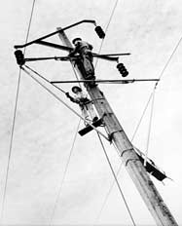
The first development loan (Loan 0005) of $13.5 million, or its equivalent in other currencies, was made to the Corporacion de Fomento de la Produccion and its subsidiary Empresa Nacional de Electricidad S.A. (Endesa) as co-borrowers. The loan agreement was signed subject to the guarantee of the Chilean Government. Legislation authorizing the Government to give its guarantee was not enacted until January 19, 1949, and the guarantee was given on March 23, 1949. The loan became effective on April 7, 1949.
Chile’s potential hydroelectric capacity was estimated at a total of 6 million kw. At the end of 1942, when Fomento formulated its power expansion program, the country's total installed capacity for the generation of electric power amounted to approximately 50,000 kw, of which only 145,000 kw was hydro power.
Fomento, through Endesa, prepared a program of electrification based on an estimate that the over-all demand for power in the country would increase by a cumulative 8 percent per annum from 1942 to 1955. The program was divided into two phases. The first phase involved an increase of 196,000 kw by 1948, thus raising the total installed capacity to 646,000 kw. Of this increase, 128,000 kw were installed by Endesa, the rest by private companies. The second phase of the program involved an increase of approximately 340,000 kw of installed capacity by 1955. Of this increase, 250,000 kw was to be installed by Endesa of which approximately 86,000 kw being financed with the assistance of the Bank loan.
Maintenance workers erecting and connecting 66KV transmission lines to link the Los Cipreses hydroelectric power plant with the Sauzal hydroelectric plan and other substations.
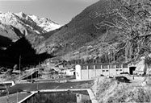
The proceeds of the Bank loan were to be used to purchase equipment, supplies and services required for the development or expansion of four electric power projects and for incidental irrigation.
The project, as originally designed, fell under the following main headings:
(a) Copiapo Diesel Electric Plant. Replacement of a 151 kw diesel unit by a new unit of 585 kw at the Copiapo Plant in northern Chile.
The Los Molles hydroelectric plant took four years to build and went into production in December 1952.
(b) Los Molles Hydroelectric Plant. Construction of a hydro plant with a generating capacity of 16,000 kw to serve an area about 400 km north of Santiago, and the erection of six substations and connecting transmission lines.
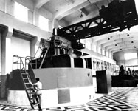
(c) Los Cipreses Hydroelectric Plant. Construction of a hydro-electric plant to serve Santiago and the surrounding areas, generating capacity planned originally at 54,000 kw. The project included construction of sixteen substations and 490 km of transmission lines.
(d) Pilmaiquen Hydroelectric Plant. Installation of a fourth unit, capacity l0,800 kw at the Pilmaiquen Plant (previous capacity 13,500 kw) in the south central region of Chile.
A new generator installed in the Pilmaiquen hydroelectric plant in South Central Chile.
(e) Secondary electrical distribution lines and Equipment. Installation of approximately 500 km of electrical distribution lines and necessary equipment to provide for the distribution of electric power to rural consumers in the territory served by the Los Molles and Los Cipreses plants.
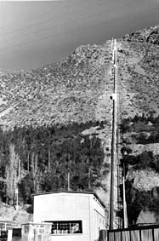
(f) Mechanical Irrigation Equipment. Installation of 2,000 H.P. in electric motors, water pumps, and other irrigation equipment to utilize excess capacity during off-peak hours from plants in the central region of Chile. It was planned to irrigate in this way an area of at least 4,000 hectares.
(g) Construction equipment. Importation of construction equipment required for several engineering works for the above mentioned projects. After completion of the projects, the construction equipment could be used in Chile for other purposes.
The second development loan (Loan 0006) was signed on the same day as the Endesa loan. It was for $2,500,000 to the Corporacion de Fomento for the purchase of agricultural machinery. The guarantee of the Chilean Government was given on March 23, 1949, after the Chilean Congress had finally enacted the necessary legislation. The loan became effective April 7, 1949.
A view of the power plant, panstocks and cable railway of the Los Molles power plant, as seen from the bridge over the Molles River.
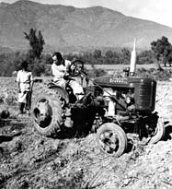
The project consisted of a program for the purchase and importation by Fomento of agricultural machinery to increase the productivity of Chilean agriculture. It was part of a large-scale program of agricultural mechanization initiated by Fomento immediately after the war years, in order to offset shortages of local production of foodstuffs resulting from under-utilization of arable land. The first stages of the program had already been financed by the Export-Import Bank.
The machinery to be imported included tractors, threshing machinery, harvesters, ploughing machines, land clearing and earth moving equipment and irrigation equipment. The project provided that the machinery should be used or disposed of by Fomento under either of the following plans:
American tractors and other agricultural equipment have been imported into Chile by the Corporacion de Fomento to increase Chilean agricultural production.
Sale Plan—Machinery allocated to this plan was to be sold by Fomento to farmers either directly or through distributors representing Fomento. Contracts for the sale of the machinery could provide that all or part of the payment be made in Chilean currency, that payments could be made in installments over a maximum period of six years and that purchasers could be asked for security.
Service Plan—Fomento was to retain title to machinery utilized under this plan and to establish equipment pools. The machinery was to be operated by trained employees of Fomento and its services sold to farmers for payment in Chilean currency.
The Loan Agreement gave Fomento complete discretion to transfer any part of the machinery from one of the above plans to the other. The machinery imported by Fomento out of the proceeds of the lean was all distributed to farmers, and none retained for employment in equipment pools.

