INCLUSIVE HOUSING FINANCE PROGRAM FOR RESULTS:
ADDITIONAL FINANCING

Addendum to the Environmental and Social Systems Assessment

DRAFT Report

May 20, 2019

Executive Summary
Background
The Egypt Inclusive Housing Finance Program was developed to support the Egyptian Government’s Social Housing Program which is an integral part of its social safety net package. The Social Housing Program launched by the Government of Egypt (GoE) (Social Housing Law 33 of 2014 establishing the Social Housing Fund) in the wake of the revolution aims to provide 1 million houses for low-income households. The US$500 million Inclusive Housing Finance Program, the parent operation, was approved in May 2015 and became effective on November 11, 2015. The Program for Results (PforR) has the development objective of improving the affordability of formal housing for low-income households in the Arab Republic of Egypt and strengthening the Social Housing Fund’s (now Social Housing and Mortgage Finance Fund [SHMFF]) capacity to design policies and coordinate programs in the social housing sector. The program directly contributed to the Government’s program that aimed to reform policies and institutions in charge of making social housing accessible, affordable, and decent and support the delivery of demand-side subsidies.

The Additional Financing (AF)
The proposed additional loan will help scale up the delivery of housing subsidies and further strengthen the institutional and regulatory environment of affordable housing through second generation structural reforms. Based on the good performance of the parent operation, the Egyptian government has requested further financing to support the scale up of the subsidy delivery program to reach an additional 40 percent beneficiaries and achieve the one million affordable homes target of the presidential program. In addition, through the AF, the government envisions the implementation of a second generation of reforms to further strengthen the SHMFF’s capacity and implement additional initiatives to improve the regulatory environment of housing finance. In parallel to this AF, the parent operation is being restructured for two reasons: (1) to change the name of the implementing entity from the SHF to the SHMFF and (2) to extend the closing date to April 30, 2022.
The AF entails modifying some of the parent Program’s Disbursement Linked Indicators (DLIs) and introducing new DLIs as indicated in the following table.

 | Disbursement linked indicator | Status | Allocated amount
DLI 1 | Establishment and operation of an internal audit function within SHF | Existing | US$ 25 million
DLI 2 | Establishment and functioning of a housing monitoring and evaluation system and an M&E unit within SHF | Existing | US$ 25 million
DLI 3 | DLI 3: The establishment and Functioning of an accountability and transparency mechanism within SHF for implementing the program | Existing | US$ 50 million
DLR 3.1 | Establishment of an operational and properly staffed Claims Management Unit | New | US$ 6 million
DLI 4 | DLI 4: The establishment by SHF of a functioning mechanism to monitor occupancy and vacancy of housing units by household receiving demand side subsidies | existing | US$ 50 million
DLI 5 | DLI 5: Number of households receiving demand side home ownership subsidy each fiscal year | scale up of $ 250 million | US$ 475 million
DLI 6 | DLI 6: Number of new households participating in rental subsidy program in each fiscal year | scale up | US$ 60 million
DLR 6.1 | Establishment of a functioning Rental Unit and a Digital Platform linking private landlords and eligible tenants | New | US$ 8 million
DLR 6.2 | Implementation of a Rental Incentive Package including tax incentives, a rental risk insurance product and a matching grant mechanism for renovation for landlords, and direct subsidies for tenants | New | US$ 11.5 million
DLI 7 | Percentage of demand side subsidies supporting the purchase or rental of housing units located within commute of 60 minutes or less to an employment center | Existing | US$ 25 million
DLI 8 | DLI 8: Number of demand side subsides provided to the purchase or rent of housing unites developed by the private sector. | Existing | US$ 50 million
DLR 8.1 | Development and implementation of new PPP guidelines addressing key bottlenecks identified by private developers | New | US$ 17 million
DLR 8.2 | Call for proposals under new PPP guidelines | New | US$ 17 million
DLR 8.3 | Roll out 10 PPP pilots representing 10,000 units | New | US$ 50 million
DLI 9 | Develop and implement an alternative scheme that progressively phases out the interest rate subsidy starting from the next round of advertisement campaign in 2019 | New | US$ 50 million
DLI 10 | Adoption of legislation regulating real estate profession and installment sales | New | US$ 50 million
DLR 10.1 | Adoption of legislation regulating real estate profession and installment sales | New | US$ 25 million
DLR 10.2 | Adoption of a real estate developer’s law (including regulation on financial practices during pre-construction and during construction phases) | New | US$ 25 million
DLI 11 | Operationalization of an Environment Unit at SHMFF | New | US$ 15 million
DLR 11.1 | Operational and properly staffed Environment Unit as per the Operations Manual | New | US$ 5 million
DLR 11.2 | Number of housing units with entry level GPRS certification from NBRC as per the Operations Manual | New | US$ 10 million
DLI 12 | Improve the efficiency of the subsidy delivery process. | New | US$ 10 million
DLR 12.1 | Pilot delegation of subsidy delivery to selected banks | New | US$ 5 million
DLR 12.2 | Reduce number of interventions of SHMFF during the subsidy approval process | New | US$ 5 million

Objectives of the ESSA Addendum
An Environmental and Social Systems Assessment (ESSA) has been prepared by the Bank team in 2014 according to the requirements of Bank’s Policy for PforR financing. As the environmental and social aspects of the Program is carried out according to the country system, the ESSA reviewed the capacity of existing country systems to plan and implement effective measures for environmental and social management and to determine if any measures would be required to strengthen the country system. This document is an Addendum for the ESSA prepared for the parent Program to cover environmental and social aspects of the AF.

Methodology of the ESSA Addendum
The preparation of the Addendum involved a series of interviews and focus group discussions that targeted a range of stakeholders related to the housing sector. The interviews and technical discussions included different interested parties in the field of green buildings, environmental control of housing construction, occupational health and safety. The focus group discussions took place in two different site locations with different socio-economic levels, where housing units have been provided to beneficiaries through the parent program in Giza and Sharqia Governorates. Each discussion included homogenous groups: (i) a group of youth, (ii) a group of women, and (iii) a group of elderly. The purpose of these discussions was to get feedback from project beneficiaries about their own experience with the parent project. The City Authority of 10th of Ramadan City, one of Al-Sharqia Governorate’s cities, hosted the first series of focus group discussions at the authority premises. The City Authority of 6th October City, one of Giza Governorate’s cities, hosted the second focus group discussions. The sessions took place at a club associated to one of the compounds in the city. The ESSA team reviewed laws and regulations relevant to the activities of the AF and assessed the institutional capacity of the implementing agency after the merge between the Social Housing Fund (SHF) and the Guarantee and Subsidy Fund (GSF) to form the Social Housing and Mortgage Finance Fund (SHMFF). The conclusions of the ESSA were used to update the Program Action Plan (PAP) and introduce new Disbursement-Linked Indicators / Disbursement-Linked Results (DLIs/DLRs).
Environmental Assessment:
The National Housing and Building Research Center (NHBRC), one of the research centers of MoHUUD, has introduced the Green Pyramid Rating System (GPRS) which covers different sustainability aspects including sustainable site selection, energy efficiency, water efficiency, materials, natural resources indoor air quality, management, innovation and added value. The GPRS gives different certification levels depending on the obtained scores for the building: starting from score 30% (achieving 30% of the standards) for the first Green Pyramid level up to the Platinum Level (Five Green Pyramid Level) with minimum score of 80%. The GPRS is considered compatible with international green building certification system and covers different building sustainability aspects. In comparison with the IFC green building system (EDGE), the GPRS covers the full range of sustainability aspects addressed by EDGE, however, the latter is more stringent in its certifying procedures as the minimum score of each of the pillars should be 20%. Despite being less stringent, the GPRS is considered suitable for the use of the Program as a certification tool, as the green building concept is quite new in the country and the sector, and it needs a staged approach to gain momentum.
Regarding environmental aspects related to the housing construction industry, the Addendum concluded that, generally, the national systems for waste management and OHS adequately address different types of risks in alignment with different international guidelines, such as the WBG EHS Guidelines. However, in terms of actual implementation on ground, there is relatively low awareness among construction workers and supervisors about the importance of waste management and OHS. Some contractors, especially large companies, abide to the Laws and standards and have an EHS system in place for their works. However, many other contractors treat EHS in a non-systematic manner and do not have a clear commitment to comply with the relevant Laws and Standards. The SHMFF has acknowledged those gaps and will address them as part of the mandates of the newly established EU which will ensure that contractors comply with environment and OHS Laws and Standards. This unit was approved by the Central Agency for Organization and Administration in 2018 and the SHMFF assigned a head for this EU in March 2019. This unit will ensure that contractors comply with environment and OHS Laws and Standards.

The AF will not cause any environmental impacts that could be considered significant, diverse, sensitive or unprecedented. The AF modified and new DLIs are not associated with activities that could pose a risk to natural habitats or physical cultural resources. The ESSA identified some community risks related to structural stability and safeguarding against fires and those risks were classified as low, and the Addendum confirms the low risks associated with building safety. It is worth noting that the housing units provided to beneficiaries so far were new units that fulfilled the different engineering codes for building safety.
The ESSA of the parent Program assessed the environmental risks as low given that the Program interventions are limited to the demand side. The AF will continue to support the demand side, while introducing best practices to the construction activities through DLI11, such as improving the environmental and health and safety measures during construction and introducing the principals of green building in 25,000 units, which are considered as environmental benefits. Except for DLI11, the modified DLIs and new DLIs did not introduce support to certain supply-side activities, however, the supply of housing units will be key in achieving the Program objectives. Therefore, although the direct risks and impacts of the AF remains related to the demand side; environmental risks related to the supply side are considered linked to the Program. Accordingly, the environmental risk of the Program was raised to moderate because: i) the construction activities are linked to the Program activities, mainly because the past period of Program implementation showed that the units delivered to beneficiaries were newly built, and those activities are generally associated with moderate OHS risks, and ii) the effective operation of the new Environment Unit is still to be assessed during the coming implementation period of the Program.
The ESSA assessed some environmental benefits for the parent Program such as reducing the need for building new housing units through improving the occupation of existing vacant ones and reducing commuting for employment through enhancing having housing units near employment centers. Those benefits are still valid for the AF.
The PAP of the parent Program included several environmental measures to incentivize energy savings, raise beneficiaries’ awareness about waste management, ensure that beneficiaries use safe buildings and provide guidelines and trainings to different stakeholders on Occupational Health and Safety (OHS) during construction. The SHF has taken good measures towards introducing energy saving measures to beneficiaries and to ensure that only safe and stable buildings are used by the Program. Waste management awareness and OHS training remain on the to-do list of the SHMFF, which plans to carry them out in a systematic manner, through the newly established EU.

Social Assessment:
In June 2018, the merger law that established the SHMFF authorized the board of directors to endorse the organizational structure which will include a Claims Management Unit under the AF.

The ESSA of the parent Program assessed the social risks as low since the Program interventions are limited to the demand side. However, given persisting risks of social exclusion, limited community outreach, and institutional capacity constraints with an anticipated increase in program reach, the ESSA addendum for the AF assessed these risks as moderate. The AF will continue to support the demand side, while strengthening the anticipated Claims Management Unit through DLR 3.1, notably by streamlining its workflow coordination for managing claims and complaints, including through updated operational procedures, enhanced MIS and web portal, staff and training to best deliver on service level agreements for claims and complaints handling, together with communications, community engagement, and outreach.

Regarding social aspects related to the SHP, the Addendum concluded the social risk management system described in the parent ESSA is largely still applicable both in terms of laws, regulations, standards, and in terms of procedures and implementation of those laws and standards. A number of changes occurred since the parent program ESSA and are summarized in the addendum. Social risks have also been identified as part of the ESSA preparation and the associated consultation process. Risks for the most part relate to limitations in institutional capacity which might be considered a crosscutting constraint for the program sustainability, with key mitigating factors encompassed in the AF.

Key risks identified under the Parent Program included: (i) limited institutional capacity to handle social issues, including but not limited to: consultations, information sharing, disclosure, verification of eligibility, and addressing concerns/complaints/grievances efficiently; (ii) social exclusion as a result of the inability to reach needy and priority cases such as poor women and illiterate groups in poor cities of remote Governorates; (ii) risks to sustainability stemming from affordability of housing units. A number of progressive actions were undertaken in the parent program to mitigate these, notably through awareness campaigns on the program; establishment of a complaints handling system coordinated with a call center; new digitized system for handling claims (applications to housing) interlinked with the complaints system; and specific weighting measures for prioritizing female headed households for subsidies. Social risks in the AF span similar issues, notably:

Continued limited institutional capacity to handle social issues, notably communications, outreach, and increased volume of grievances, particularly following the merger between SHF and MFF into the new SHMFF with new organizational structure and units (including a new Claims Management Unit), as well as new roles and responsibilities to be undertaken in the AF. Despite SHMFF’s efforts to disseminate information on the program, the announcement for application and the wide publication of the program in newspaper, TV, radio and social media, the risk of failure to capture the lowest income groups needs still persists. More efforts are necessary to promote accessibility to all income groups.

Regarding the GRM, given the expansion of the SHP under the proposed AF, the possibility of receiving complaints related to supply-side issues also exists. Capacity-building in the form of GRM protocol training therefore is needed as part of the operationalization of the Claims Management Unit to assist in handling issues related to construction, unit premises, and other supply-side issues.

Furthermore, digitization is becoming the new norm for SHMFF to support its growth and cost optimization strategies and its adopting new automation technologies. Unintended consequences, including data privacy issues, complexity in operations, and the possibility of cascading errors are areas of concern which can limit the benefits that SHMFF may be seeking. Moreover, as a result of this digitization, some groups, especially those who do not have access to the Internet might be excluded from anticipated benefits. Thus, adhering to digital best practices and building a digitally savvy workforce is crucial to effective and inclusive use of technology for program benefits.

Social exclusion spanning that of—
  - Lowest-income groups: The risk of exclusion of the poorest groups continues to exist despite the government’s efforts to bring the lowest income bracket of the population on top of the list of priorities of the social housing program during the continuous review and development stages. These groups are less likely to enroll in ownership schemes, as this makes it very expensive for them, and especially those who do not have access to formal work and therefore credit rating to access it.
  - Women: The continued risk of exclusion of poor and unmarried women, and the risk of excluding women who contribute to payment installments with no rights to unit ownership. Risks of women exclusion span first from the gender gap evident in program coverage – 19% women vs. 81% men, with program target set to 24% women by 2020. The current share of women covered under the program is a progressive figure within the social and cultural context, however, further improvement can be done to decrease this gender gap.
  - Lagging regions: Suggestions of territorial exclusion exist in program reports, for example there is over supply in some areas versus low demand in some governorates, and the opposite in other areas. Additionally, there is low demand in Upper Egypt because of cultural disposition, people in provincial areas in Egypt prefer family housing rather than living in apartments with neighbors whom they consider strangers.
  - Elderly persons. Elderly persons are among the lowest percentage of groups currently covered by the program.
  - Youth. Persons under 40 make up the majority of program beneficiaries (73%), however youth face challenges in obtaining requisite documents to apply to the program.

Recommendations:
Environmental:
Measures included as DLI
DLI11 was introduced as one of the requirements of the AF and it includes the operationalization of the EU within SHMFF, which was established in 2018. This DLI will measure the effectiveness of the EU in achieving its objectives through the supervision of the compliance with environmental and OHS measures by developers and introduce the principles of green building through the design, implementation and operation of the social housing units.
Measures to be included in the PAP
The PAP will include the following environmental measures:
- An Operation Manual for the EU should be prepared and approved by the Bank. The manual will include the staffing and capacity building requirements of the EU, the main milestones and KPIs that need to be achieved for effective operation of the EU. The Operation Manual will include the PAP measures of the parent Program, consolidate the outstanding measures of the parent Program PAP (raise awareness on solid waste management and provide OHS training to different stakeholders), and will add measures to ensure follow up and supervision of the environmental management of construction sites and the introduction of green building measures to maintain the GPRS accreditation.
- Strengthen the institutional set-up of the SHMFF EU by recruiting minimum technical staff that will be identified by the Operation Manual. At the minimum, the EU should start with one senior environmental specialist and one senior Health and Safety Specialist

Social:
Measures included as DLIs/DLRs
- DLR 3.1 was introduced as one of the requirements of the AF and includes the establishment and active operation of a Claims Management Unit within SHMFF to manage information, feedback, and grievances on the program. This DLR will measure the effectiveness of the claims unit in achieving its objectives through a number of measures including: (i) Adoption and implementation of streamlined operational procedures; (ii) Adequate staffing and training for coordinated claims handling—including a claims management officer, a grievance redress/complaints-handling focal point, communications staff, requisite IT staff, a technical review committee, and an appellate committee for communicating, collecting, evaluating, investigating, and following-up on claims as applicable within set operating standards; (iii) Service Level Agreements (SLAs) between the Claims Management Unit and pertinent SHMFF units or stakeholders essential to claims processing and resolution; (iv) Maintenance of adequate, inclusive channels for receiving and following up on claims; (v) Implementation of systematic outreach and communications campaigns; (vi) Maintenance of adequate systems for facilitating claims processing; and (vii) Periodic audits and publication of claims monitoring reports having staff to be hired under the unit supervise its performance, and in further strengthening the unit through providing capacity building trainings.
- New DLRs under DLI 1 were also introduced for the development of new processes to detect fraud. This DLI and the newly introduced DLRs will continue to measure SHMFF’s improved operational efficiency during the subsidy delivery process, and its screening and monitoring systems to prevent fraud applications, to ultimately preventing potential leakage of program benefits to ineligible cases. DLIs/DLRs 5 and 6 (respectively on number of households receiving demand-side homeownership subsidies and number of new households participating in rental subsidy programs) will also help measure efficiency of mechanisms adopted by the program to promote social inclusion, and increased access to affordable housing to different disadvantaged and vulnerable groups.

Measures to be included in the PAP
Institutional Capacity
- Training of pertinent SHMFF staff conducted to build institutional capacity covering good practices for: i) Stakeholder engagement and participatory approaches; ii) Grievance Redress Mechanisms iii) Information Disclosure and Sharing; iv) Digital Governance; v) Monitoring and Evaluation for social outcomes. Training is to be conducted by SHMFF within a year upon program approval with support from the Bank on examples and good practices.
Of note, trainings are also anticipated under the AF as part of DLI 3 and other DLIs to strengthen institutional capacity for handling social issues. To support this, Bank staff will provide examples and good practices, particularly on best practices for grievance redress mechanisms (GRM) and digital services.

Citizen Engagement
- A Stakeholder Engagement and Communication Plan to be developed by SHMFF within a year of program approval and implemented on an ongoing basis over the program, with tailored systematic outreach strategies for various vulnerable groups in coordination with Governorates and civil society.

Social Inclusion
- Periodic reporting by SHMFF on performance on social issues covering outreach, targeting, and inclusion of various disadvantaged groups notably women (including female-headed households and women eligible for joint contracts), the elderly, disabled, unmarried youth, lowest-income groups, and persons in lagging regions.

Additional recommendations for promoting sustainability
As feasible, SHMFF could identify and implement innovative mechanisms to foster linkages with other existing safety net programs, such as providing adequate information to refer ineligible program applicants as well as applicable beneficiaries to useful relevant programs (for example “Takaful and Karama” social protection program, which provides cash subsidies). SHMFF has a good basis for this level of communication, which can be further strengthened. This would help link the least advantaged groups to systems where they can continue receiving different forms of support. This approach can also ensure long-term positive impacts and continuous access to job opportunities, trainings to build skills, and services.

Contents
Executive Summary 2
Methodology of the ESSA Addendum 4
1 Introduction 12
1.1 Background 12
1.2 Objectives of the ESSA Addendum 15
1.3 Methodology of the ESSA Addendum 15
2 Program Description 17
3 Key Changes in the Environmental and Social System 28
3.1 Environmental 28
3.1.1 Environmental and OHS Management of Construction 30
3.1.2 Green Building 31
3.2 Social 32
4 Review of Benefits, Impacts, Risks and Mitigation Measures 38
4.1 Environmental 38
4.2 Social 40
5 Recommendations 54
5.1 Environmental 54
5.2 Social 54
6 Consultations 56

List of Tables
Table 2: DLIs for parent Program and AF 9
Table 2: Status for Implementing PAP Actions of the Parent Program 15

List of Figures
Figure 1: Organizational Chart of the SHMFF highlighting the location of the EU 10

Introduction

Background
Population growth, poor availability of housing stock and high prices have made access to decent housing unaffordable for the poorest segments of the Egyptian population. Ineffective and uncoordinated past housing policies, coupled with high population growth and high interest rates, have affected the availability of affordable housing in Egypt for years. According to research conducted during the preparation of the Inclusive Housing Finance Program (P150993) in 2014, the demand of new homes was evaluated at 300,000 units per year plus an additional 254,000 units to gradually deal with the existing backlog while the total housing production did not exceed 200,000 units per year. Preliminary research today shows that housing demand could have reached 700,000 units per year because of the growth of the share of the population below 40 years (estimated at 60 percent in 2017) as well as the effects of migration due to civil conflicts in the region (Syria, Libya, Yemen). The current shortage housing has made formal housing unaffordable for low-income households and contributed to the development of informal neighborhoods. This problem has been exacerbated by the complex macroeconomic environment which has contributed to rising mortgage interest rates (ranging from 20 percent over the last few years) and weak development of the mortgage market. Under these conditions, the provision of formal and decent affordable housing for the poor is not possible without an effective and targeted state intervention.
The Egypt Inclusive Housing Finance Program was developed to support the Egyptian Government’s Social Housing Program which is an integral part of its social safety net package. The Social Housing Program launched by the Government of Egypt (GoE) (Social Housing Law 33 of 2014 establishing the Social Housing Fund) in the wake of the revolution has as the goal of providing 1 million houses for low-income households. The US$500 million Inclusive Housing Finance Program, the parent operation, was approved in May 2015 and became effective on November 11, 2015. The Program for Results (PforR) has the development objective of improving the affordability of formal housing for low-income households in the Arab Republic of Egypt and strengthening the Social Housing Fund’s (now Social Housing and Mortgage Finance Fund [SHMFF]) capacity to design policies and coordinate programs in the social housing sector. The program directly contributed to the Government’s program that aimed at reforming the policies and institutions in charge of making social housing accessible, affordable, and decent and supporting the delivery of demand-side subsidies.
Parent Program Performance
With the support of the World Bank through the parent PforR, SHMFF has been able to deliver demand-side subsidies to 205,538 households since the program became effective. The average monthly income of program beneficiaries since program start is LE 1,844 (US$ 107) and the average down payment subsidy amount LE 16,537 (approx. US$ 955). At the social level, the program has contributed to greater social, gender and youth inclusion, with 19 percent of its beneficiaries being women; 73 percent below the age of 40; and 20 percent below the age of 30. The Program has also prioritized families with 57 percent of beneficiaries being married couples with young children. Among program beneficiaries, 25 percent are from the country’s poorest 20 percent, more than 13 percent come from the poorest governorates and 13 percent are from the informal sector. Indirectly, the program has contributed to decreasing the expansion of informal housing on agricultural lands and promoted job creation of skilled and unskilled labor through construction (with the potential of generating up to 1.5 million jobs over a six-year period). The ultimate goal is for the program to reach 3.6 million Egyptians.
Three years after effectiveness, the Inclusive Housing Finance Program is currently on track to meet its development objective. The parent program’s disbursement ratios have surpassed 50 percent of the total loan amount. Another disbursement request is being processed, which will increase the disbursement ratio to 65 percent. Total cumulated program expenditures covered by the PforR are close to US$245.3 million as of June 2018 (total program expenditures including government’s contribution is US$1.18 billion). Close to 90 percent of the program expenditures have been allocated to the financing of the demand-side subsidy. The Program has been consistently rated ‘Moderately Satisfactory’ since its inception. Of the four Program Development Objective (PDO) indicators, one has been met, two are progressing well, and the remaining one on private sector participation is not performing as expected. Of the 23 intermediate indicators, 16 have been met or exceeded their targets. Of the eight disbursement-linked indicators (DLIs), five have been fully achieved (institutional capacity DLIs). DLI 5 (number of beneficiaries of demand-side subsidies) has not reached its projected targets of 16,600 beneficiaries per month according to the project design; however, significant progress has been achieved and the SHMFF is now capable of delivering at least 10,000 subsidies per month. The remaining two DLIs, DLI 6 (rental component) and DLI 8 (private sector participation in construction of affordable housing), are lagging. A midterm review in July 2018 not only confirmed the strong implementation pace but also confirmed that actions needed to be taken to address the lagging performance of DLI 6 and 8 and increase the delivery pace of DLI 5.

The parent program has contributed to the institutional strengthening of the SHMFF, making the institution a good example of public sector governance. The PforR has been supporting the institutional consolidation of the SHMFF, contributing to the development of effective and transparent affordable housing policies, and encouraging the design of effective and well-targeted subsidies for housing the poor. The SHMFF has become an example of good public sector governance with a professional board and management team, robust internal controls, periodic disclosure obligations, and robust monitoring and evaluation (M&E) systems to monitor progress and impact of housing policies. The institution is also a good example of gender inclusion with key management positions taken up by women (including the chief executive officers [CEOs], several department heads, and a few board members).
Rationale for Additional Financing and Strategic Context
The rationale of the parent program remains relevant for the AF. The rationale for the AF is strong and the government request is very timely. Providing adequate housing for the poor remains a key priority for the Egyptian government. The presidential program of providing one million homes to low income people remains a national priority and there is strong commitment from country authorities to deliver on the ambitious targets. The key premises for justifying the intervention under the parent program remain unchanged: (i) lack of availability and high price of housing; and (ii) complex macroeconomic environment that has resulted in high inflation and high interest rates making it impossible for low income people to afford a home. Under these conditions, the provision of formal and decent affordable housing for the poor is not possible without an effective state intervention. Such an intervention requires strong institutional capacity to design policies that support affordability of homes for the target population while at the same time do not create market distortions.
New issues requiring immediate attention have emerged making the AF very timely. First, the CBE credit line financing the interest rate subsidy program expired in January 2019. The expiration of the credit line is a welcome decision because it was distortive and inflationary. The end of the credit line provides a window of opportunity to design a new scheme that is more transparent and fiscally responsible. Second, the structural adjustment program has affected negatively the poorest segments of the population. Therefore, it is critical for the program to scale up the delivery of the subsidy to provide this social safety net to the most vulnerable populations and preserve social peace and stability. At the same time, budget discipline is paramount to succeed with the structural adjustment program. To achieve the ambitious targets while at the same time maintaining the program fiscally responsible, it is crucial for the government to reengage with private sector on affordable housing construction. Third, construction industry is contracting due to price and output volatility and important risks to the economy are foreseeable if policy measures are not taken in the short-medium term. The affordable mortgage program can provide diversification opportunities and a steady source of income for private developers. However, an effective partnership government-private sector requires clear rules of engagement from the public sector as well as a properly regulated and supervised developers industry to protect program beneficiaries (and the Egyptian population as whole).
As the parent project, the AF has the long-term objective improving public sector governance in the area of affordable housing and increasing access to formal housing for low income people. The proposed AF would pursue the same objectives as the parent operation—which remain critically relevant to Egypt and for the World Bank Group’s Middle East and North Africa Strategy. To support these objectives, at the end of the project, the country is expected to have: (a) improved the regulatory environment for affordable housing; (b) strengthened the governance and institutional framework of SHMFF; (c) improved the operational efficiency, accountability and transparency of SHMFF; (d) increased the number of households benefiting from affordable ownership and rental programs; and (e) increased involvement of private sector in affordable housing construction. To achieve this outcomes, the program will (a) support the development and implementation of a more transparent and fiscally responsible scheme to replace the costly interest rate subsidy and regulating the private developers profession; (b) strengthen the governance of SHMFF by reviewing the composition of its Board and establishing new departments (environment, claims management and rental); (c) improve the operational efficiency by implementing new workflow arrangements and new mechanisms to tackle fraud; (d) increase access to affordable housing by scaling up the delivery of subsidies for ownership to reach additional 40% beneficiaries and developing a new rental program; and (e) promote more private sector participation in affordable housing construction.

Objectives of the ESSA Addendum
An Environmental and Social System Assessment (ESSA), has been prepared by the Bank team for the Parent Program according to the requirements of the Bank’s Policy for PforR financing for adequately managing the environmental and social effects of the program. The ESSA aimed at reviewing the capacity of existing country systems to plan and implement effective measures for environmental and social impact management and to determine if any measures would be required to strengthen them. The specific objectives of the ESSA were to:
- Identify potential environmental and social benefits, risks and impacts applicable to the program interventions
- Review the policy and legal framework related to management of environmental and social impacts of the program interventions
- Assess the institutional capacity for environmental and social management system within the program system
- Assess the program system performance with respect to the core principals of the PforR instrument and identify gaps
- Describe actions to be taken to fill the gaps that will input to the program action plan
- Describe the consultation process for the preparation and implementation of the program
This document is an Addendum for the ESSA and is aiming at addressing the environmental and social related to the AF. In doing so, this Addendum has:
- Assessed the progress so far in the implementation measures recommended in the ESSA
- Identified the risks, impacts and benefits related to the AF activities
- Identified relevant legislative and procedural changes since the preparation of the ESSA in 2014
- Identified the systems, procedures and capacities of the implementing agencies in managing the environmental and social risks
- Recommended measures to further strengthen the environmental and social system

Methodology of the ESSA Addendum
The preparation of the Addendum involved a series of interviews and focus group discussions that targeted a wide range of stakeholders related to the housing sector. The interviews and technical discussions included different interested parties in the field of green buildings, environmental control of housing construction. The consulted bodies include:
- National Housing and Building Research Center (NHBRC). The NHBRC is one of the research centers of the MoHUUD and is responsible for preparing the engineering codes for different construction and building activities and has released recently the Green Pyramid Rating System (GPRS) which is a system for evaluating the environmental sustainability of buildings. The team met with the Chairman, Vice Chairman and the technical staff responsible on the GPRS and consulted with them about the potential for having social housing units accredited.
- New Urban Communities Authorities (NUCA). The team met with the Environmental Management Department NUCA who has introduced the different environmental initiatives in new cities and the integration of social housing buildings in new cities with the general environmental procedures followed by NUCA
Focus group discussions with program beneficiaries took place in two different site locations with different socio-economic levels where the housing units have been provided, notably in Giza and Sharqia Governorates. Each discussion included homogenous group; (i) a group of youth, (ii) a group of women, and (iii) a group of elderly. The purpose of these discussions was to get feedback from the project beneficiaries about their own experience with the parent Program. The first series of focus group discussions were hosted by the City Authority of 10th of Ramadan City which is one of Al-Sharqia Governorate’s cities, at the authority premises. The Second focus group discussions were hosted by the City Authority of 6th October City, which is one of Giza Governorate’s cities. The sessions took place at a club associated to one of the compounds in the city. The ESSA team reviewed relevant laws and regulations to the activities of the AF and assessed the institutional capacity of the implementing agency after the merge between the Social Housing Fund (SHF) and the Guarantee and Subsidy Fund (GSF) to form the Social Housing and Mortgage Finance Fund (SHMFF).

Program Description

The proposed AF will include (a) scaling up of existing DLIs, (b) new disbursement-linked results (DLRs) for existing DLIs, and (c) new institutional and regulatory DLIs. Approximately 66 percent of the AF will focus on improving access to affordable housing (Component 3 of the program) while the remaining 34 percent will focus Strengthening governance and institutional set up of housing Sector (Component 1) and Enhancing transparency and accountability of social housing programs (Component 2). All the proposed additions and changes are in line with the development objective of the parent operation. Program boundaries have not changed. The AF will continue financing the delivery of the demand-side subsidies and associated operational costs within the boundaries of the Affordable Housing Program. The development objective of the program remains the same but was updated to reflect the new name of the program implementation unit (from SHF to SHMFF). New DLIs and DLRs (see sections III.A, III.B, and III.C); and an additional PDO indicator have been included to track progress of the new AF. The M&E framework remains the deadline for achieving results were updated to reflect the closing of the AF (June 28, 2024). A detailed list of DLIs, DLRs, and targets including proposed monetary amounts is provided in table 2.
Proposed Changes to Component 1: Strengthening Governance and Institutional Set Up of Housing Sector
- Improvement of the Operational Efficiency of the SHMFF
Since the inception of the program in 2015, the SHMFF has made significant progress in the operational delivery and monitoring of loans and subsidies to the targeted groups. Applications are now submitted electronically; a dedicated information technology system is in place to ensure proper workflow between the SHMFF and participating lenders; and interventions by different institutions have been limited to three key players (CAPMAS, SHMFF, and participating lenders). Owing to these major improvements, the SHMFF has been able to provide subsidies to 10,000 eligible households per month compared to 3,000 at the beginning of the program. The expansion of business has also been a strong incentive for private banks to participate in the program and set up dedicated units to serve this new type of customers. A key factor for banks to participate is indeed a substantial volume of new loans, making it profitable to invest in the program.
The SHMFF’s internal processes can further improve to more effectively support the scale-up of delivery of subsidies and ensure compliance. The internal screening process is showing two limitations that affect the prompt delivery of subsidies:

- Limitations of the national advertisement campaign approach. The SHMFF uses national (annual or semiannual) advertisement campaigns to inform potential borrowers that new units are available for sale. The resulting large inflow of applications leads to bottlenecks at the SHMFF and lenders, who are not able to match such variations in activity with staff. The resulting delays in processing the applications are above the SHMFF target of six weeks and are unsatisfactory for applicants.
- Double approval of applications. The process implies a double approval of all applications by the SHMFF and participating lenders. The SHMFF verifies compliance with eligibility by applicants (that is, no prior subsidies awarded, ownership status and income verification, and on-the-ground checks by a number of income verification companies). The participating lenders verify income and credit history. In addition to these reviews, an additional check is done by the SHMFF of the bank loan. All these processes make the application workflow inefficient.
The AF will contribute to the improvement of the efficiency of the subsidy delivery process. A more effective subsidy workflow delivery process will be implemented to allow the scale-up of the delivery of demand-side subsidies for ownership. Pilots with selected banks in selected locations will be implemented to explore full delegation of the approval process. The pilots, to be developed by the SHMFF, will be used to test a fully delegated process on a small scale and will also be a way to move away from the system of national advertisement campaigns. The AF will also encourage the reduction of the number of interventions of the SHMFF during the subsidy approval process. The process could be made more efficient (thus allowing for further increases in production reinforcing the banks ownership of the program) by reducing the number of steps in the program, and especially having less checks on the bank loans, with a view to eliminate them at a later stage.
Proposed DLI and DLRs: DLI ‘improve the efficiency of the subsidy delivery process’ with DLR 1 ‘pilot delegation of subsidy delivery to selected banks’ and DLR 2 ‘reduce number of interventions of SHMFF during the subsidy approval process’.
- Improvement of the Financial, Economic and Regulatory Environment of Affordable Housing Finance
- Interest Rate Subsidy Exit Mechanism
The AF will contribute to the development and adoption of a financially sustainable and fiscally responsible subsidy methodology that progressively phases out the interest rate subsidy. With the expiration of the CBE credit line and the transition of the payment of the interest rate subsidy to the MoF, it is critical to implement a progressive phase-out of this subsidy. The implementation pace will depend on the behavior of the macroenvironment (see figures 1 and 2). However, even with an extended stagnation of high interest rates for the medium term, a sustainable exit mechanism can be implemented. A new methodology will be developed and implemented as soon as October–November 2019 when a new advertisement campaign will be launched. The Egyptian authorities could adopt a progressive mechanism to phase out the interest rate subsidy by increasing the subsidized rate gradually each year (see box 2). Scenarios assuming an extended stagnation of interest rate will also be developed to identify the more sustainable strategy while minimizing the impact of the poorest segments of the beneficiary population. Other parameters will have to be taken into consideration, including differentiation of interest rates by income levels, review of units’ size and pricing strategies, and the level of the down payment subsidy, which currently is relatively small compared to the unit price. The implementation of the exit mechanism can make the program less affordable if market conditions do not improve and interest rates remain high. The eligibility criteria for minimum would need to be increased to keep the program financially sustainable (see Box 3) income For a detailed discussion on the vision of the interest rate phase out mechanism please see Annex 6.
Figure 3. Current Subsidy System | Figure 4. Example of Transition Over 4 Years
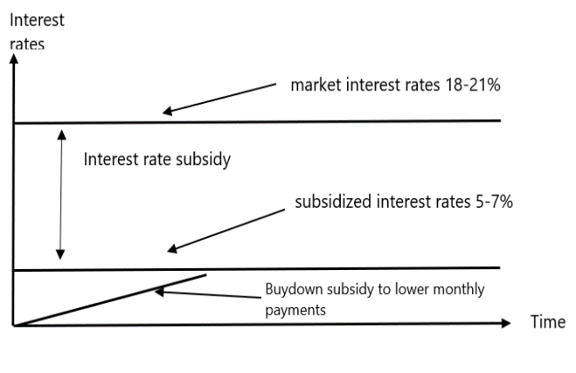 | 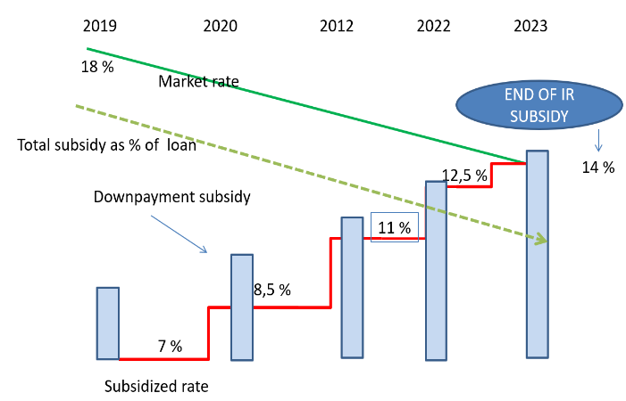
Source: Authors compilation Source: Authors’ compilation

Proposed DLI. ‘Develop and implement an alternative scheme that progressively phases out the interest rate subsidy starting from the next round of advertisement campaign in 2019’.
- Regulation of the Real Estate Profession and Installment Sales Practices
The real estate industry is contracting due to price-output volatility, which in turn can potentially have adverse economic consequences if no regulatory action is taken soon. The preliminary research on shadow banking practices by Egyptian private developers confirm an exponential growth of installment sales. From a sample of 51 projects representing close to 150,000 units and worth LE 463 billion, all units are sold in installment sales and relate to high-end housing markets. Such a system of shadow banking exceeds half of the overall bank lending to the private sector and 10 percent of GDP. These practices generate significant risks to the economy in terms of real estate cycle volatility, consumer protection, large scale mobilization of long-term retail savings, and reputation for the regulatory authorities. A well-regulated developers’ industry would (a) unlock the expansion of secured forms of financing (through mortgage during construction phase, which are not allowed by the CBE, rather than installment sales); (b) refinance (through banks loans to developers); and (c) enhance consumer protection.
The AF will support the adoption of legislation to regulate the real estate developers’ profession and installment sales. Two levels of regulatory and supervisory intervention are envisioned under this component: at the construction phase and at the installment phase (post construction). During the construction phase, there is an urgent need to make mandatory the escrow account practice (whereby homeowner’s funds are earmarked to their real estate project and finance the actual delivery of the purchased unit in time and with the expected quality instead of using the funds provided by clients to finish other projects) and establish a national registry where all real estate projects could be recorded. This should be regulated by the MHUUD under a specific real estate developer’s law (which is different from the current draft prepared by the profession proposing the creation of a self-regulatory entity). At the installment phase (after completion of the project), developers should be regulated by norms creating a level playing field with banks and mortgage companies, and this second stage of regulations may also be introduced gradually by the Financial Regulatory Authority (FRA). For real estate projects that would be implemented by private developers under PPPs (see DLI 8), the tripartite mortgage arrangements provided by the Mortgage Law would prevail for clients of a given project to receive the SHMFF subsidies, thus benefiting to the developer.
Proposed DLI and DLRs: DLI ‘Adoption of legislation regulating real estate profession and instalment sales’ and DLR 1 ‘adoption of a real estate developer’s law (including regulation on financial practices during pre-construction and during construction phases)’ and DLR 2 ‘regulation of installments sales post construction’.
- Governance and Institutional Organization of the SHMFF
- Environment
The SHMFF established an Environment Unit in 2018 to bring green concepts into affordable housing. Green building concepts and standards are nascent in Egypt (further details are in Chapter 3). However, the SHMFF is paying key attention to environmental standards to ensure that social housing in Egypt incorporates green initiatives. The EU was approved by the Central Agency for Organization and Administration in 2018 and the SHMFF assigned a head for this EU in March 2019. The mandates of the Environment Unit include ensuring that developers of the social housing (whether NUCA or private investors) are complying with relevant environmental; health; and safety regulations in the planning, design, and construction of the units. The mandate also includes introducing energy, water, and solid waste management saving measures and raising beneficiaries’ awareness about the benefits of such initiatives. The SHMFF is supporting the green building certification and has approached the National Building Research Center, the certifying entity, to work on a road map to be followed in site selection, design, and construction of new housing units.
The AF will support the operationalization of the Environment Unit and implementation of basic green initiatives in pilot projects. The program will support the operationalization including minimum staffing requirements and certain key performance indicators (such as number of Occupational Health and Safety audits conducted, number of environmental audits, correction actions that have been endorsed by developers, and documentation of the findings in Quarterly Progress Reports). This will be done through an Operations Manual (which is one of the Program Action Plan [PAP] actions). The Program will also support the effective certification process of social housing units. The initial target is 25,000 units over the life of the program (about 7 percent of the units that will be constructed in three years of the Program implementation). It is expected that the achievement of this activity would be relatively slow during the first phase of implementation and would increase at a faster pace later when green building concepts are better assimilated by developers. As the construction costs should be considered in social housing, the Program is limiting the requirement to entry level GPRS certification, which entails measures to the site selection, designs, selection of materials, and introducing some plumbing and power saving tools.
Proposed DLI and DLRs: ‘Establishment of an Environment Unit at SHMFF’ and DLR 1 ‘Operationalization of a properly staffed Environment Unit’ and ‘Number of housing units with entry level GPRS certification from NBRC’.
Proposed Changes to Component 2: Enhancing Transparency and Accountability of Social Housing Programs
- Claims Management Unit
The AF will also strengthen the capacity of the SHMFF through the establishment of a Claims Management Unit (DLI 3). Building on progress to date on DLI 3 and the need to enhance its GRM, the SHMFF will streamline its administrative and workflow procedures for handling claims. This could be done through the creation of a dedicated Claims Management Unit with adequate staffing; oversight; institutionalized standard operational procedures; and requisite training for better coordinating the handling of information requests, complaints, and feedback on the Program. A dedicated Claims Management Unit will strengthen the institutional capacity of the SHMFF to manage (a) an increasing volume of subsidy applications; (b) information requests, feedback, and grievances related to said applications and the broader program; and (c) systematic communications and outreach on the program. Enhanced procedures would necessarily entail improvements to the management information system/information technology system as well as the introduction of service-level agreements between pertinent units within the broader organizational structure to ensure effective and efficient functioning of claims handling procedures. This DLR builds on significant progress in the parent operation on DLI 3, notably underpinned by the SHMFF’s establishment and periodic improvement of an online e-service portal for receiving and preliminarily processing applications, with built-in information technology capabilities for complaints uptake and information sharing with applicants including through SMS.
Enhanced workflow will necessarily entail systematic outreach underpinned by a communications strategy coordinated with governorates and other program stakeholders as needed. This DLR also anticipates the introduction of service-level agreements between the Claims Management Unit and other pertinent units within the broader SHMFF organizational structure and program to ensure the claim unit’s effective and efficient functioning in an integrated approach, for example, to ensure requisite coordination with the audit function anticipated in DLI 1 in detecting fraudulent applications or investigating complaints and anonymous feedback pertaining to fraud.
Proposed DLR: ‘Establishment of an operational and properly staffed Claims Management Unit’.
- Proposed Changes to Component 3: Improve Access to Affordable Housing
- Scale-up of Demand-side Subsidies for Ownership
The AF aims at scaling up the delivery of demand-side subsidies (DLI 5). The AF aims at scaling up the delivery of demand-side subsidies for ownership to reach additional 40 percent beneficiaries. The original delivery pace under the parent program (that is, more than 200,000 beneficiaries per year to reach 725,000 by program closure, out of the 1 million social housing units that the GoE’s program aims at delivering) seemed overly ambitious, especially with regard to timing. As mentioned previously in section I.B, the SHMFF is serving close to 10,000 beneficiaries per month (or 120,000 per year) and can potentially increase the pace to 12,000 (or 144,000 per year) if improved internal processes are implemented (see section III, A, (a) and B, (b)). The assessments made for the preparation of the AF confirmed that the 12,000 subsidies per month target would be a maximum. Therefore, by aligning the closing date of the parent program with the one of the AF (that is, 2024) and by providing an AF of US$250 million for this component, the SHMFF will be able to deliver 1 million subsidies by 2024 which corresponds to the Government’s program ultimate objective.
Proposed scale-up. The scaling up will consist of extending the deadline to meet DLI 5 to 2024, increase the target from 725,000 subsidies to 1 million by program completion, and provide an AF of US$250 million to factor the supplemental 265,000 subsidies. The demand-side subsidy, set at US$310 per subsidy granted in the parent program, would be increased to US$465 to take into account the past inflationary pressures.
- Private Sector Participation in Affordable Housing
Increase private sector participation in affordable housing (DLI 8). Private sector participation remains problematic since current PPP framework is not viable for private developers. The key obstacles identified by private developers in the context of workshop in March 2019 were: letter of guarantee required by NUCA, density, mixed use of developments (i.e. commercial vs. housing notably retail on ground floor), unfair competition by NUCA, certain construction norms (i.e. parking requirements, land size/location). Larger developers are of the view that the existing PPP system called 70/30 system (i.e. 30 percent of developed projects back to the government for affordable housing without the company taking the construction risk) is the only way forward until the mortgage environment in Egypt improves. Medium size private developers are of the view that it is possible to develop viable affordable housing projects outside of the existing PPP system if more flexible standards are applied including: price and size of units, mixing affordable with middle income developments, and larger share of commercial areas within affordable housing projects.

The AF will propose concrete actions through DLRs for DLI 8 to encourage country authorities to support the development of a solid pipeline of PPPs in affordable housing. The AF will encourage concrete actions through DLRs to support private sector participation in affordable housing, including (a) revision (and development of new) of the PPP guidelines addressing key bottlenecks identified by private developers, (b) call for proposals under the new PPP guidelines, and (c) roll out 10 PPP pilots representing at least 10,000 units.
Proposed changes to existing DLI 8 and new DLRs. DLI 8 will be kept and the original target of 125,000 units built by the private sector will remain unchanged, but the deadline to achieve it will be extended to 2024. In addition, 3 DLRs will be included: DLR 1 Development and implementation of new PPP guidelines addressing key bottlenecks identified by private developers, DLR 2 call for proposals under the new PPP guidelines, and DLR 3 roll out 10 PPP pilots representing at least 10,000 units.
- Development and Implementation of an Affordable Rental Program
A rental program is needed to serve the population that cannot afford a mortgage or prefer renting. The AMP serves households with incomes between LE 1,500 and LE 4,750 per month. However, a large segment of poor households still cannot afford the monthly payment or qualify for a mortgage loan. Although 90 percent of Egyptian households prefer homeownership, some life starters and young workers with moderate income will also temporarily prefer a rental accommodation to remain mobile or benefit from a more central location. Despite the new Rental Law of 1996, there are multiple obstacles to the expansion of the rental housing market in Egypt. A large proportion of the housing stock is still frozen under the old rent control, particularly in Cairo, the rental risk is deemed high by landlords, the cost of refurbishing the unit after tenants have left is high and eviction procedures, though much improved, are still considered cumbersome. Tenants also face the risk that the rent could be increased beyond his/her level of affordability. As a result of the dysfunctional rental market, there is not enough investment in new rental programs and landlords keep many units vacant in both the old and new stock.
The AF will support two new interventions to encourage the development of the affordable rental market in Egypt:
- Institutional. The AF will include an institution building component that would materialize through the creation of a Rental Unit within the SHMFF with a clear mandate to design and implement rental development strategies, policies, and action plans. It would also include a digital platform aimed at facilitating the enrollment of landlords and tenants and matching of rental demand and supply. The platform would provide all the information needed by both landlords and tenants on existing laws, procedures, types of contracts, and intermediation experiences in the rental market, as well as on the rights, benefits, and obligations pertaining to the specific the SHMFF programs.
- Incentive packages. The AF will also support the development and implementation of a package of incentives aimed at stimulating private sector individual landlords to rent out their apartments/houses to low-/middle-income households. This would not only concern investors in newly built rental housing but also induce owners of vacant or unfinished units in both formal and informal neighborhoods to improve these units and bring them into the market. The package would consist of two distinct programs: (i) one for landlords, with tax incentives and guarantee schemes; it also might include subsidies by the SHMFF for renovating or finishing their unit; and (ii) one for the tenants, on the development of demand-side tenant subsidies aimed at filling the gap between the rent required by the investor and the payment affordable to the tenant, estimated at 25 percent of income.
Proposed changes and new DLRs. The rental component under the parent program (DLI 6) will remain unchanged, but the monetary value of the subsidy will be reviewed. The subsidy component of the DLI will not be modified; however, the monetary value per rental subsidy issued will be increased from US$476.07 to US$568.6 to take into account the past inflationary pressures. New DLRs: DLR 1: ‘SHMFF establishes a functioning Rental Unit and a Digital Platform linking private landlords and eligible tenants’ and DLR 2: ‘SHMFF implements a Rental Incentive Package including tax incentives, a rental risk insurance product and a matching grant mechanism for renovation for landlords, and direct subsidies for tenants’.
Table 1: DLIs of the parent Program and the AF
 | Disbursement linked indicator | Status | Allocated amount
DLI 1 | Establishment and operation of an internal audit function within SHF | Existing | US$ 25 million
DLI 2 | Establishment and functioning of a housing monitoring and evaluation system and an M&E unit within SHF | Existing | US$ 25 million
DLI 3 | DLI 3: The establishment and Functioning of an accountability and transparency mechanism within SHF for implementing the program | Existing | US$ 50 million
DLR 3.1 | Establishment of an operational and properly staffed Claims Management Unit | New | US$ 6 million
DLI 4 | DLI 4: The establishment by SHF of a functioning mechanism to monitor occupancy and vacancy of housing units by household receiving demand side subsidies | existing | US$ 50 million
DLI 5 | DLI 5: Number of households receiving demand side home ownership subsidy each fiscal year | scale up of $ 250 million | US$ 475 million
DLI 6 | DLI 6: Number of new households participating in rental subsidy program in each fiscal year | scale up | US$ 60 million
DLR 6.1 | Establishment of a functioning Rental Unit and a Digital Platform linking private landlords and eligible tenants | New | US$ 8 million
DLR 6.2 | Implementation of a Rental Incentive Package including tax incentives, a rental risk insurance product and a matching grant mechanism for renovation for landlords, and direct subsidies for tenants | New | US$ 11.5 million
DLI 7 | Percentage of demand side subsidies supporting the purchase or rental of housing units located within commute of 60 minutes or less to an employment center | Existing | US$ 25 million
DLI 8 | DLI 8: Number of demand side subsides provided to the purchase or rent of housing unites developed by the private sector. | Existing | US$ 50 million
DLR 8.1 | Development and implementation of new PPP guidelines addressing key bottlenecks identified by private developers | New | US$ 17 million
DLR 8.2 | Call for proposals under new PPP guidelines | New | US$ 17 million
DLR 8.3 | Roll out 10 PPP pilots representing 10,000 units | New | US$ 50 million
DLI 9 | Develop and implement an alternative scheme that progressively phases out the interest rate subsidy starting from the next round of advertisement campaign in 2019 | New | US$ 50 million
DLI 10 | Adoption of legislation regulating real estate profession and installment sales | New | US$ 50 million
DLR 10.1 | Adoption of legislation regulating real estate profession and installment sales | New | US$ 25 million
DLR 10.2 | Adoption of a real estate developer’s law (including regulation on financial practices during pre-construction and during construction phases) | New | US$ 25 million
DLI 11 | Operationalization of an Environment Unit at SHMFF | New | US$ 15 million
DLR 11.1 | Operational and properly staffed Environment Unit as per the Operations Manual | New | US$ 5 million
DLR 11.2 | Number of housing units with entry level GPRS certification from NBRC as per the Operations Manual | New | US$ 10 million
DLI 12 | Improve the efficiency of the subsidy delivery process. | New | US$ 5 million
DLR 12.1 | Pilot delegation of subsidy delivery to selected banks | New | US$ 5 million

Key Changes in the Environmental and Social System

Environmental
The ESSA of the parent Program assessed the environmental national system in terms of policies, legislation and standards in addition to the procedures and institutional capacity of different parties for effectively implementing those laws and regulations. The ESSA assessed the following aspects of the environmental system relevant to the Program:
- Environmental assessment: The ESSA highlighted that environmental assessment system was significantly developed since the issue of the Environment Law in 1994, however, as the Program address the demand side environmental assessment is not part of the licensing procedure. The Addendum confirms the previous conclusion of the ESSA with that respect.
- Buildings safety: The ESSA indicated that building safety is governed by Law 119/2008 which includes provisions for ensuring the building safety and validity for use including measures to ensure structural safety, fire safety, elevators’ safety, availability of utilities (water, sanitation, parking, … etc.) and maintenance requirements. Those law requirements are further detailed in engineering codes issued by NHBRC. The ESSA identified one gap regarding the maintenance of old buildings and introduced a requirement for having a safety certificates for existing buildings to ensure that maintenance is timely undertaken. The Addendum confirms that no changes have occurred to the building safety system and that the findings of the ESSA are still applicable to the AF.
In June 2018, the merger law (the merge between SHF and GSF) was issued to establish the SHMFF, to take the overall responsibility of social housing affairs and mortgage support. Consequently, the merger law abrogated the Law No. 33 of 2014 regarding Social Housing. In addition, the merger law authorized the SHMFF board of directors to endorse the organizational structure which now includes an Environment Unit (EU), as shown in the following figure. The roles and responsibilities of the Environment Unit (EU) include:
- Following up with implementing bodies the implementation of the occupational health and safety requirements during construction phases
- Confirming that engineering codes concerning structural safety of buildings and protection against fire risks are implemented
- ensuring that Egyptian code for designing buildings accessible to persons with disabilities are applied in buildings
- ensuring adaptation of the Egyptian code for buildings energy efficiency and investigating the possibility of using renewable energy in some buildings
- Ensuring that adequate waste management measures are implemented for waste collection and disposal
- Liaising with local municipalities to ensure safe disposal or treatment of waste
- Ensuring that all buildings have official valid certificate indicating the structural safety of the building, fulfilling fire safety precautions and fulfilling car parking requirements
- Liaising with competent authorities to provide tenants with awareness leaflet about best waste management practices
- Ensuing that maintenance of buildings are carried out frequently
- Ensuring compliance with applicable laws and engineering codes such as Environmental law, labor law, building law … etc.

Figure 1: Organizational Chart of the SHMFF highlighting the location of the EU
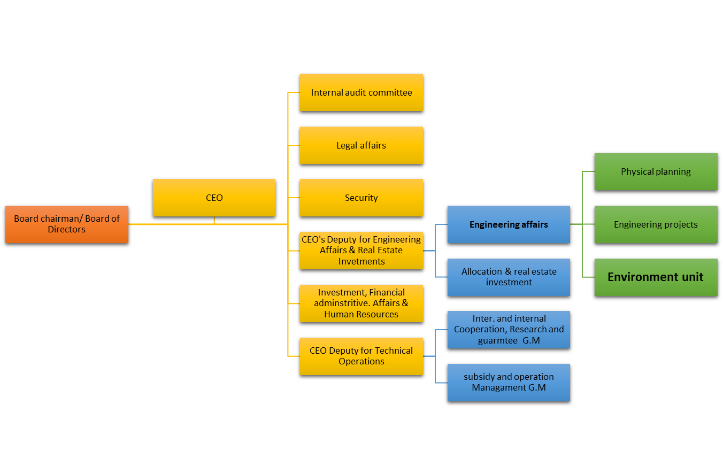

As indicated in the Program description, the AF, in addition to continuing the support to the demand side activities, is supporting the best practices of environmental sustainability of social housing construction. This will be through the support of the newly established EU in carrying out its mandates. The AF includes a new DLI that will measure the effectiveness of the EU in achieving its mandates including the introduction of green building principals in the social housing sector. Therefore, this Addendum expanded the assessments carried out in the ESSA to cover the national environmental systems related to environmental and OHS management of construction activities, and the green building standards.

Environmental and OHS Management of Construction

As indicated in the ESSA, residential buildings, unless it is a large new residential area that will be established, do not require an environmental assessment or an environmental license from the Egyptian Environmental Affairs Agency. However, construction waste management is regulated through the local authorities in Governorates, and through NUCA in new cities. Building licensing includes a requirement for collecting the construction and demolition waste and dispose it in designated areas, and contractors are required to keep areas surrounding buildings under construction clear from any accumulated waste.
For OHS, the Egyptian Labor Law 12/2003 is the main legislation regulating occupational Health and Safety. It is complemented with ministerial decrees (126/2003, 211/2003 and 134/2003) that provided more technical provisions for ensuring safe working environment. Also, there are a number of Engineering Codes that provide more details about some of the required engineering controls for maintaining OHS. The law comprises a chapter on the working environment and H&S issues and includes a comprehensive annex on the safety standards to minimize physical, dynamic, biological, and chemical risks.
The physical risks identified by the law include heat stress, cold conditions, noise and vibrations, light intensity, explosion, radiation, and pressure.

The dynamic risks are related to moving objects and collision risks. The law provides details of the required precautions to be taken during construction and demolition activities, especially the safety requirements for working at heights, scaffoldings, stairs, elevators, demolition works, excavation works, and access to work sites. Electric risks are also considered in the law among the dynamic risks and there are requirements to ensure adequate insulation of live electric conductors and instruments. The law includes stipulations for a safe working environment for construction labor, including providing safe working conditions against dynamic risks and necessary personal protective equipment.

Biological risks are related to working in areas exposed to pathogens. The law identified certain requirements for safeguarding against infections. These requirements include having a system for safe handling of food in designated areas within the establishment, regular vaccination for the workers against correspondent pathogens, providing adequate PPE, carrying out adequate cleaning and housekeeping, providing facilities for personal hygiene, providing health care and first aid equipment, and providing training.

Chemical risks are related to the exposure to harmful chemicals, where there are certain stipulations for handling hazardous chemicals. Such chemicals, such as paints and other building chemicals, should be handled according to the instructions of the Material Safety Data Sheet and workers should be trained on the adequate handling of such materials.

Generally, the national systems for waste management and OHS adequately address different types of risks in alignment with different international guidelines, such as the WBG EHS Guidelines. However, in terms of actual implementation on ground, there is relatively low awareness among construction workers and supervisors about the importance of waste management and OHS. Some contractors, especially large companies, abide to the Laws and standards and have an EHS system in place for their works. However, many other contractors treat EHS in a non-systematic manner and does not have a clear commitment to comply with the relevant Laws and Standards. The SHMFF has acknowledged this gap and included in the mandates of the newly established EU ensuring that contractors comply with environment and OHS Laws and Standards, and this is supported by a separate DLI in the AF.

Green Building

Green building concepts are recently introduced in Egypt. The green buildings concepts were officially introduced in Egypt in 2010 when the MoHUUD issued Decree 590/2010 which introduced the first issue Green Pyramid Rating System (GPRS) for evaluating the environmental sustainability of buildings, the Decree identified the NHBRC as the certifying body for the GPRS. The GPRS was later modified, through Decree 294/2017 and expanded to cover different sustainability aspects including sustainable site selection, energy efficiency, water efficiency, materials, natural resources indoor air quality, management, innovation and added value. The GPRS gives different certification levels depending on the obtained scores for the building: starting from score 30% (achieving 30% of the standards) for the Once Green Pyramid level up to the Platinum Level (Five Green Pyramid Level) with minimum score of 80%. NHBRC also issued a number of engineering codes that provides detailed guidance on how to achieve the sustainability aspects that are addressed in the GPRS, including:
- Egyptian code for buildings Energy Efficiency issued by the ministerial decrees (482/2005) which presents the energy efficiency requirements in designing and implementing new residential buildings among others. The code regulates the requirements for building envelope, natural ventilation and comfort temperature, air conditioning, water heating systems, lighting, electrical distribution systems and overall performance of buildings.
- Egyptian code for ventilation in buildings issued by the ministerial decrees (160/2013) which presents the ventilation requirements in buildings. The Code describes the needed ventilation for the human comfort in terms of temperature, humidity, indoor air quality … etc.
- Egyptian code for designing buildings accessible to persons with disabilities issued by the ministerial decrees (482/2005). The code highlights the main requirements for residential buildings and others such as general residential area layout, buildings’ entrances and residential areas design.
Although the GPRS, and other green building certifications, is effective for several years now, the interest among investors and builders in the country is quite limited. The certified buildings are mainly limited to some banks, hotels, admin buildings of multinational enterprises, international schools … etc. Having the green building accreditation in social housing sector, through DLI#, will be quite revolutionary as it would incentivize many investors and developers to consider changing their designs and building methods/materials to get certified.
It is worth noting that the International Finance Cooperation (IFC), one of the WBG institutions, has developed a system for green building (EDGE). The EDGE was developed to promote construction of green buildings globally and it measures sustainability of the buildings considering the local context as the achievement in sustainability is contextualized to the base case according to the local practices. EDGE and GPRS cover the same sustainability categories (sustainability of site, energy consumption, water consumption, natural resources, indoor air quality, management, innovation and added value), however, there are some differences in the methodologies, prioritization and weighting approaches in the two systems. EDGE has more conservative requirements for the minimum score to achieve certification, as it requires buildings to achieve a 20% reduction in three pillars to be certified, while the GPRS requires buildings to score at least 30% overall in any category to be certified. Despite being less stringent, the GPRS is considered suitable for the use of the Program as a certification tool, as the green building concept is quite new in the country and the sector, and it needs a staged approach to gain momentum.

Social

Progress in policies/legislations for Strengthening Institutional Capacity

The social risk management system described in the parent ESSA is still largely applicable in terms of laws, regulations, standards, procedures, and its actual implementation. However, during the course of time between preparing the parent ESSA and preparing this addendum as part of the AF, a number of developments took place on the institutional level. The following sections of the addendum present briefly those key developments:
3.2.1.1 The Merger between Social Housing Fund (SHF) and Mortgage Finance Fund (MFF)
The main change identified by the ESSA addendum is the merger of the project implementation entity, the Social Housing Fund (SHF), with the Guarantee Support Fund (GSF). The merger has resulted in the creation of a new entity, the Social Housing Fund and Mortgage Finance Fund (SHMFF) which was created by the Law No. 93 of 2018. The objective of this merger was to maximize the scope of intervention of these two instruments and exploiting more efficiently their synergies with an aim of providing better services to low-income citizens through one single entity.
      - Protocols signed to enhance government and private sector integration
The PforR has been supporting the institutional consolidation of SHMFF; contributing to the development of effective and transparent affordable housing policies and encouraging the design of effective and well-targeted subsidies to house the poor. SHMFF has become an example of good public-sector governance with professional board and management team, robust internal controls, periodic disclosure obligations and robust M&E systems to monitor housing policies progress and impact. Most importantly, the PforR was instrumental in the delivery of thousands of demand-side subsidies to poor households. Owing to this increased capacity, SHMFF has been able to deliver close to 180,500 ownership demand-subsidies since the program became effective.
With the beginning of the third quarter of 2014 up till mid-2017, the driving force for development in this stage was a package of protocols that were signed with parties that have the potentials to contribute to expediting the program work cycle. The Social Housing Fund believes that it is necessary to have integrated government and private sector efforts to achieve the desired target of the Social Housing Program which is facilitating the access of qualified citizens to subsidized housing units, each according to their own case. Accordingly, a package of protocols has been signed with a number of concerned institutions which largely contributed to the development of the work system. These institutions were: the Egyptian post authority, the Housing and Development Bank, the Central Agency for Public Mobilization and Statistics, and the Mortgage Finance Fund.
      - The establishment of a Claims Management Unit
Building on progress to date on DLI 3 and the need to enhance its grievance redress mechanism (GRM), SHMFF has established a Claims Management Unit to streamline its administrative and workflow procedures for handling claims. Under the AF, the Bank will be supporting the client to ensure that the newly created Claims Management Unit is functioning efficiently with adequate staffing, oversight, institutionalized standard operational procedures, and requisite training for better coordinating the handling of information requests, complaints, and feedback on the Program. Enhanced procedures would necessarily entail improvements to the MIS/IT system as well as the introduction of service level agreements (SLAs) between pertinent units within the broader organizational structure to ensure effective and efficient functioning of claims handling procedures. The AF has introduced a DLR to this effect.
      - Digital Governance
Considering the proposed measures to strengthen institutional capacity of the SHMFF claims management unit staff, and based on the continuous ongoing dialogue with the client, SHMFF expressed its need to be provided with support to enable achieve a more digitalized culture, which aligns with the ICT strategy of the Ministry of Communications and Information Technology (MCIT) for 2014-2020 entitled “Achieve the digital economy through ICT, to provide prosperity, freedom and social equity for all”. The strategy involved multi-stakeholder input from NGOs, academia, and multi-national corporations whose co-operation is central to implementing a series of strategic business plans with a focus on Citizen participation and empowerment. The three main strategic objectives are: (i) transformation of Egypt into a Digital society, (ii) development of ICT industry, and (iii) establishment of Egypt as a global digital hub. See Box 1. A study has been conducted on “Effective e-Government and Citizens Adoption in Egypt.”
It is also worth mentioning that the call to support SHMFF through introducing digital economy comes into alignment with Egypt’s ICT 2030 Strategy, which supports the development of the communications sector both regionally and internationally by designing new initiatives such as the electronics design and manufacturing and capacity building to maximize ICT contributions to the economic growth of the country.
Box.1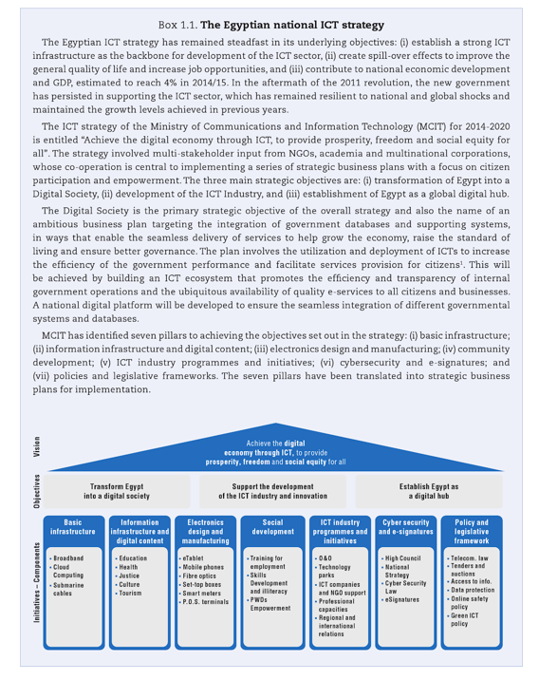
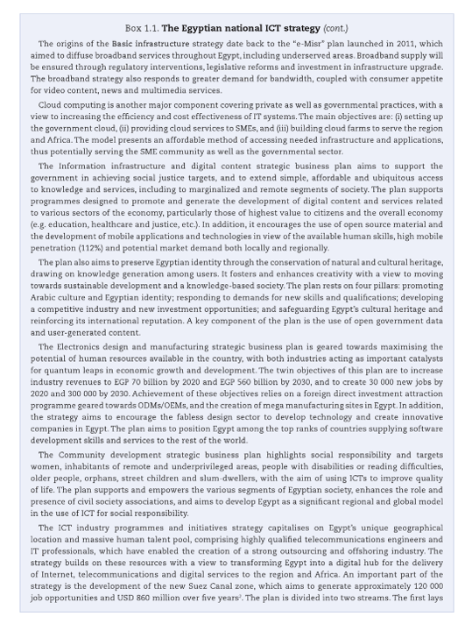

- The social housing program enhances aspects of financial inclusion and digitization. This is a state trend under the leadership of President Abdel Fatah Al Sisi who announced the establishment of the National Payment Council early 2017 upon a recommendation from the Higher Investment Council. The first tasks of the National Payment Council were to activate the concepts of financial inclusion, reduce the use of banknotes outside the banking sector and enhance the use of electronic means and channels in payment instead of banknotes. The Council is also mandated to develop national payment systems and work on establishing the concepts of financial inclusion.
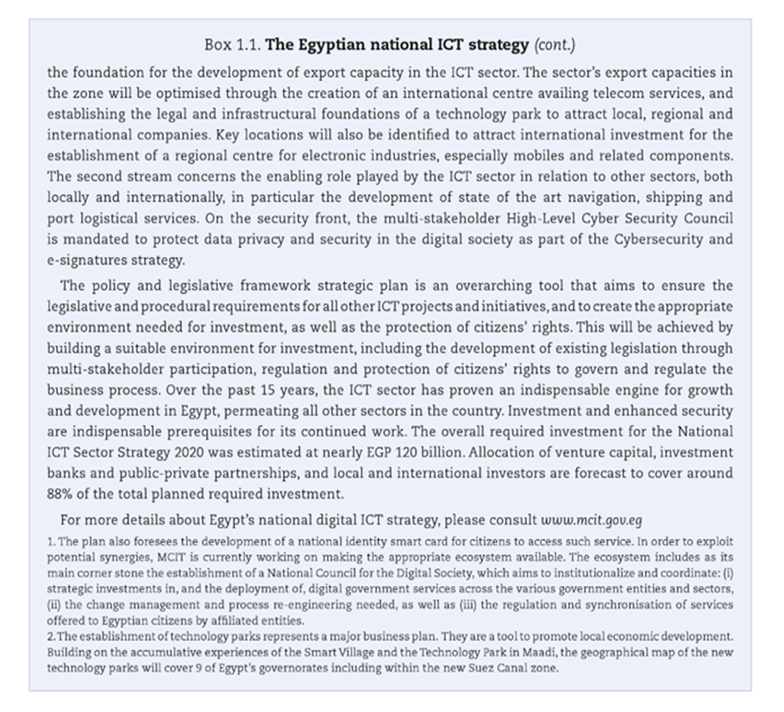
      - Progress in policies/legislations for Social Inclusion
The Government of Egypt has recently carried out several initiatives to ensure cohesive social inclusion, especially for marginalized groups considered less advantaged due to the country’s cultural context. A significant attention has been given with regards to gender equality and different marginalized groups

      - Gender Equality

A National Strategy for Women has been developed for the first time. The NCW launched the first National Strategy for Women’s Empowerment, hereafter referred to as the NCW Women Strategy. The NCW Women Strategy is aligned with the UN Sustainable Development Goals (SDGs), and it echoes Egypt's "Sustainable Development Strategy Vision 2030." The NCW Women Strategy includes four pillars: Political empowerment; Economic empowerment; Social empowerment; and Protection Against All Forms of Violence.

2017 was declared the Year of Egyptian Women. The President of Egypt and the President of the NCW declared 2017 the Year of Egyptian Women. The significance of this declaration lies in its affirmation of the State’s constitutional commitment to enact the necessary measures to empower Egyptian women and ensure their fair representation in all decision-making positions.
Egypt is proceeding steadily on its financial inclusion journey. Egypt has adopted the Maya Declaration, launched in 2011 at the Global Policy Forum (GPF) in Riviera Maya, Mexico. A commitment to the Declaration is a means to champion financial inclusion, and contribute to the SDGs, specifically to SDG 1: No Poverty. The Declaration focuses on creating the right environment, implementing the correct framework, ensuring consumer protection measures are taken, and using data to inform and track financial inclusion efforts. Women related commitments include developing a set of supply side indicators on women’s access to and use of financial services by the end of 2018, determining the baseline gender gap by the end of 2018, and halving Egypt’s gender gap by 2021.
Efficient social protection programs have been designed as a stepping-stone to financial inclusion. Egypt launched the Takaful and Karama (Solidarity and Dignity) cash transfer program in 2015, with support from the World Bank. The cash transfer program targets the poorest families in Egypt, where around 90 percent of beneficiaries are females. The program is being supplemented with a new program, Forsa, designed to serve as a graduation program that will create sustainable pathways for the poorest including time-bound multi-dimensional interventions: safety nets, education, financial literacy and savings, seeds capital, access to capital, and life skills mentoring or coaching.
Nevertheless, the emerging institutional framework including the Constitution, the NCW Women Strategy and the strong political will to support women’s political and economic empowerment together open a window of opportunity to speed up progress concerning female empowerment and gender equality.

Review of Benefits, Impacts, Risks and Mitigation Measures

Environmental

The ESSA of the parent Program assessed the environmental risks as low given that the Program interventions are limited to the demand side. The AF will continue to support the demand side, while introducing best practices to the construction activities through DLI11, such as improving the environmental and health and safety measures during construction and introducing the principals of green building in 25,000 housing units, which are considered as environmental benefits. All the remaining new or modified DLIs are not supporting the supply side activities of the national program.
The AF will not cause any environmental impacts that could be considered significant, diverse, sensitive or unprecedented. The AF modified and new DLIs are not associated with activities that could pose risk on natural habitats or physical cultural resources. The ESSA identified some community risks related to structural stability and safeguarding against fires and this risk was classified as low for new buildings as the national system is quite strong in ensuring that adequate standards are followed. The risk was also classified as low for existing building given that the beneficiaries will obtain validity certificate about the building license and its corresponding safety measures. The Addendum confirms the low risk associated with safety of buildings. It is worth noting that almost all the housing units provided to beneficiaries so far were new units that fulfilled the different engineering codes for building safety, and few units (less than 1%) were built by the private sector few years before the commencement of the parent Program (in 2012) but were also new units (first use) that fulfilled licensing requirements.
The identified gaps, in Chapter 3, for the environmental and OHS system are relevant to the supply side activities that are not supported by the Program, however, the supply of housing units will be key in achieving the Program objectives. Therefore, although the direct risks and impacts of the AF remains related to the demand side; environmental risks related to the supply side are considered linked to the Program. Accordingly, the environmental risk of the Program was raised to moderate because: i) the construction activities, considered to be linked to the Program activities mainly because the past period of Program implementation showed that the units delivered to beneficiaries were newly built, are generally associated with moderate OHS risks, and ii) the effective operation of the new Environment Unit is still to be assessed during the coming implementation period of the Program.
The ESSA assessed some environmental benefits for the parent Program such as reducing the need for building new housing units through improving the occupation of existing vacant ones and reducing commuting for employment through enhancing having housing units near employment centers. Those benefits are still valid for the AF.
The PAP of the parent Program included several environmental measures to incentivize energy savings, raise beneficiaries’ awareness about waste management, ensure that beneficiaries use safe buildings and provide guidelines and trainings to different stakeholders on Occupational Health and Safety (OHS) during construction. The following table describes the proposed PAP measures for the parent Program and the status of its implementation as of April 2019.
Table 2: Status for Implementing PAP Actions of the Parent Program
PAP Action | Status | Comment
Provide incentives for energy savings among program beneficiaries through setting targeted energy consumption rates and awareness leaflets about the best practices for saving energy saving. Households achieving the targets to be subject of incentives according to mechanism to be designed during the program implementation. | An awareness campaign about energy conservation was conducted by SHF that targeted low-income housing and the facilities that are available within SHF projects. This was parallel to the introduction of prepaid electrometers and water meters that were made available for all units. Pilot projects for solar energy in some buildings in Port Said were also implemented by the SHF | After the effectiveness of the parent Program there was a hike in electricity tariffs and this has largely incentivized households, especially low-income ones, to conserve energy consumption to the extent possible. Following that hike a nation-wide campaign started to introduce means of energy conservation, and a Program-specific action was not necessary within that context
Raise beneficiaries’ awareness about waste management through distributing leaflets describing importance of waste management at the household level and the adequate best practices. These leaflets shall be distributed to the beneficiaries with documents related to the Program (such as contracts, receipts … etc.) | There have been some campaigns done in new cities by NUCA to introduce solid waste management tools. This included introducing some waste chutes in some buildings. However, awareness leaflet distribution at the Program level was not carried out | This will be carried out in a systematic manner after the EU was established in 2018
Ensure that beneficiaries use safe buildings through Including building validity certificate among required application documents | The units delivered to beneficiaries, so far, were newly constructed units that fulfilled safety codes as part of the licensing procedures. The validity certificate would be applicable to old buildings, more than 10 years old, which were not part of the Program so far | This will be carried out in a systematic manner after the EU was established in 2018
Guidelines and training provided to SHF staff and other stakeholders about addressing occupational safety related to construction activities and handling of building chemicals and construction wastes | No action done | This will be carried out in a systematic manner after the EU was established in 2018

The above measures were included in the mandates of the newly established EU and will implemented on a systematic manner as part of the modified PAP of the Program.

Social

The AF will continue financing demand-side interventions as in the parent program. The social risk was assessed as Low in the parent program, with key risks including limited institutional capacity to handle social issues; social exclusion as a result of inability to reach needy and priority cases; and risks to program sustainability stemming from affordability of housing units. While the program has undertaken progressive actions to mitigate against these, the AF risk has been assessed as Moderate to reflect persisting limited institutional capacity with an anticipated significant increased volume of beneficiaries in the AF; with some program actions from the parent also pending completion.
Main risks identified in the parent program as well as persisting issues and proposed mitigation measures are described below:

Institutional Capacity

The ESSA preparation and consultation process identified risks related to limited institutional capacity, which may pose a crosscutting constraint to the program’s sustainability. Thus, enhancing institutional capacity is necessary to improve program management and ensure primary beneficiaries (i.e., low-and-middle income households) fully benefit.

Limited capacity to handle high volume of grievances

The program grievance redress mechanism (GRM) has limited capacity. In the parent program, progressive actions were taken to address this, notably through DLI 3 on the establishment and functioning of an accountability and transparency mechanism within SHF for implementing the program. The GRM anticipated through this parent DLI has most recently been integrated with the program’s digitized system for receiving applications, the latter rolled out as of April 1, 2019. Preceding this web portal, uptake channels for applications-related inquiries include Governorate-level service centers coordinated with SHMFF, a call center, and SMS (see template in [Figure 5] template below in Arabic). The program has also adopted operational procedures to handle and improve program response to applications-related inquiries and complaints through these channels. Consultations in Giza and Sharqia Governorates highlighted that most beneficiaries were aware of the program GRM at the Governorate local level. Beneficiaries expressed that the GRM was well functioning and efficiently handling complaints, with a complaint handling and resolution process not exceeding two weeks.
For the call center, SHMFF’s performance report for Dec 2018 outlines over 6 million calls received since the onset of the program in 2014, with 89% of these answered for an average call duration of 2 mins 48 seconds. Moreover, the performance report for Dec 2018 outlined 208,538 beneficiaries under the parent program, with L.E. 3,448,513,872 provided to these beneficiaries as subsidies, whereas under the AF, the subsidy delivery program is anticipated to be scaled up to reach additional 40 percent beneficiaries. Accordingly, further institutional strengthening is required to enable handling the anticipated increase in the volume of information requests and grievances.
Consultations with focused groups underlined the persisting risk of the inefficiency of the application process, such as lengthy durations to process any corrections in the applications or pending statuses as a result of missing documents. Majority expressed their concerns with the long duration between applying for the unit and between actual receipt of it, which in some cases lasted for 3 years, as it was unclear for them when they are expected to receive their units. This caused more further financial burden of them, as they had to pay both rent for the apartments they stay in till they receive their units, and the monthly installments for these units.
Furthermore, some project beneficiaries mentioned that they were not provided with actual timeframe for response to their claims. Moreover, a number of them encountered long wait duration over the phone to the extent that one call to inquire about the requirements for applying or the application status would cost them more than LE 50 as they get charged per minute.
Consultations revealed that the issue of prolonged wait time over the phone continued to persist, and this is basically due to the limited capacity to handle the huge number of applicants, that was significantly clear during the 8th advertisement.
Some beneficiaries had a different experience with application times, outlining that they did not have to wait for a long period of time between applying and receiving the unit, as it used to be the case previously with other neighbors and friends who applied with earlier advertisements.

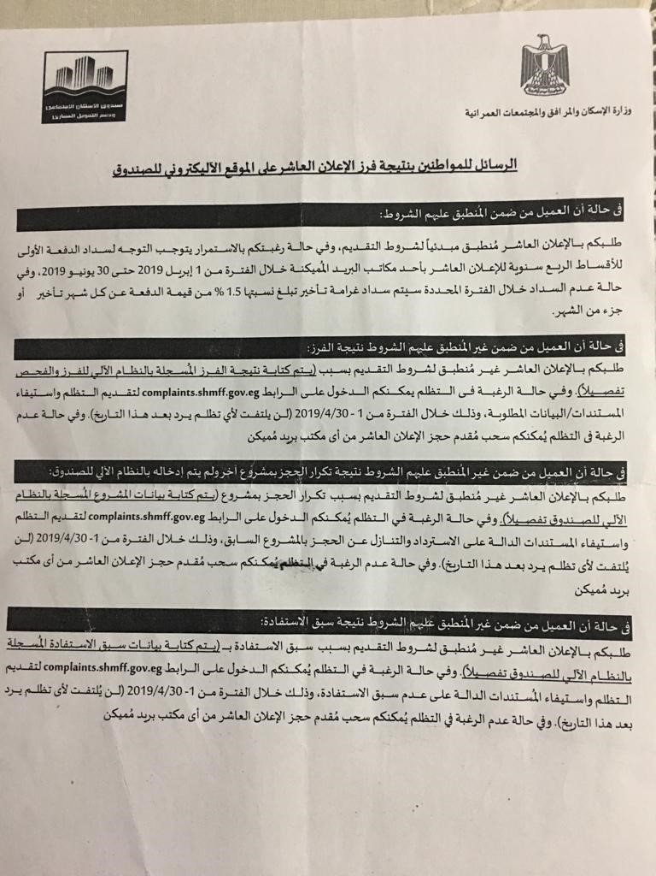
[Figure 5]: Four different forms of messages sent to the applicants according to their eligibility condition

The risk of limited institutional capacity to handle anticipated increased volume of inquiries/complaints persists in the AF and could be exacerbated by issues related to the division of roles and responsibilities among recruited staff in the new Claims Management Unit. Additionally, while the program scope primarily extends to the demand side of social housing subsidies, complaints on supply side issues may be received via the GRM, for which SHMFF has limited capacity to handle. During consultations, a major concern that was brought up by majority of the project beneficiaries was issues related to proximity of the housing units to functioning social infrastructure. All beneficiaries in the focus group discussions had a common concern that although social infrastructure is in place (schools, healthcare facilities, kindergarten), these are not functioning. For example, one lady mentioned that she and her kids had to stay apart from her spouse where they used to live earlier to be able to send her kids to school due to the unavailability of an equipped and staffed school in their area yet. The nature of these concerns highlights the potential relevance of training for SHMFF related to supply-side issues including livelihood measures and living standards, while still recognizing that supply-side activities related to land acquisition are outside of the program scope.
As part of the Bank’s efforts to support the client’s institutional capacity, the Social team earlier carried out a workshop in April 2017. The capacity building workshop provided international standards and best practices that could be used in addressing Egypt’s housing problems. The workshop also provided technical assistance for the Ministry of Housing, Utilities and Urban Development, the Mortgage Finance Fund and the Social Housing Fund to set up policies to enhance governance and transparency. The technical assistance entailed creating monitoring, evaluation and internal review systems and a mechanism to receive and address complaints. Similar support by the World Bank could be mobilized as feasible in the AF to reinforce training and capacity-building anticipated for the Claims Management Unit via DLR 3.1, potentially covering examples and good practices.
Furthermore, to promote program transparency and aid in reporting of fraudulent applications for subsidies, prior Bank missions to support the parent program have highlighted best practices around instituting an anonymous GRM uptake channel. The current SHMFF GRM requires beneficiaries and interested parties to present ID while seeking information or submitting complaints, which risks creating fear particularly for reporting fraud cases. Given that GRM procedures for verification and investigation can mitigate against risks of receiving inaccurate information, an anonymous GRM channel complemented with these would be important to help prevent fraud and ensure that program benefits are going to the intended beneficiaries in the program development objective.
Thus, overall, it is important for the program to continue to adopt measures to improve its effectiveness, transparency, and accountability through strengthening the capacity of the SHMFF for a more robust GRM and handling of social issues. To this effect, the AF anticipates the establishment of a Claims Management Unit through a new DLR 3.1. A new DLR 1.1 will also entail the development of new processes to detect fraud. The Claims Management Unit will coordinate with these processes, while primarily encompassing systematic handling of information requests, feedback, and grievances on the program. DLR 3.1 will measure the effectiveness of the claims unit in achieving its objectives through a number of measures including: (i) Adoption and implementation of streamlined operational procedures; (ii) Adequate staffing and training for coordinated claims handling—including a claims management officer, a grievance redress/complaints-handling focal point, communications staff, requisite IT staff, a technical review committee, and an appellate committee for communicating, collecting, evaluating, investigating, and following-up on claims as applicable within set operating standards; (iii) Service Level Agreements (SLAs) between the Claims Management Unit and pertinent SHMFF units or stakeholders essential to claims processing and resolution; (iv) Maintenance of adequate, inclusive channels for receiving and following up on claims; (v) Implementation of systematic outreach and communications campaigns; (vi) Maintenance of adequate systems for facilitating claims processing; and (vii) Periodic audits and publication of claims monitoring reports having staff to be hired under the unit supervise its performance, and in further strengthening the unit through providing capacity building trainings.

Leakage of the program benefits to cases that are not eligible

The risk of program subsidies abuses could arise if ineligible cases benefitted from the program’s subsidies. Law 33 of 2014 considered this social risk in addressing program benefits’ leakage beyond its intended beneficiaries. The law designed measures to limit such risk, including strong penalties for any applicant who submits false documents or shares false information.
Each specific program has eligibility requirements. The eligibility verification process entails reviewing documents submitted by the SHMFF. For specific low-income groups programs, the Ministry of Social Solidarity engages in the verification process. In some cases, the Ministry of Social Solidarity approach applicants/potential beneficiaries to verify the applicants’ socioeconomic conditions.
Reducing fraud risk can result in improved operational efficiency during the subsidy delivery process. The SHMFF has effectively implemented robust occupancy monitoring, with an internal audit unit supervising the on-site controls process. Audit results provide inputs to define new housing programs. Still, no effective deterrent prevents fraudulent applications. Mitigation measures included the adoption of legislation to prevent fraud. The SHMFF can legally sue fraudulent applicants. This approach, however, is not suitable for an entity with such a large operation. Reviewing this operational shortcoming will ensure better use of human resources and will improve service efficiency.
Additionally, as discussed earlier, it is worth noting that under the proposed new DLR 1.1 to develop new processes to detect fraud, one major measure can be to include a channel to the GRM for receiving anonymous complaints, or anonymous feedback without requirements from the whistleblower claimer to provide identity information, and subsequently independently investigated and verified to determine viable claims and thus, promote accountability under this DLR.
During one of the focus group discussions, a beneficiary mentioned having noticed that many people in their neighborhood did not really have urgent need to have units, rather they already own units at their family houses that are under the father’s name and not their name, and since the eligibility under the program is determined only based on the ability to provide the required documents, this gives room for many similar cases to take advantage of the program at the expense of others who might be more needy. Accordingly, the program should consider adapting more rigid and robust eligibility criteria and screening mechanisms, which might extend the investigations of eligible cases to community investigations rather than just ensuring adequacy of formal documentations. DLIs/DLRs lending themselves to mitigation measures are DLI1 on the the establishment and operation of an internal audit function within SHF providing assurance service for the ownership and rental programs affiliated with the SHF; with new DLRs 1.1 and 1.2 respectively on the development of new processes to detect fraud, and the implementation of new processes and report on actions taken.

Digital Governance

Digitization is becoming the new norm for SHMFF to support its growth and cost optimization strategies and it is adopting new automation technologies. As noted above, as of April 2019, SHMFF has rolled out a revamped web portal and digital system for receiving and preliminarily processing program applications. Unintended consequences, including the obsolescence of existing controls, fragmented operating environments, data privacy issues, complexity in operations, and the possibility of cascading errors, become top areas of concern, which can limit the benefits that SHMFF may be seeking. Moreover, as a result of this digitalization, some groups, especially those who do not have access to the internet might be excluded from anticipated benefits. Thus, building a digitally savvy leadership and skilled workforce leveraging digital best practices is crucial to ensure effective and inclusive use of technology.
As SHMFF transforms to thrive in a digital environment, its success is affected by how well it integrates its workforce into the transformation journey. SHMFF needs to construct a digital culture thoughtfully, incorporating principles of experimentation, smart risk-taking, continuous learning, and collaboration.
Since the program’s inception in 2015, the SHMFF has made significant progress in the operational delivery and monitoring of loans and subsidies to targeted groups. Applications are now submitted electronically; a dedicated information technology system is in place to ensure proper workflow between the SHMFF and participating lenders; and interventions by different institutions have been limited to three key players (CAPMAS, SHMFF, and participating lenders). The number of applicants who registered their applications and attached the required documents on the website for the ninth advertisement reached around 81,522 citizens.
The AF envisions digital governance related training as part of the capacity building anticipated in DLR 3.1 for the Claims Management Unit, as well as DLI 11 on Strengthening SHMFF’s governance. Ongoing dialogue with SHMFF and the World Bank is also slated to mobilize support as feasible to complement training on best practices for digital and e-services.

Social Inclusion

The program extended its benefits to cover different groups in the society, with 19 percent of its beneficiaries being women; 73 percent below the age of 40; and 20 percent below the age of 30. The Program also prioritized families with 117,855 (i.e. 57 percent) of beneficiaries being married couples with young children. Over 13 percent come from the poorest governorates and 13 percent are from the informal sector. Based on SHMFF reports, the program has indirectly contributed to decreasing informal housing’s expansion on agricultural lands and promoted job creation of skilled and unskilled labor through construction (with the potential of generating up to 1.5 million jobs over a six-year period).

Inability to reach needy and priority cases

A risk identified in the parent program and still persisting under the AF is that some eligible cases would neither know about the program nor be able to present the required documents to prove their eligibility. Such cases often involve poor women and illiterate groups in remote Governorates cities and workers in informal sectors, including those lacking the ability to register property. According to work classification, as of 31/12/2018, the total number of beneficiaries was 75,777 (i.e. 36.3%) in the government sector, 105,205 (i.e. 50.5%) in the private sector, and only 27,556 (i.e. 13.2%) in the informal sector (the self-employed). To mitigate this risk, the program has been working to identify alternatives to capture the income of informal sector groups. For example, requiring alternative forms through certified legal accountants could serve as a mitigation measure for income verification purposes.
Consultations with individuals who worked in informal sector confirmed that they were able to provide a proof of their income through a legal accountant. However, they mentioned that some banks did not accept this as a proof of income and would transfer them to other banks with less policy requirements.
The program is expected to adopt mechanisms that promote social inclusion and access to affordable housing to different disadvantaged and vulnerable groups. Such mechanisms will focus on a large bracket of the population that was formerly socially excluded and marginalized, including female headed households, poor families in remote Governorates and lagging regions, and groups with special needs.

Lowest-income groups

Risks of exclusion of the lowest-income group persist despite the government’s efforts to prioritize the lowest-income bracket in the social housing program. By income level, as of 12/31/2018, only 2 percent of beneficiaries had monthly income ranging from LE 501- LE 1000, just 3 percent had monthly income ranging from LE 1001- LE 1100, while 11 percent (highest percentage) had monthly income ranging from LE 1401- LE 1500, followed by 10 percent (second highest) with monthly income ranging from LE 1901- LE 2000. The poorest groups are less likely to enroll in ownership schemes because these schemes are still too expensive for them. Those who do not have access to formal work also face hardship due to their lack of credit history. Equally important is that less than 2% of the SHMFF’s portfolio focuses on rental, which is the component designed to serve those unable to afford a mortgage.
New issues have emerged including; i) expiration of the CBE credit line in January 2019, which provides a window of opportunity to design a new, more transparent, and fiscally responsible scheme, and ii) the structural adjustment program which negatively affected the poorest segment of the population, thus resulting in the need for scaling up the delivery of the subsidy particularly in the context of structural adjustment to protect the most vulnerable populations.
In June 2016, the Ministry of Housing advertised for 500,000 units with subsidies across governorates and new urban communities, predominantly for ownership. However, the number of applications received was only around 375,000. In March 2018, the World Bank finalized an agreement with CAPMAS (Central Agency for Public Mobilization and Statistics) to conduct a Demand Survey for Housing across Egypt. The survey consisted of a sample of 10,960 households across eight governorates.
Key Highlights from the Pilot Survey Results received in February 2019 (final survey results are currently being finalized) included; i) 67 percent of pilot survey respondents over the age of 18 were aware of the government’s social housing program, ii) Almost 80 percent of pilot survey respondents desire home ownership, not rental, iii) 31.6 percent of total survey respondents choose their neighborhoods based on proximity to their relatives; 11.5 percent choose based on suitable living conditions; and 5.6 percent choose locations based on easy access to transportation; iv) 14 percent of the pilot survey respondents aged 18 or above are planning to move out of their current homes; with 33 percent of them citing marriage as a reason, while almost 24 percent are citing better living conditions as another reason, and out of those who would like to move out, 66 percent of them are waiting for housing to become available.
It is worth noting that over 50 percent of the pilot survey respondents were females, 43 percent were employed, 22 percent have a university degree, while an additional 21 percent have a vocational degree /certificate, 43 percent of respondents are employed, most of them reside in the urbanized governorates of Cairo and Alexandria, and 63 percent of respondents are married.

Consultations with an urban and housing researcher who works for a Think Tank that looks at Social Justice and Fair housing in Egypt underlined the unavailability of recent income data. The latest available data is from 2015, before the devaluation of the Egyptian pound. Outdated data can result in an inadequate study of housing demand. It can also lead to down-streaming impacts, namely further excluding marginalized groups and failing to meet their needs.
Ownership is often limited to middle-income groups. Real estate prices rose over 70% within the past four years, however, no mortgage subsidy can compete with such an increase when incomes have not risen to a comparable ratio. To mitigate this imbalance, the program could reduce the size of the unit and consequently reduce the unit cost and undertake proper due diligence regarding land market prices which are expensive and chosen based on low real estate values. The entire procurement process must be reviewed to get lower costs for housing units and infrastructure construction. Hence, providing rental housing schemes under the AF program will give less advantaged groups access to affordable housing.
To better understand needs and tailor programs for the most vulnerable groups who are at risk of exclusion, recommendations in the AF should emphasize further demand surveys that include qualitative elements.
Some DLIs/DLRs serving as mitigating factors include DLI5 maintained from the parent program on the number of households receiving demand-side homeownership subsidies for new housing units in each Fiscal Year during Program implementation under the AMP. Additionally, DLI6 on the number of new households participating in rental subsidy programs, with new DLR 6.1 for the establishment of a functioning Rental Unit and a Digital Platform linking private landlords and eligible tenants; as well as new DLR 6.2 on the implementation of a Rental Incentive Package including tax incentives, a rental risk insurance product and a matching grant mechanism for renovation for landlords, and direct subsidies for tenants.

Women

A gender gap is evident in current program coverage – 19% women vs. 81% men, with program target set to 24% women by 2020. The current share for women under the program is however fairly considered a positive figure within the social and cultural context, though further improvement can be done aiming at decreasing this gender gap. The exclusion of women who financially contribute to installment payments with no unit ownership rights also poses a social risk. Accordingly, the SHMFF is proactively working on addressing gender ownership gaps.
Since the onset of the program in 2014, SHMFF’s performance report for December 2018 outlined that out of the total number of applicants 177 (0.1%) were widowed, 3,000 (1.4%) were widowed with kids, 45,854 (22%) were singles, 34,285 (16%) were married, 1,385 (0.7%) were divorced and 5,928 (2.8 %) were divorced with kids. Moreover, based on SHMFF’s progress report as of June 2018, out of the total units offered since the initiation of the social housing program that reached 500,000 units, female beneficiaries got 22.1%, widows and divorced women 4.4%.

The program has also dealt with households that lost a partner, through calculating the female/male income plus the pension of the other partner. Calculations also considered pension allocated to children under age 21. Upon proving sufficient amount to pay required monthly installments, household members can continue to benefit from the provided housing unit. Despite accidental events, the program ensures the continuation of program benefits. Moreover, the SHMFF ensures contractual provisions are in place to protect women if they financially contribute to installments alongside their spouses. The SHMFF also ensures the unit’s title includes the names of both the man and the woman granted they both financially contributing to its payments.
The SHMFF can further encourage female ownership by factoring additional elements into the subsidy eligibility rating system. The following issues could be considered during the analysis of the application process: (a) increasing the weighted average of women-led households with children under the age of 15; (b) increasing the weighted average of women who are self-employed, particularly those running their own businesses, to encourage home ownership among women entrepreneurs; (c) addressing women working more than one job, particularly in the informal sector; (d) increasing the weighted average for women-led households with children already enrolled in school, to indirectly encourage education; and (e) increasing the weighted average of women who may work closest to the SHMFF units by surveying the their job locations and advertising transportation services, schools, and other services in their projects, to address transportation constraints; and equipping service centers to address specific constraints that women might face in terms of access to information and program requirements.
Consultations with women revealed that based on their own experiences with the program, and other female neighbors who benefited from the program whom they know, they felt that they had equal opportunities just as men in the program. However, they were not aware they had the right to have a joint contract with their spouses if they could provide evidence that they financially contribute to the monthly installments as mentioned above.

Lagging Regions

The risk of not adequately and proportionally including different territories persists. According to governorate distribution, as of 12/31/2018, in some governorates there was high demand versus over supply to the low demand in other governorates. For instance, Giza governorate had highest percentage of beneficiaries that was 29 percent, Cairo which was 16 percent, and Sharqia was 15 percent. Whereas, lowest demand was in North Sinai reaching only 0.001%, then was 0.2 percent in New Valley, Fayoum, and Matrouh governorates.

Territorial exclusion was also emphasized in consultations with housing sector NGO/CSO representatives, and in the results of a demand survey for Housing across Egypt that was conducted in March 2018, which consisted of a sample of 10,960 households across eight governorates. From the survey, in June 2016 the Ministry of Housing advertised for 500,000 units with subsidies across governorates and new urban communities, predominantly for ownership. However, the number of applications received was only around 375,000. Moreover, a rejection rate of about 35 percent by SHMFF and lenders can be expected, leading to an actual beneficiary pool much smaller than targeted.

One NGO representative mentioned that the project targets the lagging regions and villages less than it covers the large urban cities leading to mismatch between where the program benefits are being provided and where there is more need for housing services. Hence, the program is not adequately reaching the poor, more vulnerable areas as it should be.

Thus, improved geographical targeting is important to promote territorial inclusion. As there is low demand in Upper Egypt because of cultural disposition, with people in provincial areas in Egypt preferring family housing rather than living in apartments with having neighbors whom they consider strangers, cash vouchers might give people the flexibility and provide better solutions for those kinds of groups to live nearer to their families.

Elderly

Risks of not adequately including and catering to elderly beneficiaries exists. According to age group, the total number of elderly beneficiaries above age 50 were only 4,184 i.e. 2 percent of program coverage.
The examination of the applications of rejected applicants shows that the reasons for the rejection are mostly due to their old age. Accordingly, in order to make things easier for them, two measures were taken, namely:
- Providing an alternative beneficiary for each customer to be dealt with by the Bank.
- The Council of Ministers’ Decree No. 112 dated 7/3/2018 approved that the families of military and police martyrs and injured personnel are allowed to pay the amount of the housing unit allocated to them using either the mortgage finance system or cash payment. For customers who cannot provide an alternative beneficiary, the selling price shall be the final cost of the housing unit plus 5% administrative expenses and the 5% of the value of the unit as a maintenance deposit.

Consultations with elderly underlined that the program did not consider provision on units for them in ground or lower floor, but once received the unit, they can submit a request to change the unit to a lower floor, and their requests were accepted upon availability. Of note, the program includes a weighting measure for prioritizing disabled persons, but not for the elderly.

Youth

The risk of not proving housing to the youngest of beneficiaries persists because of the challenges youth face in obtaining the requisite documents to apply. However, by age group, the total number of youth beneficiaries with age ranging from 21-30 was 42,575 i.e. 20 percent, 31-40 was 109,919 i.e. 53 percent – showing significant coverage for persons under 40. Consultations with youth underlined the inconvenience of some youth to apply due to their companies’ refusal to provide HR letters with proof of income being a major requirement document for application, as a result of the temporary nature of their work.
Under the rental program the SHMFF can allow, after 7 years of renting a unit, an individual to transfer to the ownership program, through including all the rents that were paid, calculating them and considering them as a down payment for the ownership of the unit. After the 7 years have passed and the individual still cannot afford enrolling in the ownership scheme, there is another opportunity to enroll in it after 7 more years.
As part of the SHMFF’s efforts to include more youth in the SHP, further practices will be conducted through sending pre-notification messages to youth - to be piloted in Port Said governorate, as it is piloting a digital database program for the youth as part of a 25 package government e-services platform (G2G) that introduces different government services and documents age and income groups.

Citizen Engagement

Despite SHMFF’s efforts to disseminate information on the program through announcements for application and wide publication of the program in newspaper, TV, radio and social media channels, the risk of failing to engage with and capture the needs of lowest income groups persists. More efforts need to be done to ensure outreach and accessibility to all income groups.
Further improvement of the existing systems can be achieved through designing and implementing communication strategies aiming at strengthening systematic engagement and feedback channels. SHMFF is in the process of introducing beneficiary satisfaction ratings through its digitized platform, which are intended to enable measurement of beneficiaries’ satisfaction with the program and enhance quality in output delivery.

As per the demand survey on Housing across Egypt, which was conducted by CAPMAS in coordination with the World Bank in March 2018, results show that ; i) 67 percent of pilot survey respondents over the age of 18 were aware of the government’s social housing program, ii) 80 percent of pilot survey respondents desire home ownership, not rental, iii) 31.6 percent of total survey respondents choose their neighborhoods based on proximity to their relatives; 11.5 percent choose locations based on suitable living conditions; and 5.6 percent choose locations based on easy access to transportation; iv) 14 percent of the pilot survey respondents aged 18 or above are planning to move out of their current homes; with 33 percent of them citing marriage as a reason, while almost 24 percent are citing better living conditions as another reason, and out of those who would like to move out, 66 percent of them are waiting for housing to become available. Further surveys over the life of the program can improve engagement and tailoring of program interventions to beneficiary needs.

Before SHF and GSF’s merger, fragmentation existed among different assigned roles under the two entities. However, the merger might also prompt a potential risk resulting from the new SHMFF board structure. As the SHMFF’s business model evolves, its governance structure could be upgraded to reflect the changes in the institution’s risk profile. The SHMFF board comprises 15 high-level government appointees, including ministers and deputy ministers. Egypt’s Housing and Development Bank representative currently chairs the board’s audit committee. Considering the Housing and Development Bank is a state bank, the representative’s position can create potential conflicts of interest which need to be adequately managed. Systematic engagement of the board with civil society representatives would also enhance governance.
The internal screening process has shown a limitation in the national advertisement campaign approach that affects the prompt delivery of subsidies. The SHMFF uses national (annual or semiannual) advertisement campaigns to inform potential borrowers that new units are available for sale. The resulting large inflow of applications leads to bottlenecks at the SHMFF and lenders, who are not able to match such variations in activity with staff. The resulting delays in processing the applications are above the SHMFF target of six weeks and are unsatisfactory for applicants. To mitigate this, adequate measures could be taken to implement a Stakeholder Engagement and Communication Plan that entails systematic outreach coordinated with governorates and other program stakeholders as needed.
To enhance engagement with the targeted beneficiaries, the program should establish channels for early consultation, communication and outreach as part of its Stakeholder Engagement and Communication Plan. The plan could engage other organizations (e.g. the social solidarity units on the Governorates level, NGOs/CDAs) and work to coordinate systematic outreach and GRM with Governorates. This measure would stimulate two-way communication and aim to bridge any information gaps between the program and intended beneficiaries. Another key function for this measure would be to help in verifying information by implementing first-hand data collection tools (e.g. field visits, interviews, group discussions, etc.). Early consultation with potential targeted groups would also help in strengthening the design of the program.
Thus, the existence of a mainstreamed inclusive participatory approach across the board is necessary to build program transparency and accountability as envisioned under DLI3. DLR 3.1 in the AF therefore emphasizes the retention of communications and outreach staff, along with the GRM officer/focal point to coordinate citizen engagement. Additionally, under DLI 11 with the anticipated inclusion of two independent board members in SHMFF’s board (DLR 11.1) and strengthening of SHMFF board’s audit committee composition with the committee chaired by an independent board member (11.2), measures to systematically engage with civil society can be undertaken for improved governance.

Sustainability

The component related to the subsidies of the rental program under the parent program was identified as one of the potential risks to sustainability. There was a fear that once the subsidies are removed or discontinued, beneficiaries may not be able to afford the unsubsidized rental value. The private rental component has not progressed at all over the last three years. The parent program expected to support both private landlords and tenants through the design of specific subsidies. However, this work stream never took off for various reasons. First, the GoE has focused on the ownership program since home-ownership is a high priority for Egyptian households. Second, lack of data on demand for rental units and lack of comprehensive understanding of the key constraints faced by private landlords to make their units available for affordable rental prevented the development of an effective rental strategy by SHMFF.
The average subsidy amount since 2014 has been LE 16,500 (approximately US$ 970) per household and is currently estimated to be LE 20,000 (approximately US$1,200) per household or close to 8 percent of the current house price of LE 260,000 (US$15,300). The maximum subsidy amount for the lowest qualifying income group has been increased to LE 40,000 (US$2,350) per household, which is still only 15 percent of the current house price under the program.
Mortgage debt ratio is about 40% of income and there is absence of data on how many individuals are able to benefit from the program, versus how many find it difficult to access it, and the subsequent implications on the latter. Some people underestimate their reporting on their income, others overstate it which puts them at risk of not being able to pay the required advance payments or the monthly installments. Consequently, this adds another layer of debt burden on them where they end up borrowing to pay the advance payments. Additionally, a key issue that CAPMAS survey highlighted was that preference was given to ownership over rental. Furthermore, 31.6 percent of total survey respondents choose their neighborhoods based on proximity to their relatives; whereas 11.5 percent make their decision based on suitable living conditions; and 5.6 percent based on easy access to transportation.
As a measure to promote program sustainability, the program seeks to assist in developing incentives for private rental investors to rent out their units to low-income tenants. This would also allow for the Government to focus on housing solutions for the lowest income and underserved segments.
Furthermore, the AF aims to contribute to improving the subsidy delivery process’ efficiency. A more effective subsidy workflow delivery process will be implemented to allow scaling-up the delivery of demand-side subsidies for ownership. Pilots with selected banks in selected locations will be implemented to explore full delegation of the approval process. The pilots, to be developed by the SHMFF, will be used to test a fully delegated process on a small scale and will also be a way to move away from the system of national advertisement campaigns. The AF will also encourage reducing the number of SHMFF’s interventions during the subsidy approval process. The process could be made more efficient by reducing the number of steps in the program, and especially having less checks on bank loans, with a view to eliminate them at a later stage.

In the parent program, technical support and capacity building were planned to ensure that the identified social risks are handled carefully. Key areas that still need to be covered under capacity development include but are not limited to; i) Stakeholders engagement and participatory approaches; ii) Disclosure and Information sharing; iii) Grievance redress mechanisms; and iv) Monitoring and evaluation.
It is also worth noting that consultation with NGO representatives highlighted that many people in lagging regions prefer building their own units. Thus, instead of getting a subsidy for mortgage which would not apply to their locale, it could be more feasible to provide home improvement loans and interest rate subsidies on these loans. Acoordingly, even though this is not covered under the AF program currently, there is a need for varied demand-side subsidies to cover these groups, giving room for more options in terms of responding to housing needs. As earlier mentioned, CAPMAS demand on housing survey report shows almost 80 percent of pilot survey respondents desire home ownership, not rental.
Finally, in addition to other program elements to promote sustainability, the AF could aim to ensure it extends its benefits to more individuals and HHs by linking the least advantaged and poorest groups to systems where they can continue receiving different forms of support. This approach would also ensure long-term positive impacts and continuous access to job opportunities, trainings to build skills, and provide services.

Parent PAP Implementation Status (Social)

The following table describes the proposed PAP measures for the parent Program and the status of its implementation as of April 2019.
Table 3: Status for Implementing PAP Actions of the Parent Program
PAP Action | Status | Comment
- Designing and implementing context sensitive information sharing mechanisms.  - Developing communication and information sharing plan to ensure that the criteria are transparently and widely announced.  - Designing appropriate plans for reaching out to geographically marginal communities, poor illiterate communities, women in poor and marginal areas.  - Using diversified tools of information sharing and disclosure to range from conventional means of media (newspaper, TV, radio), social media and local level traditional means of communication). | Measures have been taken to strengthen consultation, citizen engagement, information dissemination and grievance systems:  The Bank social team carried out a capacity building workshop in April 2017. The capacity building workshop provided international standards and best practices that could be used to solve Egypt’s housing problems. The workshop also provided technical assistance for the client to set up policies to enhance governance and transparency. The technical assistance entailed creating monitoring, evaluation and internal review systems and a mechanism to receive and address complaints. | Capacity-building entailing staff training on streamlined procedures and good practice is anticipated under the definition of DLR 3.1 for a Claims Management Unit, to be implemented by SHMFF within a year of program approval.
Designing and implementing consultation, communication and reaching out plans.  Establishing channels for early consultation, communication and outreach plans. | No Action taken | This will be carried out in a systematic manner as part of the establishment and functioning of the Claims Management unit
- Establishing robust local level grievance system mechanism.  Establishing efficient local level grievance mechanism to help in creating channels of trust and constructive relationship between local beneficiaries and the program. Developing and streamlining a strong mechanism to ensure that various types of complaints are handled efficiently. | The program grievance redress mechanism (GRM) - primarily consisting of a call center and Governorate level service centers coordinated with SHMFF - was established, though still faces limited capacity | Training on GRM operational procedures and good practice is anticipated in DLR 3.1 on the establishment and functioning of the Claims Management unit, and to be implemented by SHMFF within a year of program approval.

Recommendations

Environmental

The recommended environmental measures under the AF are included as a new DLI and two new PAP measures as follows:
Measures included as DLI
DLI 11 was introduced as one of the requirements of the AF and it includes the Establishment and active operation of the EU within SHMFF. This DLI will measure the effectiveness of the EU in achieving its objectives through the supervision of the compliance with environmental and OHS measures by developers and introduce the principles of green building through the design, implementation and operation of the social housing units.
Measures to be included in the PAP
The PAP will include the following environmental measures:
- An Operation Manual for the EU should be prepared and approved by the Bank. The manual will include the staffing and capacity building requirements of the EU, the main milestones and KPIs that need to be achieved for effective operation of the EU. The Operation Manual will include the PAP measures of the parent Program, consolidate the outstanding measures of the parent Program PAP (raise awareness on solid waste management and provide OHS training to different stakeholders), and will add measures to ensure follow up and supervision of the environmental management of construction sites and the introduction of green building measures to maintain the GPRS accreditation.
- Strengthen the institutional set-up of the SHMFF EU by recruiting minimum technical staff that will be identified by the Operation Manual. At the minimum, the EU should start with one senior environmental specialist and one senior Health and Safety Specialist

Social

The AF includes new DLIs/DLRs and actions as social risk mitigation measures, notably:
Measures included as DLIs/DLRs
DLI 3 and DLI 1 with new DLRs covering: (1) the establishment of an operational and properly staffed Claims Management Unit; (2) the development of new processes to detect fraud; and (3) the implementation of new processes and report on actions taken. Particularly DLR 3.1 will measure whether SHMFF’s limited institutional capacity was strengthened to handle existing and anticipated increases in the high volume of grievances as the program expands its coverage, as well as other social aspects including community engagement and outreach.
Of note, DLR 3.1 will cover: (i) Adoption and implementation of streamlined operational procedures; (ii) Adequate staffing and training for coordinated claims handling—including a claims management officer, a grievance redress/complaints-handling focal point, communications staff, requisite IT staff, a technical review committee, and an appellate committee for communicating, collecting, evaluating, investigating, and following-up on claims as applicable within set operating standards; (iii) Service Level Agreements (SLAs) between the Claims Management Unit and pertinent SHMFF units or stakeholders essential to claims processing and resolution; (iv) Maintenance of adequate, inclusive channels for receiving and following up on claims; (v) Implementation of systematic outreach and communications campaigns; (vi) Maintenance of adequate systems for facilitating claims processing; and (vii) Periodic audits and publication of claims monitoring reports having staff to be hired under the unit supervise its performance, and in further strengthening the unit through providing capacity building trainings.

Other DLIs/DLRs introduced in the AF also serve as mitigating factors to identified social issues and are discussed in the preceding section.

Measures to be included in the PAP
The PAP will include the following social measures:
- Training of pertinent SHMFF staff conducted to build institutional capacity covering good practices for: i) Stakeholder engagement and participatory approaches; ii) Grievance Redress Mechanisms; iii) Information Disclosure and Sharing; iv) Digital Governance; v) Monitoring and Evaluation for social outcomes. Training is to be conducted by SHMFF within a year upon program approval with support from the Bank on examples and good practices.

- A Stakeholder Engagement and Communication Plan to be developed by SHMFF within a year of program approval and implemented on an ongoing basis over the program, with tailored systematic outreach strategies for various vulnerable groups in coordination with Governorates and civil society.

- Periodic reporting by SHMFF on performance on social issues covering outreach, targeting, and inclusion of various disadvantaged groups notably women (including female-headed households and women eligible for joint contracts), the elderly, disabled, unmarried youth, lowest-income groups, and persons in lagging regions.
Additional recommendations for promoting sustainability: As feasible, SHMFF could identify and implement innovative mechanisms to foster linkages with other existing safety net programs, such as providing adequate information to refer ineligible program applicants as well as applicable beneficiaries to useful relevant programs (for example “Takaful and Karama” social protection program, which provides cash subsidies). SHMFF has a good basis for this level of communication which can be further strengthened. This would help link the least advantaged groups to systems where they can continue receiving different forms of support. This approach can also ensure long-term positive impacts and continuous access to job opportunities, trainings to build skills, and services.

Consultations

In coordination with SHMFF, the Bank team conducted consultations consisting of interviews and focus group discussions with program beneficiaries, stakeholders, and interest parties. Interviewees included relevant stakeholders who are non-governmental players/CSO representatives and focus group participants included discussants from different socio-economic levels, where the housing units have been provided to beneficiaries through the parent program in Giza and Sharqia Governorates.
This Chapter presents a summary of consultation activities. Consultation findings have been integrated into the foregoing analysis of benefits, impacts and risks. For example, consultation findings under institutional capacity highlighted the need for more resources to handle high volume of grievances, namely to reduce application processing time and prolonged wait time over the phone. Under social inclusion, consultations also highlighted the need to provide alternative forms of required documents to capture the income of informal sector groups. Consultations with women specifically pointed to the importance of addressing issues faced by women who financially contribute to installment payments but have no unit ownership rights. Consultations with housing sector NGO/CSO representatives emphasized the need to improve geographical targeting to promote territorial inclusion and avoid having lagging regions. Additional consultations called for reducing the size and ultimately the cost of a unit to cater to lower-income groups who could otherwise not afford participating in the program.
Furthermore, consultations with the youth emphasized the importance of helping them obtain requisite documents to apply, including documents necessary to prove their income given the temporary nature of their jobs. Lastly, consultations with the elderly underlined the need to provide them with units on the ground or lower floors. These considerations and recommendations have been integrated into the mitigation measures proposed in Chapter 5. For instance, periodic reporting by SHMFF on social issues performance covering outreach, targeting, and inclusion of various disadvantaged groups, including women, the elderly, unmarried youth, lowest-income groups, and persons in lagging regions is one of the measures to be included in the PAP.

- Summary of Focus Group Discussions
The approach adopted for focus group discussions was to ensure that each discussion included a homogenous group; (i) a group of youth, (ii) a group of women, and (iii) a group of elderly. Hence, a series of Focus Group Discussions were held in Al-Sharqia and Giza Governorates during the period from April 16-17, 2019.

The first series of focus group discussions were hosted by the City Authority of 10th of Ramadan City which is one of Al-Sharqia Governorate’s cities, at the authority premises. Two focus group discussions were conducted: (i) group with women, and (ii) group with elderly. The Bank was informed that it was inconvenient to meet a group of youth since most of them were working, and these meetings were held within the daily working hours.
The Second focus group discussions were hosted by the City Authority of 6th October City, which is one of Giza Governorate’s cities. The sessions took place at a club associated to one of the compounds in the city. Three focus group discussions were conducted: (i) group with women, (ii) group with elderly, and (iii) group with youth.

During sessions held within the course of the two-day consultations, project beneficiaries raised the following key issues, including those related to benefits provided, and recommendations for areas of improvement.

Main issues highlighted by project beneficiaries.
Application process. Application process was slightly lengthy, where the wait time between applying and receiving the unit was average 1.5 years. This caused additional financial burden on individuals, as they had to pay both rent for the apartments they stay in till they receive their units, and the monthly installments for these units at the same time.
Rejected Applications. One of the individuals mentioned that she witnessed a friend who tried to call the call center several times to check her application status, but the usual answer was that her application is pending, and she can end up paying almost 50 LE daily – the price of the call as she gets charged per minute - to receive the same repeated answer to her queries. She was informed by the call center that the only way to receive an answer to her query was through the phone and no information about places to go check her application status. When asked, it was obvious that several other attendants faced this issue.
Livability. Delay in provision of services. There was major concern about the readiness and functionality of associated services in the areas such as healthcare facilities, schools and stores for food supply. Although these facilities were constructed and in place, they were not yet functioning. Most attendees brought up major concerns related to livability. For example, one lady mentioned she and her kids had to stay apart from her spouse for her kids to attend school since the area does not yet have an equipped and staffed school.
Limitation in the provision of transportation. Transportation is relatively limited. The issue of the limited availability of public transportation seemed to be underlined more in 10th of Ramadan city than in 6th of October city. Individuals in the latter expressed their satisfaction with the level of provision of public bus transportation and its affordability. However, only one lady mentioned she had to drop her kids to school daily by taxi due to the inconvenience of putting kids in public buses and having to take several means of transportation to arrive at the school, mentioning this cost her almost LE 24 daily.
Prolonged wait time over the phone for claims and queries. Issues related to prolonged wait time were significantly clear during the 8th advertisement, as stated by those who applied in this round. Some individuals mentioned they had to wait for average 15 minutes to have their call answered. Furthermore, some project beneficiaries mentioned they were not provided with an actual timeframe to receive a response about their claims. Moreover, a number of them encountered long wait time over the phone to the extent that one call to inquire about application requirements or application status would cost them over LE 50 as they get charged per minute.
Possibility of leakage of program benefits to less needy cases. An attendee mentioned she noticed many people in her neighborhood did not really have urgent needs to have units. Rather, they already owned units at their family houses that are under the father’s name and not their name. Since the program determines eligibility only based on the ability to provide required documents, many similar cases can take advantage of the program at the expense of others who might be in need.
Inefficiency in Mortgage Banks’ performance. Many individuals – or those aware of other individuals –have encountered issues with the Banks to which they were linked like insufficient awareness about the procedures and requirements that should be followed, leading to double payment of the advance payments, prolonged time to receive refunding of the error of double payments. Other issues mainly stem from miscommunication between banks when individuals are transferred from one bank to the other and from providing misleading information to applicants about income limits, methods of payments, and extra charges for unclear reasons.

Positive aspects highlighted by attendants:
Progress in application process. A positive aspect, outlined during the consultation with different groups of project beneficiaries, is that they did not have to wait for a long period of time between applying and receiving the unit, as used to be the case with other neighbors and friends who applied through earlier advertisements.
Advertisement. There was a consensus on the adequate level of project advertisement made to the public, they were all able to hear about the program through different channels/ T.V ads/ Newspapers/social media/city authority website.
GRM Effectiveness. There was a high degree of agreement between the attendees that the Program’s GRM at the local (city) level was well functioning and efficiently handling the complaints, with allowing for a period for complaint handling and resolution not exceeding two weeks. Most of the individuals were aware of the GRM’s existence.
Addressing the most vulnerable groups. An individual mentioned she was aware of a case where a woman who was widowed and jobless but still able to benefit from the project. Her case was treated as a priority due to her vulnerable socio-economic condition.
Informal Sector. Individuals who worked in informal sector confirmed they were able to provide proof of income through a legal accountant. However, they mentioned some banks did not accept such proof of income and would transfer them to other banks with less policy requirements. Eventually, they were able to be eligible to receive subsidized units.
Linkage and protocols with different service providers. Some mentioned the project was able to create an effective link with different service providers. For instance, to facilitate monthly installments payments, they did not have to go to the bank every month. Rather, they could pay through mobile applications like “Fawry”.
Monthly Installments. The majority mentioned required monthly installments did not put a financial burden on them. They used to pay double and triple the amount of these installments in rents. They expressed their contentment that at least they are now owners of units and are paying lesser amounts than they used to pay in apartments they never owned.
Increased trust in the Government. Some individuals mentioned the program’s implementation has given them the opportunity to restore their relationship with the government and build further trust in its systems.
Gender Dimension. Women confirmed that based on their own experiences with the program, and other female neighbors who benefited from the program whom they know, they felt that they had equal opportunities just as men in the program. However, they were not aware they had the right to have a joint contract with their spouses if they could provide evidence that they financially contribute to the monthly installments.
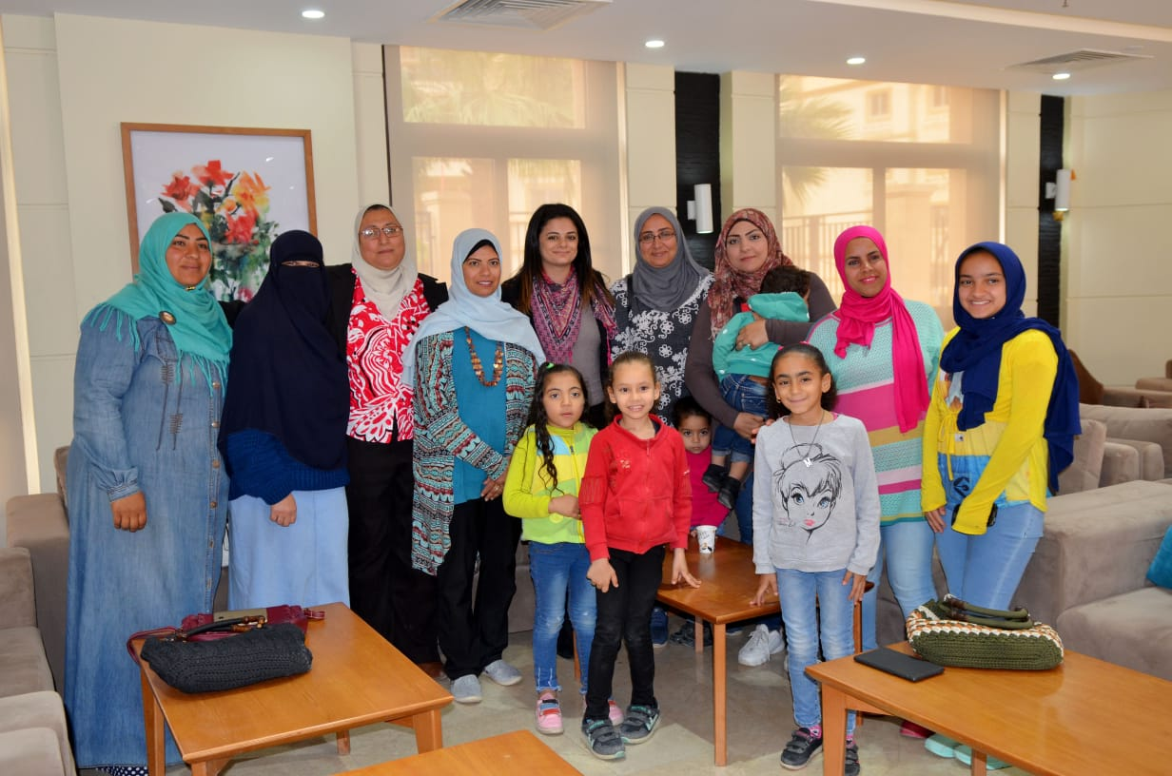
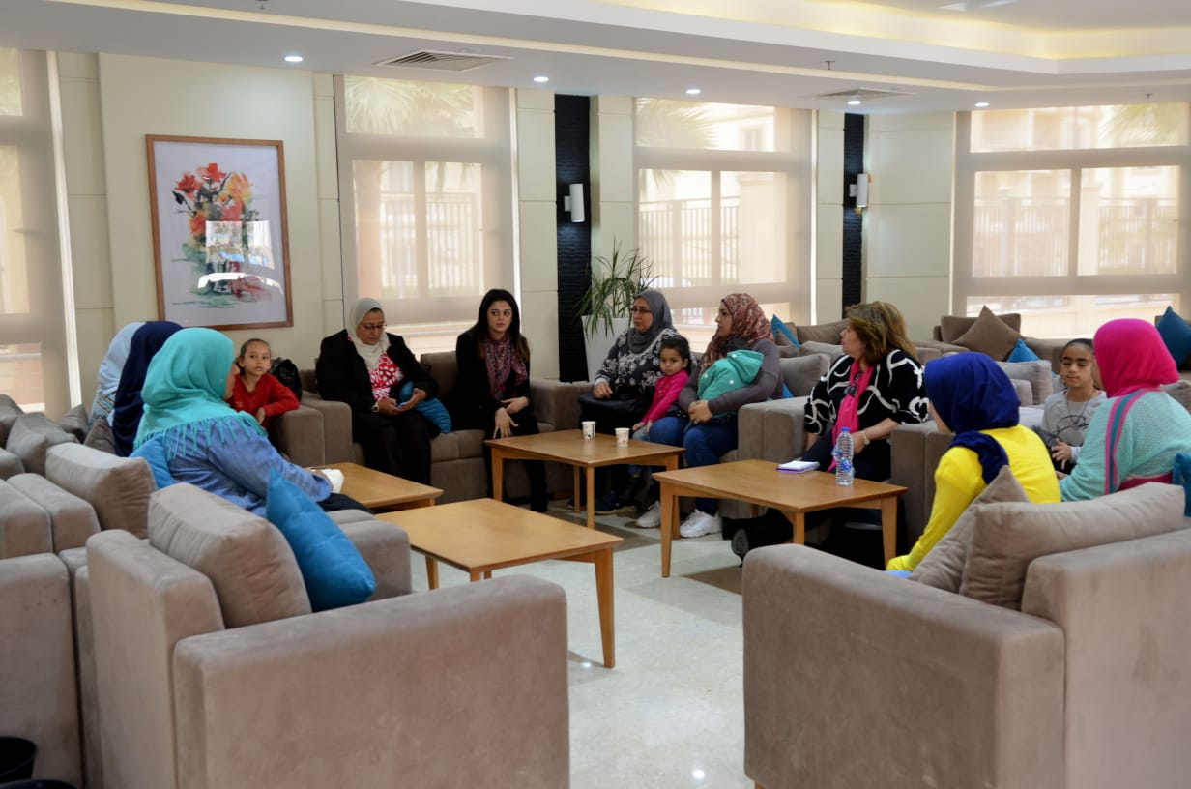
Figure 6: Discussion with Women in 6th of October City

Elderly inclusion. The elderly group discussions underlined that the program did not consider providing them with units on the ground or lower floor. However, upon receiving the unit, they could submit a request to change the unit to a lower floor, and their requests would be accepted upon availability.
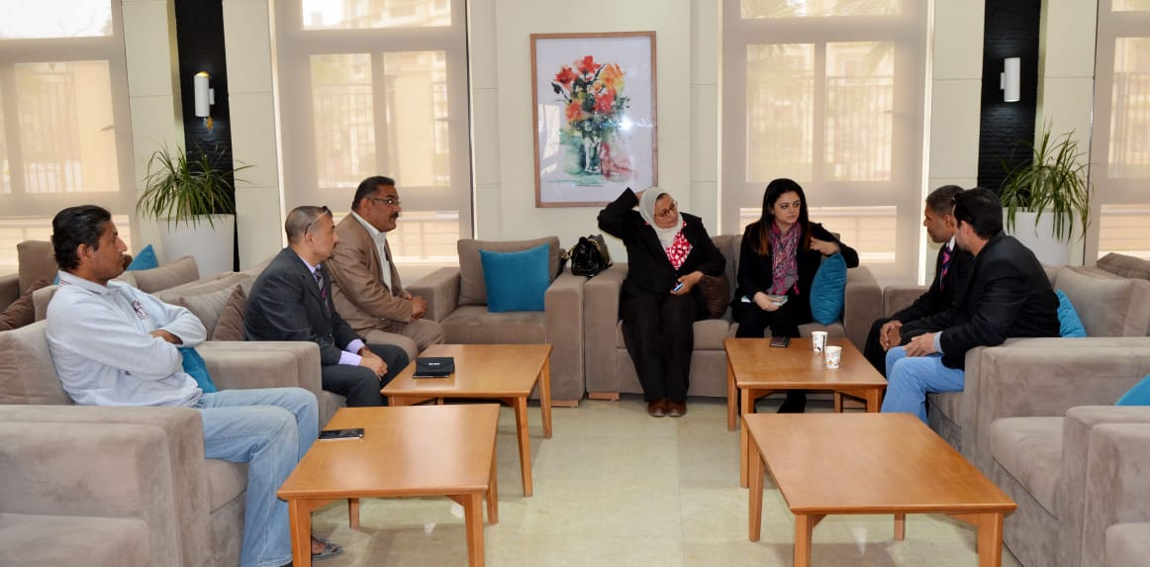
Figure 7: Discussion with Elderly (above age 40) in 6th of October City

Youth inclusion. Youth group discussions underlined the inconvenience some youth face in applying due to their companies’ refusal to provide HR letters with proof of income because of the temporary nature of their work. Yet, proving income is a major application requirement. Another issue they faced was the inability to provide insurance documents which was also due to their hired employers inadequate policies.
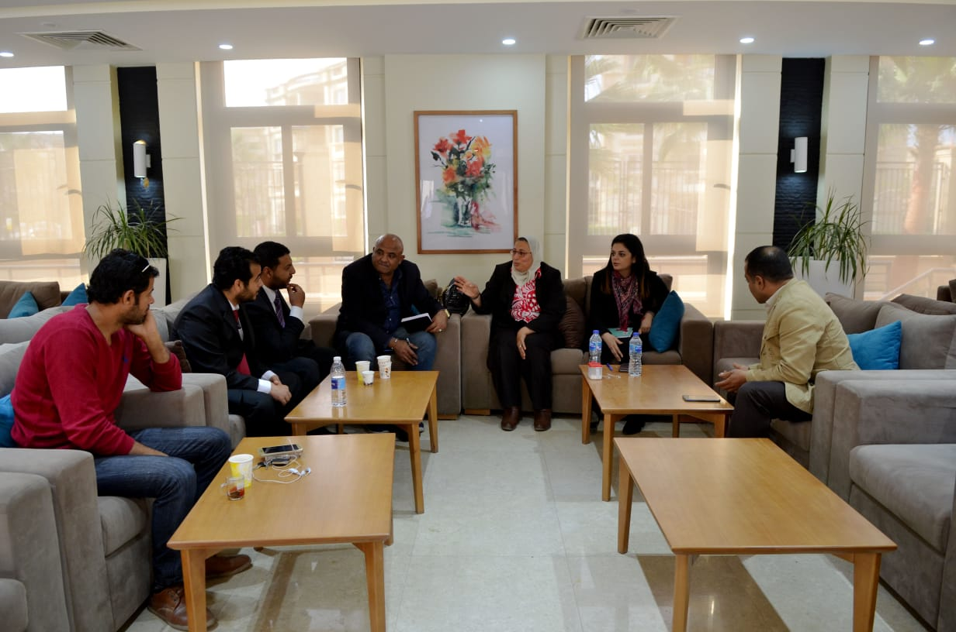
Figure 8: Discussion with Youth (below age 40) in 6th of October City

Social Cohesion.
- An individual mentioned he was continuously rejected from similar previous government affordable housing programs, after failing many application attempts. But with this program, he was able to receive a unit on his first attempt. He was surprised about the transparency in the application process and non-discrimination and equal opportunities he and his colleagues have encountered.
- Another individual mentioned that, for the first time, he is able to find a place where he really feels the sense of belonging and experiences being treated with dignity and respect. Through this program, his and his family’s needs and expectations were met in terms of immediate actions taken from the city authority in response to any issue faced in the unit, like water leakage, electricity issues, sewerage, etc.
- A woman mentioned she used to live with her kids apart from her spouse in her village. Due to their hard-living conditions, and after receiving the unit, they were all able to re-unite because they could pay reasonable monthly installments and were provided a unit close to the kids’ school and spouse’s work.
Recommendations.
Further areas of potential improvements brought up by the attendees included:
Raising awareness to all project beneficiaries though seminars about different channels available to them for application, grievances...etc. This recommendation was brought by an individual who aimed to support people who are less advantaged and marginalized due to their socio-economic conditions; more specifically the many people living in remote areas, those who do not read and write, those who do not watch TV, and those who do not know how to surf the internet and check website.
Supporting government efforts to better benefit from program interventions. Most of those who attended the sessions in 6th of October city seemed well educated with decent socio-economic level. Consequently, they took great initiatives in collecting issues facing the rest of the people living in the same area in which they live, and in presenting them to the city authority. In turn, the city authority – based on what they have personally witnessed – was always there to work on providing immediate assistance, not to mention these individuals’ own tremendous efforts to support the government’s efforts in improving the program’s outcomes, given the sense of belonging they experienced as a result of the program.
Early Planning and Design. Many individuals preferred the unit to be provided to them immediately after applying and getting their application approved. Early planning and design strategies could include: studying the demand on units first, then doing prior plans accordingly to make the units available immediately, and avoiding additional financial burdens to beneficiaries who pay rents for their current units and monthly installments for their future units at the same time.
Potential expansion of roads for increased demand and accessibility. An individual recommended building new roads and expanding others for people to access new areas and for them not to be left in isolation from the rest of the city. Furthermore, building and expanding roads would increase demand in some areas to meet excess supply in specific places in 6th of October city.
Coordination between Ministries. Most individuals expressed the importance of MOHUDD’s taking the lead in undertaking appropriate coordination with relevant ministries to ensure the provision of different crucial human resources (e.g., doctors, nurses, teachers) to allow the proper functioning of schools and healthcare units.
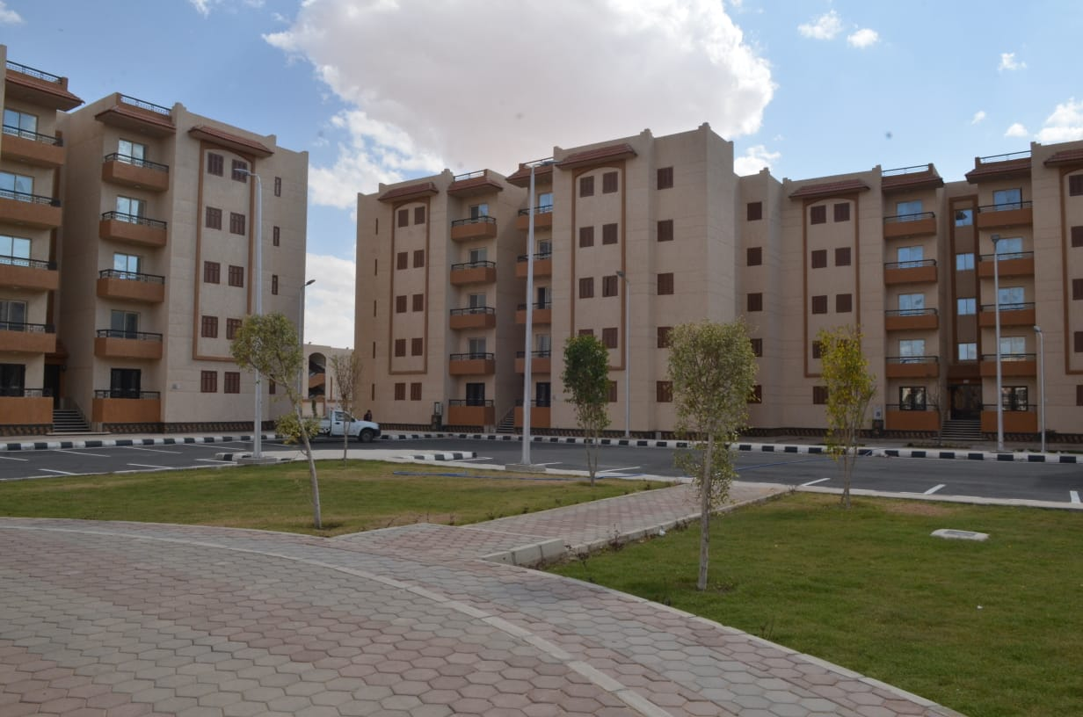
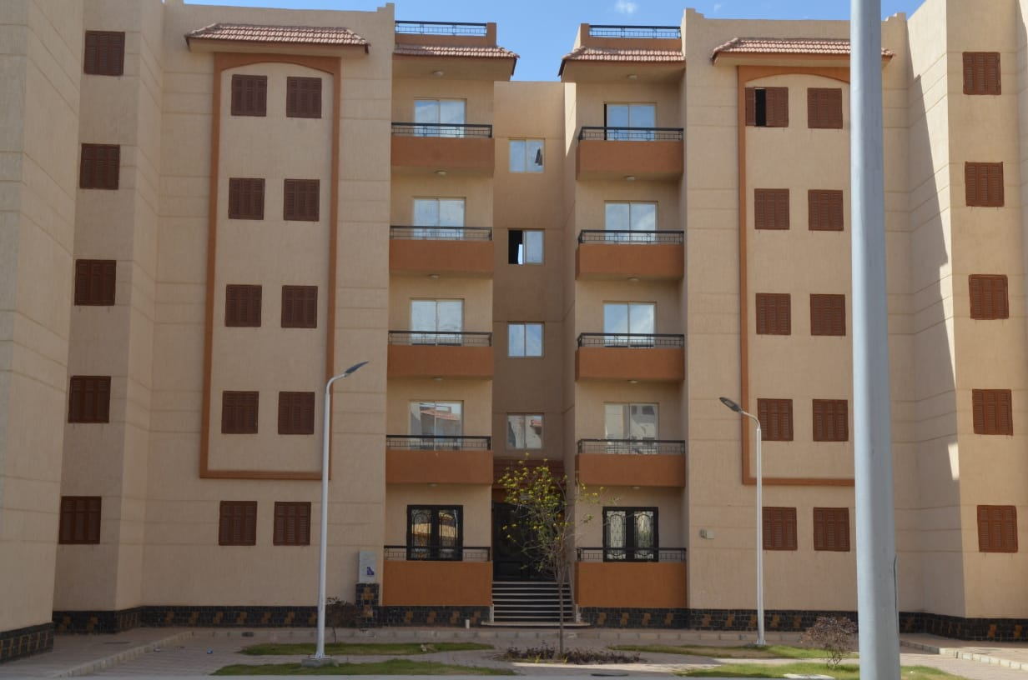
Figure 9: Design of the buildings in 6th of October city

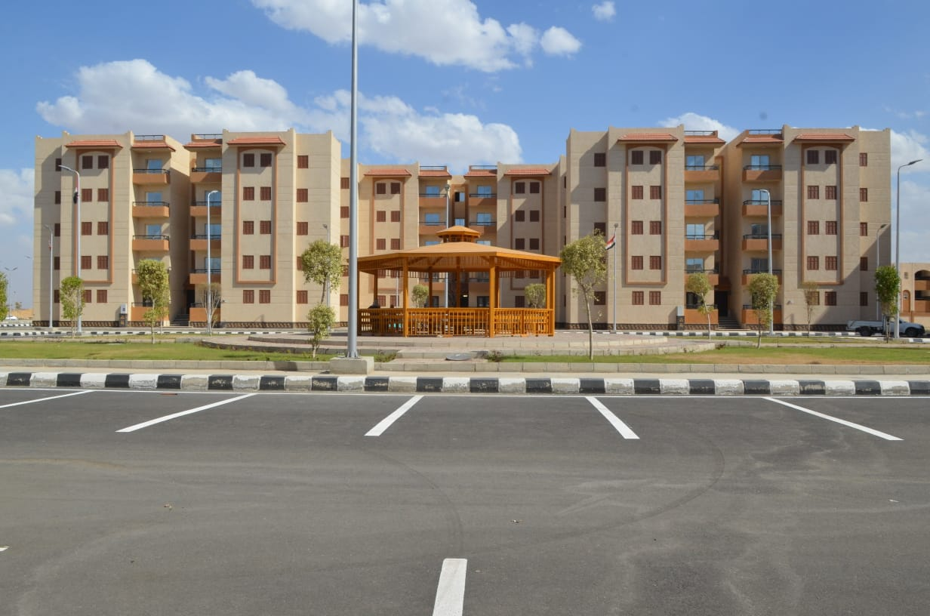
Figure 10: Social Infrastructure in 10TH of Ramadan City

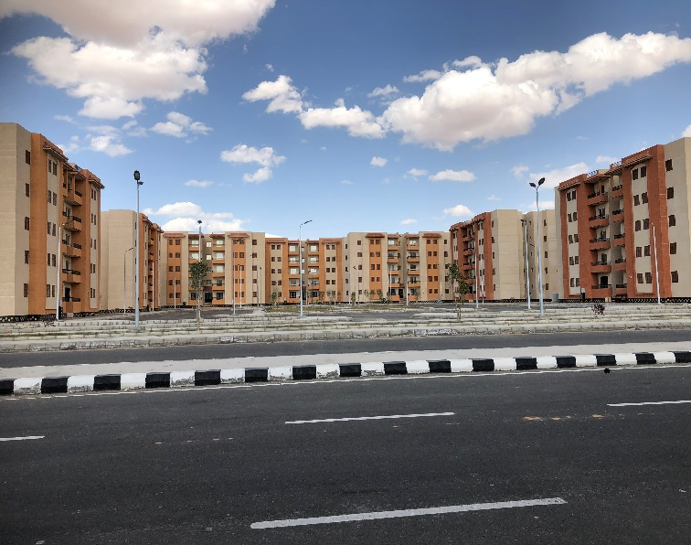
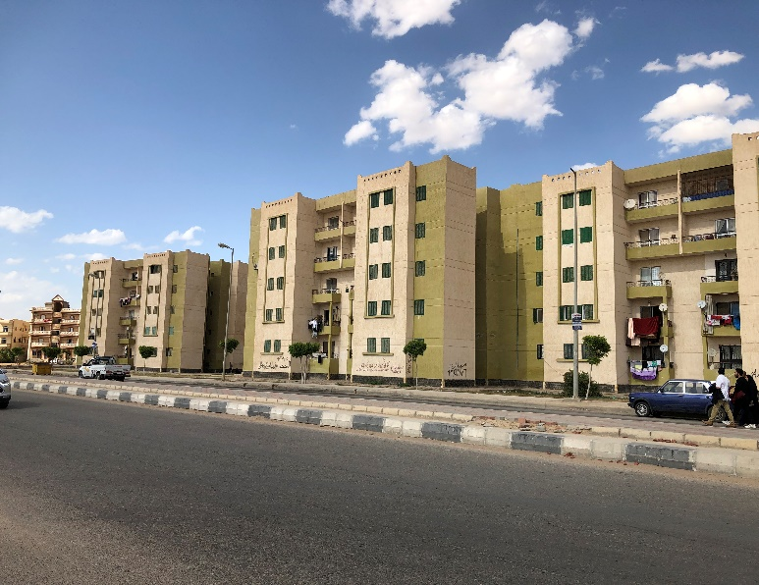
Figure 11: Road Infrastructure

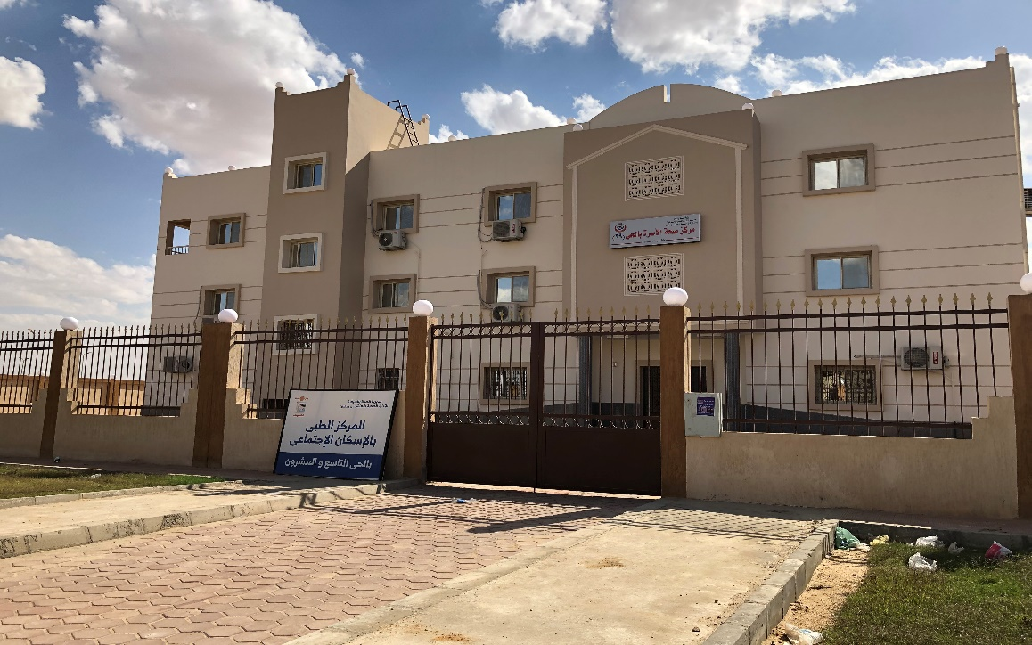
Figure 12: Healthcare facility

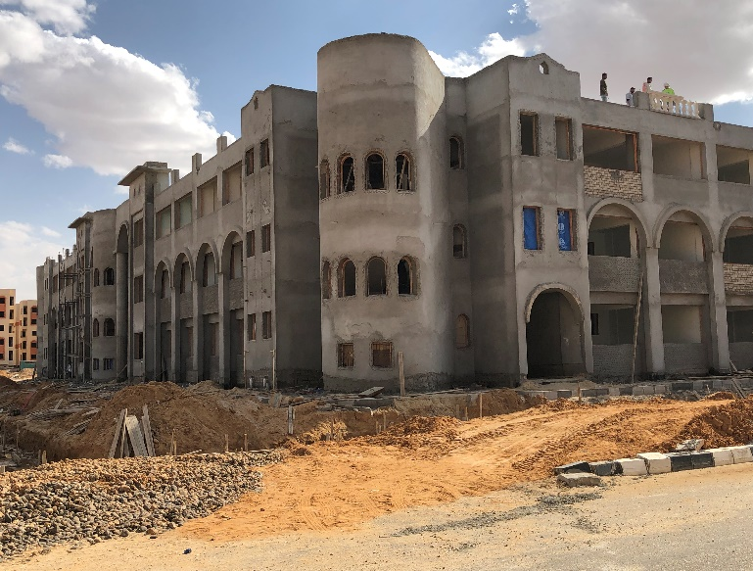
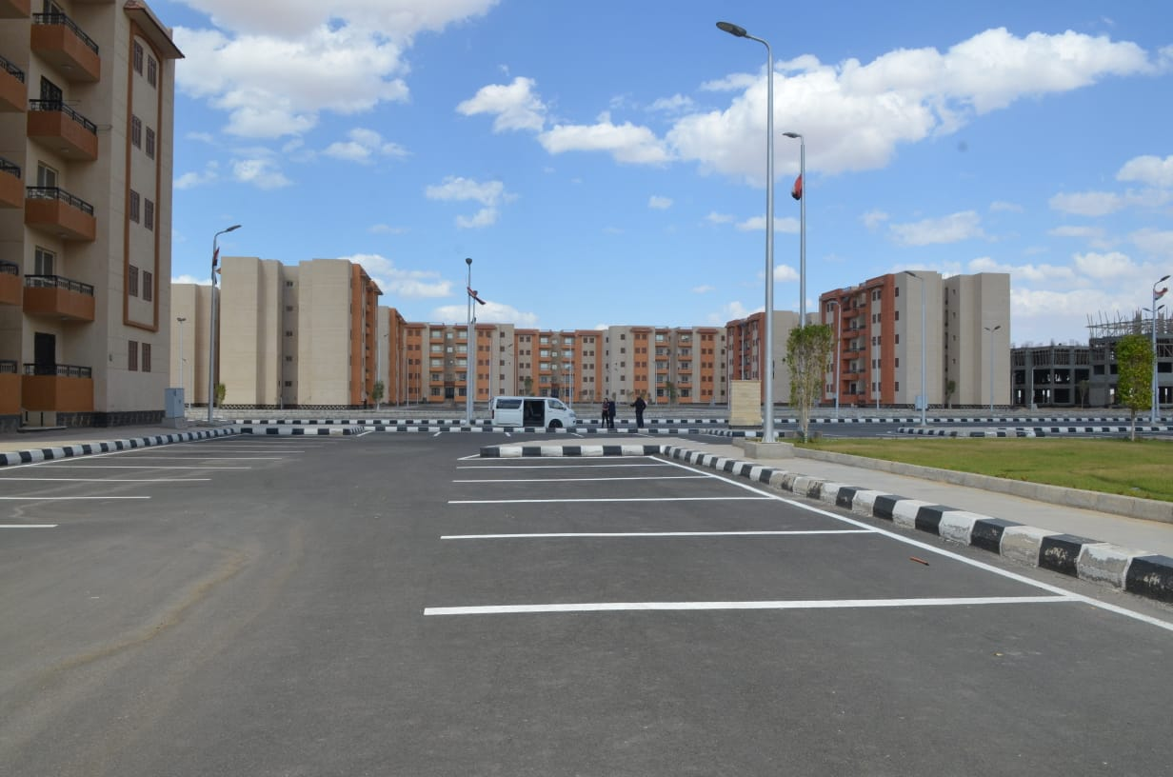
Figure 13: Parking area Figure 14: School under construction

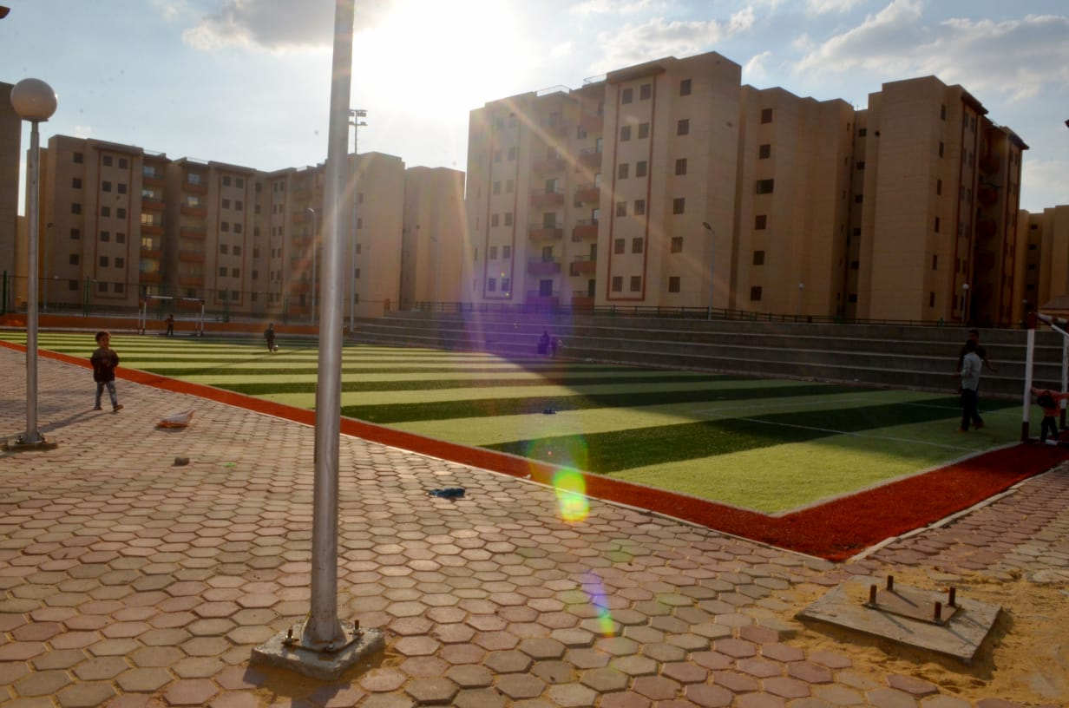
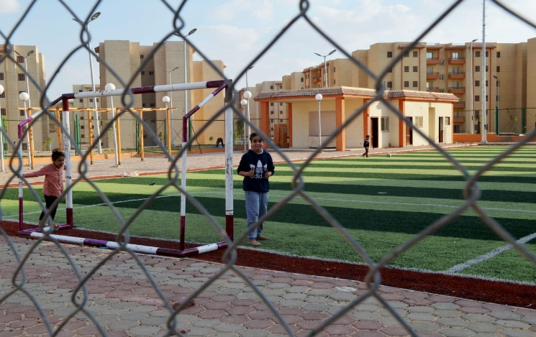
Figure 15: Social Infrastructure in 6th of October City

- Summary of interview with NGO representative:
In addition to an earlier interview with a Housing Think Tank representative, the Bank Social team conducted a meeting with Eng. Sameh Seif, founder of “Together Association for Development and Environment” and specialist in sanitation systems. His work is mainly in Minya and Beni Suef governorates in Upper Egypt and his organization provides support in housing, water and sanitations activities to poor villages.
Main issues discussed:
Background
Territorial exclusion. One major issue underlined by Eng. Seif was that the project targets lagging regions and villages less than it targets large urban cities, leading to a mismatch between where program benefits are provided and where more need for housing services exist. Hence, the program is not adequately reaching to the poor, and the more vulnerable areas as it should be.
Family setting. A family usually lives in a unit of 50-70 meters, with a number of family members ranging from 5 – 10 persons; notwithstanding that sons stay with their families after they get married. Accordingly, preference is given more to houses with 2 or 3 levels to accommodate extended families.
The project is extremely important for the poor people in the villages, since most families live in small houses comprising only one room, with livestock living in the same house.
Gender Dimension. FHHs face social and economic constraints. He estimated that thirty percent of households in Egypt are female-headed households and tend to be taking more micro-finance loans to raise their families. These women face major social and economic challenges, they need sustainability in provision of services and income to sustain their living.
Labor. Most of the labor is in agricultural activities. People prefer to live besides their farms and land, and not migrate. Nevertheless, if transport system were provided, they would be opened to using it to own units in the city and go to their agricultural land for work.

Recommendations:
Identifying mechanisms to address these people’s needs through the AF program. This can be done through:
- Units design. Considering housing needs through designing units with specific types and sizes in a way that can accommodate extended family and livestock.

- Outreach and awareness. Create a mechanism to work with organizations like “Together,” CDAs to expand outreach and communications on the program and work with beneficiaries in villages to access the benefit of the project.

- Communication and outreach plans. More awareness raising and outreach campaigns must be conducted to cover not only cities but also poor villages across Egypt. Eng. Seif proposed inviting the CDAs who are already well-established and have good relationships with the community. He also proposed coordinating efforts with other organizations like Misr el Kheir and others whose CDAs are active and work closely with the governorates to have their support extend to housing activities, following their ongoing support in health and education campaigns. Accordingly, this AF can be a good opportunity to start directly coordinating efforts to work on closing the gap between the government and the community.

- Preference for building and owning the houses. Since most people are building their own units, rather than getting a mortgage subsidy which would not apply to a village, it could be more feasible to provide home improvement loans and interest rate subsidies on these loans. Even though it is not currently covered under the AF program, there is a need for varied demand-side subsidies to cover these groups, which would give room for more options in terms of responding to diverse housing needs.

The approval of the Central Agency for Organization and Administration is necessary step per the Government procedures before assigning staff to this unit
This was not clear during the design of the parent Program, as it was assumed that subsidies will be given to units in newly constructed buildings as well as in existing buildings
World Bank. 2008. Towards an Urban Sector Strategy, paragraph 32.
Ministry of Housing, Utilities, and Urban Development 2014.
Central Agency for Public Mobilization and Statistics (CAPMAS) (the Egyptian Statistics agency) is currently conducting a survey to better understand current trends in the Egyptian housing market. The World Bank is supporting this activity in the context of the Enhancing Social Housing Governance Trust Fund. The results of the survey should become available by the end of April 2019 (after appraisal and closer to Board presentation).
In addition to the parent PforR, SHMFF capacity strengthening is supported by the Enhancing Social Housing Governance Transition Fund Trust Fund (P159757).
Minimum wage in Egypt is LE 1200 as of April 2019. An increase to LE 2000 has been submitted for approval to the Parliament.
It is worth noting that 19 percent is a significant figure taking into consideration the Egyptian context. Government studies show that more than 90% of assets in Egypt are owned by men. Also, according to the 2017 OECD report on Women’s Economic Empowerment, “the wife often has very limited or no assets. Then, throughout the marriage, property including the family home is usually registered in the husband’s name”
! million subsidies to provide homes to 3.6 million Egyptians (i.e. families with 3-4 members)
From this amount, 25 percent constitutes an advance as per the financial agreement.
Total program expenditures by parent program closure were forecasted to US$2 billion.
The PforR covers approximately a third of the of every down payment subsidy issued by SHMFF
This has been announced during the election campaign for President Sisi in 2014, confirmed in 2015, and more recently confirmed as part of the current government program. This was publicly announced: https://www.reuters.com/article/us-egypt-housing-idUSKBN0TS14620151209
The PforR has the development objective of improving the affordability of formal housing for low-income households in the Arab Republic of Egypt and strengthening the Social Housing Fund’s (now SHMFF) capacity to design policies and coordinate programs in the social housing sector.
CAPMAS (in charge of controlling data), SHMFF (liaising with investigation agencies), and lenders instead of six at the beginning (in addition, post office, Housing Developement Bank, and ministry).
The CBE does not let banks lend mortgage loans to individual buyers over a construction phase.
The FRA has experience in regulating installment sales practices. The FRA recently issued new regulations to regulate installment sales practices by commercial stores which were selling furniture and appliances on installment sales plans.
The tripartite arrangement provides that the financing of the construction phase is paid by the buyer to the developer through a financial institution and is later converted into a mortgage loan (with a bank or a mortgage company) when the construction is completed title is issued. This is regulated by the Mortgage Law.
The approval of the Central Agency for Organization and Administration is necessary step per the Government procedures before assigning staff to this unit
It is worth noting that the environmental assessment system in Egypt has been assessed in other PforRs and was found to be sufficient and compatible with the requirements of the World Bank, with some weaknesses in ensuring the implementation of the environmental assessment instruments.
In addition to the parent PforR, SHMFF capacity strengthening is supported by the Enhancing Social Housing Governance Transition Fund Trust Fund (P159757).
OECD Digital Economy Outlook 2015
See the whole study: https://pdfs.semanticscholar.org/6507/b2908b9dbe4a37f88935f1a27c5b67bbf392.pdf
http://www.mcit.gov.eg/ict_strategy
https://books.google.com.eg/books?id=T9IqCgAAQBAJ&pg=PA28&lpg=PA28&dq=MCIT+STRATEGY+and+legislative+package&source=bl&ots=IUEbAXT2OK&sig=ACfU3U3eXS_agnvHGK510O1V0Klegabz0w&hl=en&sa=X&ved=2ahUKEwjjibO68LThAhUKUhoKHd3ZBpIQ6AEwDnoECAgQAQ#v=thumbnail&q=MCIT%20STRATEGY%20and%20legislative%20package&f=true
See the whole strategy: http://ncw.gov.eg/wp-content/uploads/2018/02/final-version-national-strategy-for-the-empowerment-of-egyptian-women-2030.pdf
This was not clear during the design of the parent Program, as it was assumed that subsidies will be given to units in newly constructed buildings as well as in existing buildings
CAPMAS (in charge of controlling data), SHMFF (liaising with investigation agencies), and lenders instead of six at the beginning (in addition, post office, Housing Developement Bank, and ministry).
Government studies show that more than 90% of assets in Egypt are owned by men. Also, according to the 2017 OECD report on Women’s Economic Empowerment, “the wife often has very limited or no assets. Then, throughout the marriage, property including the family home is usually registered in the husband’s name”
As outlined in the program paper for the AF, Egypt is under an International Monetary Fund structural adjustment program which is showing positive signs of recovery. In addition, the program supports actions that are in line with the objectives of the IMF program including progressive elimination of the interest rate subsidy and PPPs on affordable housing to reduce fiscal expenses on affordable housing construction. While this structural adjustment is contributing to wide state budget reforms on the state level, some adverse impacts on the poorest include the removal of subsidies for a number of necessary goods and services.
The Housing demand survey is part of a series of technical assistance activities that the Bank will deliver under the Enhancing Social Housing Governance TF. These activities aim at supporting the implementation of the Inclusive Housing Finance Program.
According to the original Project Appraisal Document of the PforR, poor location of housing relative to employment affects women disproportionally. One of the main constraints women face is commuting long distances, which exposes them to sexual harassment and makes it more difficult for them to take care of their responsibilities that may require them to be closer to home.
This was reflected in the recent CAPMAS housing demand study.

