PNG Resource Governance Coalition

EITI NARRATIVE
A report for the EITI National Secretariat
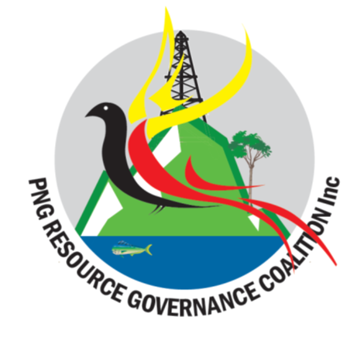
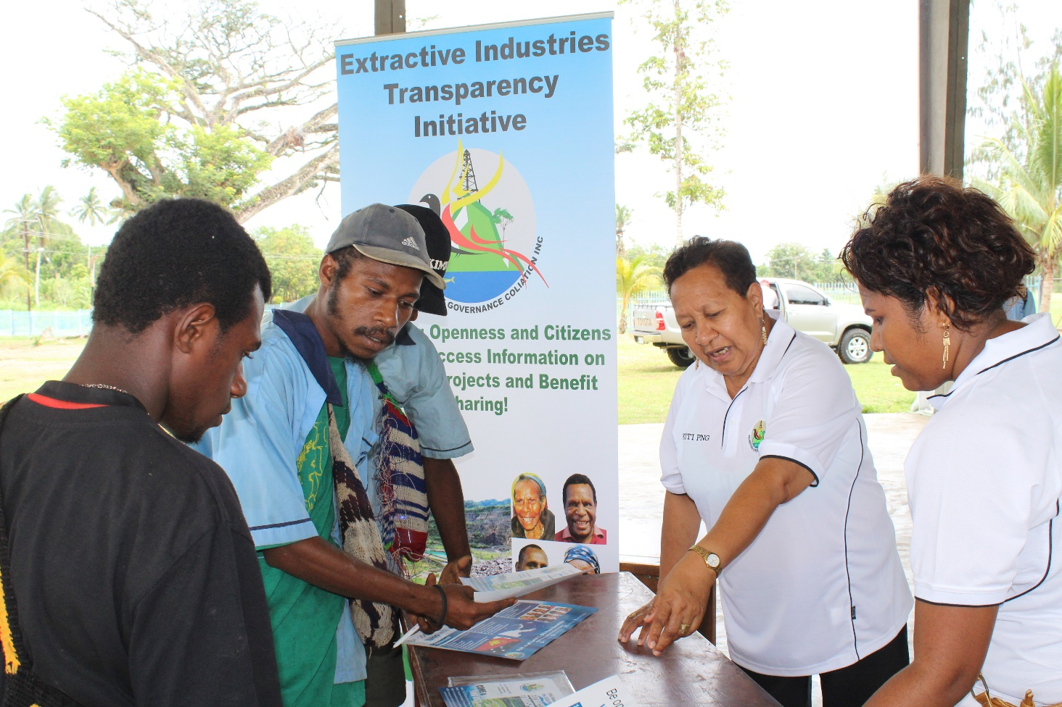

CONTENTS

EXECUTIVE SUMMARY | 3
SETUP OF PNGRGC | 5
ADVOCACY PROGRAM | 7
MADANG – MOMASE REGIONAL ROADSHOW | 7
KOKOPO – NEW GUINEA ISLANDS REGIONAL ROADSHOW | 9
MENDI – HIGHLANDS REGIONAL ROADSHOW | 11
KEREMA – SOUTHERN REGIONAL ROADSHOW | 12
MEDIA ENGAGEMENTS | 13
PUBLIC ENGAGEMENTS | 14
PUBLISH WHAT YOU PAY CAPACITY BUILDING | 15
WAY FORWARD | 16

EXECUTIVE SUMMARY

The national government has supported efforts to improve transparency and good governance in Papua New Guinea through the Extractive Industries Transparency Initiative (EITI).
Treasury allocated funds to assist civil society disseminate information on the EITI through the EITI National Secretariat.
The work of civil society in 2015 and 2016 was aimed at adding value to the National EITI Secretariat’s work plan and ensuring that PNG meets its EITI requirements.

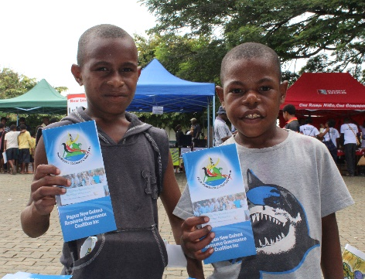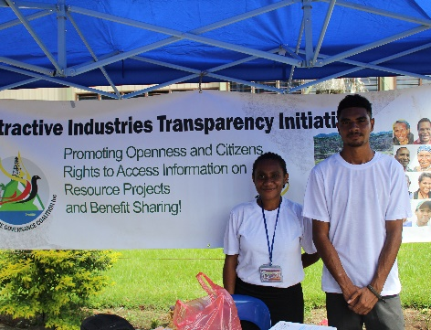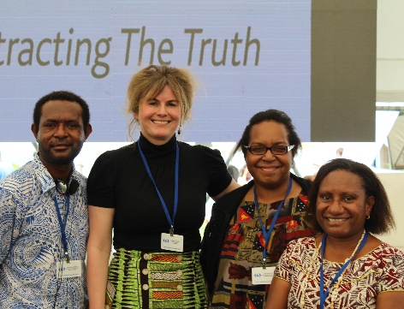

Delivering under Budget

In 2015, Civil Society requested a total of K 770, 700.00 from the Treasury Department’s civil society component of EITI funding.

OBJECTIVE | INITIAL FUNDING REQUESTED | OUTCOMES
Establishment of the PNGRGC & Capacity Support | K105, 200.00 | PNGRGC is a functional office that has delivered on all outcomes
Increase civil society/citizens active interests & engagement on the introduction, promotion and implementation of EITI in PNG | K 395, 000.00 | EITI posters, university seminars, Facebook Page, TV appearances, radio broadcasts.  Recognition by Divine Word University, the Pacific Community Geoscience Department , Pacific Network on Globalization and Queensland University as PNG’s civil society voice on Natural Resource Governance
Initiate programs & activities on EITI both at the national & sub-national levels in order to strengthen civic engagement and ownership of issues in the resource sector, in particular EITI. | K 170, 00.00 | 4 regional roadshows in Madang (MOMASE), Kokopo(NGI), Mendi (HIGHLANDS), Kerema (SOUTHERN REGION),  Divine Word University Open Day,

Above budget in money terms refers to how much was initially requested.

Papua New Guinea Resource Governance Coalition did not receive the amounts as requested.

As such civil society took a pragmatic approach to delivering on the outcomes.

Civil Society delivered 4 REGIONAL ROADSHOWS:
MOMASE REGIONAL EITI ROAD SHOW - IN MADANG
NEW GUINEA EITI REGIONAL ROADSHOW- IN KOKOPO
HIGHLANDS REGIONAL ROADSHOW - IN MENDI
SOUTHERN REGIONAL ROADSHOW – KEREMA

From the CSO perspective, the overall cumulative effect of government, civil society and industry cooperation has been the improvement of dialogue amongst all stakeholders.

SETUP OF PNGRGC

PNGRGC is a newly created national organization or movement that is broadly responsible for coordinating the Civil Society Organizations (CSOs) efforts in promoting and advocating the principles of EITI in PNG. PNGRGC is currently housed under CIMC.
Objectives

The objectives of the Coalition are to:

• be used as an umbrella organization to encompass all CSOs including community based, faith based, legal, environmental, transparency and anti-corruption and other non-governmental organizations that have an interest and work in or related to the Extractive Sector; accountability and the governance of the sector and the proceeds from the management and utilization of the resources;

• contribute constructively to civil society’s participation in the introduction, promotion, awareness and implementation of the EITI in PNG; including to hold industry and government accountable and support and guide CSO members of the EITI Multi-Stakeholder Group.

• introduce, promote and maintain programs and initiatives that are community focused in order to strengthen civil society engagement and ownership of issues in the resource sector;

• develop understanding and partnerships with other likeminded resource governance organizations locally and internationally;

• maintain high standards of good governance for the Coalition and its members;

• establish and maintain a register of membership, as the basis for programs and outreach activities; and

• do all such things as are incidental or conducive to the attainment of the objectives or any of them.

PNGRGC’s strategic partners have been Publish What You Pay (UK), CIMC, Institute of National Affairs (INA), Transparency International PNG (TIPNG), Business Against Corruption Alliance (BACA), and Center for Environmental Law and Community Rights (CELCOR), Eco Forestry Forum (EFF), and various other community based organizations and institutions.
Publish What You Pay, CIMC and INA and provided administrative and technical support to PNGRGC.
Business Against Corruption Alliance has provided funding assistance for radio broadcast and roadshows.
TIPNG recently funded a workshop conducted by PNGRGC in Kavieng.
CELCOR, EFF and others have provided technical assistance during regional roadshows.
PNGRGC has a well-equipped and functioning office that is currently located at Level 2 IPA Building and is managed by the Consultative Implementation and Monitoring Committee.

Funds have been used for the purchase of office equipment and its daily running as per the funding proposal.

ADVOCACY PROGRAM

These milestone activities encapsulate various specific targets expressed in the proposal to the EITI National Secretariat. This includes media coverage, stakeholder engagement, capacity building of journalists and civil society activities.

MADANG – MOMASE REGIONAL ROADSHOW

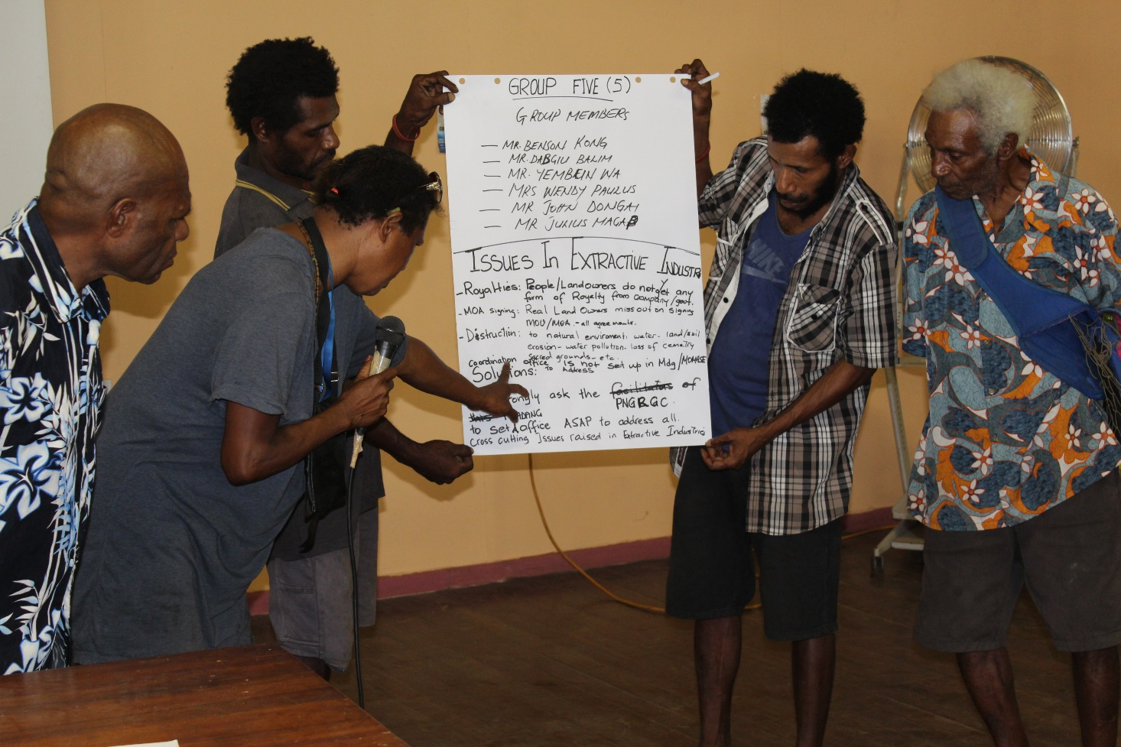PNGRGC Hosted the Momase EITI regional roadshow in Madang from the 10th -12th of November 2015. Participants from across the region were brought to Madang to attend a one day EITI awareness workshop that was also attended by over 300 local people.

Visits to Academic Institutions involved TUSBAB Secondary School and Madang Maritime College

Business Breakfast with Madang Chamber of Commerce, and training for Madang based Journalists. A public forum was then held at Jomba Catholic Hall.

The General Outcomes of the roadshow included;

- Formation of Momase Regional EITI Coalition
- Coverage of extractive sector issues by Madang based journalists
- Invite from Divine Word University to discuss EITI with staff and students
- Generation of public interest from across the Momase region including the special request for EITI training from East Sepik

KOKOPO – NEW GUINEA ISLANDS REGIONAL ROADSHOW

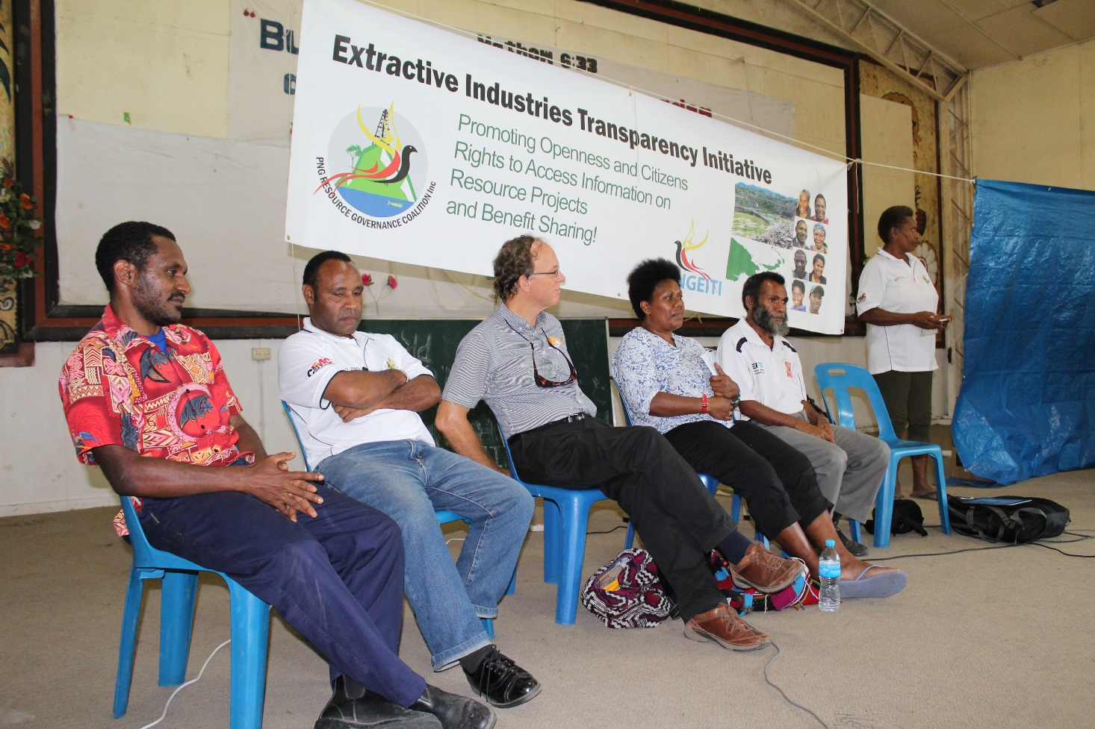PNGRGC hosted the New Guinea Islands EITI regional roadshow in Kokopo from the 25th – 27th of November.

Participants from across the region were brought to Kokopo to attend a one day EITI awareness workshop that was also attended by over 100 local people.

Other Activities included:

- Visits to Academic Institutions – Malabunga Technical Secondary School and Kokopo Secondary School

- Business Breakfast with local leaders from East New Britain

- Training for Kokopo Based Journalists

- Public Forum at Vunapope Catholic Hall

General outcomes of the roadshow included;

- Formation of a New Guinea Islands Regional EITI Coalition headed by Mrs. Rosemary Sovek
- Coverage of extractive sector issues by Kokopo based journalists
- Further invite from Transparency International PNG to participate in its anti-corruption open day in Kokopo
- Increased interest from the region leading to a further EITI workshop held in Kavieng in 2016 and sponsored by TIPNG

MENDI – HIGHLANDS REGIONAL ROADSHOW

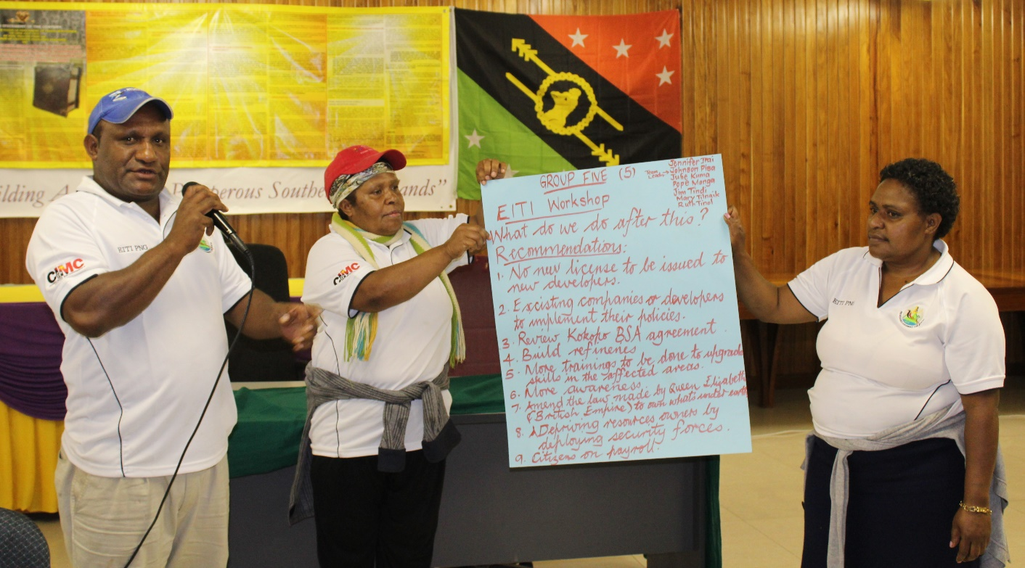PNGRGC Hosted the Highlands EITI regional roadshow in Mendi from the 9th to 11th of March 2016

Participants from all across the highlands region attended the EITI workshop including representatives from Exxon Mobil.

Local academic institutions such as Mendi Secondary School and Mendi School of Nursing were visited.

The team also conducted a 1 hour EITI awareness broadcast on radio Southern Highlands.

The team also visited the local market and conducted EITI awareness

General outcomes of the roadshow included;
- Interest from Southern Highlands Provincial Government in sharing EITI Messages on their website. EITI material provided.
- Formation of highlands regional EITI Cluster group
- Further participation by Radio Southern Highlands manager in subsequent EITI Civil Society workshop due to his continued interest

KEREMA – SOUTHERN REGIONAL ROADSHOW

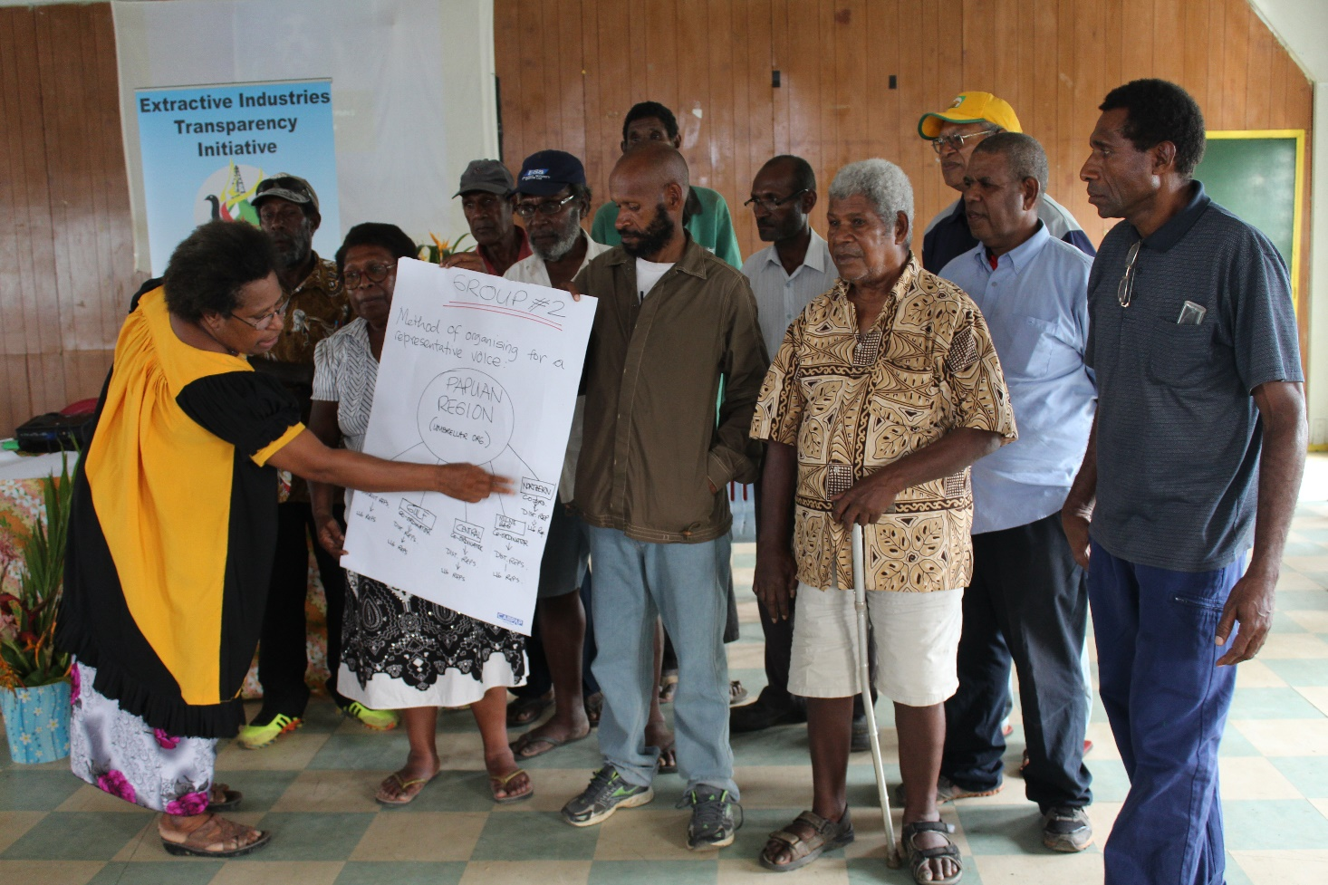PNGRGC Hosted the Southern EITI regional roadshow in Kerema from the 1th to 13th of May 2016.

The team visited Kerema Secondary School on the first day.

The next two days comprised of workshop presentations. Due to the logistical and communications challenges in the region, regional participants felt that provincial EITI contact points were more viable than a regional coalition

General outcomes of the roadshow included;

- Continued engagement with the Gulf Provincial Administration through Deputy Administrator Mr. Ahovo Laepa.

- Formation of a Gulf EITI Pressure Group and continued feedback with PNGRGC on development of constitution of group. IPA registration is currently pending.

- Continued communications with Star Mountains (Ok Tedi) local representative.

MEDIA ENGAGEMENTS

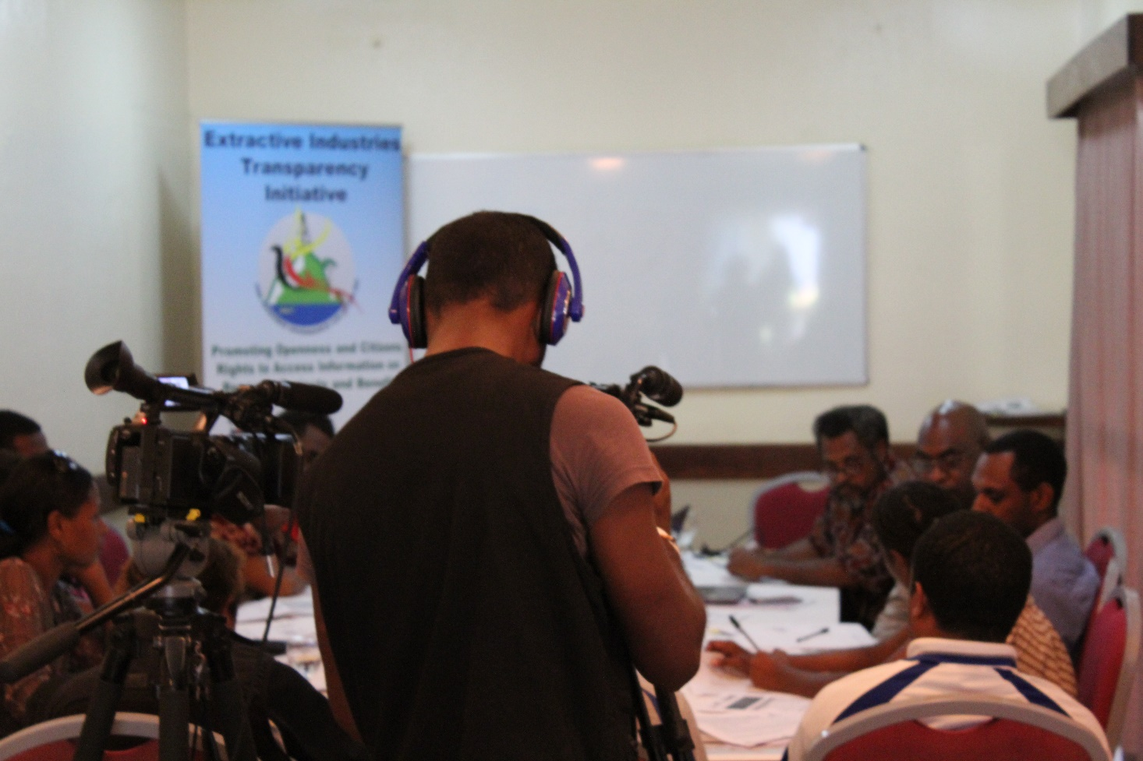PNGRGC recognizes the media as an important enabler of information dissemination to the masses. However communication information about the EITI can be too technical and difficult if journalists are not equipped with the knowledge about PNG’s resource sector.

PNGRGC conducted trainings for Journalists based in Madang and Kokopo and will continue to do so in the years to come.

PNGRGC also recognizes that the PNG Chamber of Mines and Petroleum provides similar training for Port Moresby based journalists.

PNGRGC is therefore more focused on sub national engagement with journalists. However during the Southern regional roadshow held in Kerema, PNGRGC facilitated the attendance of Port Moresby based journalists from the Post Courier and EMTV.

PUBLIC ENGAGEMENTS

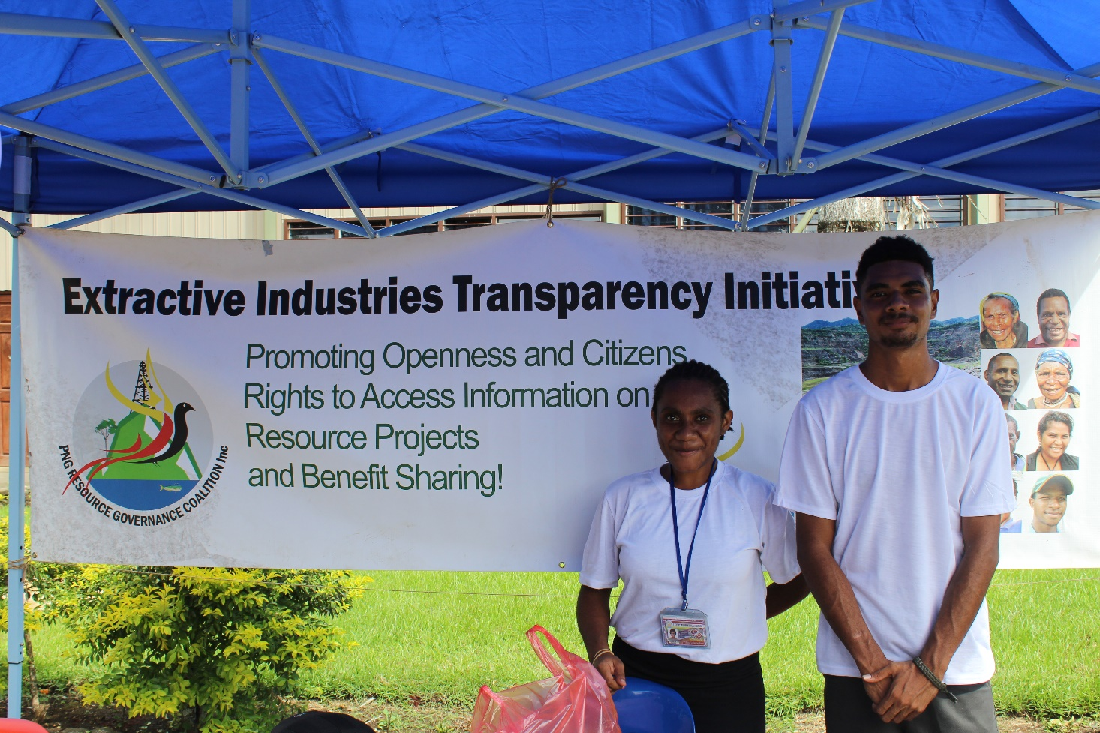PNGRGC had display booths in Kokopo and Madang in 2016.
In Kokopo, PNGRGC had sponsored a booth during Transparency International’s regional open day

In Madang, PNGRGC had a display booth at during the Divine Word University Open Day.

Engagements with broader civil society are key not just in terms of spreading the message about the EITI but also in terms of engaging the academia in shaping the implementation of the EITI.

PNGRGC is also PNG’s sole civil society representative on at the newly formed Pacific Center for Social Responsibility and Natural Resources.

PUBLISH WHAT YOU PAY CAPACITY BUILDING

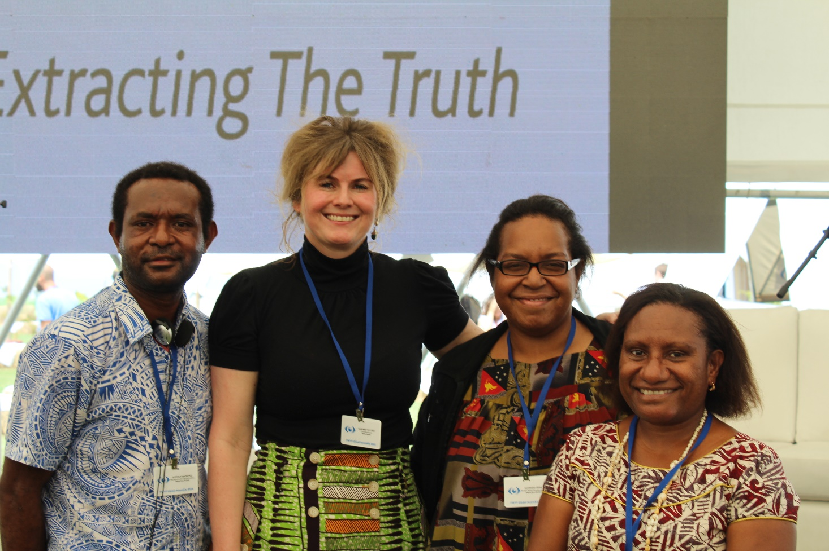
Publish What You Pay UK has been PNGRGC‘s key strategy partner, providing capacity building support for civil society.

PNGRGC and its coalition partners’ links with PYWP ensures that PNG’s CSOs are part of a global network of civil society organizations involved in the EITI process.

In late 2015, the Philippines EITI Coalition hosted PNGRGC Coalition members.

PNGRGC Coalition members also attended the 2016 EITI Conference in Lima, Peru.

The Philippines study tour has enabled PNGRGC to improve its capacity to build a coalitions at the sub-national level.

Participation of CSO coalition members at the EITI Global conference in Lima provided insights into international best practices as well as an opportunity for CSO coalition members to participate during panel discussions.

Publish What You Pay also assisted PNGRGC in defining PNG’s civil society goals in EITI implementation during a workshop hosted at Lamana in May 2016.

WAY FORWARD

PNG Resource Governance Coalition is the umbrella civil society organization see the following areas as key to achieving CSO aspirations in EITI implementation.

These are its two main areas with the following overall objectives:
- Enhancing transparency and accountability in the EI in PNG
  - Supporting the implementation of the EITI in PNG
  - Going beyond the EITI requirements
  - Supporting CS role in the implementation of other transparency initiatives: the OGP
- Strengthening of the Coalition
  - Building the capacity of the coalition members
  - Enhancing the governance structure of the coalition
  - Establishing a communication strategy
  - Diversifying sources of funding for the coalition

GOAL: Enhancing transparency and accountability in the EI in PNG
OBJECTIVE | Activities | Expected outcomes
Supporting the implementation of the EITI in PNG | -Setting up a communication plan between civil society reps on the MSG and the wider CS  -Regular discussion of MSG agenda and with agreement on CS stance on issues prior to MSG meetings  -Increasing regional CS representation on the MSG  -Dissemination of information from the EITI report: (Infographics, photobooks from extractive areas related to points addressed in the recommendations, eg: environmental damage photos,..)  -3 radio shows engagements | PNG EITI National Secretariat plan endorsed by PNGRGC Coalition Partners  CSO MSG Members fully briefed on CSO stance by coalition partners  At least one regional representative on MSG by 2018  Communications material published and disseminated  Production of EITI Advert for Radio
Going beyond the EITI requirements | -Produce recommendations for the next EITI 2015 report that demand the inclusion of environmental information, and contract disclosure. | 2015 report to include environmental data and contract information
Supporting CS role in the implementation of other transparency initiatives: the OGP | -Give input on the National action Plan of the OGP through the CS group (Wallis, Paul, Martyn, Emily, Eco forestry)  -Monitor the implementation of the NAP and present recommendations to the annual IRM (evaluation report for the OGP produced annually by PNG). | Implementation of OGP National Action Plan including EITI Cluster Group plan
Enhance communication amongst civil society representatives and the wider civil society | -Write a communication plan for CS reps on the MSG and the wider CS. (regular updates, meetings, creation of email list...etc)  Website and Mailing List | Communications Plan approved and implemented
Raising awareness around the EITI | -Engage the academia and youth through targeted seminars at the universities to explain about the EITI, contract disclosure, revenue management, sharing. | Form EITI focal points (nodes) at Universities
Support contract disclosure in PNG | -Perform a mapping of allies and advocacy plan.  -Meet with primary targets  -Set up joint meetings with National EITI secretariat and Chamber of Mines.  -Lobby with some MPs to set up an energy committee.  -Commission an investigative piece about agreements that are already accessible to the public, while pointing out why it is beneficial to the government and companies to publish these agreements. | Disclosure of contracts by government and companies  Meeting held between PNGEITI National Secretariat/ Chamber of Mines and Petroleum and Civil Society  Meeting with Minister Hon Ben Micah, Minister for Petroleum and Energy  Publication of Investigative Piece
OBJECTIVE | ACTIVITIES | Expected outcomes
Building the capacity of the coalition members | -Participating in the NRGI Hub in Indonesia  -Produce a position paper on revenue sharing at the subnational level  -Invite experts from PNG (become friends of the coalition) to hold subject specific seminars (2 seminars). | 2 PNGRGC Coalition members attend  Position paper published  2 Seminars held
Enhancing the governance structure of the coalition | -Draft a code of conduct for CS representation on the MSG  -Run council elections and select the executive board members as per the coalition charter  -Do a connections mapping exercise for the coalition members | Code of Conduct Approved by coalition  Board elected  Processes mapped
Subnational Capacity Building Workshops for CSO Leaders | Conduct Capacity Building workshops in Kerema, Mendi, Kokopo and Madang | CSO Leaders empowered with  -Basic information on PNG’s mineral and hydrocarbon legal and regulatory framework with special focus on seabed mining  - information on Land law and landowners rights in the resource sector in relation their benefits  - tools on constructive engagement with the government regulators and resource companies  - capacity to use of mainstream and social media tools for advocacy  - capacity to Network and build coalitions

Conclusion

Civil society has delivered on its proposed activity plan to the EITI National Secretariat.

Due to the fact that the amount provided to civil society was less than what had been requested, adjustments had to be made to accommodate the deficit.

Adjustments had to be made in terms of recruitment of communications staff and the purchase of a vehicle as well as the setting up of the website.

Nevertheless, PNGRGC has been able to overcome its logistical and communications challenges by leveraging partners in civil society and the media.

PNGRGC continues to advocate for greater transparency in the resource sector. PNG’s civil society have identified Contract Transparency as an important first step in ensuring a more open and transparent management of natural resource wealth. Fiscal and land access contracts define the benefits from resource extraction. One cannot talk about natural resource revenue transparency without understanding the agreements the dictate benefit streams.

PNGRGC also recognizes that natural resources wealth can be translated into sustainable human development through the promotion and implementation of the government’s National Strategy for Sustainable Development.

PNG’s civil society organization have made an enormous contribution towards EITI implementation. Continued support from the national government through its state-CSO partnership initiative is essential for continued success of EITI implementation in PNG.

