
E 4116v2
Beograd, Bulevar kralja Aleksandra 282
tel: +381 11 30 40 700
fax: +381 11 30 40 699

ROAD REHABILITATION AND SAFETY PROJECT (RRSP)

Rehabilitation and Maintenance of State Roads of the 1st and 2nd category in the Republic of Serbia

site-specific
ENVIRONMENTAL MANAGEMENT PLAN

for
road rehabilitation works on State Road of the IB Class, No. 23 (old marking; M-4) Lazarevac – Topola, section :

ARANDJELOVAC – KRCEVAC

- Environmental Category B -

FINAL DOCUMENT
BELGRADE, December 2012

TABLE OF CONTENTS

INTRODUCTION ………………………………………………………………………..4
EXECUTIVE SUMMARY ………………………………………………………………..4
EXECUTIVE SUMMARY ………………………………………………………………….4
1. PROJECT DESCRIPTION ……………………………………………………….10
2. POLICY, LEGAL AND ADMINISTRATIVE FRAMEWORK ………………….13
3. BASELINE CONDITIONS ASSESSED DURING ROUTE SURVEY ………..14
4. SUMMARY OF ENVIRONMENTAL IMPACTS ……………………………….17
5. ENVIRONMENTAL MANAGEMENT PLAN ……………………………………20
A. MITIGATION PLAN 20
B. MONITORING PLAN 26
C. INSTITUTIONAL IMPLEMENTATION AND REPORTING ARRANGEMENTS 27
6. STAKEHOLDER ENGAGEMENT - INFORMATION DISCLOSURE, CONSULTATIONS, AND PARTICIPATION …………………………………..30
7. REFERENCE ……………………………………………………………………..31

APPENDICES

I EMP - MITIGATION PLAN
II EMP - MONITORING PLAN
III RELEVANT SERBIAN LEGISLATION
IV STAKEHOLDER ENGAGEMENT AND PUBLIC CONSULTATION

ABBREVIATIONS AND ACRONYMS

AADT Annual Average Daily Traffic
CEP Contractor’s Environmental Plan
EBRD European Bank for Reconstruction and Development
EIA Environmental Impact Assessment
EIB European Investment Bank
EMP Environmental Management Plan
HSE Health, Safety and Environment
IFIs International Financing Institutions
INP Institute for Nature Protection of the Republic of Serbia
IPCM Institute for Protection of Cultural Monuments of the Republic of Serbia
MoEDEP Ministry of Energy, Development and Environmental Protection
MoT Ministry of Transport (fmr. Ministry of Infrastructure and Energy – MoIE)
PERS Public Enterprise “Roads of Serbia”
PSC Project Supervision Consultant
RE Resident Engineer
RRSP Road Rehabilitation and Safety Project
SE Site Engineer
SLMP Safety Labour Management Plan
SSIP Site Specific Implementation Plan
WB The World Bank Group
WMP Waste Management Plan
INTRODUCTION

This Environmental Management Plan (EMP) has been prepared for the proposed rehabilitation of the State Road of the IB class, no. 23 (old marking; M-4), section Arandjelovac - Krcevac to ensure application of the good environmental practice and document compliance with the requirements of the International Financing Institutions which will finance Serbian Road Rehabilitation and Safety Project. This road section is 8,7 km long. The Project has been classified as Environmental Category B. i.e., a project requiring an EMP pursuant to WB, EBRD and EIB Safeguard Policies.

The Project Proponent is the Government of Serbia, acting through its Ministry of Transport (MoT), former Ministry of Infrastructure and Energy (MoIE). Project implementing entity is Public Enterprise Putevi Srbije (PERS).

The objective of this EMP is to address the environmental impacts and management issues associated with the proposed road rehabilitation. Project will comply with Serbian legislation, procedures and policies, international conventions and IFIs safeguard policies.

This site specific EMP is focusing more on the rehabilitation phase of the selected investment, as it will become part of the respective Contract for the implementation of civil works, and as such, the future contractor's obligation. The activities related to subsequent regular maintenance of this section are not the main focus of this EMP, but are presented herewith for the purpose of completeness.

The preparation of this EMP was undertaken through a desk study and field investigations, including consultations with regional level representatives and local stakeholders. The EMP is based primarily on field investigations performed during July and August 2012.

EXECUTIVE SUMMARY
Project description

Road Rehabilitation and Safety Project (RRSP) represents the first phase of the Government’s National Road Rehabilitation Program and is expected to cover, over a period of 4-5 years, the rehabilitation of about 1,370 km of national roads spread over the entire country.

Road rehabilitation works on proposed road section Arandjelovac - Krcevac belongs to the list of sub-project to be implemented during first year of project implementation and it is selected as one of 4 relevant sample sections (sample subprojects) for which site-specific EMPs are prepared in the first batch of projects.

Proposed road section is located in the Sumadija District, and belongs to the state road of the IB class, no. 23 (old marking; M-4) on Lazarevac – Topola road direction. Administrative units where the section is located are municipality of Arandjelovac and municipality of Topola. Length of the section to be rehabilitated is 8,7 km.
Although being characterized as rural, the section is recognized as one with a dense construction alongside the road and there is a significant number of commercial and private buildings, especially to the chainage mark of km 5+000. Afterwards, the section really becomes a rural one. Special attention should be paid to the area near the “Knjaz Milos” factory (at km 0+397 to km 1+500), as well as to the area of primary school in Banja settlement (at km 3+485). The said locations should be particularly treated from the safety improvement point of view.

It is necessary to have a pavement widening of app. 1.00-1.20 m along the whole section. An assessment is that it would be more appropriate to have the widening constructed on the right pavement edge, as there are fewer accesses on this side. It is necessary to plan a removal of marginal strip made of small-sized stone setts on the side of widening as the strip was noted on some of the locations along the section. However, there will be no relocation and resettlement issues as defined by OP 4.01 during project preparation and implementation.

On some of the sub-sections, cold recycling should be applied as relevant pavement rehabilitation measure, while the remaining sub-sections would be improved by additional layers with previous slope staking and leveling. Pavement widening and removal of marginal strip along the whole section with construction of new pavement are also considered necessary. At locations of pavement depressions and cracks, it is necessary to have a deep pavement repair.

The existing sidewalks from the beginning of the section to km 1+500 should be rehabilitated, new ones should be designed on locations of interruptions and where the sidewalks are missing by km 5+000 since there is a school at km 3+500 and the pedestrian movement is intensive.

Policy, legal and administrative framework

The Ministry of Energy, Development and Environmental Protection (MoEDEP), former Ministry for Environment and Spatial Planning is the key institution in Serbia responsible for formulation and implementation of environmental policy matters.

The environmental legislation currently in force in Republic of Serbia is summarized in Appendix III.

In the Republic of Serbia, the Environmental Impact Assessment procedure is regulated by the Law on Environmental Impact Assessment, which is completely in line with European EIA Directive - 85/337/EEC. Therefore Environmental Impact Assessment is not required for road rehabilitation projects unless theirs alignment is placed within or in the vicinity of natural/cultural protected areas. Road section Arandjelovac - Krcevac is not placed within the vicinity of any protected area so EIA is not required for this project in accordance with the Serbian legislation.

Lender requirements will also apply to this project and include the following Environmental Policies
- Operational Policy OP 4.01 Environmental Assessment;
- EBRD Environmental and Social Policy 2008
- EIB Statement of Environmental and Social Principles and Standards (2008).

EBRD and EIB will require that the project complies with the Republic of Serbia national laws and EU standards. WB will require that the projects comply with the Serbian legislation and the Bank’s OP 4.01.

Baseline conditions assessed during route survey

On subject road section (sample subproject) there are no protected natural or cultural areas which could be endangered by the road rehabilitation works. There will be no land acquisition as defined by OP 4.01 during the project implementation.

The start of the section is in city of Arandjelovac and it goes to km 8+700. Although being characterized as rural, the section is as one with a dense construction alongside the road and there is a significant number of commercial and private buildings, especially to the chainage mark of km 5+000. The significant structures are “Knjaz Milos” factory at km +397 to km 1+500 and the primary school at km 3+485.

The Kubrsnica River runs in parallel with the section, on the right side in a direction of the chainage mark increase, at distance of 50-100 m.

Within the corridor of road section Arandjelovac - Krcevac there is no significant point sources of air pollution. Existing major road Lazarevac – Topola (M-4) is linear sources which cause emission of air pollutants along the corridor of proposed road section.

Current traffic load (AADT) on Arandjelovac – Krcevac sub section is 4.100 vehicles/day.

Summary of environmental impacts

The possible temporary impacts as consequence of the construction activities will consist of, among others, disruption of current traffic circulation, roadway safety, damage to access roads, dust nuisance, and gaseous emissions, potential pollution of soils and water resources, brief disturbance to biota, and momentary interference to neighbouring settlements through various operation activities. Off-site activities include quarry, burrow pit and asphalt plant operations, which if not managed properly, may cause localized adverse impacts. The Contractor’s yard and workers’ camp can be potential sources of temporary adverse impacts.

No relocation and resettlement issues as defined by OP 4.01 are anticipated.

Local residents (in Arandjelovac and Krcevac) will be affected with air and noise pollution during rehabilitation works on proposed road section. Also, air quality will undergo some moderate and temporary deterioration.

Various cases of water contamination can occur during the rehabilitation of the road and future operation. Wastewater discharged during the works can jeopardize the quality of the surface and underground water in river Kubrsnica. Adequate mitigation measures and monitoring activities are planned, in accordance with the Law on water (“Official Gazette of RS”, 54/96, 101/05). As for the potential pollution during operation, these are limited to accidents only. In such a case, procedures for action in incidental situations, as defined by the Ministry of Interior and in the Water Law, will apply.

Rehabilitation of the Arandjelovac - Krcevac road section could result in range of cumulative impacts, due to existence of other structures in the project area as well as possible construction and operation of new facilities. Most important cumulative impacts are noise and air pollution.

The proper implementation of the EMP measures, as listed in Appendix I would offset or minimize any impact on local human and biotic environment that might be related with any long-term cumulative negative effects.

It is expected that local residents in Arandjelovac will be affected with air and noise pollution during rehabilitation works on proposed road section.

Environmental management plan

Possible environmental impacts will be mitigated during the design/pre-rehabilitation, rehabilitation, and operation Phases, as summarized in the Environmental Management Plan as shown in Appendix I.

A basic assessment of the proposed road rehabilitation project concluded that the rehabilitation impacts will be minor, reversible and manageable if the mitigation measures as given in the EMP are properly implemented. The EMP consist 3 parts: Mitigation Plan (Appendix I), Monitoring Plan (Appendix II) and institutional arrangements and reporting procedures

During the rehabilitation, the Contractor will work according to the requirements of the Contractor‘s Environmental Plan (CEP) (based on the EMP) which has been prepared by the Contractor. Following the award of the contract and before commencing the work, the Contractor will prepare a Contractor‘s Environmental Plan (CEP) that addresses the conditions of the rehabilitation in the EMP that has been attached to the Bid and Contract Documents. The CEP will amplify how the Contractor will address the activities in the rehabilitation section of the EMP. The contractor will submit the CEP to the PERS for approval.

The findings and proposed mitigation measures have been compiled into an Environmental Mitigation Plan (Appendix I). It summarizes all the anticipated environmental impacts and its associated mitigation measures during the design, rehabilitation and operational phases. It makes reference to the laws and contract documents, approximate location, timeframe, and the responsibility for its implementation and supervision.

It is the Contractor’s obligation to cost implementation of environmental mitigation measures in his overall cost. The Contractor will be required to provide a short statement that confirms that:

- the EMP conditions have been costed into the bid price,
- the Contractor has a qualified and experienced person on the Contractor‘s team who will be responsible for the environmental compliance requirements of the EMP
and its sub-contractors will comply with Republic of Serbia national laws, EU standards and Lender requirements.

PERS will build fines and penalties for any non-compliance into contracts, and enforce them.

A monitoring plan for the proposed Project (Appendix II) has been prepared. The main components of the monitoring plans are the following:

- Environmental issues to be monitored and the means of verification,
- Specific areas, locations and parameters to be monitored;
- Applicable standards and criteria;
- Duration and frequency and
- Institutional responsibilities for monitoring and supervision.

Information disclosure, consultations and public participation

The in-country disclosure of the EMP document started on Dec 05th 2012 when invitation to the interested parties were published in the daily newspaper Politika, inviting the public, authorities and relevant institutions to have an insight into the proposed road rehabilitation works and environmental impact of the project with presented mitigation and monitoring measures. Prior to announcement in the newspapers, all documents were delivered to the Municipality of Arandjelovac and made publicly available on site, and also placed at PERS web site.

Insight into the EMP document was ensured on following addresses:

- the premises of the PE “Roads of Serbia“, investment sector, 19a Vlajkoviceva St., Belgrade, on the first floor, on working days from 11:00 AM to 01:00 PM (local time), within 7 days starting from December 05, 2012.
- the premises of Arandjelovac Municipality, Venac slobode 10, 34300 Arandjelovac, on working days, within 7 days starting from Dec 05, 2012.
- on PE “Roads of Serbia“ web site: www.putevi-srbije.rs

Public Consultation and presentation of EMP document were held in the premises of Arandjelovac Municipality, on Dec 12, 2012, from 12:00 PM to 02:00 PM and there were no complains on prepared draft EMP document. Question raised and clarification provided are presented within Report on Public Consultations.

Representatives of the local self-government informed the public through local media of the time and place of public consultations. Disclosure of draft EMP document finished on December 12th 2012 when the public meeting was held in city of Arandjelovac.

There were 9 attendees on public consultation meeting in Arandjelovac. Two of them were local citizens. Among the others, there were local municipals, PERS representative and local environmental officer.

The meeting started according to schedule at 12:00 PM. EMP document was presented in detail to the interested attendees by the PERS representatives. During the public consultations, there were no significant remarks in regards to environmental protection issues.

During the 7 days aimed for insight into the EMP document, nobody came into PERS premises to see the EMP document. During disclosure period there were no telephone or E-mail contacts regarding proposed EMP document.

During Public Consultation process and EMP document disclosure no interested groups or other stakeholders visited the environmental department of Arandjelovac municipality in order to have insight into the EMP document.

Consultation ended at 02:00 PM, local time

PROJECT DESCRIPTION

Road Rehabilitation and Safety Project (RRSP) represents the first phase of the Government’s National Road Rehabilitation Program and is expected to cover, over a period of 4-5 years, the rehabilitation of about 1,370 km of national roads spread over the entire country.

RRSP main objective is “to support the Government of Serbia in enhancing the efficiency, effectiveness and safety of its main and regional road network, through the improvement of a proportion of these road networks, scaling up of the use of efficient road asset management practices, the institutionalization of safe road design principles and road safety audits, and the strengthening of the institutional capacity of PERS”.

Road rehabilitation works on proposed 8.7 km long road section Arandjelovac – Krcevac belongs to the list of sub-project to be implemented during first year of project implementation and it is selected as one of 4 relevant sample subprojects for which site-specific EMPs are prepared.

Location Description

Proposed road section is located in the Sumadija District, and belongs to the state road of the IB class, no. 23 (old marking; M-4) on Lazarevac – Topola road direction. It represents a section from turning to Orasac from Arandjelovac direction to the point of intersecting with the state road of the IB class no. 16 (old marking; M-23). Administrative units where the section is located are municipality of Arandjelovac and municipality of Topola. Length of the section to be rehabilitated is 8,7 km.

Picture 1. Location of Arandjelovac - Krcevac road section
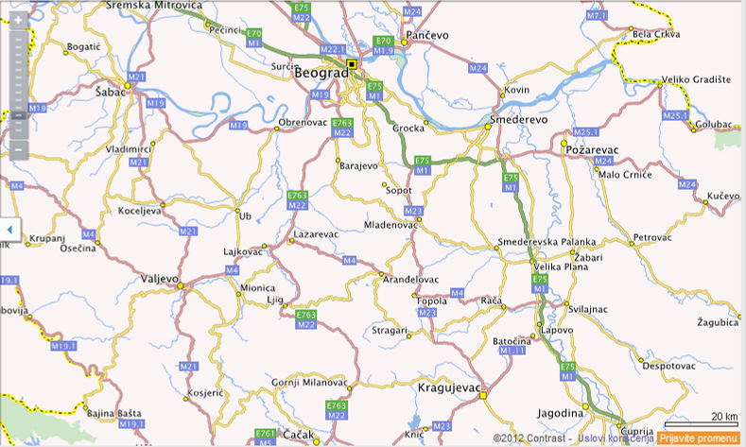
Although being characterized as rural, the section is as one with a dense construction alongside the road and there is a significant number of commercial and private buildings, especially to the chainage mark of km 5+000. Afterwards, the section really becomes a rural one. A detailed position and number of structures are presented within the document “Diagnostic assessment of road condition, section Arandjelovac-Krcevac”, while the significant structures are “Knjaz Milos” factory at km 0+397 to km 1+500 and the primary school at km 3+485.

The section is dominantly in the mild side cut, while with shorter stretches it covers an embankment (total of 1050m), i.e. side cut (total of 380 m). The terrain is lower on the right side of the road body.

Measured pavement widths are within the range from 6.10 to 6.70 m, while the average pavement width is 6.40 m.

Picture 2. Location of Arandjelovac - Krcevac road section
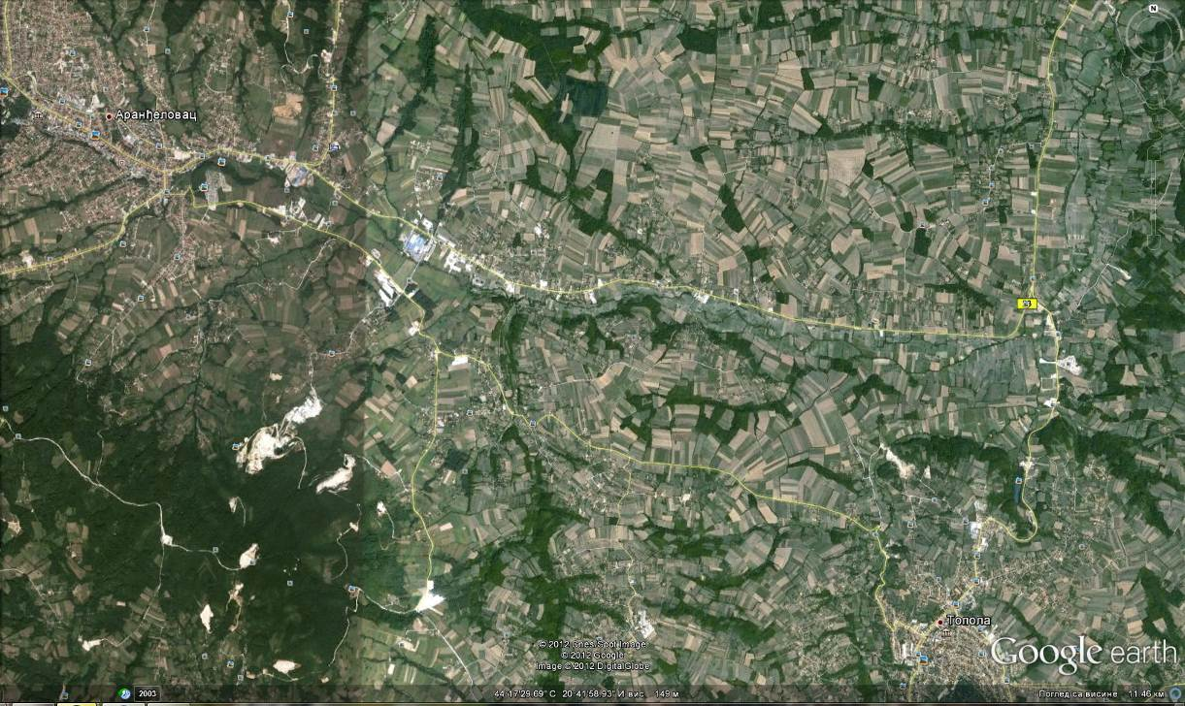
Arandjelovac
Krcevac

“Knjaz Milos” factory
primary school in Banja settlement

Trees (large ones) have been also noted along the section, in close proximity to existing pavement. If possible, these should be saved. The trees are located along the right and left pavement edges, sporadically along the whole section, and especially along the stretch from km 1+400 to km 2+200. Within the design of pavement widening, a designer should check whether the trees represent an obstacle for the widening construction.

A detailed description of the Works on improvement of condition will be provided by the designer within preparation of the Final Design, while the team performing the diagnostics noted the following necessary Works.

It is necessary to have a pavement widening of app. 1.00-1.20 m along the whole section. An assessment is that it would be more appropriate to have the widening constructed on the right pavement edge, as there are fewer accesses on this side. It is necessary to plan a removal of marginal strip made of small-sized stone setts on the side of widening as the strip was noted on some of the locations along the section. However, there will be no relocation and resettlement issues as defined by OP 4.01 during project preparation and implementation.

Extension of arched culverts is also necessary due to pavement widening, as well as widening of the noted box culverts and the bridge at km 4+705.

Picture 3: the bridge at km 4+705
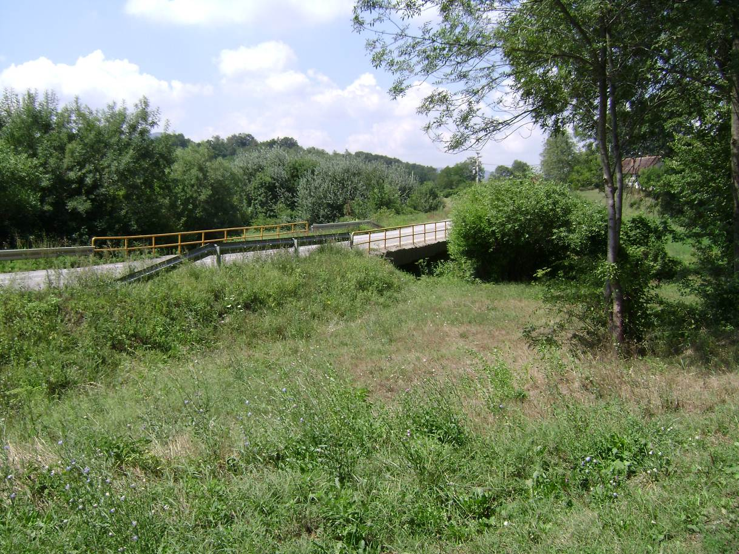

It is necessary to inspect a condition of all culverts on the section, check their through-put capacity and consequently plan appropriate measures (cleaning, repair, replacement, removal of installations, etc.). A detailed survey and possible correction of levels of open canals is also needed in order to ensure longitudinal water draining to culverts, i.e. out of the road body. “Wild” culverts and improvised draining solutions should be also examined.

As for the potential pollution during operation, these are limited to accidents only. In such a case, procedures for action in incidental situations, as defined by the Ministry of Interior and in the Water Law, will apply.
Special attention should be paid to the area near the “Knjaz Milos” factory, as well as to the area of primary school in Banja settlement. The said locations should be particularly treated from the safety improvement point of view.

The existing sidewalks from the beginning of the section to km 1+500 should be rehabilitated, new ones should be designed on locations of interruptions and where the sidewalks are missing by km 5+000 since there is a school at km 3+500 and the pedestrian movement is intensive.

The proposal is to have the existing bus stops rehabilitated, possibly relocate the unsafe ones and construct the bus bays at locations where such construction would remain within the right of way.

On some of the sub-sections, cold recycling should be applied as relevant pavement rehabilitation measure, while the remaining sub-sections would be improved by additional layers with previous slope staking and leveling. Pavement widening and removal of marginal strip along the whole section with construction of new pavement are also considered necessary. At locations of pavement depressions and cracks, it is necessary to have a deep pavement repair.

A detailed description of needed works will be established once the diagnostics and surveys are fully completed and the clear picture of the current condition is created.

Road section Arandjelovac – Krcevac does not go through or near the natural/cultural protected areas.

Rehabilitation works description

The road works covered by the Project will be carried on existing road with no change of the alignments but with minimum of widening on some places, within the right of way. The project therefore entails no resettlement and land acquisition as defined by OP 4.01, nor long lasting disruptions to the natural environment and human settlements and activities .

POLICY, LEGAL AND ADMINISTRATIVE FRAMEWORK

Relevant Institutions

The Ministry of Energy, Development and Environmental Protection (MoEDEP), former Ministry for Environment and Spatial Planning is the key institution in Republic of Serbia responsible for formulation and implementation of environmental policy matters.

The other aspects of environmental management related to road rehabilitation projects are dealt with several other institutions, among which are the Institute for Nature Protection of Serbia (INP) and the Institute for Protection of Cultural Monuments of the Republic of Serbia (IPCM), and the Public Enterprise ‘Putevi Srbije’ (PERS).

Existing Serbian legislation

Environmental protection in Republic of Serbia is regulated by several national and municipal laws and by-laws. The environmental legislation in force in Serbia is summarized in Appendix III.

EIA procedure in the Republic of Serbia

In the juridical system of the Republic of Serbia, the Environmental Impact Assessment procedure is regulated by the Law on Environmental Impact Assessment, which is completely in line with European EIA Directive - 85/337/EEC. Therefore Environmental Impact Assessment is not required for road rehabilitation projects unless theirs alignment is placed within or in the vicinity of natural/cultural protected areas. In that case Project proponent is obliged to submit Request for Decision-making on the necessity of preparation of the Environmental Impact Assessment to the MoEDEP. Depending on assessment of significance of potential environmental impacts of project it could be decided that it is necessary to implement full EIA procedure for that kind of projects.

Road section Arandjelovac - Krcevac is not placed within neither in the vicinity of any protected area so the EIA is not required for this project.

Relevant IFIs Policies and Statements

As the road rehabilitation will be funded by IFIs the following Lender requirements will need to be applied to the any works:

- WB: Operational Policy OP 4.01 Environmental Assessment, which require partial EIA and development of site specific EMPs for projects belonging to Category B.;
- EBRD: Environmental and Social Policy 2008
- EIB: Statement of Environmental and Social Principles and Standards (2008).

EBRD and EIB will require that the project complies with the Republic of Serbia national laws and EU standards. WB will require that the projects comply with the Serbian legislation and the Bank’s OP 4.01.

As a conclusion, it could be stated that GoS regulations do not require separate section-specific EMP to be undertaken for this type of investments (road rehabilitation), while the WB policy requires partial EIA assessment and preparation of site-specific EMP for each section.

BASELINE CONDITIONS ASSESSED DURING ROUTE SURVEY
Road section Arandjelovac – Krcevac is 8,7 km long.
Route survey was carried out by the PERS representatives several times during 2012, as an integral part of project preparation activities. PERS is performed detailed diagnostic on proposed Arandjelovac – Krcevac road section during period between June and July 2012.
A PIT representative appointed for environmental protection took independent field survey together with the WB representative during August 2012.

Within road section there are no protected natural or cultural areas which could be impacted by the road rehabilitation works. There will be no land acquisition as defined by OP 4.01 during the project implementation.

Picture 4: current state of the road
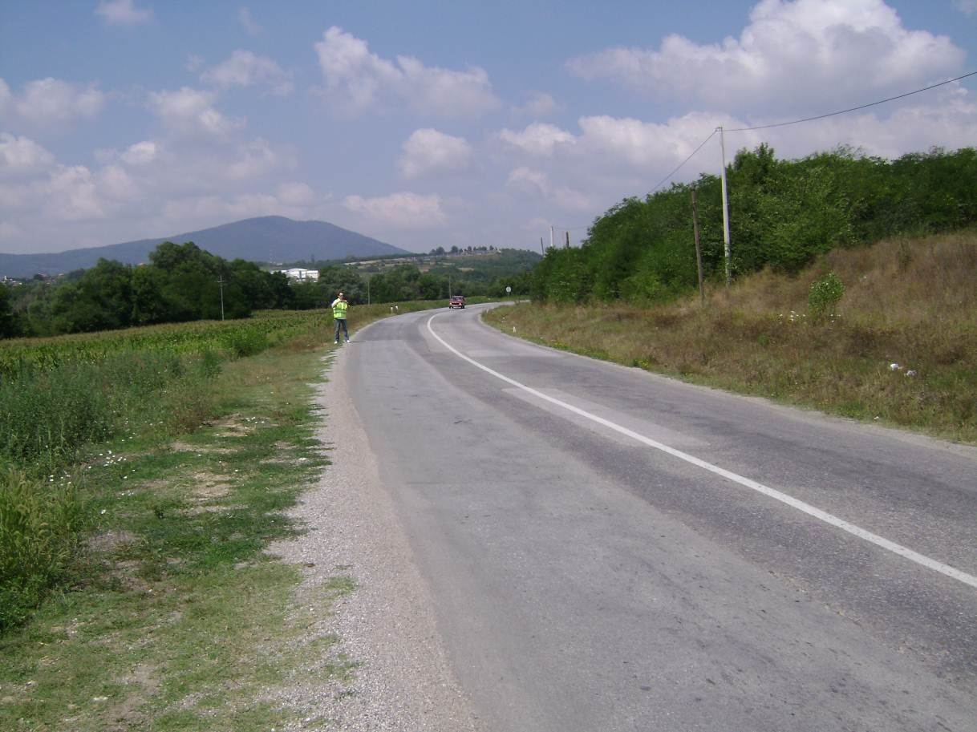

Settlements

The start of the section is in city of Arandjelovac and it goes to km 8+700. The significant structures are “Knjaz Milos” factory at km 0+397 to km 1+500 and the primary school at km 3+485. End of the section is close to the settlement Krcevac.

Watercourses

The Kubrsnica River runs in parallel with the section, on the right side in a direction of the chainage mark increase, at distance of 50-100 m (it is the biggest tributary to the Jasenica River). The road is intersected by three streams that are bridged by means of box culverts. All three streams gravitate towards the said river.

The water quality standard of the river is II class according to the Serbian categorization of watercourses. Due to the nature of road rehabilitation works the watercourse will not be affected by the works through the implementation of good construction management practices. There are no sensitive species (fish) in Kubrsnica River that could be impacted by the project works.
Drainage of run-off water is ensured on both directions, transversally (to gutters, over the shoulders into the ditches or along the slopes of embankments) and longitudinally (by gutters and ditches to culverts or watercourses). As for the potential pollution during operation, these are limited to accidents only. In such a case, procedures for action in incidental situations, as defined by the Ministry of Interior and in the Water Law, will apply.

Air

Within the corridor of road section Arandjelovac - Krcevac there is no significant point sources of air pollution.

Existing major road Lazarevac – Topola (M-4) is linear sources which cause emission of air pollutants along the corridor of proposed road section.

Industrial structures are present within the studied area (“Knjaz Milos” water factory) and they could cause increased levels of concentrations of pollutants in the atmosphere when operating in full capacity or without applying air-pollution reduction measures. However, the measurements and action in respect to operation of that facility are outside the jurisdictions of institutions involved in preparation and execution of this project.

Data on the measured values of air pollution in the observed corridor were not available.

Traffic counting performed in recent years and traffic forecast shows that no significance increase of road traffic will occur after the rehabilitation works on proposed road section.

Based on experience and expected traffic load during and after the planned road rehabilitation works, the increase of existing levels of air pollutants within the corridor of proposed road section is not expected.

Noise

Existing state road of the IB class, no. 23 (old marking; M-4) on Lazarevac – Topola road direction as linear source is the only dominant noise source.

Based on experience and expected traffic load during and after the planned road rehabilitation works, the increase of existing levels of noise within the corridor of proposed road section is not expected.

SUMMARY OF ENVIRONMENTAL IMPACTS

The following table provides a summary of the Environmental Impacts that are predicted for the project impact | significance | comment
impacts on land use/ settlements, | low | There will be no land acquisition as defined by OP 4.01 during the project implementation
ground and surface water, | low | Due to low amount of drainage water that can be drained into Kubrsnica River, the consequential impact is minimal to negligible
air quality, | low | Temporary impact
flora and fauna (protected areas and species), | low | No protected areas
noise, | low | Temporary impact
access/crossing points of the main road and local roads, | low | The rehabilitation and widening works won't affect existing crossing points.  No specific issues
soil management, | low | With application of waste handling measutres
waste, | low | Ensured through environmental management - waste and wastewater management plan will be prepared and implemented
cumulative impacts etc. | Medium/moderate | Temporary, rehabilitation works may cause a slight increase of noise levels and air pollutants concentrations during the works only
Road rehabilitation works on proposed Arandjelovac - Krcevac section will have only minor impacts on the environment (environmental category B). Most of the impacts are of temporary character and they disappear after the road rehabilitation works are completed.

In respect to future use of the rehabilitated road section - this section belongs to the local and regional roads network, on which significant increase of road traffic as a result of rehabilitation works is not expected, since they are the primary transport routes for communication between these settlements - i.e. belong to group of the "commuter roads". In respect to impact of the potential increase of the vehicle speed on rehabilitated roads, this issue will be addressed through the project's road safety component, which will include implementation of the active and passive measures to control the vehicle speed on rehabilitated road sections.
The possible temporary impacts as consequence of the construction activities will consist of among others: disruption of current traffic circulation; roadway safety; damage to access roads; noise, waste and dust nuisance; and air emissions; potential impacts of soils and water resources; brief disturbance to biota, and momentary interference to neighbouring settlements through various construction and operation activities. Off-site activities include quarry, borrow pit and asphalt plant operations, which if not managed properly, may cause localized adverse impacts. The Contractor’s yard and workers’ camp can be potential sources of temporary adverse impacts.

Summary of key impacts

This site specific EMP is focusing more on the rehabilitation phase of the selected investment, as it will become part of the respective Contract for the implementation of civil works, and as such, the future contractor's obligation. The activities related to subsequent regular maintenance of this section are not the main focus of this EMP, but bare presented herewith for the purpose of completeness.

Air and noise pollution within the residential areas

It is expected that local residents in Arandjelovac will be affected with air and noise pollution during rehabilitation works on proposed road section. Local Air quality may experience some moderate and temporary deterioration due to dust from the construction traffic and elevated levels of nitrogen oxide (NOx) and sulphur oxide (SOx) from construction equipment exhaust are the primary pollutants. The dust may settle on vegetation, crops, structures and buildings, and may cause some degree of impact.

Noise caused by the rehabilitation works will be only a temporary impact. Although temporary and mostly moderate, construction-related noise impacts in the vicinity of residential areas may cause negative health impact, if not mitigated. Of particular concern are noise levels in the vicinity of school at km 3+485, where noise levels should not exceed 45 dBA. The Contractor has to make all possible efforts to keep the noise production at the lowest possible level when carrying out his works in the vicinity of the school. Relatively small traffic load on proposed road and non-presence of significant amount of residential buildings placed close to the road lead to the conclusion that noise barriers will not be implemented within this project. However, the Contractor should erect temporary barriers in case he needs to reduce the noise levels during construction. Mitigation measures need to be implemented if the levels are higher that legally prescribed.

Potential water contamination
Cases of water contamination may occur during the rehabilitation of the project road from site run off, spills and -water from the equipment maintenance areas and sanitary wastewater effluent from the work camps.

As for the potential pollution during operation, these are limited to accidents only. In such a case, procedures for action in incidental situations, as defined by the Ministry of Interior and in the Water Law, will apply.

Fuel and lubricant spills can, in most instances, occur at the Contractor’s work camp and motorpool while maintaining and washing equipment and work vehicles. The oily wash-water should be passed through an adequately sized, gravity oil separator prior to discharge.

Should spills occur in any part of the road, especially where the river Kubrsnica is closest to the road, to mitigate the problem the Contractor should use absorbing materials, such as absorbent mats/fabrics, or sand and scrape off the contaminated soils and dispose them in approved facility, in accordance with the Law on water (“Official Gazette of RS”, 54/96, 101/05).

Potential Cumulative impacts
Rehabilitation of the Arandjelovac - Krcevac road section will not result in any cumulative impacts.

The proper implementation of the EMP would minimize any impact on local human and biotic environment that might be related with any long-term cumulative negative effects.

Other impacts:

- social impacts: Social impacts on the construction phase include socio-economic conflicts, including health and safety. Likewise, included are those temporary facilities used for activities that result to short-term impacts such as quarry sites and borrow pits, excess soil disposal sites, contractor’s workers camps, and asphalt plants. It is expected that impacts from these types of activities will cease once the contractor completes the project road and demobilizes from the site.
- pollution: During the course of road rehabilitation, certain but not significant emission of pollutants is expected. Recognized are: air pollution, water pollution, soil pollution, noise and vibration.
- solid waste: It is expected that activities on road rehabilitation will generate certain amount of solid wastes that will be collected within the building site and transported to the waste storage outside the building site zone.

ENVIRONMENTAL MANAGEMENT PLAN
Possible environmental impacts will be mitigated during the design/pre-rehabilitation, rehabilitation, and operation Phases, as summarized in the Environmental Management Plan.
A basic assessment of the proposed road reconstruction and rehabilitation project concluded that the rehabilitation impacts will be minor, reversible and manageable if the mitigation measures as given in the EMP are properly implemented. The EMP (Appendix I and Appendix II) is based on the type, extent and duration of the identified environmental impacts. PERS (the Implementing Agency) will guide the design and supervision engineers and contractors on the implementation of the EMP.

A. MITIGATION PLAN

The findings and proposed mitigation measures have been compiled into an Environmental Mitigation Plan (Appendix I). It summarizes all the anticipated environmental impacts and its associated mitigation measures during the design, rehabilitation and operational phases. It makes reference to the law and contract documents, approximate location, timeframe, and the responsibility for its implementation and supervision.

Contractor Management

The recommendations and proposed mitigation measures, as shown in Appendix I will be attached to the Project Bidding Documents and subsequently the Contractors‘ contracts. Mitigation measures will be incorporated as part of the standard design and rehabilitation practices and as such their costs will be included in the rehabilitation cost. This will be refined during the detailed design stage.

Experience shows that inadequate application of the EMP by the Contractor may occur due to weak linkages of the EMP with the contract documents. The EMP is a part of the work program and as such it must be addressed by the Contractor and carried out as required.

EMP is a forming part of the Bid and Contract document. The contractor will use this document to cost his compliance with the EMP. It is the Contractor’s obligation to cost the implementation of environmental mitigation measures in his overall cost. The Contractor will be required to provide a short statement that confirms that:
- the EMP conditions have been costed into the bid price,
- the Contractor has a qualified and experienced person on the Contractor‘s team who will be responsible for the environmental compliance requirements of the EMP.
- the Contractor and its sub-contractors will comply with Republic of Serbia national laws, EU standards and Lender requirements .

Design Phase

Mitigation measures will be incorporated as part of the standard design and rehabilitation practices and as such their costs will be included in the rehabilitation cost. This will be refined during the detailed design stage.

In addition to addressing the requirements of the Mitigation Plan the following additional activities, will be carried out during the design phase in preparation for the mobilisation of the project:

The Site Organization Plan will be prepared as part of Detailed design. Design phase will take place just after the appraisal of the project. Site organization study incorporates environmental, health and safety protection measures that meet legal and Lender requirements (including the measures defined in the EMP and Safety Labour Management Plan.
As for the potential pollution during operation, these are limited to accidents only. In such a case, procedures for action in incidental situations, as defined by the Ministry of Interior and in the Water Law, will apply.

The plan will contain basic requirements related to:

1. Provision of materials needed for construction works
2. Material transport
3. Material placement
4. Site organization
5. Waste management
6. The right-of-way arrangement (cleaning)

Technical specifications for work execution which address environmental, health and safety protection measures:

1. Preliminary works
2. Rehabilitation works on the existing pavement
3. Earth works
4. Drainage
5. Traffic signage systems

PERS is responsible for checking that the EMP and SLMP requirements are incorporated into the site organization.

Rehabilitation PhaseMobilisation – Contractor EMP

During the rehabilitation, the Contractor will work according to the requirements of the Contractor‘s Environmental Plan (CEP) (based on the EMP) which has been prepared by the Contractor and approved by PERS. Supervision and monitoring of the CEP activities will be undertaken as follows:

- The contractor has the initial responsibility for preparing and implementing the CEP as per the works contract.
- The Resident Engineer (RE) will direct the Contractor with regard to compliance with the CEP.
- The PERS will carry out independent monitoring of the work and can issue Defect Notices to the RE who will transmit these to the Contractor.
- The contractor will have his own representative on site – the Site Engineer (SE) who will be responsible for implementing the contract and complying with the CEP.

Contractor prepares CEP: following the award of the contract and before commencing the work, the Contractor will prepare a Contractor‘s Environmental Plan (CEP) that addresses the conditions of the rehabilitation in the EMP that has been attached to the Bid and Contract Documents including measures to comply with national legalisation and Lender requirements. The CEP will detail how the Contractor will address the activities in the rehabilitation section of the EMP. The contractor will submit the CEP to the PERS for approval.
Following the approval of the CEP, the Contractor together with the person on the Contractor‘s staff who will be responsible for supervising the CEP will meet the Project Supervision Consultant PSC (Environment) on-site. If the plan is appropriate and implementable, the PSC will advise the PE that the Contractor can now commence work.

Rehabilitation works

Preparation of site and establishment of contractor‘s facilities: This applies to all of the Contractor‘s facilities, storage areas, workshops, labour camps (when needed), concrete batching areas, asphalt plant, etc. The location and development of the Contractors‘ facilities will be approved by the RE. Locations will be selected so that:

- they do not interfere with the environment and social well-being of the surrounding communities re noise, dust. vibration, etc.,
- the size of contractor‘s facilities are limited to absolute minimum to reduce unnecessary clearing of vegetation,
- sanitary waste and grey waters are treated before release into surface water systems, in accordance with the Law on water (“Official Gazette of RS”, 101/05).
- the sites are properly drained. Paved areas, including vehicle parking areas, workshops and fuel storage areas are to drain to an oil and water separator, and
- fuel storage areas are not located within 20m of a water course. The contractor‘s facilities are to be contained within an adequate security fence.
- Clearing of sites and removal and disposal of vegetation:
- Wherever possible limit area to be cleared and avoid excessive machine disturbance of the topsoil.
- Cleared material is to be piled into manageable sized heaps according to disposal or re-use requirements.
- Prevention of soil erosion on construction site: The contractor will be responsible for ensuring that the erosion is contained by soil conservation protection methods. The contractor will:
- Limit the extent of excavation to reduce soil erosion potential.
- Apply soil conservation protection methodology to susceptible areas to prevent / minimize storm water runoff carrying eroded materials off-site.
- Avoid excavation and operating machinery in wet ground conditions.
- Where fuel in excess of 5,000 litres is stored on site, it will be stored in sealed tanks on a concrete base that is bunded to hold 110% of the tank capacity.
- All workshops would be provided with oil and water separators.
- The contractor must have trained personnel who are competent in fuel handling procedures and for cleaning up accidental spills.
- All waste oil, oil and fuel filters will be collected and disposed of in secure landfill areas. At the closure of the site, all contaminated soil will be excavated, removed and replaced with fresh topsoil.

Environmental Management during Rehabilitation works

Considering all the identified impacts, it becomes essential for the Contractor to prepare and later conscientiously implement the EMP throughout the duration of the project to ensure compliance with legislative and Lender requirements. . The emphasis of the EMP shall be on the following:

- Layout of the work camp and details of the proposed measures to address adverse environmental impacts resulting from its installation. Description and layout of equipment maintenance areas and lubricant and fuel storage facilities including distance from water sources/bodies;
- Sewage and septage management plan for provision of sanitary latrines and proper sewage collection and disposal system to prevent pollution of watercourses
- A plan (mechanism and organizational structure) detailing the means by which local people and other project affected persons (PAP) can raise grievances arising from the rehabilitation process and how these will be addressed (e.g., through dialogues, consultations, etc.) (see Appendix 4 for the Project grievance mechanism) .
- Soil Management Plan detailing measures to be undertaken to minimize effects of wind and water erosion on stockpiles, measures to minimize loss of fertility of topsoil, timeframes, haul routes and disposal site;
- Dust management plan which shall include schedule for water spraying on access road and in nearby settlements along the project road, as well as list of equipment to be used; This applies to all of construction sites and haul roads. During rehabilitation, when dust may be generated, the Contractor will monitor the worksite conditions and apply dust control measures, which include reducing construction traffic movements and spraying water on exposed areas.
- A plan indicating the location of the proposed material extraction site as well as rehabilitation measures to be implemented for the borrow areas and access roads upon project completion;
- Waste and wastewater management plan. Disposal of waste materials: All construction waste materials including drums, lumber, sand and gravel, cement bags etc. are to be suitably disposed of. If these cannot be recovered for scrap value these materials should be taken to an approved landfill sites for safe disposal. Hazardous waste will be stored and removed from the construction site on demobilization, in accordance with the Law on Waste management (“Official Gazette of RS”, 36/09) The Contractor’s SSIP should cover all aspects of waste management, including implementation of practice standards such as reduce, re-use and recycle. It should specify final disposal alignments for all waste and demonstrate compliance to national legislation and best practice procedures on waste management. The Waste Management Plan will, as a minimum, include details of temporary waste storage, waste transfer and pre-treatment prior to final disposal or recycling. Licensed/approved facilities for solid and liquid waste disposal must be used and a duty of care and chain of custody for all waste leaving the site will be followed. As part of the plan Contractors will be expected to produce waste handling forms for chain of custody, which will be used to control waste leaving site. Thus the waste controller will keep a copy of the form and the driver will always carry a copy and will ensure that the load is signed for at the final disposal site. All records will be kept by the Contractor for audit purposes and to demonstrate that the project is complying with best practice and applicable legislation.
- Oil and fuel storage management plan. The Contractor’s SSIP should cover all procedures for storage, transportation and usage of oils and fuels, refuelling of plant and machinery and procedures for minimizing the risk of ground and water contamination. All oils and fuels will be required to be stored within secondary containment of 110 % capacity and all spillages shall be cleaned up immediately. Re-fuelling vehicles will carry Spill Kits to enable spillages to be cleaned up as soon as possible. All categories of spillage will be reported in accordance with the Plan to be developed by The Contractor. Toolbox Talks would be expected to be delivered on an ongoing basis as „continued training‟ and following any significant incident.
- In-river works management plan. The Contractor’s SSIP should cover procedures and plans for safeguarding aquatic habitats and fish during in-river work (Kubrsnica River) and will complement the Construction Method Statements.
- Camp management plan. The Contractor’s SSIP should contain procedures for establishing and operating construction camps in order to safeguard nearby communities and environmental resources.
- Emergency response plan. The Contractor’s SSIP should contain procedures for emergency response in the event of accidents or major incidents, in order to safeguard people, property and environmental resources. Details of the spill response equipment to be provided on site are to be specified.
- Noise – all equipment is licenced and approved in accordance with EU standards. This applies to all machinery, vehicles and construction sites where noise and vibration may affect susceptible receptors. The contractor will be responsible for ensuring that noise and vibration does not affect the adjacent communities, in accordance with the Law on noise protection (“Official Gazette of RS”, 36/09).. While it is unlikely that noise and vibration will be an issue due to the large distances between the activities and the communities the Contractor will confine all work to daylight hours (0700hrs - 1900hrs) should the community find that any night time operations become a nuisance.
- Rehabilitation Plan: Clearance and rehabilitation of construction sites and removal of contractor‘s facilities: It is the contractor the Contractor‘s responsibility to address site cleanup. This includes the removal of all waste materials, machinery and any contaminated soil. The contractor will develop a plan for handover, sale or removal of all plant, vehicles and machinery to ensure that no unserviceable items are left on the construction site, in accordance with the Law on Waste management (“Official Gazette of RS”, 36/09). All construction sites and work areas will be rehabilitated so that these can be returned as close as possible to their previous uses. This includes the stabilization and landscaping of all of the construction sites. No waste will be left on site after the work is completed, in accordance with the Law on environmental protection (“Official Gazette of RS”, 135/04, 36/09, 72/09). Should the Contractor fail to remove the waste, the PERS is entitled to withhold payment and arrange the clean-up and deduct the cost of the clean-up and administrative charges from the final payment.

Safety

Safety and Hazard Assessment: Before commencing work, the Contractor will be required to identify potential hazards. Provisions for emergency responses are to be included in the Contractor‘s site safety plan which is to include nomination of a person who will be immediately contacted should an accident occur. The site safety plan will be submitted to the PSC for approval one week prior to starting work.

1. The contractor will be required to keep the site free of drugs and alcohol.
2. The contractor‘s site safety plan will include provision for a safe work environment and provide safety measures and protective equipment to all workers including; hand, head, eye and ear protection and safety footwear.
3. The site safety plan will include provision for first aid facilities on-site and employ a trained first aid person, in accordance with the Law on Safety and Health at work (“Official Gazette of RS”, 101/05).
4. The contractor will provide supplies of potable water, toilets and wash water to the workers.
5. Safety and Labour Management Plan (SLMP), prepared by the PERS, will be consisting part of bidding documentation, in order to ensure H&S provisions during rehabilitation works.
6. Contractor is obliged to perform all project activities by respecting SMP recommendations and all Serbian laws and sub-laws which are covering H&S issues.

The PERS and Contractor together have responsibility for reporting and investigating incidents.

Community safety from increased vehicle movements: This applies to all vehicles and particularly to haul trucks that pass through villages. The contractor will ensure that all vehicles which pass through villages are operated safely without endangering these communities.
The contractor is to ensure that:

- all trucks and equipment is maintained in a safe operating condition,
- all drivers and machinery operators are trained and act responsibly (to be stipulated in the Contractor‘s site safety plan),
- all loads are secured and all loads with potential dust generating materials (e.g. excavated soil and sand) will be covered with tarpaulins,
- the Contractor will immediately remove any drivers that ignore any of the community safety requirements.
- Speed limits will be observed

Prior to commencement of construction activities/site works, all of the above plans will be submitted by the Contractor to the Sector for Investment within the PERS for approval.

Following the completion of works a Site restoration will take place. It’s Contractor obligation to restore location of the project as it was at beginning of the project.
Operational Phase

People Safety: During operation, according to the assessment performed within the design phase, road safety features will include (i) measures to slow the traffic; e.g. decreasing of speed at selected places (e.g. settlements, schools, markets, etc.), (ii) dust suppression sealing, (iii) improvements in road signage and pavement markings, and (iv) attention to road accident black spots.

Road Maintenance: Routine maintenance (grading, grass cutting, drain clearing, and pothole patching and shoulder repairs, together with regular control and maintenance of drainage structures and retention) will be undertaken on regular basis. Seasonal maintenance such as flood repairs, emergency maintenance to reinstate roads after major failures, and the regular upkeep of safety features and road signs will be undertaken as necessary. Major maintenance that include resurfacing and repairs are typically scheduled over periods of several years.

B. MONITORING PLAN

A monitoring plan for the proposed Project (Appendix II) has been prepared. The main components of the monitoring plans include:

- Environmental issue to be monitored and the means of verification,
- Specific areas, locations and parameters to be monitored;
- Applicable standards and criteria;
- Monitoring of noise levels near residential areas
- Monitoring of the procurement of materials (checks that valid permits are in place)
- Duration and frequency and estimated monitoring costs; and
- Duration and frequency and estimated monitoring costs; and
- Institutional responsibilities for monitoring and supervision.
A field monitoring checklist has been prepared based on the EMP and monitoring plan (Appendix II). The field monitoring checklist will be used by the supervising field engineers. The signed checklists will be provided to the PERS who will be responsible for the follow-up and compliance reporting.
The PERS will maintain a Complaints Database, which will contain all the information on complaints or grievances received from the communities or other stakeholders. This would include: the type of complaint, location, time, actions to address these complaints, and final outcome.

C. INSTITUTIONAL IMPLEMENTATION AND REPORTING ARRANGEMENTS
Project Implementation
PERS is the Implementing Agency for the Project and will be responsible for the implementation and compliance with the EMP and Monitoring Plan. Day-to-day implementation and compliance will be the task of PSC.
Prior to the commencement of works PERS will submit to the Bank for its approval this section specific Environmental Management Plan.
The Contractor will provide “Zero monitoring” results prior to commencement of earth works, during its own mobilization phase.
To ensure that the proposed mitigation measures will be carried out by the Contractors during the construction stage, the Project Proponent will undertake the following:
  - clearly set out in the tender and contract documents the Contractor’s obligation to prepare CEP and undertake environmental mitigation measures as specified in the Environmental Mitigation Plan in Appendix I (to be appended to Contract specifications);
  - No compensation for the costs of the required environmental mitigation measures and monitoring activities in the form of the particular item in the BoQ shall be given to the Contractor, except for the water quality analysis and noise measurement. It shall be regarded as if the Contractor has included these costs in the other items of the BoQ. Real expenditures of water quality analysis and noise measurement in scope defined by the BDs and the Contract shall be compensated to the Contractor in the form of the particular item in the BoQ.
For noncompliance with requested environmental mitigation measures and monitoring activities the Contractor shall suffer specific liquidated damages in a form of demerit points. Demerit points are provided as a measure that should stimulate the Contractor to carry out his obligations in an organized and timely way and to perform his duty meeting high standards even though those tasks does not appear to be of a serious nature. Demerit points have in the same time two meanings – numeric and monetary.
Each demerit point has associated monetary value which represents permanent payments reduction for determined noncompliance of the contracted obligations.
Number of received demerit points has cumulative effect. If during the Contract the Contractor receives more than certain number of demerit points specified in the BDs and the Contract, the Contractor will for a period of 2 years not be allowed to compete for any other PERS works contract. Also, if the Contractor is awarded over a specified number of demerit points, the Employer has a right to terminate the Contract. Monetary value of each demerit points as well as limits for other possible actions by the Employer shall be clearly specified in the BDs and the Contract.
Application of explained two measures - compensation for specific costs and penalties for noncompliance – should assure implementation of all requested environmental mitigation measures and monitoring activities, and
  - Explicitly require the Contractor to recruit an environmental specialist. The contractor will be responsible for the implementation of environmental mitigation measures during construction and shall employ an environmental specialist who will supervise implementation of the Contractor’s environmental responsibilities and coordinate with the PERS and MoT. The contractor, in coordination with PERS, shall set-up a grievance redress committee that will address any complaints during project implementation. During project implementation, the PERS shall monitor the compliance of the Contractor with the EMP provisions. It is proposed that the project supervision consultants (PSC) employ an environment specialist (with civil engineering/environmental management background) to assist the environmental supervision.

Upon Project completion, the PERS will be in charge of the operation and maintenance of the Project Road. Routine and random monitoring will be undertaken as scheduled in the monitoring plan.

The Public Enterprise “Roads of Serbia” (PERS) is also responsible for:
- Implementation of requests for environmental protection given by:
- Government environmental authorities and EIA document (if exists),
- IFIs and other institutions,
- Law on environmental protection (“Official Gazette of RS”, 36/09, 72/09),
- Implementation of requests for environmental protection through contractors specifications,
- Supervision of the project through the consulting services for supervision and implementation of the project,
- Supervision of environmental monitoring through the consulting services for environmental monitoring,
- Preparation of the final environmental reports.

Construction Contractor will make proposal for environmental protection, including safety of persons associated with the works and the public, during a pre-construction period within the Environmental Management Plan. This proposal will be reviewed by PERS in order to obtain the “no objection” to the proposal’s recommendations. In this regard, attention will be given to:

- taking all reasonable steps to protect the environment on and off site and avoid damage or nuisance to persons or property arising from its operations,
- maintaining conditions of safety for all persons entitled to be on site and
- provision of all lights, guards, fencing, warning signs, traffic control and watching for protection of the works and other property and for the safety and convenience of the public.

MoEDEP will have the authority for immediate suspension of works if performance is not in accordance with environmental standards and regulations. Inspection will then inform the PERS about suspension and order to proceed according to its directive.

During the implementation of this Project, the public has the right to participate either directly or indirectly, which introduces the possibility to present its interests and opinion in the process of decision making. In order to reach the best option during this process, PERS was disclosed this EMP document to stakeholders (See Appendix 4) such as interested public, including local municipalities and NGOs. Draft EMP document was placed in PERS web site too (www.putevi-srbije.rs). During process of public consultations interested public collected all project information, including all environmental issues related to this project. Opinions and suggestions are incorporated within the final version of EMP document which will be an integral part of project bidding documentation. A grievance mechanism will be maintained by PERS via their website.
During rehabilitation works, a public liaison officer, named by the Contractor will establish communication with the local residents affected with the project and will be responsible to inform them about all project activities, especially related to environmental impacts of the project and planed mitigation measures.

Reporting Arrangements
A) Contractor to PERS
The Contractor will prepare his compliance reports in respect to this EMP and his SSIP as a Quarterly Progress Reports and submit them to PERS, in both Serbian and English language, in hard copy and electronic versions.

Construction Contractor will provide quarterly reports to the PERS which document the environmental mitigation and protection measures, together with prescribed monitoring activities carried out during that quarter’s reporting period. Construction Contractor will take care on environment quality according to the mitigation and monitoring plan which are a consisting part of EMP (Appendix I and Appendix II) through those phases and will report quarterly to the PERS.

If any kind of accident or endangerment of environment happens, reporting will be immediate. Contractor is obliged to inform the project manager and local authorities about accidents immediately after it happened. In case that project manager is not responding on a call, the Contractor is obliged to inform PERS about accident (phone number +381113040701 or via E-mail on following address: office@putevi-srbije.rs).

The Consulting Services of Supervision, to be contracted under the loan, includes the services of environmental monitoring as well. Within the Services in question, The Contractor will monitor quality of environmental conditions according to the monitoring plan which is a consisting part of EMP (Annex II) through those phases and will report quarterly to the PERS. These reports will encompass a list and explanation of all undertaken activities at the site and results of the field research, as well as recommendations for future field activities and protection measures.

B) Project Supervision Consultant to PERS
The findings of the regular monitoring activities, including activities specified in the Monitoring Plan (Appendix II) carried by the Contractor will be included in the quarterly PSC progress reports.

If some kind of accident or endangerment of environment happens, reporting will be immediate.

C) PERS to MoT, WB, EBRD and EIB
Annual Environmental Health and Safety (EHS) reports, including monitoring indicators and reporting on the implementation of the requirements set forth in the EMP will be prepared by PERS and submitted for IFIs review. IFIs will review the reports and verify their contents through periodic site visits. The PERS shall provide Annual reports to MoT and IFIs regarding the status of implementation of mitigation measures by the Contractors, additional mitigation measures that may need to be implemented, incidents of non-compliance with applicable environmental permits, complaints received from local residents, NGOs, etc. and how these were addressed.

In case of fatalities or major incidents on site the PERS will immediately report to the Bank which is financing the road section.

STAKEHOLDER ENGAGEMENT - INFORMATION DISCLOSURE, CONSULTATIONS, AND PARTICIPATION
As required by the IFIs Safeguards Policies, public consultations will be undertaken during the preparation of EMP. The EMP and other project information will be disclosed to the Public and will be available locally to the communities at the:

PERS office | 19a Vlajkoviceva St., Belgrade, contact person Igor Radovic, 011 3206811
Community centres | City of Arandjelovac
PE “Roads of Serbia“ web site | www.putevi-srbije.rs

Detailed Report on Public Consultation process will be presented within the Appendix IV of this EMP document and will include a list of identified stakeholders, which shall be updated as necessary.

Beneficiary consultations will be conducted during the construction phase, and records of environmental and social issues raised and complaints received during consultations, field visits, informal discussions, formal letters, etc., will be followed up and the records will be kept in the project office at PERS.

In advance of the work commencing PERS will provide information in:

- Newspaper articles in one national and also in one local media.
- Posters on main notice board at all community centres of potential affected Communities
- Radio announcement of road diversions
- Provide contact details of community liaison officers who are appointed to work with local communities.

A Grievance Mechanism will be implemented to ensure that all complaints from local communities are dealt with appropriately, with corrective actions being implemented, and the complainant being informed of the outcome. It will be applied to all complaints from affected parties. A grievance form is attached in Appendix and hard copies will be made available at community centres.

Report on Public Consultation will be presented within the Appendix IV of this EMP document.

REFERENCE

- Environmental Assessment Sourcebook No 25, Environmental Management Plans, The World Bank Environment Department, January 1999

- Roads and the environment: A Handbook, The World Bank Environment Department

- EIB ENVIRONMENTAL AND SOCIAL PRACTICES HANDBOOK, Environment and Social Office Projects Directorate Version 2 of 24/02/2010

- EBRD Environmental and Social Policy 2008

- EIB Statement of Environmental and Social Principles and Standards (2008).

- Environmental Management Plan for rehabilitation of roads, bridges and tunnels under the World Bank road management and safety project, Republic of Ruska Road Directorate, Banja Luka, 2001

- Environmental Assessment REPORT & Environmental Management Plan for Serbian Transport Rehabilitation Project, report No: E866, project name/ID: YF-Transport Rehabilitation Project – P075207, document date 2003/11/30

Appendix I

MITIGATION PLAN

MITIGATION PLAN
Phase | Issue | Mitigating measure | Institutional responsibility |  | Comments  (e.g. secondary impacts)
Phase | Issue | Mitigating measure | Install | Supervision | Comments  (e.g. secondary impacts)
PRE-CONSTRUCTION | Detailed Design
 | Bid documents prepared without access to or use of the this EMP in a translated version | No bid documents will be prepared without the authors having incorporated a (Serbian) copy of the mitigation and monitoring plan EMP, which shall be included in the safeguard clauses of the Technical Specifications in the contracts and commitment to comply with Lender Requirements | Detailed Design Consultant and RC | Technical Control of Detailed Design  PERS
 | The location and development of the contractors‘ facilities will be approved by the PE. Locations will be selected so that: | they do not interfere with the environment and social well-being of the surrounding communities re noise, dust. vibration, etc.,  the size of contractor‘s facilities are limited to absolute minimum to reduce unnecessary clearing of vegetation,  sanitary waste and grey waters are treated before release into surface water systems, in accordance with the Law on water (“Official Gazette of RS”, 101/05).  the sites are properly drained. Paved areas, including vehicle parking areas, workshops and fuel storage areas are to drain to an oil and water separator, and  fuel storage areas are not located within 20m of a water course. The contractor‘s facilities are to be contained within an adequate security fence.  Clearing of sites and removal and disposal of vegetation:  Wherever possible limit area to be cleared and avoid excessive machine disturbance of the topsoil.  Cleared material is to be piled into manageable sized heaps according to disposal or re-use requirements.  Prevention of soil erosion on construction site: The contractor will be responsible for ensuring that the erosion is contained by soil conservation protection methods. The contractor will:  Limit the extent of excavation to reduce soil erosion potential.  Apply soil conservation protection methodology to susceptible areas to prevent / minimize storm water runoff carrying eroded materials off-site.  Avoid excavation and operating machinery in wet ground conditions.
 | Site selection for construction camps, near or within existing settlements. Impact on public health and sociological setting | Proper site selection, observing criteria which primarily protect the public general. Observe a minimum distance (buffer zone) between camp site and nearest residential area. Observe local wind conditions to reduce nuisances. Work safety and environmental protection measures to be specified by the Contractor in his Site Management Plan. Planning for independent water and electric supply network and a medical service station at the site. | Detailed Design Consultant and RC | Technical Control of Detailed Design  PERS
 | Road safety issues associated with pedestrian crossing | Plan for safe and adequate pedestrian crossing facilities that can be in most cases over passages equipped with ramps and structures that allow the use of wheelchairs, pushcarts, bicycles and prams.  Planning for public awareness meetings | Detailed Design Consultant and RC | Technical Control of Detailed Design  PERS
 | Stakeholder engagement | Details of the proposed road alignment, access points and safety features will be disclosed in the locality of the planned works. Feedback from local stakeholders will be sought and recorded. Evidence of how feedback has been considered in the final design will be recorded.
Construction | Management Plans
Contractor to prepare implement the following plans as described in the EMP to ensure compliance with legislative and Lender requirements.
- Site organisation plan
- Sewage and septage management
- Project grievance mechanism) .
- Soil Management Plan
- Dust management plan
- A plan indicating the location of the proposed material extraction site as well as rehabilitation measures to be implemented for the borrow areas and access roads upon project completion;
- Waste and wastewater management plan in accordance with the Law on Waste management (“Official Gazette of RS”, 36/09).
- Oil and fuel storage management plan.
- In-river works management plan.
- Camp management plan.
- Emergency response plan..
- Rehabilitation Plan
- Safety and Hazard Assessment
- Safety and Labour Management Plan (SLMP),

CONSTRUCTION | Site Induction
 | All workers and visitors to site shall be given a Health, Safety and Environment Induction and instructed in the need and use of PPE.
CONSTRUCTION | Material supply
 | Asphalt plant  dust, fumes, workers health and safety, ecosystem disturbance | use existing asphalt plants; requirement for official approval or valid operating license | Asphalt plant | Asphalt plant | a)-c) to be specified in bid documents-Conditions for selection of subcontractors for material supply
 | Stone quarry  dust, workers health and safety, ecosystem disturbance | use existing stone quarries, requirement for official approval or valid operating license | Stone quarry | Stone quarry
 | Sand and gravel borrow pit, disturbance of river bed, water quality, ecosystem disturbance | use existing borrow pits or buy material at licensed separations; requirement for official approval or valid operating license | Sand and gravel Contractor or Separation | Sand and gravel Contractor or Separation
 | School children safety | Reduction of vehicular speed prior to settlements and school at 3+485 should be considered in the design using necessary measures such as rumble bars and speed limit signs. | Detailed Design Consultant and RC | Technical Control of Detailed Design  PERS
CONSTRUCTION | Material transport
 | Stone, sand and gravel Dust | wet or cover truck load, particularly in sections where critical receptors (residential areas and school at 3+485) are located | Truck operator | Truck operator
 | Asphalt  dust, fumes | All trucks are to be covered | Truck operator | Truck operator | a)-d) to be specified in bid documents-Technical Specifications for realization of works
 | Stone  Dust | wet or cover truck load | Truck operator | Truck operator
 | Sand and gravel  Dust | wet or cover truck load | Truck operator | Truck operator
 | Traffic management  noise, vehicle exhaust, road congestion | haul material at off peak traffic hours (preferably 9-14h); use alternative routes to minimize major traffic sites  Need to ensure that adequate signs to work fronts to minimise ‘wrong turn’ chances causing even more congestion | Transport manager; Truck operator | Transport manager; Truck operator
 | Archaeological chance finds | In case of chance finds Contractor is obliged to stop the works immediately and inform institute for protection of Cultural Monuments and PERS about it,. | Contractor | Supervision Contractor
CONSTRUCTION | Construction site
 | Noise disturbance to human and animal population and workers | limit activities to daylight working hours (not between 8 p.m. and 7 a.m. or as agreed with public and authorities); equipment operating with noise mufflers. The Contractor has to make all possible efforts to keep the noise production at the lowest possible level when carrying out his works in the vicinity of school at the km 3+485. Contractor should erect temporary barriers in case he needs to reduce the noise levels during construction. Mitigation measures need to be implemented if the levels are higher that legally prescribed. Noisy equipment will be located as far as possible from residential or other sensitive receptors. | Construction Contractor | Construction Contractor
 | Dust | water construction site and organized material storage sites organized as appropriate, limited speed of vehicles, particularly in sections where critical receptors (residential areas and school at 3+485) are located  Implement a Dust Management Plan: measures to avoid/minimize dust emissions, including use of hoardings; wetting down/spraying of construction areas, accesses, materials stockpiles and during loading/unloading activities; covering of vehicles carrying dusty materials; wheel washing/spraying of vehicles; and management of spoil, etc. | Construction Contractor | Construction Contractor
 | Vibrations | limit activities to daylight working hours (not between 8 p.m. and 7 a.m. or as agreed with public and authorities)  iif any material damage proved to have been caused to local houses, buildings and other infrastructure (including access roads) by the works will be compensated for and subject to repair on a timely basis. Earthmoving equipment will be located as far away as possible from vibration-sensitive receptors. | Construction Contractor | Construction Contractor
 | Traffic disruption during construction activity | traffic management plan with measures to redirect traffic that are easily seen or easy to follow; include traffic police assistance if needed  Construction Traffic Management Plan will establish speed limits for construction vehicles and organize traffic to avoid as much as possible populated areas. Local residents will be kept informed of planned works | Construction Contractor | Construction Contractor
 | Reduced access to roadside activities | provide alternative access to roadside activities at all times | Construction Contractor | Construction Contractor
 | Vehicle and pedestrian safety when there is no construction activity | appropriate lighting and well defined safety signs and protection measures. | Construction Contractor | Construction Contractor
 | Water and soil pollution from improper material storage, management and usage | organize and cover material storage areas; isolate concrete, asphalt and other works from watercourse by using sealed formwork or covers; isolate wash down areas of concrete and asphalt trucks and other equipment from watercourse by selecting areas for washing that are not free draining directly into watercourse  Operate construction site in a way to reduce the risk of generating sediments and wastewater that may pollute local soils or receiving water bodies (considering situations such as including stormwater runoff, wastewater generated from facilities on site such as wheel washing facility).  Soil Management Plan shall be prepared for the controlled removal of top soil, storage and reuse. Prevent sediments flowing into surface waters and drainage channels by localised control measures (eg sediment fences, check dams, mulch barriers, rock groynes, or geofabric barriers, sediment basins), contouring to optimise slope angle and steepness,  Prevent wind erosion via fencing, covering, etc. | Construction Contractor | Construction Contractor
 | Water and soil pollution from improper disposal of waste materials | dispose waste material at location protected from washing out, should be marked in the site plan; if not on site, then at authorized landfill / depot | Construction Contractor | Construction Contractor
 | Water and soil pollution from improper disposal of waste materials | Storage of wastes according to international best practice (IFC EHS General Guideline). Apply additional measures for storage of hazardous wastes (such as use of secondary containment, access restriction, provision of PPE etc.) as necessary to prevent harm to construction staff, environment and public. Use and labelling of designated waste collection containers and storage areas for different kinds of wastes (hazardous and non-hazardous). | Construction Contractor | Construction Contractor
 | Potential contamination of soil and water from improper maintenance and fuelling of equipment | apply best engineering practice in safe storage and handling of lubricants, fuel and solvents by secured storage; ensure proper loading of fuel and maintenance of equipment; collect all waste and dispose to permitted waste recovery facility | Construction Contractor | Construction Contractor
 | Water and soil pollution from improper disposal of waste materials | Transport of waste in marked vehicles designed to the type of waste to minimise the risk of release of materials (hazardous and non-hazardous materials) and windblown debris. Training of drivers in handling and disposal of their cargo and the documentation of the transport describing the nature of the waste and its degree of hazard. | Construction Contractor | Construction Contractor
 | Workers safety | provide workers with safety instructions and protective equipment; safe organization of bypassing traffic | Construction Contractor | Construction Contractor
 | Landscaping | Undertyaking of re-vegetation progressivellty with cover crop and native endemic species and monitor its effectiveness. Where initial plantings were not successful, replacement plantings will be carried out.
OPERATION | Maintenance
 | Noise disturbance to human and animal population and workers | limit activities to daylight working hours (not between 8 p.m. and 7 a.m. or as agreed with public); equipment operating with noise mufflers | Maintenance Contractor | Maintenance Contractor | a)-d) to be specified in maintenance contract documents-Technical Specifications for realization of maintenance works
 | Possible air, water and soil pollution  dust, vehicle exhaust, fuel and lubricants spills | apply best engineering practice in safe storage and handling of lubricants, fuel and solvents by secured storage; ensure proper loading of fuel and maintenance of equipment; collect all waste and dispose in line with the Law on waste management; organize and cover material storage areas; isolate asphalt from watercourse by using sealed formwork; selecting areas for washing that are not free draining directly or indirectly into watercourse (Kubrsnica River); dispose waste material at location protected from washing out | Maintenance Contractor | Maintenance Contractor
 | Vibrations | limit activities to daylight working hours (not between 8 p.m. and 7 a.m. or as agreed with public and authorities) | Maintenance Contractor | Maintenance Contractor
 | Workers safety | provide workers with safety instructions and protective equipment; safe organization of bypassing traffic  This could really be expanded as it rather limited. | Maintenance Contractor | Maintenance Contractor
OPERATION | Maintenance
 | Increased vehicle speed | install traffic signs for speed limit | Maintenance Contractor | Maintenance Contractor | a)-b) to be specified in maintenance contract documents-Technical Specifications for realization of maintenance works
 | Possible air, water and soil pollution  dust, vehicle exhaust, fuel and lubricants spills | ensure proper handling of lubricants, fuel and solvents by secured storage; ensure proper loading of fuel and maintenance of equipment; collect all waste and properly dispose; properly organize and cover material storage areas; isolate asphalt from watercourse by using sealed formwork; selecting areas for washing that are not free draining directly or indirectly into watercourse (river Kubrsnica); dispose waste material at appropriate location protected from washing out | Maintenance Contractor | Maintenance Contractor
 | Erosion, rockfall, hazardous conditions | install warning signs (rockfall, landslide, wet or slippery conditions, dangerous curve, animal or pedestrian crossing, school, slow moving vehicles, merge), reflective markers to indicate steep edge or convex mirrors to see oncoming traffic at blind curves; locate warnings at points considered necessary by good engineering practice, or as agreed in writing with public and authorities | Maintenance Contractor | Maintenance Contractor

Appendix II

MONITORING PLAN

MONITORING PLAN
Phase | What is the parameter to be monitored? | Where the parameter should be monitored? |  | How the parameter should be monitored?/ type of monitoring equipment | When the parameter should be monitored? (frequency of measurement or continuous) | Why the parameter should be monitored? (optional) | Institutional responsibility
 |  |  |  |  |  |  | Operate
CONSTRUCTION |  |  |  | Material supply
Asphalt plant | possession of official approval or valid operating license | asphalt plant |  | Inspection /  supervising engineer | before work begins | assure plant compliance with environment, health and safety requirements | Plant Operator
Stone quarry | possession of official approval or valid operating license | stone quarry |  | Inspection /  supervising engineer | before work begins |  | Quarry Operator
Sand and gravel borrow pit | possession of official approval or valid operating license | sand and gravel borrow pit or separation |  | Inspection /  supervising engineer | before work begins |  | Borrow pit or Separation Operator
CONSTRUCTION |  |  |  | Material transport
Asphalt | truck load covered | job site |  | supervision | unannounced inspections during work, at least once per week | assure compliance of performance with environment, health | Supervision Contractor
Stone | truck load covered or wetted | job site |  | supervision | unannounced inspections during work, at least once per week | and safety requirements and enable as | Supervision Contractor
Sand and gravel | truck load covered or wetted | job site |  | supervision | unannounced inspections during work, at least once per week | little disruption to traffic as it is possible | Supervision Contractor
Traffic management | hours and routes selected | job site |  | supervision | unannounced inspections during work, at least once per week |  | Supervision Contractor
CONSTRUCTION |  |  |  | Construction Site
Noise disturbance to workers and neighboring population | noise levels | job site; nearest homes at settlement Arandjelovac and school at km 3+485 |  | equipment – hand-held analyzer with application software | once at the beginning of the project and later on quarterly basis, and on complaint. If the results of monitoring are not satisfactory, monitoring should be conducted on monthly basis | a)-k) assure compliance of performance with environment | Construction Contractor
Dust | air pollution (solid particles) | at and near job site particularly in residential areas and school at km 3+485 |  | inspection and visual observation | unannounced inspections during material delivery and construction | health and safety requirements and enable as little disruption to traffic as it is possible | Supervision Contractor
Vibrations | limited time of activities | job site |  | supervision | unannounced inspections during work and on complaint |  | Supervision Contractor
Traffic disruption during construction activity | existence of traffic management plan; traffic patterns | at and near job site |  | inspection; observation | before works start; once per week at peak and non-peak periods |  | Supervision Contractor
Reduced access to roadside activities | provided alternative access | job site |  | supervision | random checks at least once per week during construction activities |  | Supervision Contractor
Vehicle and pedestrian safety when there is no construction activity | visibility and appropriateness | at and near job site |  | observation | random checks at least once per week in the evening |  | Supervision Contractor
Water and soil pollution from improper material storage, management and usage | water and soil quality (suspended solids, oils, pH value, conductivity) | river Kubrsnica |  | unannounced sampling; analysis at accredited laboratory with necessary equipment | At least 3 times during project period. Monitoring should be done prior construction (or on a referent point upstream of construction site) and during and after rehabilitationworks |  | Construction Contractor
Workers safety  I think this could be exp | protective equipment; organization of bypassing traffic  Methods of work? | job site |  | inspection | Unannounced inspections during work. It is recommended to use proposed template for this purpose (next table) |  | Supervision Contractor
OPERATION |  |  |  | Maintenance
Noise disturbance to human population and workers | noise levels | job site; nearest homes |  | equipment – hand-held analyzer with application software | unannounced inspections during maintenance activities and on complaint | assure compliance of performance with environment, health and safety requirements | PERS
Vibrations | limited time of activities | job site |  | supervision | unannounced inspections during maintenance activities and on complaint |  | PERS
Workers safety | protective equipment; organization of bypassing traffic | job site |  | inspection | unannounced inspections during maintenance activities and on complaint |  | ISTO TAKO
OPERATION |  |  |  | Road Safety
Increased vehicle speed | condition of traffic signs; vehicle speed | road section included in project |  | visual observation; speed detectors | during maintenance activities; unannounced | enable safe and economical traffic flow | Maintenance Contractor; Traffic Police
Erosion, rockfall, hazardous conditions | road section included in project | condition of hazard signs |  | visual observation | during maintenance activities |  | Maintenance Contractor

Proposed Template - additional data required that should be incorporated into monitoring plans:

1. General
Is the project materially compliant with all relevant Performance Requirements (taking account of agreed action plans, exemptions or derogations)? | Yes   No  | If No, please provide details of any material non-compliances:
Is the project materially compliant with all applicable environmental and social laws and regulations? | Yes   No  | If No, please provide details of any material non-compliances:
Have there been any accidents or incidents that have caused damage to the environment, brought about injuries or fatalities, affected project labour or local communities, affected cultural property, or created liabilities for the company? | Yes   No  | If yes, please describe, including details of actions to repair and prevent reoccurrence:
Have there been any changes to environment, social, labour or health and safety laws or regulations that have materially affected the company? | Yes   No  | If yes, please describe:
How many inspections did you receive from the environmental authorities during the reporting period? | Number: | Please provide details of these visits, including number and nature of any violations found
How many inspections did you receive from the health and safety authorities during the reporting period? | Number: | Please provide details of these visits, including number and nature of any violations found
How many inspections did you receive from the labour authorities during the reporting period? | Number: | Please provide details of these visits, including number and nature of any violations found:
Have these visits resulted in any penalties, fines and/or corrective action plans? | Yes   No  | If yes, please describe, including status of implementing corrective actions to address any violations found:
Has the Company engaged any contractors for project-related work in the reporting period? | Yes   No  | If yes, please state for which types of work, and how the company has monitored the compliance of contractors with Performance Requirements and the Environmental and Social Action Plan:
Were any of the violations stated above the responsibility of contractors? | Yes   No  | If yes, please provide details, including how the Company is ensuring that corrective actions are implemented by the Contractor?
Have any operations been reduced, temporarily suspended or closed down due to environmental, health, safety or labour reasons? | Yes   No  | If yes, please describe:
Please describe any environment or social programmes, initiatives or sub-projects undertaking during the reporting period to improve the company’s environmental or social performance and/or management systems:

Please indicate the level of associated expenditure (capital expenditure and operating expenditure), and whether this relates to the requirements of the Environmental and Social Action Plan, or to any other initiative:

2. Status of the Environmental and Social Action Plan
Please provide information on the status of each item in the Environmental and Social Action Plan (ESAP). If the ESAP has been updated during the reporting period, please attach a copy of the new plan.

3. Environmental Monitoring Data
Please provide the name and contact details for your environmental manager:

Parameter | Value | Unit | Compliance Status | Comments
Waste Water
Total waste water generated
BOD
COD
Suspended Solids
Phosphorus
Nitrates
Heavy metals
[Other]
Air Emissions
SO₂
NO_{X}
Particulates
CO₂
CH₄
N₂O
HFCs
PFCs
SF₆
[Other]
Other Parameters
Noise
[Other]
Solid Waste
Please provide details of the types and amounts of solid wastes generated by the project. Indicate where wastes are classified as hazardous. Indicate the final re-use, recycle or disposal method for each waste type.

4. Resource Usage and Product Output
Parameter | Value | Measurement Unit | Comments
Fuels used
Oil
Gas
Coal
Lignite
Grid Electricity
Heat Purchased
Feedstocks and raw materials consumed
Name 1
Name 2
Product output
Product 1
Product 2

5. Human Resources Management
Please provide the name and contact details for your Human Resources manager:
 | Total |  |  | Recruited in this reporting period | Dismissed in this reporting period
Number of direct employees:
Number of contracted workers:
Were there any collective redundancies during the reporting period? |  | Yes   No  | If yes, please describe the redundancy plan, including reasons for redundancies, number of workers involved, how they were selected, consultation undertaken, and measures to mitigate the effects of redundancy:
Are there any planned redundancies to the workforce in the next year? |  | Yes   No  | If yes, please describe the redundancy plan, including reasons for redundancies, number of workers involved, and selection and consultation process:
Were there any changes in trade union representation at Company facilities during the reporting period? |  | Yes   No  | If yes, please provide details, and summarise engagement with trade unions during reporting period:
Were there any other worker representatives (e.g. in the absence of a trade union)? |  | Yes   No  | If yes, please provide details and summarise engagement with them during reporting period:
Were there any changes in the status of Collective Agreements? |  | Yes   No  | If yes, please provide details:
Have employees raised any grievances with the project during the reporting period? |  | Yes   No  | If yes, please state how many, split by gender, summarise the issues raised in grievances by male and female staff and explain how the Company has addressed them:
Have employees raised any complaints about harassment or bullying during the reporting period? |  | Yes   No  | If yes, please state how many, split by gender, summarise the issues raised by male and female staff and explain how the Company has addressed them:
Have there been any strikes or other collective disputes related to labour and working conditions at the Company in the reporting period? |  | Yes   No  | If yes, please summarise nature of, and reasons for, disputes and explain how they were resolved
Have there been any court cases related to labour issues during the reporting period? |  | Yes   No  | If yes, please summarise the issues contested and outcome:
Have there been any changes to the following policies or terms and conditions during the reporting period in any of the following areas:  - Union recognition  - Collective Agreement  - Non-discrimination and equal opportunity  - Equal pay for equal work  - Gender Equality  - Bullying and harassment, including sexual harassment  - Employment of young persons under age 18  - Wages (wage level, normal and overtime)  - Overtime  - Working hours  - Flexible working / work-life balance  - Grievance mechanism for workers  - Health & safety |  | Yes   No  | If yes, please give details, including of any new initiatives:

6. Occupational Health and Safety Data
Please provide the name and contact details for your Health and Safety manager:
 | Direct employees | Contracted workers |  | Direct employees | Contracted workers
Number of man-hours worked this reporting period: |  |  | Number of Fatalities:
Budget spent on OHS in this period (total amount and currency): |  |  | Number of disabling injuries:
OHS training provided in this period in person-days: |  |  | Number of Lost Time Incidents (including vehicular):
Number of lost workdays resulting from incidents: |  |  | Number of cases of occupational disease:
Number of sick days:
Accident causes (falling, heavy loads, struck by object, contact with energy source etc.):

Please provide details of any fatalities or major accidents that have not previously been reported to Banks, including total compensation paid due to occupational injury or illness (amount and currency):

Please summarise any emergency prevention and response training that has been provided for company personnel during the report period:

Please summarise any emergency response exercises or drills that have been carried out during the report period:

7. Stakeholder Engagement
Please provide the name and contact details for your external relations or community engagement manager:
Please provide information on the implementation of the stakeholder engagement plan and summarise interaction with stakeholders during the reporting period, including:
- Meeting or other initiatives to engage with members of the public or public organisations during the report period,
- information provided to members of the public and other stakeholders during the report period relating to environmental, social or safety issues
- coverage in media,
- and interaction with any environmental or other community groups.
Please describe any changes to the Stakeholder Engagement Plan:

How many complaints or grievances did the project receive from members of the public or civil society organisations during the reporting period? Please split by stakeholder group. Summarise any issues raised in the complaints or grievances and explain how they were resolved:

8. Status and Reporting on Resettlement Action Plan/Livelihood Restoration Framework
Existing Land Acquisitions
Please report any further progress made during this reporting period in the implementation of the Resettlement Action Plan (RAP) or Livelihood Restoration Framework (LRF), using the monitoring indicators as detailed in the RAP or LRF, and complete the table below. Please provide the results of any other related monitoring carried out by the Company or its consultants and attach any additional information you think would be useful.

Have all the affected persons been fully compensated for their physical displacement and, if applicable, any economic losses resulting from the project? | Yes  No  | If no, specify how many compensation payments are still outstanding (in terms of number and percentage of recipients and payment amounts) and state when these payment will be made:
Has the land acquisition had any additional, unforeseen impacts on affected persons’ standard of living or access to livelihoods that were not previously covered in the RAP? | Yes  No  | If yes, quantify these impacts and specify what measures have been undertaken to minimize and mitigate these impacts. If no, specify how potential impacts on livelihoods have been monitored.
Have any vulnerable groups been identified? | Yes  No  | If yes, list the groups that were identified and describe any additional measures undertaken in order to mitigate impacts specific to these groups.
If applicable, have all transit allowances been paid? | Yes  No  | If no, specify how many payments are still outstanding (in terms of number and percentage of recipients and payment amounts) and state when these payments will be made.
Has legal support been provided to all the affected persons? | Yes  No  | If yes, specify how many persons effectively made use of the legal support.
Have all outstanding land and/or resource claims been settled? | Yes  No   Not applicable  | If no, specify how many claims are still outstanding and state what the expected timing is for settling them.
Have there been any new land acquisition-related complaints or grievances? | Yes  No  | If yes, please state how many and summarize their content.
Has the company regularly reported to the affected communities on progress made in implementing the RAP? | Yes  No  | If yes, please state how many meetings were held and how many participants attended.
New Land Acquisitions
If the company acquired any new land for the project during the reporting year, please provide documents to show closure of land acquisition transactions. Please attach new/revised RAP covering the new land acquisition and describe mitigation measures, compensation, agreements reached, etc., and provide in tabular form a list of affected people and status of compensation.

Have any persons been physically displaced? | Yes  No  | If yes, how many?
Have any persons been economically displaced? | Yes  No  | If yes, how many?
Was it a government assisted resettlement? | Yes  No 

9. Community Interaction and Development
Please summarise any social or community development initiatives undertaken by the company during the reporting period, and any associated expenditure:

Appendix III

LEGISLATION

MAIN SERBIAN LEGISLATION:

The main laws and regulations currently in force in Republic of Serbia which are relevant to the environmental protection during planning, design, construction and operating of this Project are listed below:

- Law on planning and construction (“Official Gazette of RS” No. 72/2009, 81/2009)
- Law on nature protection (“Official Gazette of RS”, 36/09)
- Law on environmental protection (“Official Gazette of RS” No. 135/04, 36/09, 72/09)
- Law on EIA (“Official Gazette of RS” No. 135/2004, 36/2009)
- Law on Strategic EIA (“Official Gazette of RS” No. 135/2004)
- Law on waste management (“Official Gazette of RS”, 36/09)
- Law on noise protection (“Official Gazette of RS”, 36/09)
- Law on water (“Official Gazette of RS”, 46/91, 53/93, 67/93, 48/94, 54/96, 101/05)
- Law on forest (“Official Gazette of RS”, 46/91, 83/92, 54/93, 60/93, 53/93, 67/93, 48/94, 54/96, 101/05)
- Law on air protection (“Official Gazette of RS”, 36/09)
- Law on Safety and Health at Work (“Official Gazette of RS”, 101/05)

Regulations established on the basis of the Law on EIA include the following:

- Decree on establishing the List of Projects for which the Impact Assessment is mandatory and the List of projects for which the EIA can be requested (“Official Gazette of RS” No. 114/08)
- Rulebook on the contents of requests for the necessity of Impact Assessment and on the contents of requests for specification of scope and contents of the EIA Study (“Official Gazette of RS” No. 69/05)
- Rulebook on the contents of the EIA Study (“Official Gazette of RS” No. 69/05)
- Rulebook on the procedure of public inspection, presentation and public consultation about the EIA Study (“Official Gazette of RS” No. 69/05)
- Rulebook on the work of the Technical Committee for the EIA Study (“Official Gazette of RS” No. 69/05)
- Regulations on permitted noise level in the environment (“Official Gazette of RS” No. 54/92)
- Decree on establishing class of water bodies (“Official Gazette of SRS” No. 5/68)
- Regulations on dangers pollutants in waters (“Official Gazette of SRS” No. 31/82)

Other relevant Serbian legislation

- Law on confirmation of convention on information disclosure, public involvement in process of decision making and legal protection in the environmental area (“Official Gazette of RS”, 38/09)
- Law on public roads (“Official Gazette of RS” No. 101/2005, 123/07)

Appendix IV

STAKEHOLDER ENGAGEMENT AND REPORT ON PUBLIC CONSULTATION

Identified Stakeholders

Stakeholders can be defined as those people and organisations who may affect, be affected by, or perceive themselves to be affected by, a decision or activity. For the Project, the stakeholders range according to the following main groups:

Potential affected parties:
Employees of PERS and Contractors;
Representatives of companies operating the area immediately adjacent to the Project;
Residents from settlements within the zone of influence of the Project

Statutory regulatory authorities, on local or regional level, such as:
Local landowners and leaseholders within Project easements; and
Potentially affected industries/businesses.

Interested parties:
General public;
Other companies operating on the National Grid; and
Non-Governmental Organisations (NGO).

It is acknowledged that, as the Project develops, more stakeholders may be identified and engaged. In this regard, once identified, each stakeholder will be characterized in terms of their interests, concerns and requirements and will be included within this list.
Grievance mechanism and form

Flowchart of Complaints/Grievance Procedure

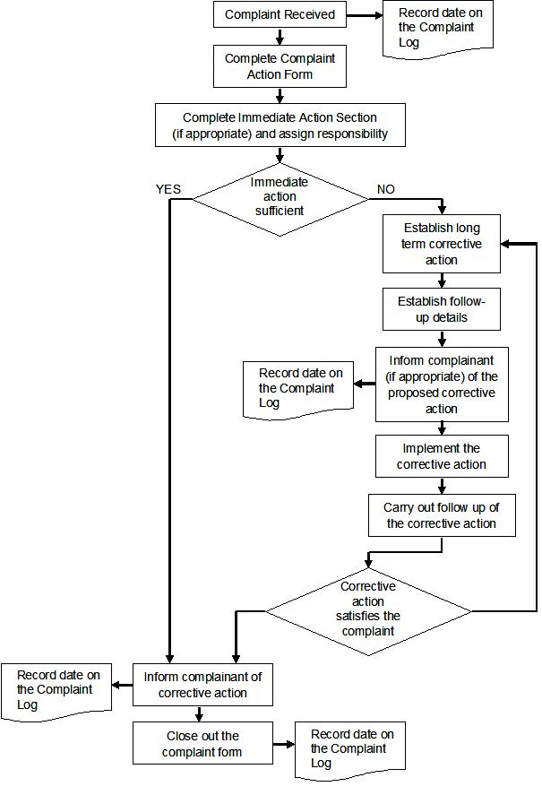
Grievances to be resolved within 15 working days.

Grievance Reference Number (to be filled in by [name ]):
Contact Details |  | Name:
 |  | Address:
 |  | Tel:
 |  | e-mail:
How would you prefer to be contacted? Please tick box |  | By post | By phone |  | By e-mail
Name and the identification information (from identity card).

Details of your grievance. Please describe the problems, who it happened to, when, where and how many times, as relevant

What is your suggested resolution for the grievance?

How to submit this form to /[name of concessionaire] | By Post to: [tbc]
How to submit this form to /[name of concessionaire] | By hand: please drop this form at [tbc]
How to submit this form to /[name of concessionaire] | By e-mail: Please email your grievance, suggested resolution and preferred contact details to: [tbc]
Signature |  |  |  | Date

Feedback from public consultation on EMP:
On Dec 05, 2012 PERS announced invitation for Public Consultations for the public, bodies and organizations interested in EMP for road rehabilitation works on Arandjelovac - Krcevac road section. Public and other interested parties and organizations were invited to participate in process of public consultation on draft EMP document. Prior to announcement in the newspapers, the EMP was delivered to the Municipality of Arandjelovac. Representatives of the local municipality informed the public through their local media of the time and place of public consultations. Invitation was placed on PERS web site too. Insight into the EMP document was ensured on following addresses:
- the premises of the PE “Roads of Serbia“, investment sector, 19a Vlajkoviceva St., Belgrade, on the first floor, on working days from 11:00 AM to 01:00 PM (local time), within 7 days starting from December 05, 2012.
- the premises of Arandjelovac Municipality, Venac slobode 10, 34300 Arandjelovac, on working days, within 7 days starting from Dec 05, 2012.
- on PE “Roads of Serbia“ web site: www.putevi-srbije.rs
Public Consultation and presentation of EMP document were held in the premises of Arandjelovac Municipality, on Dec 12, 2012, from 00:00 PM to 02:00 PM and there were no complains on prepared draft EMP document. Question raised and clarification provided are presented within this Report on Public Consultations.

In accordance with OP/BP 4.01, PERS has prepared EMP document for Road rehabilitation works on 8.7 km long road section Arandjelovac - Krcevac.
The in-country disclosure of the EMP document started on Dec 05th 2012 when invitation to the interested parties were published in the daily newspaper Politika, inviting the public, authorities and relevant institutions to have an insight into the proposed road rehabilitation works and environmental impact of the project with presented mitigation and monitoring measures. Prior to announcement in the newspapers, all documents were delivered to the Municipality of Arandjelovac and made publicly available on site, and also placed at PERS web site.
Representatives of the local self-government informed the public through local media of the time and place of public consultations. Disclosure of draft EMP document finished on December 12th 2012 when the public meeting was held in city of Arandjelovac.
There were 9 attendees on public consultation meeting in Arandjelovac. Two of them were local citizens. Among the others, there were local municipals, PERS representative and local environmental officer.
On behalf of PERS the meeting was attended by Mr. Igor Radovic, PERS representative for environmental issues of the projects.
On behalf of Local Municipality the meeting was attended by:
- Mrs. Jelena Strizovic Arandjelovac municipality – Chief of Department for Real Estate Affairs, Urban Planning, Construction and Housing and Utilities,
- Mrs. Aleksandra Lukic Arandjelovac Municipality
- Mrs. Nada Petrovic Arandjelovac Municipality
- Mrs. Dusica Popovic Arandjelovac Municipality
- Mrs. Javorka Stojkovic Arandjelovac Municipality
- Mrs. Sladjana Milovanovic Arandjelovac Municipality
- Mr. Zoran Popovic Arandjelovac Municipality
- Mrs. Anka Lukovic Technology High School
- Mrs. Ljiljana Plecevic Technology High School

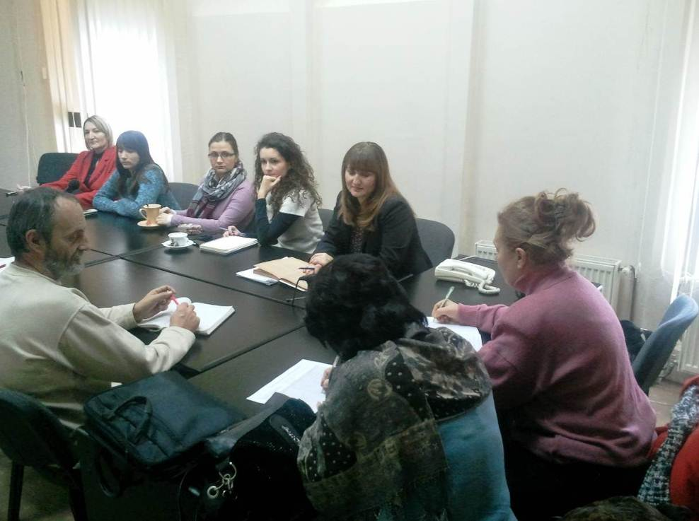
Picture 1: Public consultation in Arandjelovac, December 12, 2012

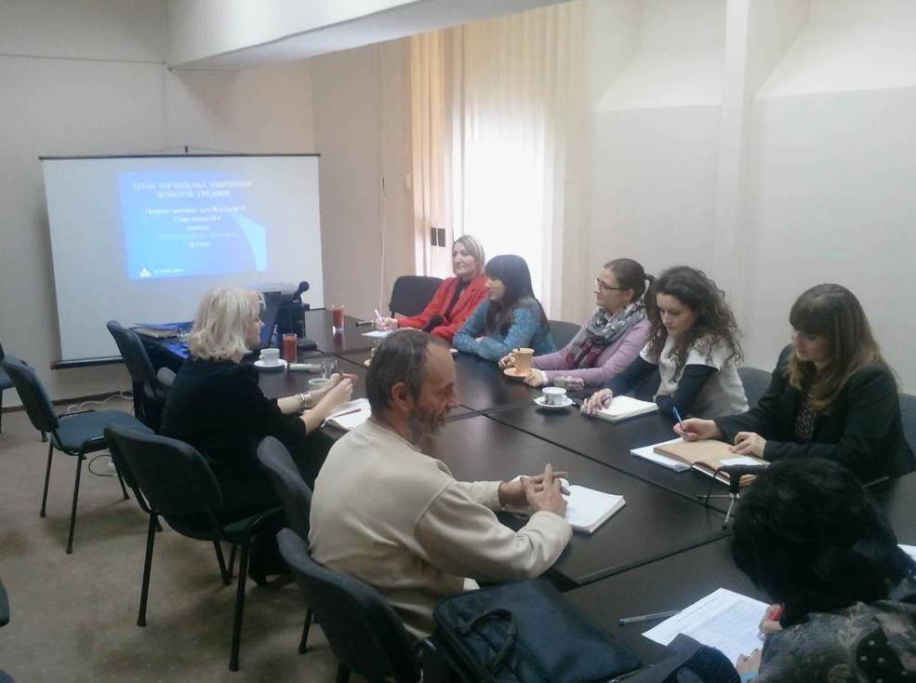
Picture 2: Public consultation in Arandjelovac, December 12, 2012

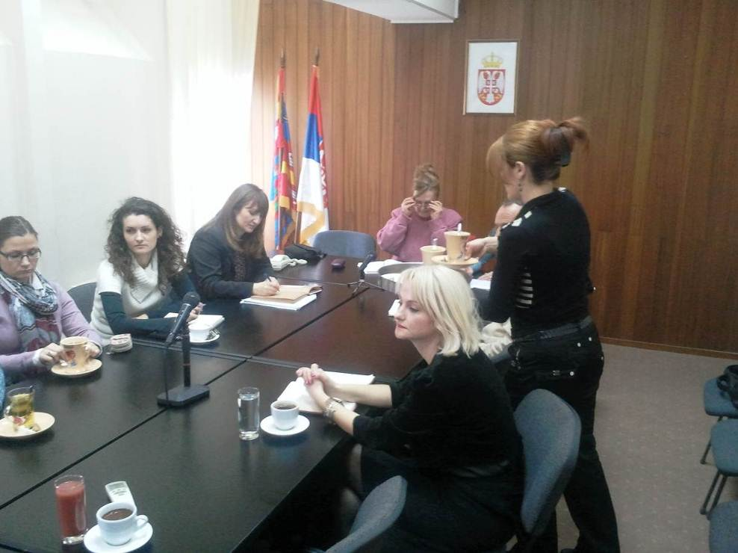
Picture 3: Public consultation in Arandjelovac, December 12, 2012

The meeting started according to schedule at 12:00 PM. EMP document was presented in detail to the interested attendees by the PERS representatives. During the public consultations, there were no significant remarks in regards to environmental protection issues.
The Remarks, Question and Answers:
Q1: Mr. Zoran Popovic: Will appropriate safety measures take place in the zone of primary school in Banja Settlement?
A1: Yes, safety is an integral part of each RRSP sub-project and increasing of safety is recognized as one of the major project tasks. Special attention will be paid to the area of primary school in Banja settlement (at km 3+485). That location will be particularly treated from the safety improvement point of view. The existing sidewalks will be rehabilitated, new ones will be designed on locations of interruptions and where the sidewalks are missing by km 5+000, since there is a school at km 3+500 and the pedestrian movement is intensive. Special safety workshops/courses for school children will be held in many schools which are placed along the roads which are subject of RRSP Project. Additionally, during design phase, it will be requested that designers provides design with proper traffic warning signs and speed limitations within the zone of primary school, and to consider possibility to implement vibro-acoustic trips as appropriate design solution for ensuring driver awareness about the particularly sensitive area in safety point of view.
Q2: Mr. Zoran Popovic: How existing access/crossing points of the main road and local roads will be treated through project implementation?
A2: The rehabilitation and widening works won't affect existing crossing points.
Q3: Mr. Zoran Popovic: How protection of different water bodies (streams and river Kubursnica) will be ensured during Project implementation? Are the works on existing culverts and bridges also treated in a manner to ensure protection of water bodies from any kind of pollution?
A3: The Rehabilitation Contractor will operate construction site in a way to reduce the risk of generating sediments and wastewater that may pollute local soils or receiving water bodies. The Contractor’s Site Specific Implementation Plan (SSIP) will cover procedures and plans for safeguarding aquatic habitats and fish during works over all water bodies, including the ones connected with Kubrsnica River, and will complement the Construction Method Statements. All request related to possible water pollution will be ensured through environmental management - waste and wastewater management plan will be prepared and implemented.
Q4: Mr. Zoran Popovic: How oily wash-water or accidental spills are treated through the project? In case of spillage, will oils and fuels be drained into appropriate reservoirs or it will be allowed to leek directly or indirectly into watercourse?
A4: The construction Site will be properly drained. The oily wash-water will be passed through an adequately sized, gravity oil separator prior to discharge. Paved areas, including vehicle parking areas, workshops and fuel storage areas are to drain to an oil and water separator. The contractor will have trained personnel who are competent in fuel handling procedures and for cleaning up accidental spills. The Rehabilitation contractor will prepare Oil and fuel storage management plan. Where fuel in excess of 5,000 litres is stored on site, it will be stored in sealed tanks on a concrete base that is bunded to hold 110% of the tank capacity. The Contractor’s SSIP will cover all procedures for storage, transportation and usage of oils and fuels, refuelling of plant and machinery and procedures for minimizing the risk of ground and water contamination. All oils and fuels will be required to be stored within secondary containment of 110 % capacity and all spillages shall be cleaned up immediately. Re-fuelling vehicles will carry Spill Kits to enable spillages to be cleaned up as soon as possible. Fuel storage areas will not be located within 20m of a water course.
Q5: Mrs. Ljiljana Plecevic: Will contractor equipment and machinery be certified regarding noise and air pollution emissions? Suggestion to PERS to carefully control including of subcontractors into the rehabilitation works.
A5: Rehabilitation Contractor is obliged to prove that all equipment is licenced and approved in accordance with EU standards. This applies to all machinery, vehicles and construction sites where noise and vibration may affect susceptible receptors. The contractor will be responsible for ensuring that noise and vibration does not affect the adjacent communities, in accordance with the Law on noise protection (“Official Gazette of RS”, 36/09).
Q6: Mrs. Ljiljana Plecevic: How noise, water and soil pollution monitoring activities will look like during project implementation?
A6: Noise disturbance to workers and neighboring population: noise levels will be monitored with appropriate equipment (hand held analyser), once at the beginning of the project and later on quarterly basis, and on complaint. If the results of monitoring are not satisfactory, monitoring should be conducted on monthly basis.
Water and soil pollution: water and soil quality (suspended solids, oils, pH value, and conductivity) will be monitored by unannounced sampling; analysis will be done at accredited laboratory with necessary equipment. These activities will be performed at least 3 times during project period. Monitoring should be done prior construction (or on a referent point upstream of construction site) and during and after rehabilitation works.
Q7: Mrs. Anka Lukovic: Which party is obliged to produce Waste Management Plan (WMP) during project preparation?
A7: Rehabilitation Contractor is obliged to produce his own WMP based on EMP requirements. WMP is one of five site specific implementation plans which are necessary to be produced by the Contractor and Approved by the PERS.
During the 7 days aimed for insight into the EMP document, nobody came into PERS premises to see the EMP document. During disclosure period there were no telephone or E-mail contacts regarding proposed EMP document.
During Public Consultation process and EMP document disclosure no interested groups or other stakeholders visited the environmental department of Arandjelovac municipality in order to have insight into the EMP document.
Consultation ended at 02:00 PM, local time.
LIST OF PARTICIPANTS
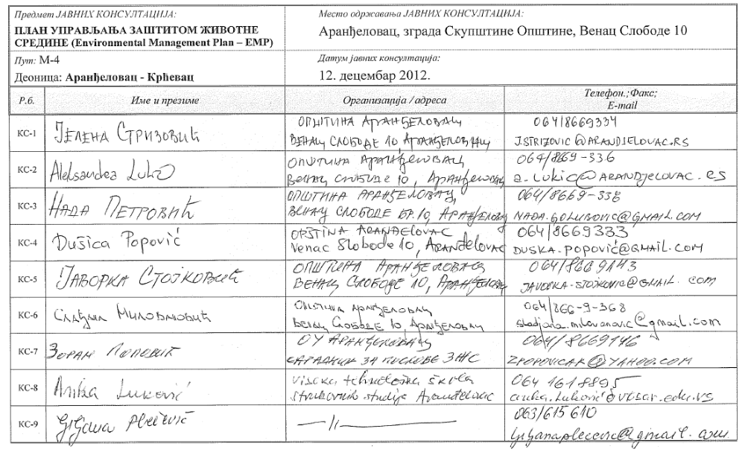
DOCUMENTATION
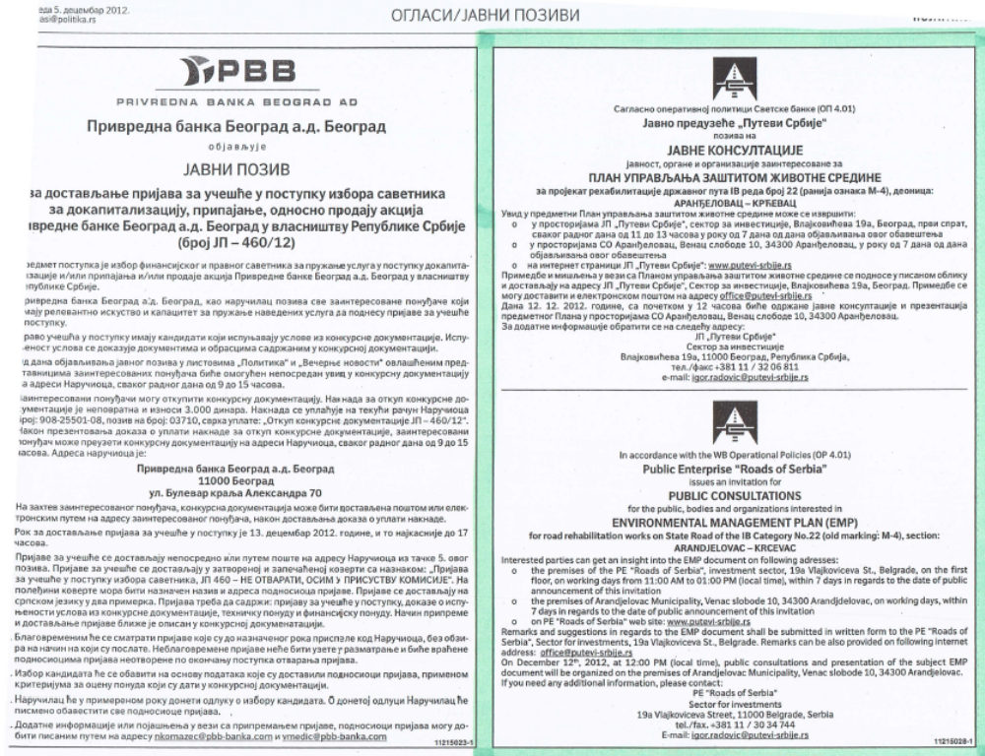
Announcement of public consultation in daily newspaper (“Politika”, December 05, 2012)
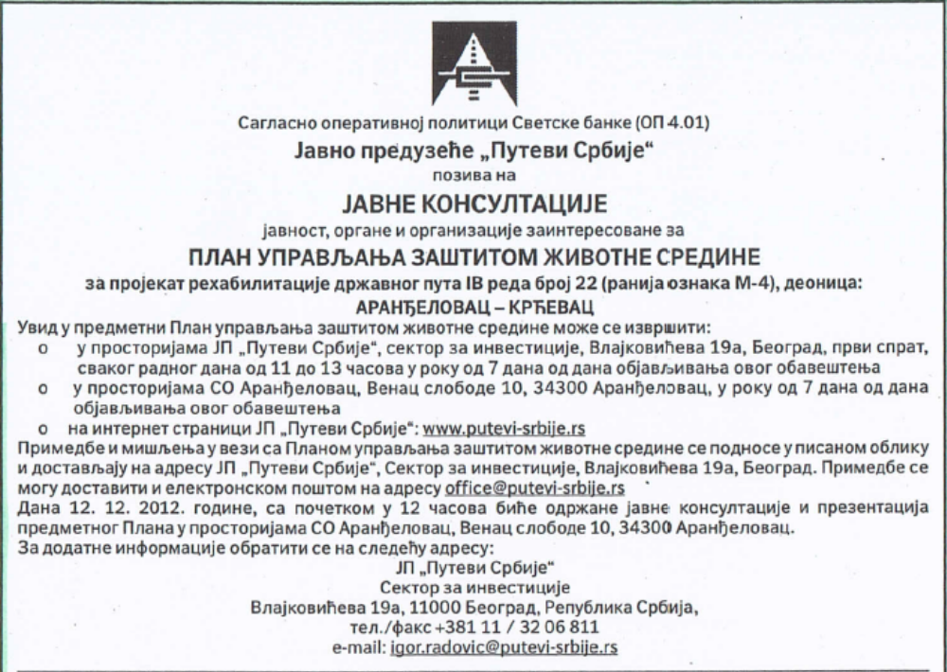
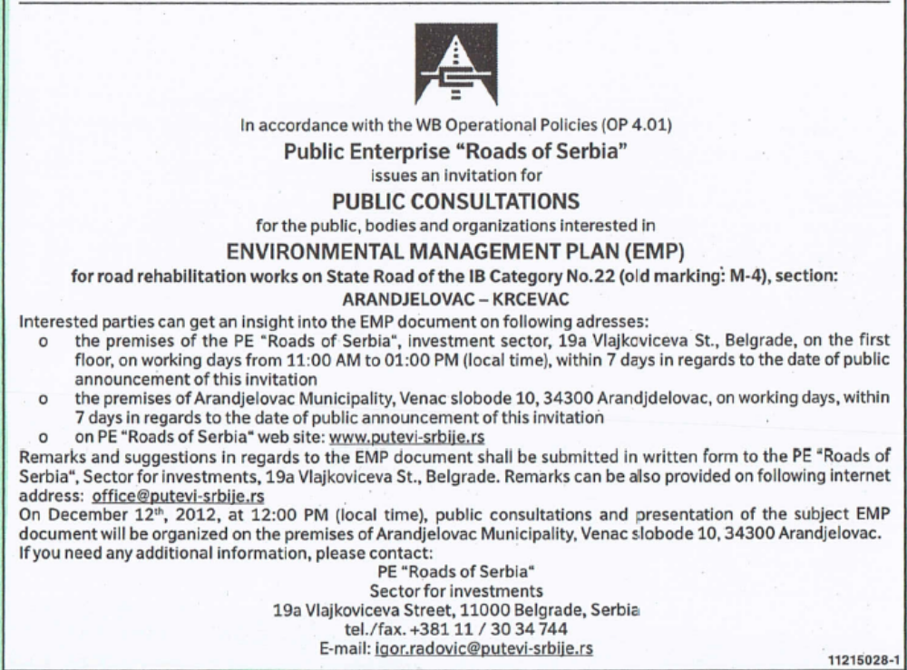
Announcement of public consultation in daily newspaper (“Politika”, Dec 05, 2012)

Annex IV of this EMP document
List of participants is presented within the Annex IV of this EMP document
Document is available in PE “Roads of Serbia” – Sector for Investment
Available on PERS web site
Please provide the results of any environmental monitoring carried out by the Company or its consultants. If you already have all the data requested available in another format, then this can used instead.
Not all parameters will necessarily apply. Please complete those rows that are most relevant to the industry sector. Additional parameters can be added as necessary.
Please ensure that the units of measurement are clearly stated
Please report on compliance against the standards for this project (typically local, EU and/or World Bank Group)
In addition to any other comments, please indicate whether the measurements reported apply to all or only some process operations at the facility
In addition to any other comments, please indicate whether the measurements reported apply to all or only some process operations at the facility Please include any fuel quality parameters (e.g. calorific value)
If you have not already done so, please provide a separate report detailing the circumstances of each fatality.
Incapacity to work for at least one full workday beyond the day on which the accident or illness occurred.
Lost workdays are the number of workdays (consecutive or not) beyond the date of injury or onset of illness that the employee was away from work or limited to restricted work activity because of an occupational injury or illness.
List of participants is presented within the Chapter 3.

